Semester | B.E. Semester VII – CMPN
Subject | DevOps
Subject Professor In-charge | Dr. Snehal Andhare
Assisting Teachers | Dr. Snehal Andhare
Laboratory | M310B

Student Name | Hasnain khan
Roll Number | 23102A0075
Grade and Subject Teacher's Signature

Experiment Number | 12
Experiment Title | Jenkins-Docker Continuous Deployment
Objectives  (Skill Set / Knowledge Tested / Imparted) | To implement and verify Docker image building and container deployment through the Jenkins pipeline. Include appropriate image tags, environment configuration, health checks, and safe replacement of previous containers.
Description | [CD Pipeline] 1. Continuous Deployment Pipeline Design:  Extended the Jenkins pipeline with Docker build and deployment stages:  * Docker Build: Tags image with Jenkins ${BUILD_NUMBER} and 'latest'.  * Safe Container Replacement: Stops and removes any previously running container before starting the new revision, preventing port collisions on 8081.  * Automated Health Check: Polls http://localhost:8081/index.html after startup and fails the pipeline if HTTP 200 is not received.
Output | 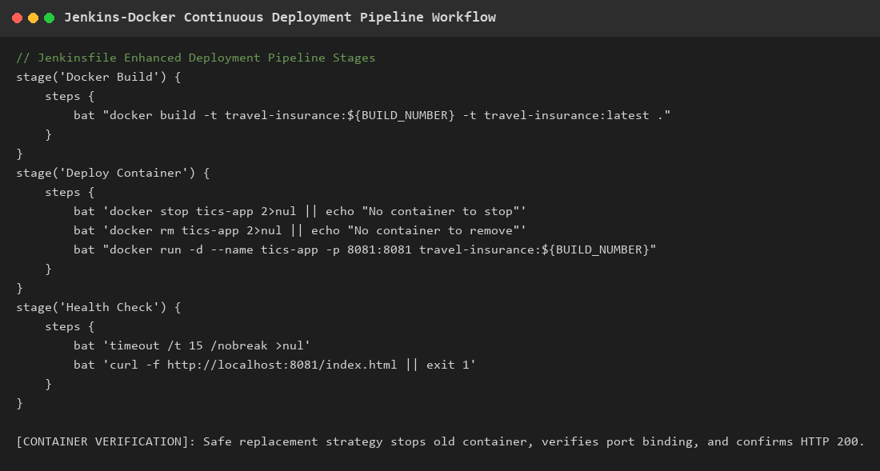  Figure 12.1: Jenkins-Docker Continuous Deployment Pipeline Workflow  Observation: Pipeline architecture showing automated Docker image build, safe container replacement, and post-deployment health verification.
Conclusion | The Jenkins-Docker Continuous Deployment pipeline was successfully implemented with build-number tagging, safe container replacement, and post-deployment HTTP health checks.

