Semester | B.E. Semester VII – CMPN
Subject | DevOps
Subject Professor In-charge | Dr. Snehal Andhare
Assisting Teachers | Dr. Snehal Andhare
Laboratory | M310B

Student Name | Hasnain khan
Roll Number | 23102A0075
Grade and Subject Teacher's Signature

Experiment Number | 13
Experiment Title | Configuration Management Using Ansible
Objectives  (Skill Set / Knowledge Tested / Imparted) | To create an appropriate Ansible project structure and playbooks for the deployment environment. Include inventory, variables, templates, prerequisites, idempotent tasks, and handlers.
Description | [Ansible Architecture] 1. Ansible Project Structure & Playbooks:  Implemented modular Configuration Management under c:\Users\Hasnain\Desktop\Devops\ansible:  * ansible.cfg: Sets inventory, privilege escalation (become=True), and YAML output.  * inventory/hosts.yml: Defines target host group 'app_servers'.  * group_vars/all.yml: Centralizes deployment variables (port 8081, paths, Java package).  * templates/app.service.j2: Jinja2 template for systemd service management.  * playbooks/deploy.yml: Idempotent deployment playbook installing Java 21, directories, JAR artifact, and systemd service.  [Idempotency] 2. Idempotency Principle:  All tasks are idempotent: apt checks state=present, file checks state=directory, copy performs checksum comparison, and systemd reloads only when triggered by handlers.
Output | 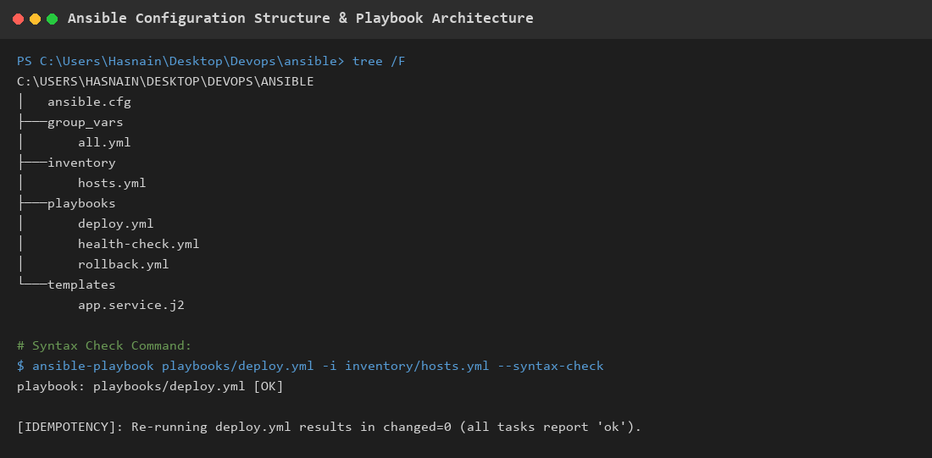  Figure 13.1: Ansible Directory Layout, Playbook Structure & Idempotency Architecture  Observation: Terminal display of the Ansible project structure, YAML syntax validation, and idempotency configuration.
Conclusion | Ansible configuration management was successfully structured and validated with idempotent playbooks, centralized variables, Jinja2 systemd templates, and handlers.

