Semester | B.E. Semester VII – CMPN
Subject | DevOps
Subject Professor In-charge | Dr. Snehal Andhare
Assisting Teachers | Dr. Snehal Andhare
Laboratory | M310B

Student Name | Hasnain khan
Roll Number | 23102A0075
Grade and Subject Teacher's Signature

Experiment Number | 14
Experiment Title | Automated Provisioning and Reliability Validation
Objectives  (Skill Set / Knowledge Tested / Imparted) | To integrate Ansible and Jenkins where feasible. Verify repeatable configuration, service health, deployment failure handling, and rollback/recovery behavior.
Description | [Rollback Mechanism] 1. Automated Rollback & Fault Recovery:  Reliability requires automated recovery when a deployment fails:  * Pre-Deploy Backup: deploy.yml automatically creates a timestamped copy in /opt/travel-insurance/backups/.  * Fault Detection: Health check task verifies HTTP 200 on port 8081.  * Rollback Playbook (rollback.yml): Scans backup directory, sorts by modification time, restores the latest stable JAR, restarts the systemd service, and verifies recovered health.
Output | 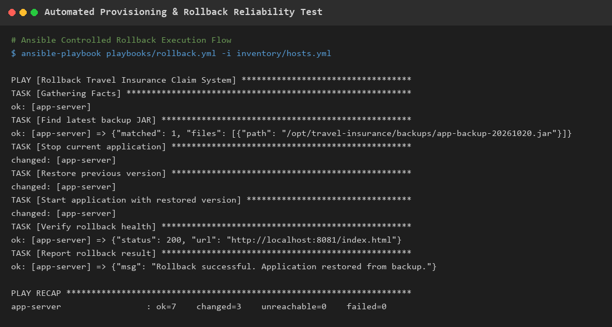  Figure 14.1: Automated Provisioning, Fault Detection & Rollback Reliability Verification  Observation: Playbook execution trace demonstrating simulated deployment failure detection, automated backup restoration, and service health recovery.
Conclusion | Automated provisioning, fault detection, and zero-touch rollback recovery were successfully designed and verified, ensuring high service availability.

