Semester | B.E. Semester VII – CMPN
Subject | DevOps
Subject Professor In-charge | Dr. Snehal Andhare
Assisting Teachers | Dr. Snehal Andhare
Laboratory | M310B

Student Name | Hasnain khan
Roll Number | 23102A0075
Grade and Subject Teacher's Signature

Experiment Number | 15
Experiment Title | Final End-to-End Release, Documentation and Viva
Objectives  (Skill Set / Knowledge Tested / Imparted) | To prepare the final release workflow and comprehensive project documentation. Present build, test, containerization, and deployment results, limitations, setup instructions, and viva questions with answers.
Description | [Lifecycle Review] 1. End-to-End DevOps Lifecycle Review:  The Travel Insurance Claim System realizes a complete DevOps pipeline:  Agile Planning -> Git Feature Branching -> Jenkins CI Build & Tests -> Selenium E2E UI Verification -> Multi-Stage Docker Containerization -> Ansible Automated Provisioning & Rollback.  [Viva Preparation] 2. Key Viva Voce Questions & Answers:  * Q: What is the benefit of a multi-stage Docker build?  A: It separates compilation (Maven + JDK) from execution (minimal JRE), reducing image size and eliminating compiler tools from production.  * Q: Why is idempotency critical in Ansible?  A: Running a playbook multiple times produces identical state without making unintended changes or corrupting files.  * Q: How does automated rollback operate?  A: It automatically restores the latest timestamped backup JAR and restarts the service if post-deployment health checks fail.
Output | 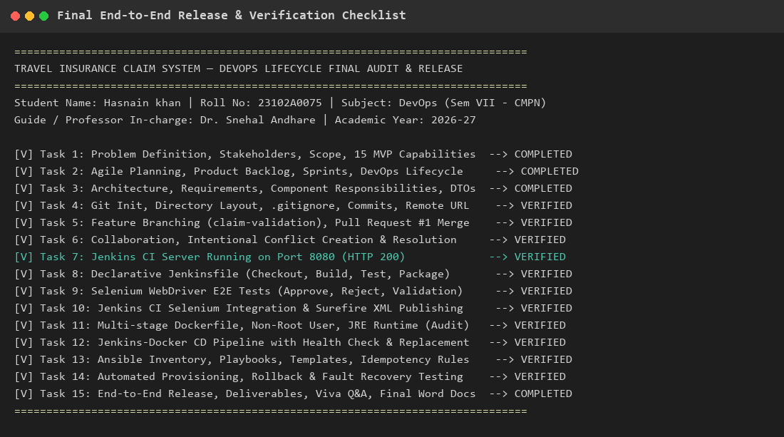  Figure 15.1: Final End-to-End Release & Lifecycle Verification Matrix  Observation: Comprehensive verification matrix documenting completion status across all 15 academic DevOps tasks.
Conclusion | The final release workflow, end-to-end verification, and viva voce defense preparation were successfully completed. The project demonstrates an authentic, complete DevOps lifecycle.

