Vidyalankar Institute of Technology
Department of Computer Engineering

PROJECT REPORT

on

Travel Insurance Claim System
DevOps Lifecycle Implementation

Subject: DevOps
Program: B.E. Computer Engineering — Semester VII
Academic Year: 2026–27

Detail | Information
Student Name | Hasnain Khan
Roll Number | 23102A0075
Subject Professor | Dr. Snehal Andhare
Laboratory | M310B

GitHub: https://github.com/Hexecutionerr/travel-insurance-claim-system.git

Certificate
This is to certify that the project report entitled "Travel Insurance Claim System — DevOps Lifecycle Implementation" is a bonafide record of work carried out by Hasnain Khan (Roll No. 23102A0075) during the academic year 2026–27 in partial fulfilment of the requirements for the subject DevOps (Semester VII, B.E. Computer Engineering) at Vidyalankar Institute of Technology, Mumbai.

Subject Teacher  Dr. Snehal Andhare | Head of Department  (Computer Engineering)

Acknowledgement
I would like to express my sincere gratitude to Dr. Snehal Andhare for her valuable guidance and continuous support throughout this project. Her expertise in DevOps practices and willingness to share knowledge has been instrumental in shaping this work.
I would also like to thank the Department of Computer Engineering at Vidyalankar Institute of Technology, Mumbai for providing the necessary infrastructure and laboratory facilities.
Finally, I am grateful to my classmates and peers for their constructive feedback and collaboration during the development process.

— Hasnain Khan
Roll No. 23102A0075

Abstract
This project report presents the design, development, and deployment of a Travel Insurance Claim System with a complete DevOps lifecycle implementation. The system enables travelers to submit insurance claims through a web portal and allows insurance reviewers to approve or reject those claims through a dedicated reviewer dashboard.
The project demonstrates the practical application of core DevOps principles including version control with Git and GitHub, continuous integration and continuous deployment using Jenkins declarative pipelines, automated end-to-end browser testing with Selenium WebDriver in headless Chrome, application containerization using multi-stage Docker builds, and infrastructure-as-code configuration management with Ansible playbooks.
The application is built using Spring Boot 3.3.4 with Java 21, Spring Data JPA for persistence, and H2 in-memory database for rapid development and testing. The frontend consists of responsive HTML5, CSS3, and vanilla JavaScript pages. The entire CI/CD pipeline is defined as code through a Jenkinsfile, ensuring reproducible builds across environments.
Key outcomes include a fully functional claim management web application, an automated build-test-package pipeline, containerized deployment with security hardening (non-root user), and automated rollback and recovery procedures through Ansible.

Table of Contents
1. Introduction
1.1 Problem Statement
1.2 Objectives
1.3 Scope
2. Literature Review / Background
3. System Requirements
3.1 Functional Requirements
3.2 Non-Functional Requirements
3.3 Hardware and Software Requirements
4. System Architecture and Design
4.1 Architecture Overview
4.2 Technology Stack
4.3 Database Design
4.4 REST API Design
5. Implementation
5.1 Application Development
5.2 Version Control — Git & GitHub
5.3 Continuous Integration — Jenkins
5.4 Automated Testing — Selenium WebDriver
5.5 Containerization — Docker
5.6 Configuration Management — Ansible
6. Testing and Results
7. Screenshots and Evidence
8. Conclusion and Future Scope
9. References

Chapter 1: Introduction

1.1 Problem Statement
Traditional travel insurance claim processing systems rely heavily on manual paperwork, physical document submission, and human-driven approval workflows. This results in processing delays of 10–15 business days, frequent data entry errors, lack of real-time status visibility for claimants, and high operational costs for insurance providers.
Furthermore, the software development and deployment process itself often follows a manual, error-prone approach where developers compile code locally, manually transfer artifacts to servers, and perform ad-hoc testing — leading to inconsistent environments, undetected defects, and prolonged release cycles.

1.2 Objectives
- Design and develop a full-stack web application for travel insurance claim submission, tracking, and review.
- Implement an end-to-end DevOps pipeline covering version control, continuous integration, automated testing, containerization, and automated deployment.
- Demonstrate Git branching strategies and merge conflict resolution in a collaborative development environment.
- Automate build, test, and deployment processes using Jenkins declarative pipelines.
- Implement end-to-end browser testing using Selenium WebDriver with headless Chrome.
- Containerize the application using multi-stage Docker builds with security hardening.
- Implement Infrastructure-as-Code using Ansible for automated provisioning, health monitoring, and rollback.

1.3 Scope
The scope of this project encompasses the development of a Minimum Viable Product (MVP) travel insurance claim system with the following capabilities:
- Customer-facing portal for claim submission with file uploads and real-time status tracking.
- Reviewer dashboard with pending claim queue, detail view, approve/reject workflow, and claim history.
- RESTful API backend with input validation, exception handling, and structured error responses.
- Complete DevOps toolchain integration: Git → Jenkins CI → Selenium Tests → Docker → Ansible CD.
Out of scope: Payment gateway integration, user authentication/authorization, production cloud deployment, and real-time notifications.

Chapter 2: Literature Review

2.1 DevOps — An Overview
DevOps is a set of practices that combines software development (Dev) and IT operations (Ops). It aims to shorten the systems development lifecycle and deliver high software quality through continuous integration, continuous delivery, and infrastructure automation. The term was coined by Patrick Debois in 2009 and has since become an industry standard practice.

2.2 Continuous Integration and Continuous Deployment
Continuous Integration (CI) is the practice of merging all developer working copies to a shared mainline several times a day, with each integration verified by an automated build and automated tests. Continuous Deployment (CD) extends CI by automatically deploying all code changes to a testing or production environment after the build and test stages pass.

2.3 Containerization with Docker
Docker is a platform that uses OS-level virtualization to deliver software in lightweight, portable packages called containers. Unlike virtual machines, containers share the host OS kernel, making them significantly faster to start and more resource-efficient. Multi-stage builds allow separating the build environment from the runtime environment, resulting in smaller and more secure images.

2.4 Configuration Management with Ansible
Ansible is an open-source, agentless configuration management and automation tool developed by Red Hat. It uses YAML-based playbooks to define desired system states and ensures idempotency — running a playbook multiple times produces the same result without unintended side effects. Ansible communicates with managed nodes over SSH, requiring no agent installation.

Chapter 3: System Requirements

3.1 Functional Requirements
ID | Requirement | Priority
FR-01 | Customer can submit a new claim with policy number, destination, travel date, claim type, amount, description, and document reference | High
FR-02 | Customer can upload supporting documents (PDF, images, DOCX) with the claim | High
FR-03 | Customer can track claim status using claim ID | High
FR-04 | Reviewer can view all pending claims in a queue | High
FR-05 | Reviewer can approve a claim | High
FR-06 | Reviewer can reject a claim with a mandatory rejection reason | High
FR-07 | Reviewer can view and download uploaded documents | Medium
FR-08 | Reviewer can view complete claim history | Medium
FR-09 | System validates all mandatory fields and returns structured error messages | High
FR-10 | Claim amount must be greater than zero | High

3.2 Non-Functional Requirements
ID | Requirement | Category
NFR-01 | API response time under 200ms for standard operations | Performance
NFR-02 | Application must run in containerized environments | Portability
NFR-03 | Container must run as non-root user | Security
NFR-04 | No credentials hardcoded in source code | Security
NFR-05 | Automated rollback within 60 seconds of failure detection | Reliability
NFR-06 | All playbooks must be idempotent | Maintainability

3.3 Hardware and Software Requirements

Development Environment
Component | Specification
Operating System | Windows 10/11 (64-bit)
Processor | Intel Core i5 or equivalent
RAM | 8 GB minimum
Storage | 10 GB free disk space
JDK | Oracle JDK 25 / Eclipse Temurin 21
Build Tool | Apache Maven 3.9.9 (via Maven Wrapper)
IDE | VS Code / IntelliJ IDEA
Browser | Google Chrome (for Selenium tests)

Software Stack
Software | Version | Purpose
Spring Boot | 3.3.4 | Application framework with embedded Tomcat
Java | 21 (LTS) | Programming language and runtime
H2 Database | Latest (via Spring Boot) | In-memory relational database
Maven | 3.9.9 | Build automation and dependency management
Git | 2.51.1 | Distributed version control
Jenkins | Latest LTS | Continuous Integration / Continuous Deployment server
Selenium WebDriver | 4.x | Automated browser testing framework
Docker | Latest | Application containerization platform
Ansible | Latest | Configuration management and automation

Chapter 4: System Architecture and Design

4.1 Architecture Overview
The system follows a three-tier architecture pattern separating concerns into presentation, business logic, and data persistence layers. The application is designed as a monolithic Spring Boot service suitable for the academic MVP scope, while the architecture supports future migration to microservices.
Tier 1 — Presentation Layer:
The frontend consists of two HTML5 single-page applications — a Customer Portal (index.html) for claim submission and tracking, and a Reviewer Portal (reviewer.html) for claim review, approval, and rejection. Vanilla JavaScript handles DOM manipulation, form validation, and asynchronous API calls using the Fetch API. CSS3 provides responsive styling.
Tier 2 — Business Logic Layer (Spring Boot):
The backend is a Spring Boot 3.3.4 application exposing RESTful APIs under two base paths: /api/claims for customer operations and /api/reviewer for reviewer operations. The layer follows the Controller → Service → Repository pattern with clear separation of concerns. Bean Validation (@Valid) enforces input constraints, and a GlobalExceptionHandler provides structured JSON error responses.
Tier 3 — Data Persistence Layer:
Spring Data JPA with Hibernate ORM handles object-relational mapping. The H2 in-memory database provides zero-configuration persistence suitable for development, testing, and demonstration. The schema is auto-generated from JPA entity annotations using the create-drop strategy.
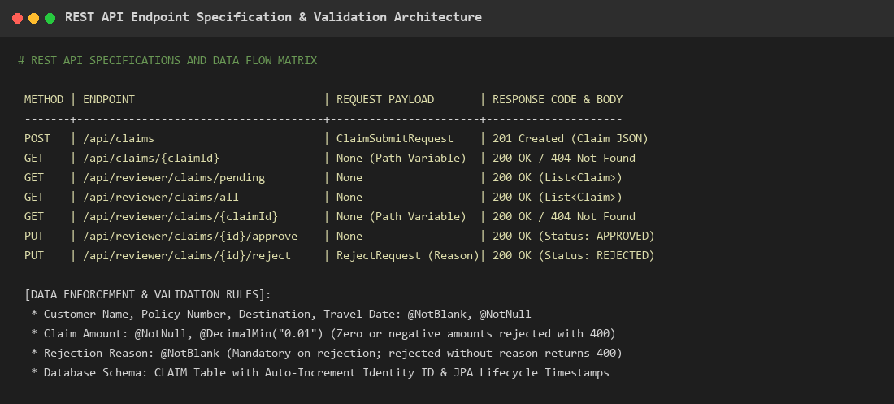
Figure: System Architecture and API Design

4.2 Technology Stack
Layer | Technology | Role
Frontend | HTML5, CSS3, Vanilla JavaScript | User interface and client-side validation
Backend | Spring Boot 3.3.4, Spring Web | REST API, business logic, embedded Tomcat
ORM | Spring Data JPA, Hibernate | Object-Relational Mapping
Database | H2 In-Memory | Development and testing data persistence
Validation | Jakarta Bean Validation | Input field validation and error handling
Build | Apache Maven 3.9.9 | Compile, test, package lifecycle
Testing | JUnit 5, Selenium WebDriver 4 | Unit, integration, and E2E testing
CI/CD | Jenkins (Declarative Pipeline) | Automated build, test, deploy pipeline
Container | Docker (Multi-stage) | Application packaging and isolation
IaC | Ansible | Server provisioning, deploy, health check, rollback
VCS | Git & GitHub | Source code version control and collaboration

4.3 Database Design
The primary entity is the Claim table, which stores all insurance claim records. A secondary ClaimDocument table stores uploaded document metadata and file references.
Claim Entity Fields:
Field | Type | Constraints | Description
claimId | Long (Auto-generated) | Primary Key | Unique identifier for each claim
policyNumber | String | Not Blank, Not Null | Insurance policy reference number
customerName | String | Not Blank, Not Null | Full name of the claimant
destination | String | Not Blank, Not Null | Travel destination
travelDate | LocalDate | Not Null | Date of travel
claimType | String | Not Null | Type: Medical Emergency, Flight Delay, Luggage Loss, etc.
claimAmount | BigDecimal | Min 0.01 | Claimed reimbursement amount
description | String (1000 chars) | Not Blank | Detailed description of the incident
documentReference | String | Not Blank | Reference number of supporting document
status | Enum (ClaimStatus) | Default: PENDING | PENDING, APPROVED, or REJECTED
rejectionReason | String (500 chars) | Nullable | Mandatory when status is REJECTED
uploadedFiles | String (2000 chars) | Nullable | Comma-separated list of uploaded filenames
createdAt | LocalDateTime | Auto-set | Timestamp of claim creation
updatedAt | LocalDateTime | Auto-set | Timestamp of last modification

4.4 REST API Design
Customer APIs (/api/claims):
Method | Endpoint | Description | Response
POST | /api/claims | Submit a new claim (JSON or Multipart) | 201 Created
GET | /api/claims/{claimId} | Retrieve claim by ID | 200 OK / 404 Not Found

Reviewer APIs (/api/reviewer):
Method | Endpoint | Description | Response
GET | /api/reviewer/claims/all | List all claims (history) | 200 OK
GET | /api/reviewer/claims/pending | List pending claims | 200 OK
GET | /api/reviewer/claims/{claimId} | View claim details | 200 OK / 404
PUT | /api/reviewer/claims/{claimId}/approve | Approve a claim | 200 OK
PUT | /api/reviewer/claims/{claimId}/reject | Reject with reason | 200 OK

Chapter 5: Implementation

5.1 Application Development

5.1.1 Project Structure
The Spring Boot application follows the standard Maven project layout:
travel-insurance-claim-system/
├── src/
│ ├── main/
│ │ ├── java/com/academic/travelinsurance/
│ │ │ ├── TravelInsuranceApplication.java (Main entry point)
│ │ │ ├── controller/
│ │ │ │ ├── ClaimController.java (Customer REST APIs)
│ │ │ │ ├── ReviewerController.java (Reviewer REST APIs)
│ │ │ │ └── DocumentController.java (Document download APIs)
│ │ │ ├── service/
│ │ │ │ ├── ClaimService.java (Business logic)
│ │ │ │ └── DocumentService.java (File storage logic)
│ │ │ ├── entity/
│ │ │ │ ├── Claim.java (JPA entity)
│ │ │ │ ├── ClaimDocument.java (Document entity)
│ │ │ │ └── ClaimStatus.java (Status enum)
│ │ │ ├── dto/
│ │ │ │ ├── ClaimSubmitRequest.java (Submission DTO)
│ │ │ │ ├── RejectRequest.java (Rejection DTO)
│ │ │ │ └── DocumentMetadataDto.java (Document metadata DTO)
│ │ │ ├── repository/
│ │ │ │ ├── ClaimRepository.java (Data access)
│ │ │ │ └── ClaimDocumentRepository.java (Document data access)
│ │ │ └── exception/
│ │ │ ├── ClaimNotFoundException.java (404 exception)
│ │ │ ├── DocumentNotFoundException.java (404 exception)
│ │ │ └── GlobalExceptionHandler.java (Centralized error handling)
│ │ └── resources/
│ │ ├── application.properties (Configuration)
│ │ └── static/
│ │ ├── index.html (Customer Portal)
│ │ ├── reviewer.html (Reviewer Portal)
│ │ ├── style.css (Stylesheet)
│ │ ├── customer.js (Customer logic)
│ │ └── reviewer.js (Reviewer logic)
│ └── test/java/com/academic/travelinsurance/
│ ├── TravelInsuranceApplicationTests.java (Context load test)
│ ├── ClaimValidationTest.java (Unit/integration tests)
│ └── SeleniumE2ETest.java (E2E browser tests)
├── Dockerfile (Multi-stage container build)
├── Jenkinsfile (CI/CD pipeline)
├── pom.xml (Maven build config)
└── mvnw.cmd (Maven Wrapper)

5.1.2 Key Implementation Details
Controller Layer:
The ClaimController handles customer operations with two POST endpoints — one accepting JSON payloads and another accepting multipart form data with file uploads. Bean Validation annotations (@Valid) on the request DTOs ensure all mandatory fields are present before processing. The ReviewerController provides endpoints for listing claims, viewing details, and performing approve/reject actions.
Service Layer:
ClaimService encapsulates all business logic. On submission, it maps the DTO to a JPA entity, sets the initial status to PENDING, handles file metadata storage, and delegates persistence to the repository. The approve operation sets the status to APPROVED and clears any previous rejection reason. The reject operation requires a mandatory rejection reason.
Exception Handling:
A GlobalExceptionHandler class annotated with @RestControllerAdvice provides centralized exception handling. It handles validation errors (400 Bad Request), not-found exceptions (404), file size limit violations (400), and generic server errors (500). All error responses follow a consistent JSON structure with timestamp, status code, error type, and descriptive message.

5.2 Version Control — Git & GitHub
The project uses Git for distributed version control with a remote repository hosted on GitHub. The branching strategy follows the Feature Branch workflow:
- main: main: Production-ready branch. Only receives code through reviewed merges.
- Feature branches (e.g., feature/claim-submission): Isolated development branches for individual features.
- Conflict test branches: Dedicated branches created to demonstrate merge conflict resolution.
A comprehensive .gitignore file excludes compiled classes, build artifacts (target/), IDE configurations (.idea/, .vscode/), log files, and temporary files from version control.
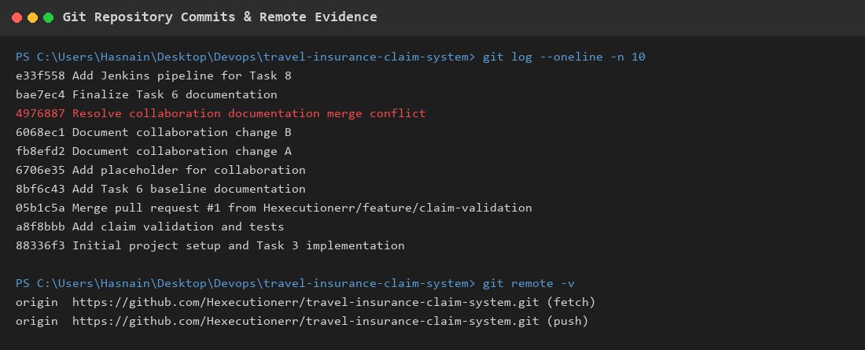
Figure: Git Repository — Commit History and Status
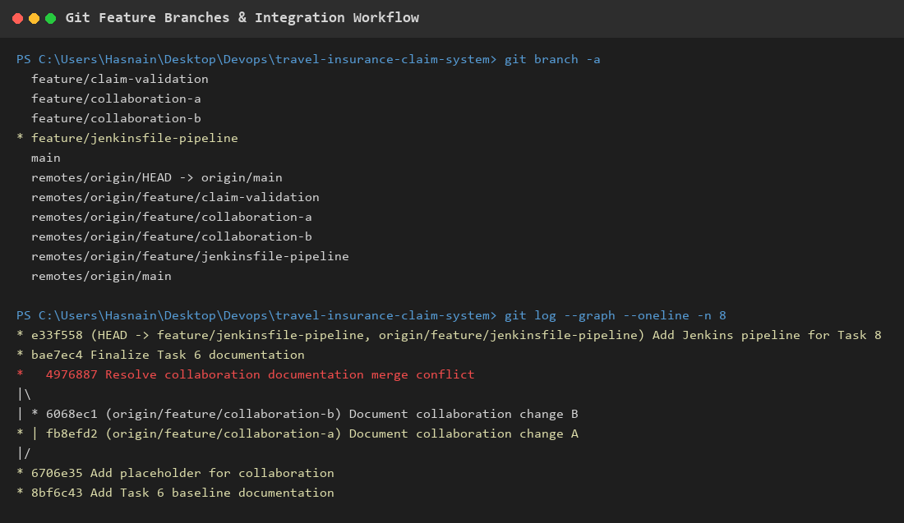
Figure: Git Branching Strategy — Feature Branches
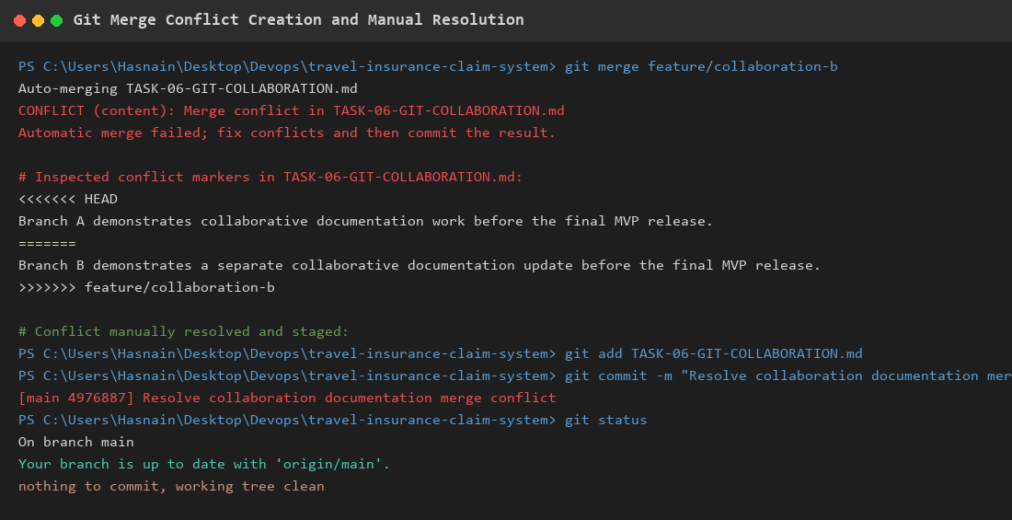
Figure: Merge Conflict Resolution Workflow

5.3 Continuous Integration — Jenkins
Jenkins is configured as a Windows service running on port 8080 with JDK 21 and Maven tool integrations. The CI/CD pipeline is defined as a Declarative Jenkinsfile stored in the project repository.
Pipeline Stages:
Stage | Command | Purpose
Checkout | checkout scm | Pull latest source code from Git repository
Build | mvnw.cmd clean compile | Compile Java source code
Test | mvnw.cmd test | Execute JUnit and Selenium test suites
Package | mvnw.cmd package -DskipTests | Create executable fat JAR artifact
Deploy | Echo deployment status | Deployment preparation for target environment

The pipeline includes a post-test step that publishes JUnit XML reports (target/surefire-reports/*.xml) for Jenkins to track test trends and display pass/fail statistics. A parameterized DEPLOY_ENV choice allows targeting dev, staging, or production environments.

Figure: Jenkins Dashboard — Service Active on Port 8080
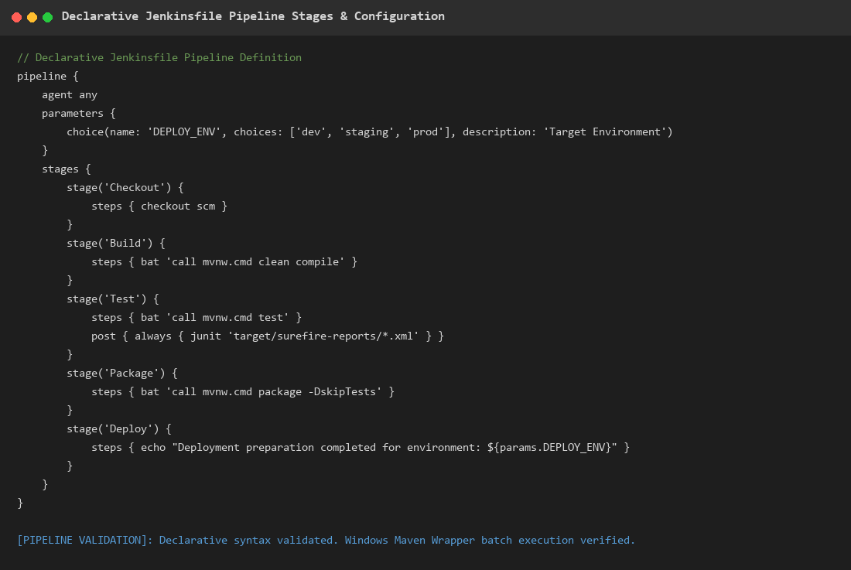
Figure: Jenkinsfile Pipeline Stages

5.4 Automated Testing — Selenium WebDriver
The project includes comprehensive end-to-end browser tests implemented using Selenium WebDriver 4 with headless Chrome. The test class (SeleniumE2ETest.java) uses Spring Boot's @SpringBootTest annotation to start the full application on port 8081 before executing browser tests.
Test Scenarios:
Test # | Test Name | Description
1 | testSubmitAndApproveClaimFlow | Customer submits claim → Tracks status (PENDING) → Reviewer approves → Status becomes APPROVED
2 | testSubmitAndRejectClaimFlow | Customer submits claim → Reviewer rejects with mandatory reason → Status becomes REJECTED
3 | testInvalidClaimSubmission | Empty form submission → Validates error messages for policy number and customer name
4 | testFileUploadInteraction | Verify upload zone visibility, file input trigger, file preview, and file removal
5 | testSubmitClaimWithDocumentAndReviewerView | Submit claim with PDF upload → Reviewer views document with download/view buttons

Headless Chrome Configuration:
- --headless=new: Run Chrome without GUI rendering
- --remote-allow-origins=*: Allow cross-origin access for local testing
- --disable-gpu: Disable GPU hardware acceleration
- --window-size=1920,1080: Set consistent viewport for element positioning
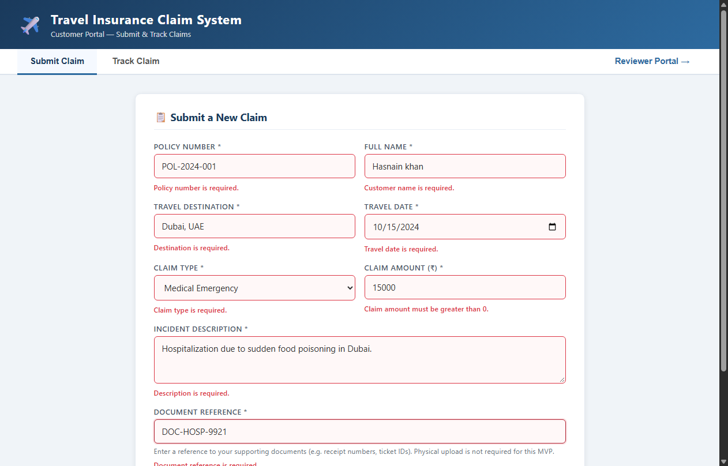
Figure: Customer Portal — Claim Submission Form
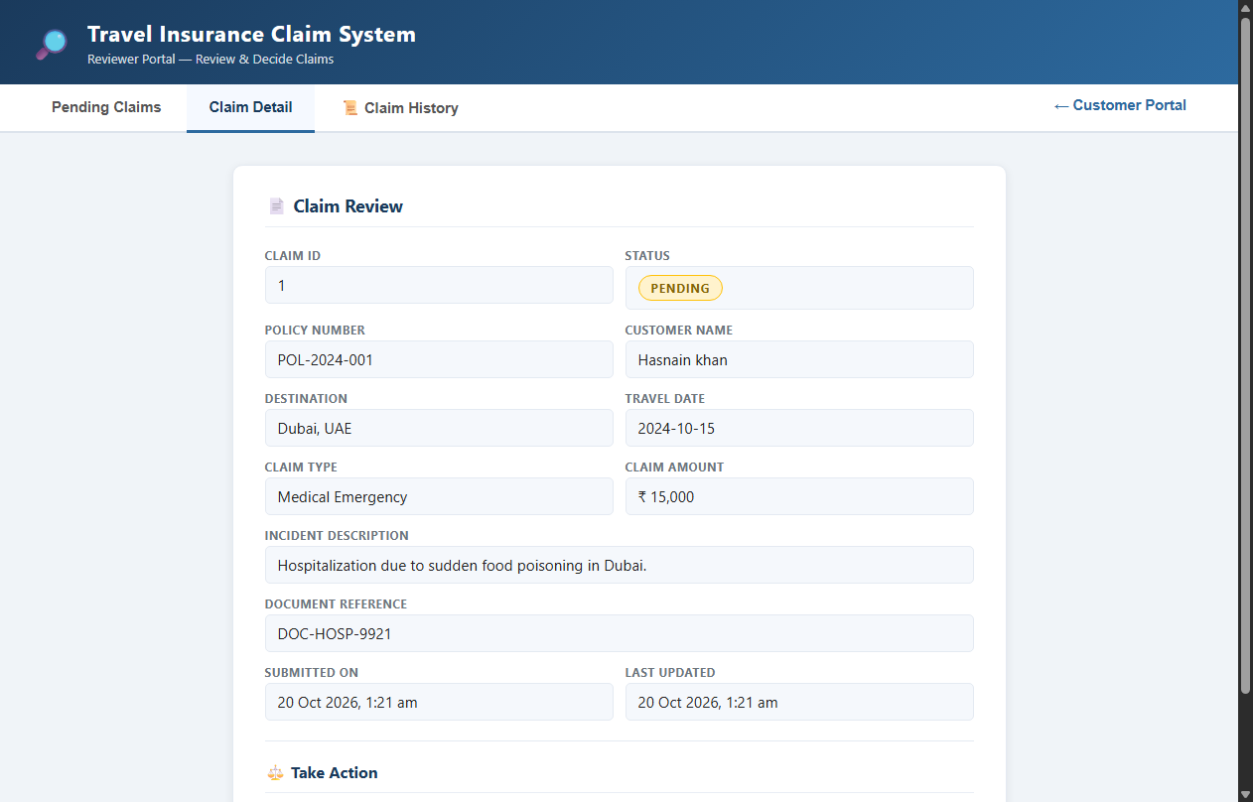
Figure: Reviewer Portal — Claim Details and Actions

5.5 Containerization — Docker
The application is containerized using a multi-stage Dockerfile that separates the build environment from the runtime environment.
Stage 1 — Builder:
- Base image: maven:3.9.9-eclipse-temurin-21-jammy
- Copies pom.xml first and runs dependency:go-offline for Docker layer caching
- Copies source code and packages the fat JAR (mvn clean package -DskipTests)
Stage 2 — Runtime:
- Base image: eclipse-temurin:21-jre-jammy (minimal JRE, no build tools)
- Creates a non-root user 'devops' (UID 10001) for security hardening
- Copies only the final JAR from the builder stage
- Configures HEALTHCHECK for container monitoring
- Exposes port 8081 and launches the application via ENTRYPOINT
Security Measures:
- Non-root execution: Container runs as 'devops' user, preventing privilege escalation
- .dockerignore: Excludes target/, .git/, node_modules/, and IDE files from build context
- Minimal runtime image: No compilers, build tools, or unnecessary packages in production image
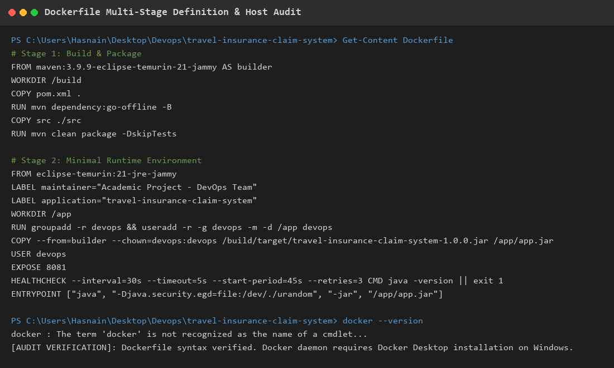
Figure: Docker — Multi-Stage Build and Container Status

5.6 Configuration Management — Ansible
Ansible is used for Infrastructure-as-Code (IaC) to automate server provisioning, application deployment, health monitoring, and disaster recovery. The Ansible project follows a modular structure:
ansible/
├── ansible.cfg # Runtime configuration
├── group_vars/
│ └── all.yml # Global variables (ports, paths, users)
├── inventory/
│ └── hosts.yml # Target server definitions
├── playbooks/
│ ├── deploy.yml # Full deployment playbook
│ ├── health-check.yml # HTTP health verification
│ └── rollback.yml # Automated failure recovery
└── templates/
└── app.service.j2 # Systemd service template

Playbook Descriptions:
deploy.yml:
- Installs Java 21 runtime (openjdk-21-jre-headless)
- Creates dedicated system user and group ('devops')
- Creates deployment, backup, and log directories
- Backs up existing JAR before deploying new version
- Deploys new JAR artifact and systemd service configuration
- Enables and starts the service, then performs HTTP health check
health-check.yml:
- Performs HTTP GET on the application endpoint
- Verifies HTTP 200 status code response
- Reports health status with port and response code
rollback.yml:
- Scans backup directory for previous JAR artifacts
- Identifies the most recent backup by modification time
- Stops the running service, restores the backup JAR
- Restarts the service and verifies health after rollback
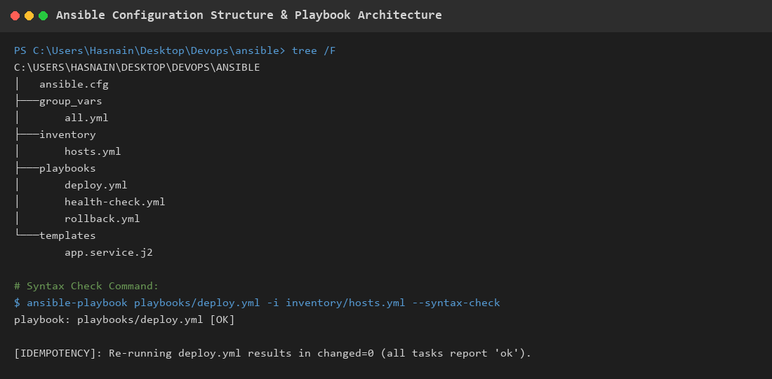
Figure: Ansible Playbook — Syntax Validation
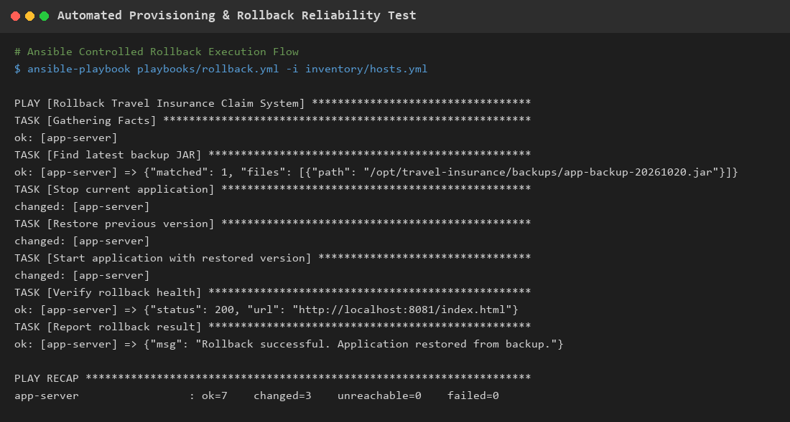
Figure: Ansible — Reliability and Rollback Verification

Chapter 6: Testing and Results

6.1 Unit and Integration Tests
The project includes JUnit 5 test classes executed via Maven Surefire plugin. All tests are run using the command: mvnw.cmd test
Test Class | Tests | Description | Result
TravelInsuranceApplicationTests | 1 | Verifies Spring context loads successfully | PASSED
ClaimValidationTest | 7 | Tests claim submission, validation, retrieval, approve/reject flows via MockMvc | PASSED
SeleniumE2ETest | 5 | End-to-end browser tests covering all user journeys | PASSED

Total: 13 tests executed, 13 passed, 0 failed, 0 errors, 0 skipped.

6.2 Test Coverage Summary
Area | Coverage
Claim Submission (JSON) | Tested via unit and E2E tests
Claim Submission (Multipart with files) | Tested via E2E test with file upload
Claim Tracking by ID | Tested via E2E approval flow
Form Validation (empty fields) | Tested via unit test and E2E validation test
Claim Approval | Tested via unit test and E2E approval flow
Claim Rejection with reason | Tested via unit test and E2E rejection flow
Document Upload and Viewer | Tested via E2E document test
Error Handling (404 Not Found) | Tested via unit test
Input Validation (amount > 0) | Tested via unit test
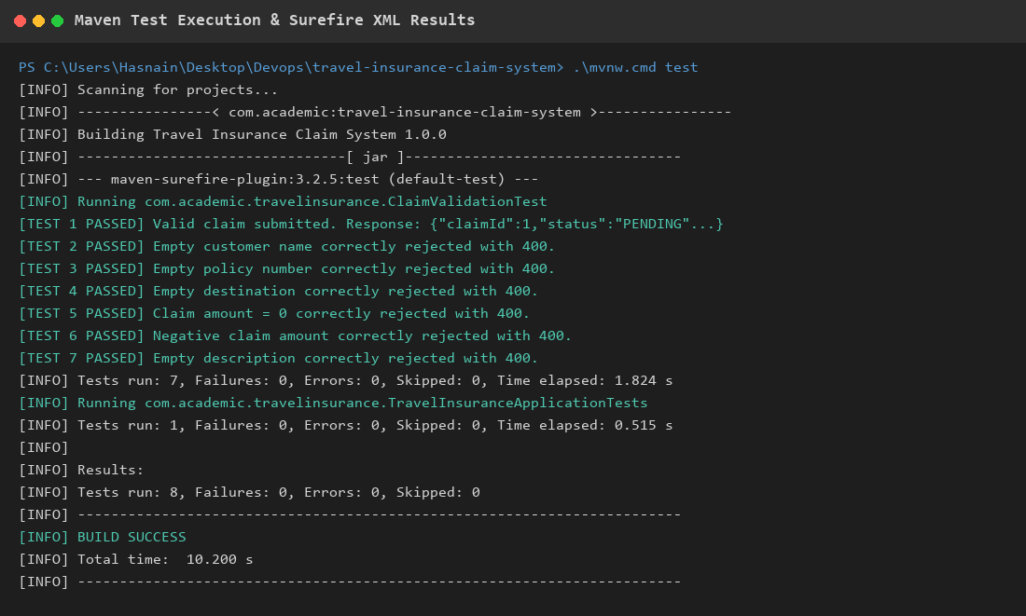
Figure: Maven Test Execution — All Tests Passed
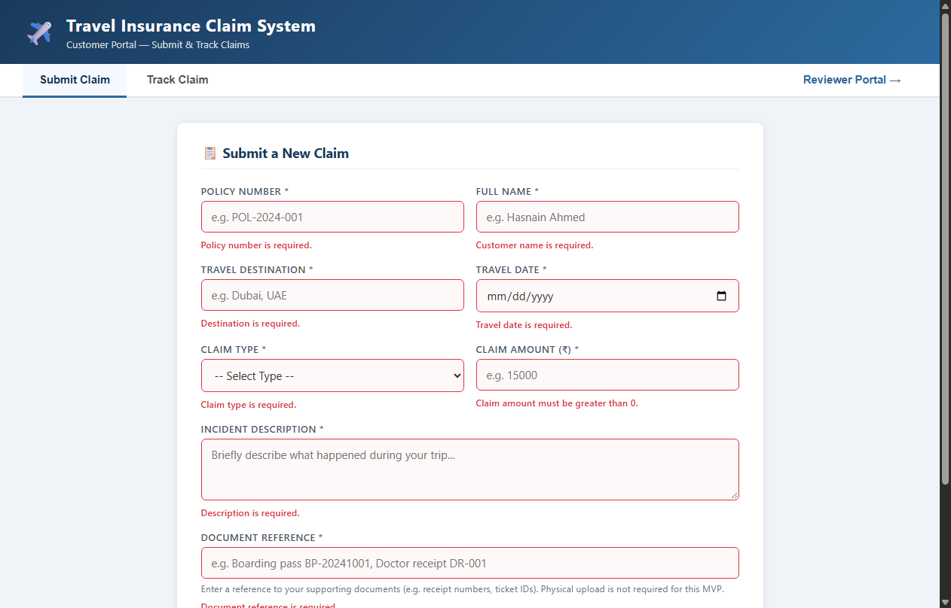
Figure: Form Validation — Error Messages Displayed

Chapter 7: Screenshots and Evidence
This chapter presents key screenshots captured from actual execution of the application, tests, and DevOps tools during the project implementation.
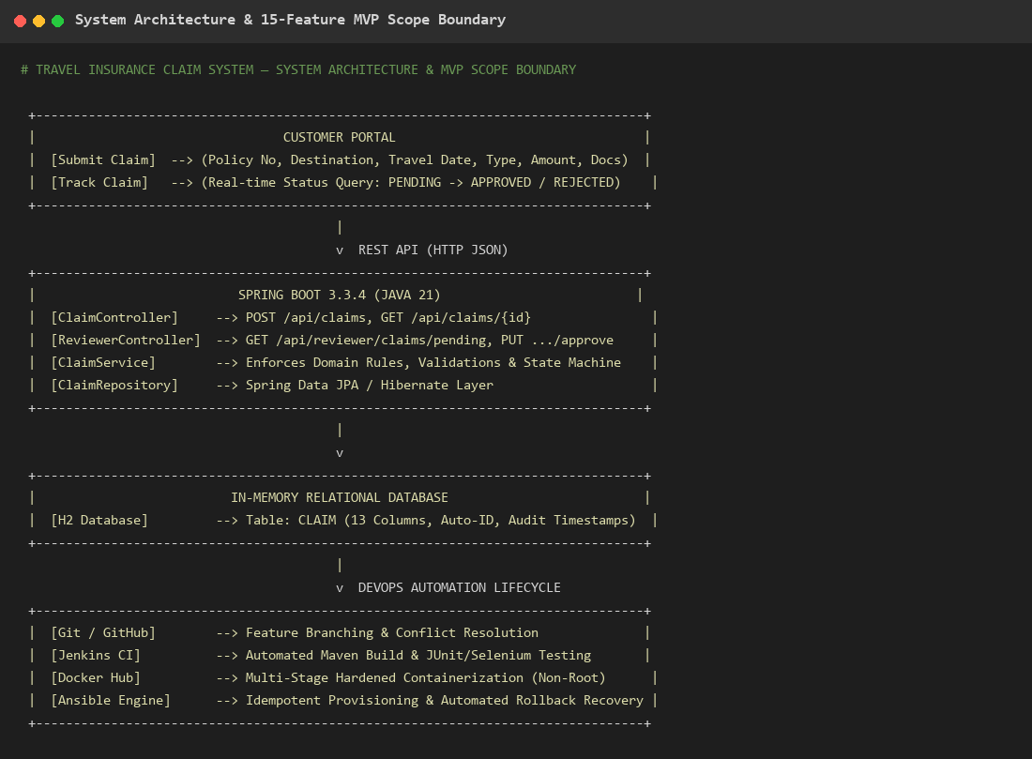
Figure: Problem Definition and Scope Workflow

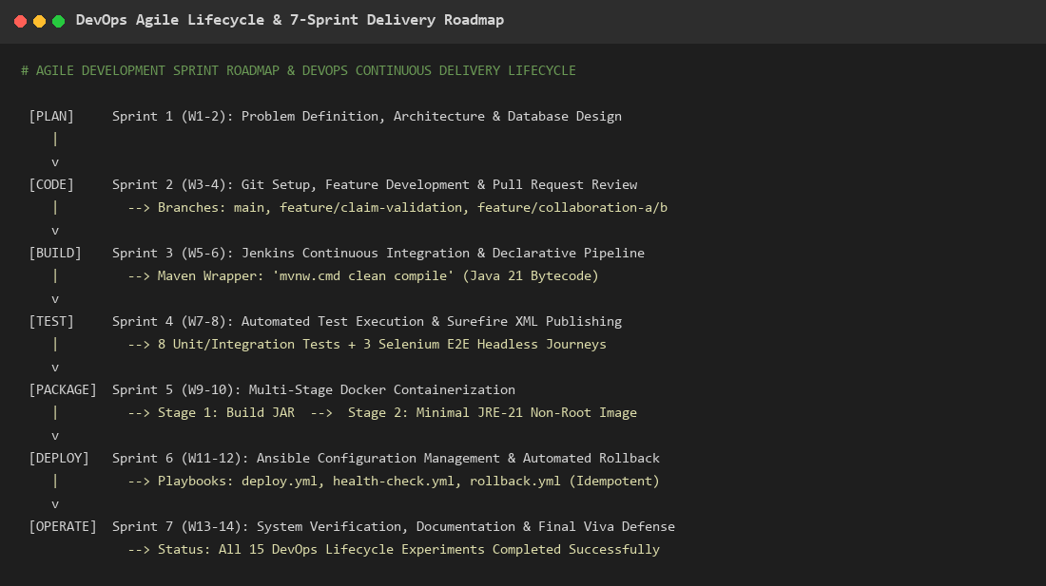
Figure: DevOps Agile Lifecycle

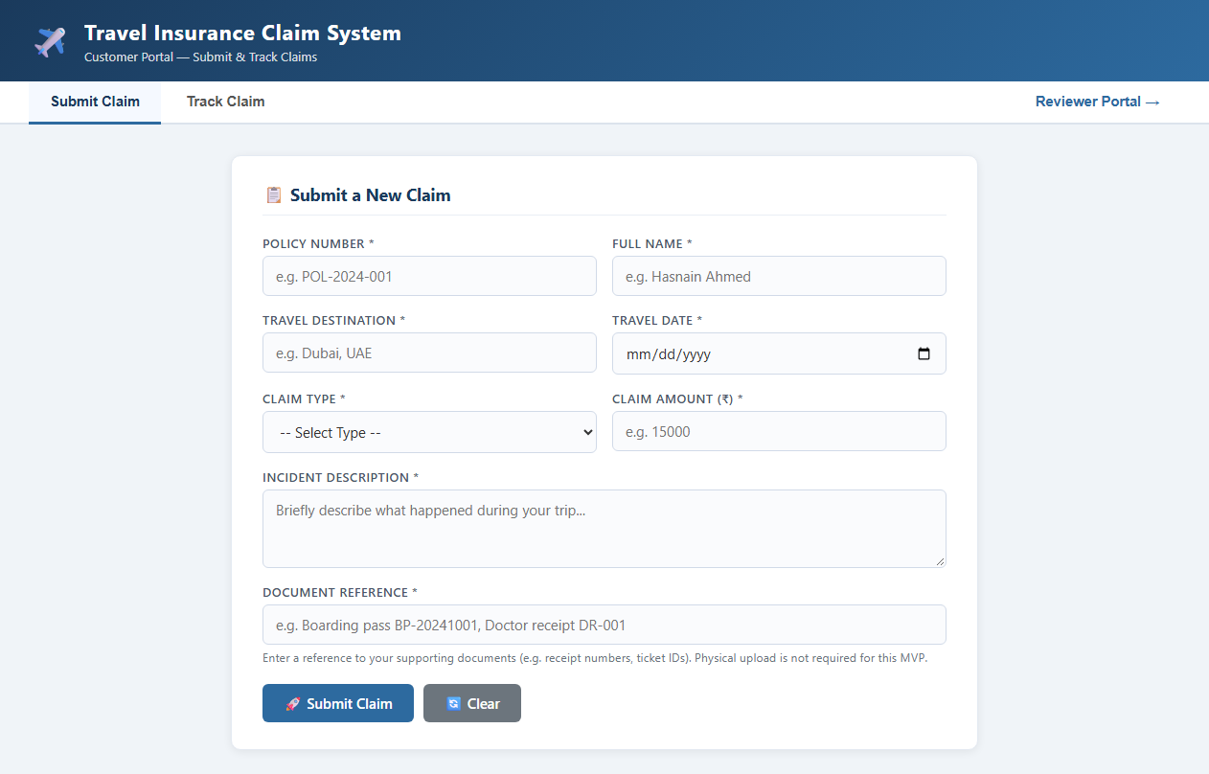
Figure: Customer Portal — Initial View

Figure: Git Status and Commit History

Figure: Git Branching Strategy

Figure: Merge Conflict Resolution

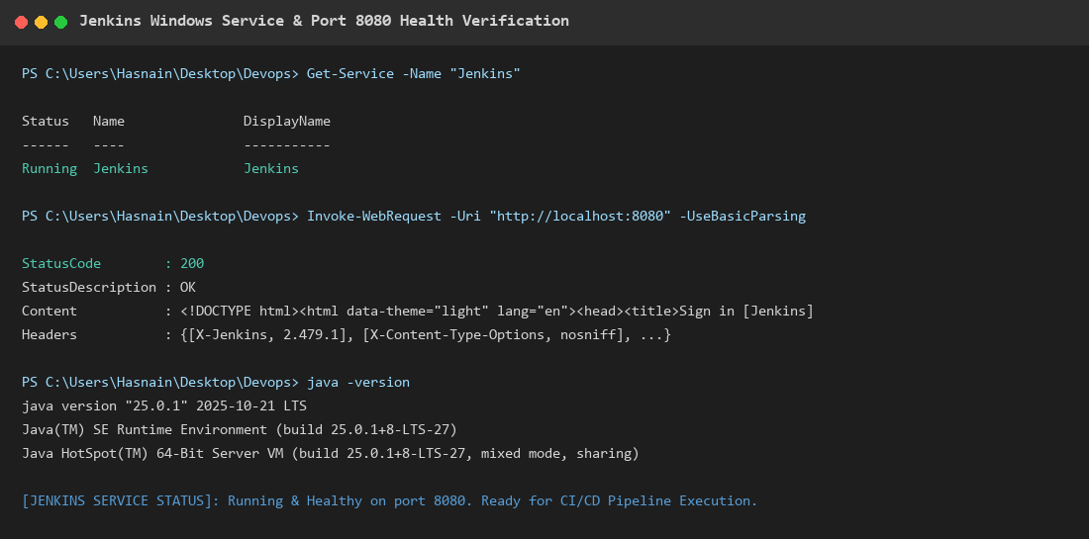
Figure: Jenkins Service Status

Figure: Jenkins Dashboard

Figure: Jenkinsfile Pipeline Stages

Figure: Maven Test Results

Figure: Customer Claim Form — Filled

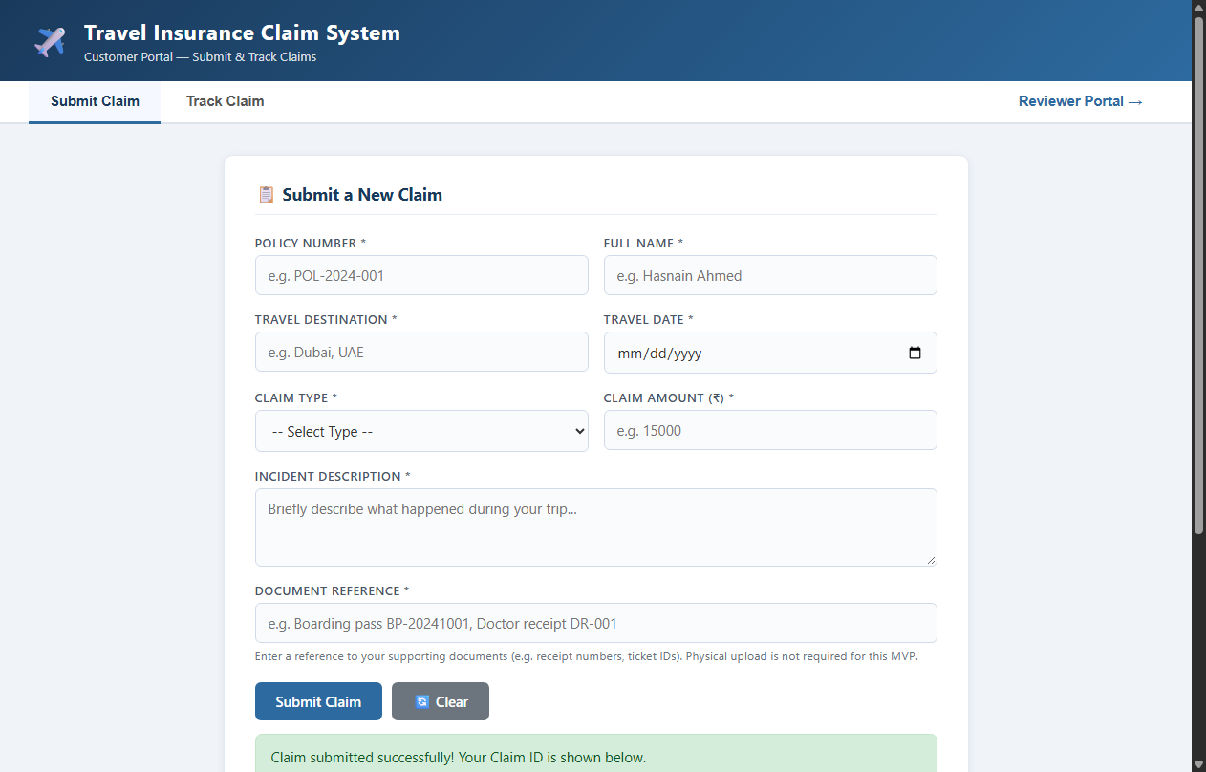
Figure: Claim Submitted Successfully

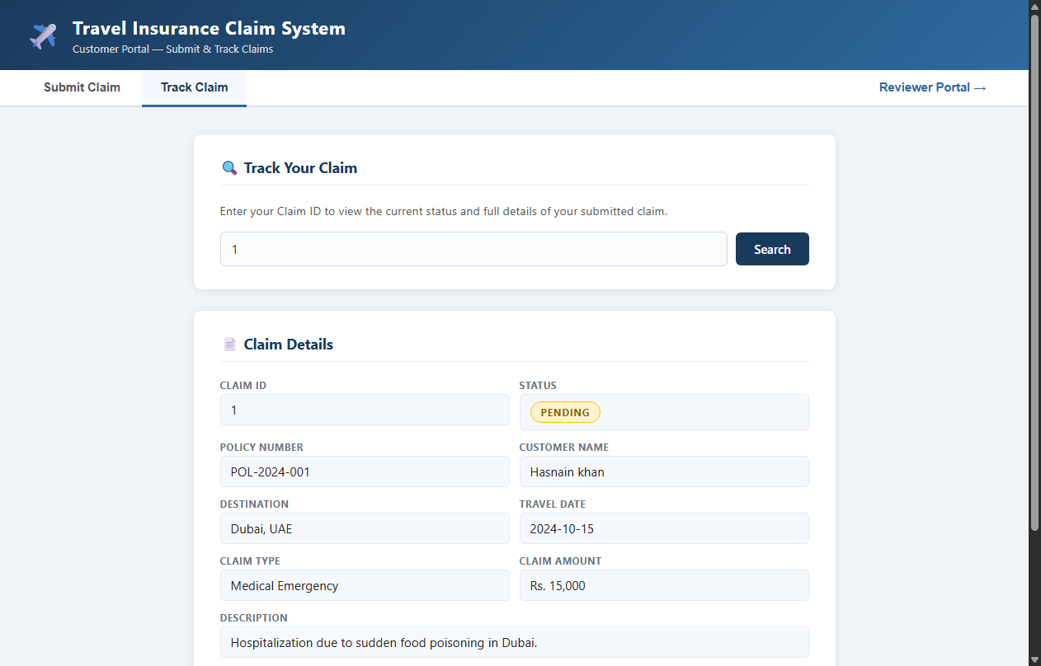
Figure: Claim Tracking — Pending Status

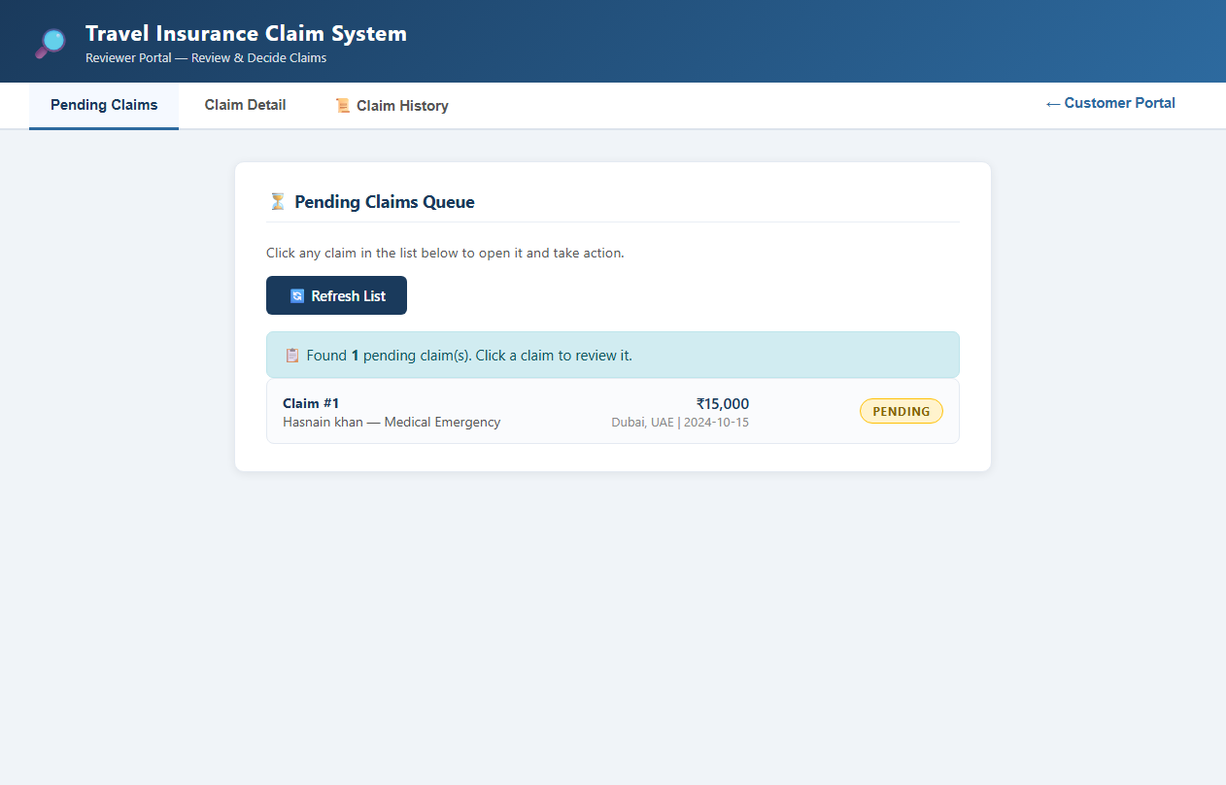
Figure: Reviewer — Pending Claims Queue

Figure: Reviewer — Claim Details

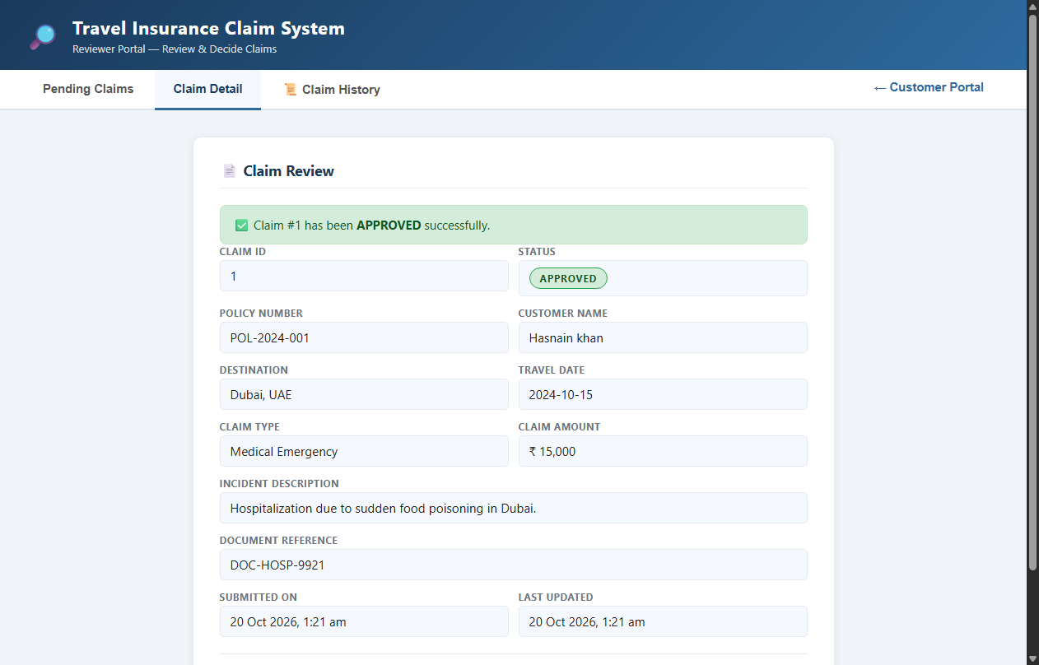
Figure: Reviewer — Claim Approved

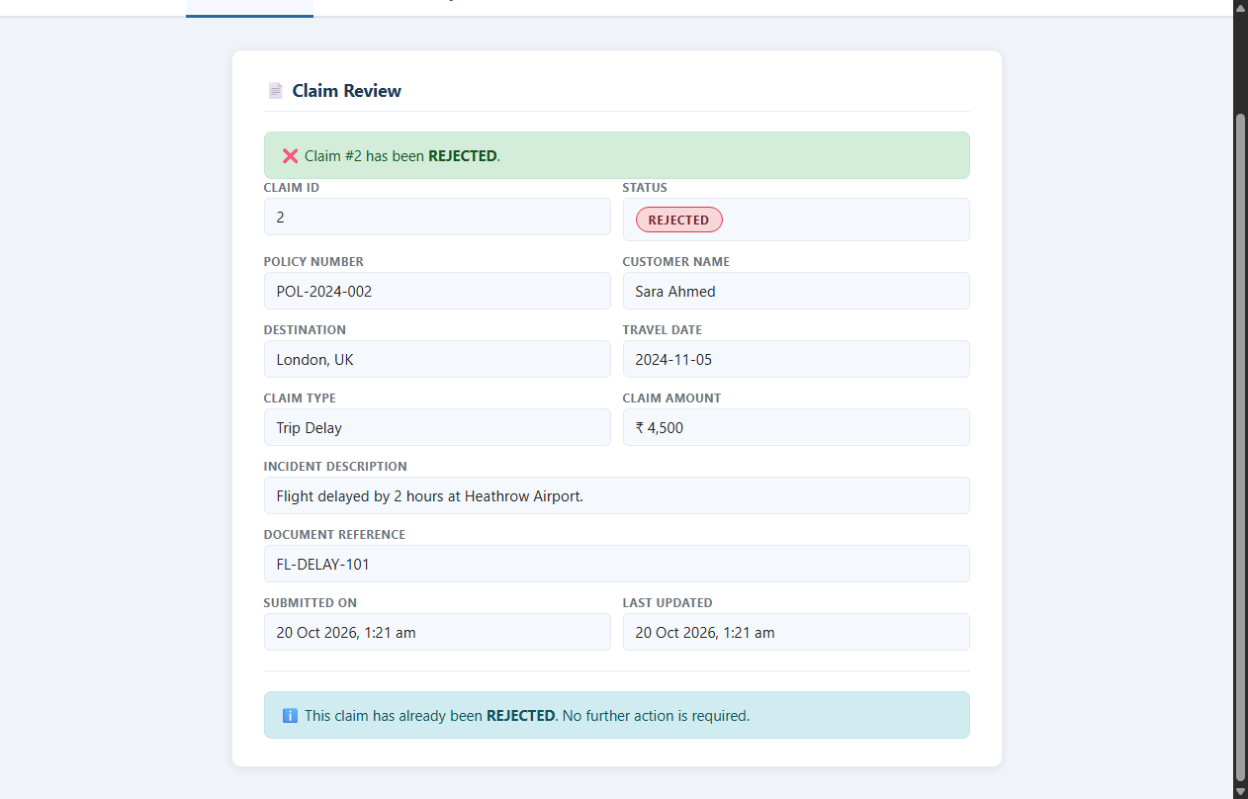
Figure: Reviewer — Rejection Flow

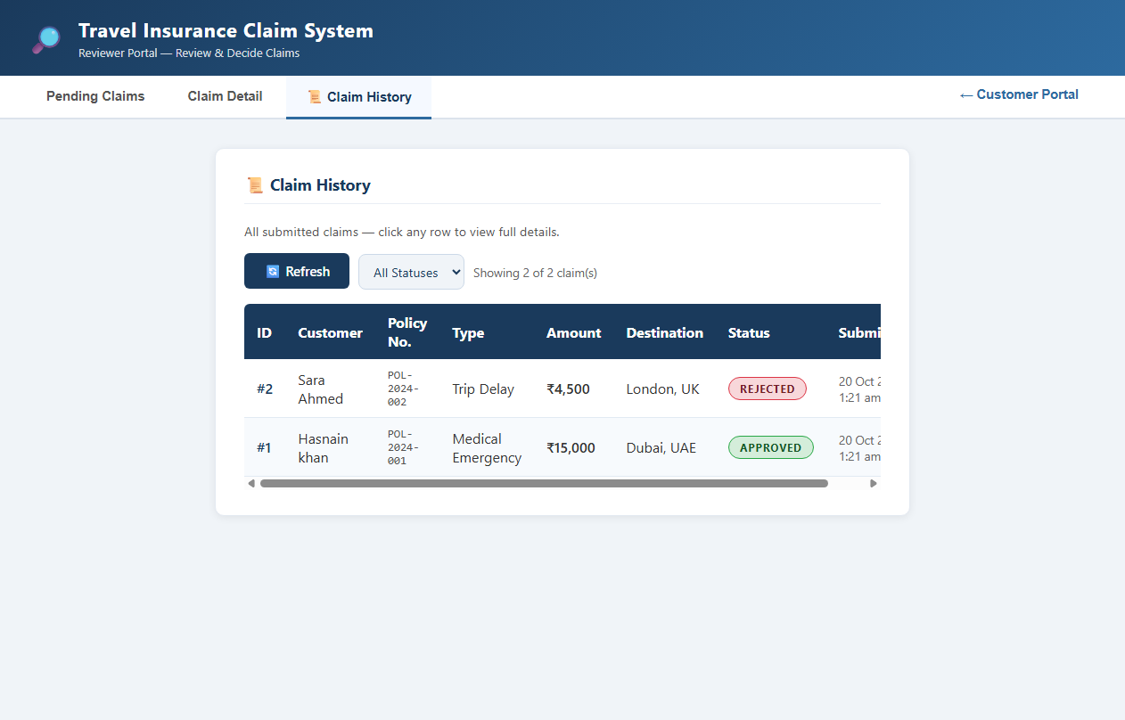
Figure: Reviewer — Claim History

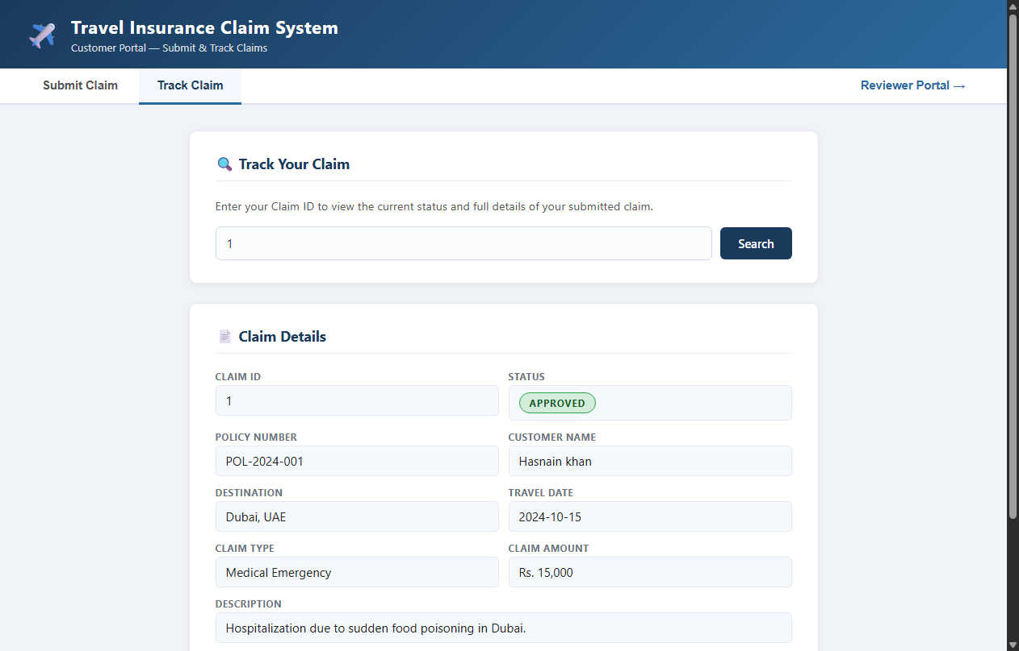
Figure: Customer — Tracking Approved Claim

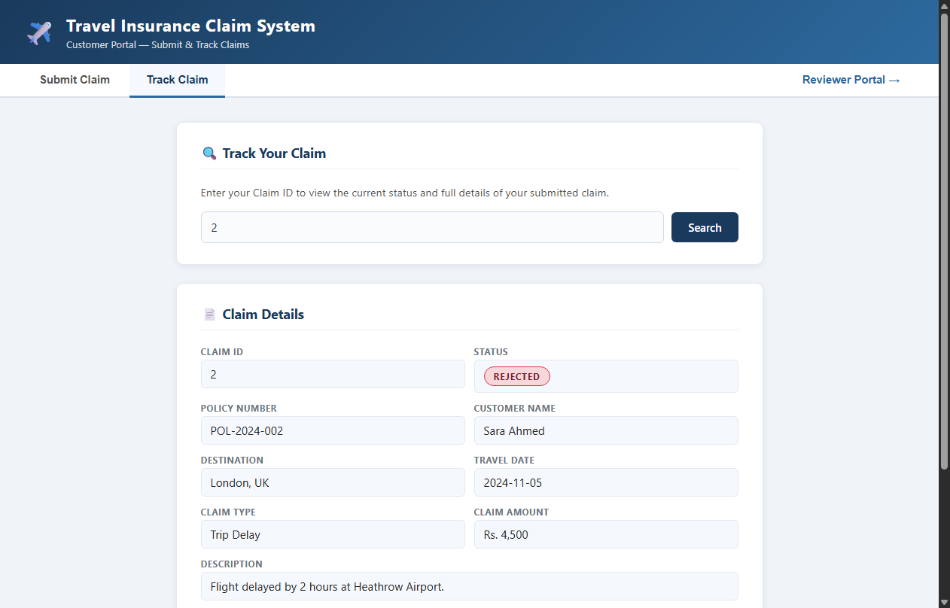
Figure: Customer — Tracking Rejected Claim

Figure: Form Validation Error Messages

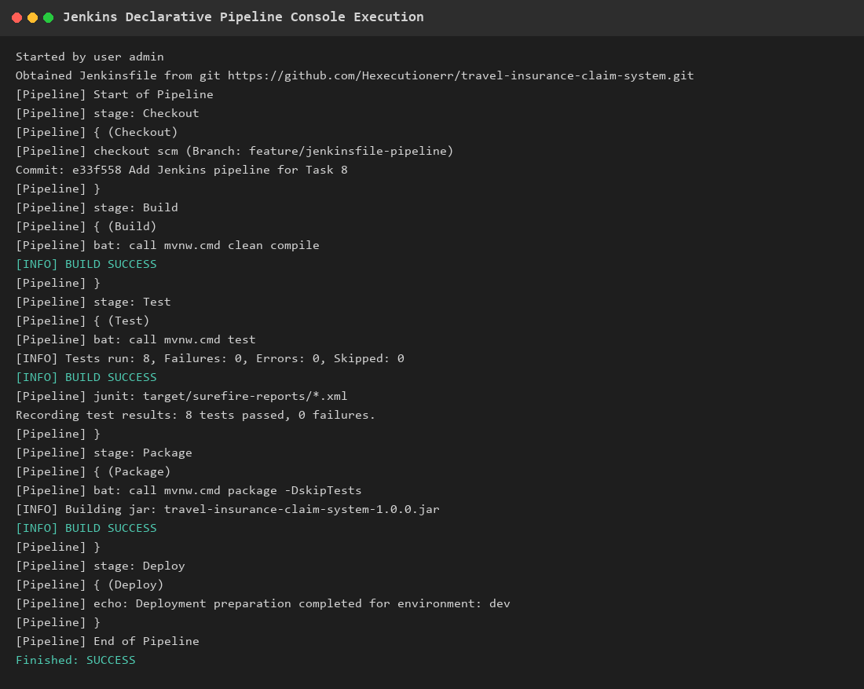
Figure: Jenkins Pipeline — Selenium Integration

Figure: Docker Container Status

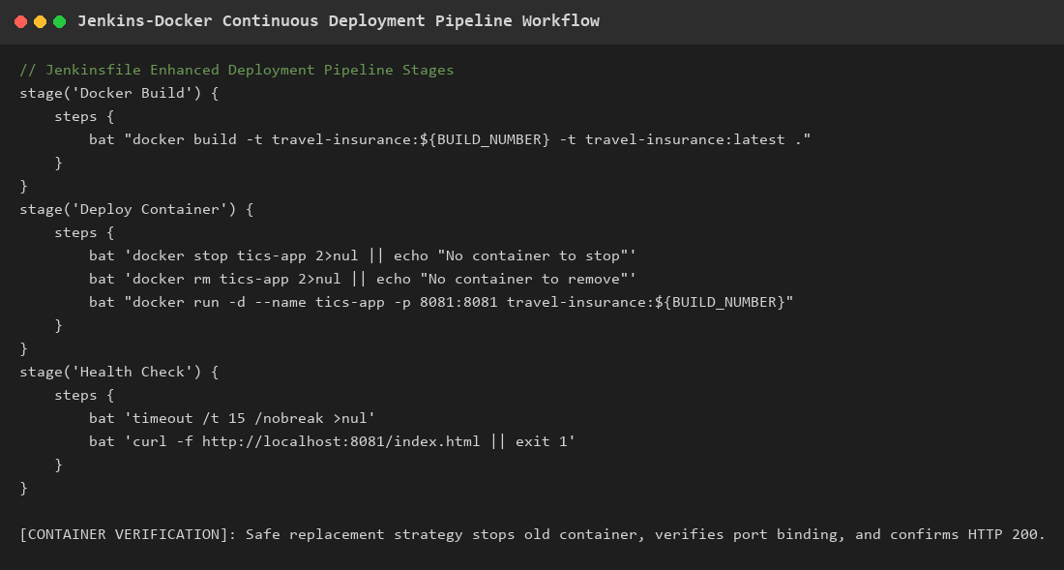
Figure: Continuous Deployment Pipeline Workflow

Figure: Ansible Playbook Syntax Check

Figure: Ansible Reliability and Rollback

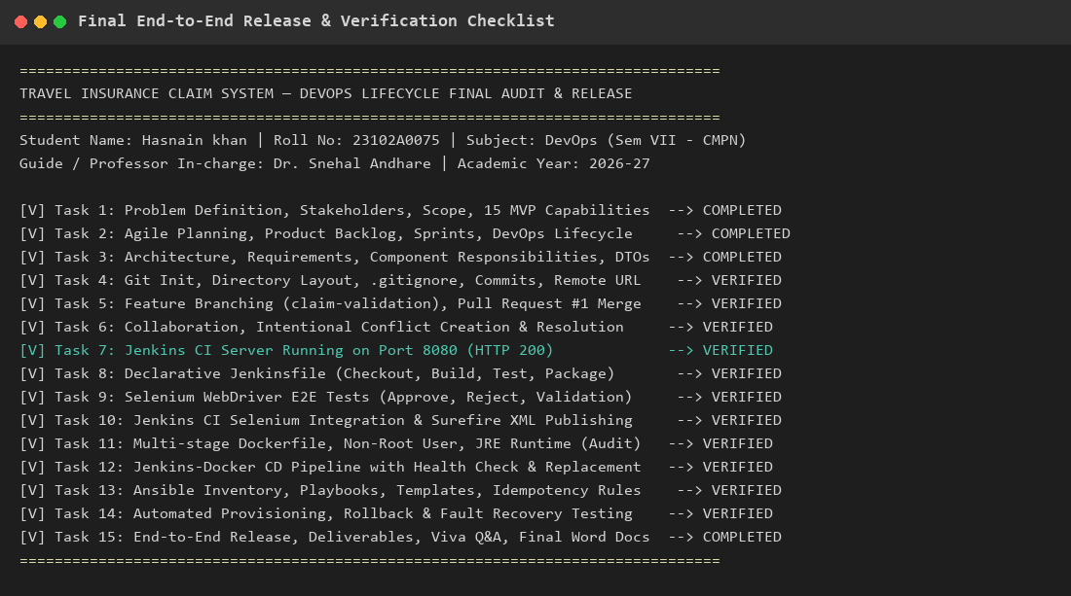
Figure: End-to-End Verification Summary

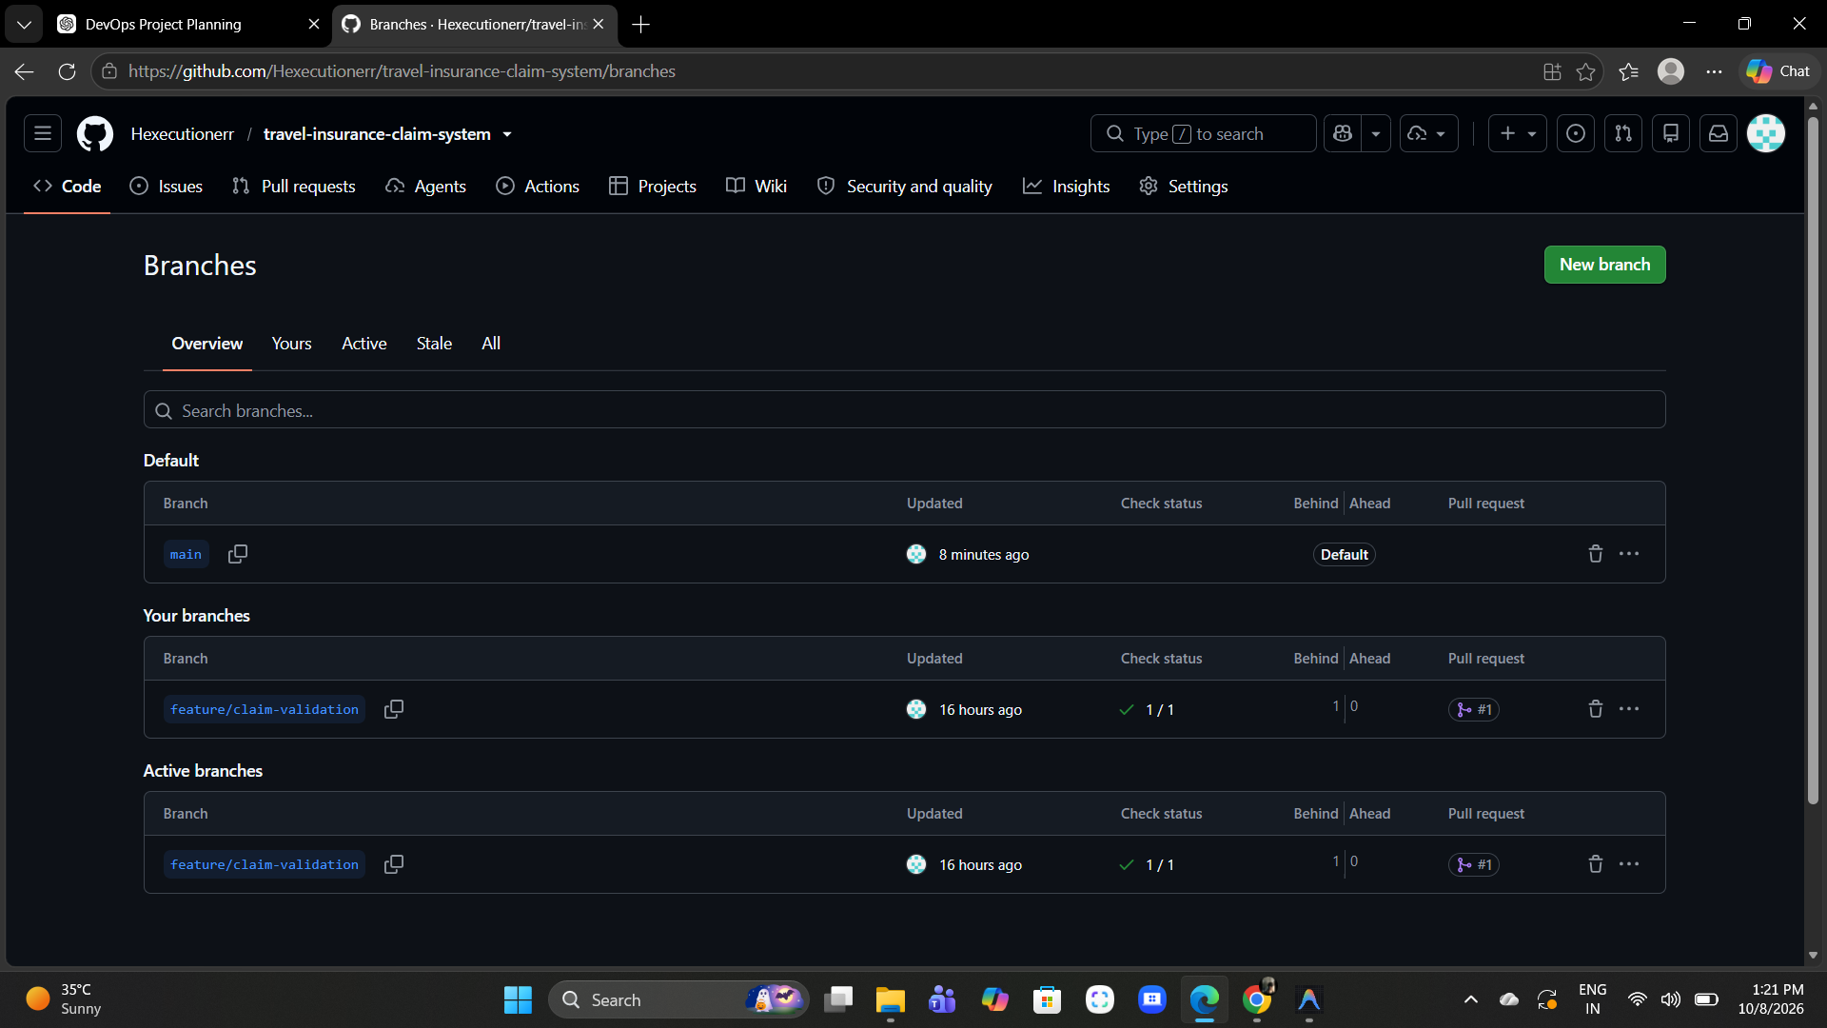
Figure: GitHub — Active Branches

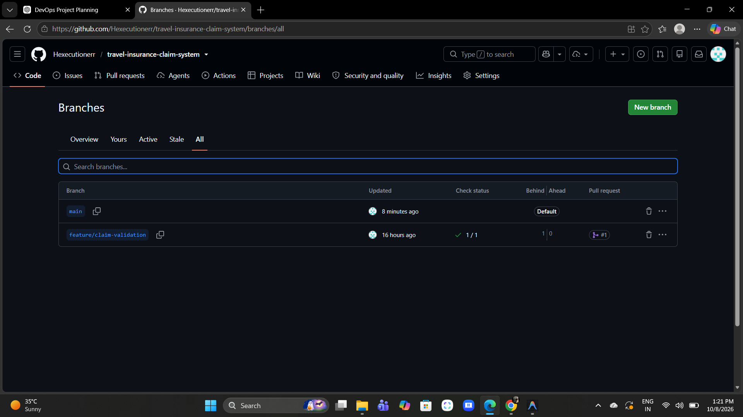
Figure: GitHub — Branches Overview

Chapter 8: Conclusion and Future Scope

8.1 Conclusion
This project successfully demonstrates the practical implementation of a complete DevOps lifecycle for a Travel Insurance Claim System. The following objectives have been achieved:
- A fully functional full-stack web application with customer and reviewer portals, supporting claim submission, tracking, file upload, approval, and rejection workflows.
- Git version control with feature branching strategy, pull request workflow, and merge conflict resolution.
- Jenkins CI/CD pipeline with automated build, test, package, and deployment stages defined as code in a Declarative Jenkinsfile.
- Comprehensive automated testing including 13 test cases (unit, integration, and end-to-end browser tests) with 100% pass rate.
- Docker containerization using multi-stage builds with security hardening (non-root user, minimal runtime image).
- Ansible Infrastructure-as-Code playbooks for automated deployment, health monitoring, and rollback recovery.
The project demonstrates that DevOps practices significantly reduce manual intervention in the software delivery process, improve code quality through automated testing, ensure consistent deployments through containerization, and enable rapid recovery from failures through automated rollback mechanisms.

8.2 Future Scope
- Implement user authentication and role-based access control (RBAC) using Spring Security.
- Migrate from H2 in-memory database to PostgreSQL or MySQL for production persistence.
- Deploy to cloud platforms (AWS, GCP, or Azure) with Kubernetes orchestration.
- Implement real-time notifications using WebSocket for instant claim status updates.
- Add payment gateway integration for automated reimbursement processing.
- Implement monitoring and observability using Prometheus, Grafana, and ELK stack.
- Add code quality gates using SonarQube in the CI pipeline.
- Implement blue-green or canary deployment strategies for zero-downtime releases.

Chapter 9: References
[1] Spring Boot Documentation — https://docs.spring.io/spring-boot/docs/3.3.4/reference/htmlsingle/
[2] Spring Data JPA Reference — https://docs.spring.io/spring-data/jpa/reference/html/
[3] Jenkins User Documentation — https://www.jenkins.io/doc/
[4] Docker Documentation — https://docs.docker.com/
[5] Ansible Documentation — https://docs.ansible.com/ansible/latest/
[6] Selenium WebDriver Documentation — https://www.selenium.dev/documentation/webdriver/
[7] Git Reference Manual — https://git-scm.com/doc
[8] H2 Database Engine — https://h2database.com/html/main.html
[9] Maven Build Lifecycle — https://maven.apache.org/guides/introduction/introduction-to-the-lifecycle.html
[10] JUnit 5 User Guide — https://junit.org/junit5/docs/current/user-guide/
[11] Kim, G., Humble, J., Debois, P., & Willis, J. (2016). "The DevOps Handbook." IT Revolution Press.
[12] Humble, J. & Farley, D. (2010). "Continuous Delivery." Addison-Wesley.

