Student workbook
UEECD0010 Compile and produce an energy sector detailed report

TAFE NSW would like to pay our respect and acknowledge Aboriginal and Torres Strait Islander Peoples as the Traditional Custodians of the Land, Rivers and Sea. We acknowledge and pay our respect to Elders, past, present and emerging of all Nations.
Version: 20241024
Date created: 24/10/2024
Date modified:
For queries contact:
Infrastructure, Energy and Construction SkillsPoint
Ultimo, Sydney
© TAFE NSW 2021
RTO Provider Number 90003 | CRICOS Provider Code: 00591E
This resource can be found in the TAFE NSW Learning Bank.
The content in this document is copyright © TAFE NSW 2024 and should not be reproduced without the permission of TAFE NSW. Information contained in this document is correct at time of printing: 25 October 2024. For current information please refer to our website or your teacher as appropriate.
Table of Contents
Getting started 4
1 Overview 5
2 Introduction: The Australian Energy Industry 6
2.1 Overview of the Australian Utility Industry 6
2.2 Analysis of Power Generation in Australia 7
2.3 Transition from Fossil Fuels to Renewables 10
2.4 Major Australian Electricity Authorities: An Overview 18
2.5 Major Electricity Authorities in New South Wales (NSW) 26
2.6 Electricity Price Structure for a Commercial Contract in Australia 33
3 Energy and Its Application 39
3.1 Types Energy 39
3.2 Energy Calculation in a Refrigeration System 43
3.3 Energy Efficiency in Electric Motors 49
3.4 AS 3598.1: Energy Audits for Commercial Buildings 52
3.5 The Fan and Pump Laws 57
3.6 Energy Efficient Components – BLDC Motors and EC Fans 61
4 Energy Sector Report 65
4.1 Requirements for Energy Sector Report 65
4.2 Developing the Energy Sector Report 67
4.3 Report Writing Techniques 72

Getting started

Overview
This workbook has been designed to provide learners with a comprehensive understanding of how to compile and produce energy sector reports, with a focus on the Australian utility industry. The expanded sections on collaboration, data analysis, and report presentation will help learners navigate the complexities of energy reporting, while the deep dive into Australia’s energy mix will ensure that learners are well-equipped to handle real-world scenarios.

Introduction: The Australian Energy Industry
The Australian utility industry is a key driver of the nation's economy and everyday life, providing essential services such as electricity and gas to both residential and commercial users. Over recent decades, the industry has undergone significant transformations, driven by technological advancements, environmental concerns, and shifts in energy policies. This workbook will guide learners through the process of compiling and producing detailed energy sector reports, with a specific focus on the Australian context.

Overview of the Australian Utility Industry
Australia's energy mix is defined by a diverse range of energy sources, including fossil fuels such as coal and natural gas, as well as an increasing share of renewable energy sources like solar, wind, hydro, and bioenergy. The energy industry plays a critical role in delivering energy to millions of households and businesses, ensuring economic stability, and supporting the shift toward sustainable energy solutions.

Key components of Australia's energy industry include:

Electricity Generation: Primarily from coal, natural gas, and renewable sources.
Natural Gas Distribution: Widely used in both power generation and as a domestic fuel.
Energy Export: Australia is one of the world’s leading exporters of liquefied natural gas (LNG).

Analysis of Power Generation in Australia
Introduction
Australia's energy landscape has been undergoing significant transformation, driven by the need to transition to sustainable energy sources while maintaining reliability and affordability in power generation. Power generation in Australia has traditionally been dominated by coal, but in recent years, the shift towards renewable energy sources such as wind, solar, and hydropower has been gaining momentum. This analysis examines the current power generation mix, the key drivers behind changes in the energy sector, the challenges faced during the transition to renewable energy, and the future outlook for power generation in Australia.

Power Generation Mix
Australia's electricity generation mix is diverse, encompassing coal, natural gas, wind, solar, hydro, and other renewable energy sources. Each of these energy sources has played a significant role in ensuring the country's energy demands are met while also contributing to economic growth.
Coal and Gas
For decades, coal has been the dominant source of electricity generation in Australia. In 2021, coal-fired power plants contributed around 51% of the country's total electricity output, according to data from the Australian Energy Regulator (AER). These plants are located primarily in Queensland, New South Wales, and Victoria, with the latter being home to the country's largest coal plant, Loy Yang.
Natural gas is another critical contributor to Australia's electricity supply, providing about 19% of the total power generation mix. Gas-fired plants, unlike coal plants, have the flexibility to ramp up quickly, which makes them valuable for balancing intermittent renewable sources like solar and wind. Despite the significant role of gas, its share in the energy mix is declining due to the increasing competitiveness of renewable energy sources and the global focus on reducing carbon emissions.
Renewable Energy Sources
Renewable energy sources, including wind, solar, and hydroelectricity, have experienced rapid growth over the past decade. As of 2021, renewables accounted for 32% of Australia’s electricity generation, up from 26% in 2020. The growth is largely driven by policy measures, technological advancements, and a decline in the costs associated with renewable technologies.
Wind Power: Wind energy is currently the largest source of renewable electricity in Australia, contributing 10% to the national grid in 2021. Major wind farms are located in South Australia, Victoria, and New South Wales.
Solar Power: Solar energy has seen unprecedented growth, both at the utility-scale and rooftop solar levels. In 2021, solar power accounted for approximately 12% of total generation. The large uptake of rooftop solar, driven by government incentives and declining installation costs, has made Australia one of the world leaders in rooftop solar installations.
Hydropower: While hydroelectricity has been part of Australia’s energy mix for decades, its share remains relatively stable, contributing around 7% of total electricity generation. The Snowy Mountains Hydroelectric Scheme remains one of the most iconic energy projects in the country.
The shift towards renewable energy sources is expected to accelerate further as Australia works towards achieving its climate goals under international agreements like the Paris Agreement.
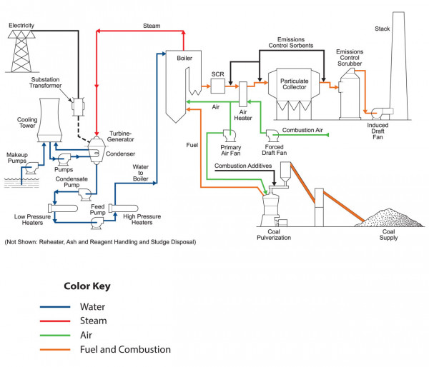

Modern coal-fired power plants primarily generate electricity or supply process steam, and in some cases, both functions are combined in a process called cogeneration. In each application, the steam generator is a crucial component of a broader system with multiple subsystems and parts. A typical coal-fired power plant includes several key subsystems:

Fuel Receiving and Preparation
Steam Generator
Environmental Protection Equipment
Turbine-Generator
Heat Rejection (Cooling Tower)
Fuel and Combustion (Flue Gas)
The fuel handling system stores and prepares the fuel (in this case, coal) for combustion and delivers it to the steam generator. An air system, through a forced draft fan, supplies air to the burners. In the steam generator, the fuel-air mixture is burned, and the resulting heat is captured to produce high-pressure, high-temperature steam. The flue gas then exits the steam generator and passes through pollution control systems, including selective catalytic reduction (if present), particulate collectors (like electrostatic precipitators or fabric filters), and sulfur dioxide scrubbers (wet or dry). These systems remove pollutants such as ash and sulfur dioxide. Additional technologies, such as sorbent injection and fuel additives, may be used to capture mercury and other hazardous pollutants. Finally, the treated flue gas is released through a stack using an induced draft fan.

Steam-Water Path
The steam generator produces high-temperature, high-pressure steam, which is delivered to a turbine-generator system to generate electricity. In some setups, the steam is reheated after passing through part of the turbine and sent back to the boiler. Once the steam completes its cycle through the turbine, it enters a condenser where waste heat is removed. The condensed water is then pumped back to the boiler, passing through heat exchangers (feedwater heaters) to increase its pressure and temperature. The rejected heat is typically dissipated into the atmosphere via cooling towers. These towers can be either natural draft, which uses natural air circulation, or mechanical draft, which employs large fans to move air through the system.

In industrial power systems, similar processes are used, though the turbine-generator and heat rejection systems are replaced with applications such as space heating or heat exchangers for specific industrial processes.

Transition from Fossil Fuels to Renewables
Historically, coal has dominated Australia’s energy generation. However, environmental concerns, global shifts toward renewable energy, and the competitiveness of solar and wind energy have led to a notable reduction in coal's dominance. Investments in large-scale renewable projects and battery storage have become a core focus of the government’s strategy to ensure a sustainable energy future.

Transition to Renewable Energy
The transition from fossil fuels to renewable energy is a fundamental aspect of Australia's energy policy and strategy. This section explores the key drivers and policy initiatives that have accelerated the transition.
Environmental Considerations and Emissions Reduction
Australia's energy sector is the largest contributor to the nation's greenhouse gas emissions, primarily due to its heavy reliance on coal and gas. The need to reduce carbon emissions in line with global climate commitments has been a significant factor driving the transition to renewable energy. The Australian government has committed to achieving net-zero emissions by 2050, which necessitates a rapid and large-scale adoption of renewable energy.
To support emissions reduction, the government has implemented a range of policies and programs, including the Renewable Energy Target (RET). The RET scheme, which ended in 2020, required that 33,000 GWh of Australia's electricity come from renewable sources by 2020, a target that was achieved. Post-RET, the focus has shifted towards more market-driven mechanisms, such as the Emissions Reduction Fund and state-based renewable energy targets.
Technological Advances and Cost Reductions
Technological advancements have significantly reduced the cost of generating electricity from renewable sources. According to a 2021 report by the Australian Energy Market Operator (AEMO), the cost of generating electricity from solar and wind is now lower than the cost of new coal or gas plants. This has spurred investment in renewable energy projects, both from private investors and the government.
Energy storage technologies, particularly batteries, have also seen significant improvements. Projects like the Hornsdale Power Reserve in South Australia have demonstrated the viability of large-scale battery storage in providing grid stability and supporting intermittent renewable energy sources.
Grid Modernization and Decentralization
The Australian electricity grid is transitioning from a centralized system dominated by large-scale power plants to a more decentralized system. The rapid adoption of rooftop solar has turned many Australian households into “prosumers,” capable of generating, consuming, and feeding electricity back into the grid. This has necessitated the modernization of grid infrastructure to manage the increased variability and ensure reliable supply.
The AEMO's Integrated System Plan (ISP) outlines the development of Renewable Energy Zones (REZs) across the country. These REZs are designed to coordinate renewable energy development with transmission infrastructure to maximize efficiency and minimize costs.
Challenges in the Transition
Despite significant progress, the transition to a low-carbon energy future in Australia faces several challenges. These challenges span technical, economic, regulatory, and social dimensions, and must be addressed to ensure a smooth and just transition.
Grid Reliability and Intermittency
One of the most critical challenges associated with renewable energy is its intermittent nature. Wind and solar power depend on weather conditions and sunlight, which are inherently variable. This intermittency poses challenges for grid operators who must balance supply and demand in real-time to prevent blackouts or grid instability.
The AEMO has noted that the transition to renewable energy requires careful management to ensure grid reliability. Investments in energy storage, demand response technologies, and grid infrastructure are necessary to provide the flexibility needed to manage fluctuations in renewable energy supply. Furthermore, backup power from gas-fired plants or hydropower is essential during periods of low renewable energy generation.
Investment in Infrastructure
Australia’s electricity grid was originally designed to deliver power from centralized coal-fired power stations. As the energy mix changes, significant investments are required to upgrade and expand grid infrastructure. The construction of new transmission lines to connect renewable energy projects, especially in remote areas, is a major challenge. Delays in infrastructure development can hinder the deployment of renewable energy projects.
Moreover, the costs of upgrading grid infrastructure can be significant, and there is an ongoing debate about how these costs should be distributed between consumers, government, and private investors. The Australian Energy Market Commission (AEMC) is exploring regulatory reforms to ensure that the grid modernization is achieved in an efficient and cost-effective manner.
Policy Uncertainty and Regulatory Hurdles
Australia’s energy policy landscape has been marked by periods of uncertainty, which can deter investment in renewable energy projects. Changes in government leadership, coupled with divergent views on climate policy, have led to an inconsistent policy environment. Investors require clear, long-term policy signals to commit to large-scale renewable energy projects, and uncertainty can result in delays or cancellations of projects.
In addition, the regulatory environment can present hurdles for renewable energy projects. Complex approval processes, land use concerns, and opposition from local communities can slow the deployment of wind and solar farms. State and federal governments need to work together to streamline the regulatory process and provide incentives for communities to embrace renewable energy development.
Social and Economic Impacts
The transition to renewable energy has profound social and economic implications, particularly for regions dependent on coal mining and coal-fired power generation. The closure of coal plants can lead to job losses and economic decline in these regions, prompting calls for a “just transition” that supports workers and communities during the shift to a low-carbon economy.
Programs to retrain workers and attract new industries to coal-dependent regions are essential to ensure that the transition to renewable energy is equitable. Without adequate support, the shift could exacerbate inequality and social division.

Future Outlook
The future of power generation in Australia is expected to be increasingly dominated by renewable energy sources, with the potential for the country to become a global leader in green energy.
Renewable Energy Growth
Australia is well-positioned to continue its rapid uptake of renewable energy. The country has abundant wind and solar resources, and technological advancements are making these energy sources more competitive. The Australian Renewable Energy Agency (ARENA) is also actively supporting research and development in emerging technologies such as hydrogen and advanced battery storage.
By 2030, renewables are expected to account for more than 50% of Australia’s electricity generation. The expansion of Renewable Energy Zones, coupled with investments in storage and grid infrastructure, will be key to achieving this target.
Role of Hydrogen
Green hydrogen is emerging as a promising energy vector for Australia’s future energy system. Hydrogen can be produced using renewable electricity to split water into hydrogen and oxygen, providing a clean and flexible energy source. The Australian government has released a National Hydrogen Strategy aimed at positioning the country as a major player in the global hydrogen market.
Hydrogen has the potential to decarbonize sectors that are difficult to electrify, such as heavy industry and long-distance transport. Additionally, Australia’s vast renewable resources could allow it to become a major exporter of green hydrogen to countries like Japan and South Korea.
Electrification and Decarbonization
As Australia transitions to renewable energy, there will be increased electrification of sectors such as transport and industry. The electrification of transport, in particular, is expected to drive significant growth in electricity demand. This presents both challenges and opportunities for power generation.
Meeting the increased demand while decarbonizing the grid will require continued investment in renewable energy, storage, and grid management technologies. The electrification of industries such as steel and cement production, powered by renewable energy, could also help Australia reduce its carbon footprint while maintaining economic competitiveness.

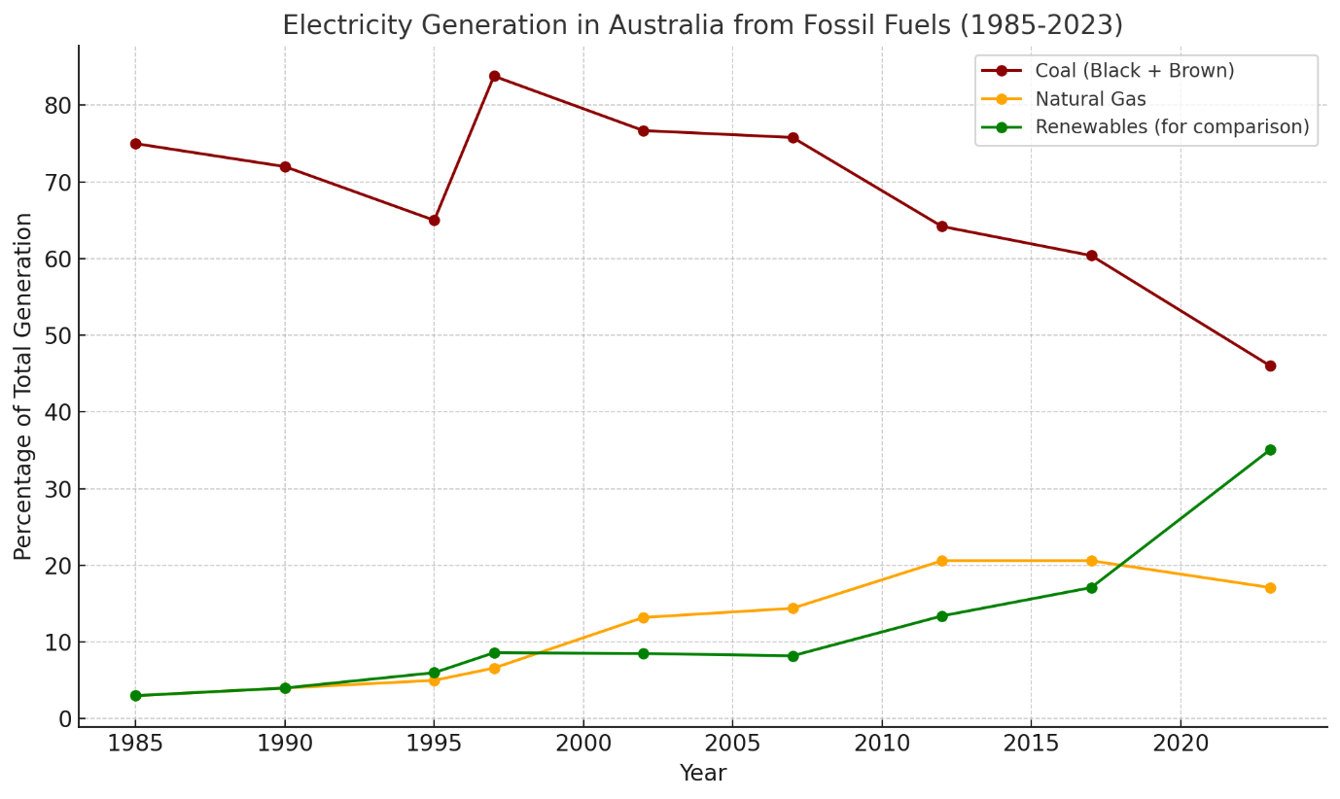

Australia’s electricity generation from fossil fuels has been declining over the years as the country transitions towards more renewable energy sources. Here is a trend of electricity generation from fossil fuels, based on data from 1997 to 2023:

1997-98: Fossil fuels, particularly coal, dominated electricity generation, with Black coal contributing nearly 60% of the total, and Brown coal adding about 24%. Natural gas accounted for 6.6%.

2007-08: The share of fossil fuels remained high, but natural gas started increasing, contributing 14.4%, while Black coal remained at around 53%. Renewables were still a small portion at 8.2%.

2017-18: The share of coal started to drop more significantly. Black coal contributed 46.6%, while Brown coal declined to 13.8%. Natural gas held steady at 20.6%. Renewables gained momentum, increasing to 17.1% of total generation.

2022-23: Fossil fuels accounted for 65% of electricity generation. Black coal was down to 34.4%, and Natural gas to 17.1%. Renewables, however, surged to 35%, with solar and wind taking larger shares.

The decline in fossil fuel use, particularly coal, is driven by increased investment in renewable energy projects, higher gas prices, and environmental policies. This trend is expected to continue as Australia aims to reduce carbon emissions and increase the use of renewable energy.

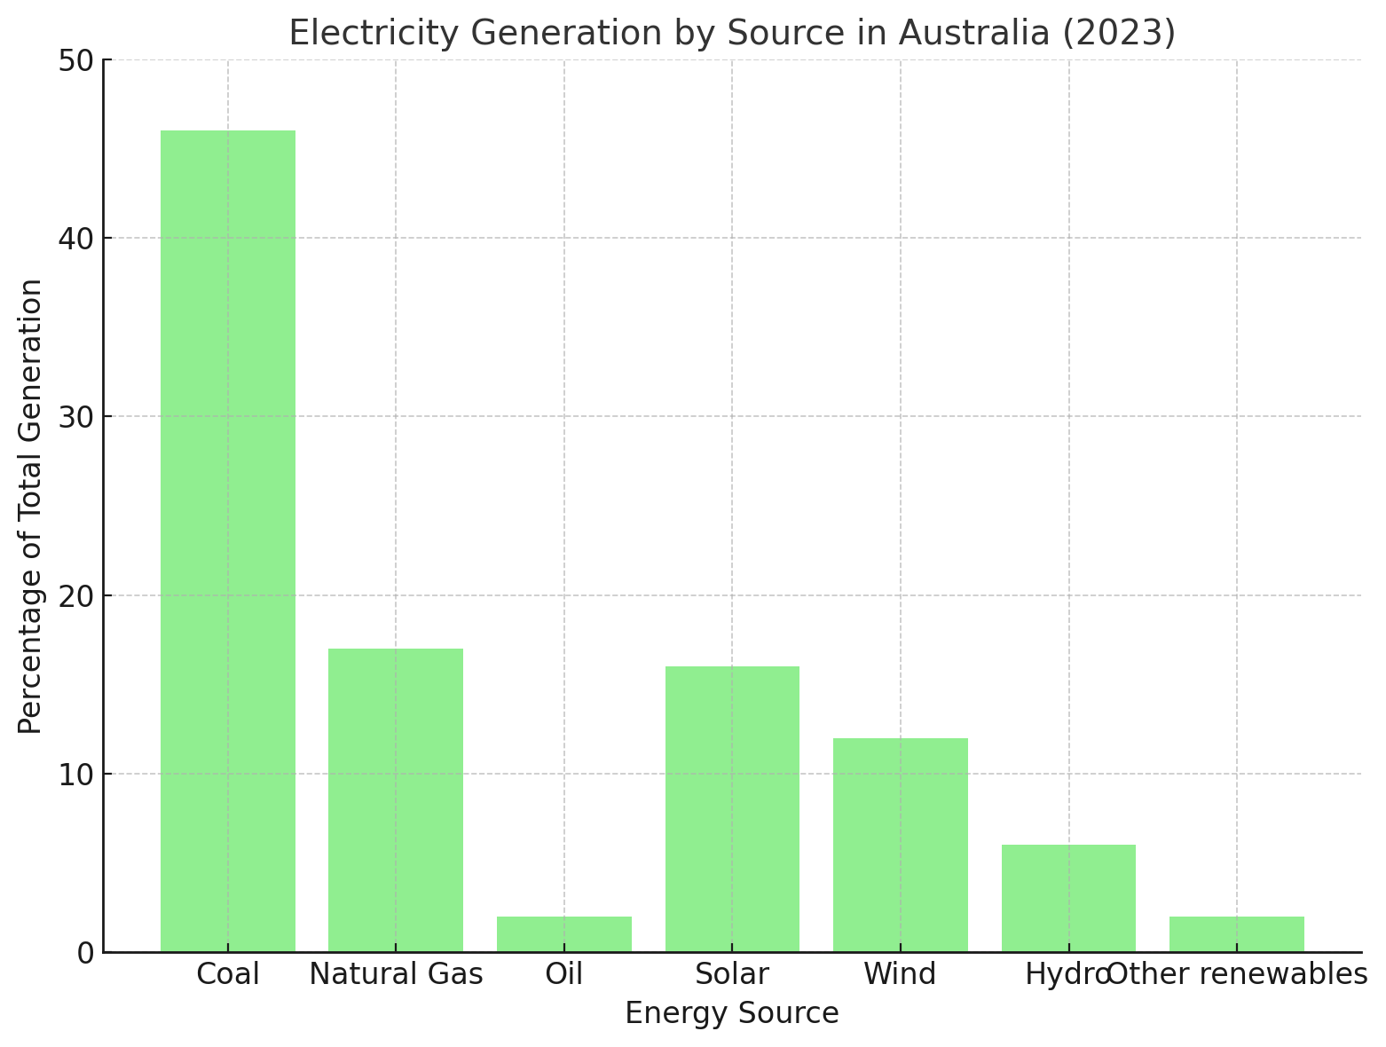

For the year 2023, Australia's total electricity generation was around 274 terawatt hours (TWh), showing a 1% increase in demand. The breakdown of electricity generation by source is as follows:

Fossil Fuels: 65% of total electricity generation, with coal being the largest contributor at 46%. Natural gas made up 17%, while oil contributed about 2%.
Renewables: Contributed 35% of total electricity, with solar accounting for 16%, wind 12%, and hydro 6%. The share of renewables increased by 3% compared to 2022, marking the highest renewable share recorded.
This data reflects Australia's ongoing shift toward renewable energy sources, reducing reliance on coal and natural gas​
​
Conclusion
Australia’s power generation sector is at a crossroads as the country seeks to transition to a more sustainable energy future. While coal and gas continue to play a significant role in the energy mix, the rapid growth of renewable energy is transforming the sector. The transition presents both opportunities and challenges, ranging from technological advancements to grid reliability and social impacts.
As Australia moves towards its goal of net-zero emissions by 2050, the country will need to invest in new infrastructure, support communities impacted by the transition, and foster innovation in emerging technologies like hydrogen and energy storage. With the right policy framework and investment, Australia has the potential to lead the world in renewable energy and become a key player in the global energy transition.

Major Australian Electricity Authorities: An Overview
Australia’s electricity market is a complex network of entities that work together to ensure the delivery of reliable, affordable, and increasingly sustainable energy. Several key organizations are responsible for overseeing, regulating, and managing different aspects of the electricity market. These entities play a crucial role in the transition to renewable energy and in maintaining the stability of the electricity grid. This analysis will provide an overview of the major Australian electricity authorities, highlighting their responsibilities and influence on the energy landscape.

The major electricity authorities in Australia include:

The Australian Energy Market Operator (AEMO)
The Australian Energy Regulator (AER)
The Australian Energy Market Commission (AEMC)
Clean Energy Regulator (CER)
Australian Renewable Energy Agency (ARENA)

Australian Energy Market Operator (AEMO)

Role and Responsibilities
The Australian Energy Market Operator (AEMO) is one of the most critical entities in Australia's electricity sector, responsible for the operation of the electricity and gas systems and markets across the country. Established in 2009, AEMO manages the National Electricity Market (NEM), which serves the eastern and southern states, as well as the Wholesale Electricity Market (WEM) in Western Australia.

AEMO’s key responsibilities include:

System and Market Operation: AEMO ensures the reliable and efficient operation of Australia’s electricity grid. It balances electricity supply and demand in real-time, coordinating the dispatch of electricity from generators and ensuring that the grid operates within its technical limits.

Planning and Forecasting: AEMO is responsible for long-term planning to ensure that Australia’s electricity infrastructure can meet future demand. It regularly publishes reports, such as the Integrated System Plan (ISP), which outlines future development pathways for the NEM, including infrastructure needs, renewable energy zones, and interconnectors.

Energy Security and Reliability: AEMO oversees mechanisms to maintain energy security, including managing the risks associated with the intermittency of renewable energy sources like wind and solar. It is also involved in emergency responses during periods of system stress, such as extreme weather events or major equipment failures.
Impact on Renewable Energy Transition
AEMO has a pivotal role in supporting Australia’s transition to renewable energy. The organization’s Integrated System Plan has been instrumental in identifying key areas for the development of renewable energy infrastructure, including Renewable Energy Zones (REZs) and the expansion of grid interconnectors to enhance reliability as more renewable energy enters the market.

Additionally, AEMO manages the integration of new technologies, such as large-scale battery storage and distributed energy resources (DER), including rooftop solar. AEMO’s efforts to modernize the grid will be crucial as Australia aims to decarbonize its electricity system.

Australian Energy Regulator (AER)
Role and Responsibilities
The Australian Energy Regulator (AER) is tasked with regulating the electricity and gas markets in Australia. Established in 2005, the AER’s primary function is to protect consumers while ensuring that the electricity system operates efficiently. It achieves this by overseeing energy companies and ensuring compliance with national energy laws.

The AER’s key responsibilities include:

Price Regulation: The AER regulates the revenues that network companies (which own and operate transmission and distribution infrastructure) can earn, ensuring that prices for consumers are fair and reflect the cost of providing electricity. The AER sets network tariffs that are a component of the final electricity price paid by consumers.

Monitoring and Compliance: The AER monitors the performance of electricity retailers, generators, and networks to ensure they comply with the National Electricity Rules and other regulations. This includes ensuring that companies do not engage in anti-competitive behaviour and that consumers are treated fairly.

Market Performance Reporting: The AER publishes reports on market performance, including energy price trends and reliability. Its State of the Energy Market report provides comprehensive insights into the Australian electricity market's current state and future challenges.

Consumer Protection and Renewable Energy
One of the AER’s major focuses is on protecting consumers, especially as the energy market evolves with the introduction of more renewable energy and new technologies. As part of this role, the AER works to ensure that energy providers offer clear and fair pricing, prevent “bill shock,” and protect vulnerable customers.

The AER is also tasked with ensuring that renewable energy generators and the companies connecting these to the grid meet performance standards, contributing to grid stability as Australia transitions to a cleaner energy future.

Australian Energy Market Commission (AEMC)

Role and Responsibilities
The Australian Energy Market Commission (AEMC) is the rule-making body for the electricity and gas markets in Australia. Established in 2005, its main function is to develop and amend the National Electricity Rules, which dictate how the electricity market operates.

The AEMC’s key responsibilities include:
Rule-making: The AEMC is responsible for making and amending rules that govern the operation of the electricity market. These rules cover everything from market structure to network pricing and reliability standards.

Advisory Role: The AEMC provides independent advice to governments on energy policy matters. It conducts reviews and consultations on market reforms and publishes reports that influence energy policy decisions.

Market Development: The AEMC works to ensure that the electricity market evolves to meet future needs, including integrating renewable energy, encouraging competition, and ensuring that new technologies such as electric vehicles and energy storage are accommodated.

Role in Energy Transition
As the primary rule-making body, the AEMC plays a crucial role in enabling the transition to renewable energy. The commission has overseen the development of market reforms to support the integration of renewable energy into the grid, including changes to pricing structures that incentivize the adoption of clean energy technologies and improvements to the grid's flexibility.
The AEMC is also involved in planning for future energy markets that incorporate greater levels of decentralized generation, such as rooftop solar and other distributed energy resources (DER), ensuring that consumers can benefit from technological advancements while maintaining grid stability.

Clean Energy Regulator (CER)
Role and Responsibilities
The Clean Energy Regulator (CER) is responsible for administering key climate and energy programs that promote the uptake of renewable energy and reduce carbon emissions. Established in 2012, the CER plays a pivotal role in supporting Australia’s transition to a low-carbon economy.

Key responsibilities include:

Renewable Energy Target (RET): The CER manages the Renewable Energy Target, which aims to increase the proportion of electricity generated from renewable sources. The RET has been a major driver of investment in renewable energy projects, particularly wind and solar farms.

Emissions Reduction Fund (ERF): The CER administers the ERF, which provides financial incentives for businesses and other organizations to adopt practices that reduce greenhouse gas emissions.

National Greenhouse and Energy Reporting (NGER): The CER collects and publishes data on emissions, energy production, and consumption, providing transparency and accountability in efforts to reduce Australia’s carbon footprint.

Role in Renewable Energy
The CER is central to Australia’s renewable energy transition. By administering the RET, the CER has facilitated significant growth in wind and solar projects across the country. As the RET concluded in 2020, the CER continues to support clean energy development through other programs, such as the Emissions Reduction Fund, which provides opportunities for renewable energy projects to generate revenue by selling carbon credits.

Australian Renewable Energy Agency (ARENA)
Role and Responsibilities
The Australian Renewable Energy Agency (ARENA) was established in 2012 with the goal of accelerating the adoption of renewable energy technologies. ARENA provides funding for research, development, and demonstration projects that aim to improve the cost-effectiveness and reliability of renewable energy.

ARENA’s key responsibilities include:

Project Funding: ARENA funds innovative renewable energy projects, including solar, wind, bioenergy, and energy storage. This funding supports the commercialization of new technologies that can help meet Australia’s energy needs.

Research and Development: ARENA invests in research to improve renewable energy efficiency and reduce costs, focusing on emerging technologies like hydrogen and advanced energy storage systems.

Collaboration: ARENA works with industry, government, and academia to advance the renewable energy sector through collaborative projects and knowledge sharing.

Role in Innovation and the Future Energy System
ARENA’s funding has been instrumental in advancing Australia’s renewable energy capabilities. By supporting projects that improve the performance and integration of renewables, ARENA helps to ensure that Australia remains a leader in clean energy innovation. The agency is particularly focused on emerging technologies like hydrogen, which has the potential to revolutionize energy storage and decarbonize industries.

Conclusion
The major electricity authorities in Australia—AEMO, AER, AEMC, CER, and ARENA—play critical roles in ensuring the efficient, reliable, and sustainable operation of the energy system. As Australia transitions to renewable energy, these organizations will continue to shape the future of the electricity market through their regulation, operation, and support of innovative technologies. Together, they ensure that Australia can meet its energy demands while reducing carbon emissions and integrating renewable energy sources into the national grid.

Major Electricity Authorities in New South Wales (NSW)
New South Wales (NSW) is Australia's most populous state and one of its largest energy consumers. To meet the growing demand for electricity and facilitate the transition to renewable energy, several key authorities are responsible for overseeing and regulating the electricity sector in NSW. These authorities manage the production, distribution, and consumption of electricity, ensuring reliability, affordability, and environmental sustainability.

The major electricity authorities that play a critical role in the NSW electricity market include:

TransGrid
Ausgrid
Endeavour Energy
Essential Energy
The NSW Department of Planning, Industry, and Environment (DPIE)

TransGrid
Role and Responsibilities
TransGrid is the primary operator of the high-voltage transmission network in NSW, responsible for transmitting electricity from power stations to large industrial customers and distribution networks. Established in 1995 as part of the electricity market reforms, TransGrid’s role is essential for maintaining the stability of the electricity system across NSW and the Australian Capital Territory (ACT).

TransGrid operates more than 13,000 kilometers of high-voltage transmission lines, which are crucial for moving electricity across long distances and connecting large-scale renewable energy projects to the grid. The company's main responsibilities include:

Transmission Network Management: TransGrid ensures the reliable delivery of high-voltage electricity to meet the needs of NSW consumers, including households, businesses, and industries. This involves the management and maintenance of the transmission network and the coordination of electricity flows across the state.

Network Planning and Expansion: As the NSW electricity system transitions to renewable energy, TransGrid is responsible for planning and expanding the transmission network to connect new renewable energy projects, such as wind and solar farms, to the grid. This is particularly important as the state works to reduce its reliance on coal-fired power and increase its share of renewable energy sources.

Energy Security and Reliability: TransGrid plays a vital role in ensuring the security and reliability of the electricity system, especially as the energy mix changes. It manages risks associated with extreme weather events and ensures that power can be delivered efficiently and reliably under all conditions.
Role in Renewable Energy Transition
One of TransGrid's most important contributions to NSW’s energy future is its involvement in the development of Renewable Energy Zones (REZs). These zones are critical for clustering renewable energy generation projects and connecting them to the transmission grid. TransGrid is working closely with the NSW government and other stakeholders to expand its transmission network and accommodate the growing share of wind and solar in the state's electricity mix.

TransGrid is also involved in several large-scale projects aimed at improving the resilience and capacity of the transmission network. For example, the EnergyConnect project, a new interconnector between NSW and South Australia, is designed to increase the flow of renewable energy across state borders, enhancing the overall reliability of the grid.

Ausgrid
Role and Responsibilities
Ausgrid is one of the largest electricity distribution networks in NSW, serving around 1.8 million customers across Sydney, the Central Coast, and the Hunter region. Ausgrid is responsible for the delivery of electricity from the transmission network (operated by TransGrid) to homes and businesses.

The main responsibilities of Ausgrid include:

Electricity Distribution: Ausgrid manages the poles and wires that deliver electricity to homes and businesses in its service area. This involves maintaining the network, managing outages, and ensuring the reliable delivery of electricity to consumers.

Network Upgrades and Maintenance: Ausgrid invests in upgrading and maintaining its infrastructure to improve reliability and accommodate new technologies. This includes modernizing the grid to handle the increasing penetration of distributed energy resources (DERs) such as rooftop solar and batteries.

Customer Service and Engagement: Ausgrid is responsible for providing customer service to the millions of people who depend on its network. This includes billing, responding to outages, and managing new connections.

Role in Sustainable Energy
As a distribution network, Ausgrid plays a key role in facilitating the adoption of renewable energy technologies. With the rapid growth of rooftop solar installations in NSW, Ausgrid has been working to modernize its grid to ensure that it can accommodate the two-way flow of electricity, as more consumers become "prosumers" (producing and consuming electricity).

Ausgrid is also involved in energy efficiency initiatives and demand management programs designed to reduce peak electricity consumption and improve the overall efficiency of the electricity system. This includes initiatives to encourage the uptake of battery storage, electric vehicles, and other emerging technologies that can help balance supply and demand in real-time.

Endeavour Energy
Role and Responsibilities
Endeavour Energy is another key electricity distribution network in NSW, serving around 2.7 million people across Greater Western Sydney, the Blue Mountains, the Illawarra, and the Southern Highlands. Similar to Ausgrid, Endeavour Energy is responsible for maintaining the local electricity network and ensuring the reliable delivery of electricity to customers.

Endeavour Energy’s main responsibilities include:

Electricity Delivery: Endeavour Energy manages the poles, wires, substations, and transformers that deliver electricity to homes and businesses in its service area. This involves maintenance, network upgrades, and response to outages.

Network Modernization: Endeavour Energy is investing in network modernization efforts to handle the increasing penetration of distributed energy resources such as solar panels and battery storage systems. The company is also working to improve grid resilience in the face of natural disasters such as bushfires and storms.

Role in Sustainable Energy
Endeavour Energy is committed to supporting NSW’s transition to renewable energy. The company has been actively involved in demand management programs that help reduce peak electricity use and improve network efficiency. Endeavour Energy is also working to integrate more renewable energy and distributed generation into its network by investing in new technologies and upgrading its infrastructure.

Like Ausgrid, Endeavour Energy is focused on supporting the growth of rooftop solar installations and ensuring that its grid can accommodate the changes brought about by the rise of prosumers. The company is also working on initiatives to encourage the adoption of electric vehicles and charging infrastructure within its service area.
Essential Energy
Role and Responsibilities
Essential Energy is the electricity distribution network serving regional and rural NSW, covering over 95% of the state’s land area. Essential Energy serves approximately 865,000 customers, many of whom are located in remote and regional areas. The company’s extensive network includes more than 183,000 kilometers of power lines, making it one of the largest electricity networks in Australia by geographic area.

Essential Energy’s primary responsibilities include:

Electricity Distribution in Regional Areas: Essential Energy manages the delivery of electricity to customers in regional and rural areas, ensuring that even remote communities have access to reliable electricity.

Network Resilience and Maintenance: Due to the vast area it serves, Essential Energy faces unique challenges in maintaining its infrastructure. The company is focused on improving network resilience, particularly in areas prone to extreme weather conditions such as bushfires and floods.

Supporting Regional Development: Essential Energy plays an important role in supporting economic development in regional NSW by ensuring that businesses and industries in these areas have access to reliable and affordable electricity.

Role in Renewable Energy
Essential Energy is working to support the growth of renewable energy in regional NSW, where many large-scale solar and wind projects are being developed. The company is upgrading its infrastructure to facilitate the connection of these projects to the grid, helping to drive the state’s renewable energy transition.

The company also supports the uptake of rooftop solar in rural areas, where many customers have the potential to generate their own electricity due to the availability of large rooftop spaces.

NSW Department of Planning, Industry, and Environment (DPIE)
Role and Responsibilities
The NSW Department of Planning, Industry, and Environment (DPIE) is the government body responsible for overseeing the state’s energy policies, planning, and regulatory framework. DPIE’s key responsibilities in the electricity sector include:

Energy Policy Development: DPIE develops and implements policies aimed at ensuring a reliable, affordable, and sustainable electricity supply for NSW. This includes initiatives to promote the adoption of renewable energy and reduce greenhouse gas emissions.

Planning and Regulatory Oversight: DPIE oversees the planning and approval processes for large-scale energy projects, including renewable energy developments. The department works to ensure that projects comply with environmental and planning regulations while supporting the growth of clean energy.

Renewable Energy Zones (REZs): DPIE is leading the development of Renewable Energy Zones (REZs) in NSW, which are designed to coordinate renewable energy projects with the necessary transmission infrastructure. These zones are a key part of the state’s strategy to increase renewable energy generation and reduce reliance on coal-fired power.

Role in Renewable Energy
DPIE plays a central role in facilitating NSW’s transition to a clean energy future. The department is responsible for implementing the NSW Electricity Infrastructure Roadmap, which sets out a plan for increasing renewable energy capacity, developing new energy storage, and modernizing the electricity grid.

The roadmap includes ambitious targets for renewable energy generation and outlines the state’s plans for phasing out coal-fired power plants while increasing investment in wind, solar, and storage technologies.

Conclusion
NSW’s electricity system is supported by a range of authorities, each playing a crucial role in the generation, transmission, distribution, and regulation of electricity. From the high-voltage transmission network managed by TransGrid to the distribution networks operated by Ausgrid, Endeavour Energy, and Essential Energy, these organizations are essential in ensuring that NSW has a reliable and sustainable electricity supply. As the state transitions towards a renewable energy future, these authorities

Electricity Price Structure for a Commercial Contract in Australia
The electricity price structure for a commercial contract in Australia typically consists of multiple components that reflect the varying demands and usage patterns of a business. Depending on the size and needs of the business, electricity charges can include fixed and variable costs, time-of-use tariffs (including shoulder rates), demand charges, network fees, and environmental levies. Here’s a detailed breakdown of these components, with a focus on the inclusion of shoulder rates, which are part of the time-of-use (TOU) pricing system.

Fixed Charges
Daily Supply Charge (Fixed Charge)
This is a fixed daily charge that covers the cost of maintaining the electricity connection to the business premises. It is incurred regardless of how much electricity is consumed and reflects the cost of grid maintenance, meter servicing, and other overhead costs.

Structure: A fixed daily fee, generally expressed in dollars per day.
Example: $1 to $10 per day, depending on the size of the business and the type of contract.
Variable (Usage) Charges

Energy Consumption Charge (Usage Charge)
This charge is based on the actual electricity consumed by the business, measured in kilowatt-hours (kWh). It forms the bulk of the variable component of a commercial electricity bill and can be subject to different rates depending on the time of day (i.e., peak, off-peak, and shoulder rates).

Structure: Charged per kWh of electricity used.
Rates: Typically range from $0.15 to $0.30 per kWh, depending on the retailer and consumption level.

Time-of-Use (TOU) Tariffs
Time-of-use tariffs are designed to reflect the varying costs of electricity at different times of the day, encouraging businesses to use power during off-peak or shoulder periods when electricity is cheaper. In a TOU structure, there are usually three key periods:

Peak: When demand is highest (usually during business hours on weekdays).
Off-Peak: When demand is lowest (typically at night and weekends).
Shoulder: The transitional period between peak and off-peak, which often has moderate demand and prices.
Peak Rate: The highest rate, charged during periods of high demand (e.g., 7 AM to 10 PM on weekdays).
Off-Peak Rate: The lowest rate, applied during periods of low demand (e.g., late nights and weekends).
Shoulder Rate: Charged during transitional periods, usually late morning to early evening, and on weekends. Shoulder rates are typically lower than peak rates but higher than off-peak rates.
Example of Time-of-Use Rates:
Peak Rate: $0.25 to $0.35 per kWh.
Shoulder Rate: $0.15 to $0.25 per kWh.
Off-Peak Rate: $0.10 to $0.15 per kWh.

Controlled Load Tariffs
Controlled load tariffs apply to specific high-consumption appliances or equipment that operate during off-peak times, such as hot water systems or industrial machinery. These loads are often metered separately and charged at a lower rate.

Structure: Charged per kWh for electricity used by controlled devices.
Example: Controlled load rates can range from $0.10 to $0.20 per kWh, depending on the agreement with the retailer.
Demand Charges
Demand-Based Pricing
Demand charges are particularly relevant for larger businesses and are based on the maximum electricity demand (measured in kilowatts, or kW) during peak periods in a billing cycle. These charges help cover the costs of maintaining grid capacity to meet the business's peak electricity requirements and are applied in addition to consumption charges.
Structure: Charged per kW of peak demand, typically based on the highest demand recorded during a specific interval (e.g., 30 minutes).
Example: Demand charges may range from $10 to $30 per kW of peak demand per month.

Maximum Demand Penalties
In some contracts, exceeding an agreed demand threshold can result in additional charges. These penalties encourage businesses to manage their electricity usage more effectively and avoid placing excess strain on the grid during peak periods.

Structure: A surcharge per kW of demand exceeding the threshold.
Example: A penalty of $5 to $15 per kW above the agreed demand limit.

Network Charges
Transmission and Distribution Charges
Network charges are imposed to cover the cost of transporting electricity from generation plants to business premises via transmission and distribution networks. These costs are passed on to businesses by electricity retailers and are often itemized separately for larger consumers.

Structure: Charged based on kWh of electricity consumed or kW of demand.
Example: Transmission and distribution charges can add $0.05 to $0.15 per kWh to the total electricity bill.

Capacity Charges
Capacity charges may apply to businesses with large electricity needs, reflecting the cost of ensuring that the grid can meet their peak demand. These charges help fund the infrastructure required to deliver power at these high loads.

Structure: Charged per kW or kVA of peak demand.
Example: Capacity charges can range from $10 to $20 per kW or kVA of maximum demand.
Environmental and Policy-Related Charges

Renewable Energy Certificates (RECs) or Green Power Charges
Commercial electricity contracts may include charges related to renewable energy programs, such as Australia's Renewable Energy Target (RET). These charges fund the development of renewable energy projects and are typically passed on to consumers.

Structure: Charged as a per-kWh fee or a percentage of the total electricity cost.
Example: Green energy charges can range from $0.005 to $0.01 per kWh.

Market and Policy Fees
Retailers may also pass on other costs associated with complying with government policies and regulations, such as the National Electricity Market (NEM) participation fees and other environmental levies.
Structure: Fixed monthly fees or per-kWh charges.
Example: Policy-related fees may range from $0.002 to $0.005 per kWh.
Additional Charges

Metering Charges
Metering charges cover the cost of installing, maintaining, and reading electricity meters. For commercial customers, advanced metering infrastructure, such as smart meters, may be required to enable accurate billing and time-of-use monitoring.

Structure: Fixed monthly or annual fee.
Example: Metering charges can range from $10 to $30 per month, depending on the complexity of the metering system.

Contractual and Administrative Fees
Some commercial contracts may include administrative or account management fees, which cover costs related to account maintenance, billing, and customer service.

Structure: Fixed monthly or annual fee.
Example: $5 to $50 per month for account management, depending on the size of the business and contract terms.

Exit or Early Termination Fees
If a business terminates its electricity contract early, it may face early termination fees, which compensate the retailer for any losses incurred by the early exit.

Structure: A fixed fee or a percentage of the remaining contract value.
Example: $200 to $500, or more, depending on the contract length and terms.

Discounts and Incentives
Volume Discounts
Large businesses with significant electricity usage may qualify for volume discounts, where the unit cost of electricity decreases as consumption increases beyond certain thresholds.

Structure: Discounts apply to usage above a certain kWh threshold.
Example: A 5% to 10% discount on consumption exceeding 100,000 kWh per month.

Demand Response Incentives
Some contracts offer financial incentives for businesses that participate in demand response programs, which involve reducing electricity use during periods of peak demand in exchange for rebates or lower rates.

Structure: Rebates or credits for reducing consumption during peak events.
Example: $0.10 to $0.30 per kWh reduced during demand response events.

Energy and Its Application

Types Energy
Energy is the driving force behind all the processes in the universe. From the movement of objects to the burning of fuels, energy exists in various forms and can be transferred or converted from one type to another. Understanding the different types of energy is crucial in many fields, including physics, engineering, and even everyday life. This article will explore five major types of energy — kinetic, potential, thermal, electrical, and nuclear energy — and provide real-life examples of each.
Kinetic Energy
Definition: Kinetic energy is the energy that an object possesses due to its motion. Anything that moves has kinetic energy, and the faster it moves, the more kinetic energy it has. The mass of the object also plays a role in determining how much kinetic energy it possesses. The heavier the object and the faster it moves, the more kinetic energy it has.
Real-Life Example: Think about a speeding car on a highway. A car moving at 100 kilometers per hour has much more kinetic energy than a bicycle moving at 20 kilometers per hour. This is why it takes a lot more energy to stop a fast-moving car than a slow-moving bicycle. The kinetic energy of the car is evident when it comes to a sudden stop; the energy has to be dissipated, often in the form of heat, which is why car brakes can get hot after frequent use.
Another simple example is a ball rolling down a hill. When the ball is moving, it has kinetic energy. The steeper the hill, the faster the ball will move, increasing its kinetic energy. This energy is why it takes more effort to stop a fast-moving ball than one that’s moving slowly.
Kinetic energy also plays a significant role in activities like running, cycling, and swimming. The faster an athlete moves, the more kinetic energy they generate, and this energy is what propels them forward. Athletes in sports like soccer, basketball, and football use their kinetic energy to move quickly across the field or court.
Example in Technology: Wind turbines are a great example of how we harness kinetic energy in a practical way. The wind, which is moving air, has kinetic energy, and when it blows through the blades of a wind turbine, the blades spin. This spinning motion is converted into electrical energy, which can then be used to power homes and businesses. Wind turbines are a perfect example of using the kinetic energy of nature to create sustainable energy.
Potential Energy
Definition: Potential energy is stored energy that an object has because of its position, condition, or configuration. This type of energy has the potential to do work, and when the object moves or changes, the potential energy is often converted into kinetic energy.
Real-Life Example: A classic example of potential energy is a book placed on a shelf. The book has potential energy because of its height above the ground. If the book falls, the potential energy is converted into kinetic energy as it speeds toward the ground. The higher the shelf, the more potential energy the book has, and the more kinetic energy it will have when it falls.
Another everyday example is a stretched rubber band. When you stretch a rubber band, you're giving it potential energy. If you let go, that potential energy is quickly converted into kinetic energy as the rubber band snaps back to its original shape. This concept of potential energy is essential in understanding how objects store energy and release it later.
Example in Nature: A dam is a large-scale example of potential energy at work. The water stored in a reservoir behind a dam has gravitational potential energy because it is elevated above the base of the dam. When the water is released, the potential energy is converted into kinetic energy as it flows through turbines, generating electricity. This process is a cornerstone of hydroelectric power, which provides renewable energy to millions of people worldwide.
Another natural example is a roller coaster at the top of a hill. When the roller coaster is at its highest point, it has maximum potential energy. As it starts to move downward, that potential energy is transformed into kinetic energy, making the roller coaster speed down the track.
Thermal Energy
Definition: Thermal energy, or heat energy, is the energy that comes from the movement of particles within a substance. The more the particles move, the more thermal energy the object has. Thermal energy is closely related to temperature; when an object heats up, its particles move faster, and its thermal energy increases.
Real-Life Example: One of the simplest examples of thermal energy is a cup of hot coffee. The heat you feel when you hold the cup comes from the thermal energy of the liquid inside. The higher the temperature of the coffee, the more thermal energy it has. As the coffee cools, its thermal energy decreases, and the heat dissipates into the surrounding air.
Another everyday example is cooking food. When you heat a pan on a stove, the thermal energy from the flame or electric burner is transferred to the pan. This energy then moves to the food, cooking it. This process of transferring thermal energy from one object to another is what makes cooking possible.
Example in the Environment: The Earth’s atmosphere and oceans are full of thermal energy. The sun heats the Earth, and that heat is distributed through the atmosphere and oceans, creating weather patterns and climate systems. For instance, warm ocean water in the tropics has a lot of thermal energy, and this heat is transferred to the atmosphere, fueling weather phenomena like hurricanes and thunderstorms.
In industry, thermal energy is used in power plants, where heat from burning fossil fuels or nuclear reactions is used to create steam. The steam then turns turbines to generate electricity. This process shows how thermal energy can be converted into mechanical and electrical energy, powering homes and businesses.

Electrical Energy
Definition: Electrical energy is the energy that comes from the movement of electrons through a conductor, such as a wire. Electrical energy is one of the most widely used forms of energy in the modern world, powering everything from homes to industrial machinery.
Real-Life Example: Consider turning on a light switch in your home. When you flip the switch, electrical energy flows through the wires to the light bulb, where it is converted into light and heat. This simple action of turning on a light demonstrates the everyday use of electrical energy.
Another example is the use of batteries. A battery stores chemical potential energy, which is converted into electrical energy when it powers a device like a smartphone or a flashlight. The flow of electrons through the device is what allows it to operate.
Example in Technology: Electrical energy is also crucial in powering large systems like electric grids, which provide electricity to cities and towns. Power plants generate electrical energy by converting other types of energy, such as kinetic or thermal energy, into electricity. This energy is then transmitted over power lines to homes, offices, and factories, providing the electrical power needed for lighting, heating, air conditioning, and appliances.
Electric vehicles are another example of how electrical energy is used in modern technology. Instead of relying on gasoline, electric cars use batteries to store electrical energy, which powers the car’s motor. This form of energy is more sustainable than fossil fuels and is becoming increasingly popular as the world shifts toward renewable energy sources.
Nuclear Energy
Definition: Nuclear energy is the energy stored in the nucleus of atoms. This energy can be released through nuclear reactions, either by splitting atomic nuclei (nuclear fission) or combining them (nuclear fusion). Nuclear energy is incredibly powerful and has been harnessed for both peaceful and destructive purposes.
Real-Life Example: The most well-known example of nuclear energy is in nuclear power plants. These plants use nuclear fission to release energy from uranium atoms. The energy released is used to heat water, producing steam that turns turbines to generate electricity. Nuclear power is a significant source of electricity in many countries, providing a large amount of energy from a relatively small amount of fuel.
Another everyday example of nuclear energy is found in the sun. The sun generates its energy through nuclear fusion, where hydrogen atoms combine to form helium, releasing vast amounts of energy in the process. This energy travels through space and reaches Earth as sunlight, providing the energy necessary for life on our planet.
Example in Medicine: Nuclear energy is also used in medicine, particularly in treatments like radiation therapy for cancer. In this therapy, controlled amounts of nuclear energy are used to target and kill cancer cells. Nuclear medicine also uses radioactive isotopes to diagnose and treat various conditions, showing the diverse applications of nuclear energy in science and health.

Class Activity - Identify the energy sources below

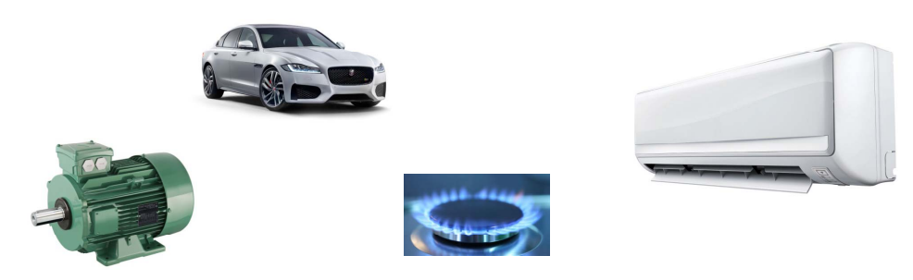

Energy Calculation in a Refrigeration System

In refrigeration systems, power and energy calculations are essential for determining the system’s efficiency and effectiveness. These calculations help engineers, technicians, and operators understand how much work the refrigeration system is doing and how much energy it consumes. Below is a guide to calculating power and energy in refrigeration systems, including the key concepts, formulas, and examples.
Key Concepts in Refrigeration
Before diving into the calculations, it’s essential to understand some of the basic terms used in refrigeration systems:
Cooling Load (Q): The amount of heat that must be removed from the refrigerated space or substance to maintain a desired temperature. It’s measured in watts (W) or kilowatts (kW).
Coefficient of Performance (COP): A measure of the efficiency of a refrigeration system. It’s the ratio of the cooling effect produced to the power input required to produce that cooling effect. A higher COP means a more efficient system.
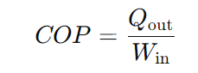

Compressor Power (W): The amount of electrical power required to drive the compressor in the refrigeration cycle. This is the main component of power consumption in a refrigeration system.
Energy Consumption (E): The total amount of energy used by the refrigeration system over a period of time. It is typically measured in kilowatt-hours (kWh).

Calculating Power in a Refrigeration System
The power required for the refrigeration system mainly comes from the compressor, which is responsible for circulating the refrigerant through the system. To calculate the power, follow these steps:

Step 1: Determine the Cooling Load
The cooling load is the amount of heat that needs to be removed from the space or substance being cooled. This can be calculated using the following formula:
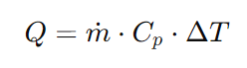
Where:
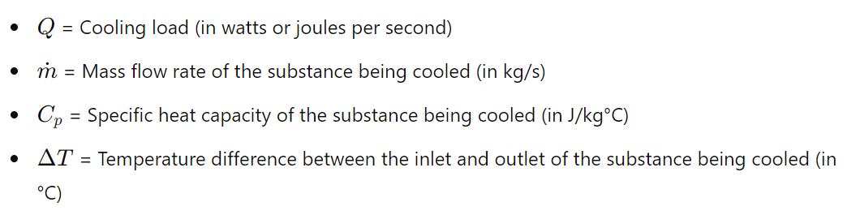
Example: If you are cooling 10 liters of water (10 kg) from 25°C to 5°C and the specific heat capacity of water is 4186 J/kg°C, the cooling load can be calculated as follows:
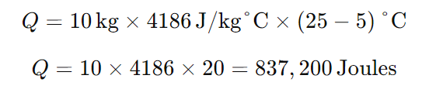
This is the total energy required to cool the water. To convert this to power (in watts), divide by the time (in seconds) over which the cooling occurs. If the cooling process takes 1 hour (3600 seconds), the power is:

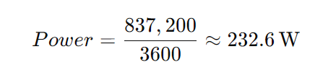

Step 2: Calculate the Compressor Power Input
The compressor power can be calculated using the formula for COP (Coefficient of Performance). Rearranging the COP formula to solve for power input:
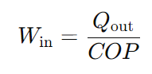
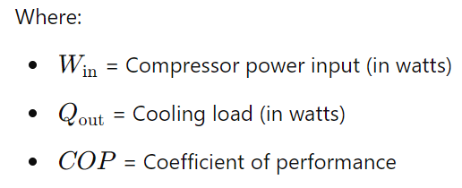
Example: If the cooling load QoutQ_{\text{out}}Qout​ is 232.6 W and the COP of the refrigeration system is 3, the power input required to run the compressor is:
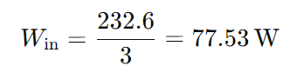
This means that the compressor requires 77.53 watts of power to maintain the cooling load.

Step 3: Determine Total Power Consumption
The total power consumption of the refrigeration system will include not only the compressor but also any other components that consume power, such as fans or pumps. However, in most basic calculations, the compressor power is the primary focus.
Calculating Energy Consumption
The energy consumption of the refrigeration system can be calculated by multiplying the power consumed by the compressor by the time the system is operating. The energy is typically measured in kilowatt-hours (kWh), which is a standard unit for energy usage.
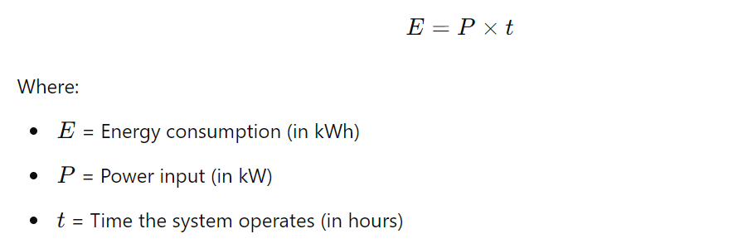

Example: If the compressor consumes 0.07753 kW (77.53 W) and it runs for 8 hours a day, the energy consumption for one day is:
E=0.07753 kW×8 hours=0.62024 kWhE = 0.07753 \, \text{kW} \times 8 \, \text{hours} = 0.62024 \, \text{kWh}E=0.07753kW×8hours=0.62024kWh
Over a month (30 days), the energy consumption would be:
Emonthly=0.62024 kWh/day×30=18.61 kWh/monthE_{\text{monthly}} = 0.62024 \, \text{kWh/day} \times 30 = 18.61 \, \text{kWh/month}Emonthly​=0.62024kWh/day×30=18.61kWh/month
This means the refrigeration system uses 18.61 kWh of energy each month if it runs 8 hours per day.

Factors Influencing Power and Energy in Refrigeration Systems
Several factors affect the power and energy consumption of a refrigeration system, including:
Temperature Difference: The larger the difference between the temperature of the space being cooled and the surrounding environment, the more energy the system will use. A bigger difference means the system has to work harder to remove heat.
Efficiency (COP): Systems with higher coefficients of performance (COP) are more efficient and consume less power for the same cooling load. Improving COP can reduce energy consumption.
Operating Time: The longer a refrigeration system operates, the more energy it consumes. Systems that run continuously will have higher energy consumption compared to systems that operate intermittently.
System Maintenance: Proper maintenance, such as cleaning coils and replacing refrigerant, can improve the system's efficiency and reduce energy consumption. Dirty components can cause the system to work harder, increasing power usage.
Insulation: Better insulation around the refrigerated space reduces the amount of heat that enters the system, which lowers the cooling load and decreases power consumption.
Energy Efficiency Tips for Refrigeration Systems
To optimize energy consumption in a refrigeration system, consider these strategies:
Use energy-efficient compressors: Modern compressors with variable-speed drives adjust their power consumption based on the cooling demand, reducing energy waste.
Regular maintenance: Ensure that refrigerant levels are correct, coils are clean, and components are functioning optimally.
Improve insulation: Ensure that doors, windows, and walls around the refrigerated space are well-insulated to prevent heat ingress.
Monitor operating times: Use timers or automatic controls to ensure the system only runs when necessary, reducing unnecessary energy consumption.
Upgrade to energy-efficient systems: If possible, consider upgrading older refrigeration systems to more energy-efficient models with higher COP values.

Class Activity –

A split air-conditioning system operates from 3.30pm to 5pm
in cooling mode. The electricity tariff for that period is
30 cents/kWh

Calculate
Total electrical energy consumed
Total thermal energy transferred Total thermal energy transferred
Cost of running the whole period

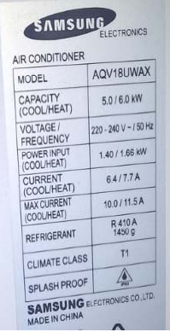

Energy Efficiency in Electric Motors
Efficiency (𝜂) is a crucial factor in electric motor performance. It measures how much of the electrical energy input is converted into useful mechanical energy. The efficiency of an electric motor is typically expressed as a percentage and can be calculated using:

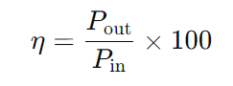

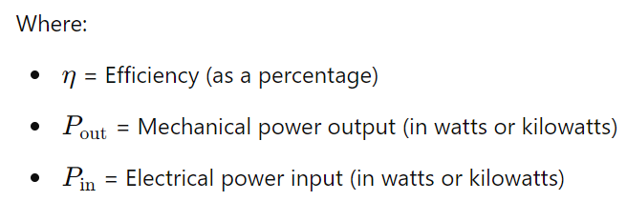
Example: If an AC induction motor has a mechanical output of 9.42 kW and consumes 12 kW of electrical power, its efficiency is:
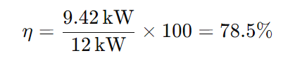

Class Activity –
A three phase electrical motor has a frame size of 90L.
Calculate:
Shaft power
Electrical Input power
Cost of running the motor for 24hrs @35C/kWh
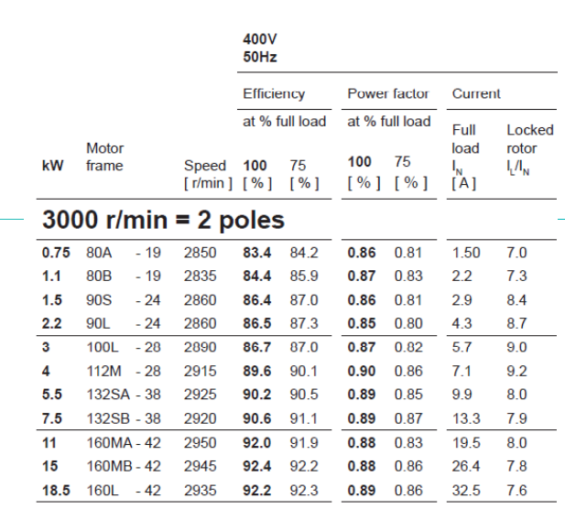

Class Activity –
Electricity Tariff

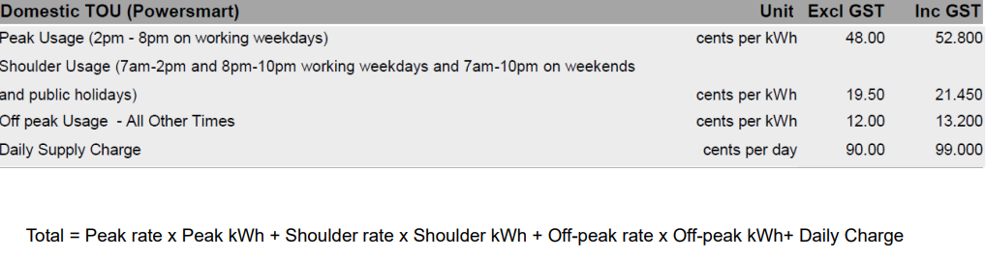

Calculating Electricity Cost Calculating Electricity Cost
A commercial property has the following items:
Lighting system 300W (All lights go off after hours)
Air-conditioning system power input 1kW
Refrigerator power input 1.5kW
Hot water system 2.5kW (Only works during off-peak period)
Others 0.5kW average per hour during operation hours
The commercial property open from 8am-5pm.
Calculate the electricity cost for a typical day

AS 3598.1: Energy Audits for Commercial Buildings
Introduction
AS 3598.1, titled Energy Audits for Commercial Buildings, is a critical Australian Standard that provides a framework for conducting energy audits in commercial environments. Its main objective is to ensure that organizations can accurately evaluate their energy use, identify areas where energy efficiency improvements can be made, and ultimately reduce energy consumption and costs. Energy audits play a vital role in sustainable business operations, particularly as global climate change concerns increase, and governments implement stricter energy efficiency regulations.
This standard is part of the broader AS 3598 series, which also covers energy audits for industrial and residential sectors. AS 3598.1 specifically focuses on commercial buildings, and it applies to a wide range of building types, including office buildings, retail spaces, hotels, hospitals, and schools. This standard not only ensures uniformity in the approach to energy audits but also emphasizes the importance of improving energy performance in a way that is both practical and cost-effective.
In this detailed overview, we will explore the purpose, structure, scope, and significance of AS 3598.1, as well as delve into the different levels of energy audits defined by the standard, the process involved, and how this framework aligns with broader sustainability goals.
Purpose and Objectives of AS 3598.1
AS 3598.1 is designed to help organizations achieve several key objectives:
Reduce Energy Consumption: By providing a structured approach to energy audits, the standard helps organizations identify inefficiencies in their energy use. This can lead to significant reductions in energy consumption.
Cost Savings: Lower energy consumption translates to reduced operating costs. The standard helps organizations discover opportunities for energy savings, which can positively impact their bottom line.
Environmental Impact: Reducing energy use contributes to lower greenhouse gas emissions, which is critical in addressing global climate change. AS 3598.1 helps organizations become more environmentally responsible by reducing their carbon footprint.
Compliance with Regulations: Many regions have regulations that mandate energy audits or energy efficiency improvements for commercial buildings. Following the standard ensures that organizations remain compliant with these regulations and avoid penalties.
Enhanced Energy Efficiency: The standard provides a methodology for continuous improvement in energy performance, helping organizations adopt a long-term energy efficiency strategy.
Risk Management: By improving energy efficiency and reducing reliance on energy sources, businesses can manage risks related to energy price fluctuations, supply chain disruptions, and regulatory changes.
Structure and Scope of AS 3598.1
AS 3598.1 is structured to provide clear guidance for conducting energy audits. The standard covers:
Audit Levels: AS 3598.1 defines three levels of energy audits, ranging from basic assessments to detailed technical evaluations. These levels offer flexibility, allowing organizations to choose the appropriate depth of analysis depending on their needs and objectives.
Audit Process: The standard outlines a step-by-step process for conducting energy audits, including planning, data collection, analysis, and reporting. It also provides guidance on the types of data to collect and the analytical methods to use.
Performance Indicators: AS 3598.1 encourages the use of key performance indicators (KPIs) to measure and monitor energy performance. These indicators help organizations track progress over time and identify areas for further improvement.
Reporting Requirements: The standard includes detailed reporting requirements to ensure that audit findings are presented in a clear, concise, and actionable manner. This includes recommendations for improving energy performance and potential cost savings.
Applicability to Different Building Types: AS 3598.1 is designed to be flexible and can be applied to a wide range of commercial building types. This includes office buildings, retail spaces, hospitals, hotels, educational institutions, and more.
Three Levels of Energy Audits in AS 3598.1
AS 3598.1 defines three levels of energy audits, each with varying degrees of detail and complexity. These levels provide a scalable approach to energy audits, allowing organizations to tailor the audit to their specific needs and budget.
Level 1: Basic Energy Audit
A Level 1 energy audit, also known as a walk-through audit, provides a basic assessment of energy use within a commercial building. It is the simplest and quickest form of audit, typically involving a high-level inspection of the building and its energy systems. The goal of a Level 1 audit is to identify low-cost or no-cost opportunities for energy savings.
Key features of a Level 1 audit include:
A brief on-site inspection of the building, including lighting, heating, ventilation, air conditioning (HVAC) systems, and other energy-consuming equipment.
Review of utility bills and energy consumption data to establish a baseline.
Identification of simple, low-cost energy efficiency measures, such as upgrading lighting, improving insulation, or adjusting thermostat settings.
A basic report that outlines the potential energy savings and cost benefits of implementing these measures.
A Level 1 audit is suitable for organizations looking for a quick assessment of their energy use, with minimal upfront costs. It is often used as a starting point to identify whether more detailed audits are necessary.
Level 2: Detailed Energy Audit
A Level 2 energy audit provides a more in-depth analysis of energy use within a building compared to a Level 1 audit. It includes a more thorough investigation of the building’s energy systems, equipment, and operational procedures. A Level 2 audit aims to identify cost-effective energy efficiency opportunities that may require a moderate level of investment.
Key features of a Level 2 audit include:
A detailed on-site inspection of all major energy-consuming systems, including lighting, HVAC, mechanical systems, and any industrial processes.
Collection of more comprehensive energy consumption data, including energy sub-metering if available.
Analysis of the building’s operational procedures to identify inefficiencies, such as excessive energy use during off-peak hours.
Development of a detailed list of energy efficiency measures, including estimates of energy savings, implementation costs, and return on investment (ROI).
A comprehensive audit report that provides actionable recommendations for improving energy efficiency, along with a cost-benefit analysis.
A Level 2 audit is suitable for organizations that are looking for more significant energy savings and are willing to invest in energy efficiency measures with a good ROI. This level of audit often results in recommendations for capital improvements, such as upgrading HVAC systems or installing energy management systems.
Level 3: Precision Subsystem Audit
Type 3 audits are detailed audits of specific subsystems, with additional data gathering and measurement to provide a higher level of accuracy, see Clause 5.1(c). Audits of this type are typically focused on a process or subsystem level, such as for HVAC, building
management systems, compressed air or lighting, rather than the whole building. Type 3
audits involve onsite measurements to monitor energy data over a period of time to capture the various operating conditions and relevant variables which require their own set of measurements in order to quantify the business case for energy saving measures more accurately than is possible under a Type 2 audit.

The Energy Audit Process
AS 3598.1 outlines a clear process for conducting energy audits, ensuring that the audit is both thorough and systematic. The process involves several key steps:
Planning and Preparation
The first step in the energy audit process is to define the scope of the audit and establish the objectives. This includes identifying which areas of the building will be audited, what energy systems will be evaluated, and the level of detail required (Level 1, 2, or 3 audit). It also involves collecting preliminary data, such as utility bills, building plans, and equipment specifications.
On-Site Inspection
The on-site inspection involves physically inspecting the building and its energy systems. Depending on the level of the audit, this could range from a simple walk-through to a detailed analysis of equipment performance and operational procedures. The auditor may use tools such as energy meters, infrared cameras, and data loggers to collect real-time energy data.
Data Collection and Analysis
Once the on-site inspection is complete, the auditor will analyse the collected data to identify patterns of energy use and inefficiencies. This may involve creating energy consumption models, comparing energy use against industry benchmarks, and identifying areas where energy efficiency improvements can be made.
Reporting and Recommendations
After analysing the data, the auditor will prepare a report outlining the audit findings. The report will include a list of recommended energy efficiency measures, along with estimates of energy savings, implementation costs, and payback periods. For Level 2 and Level 3 audits, the report will also include a financial analysis of each recommended measure.
Implementation and Follow-Up
The final step in the energy audit process is the implementation of the recommended energy efficiency measures. AS 3598.1 emphasizes the importance of continuous improvement, and organizations are encouraged to monitor the results of the audit and track their energy savings over time.
Alignment with Sustainability Goals
AS 3598.1 aligns with global sustainability goals by helping organizations reduce their energy consumption, lower greenhouse gas emissions, and improve their overall environmental performance. By providing a structured approach to energy audits, the standard supports the transition to more energy-efficient and sustainable business operations.
Conclusion
AS 3598.1 provides a comprehensive framework for conducting energy audits in commercial buildings, offering a clear methodology for evaluating energy use and identifying opportunities for improvement. Whether an organization is looking for quick energy savings or planning a major capital investment in energy efficiency, the standard provides the tools and guidance needed to achieve those goals.
By adopting AS 3598.1, businesses can reduce their energy consumption, lower operating costs, and contribute to a more sustainable future. As energy efficiency becomes an increasingly important factor in business operations, AS 3598.1 will continue to play a key role in helping organizations meet their energy and sustainability targets.
Fan laws and pump laws are sets of mathematical relationships that describe how changes in the size, speed, and other variables of a fan or pump affect its performance. These laws are essential for engineers, technicians, and professionals working with fluid dynamics, HVAC systems, industrial fans, or pumps, as they allow for predictions on how changes in system design or operation will affect the flow rate, pressure, and power consumption.
Both fan and pump laws rely on the principles of similarity and dimensional analysis, and they are often used when scaling up or down the size of a fan or pump or when adjusting the speed (RPM) of an existing system.

The Fan and Pump Laws
The fan laws and pump laws are essentially the same in terms of their principles, as both fans and pumps move fluids (air for fans, liquids for pumps). The difference is the medium that is being moved, and the specific design of the equipment.
There are three primary fan/pump laws, which relate changes in performance parameters when altering the speed (RPM), size, or other key characteristics of the equipment. These are:
Law 1: Flow Rate (Q)
The first law states that flow rate (Q) is directly proportional to the rotational speed (N) of the fan or pump. This relationship shows how the volume of air or fluid moved by the fan or pump changes when the speed of the motor changes.
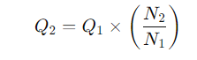
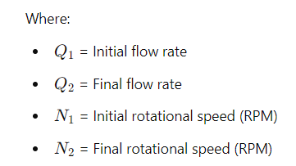
Explanation: If the speed of the fan or pump doubles, the flow rate also doubles. Similarly, if the speed is reduced by half, the flow rate is reduced by half. This law is linear and provides a simple way to predict how the system will behave under different speeds.

Law 2: Pressure (ΔP)
The second law states that the pressure (ΔP) generated by the fan or pump is proportional to the square of the rotational speed. This law applies to both the static pressure (in a fan) and the head pressure (in a pump).

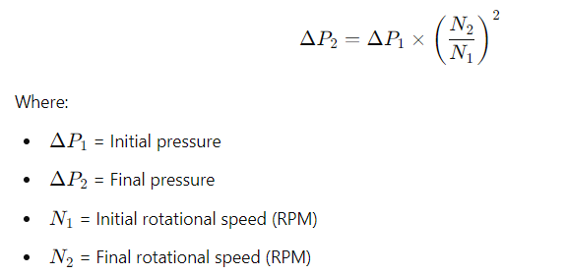
Explanation: If you double the speed of the fan or pump, the pressure generated increases by a factor of four (since 2^2=4). Similarly, halving the speed results in a reduction of pressure by a factor of four.
Law 3: Power (P)
The third law states that the power (P) required to drive the fan or pump is proportional to the cube of the rotational speed. This law is critical because it shows how increasing the speed of a fan or pump can significantly increase the power consumption.

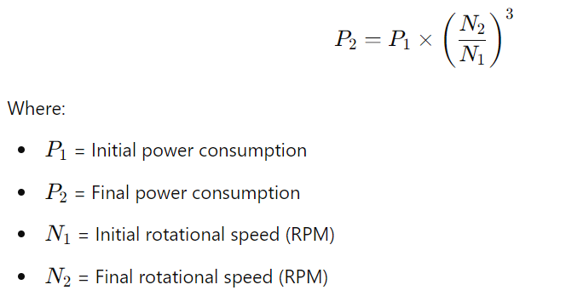

Explanation: If you double the speed of the fan or pump, the power required increases by a factor of eight (since 2^3 =8). Conversely, reducing the speed by half decreases the power consumption to one-eighth of the original value. This law demonstrates why fans and pumps running at high speeds can consume large amounts of energy.

Class Activity-
A pump motor has a shaft power of 1.5kW @ 1450rmp. Calculate the shaft power for the same motor in the system
20% of the speed
50% of the speed
75% of the speed

Class Activity-
A cooling tower fan which operates 24/7 is driven by a 5.5kW three phase motor with efficiency of 90% and speed of 1450rpm.
As the energy auditor, you are investigating the benefit of implementing a variable speed drive and associate control to save energy during the part-load.
You have designed a control method so the fan speed will vary based on the condensing water temperature.
You have created a model which represents the motor speed on an average daily basis.
7am-10am 60%
10am-2pm 80% 2pm 80%
2pm-5pm 90%
Other time 50%

•Find the cooling tower fan motor power input profile
•Refer to the tariff chart below and calculate annual electricity cost without using VSD
•Calculate the annual electricity cost after using VSD

The cost implementing a VSD includes:
5.5 VSD Drive ‐ $2000
Temperature Control Kit ‐ $500
Wiring modification ‐ $1500
Control Setup and programming ‐ $1000
Other overhead ‐ $500
Based on the energy saving, calculate the payback period for implementing the VSD option

Energy Efficient Components – BLDC Motors and EC Fans
Brushless DC (BLDC) motors and EC (Electronically Commutated) fans have revolutionized various industries, offering higher efficiency, durability, and performance compared to traditional motor technologies. This article delves into the intricacies of BLDC motors, the working principles behind EC fans, their benefits, and real-world applications. By the end of this comprehensive guide, you’ll understand how these technologies play a critical role in modern machinery and electronics.

Introduction to Brushless DC Motors
Brushless DC motors (BLDC motors) are a type of electric motor that, as the name suggests, do not rely on brushes for operation. In contrast to conventional DC motors, which use brushes to transfer current, BLDC motors utilize an electronic controller to switch the current in the motor's windings. This innovation offers significant advantages in terms of efficiency, longevity, and precision control.

Key Characteristics of BLDC Motors:
Efficiency: BLDC motors are known for their high efficiency. This is because they minimize energy loss through friction (due to the absence of brushes) and can more precisely control their speed and torque.
Longevity: The lack of brushes eliminates a major point of wear and tear, leading to longer operational lifespans for BLDC motors compared to their brushed counterparts.
Speed and Torque Control: BLDC motors provide precise control over speed and torque, making them ideal for applications where precision is critical, such as robotics, industrial machines, and electric vehicles.
Reduced Maintenance: With fewer mechanical parts to wear down, maintenance costs and downtime are significantly reduced.
Working Principle of BLDC Motors
The fundamental principle behind a BLDC motor is the interaction between a permanent magnet rotor and an electronically controlled stator. Here’s how it works:

Rotor: The rotor is the moving part of the motor, typically composed of permanent magnets.
Stator: The stator consists of coils of wire through which electricity flows, creating a magnetic field.
Electronic Commutation: Instead of brushes, the BLDC motor uses an electronic controller to switch the direction of the current in the stator windings. This switching creates a rotating magnetic field that interacts with the rotor’s magnets, causing the rotor to spin.
The controller constantly adjusts the current in response to feedback from the rotor’s position, ensuring smooth and efficient operation. This real-time adjustment is critical for applications that demand precise speed and torque control.

Types of BLDC Motors
BLDC motors are classified into two primary types based on the arrangement of their stator windings:

Inner Rotor BLDC Motors: In this configuration, the rotor is positioned inside the stator. Inner rotor motors are commonly used in applications requiring high-speed operation, such as power tools and drones.
Outer Rotor BLDC Motors: In these motors, the rotor surrounds the stator. Outer rotor BLDC motors are often used in applications requiring high torque at lower speeds, such as electric bicycles and fans.
EC Fans: An Application of BLDC Motors
Electronically Commutated (EC) fans are a direct application of BLDC motor technology. EC fans utilize BLDC motors combined with electronic controls to deliver superior performance compared to traditional fan designs. The term "electronically commutated" refers to the fact that the motor’s commutation (the process of switching current direction) is managed electronically rather than mechanically.

How EC Fans Work:
An EC fan is composed of the following key components:

BLDC Motor: At the heart of every EC fan is a brushless DC motor that drives the fan blades.
Electronic Controller: The controller adjusts the speed of the fan by regulating the power supply to the motor. This allows for precise control over airflow and energy consumption.
The integration of a BLDC motor into the design gives EC fans several unique advantages.

Advantages of EC Fans
Energy Efficiency
One of the most significant benefits of EC fans is their exceptional energy efficiency. Traditional AC (alternating current) fans operate at a fixed speed, regardless of the actual demand for airflow. In contrast, EC fans can dynamically adjust their speed based on the specific requirements of the environment. For instance, in an HVAC system, the EC fan can increase or decrease its speed based on the temperature and air quality, minimizing energy waste.

Because of their higher efficiency, EC fans are becoming a preferred choice in industries where energy consumption is a critical factor, such as data centres, commercial refrigeration, and HVAC systems.

Variable Speed Control
Another advantage of EC fans is their ability to operate at variable speeds. Traditional fans often operate at full power, even when it isn’t necessary, leading to wasted energy and excessive noise. EC fans, however, can adjust their speed to match the exact cooling or ventilation needs, reducing both energy consumption and noise levels. This capability makes EC fans particularly valuable in environments where quiet operation is important, such as hospitals, offices, and residential buildings.

Longevity and Durability
As with BLDC motors, EC fans benefit from the lack of brushes, which are a common point of failure in traditional motors. With fewer moving parts that can wear out, EC fans offer significantly longer operational lifespans and require less maintenance over time. This longevity is especially important in industrial applications where downtime can be costly.

Enhanced Control and Monitoring
Modern EC fans come equipped with sophisticated control systems that allow for detailed monitoring and control of fan operation. For example, some EC fans can be integrated with building management systems (BMS) to provide real-time data on airflow, temperature, and energy consumption. This data can be used to optimize building performance, reduce energy costs, and ensure that HVAC systems are operating efficiently.

Applications of BLDC Motors and EC Fans
Both BLDC motors and EC fans are widely used across various industries, thanks to their efficiency, reliability, and versatility. Here are a few key applications:

HVAC Systems
EC fans are a popular choice in heating, ventilation, and air conditioning (HVAC) systems. Their ability to adjust speed based on real-time demand makes them highly energy-efficient, helping reduce operational costs while maintaining optimal indoor air quality.

Data Centers
In data centers, managing airflow is crucial for cooling servers and preventing overheating. EC fans provide the precise control necessary to maintain stable temperatures while minimizing energy consumption, making them an ideal solution for large-scale cooling systems.

Electric Vehicles
BLDC motors play a critical role in the automotive industry, particularly in electric vehicles (EVs). Their high efficiency and ability to deliver precise control make them suitable for electric drivetrains, power steering, and auxiliary systems like fans and pumps.

Consumer Electronics
BLDC motors are used in various consumer products, including computer cooling fans, drones, and household appliances. Their compact size, quiet operation, and energy efficiency make them an excellent choice for modern electronics.

Energy Sector Report

Requirements for Energy Sector Report
This section will cover how to identify and understand the critical requirements when producing a detailed energy sector report. In the context of the Australian energy sector, it is essential to take into account regulatory requirements, industry standards, and safety guidelines.

Workplace Health and Safety (WHS)/Occupational Health Safety (OHS)
In Australia, adhering to WHS/OHS standards is a critical requirement when compiling an energy sector report. Energy companies must comply with government regulations, such as those set by Safe Work Australia, which are designed to protect workers in potentially hazardous environments like power plants and transmission sites.

Key Points:
Understand the specific WHS/OHS regulations applicable to energy projects.
Conduct a thorough risk assessment of project sites.
Ensure that all personnel involved in energy generation and reporting are trained in safety protocols.

Scope and Parameters of the Report
The scope of an energy sector report varies depending on the project or issue being addressed. When drafting the report, the key aspects to consider include:

Regulatory Requirements: Compliance with bodies like the Australian Energy Regulator (AER) and the Clean Energy Regulator.
Environmental Impact: Consider the environmental footprint of energy generation, particularly with fossil fuels.
Economic Considerations: The cost-effectiveness of various energy projects, particularly in transitioning to renewable sources.
Stakeholder Engagement: Collaboration with stakeholders from regulatory bodies, communities, and corporate leadership.
Information Sources for Energy Sector Reports
Data and information for energy sector reports can come from a variety of sources. In Australia, key sources include:

Australian Energy Market Operator (AEMO): Provides data on electricity and gas usage across the country.
Australian Bureau of Statistics (ABS): Offers data on economic and energy consumption trends.
Clean Energy Regulator: Information on renewable energy projects and compliance with emissions targets.

Class Activity – Research an energy sector report in an peak body such as Australian energy Council (https://www.energycouncil.com.au/reports/) and make a 15 min presentation of the report.

Developing the Energy Sector Report
Developing an energy sector report involves synthesizing a large amount of data and presenting it in a clear, concise manner. This section will cover how to collaborate with stakeholders, collect and analyse data, and compile a comprehensive report that meets industry standards.

Collaboration and Communication in Report Development
Energy sector reports often require input from multiple teams, including engineers, environmental scientists, and financial analysts. Effective communication ensures that all relevant information is collected and accurately represented.

Key Points:
- Use clear and structured communication methods to collaborate with stakeholders.
- Engage with both internal teams and external stakeholders, such as government bodies and environmental groups.
- Regularly update key stakeholders throughout the report development process.

Case Study: Collaboration between government regulators and energy companies in the development of Australia's wind energy sector has led to the establishment of key wind farms in South Australia and Victoria.

Data Collection and Analysis in the Australian Energy Sector
Data collection is a critical component of energy sector reporting. In Australia, key datasets may include:
Energy Consumption Data: How much energy is being used in residential, commercial, and industrial sectors.
Renewable Energy Production: Tracking the output of solar, wind, and hydroelectric plants.
Environmental Data: Impact assessments related to emissions, water usage, and land use.

Report Structure and Formatting

A technical report provides detailed information on a specific project, process, or technical subject, often used to communicate findings, analyses, or technical recommendations. The structure of a technical report is designed to present data and insights in a clear, logical manner. Here is a general format for a technical report:

1. Title Page
Report Title: Should be concise and clearly reflect the content.
Author(s): Names of the individual(s) or organization responsible for the report.
Date of Submission: The date the report is submitted or published.
Organization Name and Logo (if applicable):
Report Number or Reference (if applicable):
2. Abstract
Purpose: Provide a brief summary of the report, including the objectives, methods, key findings, and conclusions.
Content:
Overview of the problem or topic addressed.
A summary of key results or discoveries.
Main conclusions or recommendations.
Should typically be 150-300 words.

3. Table of Contents
A detailed list of sections and subsections with page numbers for easy navigation.

4. List of Figures, Tables, and Acronyms (if applicable)
Figures: A list of all figures (charts, graphs, diagrams) with corresponding page numbers.
Tables: A list of tables included in the report.
Acronyms/Abbreviations: A list of abbreviations and their meanings used throughout the report to clarify technical terms.

5. Introduction
Purpose: Introduce the background and objectives of the report.
Content:
The context or problem that the report addresses.
The scope and purpose of the study.
Any assumptions or constraints that influence the report.
Overview of how the report is organized.

6. Background or Literature Review (if applicable)
Purpose: Provide background information, context, or a review of existing literature on the subject.
Content:
Previous studies or relevant research.
Theoretical concepts or technical knowledge required to understand the topic.
Relevant regulations, standards, or technologies.

7. Methodology
Purpose: Detail the methods or procedures used to conduct the research or complete the project.
Content:
Description of the experimental design, tools, or techniques used.
Data collection methods, testing processes, or simulation models.
Explanation of analytical techniques or software used in data analysis.
Any assumptions, limitations, or challenges encountered during the process.

8. Results
Purpose: Present the data, observations, or findings from the study.
Content:
Quantitative and qualitative results.
Use of tables, figures, and charts to present data clearly.
Explanation of key trends, patterns, or observations.

9. Discussion
Purpose: Interpret and explain the significance of the results.
Content:
Analysis of the results in relation to the objectives or problem statement.
Comparison with previous studies or expected outcomes.
Discussion of any unexpected findings, errors, or anomalies.
Implications of the results on the project, study, or field.
Potential improvements or alternatives to methods used.

10. Conclusion
Purpose: Summarize the main findings, conclusions, and recommendations based on the study.
Content:
Recap of key points or results.
Final conclusions drawn from the analysis.
Significance of the findings.
Recommendations for future work or further study.

11. Recommendations (if applicable)
Purpose: Provide specific recommendations based on the findings.
Content:
Actionable suggestions for resolving the problem or improving the process.
Considerations for future projects, research, or implementations.
Any limitations of the recommendations.

12. References
Purpose: Provide a list of all the sources cited in the report.
Content:
Citation of all references, including books, journal articles, websites, standards, or patents, in an appropriate format (e.g., APA, IEEE, or Harvard style).

13. Appendices
Purpose: Include supplementary material that supports the main body of the report but is too detailed or large to be included in the main sections.
Content:
Raw data, additional figures, or extended tables.
Detailed calculations, code, or technical specifications.
Copies of surveys, questionnaires, or other supporting documents.

Report Writing Techniques
Clarity and Conciseness
Clarity and conciseness are the cornerstones of effective technical report writing. A well-written report should communicate complex ideas in a way that is easy to understand, without unnecessary details or convoluted explanations. This ensures that readers can quickly grasp the core message without being bogged down by excessive information.

Techniques for Achieving Clarity:
Use Simple, Direct Language: When writing, always aim for simplicity. Use common words and avoid overly complex sentences. This is especially important in technical reports, where the subject matter itself may already be complicated.

Instead of: "The system displayed anomalous behavior indicative of a potential failure in the data processing unit."
Use: "The system showed unusual behavior, suggesting a failure in the data processing unit."

Active Voice vs. Passive Voice: Use the active voice whenever possible, as it makes sentences clearer and more direct. In technical writing, passive voice can sometimes obscure the subject of the sentence.

Instead of: "The results were analysed by the team."
Use: "The team analysed the results."

Be Specific: Avoid vague terms like "several," "various," or "numerous." Precision is critical in technical writing, and specific numbers or details improve clarity.

Instead of: "Several issues were identified during testing."
Use: "Three issues were identified during testing."
Techniques for Conciseness:
Avoid Redundancy: Many technical writers unintentionally repeat themselves. Phrases like "completely full," "past history," or "in close proximity" add unnecessary words.

Instead of: "The tank was completely full."
Use: "The tank was full."

Shorten Sentences: Long sentences are harder to follow. Try breaking them into smaller sentences to improve readability and focus.

Instead of: "The experiment was carried out to evaluate the impact of varying temperatures on the efficiency of the new system, and the results showed a significant decrease in performance as temperatures increased."
Use: "The experiment evaluated how different temperatures affect system efficiency. The results showed a significant decrease in performance as temperatures increased."

Use Bullet Points and Lists: Where possible, use bullet points or numbered lists to break up long sections of text. This makes the report easier to skim and helps highlight key points.
In summary, clarity and conciseness enhance the readability of a technical report, making complex information more accessible and easier to digest.

Use of Technical Language and Jargon
Technical reports often require the use of specialized terminology and jargon. While this is essential for accuracy and precision, overuse of complex terms can hinder understanding, especially for readers unfamiliar with the field. Striking a balance between technical accuracy and readability is critical to effective communication.

Strategies for Using Technical Language:
Define Key Terms: The first time a technical term or acronym is introduced, it should be clearly defined. This ensures that all readers, regardless of their expertise level, can follow along. Definitions can be included in parentheses, footnotes, or a glossary at the end of the report.

Example: "The system's CPU (Central Processing Unit) experienced an unexpected shutdown."
Use Jargon Appropriately: Tailor your use of jargon based on the audience. If your report is for experts in the field, more technical terms can be used without explanation. However, for a broader or less specialized audience, avoid jargon or explain it clearly.

Be Consistent: Once a term has been introduced, be consistent in its use. Avoid switching between different terms for the same concept, as this can confuse the reader. For instance, if you start using "CPU" to refer to a Central Processing Unit, do not later switch to "processor" unless both terms have been clearly defined as equivalent.

Avoid Overuse of Acronyms: While acronyms can save space and reduce repetition, using too many in one report can make it difficult to read. Use acronyms sparingly, and ensure they are well-defined before use.

Simplifying Language:
While it’s important to remain technically accurate, overly complex sentences or obscure terms should be avoided. Even in highly technical fields, clarity should never be sacrificed for the sake of sounding more professional or technical. If a simpler term can convey the same meaning, use it.

In conclusion, using technical language effectively involves balancing precision with accessibility. The goal is to ensure that the necessary technical details are communicated without alienating non-expert readers.

Visual Presentation and Formatting
Visual presentation is an often overlooked but essential aspect of technical report writing. The way a report is formatted can greatly influence its readability, professionalism, and the overall impression it leaves on the reader. Well-organized reports not only look more professional but also help guide the reader through complex information more easily.

Key Elements of Visual Presentation:
Consistent Formatting: Consistency in formatting ensures that the report is easy to follow. Headings, subheadings, font styles, and sizes should be uniform throughout the document. For instance, all major headings might be in bold, size 14, while subheadings are in bold, size 12.

Use of White Space: Avoid cramming too much information onto a single page. Adequate white space between paragraphs, sections, and visual elements makes the report less intimidating and easier to read.

Headings and Subheadings: Clear headings and subheadings break up the text and allow readers to quickly find specific sections. Using a hierarchical structure (e.g., 1.0, 1.1, 1.1.1) provides clarity about the organization of the report.

Use of Bullet Points and Lists: Where applicable, use bullet points or numbered lists. These are particularly useful for breaking down complex procedures, summarizing findings, or listing recommendations. Bullet points improve readability by breaking up long paragraphs into digestible chunks.

Visual Aids:
Tables, Charts, and Graphs: Technical reports often include a lot of data. Tables, charts, and graphs are effective ways to present numerical data or complex relationships in a visually accessible format. Make sure all visual aids are clearly labeled and referenced in the text.

Captions and Labels: Any figure, table, or chart should include a caption that explains what it represents. Readers should be able to understand the significance of a visual element without needing to refer back to the main text.

Data Visualization: When presenting data, choose the appropriate type of chart or graph. For example, line graphs are useful for showing trends over time, while bar charts compare different variables. Ensure that your visualizations are not overcrowded with data points, which can make them hard to interpret.

Consistency and Professionalism:
Numbering: Use consistent numbering for sections, figures, and tables throughout the report. This helps readers easily navigate the document and refer back to specific sections when needed.

Page Layout: Ensure that margins, spacing, and alignment are consistent across all pages. Misaligned text or figures can give a report an unprofessional look, even if the content is excellent.

Effective visual presentation can significantly enhance a technical report's clarity and professionalism. By using formatting tools strategically, writers can improve both the appearance and the usability of their reports.
Revision and Proofreading
No technical report is complete without thorough revision and proofreading. Even the best content can be overshadowed by grammatical errors, inconsistent formatting, or unclear phrasing. The revision process allows you to refine your message and ensure that it is clear, consistent, and free of mistakes.

Steps for Effective Revision:
Take a Break: After completing the initial draft, step away from the report for a few hours or even a day. This allows you to review it with fresh eyes and spot issues that you might have overlooked earlier.
Read Aloud: Reading the report aloud can help identify awkward phrasing, unclear sentences, or sections that are too long. If something sounds confusing when spoken, it will likely be confusing for the reader as well.

Check for Consistency: Ensure that terminology, tone, and style remain consistent throughout the document. Inconsistent language or formatting can confuse the reader and make the report seem disorganized.

Proofreading Techniques:
Grammar and Spelling Check: Use software tools to check for spelling and grammar errors, but don't rely solely on them. Manual proofreading is essential for catching context-based mistakes that automated tools might miss.

Verify Data and References: Double-check all data points, tables, and references to ensure their accuracy. Incorrect data can significantly undermine the credibility of your report.

Peer Review: If possible, ask a colleague to review your report. A second set of eyes can catch mistakes you may have missed and provide feedback on the clarity of your writing.

References
Australian Energy Regulator (AER). (2021). State of the Energy Market.
Australian Energy Market Operator (AEMO). (2021). Integrated System Plan.
Australian Renewable Energy Agency (ARENA). (2021). Annual Report.
Australian Energy Market Commission (AEMC). (2021). Electricity Network Infrastructure Review.

