Web Development – Course

Notes

Praneeth Reddy Anreddy

February 19 , 2024
Table of Contents
1. Introduction – Computer Basics 3
What is a Computer ? 3
Hardware vs. software 3
What are the different types of computers? 3
Desktop computers 3
Laptop computers 4
Servers 4
What is an application? 4
What is a Desktop App? 4
What is a web app? 4
What is an operating system? 4
Types of operating systems 5
1 Microsoft Windows 5
2. MacOS 5
3. Linux 5
Open source vs. closed source software 5
What is open source and closed source? 6
Which type is more common? 6
What are the pros and cons? 6
2. Internet Basics 7
What is a Web Page ? 7
What is a Website ? 7
What is a Web Server ? 7
What is a Search Engine ? 7
Internet and a Deeper Dive 8

1. Introduction – Computer Basics

What is a Computer ?
A computer is an electronic device that manipulates information, or data. It has the ability to store, retrieve, and process data. You may already know that you can use a computer to type documents, send email, play games, and browse the Web. You can also use it to edit or create spreadsheets, presentations, and even videos.

Hardware vs. software
Before we talk about different types of computers, let's talk about two things all computers have in common: hardware and software.
- Hardware is any part of your computer that has a physical structure, such as the keyboard or mouse. It also includes all of the computer's internal parts, which you can see in the image below.
- Software is any set of instructions that tells the hardware what to do and how to do it. Examples of software include web browsers, games, and word processors.

Everything you do on your computer will rely on both hardware and software. For example, right now you may be viewing this lesson in a web browser (software) and using your mouse (hardware) to click from page to page. As you learn about different types of computers, ask yourself about the differences in their hardware. As you progress through this tutorial, you'll see that different types of computers also often use different types of software.

What are the different types of computers?
When most people hear the word computer, they think of a personal computer such as a desktop or laptop. However, computers come in many shapes and sizes, and they perform many different functions in our daily lives. When you withdraw cash from an ATM, scan groceries at the store, or use a calculator, you're using a type of computer.

Desktop computers
Many people use desktop computers at work, home, and school. Desktop computers are designed to be placed on a desk, and they're typically made up of a few different parts, including the computer case, monitor, keyboard, and mouse.

Laptop computers
The second type of computer you may be familiar with is a laptop computer, commonly called a laptop. Laptops are battery-powered computers that are more portable than desktops, allowing you to use them almost anywhere.

Servers
A server is a computer that serves up information to other computers on a network. For example, whenever you use the Internet, you're looking at something that's stored on a server. Many businesses also use local file servers to store and share files internally.

What is an application?
You may have heard people talking about using a program, an application, or an app. But what exactly does that mean? Simply put, an app is a type of software that allows you to perform specific tasks. Applications for desktop or laptop computers are sometimes called desktop applications, while those for mobile devices are called mobile apps.
When you open an application, it runs inside the operating system until you close it. Most of the time, you will have more than one application open at the same time, which is known as multi-tasking.
App is a common term for an application, especially for simple applications that can be downloaded inexpensively or even for free. Many apps are also available for mobile devices and even some TVs

What is a Desktop App?
Desktop apps are applications you install on your computer to perform certain tasks. These task may be reading a document (word) , accessing the internet (Web browser ) , etc .

What is a web app?
There are also web applications—or web apps—that run in the cloud and do not need to be installed on your computer. Many of the most popular sites on the Internet are actually web apps. You may have even used a web app without realizing it!

What is an operating system?
An operating system is the most important software that runs on a computer. It manages the computer's memory and processes, as well as all of its software and hardware. It also allows you to communicate with the computer without knowing how to speak the computer's language. Without an operating system, a computer is useless.

Types of operating systems
Operating systems usually come pre-loaded on any computer you buy. Most people use the operating system that comes with their computer, but it's possible to upgrade or even change operating systems. The three most common operating systems for personal computers are Microsoft Windows, macOS, and Linux.
Modern operating systems use a graphical user interface, or GUI (pronounced gooey). A GUI lets you use your mouse to click icons, buttons, and menus, and everything is clearly displayed on the screen using a combination of graphics and text.
Each operating system's GUI has a different look and feel, so if you switch to a different operating system it may seem unfamiliar at first. However, modern operating systems are designed to be easy to use, and most of the basic principles are the same.

1 Microsoft Windows
Microsoft created the Windows operating system in the mid-1980s. There have been many different versions of Windows, but the most recent ones are Windows 10 (released in 2015), Windows 8 (2012), Windows 7 (2009), and Windows Vista (2007). Windows comes pre-loaded on most new PCs, which helps to make it the most popular operating system in the world.

2. MacOS
MacOS (previously called OS X) is a line of operating systems created by Apple. It comes preloaded on all Macintosh computers, or Macs. Some of the specific versions include Mojave (released in 2018), High Sierra (2017), and Sierra (2016).
According to StatCounter Global Stats, macOS users account for less than 10% of global operating systems—much lower than the percentage of Windows users (more than 80%). One reason for this is that Apple computers tend to be more expensive. However, many people do prefer the look and feel of MacOS

3. Linux
Linux (pronounced LINN-ux) is a family of open-source operating systems, which means they can be modified and distributed by anyone around the world. This is different from proprietary software like Windows, which can only be modified by the company that owns it. The advantages of Linux are that it is free, and there are many different distributions—or versions—you can choose from.

Open source vs. closed source software
Almost every piece of computer software is created using source code, which is the technical blueprint that tells a program how to function. When creators release their finished product to the public, they must decide whether to make its code open source or closed source.

What is open source and closed source?
With closed source software (also known as proprietary software), the public is not given access to the source code, so they can’t see or modify it in any way.
But with open source software, the source code is publicly available to anyone who wants it, and programmers can read or change that code if they desire. Keep in mind that you don’t have to read or modify any code in order to use an open source product.

Which type is more common?
The vast majority of apps, games, and other popular software is closed source. However, there are open source options for many types of programs. If you want an open source alternative to Microsoft Office, you could use LibreOffice. Instead of using Windows, you could try an open source Linux operating system. Other common open source examples include the Firefox web browser and WordPress blogging platform.

What are the pros and cons?
One of open source’s biggest advantages is that it’s usually free, although some features and technical support may cost extra. Also, because the code is available to anyone who wants it, public collaboration can fix bugs, add features, and improve performance within a relatively short amount of time. However, open source software isn’t perfect. It may not be as user friendly as closed source software, and if you run into trouble it may be difficult to find technical support, especially for less popular programs.
Closed source software is more likely to be a stable, focused product, and if you need support customer service is typically easier to access. However, closed source software often costs money, and if it has any bugs or missing features you’ll have to wait on the creator to address the problems.

2. Internet Basics

What is a Web Page ?
A web page is a simple document displayable by a browser. Such documents are written in the HTML language (which we look into in more detail in other articles). A web page can embed a variety of different types of resources such as:
- style information — controlling a page's look-and-feel
- scripts — which add interactivity to the page
- media — images, sounds, and videos.
All web pages available on the web are reachable through a unique address. To access a page, just type its address in your browser address bar:

What is a Website ?
A website is a collection of linked web pages (plus their associated resources) that share a unique domain name. Each web page of a given website provides explicit links—most of the time in the form of clickable portions of text—that allow the user to move from one page of the website to another.
To access a website, type its domain name in your browser address bar, and the browser will display the website's main web page, or homepage (casually referred as "the home")
Note that it is also possible to have a single-page website: a site that consists of a single web page which is dynamically updated with new content when needed.

What is a Web Server ?
A web server is a computer hosting one or more websites. "Hosting" means that all the web pages and their supporting files are available on that computer. The web server will send any web page from the website it is hosting to any user's browser, per user request.
Don't confuse websites and web servers. For example, if you hear someone say, "My website is not responding", it actually means that the web server is not responding and therefore the website is not available. More importantly, since a web server can host multiple websites, the term web server is never used to designate a website, as it could cause great confusion. In our previous example, if we said, "My web server is not responding", it means that multiple websites on that web server are not available.

What is a Search Engine ?
Search engines are a common source of confusion on the web. A search engine is a special kind of website that helps users find web pages from other websites.There are plenty out there: Google, Bing, Yandex, DuckDuckGo, and many more. Some are generic, some are specialized about certain topics. Use whichever you prefer.
Many beginners on the web confuse search engines and browsers. Let's make it clear: A browser is a piece of software that retrieves and displays web pages; a search engine is a website that helps people find web pages from other websites. The confusion arises because, the first time someone launches a browser, the browser displays a search engine's homepage. This makes sense, because, obviously, the first thing you want to do with a browser is to find a web page to display. Don't confuse the infrastructure (e.g., the browser) with the service (e.g., the search engine). The distinction will help you quite a bit, but even some professionals speak loosely, so don't feel anxious about it.

Internet and a Deeper Dive
The Internet is the backbone of the Web, the technical infrastructure that makes the Web possible. At its most basic, the Internet is a large network of computers which communicate all together.
The history of the Internet is somewhat obscure. It began in the 1960s as a US-army-funded research project, then evolved into a public infrastructure in the 1980s with the support of many public universities and private companies. The various technologies that support the Internet have evolved over time, but the way it works hasn't changed that much: Internet is a way to connect computers all together and ensure that, whatever happens, they find a way to stay connected.
A simple Network
When two computers need to communicate, you have to link them, either physically (usually with an Ethernet cable) or wirelessly (for example with Wi-Fi or Bluetooth systems). All modern computers can sustain any of those connections.
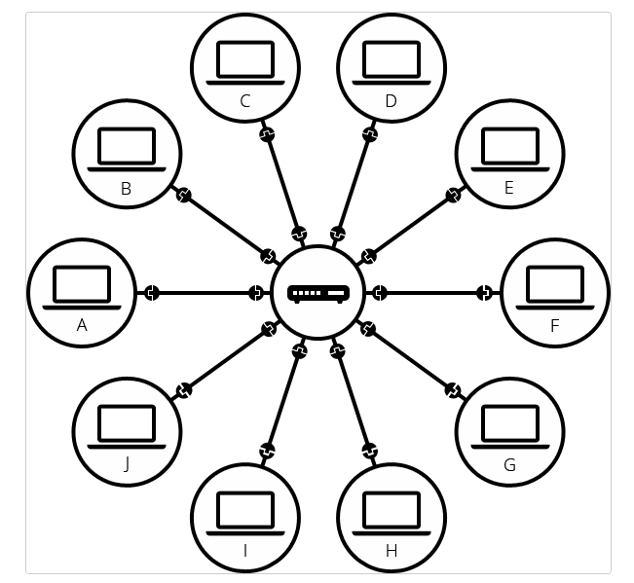
Such a network is not limited to two computers. You can connect as many computers as you wish. But it gets complicated quickly. If you're trying to connect, say, ten computers, you need 45 cables, with nine plugs per computer!
To solve this problem, each computer on a network is connected to a special tiny computer called a router. This router has only one job: like a signaller at a railway station, it makes sure that a message sent from a given computer arrives at the right destination computer. To send a message to computer B, computer A must send the message to the router, which in turn forwards the message to computer B and makes sure the message is not delivered to computer C.
Once we add a router to the system, our network of 10 computers only requires 10 cables: a single plug for each computer and a router with 10 plugs.

A Network of Networks
So far so good. But what about connecting hundreds, thousands, billions of computers? Of course a single router can't scale that far, but, if you read carefully, we said that a router is a computer like any other, so what keeps us from connecting two routers together? Nothing, so let's do that.
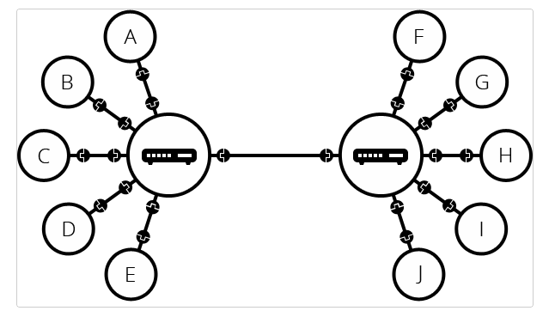
By connecting computers to routers, then routers to routers, we are able to scale infinitely.
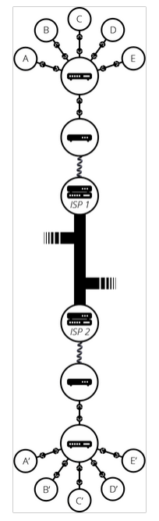
Such a network comes very close to what we call the Internet, but we're missing something. We built that network for our own purposes. There are other networks out there: your friends, your neighbours, anyone can have their own network of computers. But it's not really possible to set cables up between your house and the rest of the world, so how can you handle this? Well, there are already cables linked to your house, for example, electric power and telephone. The telephone infrastructure already connects your house with anyone in the world so it is the perfect wire we need. To connect our network to the telephone infrastructure, we need a special piece of equipment called a modem. This modem turns the information from our network into information manageable by the telephone infrastructure and vice versa.

So we are connected to the telephone infrastructure. The next step is to send the messages from our network to the network we want to reach. To do that, we will connect our network to an Internet Service Provider (ISP). An ISP is a company that manages some special routers that are all linked together and can also access other ISPs' routers. So the message from our network is carried through the network of ISP networks to the destination network. The Internet consists of this whole infrastructure of networks.
Finding computers
If you want to send a message to a computer, you have to specify which one. Thus any computer linked to a network has a unique address that identifies it, called an "IP address" (where IP stands for Internet Protocol). It's an address made of a series of four numbers separated by dots, for example: 192.0.2.172.
That's perfectly fine for computers, but we human beings have a hard time remembering that sort of address. To make things easier, we can alias an IP address with a human-readable name called a domain name. For example (at the time of writing; IP addresses can change) google.com is the domain name used on top of the IP address 142.250.190.78. So using the domain name is the easiest way for us to reach a computer over the Internet.
Internet and the web
As you might notice, when we browse the Web with a Web browser, we usually use the domain name to reach a website. Does that mean the Internet and the Web are the same thing? It's not that simple. As we saw, the Internet is a technical infrastructure which allows billions of computers to be connected all together. Among those computers, some computers (called Web servers) can send messages intelligible to web browsers. The Internet is an infrastructure, whereas the Web is a service built on top of the infrastructure. It is worth noting there are several other services built on top of the Internet, such as email and IRC.
Intranets and Extranets
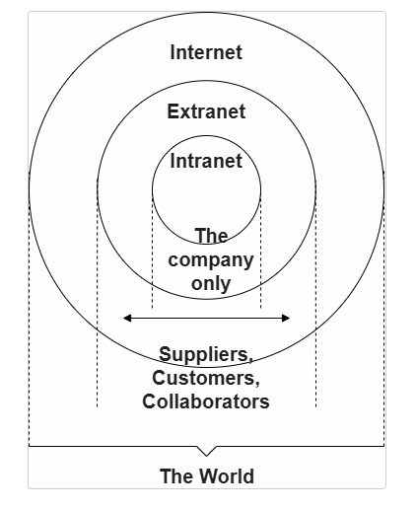
Intranets are private networks that are restricted to members of a particular organization. They are commonly used to provide a portal for members to securely access shared resources, collaborate and communicate. For example, an organization's intranet might host web pages for sharing department or team information, shared drives for managing key documents and files, portals for performing business administration tasks, and collaboration tools like wikis, discussion boards, and messaging systems.
Extranets are very similar to Intranets, except they open all or part of a private network to allow sharing and collaboration with other organizations. They are typically used to safely and securely share information with clients and stakeholders who work closely with a business. Often their functions are similar to those provided by an intranet: information and file sharing, collaboration tools, discussion boards, etc.
Both intranets and extranets run on the same kind of infrastructure as the Internet, and use the same protocols. They can therefore be accessed by authorized members from different physical locations.
Link : https://www.youtube.com/watch?v=7_LPdttKXPc&t=46s

Linux Bash Course

What is a Shell ?
The Unix shell is both a command-line interface (CLI) and a scripting language, allowing such repetitive tasks to be done automatically and fast. With the proper commands, the shell can repeat tasks with or without some modification as many times as we want. Using the shell, the task in the literature example can be accomplished in seconds.
The shell is a program where users can type commands. With the shell, it’s possible to invoke complicated programs like climate modeling software or simple commands that create an empty directory with only one line of code. The most popular Unix shell is Bash (the Bourne Again SHell — so-called because it’s derived from a shell written by Stephen Bourne). Bash is the default shell on most modern implementations of Unix and in most packages that provide Unix-like tools for Windows.
When the shell is first opened, you are presented with a prompt, indicating that the shell is waiting for input.

Key Points
- Information is stored in files, which are stored in directories (folders).
- Directories can also store other directories, which then form a directory tree.
- pwd prints the user’s current working directory.
- ls [path] prints a listing of a specific file or directory; ls on its own lists the current working directory.
- cd [path] changes the current working directory.
- Most commands take options that begin with a single -.
- Directory names in a path are separated with / on Unix, but \ on Windows.
- / on its own is the root directory of the whole file system.
- An absolute path specifies a location from the root of the file system.
- A relative path specifies a location starting from the current location.
- . on its own means ‘the current directory’; .. means ‘the directory above the current one’.
- cp [old] [new] copies a file.
- mkdir [path] creates a new directory.
- mv [old] [new] moves (renames) a file or directory.
- rm [path] removes (deletes) a file.
- * matches zero or more characters in a filename, so *.txt matches all files ending in .txt.
- ? matches any single character in a filename, so ?.txt matches a.txt but not any.txt.
- Use of the Control key may be described in many ways, including Ctrl-X, Control-X, and ^X.
- The shell does not have a trash bin: once something is deleted, it’s really gone.
- Most files’ names are something.extension. The extension isn’t required, and doesn’t guarantee anything, but is normally used to indicate the type of data in the file.
- Depending on the type of work you do, you may need a more powerful text editor than Nano.
- wc counts lines, words, and characters in its inputs.
- cat displays the contents of its inputs.
- sort sorts its inputs.
- head displays the first 10 lines of its input.
- tail displays the last 10 lines of its input.
- command > [file] redirects a command’s output to a file (overwriting any existing content).
- command >> [file] appends a command’s output to a file.
- [first] | [second] is a pipeline: the output of the first command is used as the input to the second.
- The best way to use the shell is to use pipes to combine simple single-purpose programs (filters).
- A for loop repeats commands once for every thing in a list.
- Every for loop needs a variable to refer to the thing it is currently operating on.
- Use $name to expand a variable (i.e., get its value). ${name} can also be used.
- Do not use spaces, quotes, or wildcard characters such as ‘*’ or ‘?’ in filenames, as it complicates variable expansion.
- Give files consistent names that are easy to match with wildcard patterns to make it easy to select them for looping.
- Use the up-arrow key to scroll up through previous commands to edit and repeat them.
- Use Ctrl+R to search through the previously entered commands.
- Use history to display recent commands, and ![number] to repeat a command by number.
- Save commands in files (usually called shell scripts) for re-use.
- bash [filename] runs the commands saved in a file.
- $@ refers to all of a shell script’s command-line arguments.
- $1, $2, etc., refer to the first command-line argument, the second command-line argument, etc.
- Place variables in quotes if the values might have spaces in them.
- Letting users decide what files to process is more flexible and more consistent with built-in Unix commands.
- find finds files with specific properties that match patterns.
- grep selects lines in files that match patterns.
- --help is an option supported by many bash commands, and programs that can be run from within Bash, to display more information on how to use these commands or programs.
- man [command] displays the manual page for a given command.
- $([command]) inserts a command’s output in place.
- find finds files with specific properties that match patterns.
- grep selects lines in files that match patterns.
- --help is an option supported by many bash commands, and programs that can be run from within Bash, to display more information on how to use these commands or programs.
- man [command] displays the manual page for a given command.
- $([command]) inserts a command’s output in place.

GIT and Github

Version Control
Version control is a system that records changes to a file or set of files over time so that you can recall specific versions later. It allows you to revert selected files back to a previous state, revert the entire project back to a previous state, compare changes over time, see who last modified something that might be causing a problem, who introduced an issue and when, and more.

History of Git
The Linux kernel is an open source software project of fairly large scope. During the early years of the Linux kernel maintenance (1991–2002), changes to the software were passed around as patches and archived files. In 2002, the Linux kernel project began using a proprietary DVCS called BitKeeper. In 2005, the relationship between the community that developed the Linux kernel and the commercial company that developed BitKeeper broke down, and the tool’s free-of-charge status was revoked. This prompted the Linux development community (and in particular Linus Torvalds, the creator of Linux) to develop their own tool based on some of the lessons they learned while using BitKeeper. Some of the goals of the new system were as follows:
1. Speed
2. Simple design
3. Strong support for non-linear development (thousands of parallel branches)
4. Fully distributed
5. Able to handle large projects like the Linux kernel efficiently (speed and data size)
Since its birth in 2005, Git has evolved and matured to be easy to use and yet retain these initial qualities. It’s amazingly fast, it’s very efficient with large projects, and it has an incredible branching system for non-linear development

What is GIT ?
Even though Git’s user interface is fairly similar to these other VCSs, Git stores and thinks about information in a very different way , that is through Snapshots , not differences.
The major difference between Git and any other VCS (Subversion and friends included) is the way Git thinks about its data. Conceptually, most other systems store information as a list of file-based changes. These other systems (CVS, Subversion, Perforce, and so on) think of the information they store as a set of files and the changes made to each file over time (this is commonly described as delta-based version control).
Git doesn’t think of or store its data this way. Instead, Git thinks of its data more like a series of snapshots of a miniature filesystem. With Git, every time you commit, or save the state of your project, Git basically takes a picture of what all your files look like at that moment and stores a reference to that snapshot. To be efficient, if files have not changed, Git doesn’t store the file again, just a link to the previous identical file it has already stored. Git thinks about its data more like a stream of snapshots.
This is an important distinction between Git and nearly all other VCSs. It makes Git reconsider almost every aspect of version control that most other systems copied from the previous generation. This makes Git more like a mini filesystem with some incredibly powerful tools built on top of it, rather than simply a VCS.
Some Key features of Git are :
1. Nearly Every Operation is local : Most operations are local and don’t need your your computer to be connected to internet.
2. Git has integrity : Git has checksumm integrity , its impossible to change files without git knowing about it.

The Three Stages
Git has three main states that your files can reside in: modified, staged, and committed:
- Modified means that you have changed the file but have not committed it to your database yet.
- Staged means that you have marked a modified file in its current version to go into your next commit snapshot.
- Committed means that the data is safely stored in your local database.
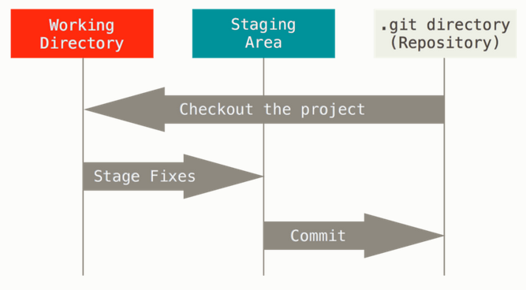
The basic Git workflow goes something like this:
- You modify files in your working tree.
- You selectively stage just those changes you want to be part of your next commit, which adds only those changes to the staging area.
- You do a commit, which takes the files as they are in the staging area and stores that snapshot permanently to your Git directory.

