

Prepared by,  Bayazid Hossain Parvez ©  ID : 2024200000324  github.com/Hey-zid  Md Mahidur Rahman  ID : 2024200000346  github.com/mdmahidurrahman-346  Samia Afroz  ID : 2024200000331  github.com/samiaafroz331  MD SADIQUZZAMAN  ID : 2024200000223  github.com/sadiq1030  Sameer Hossain  ID : 2024200000209  github.com/sameerhossain | Submitted to,  Name : Md. Ayon Mia  Lecturer : Southeast University Dhaka  Dept. : Computer Science and Engineering  Project details  Course : Introduction to Programming Language II (Java)  Lab Section : 6  Project : Electricity Management System  IDE Used : IntelliJ IDEA
Date of submission : 30/09/2026

Table of Contents
1. Introduction 2
2. Objectives 3
2.1 Aim 3
2.2 Goals 3
2.3 Key Functions 3
3. Motivation 4
3.1 Why we chose it 4
3.2 Problems and how we solve them 4
4. Applications 5
4.1 Where it can be used 5
4.2 Users 5
4.3 Benefits 5
5. Project Description 6
5.1 System Design 6
5.2 Main Features 6
5.3 Classes 7
5.4 Class Hierarchy 8
5.5 Workflow 8
5.6 Java / OOP Concepts Used 9
6. Tools & Technologies 10
7. Output / Results 10
7.1 Screenshots of the Developed System 10
7.2 Sample Inputs and Outputs 15
7.3 Error Handling and Output 17
8. Conclusion 18
9. References 18

1. Introduction
Utility offices have to record usage, work out charges and track payments for many customers every month. Doing this by hand is slow and mistakes happen where readings get mistyped, customers get registered twice and payment history gets lost.
The Electricity Management System is a desktop app that handles this for a small utility office. It is written in Java with a Swing GUI. The operator can register customers, record meter readings, make monthly bills, update payment status and see an annual report. Data is saved in three simple text files, so no database is needed.
The project shows all four OOP principles (encapsulation, abstraction, inheritance, polymorphism), custom exceptions with try-catch, file storage and full CRUD through a multi panel GUI. Electricity costs a flat 5.0 Taka per unit.
6  Core classes |  | 10  GUI panels |  | 3  Data files |  | 5.0  Taka per unit |  | 2  Custom exceptions

Core classes: Record, Customer, Meter, Bill, FileManager and Main. Data files: customers.txt, meters.txt and bills.txt. Custom exceptions: DuplicateCustomerException and CustomerNotFoundException.

2. Objectives

2.1 Aim
To build a reliable and easy billing and record system for electricity customers using core Java concepts with no external database or framework.

2.2 Goals
- Manage customers: register, search, update and delete, with no duplicate IDs.
- Keep readings correct: reject a current reading lower than the previous one.
- Bill each reading once: link a new bill to the oldest unbilled reading, amount = units × 5.0.
- Track payments: each bill has a Paid or Unpaid status that can be changed.
- Report quickly: annual report with monthly rows and totals for units, billed, paid and due.
- Show OOP through a clear class hierarchy.
- Handle errors: check every input and show clear messages instead of crashing.

2.3 Key Functions
# | Function | Type
1 | Register Customer | Create
2 | Search Customer | Read
3 | Update Customer | Update
4 | Delete Customer (cascade) | Delete
5 | Add Meter Reading | Create
6 | Add Monthly Bill | Create
7 | Update Bill Status | Update
8 | Delete Bill | Delete
9 | Annual Bill Report | Read / Report

3. Motivation

3.1 Why we chose it
Electricity billing is something everyone knows. It has a few related things (customer, reading, bill) with clear rules, which suits class hierarchies, abstraction and polymorphism. Rules like non-decreasing readings and unique IDs also give real use to custom exceptions.
Bangladesh has millions of electricity users, and billing accuracy matters to both households and providers. So we solved a problem we all understand while practising software engineering.

3.2 Problems and how we solve them
Problem | Our solution
Duplicate customers | isCustomerIdTaken() check throws DuplicateCustomerException
Readings going backwards by typing mistake | Meter guard rejects current < previous
Manual calculation | getUnitsUsed() and unitsUsed × RATE_PER_UNIT are automatic
Lost payment history | Every bill keeps Paid/Unpaid in bills.txt
Slow reports | Annual report totals everything in one click
Costly setup | Plain text files, no database or login

4. Applications

4.1 Where it can be used
- Small electricity offices and local billing counters
- Housing societies and apartment complexes with sub-meters
- Industrial parks, markets and malls billing each shop
- Campuses billing hostels or departments
- Training labs as an OOP example with file storage

4.2 Users
User | Use
Billing clerk / operator | Registers customers, enters readings, makes bills
Accounts officer | Updates payment status, checks annual reports
Building / estate manager | Tracks tenant usage and dues
Students and teachers | Learn OOP, exceptions, file I/O and Swing

4.3 Benefits
- Accuracy: automatic calculation, fewer mistakes.
- Data safety: cascade delete and checked exceptions keep the three files consistent.
- Transparency: CSV files open in any text editor or spreadsheet.
- Low cost: runs on any machine with a JDK, no server.
- Speed: paid and due totals shown instantly.

5. Project Description

5.1 System Design
The app has four layers. Every request goes from top to bottom.
Layer | What it does
1. Presentation | Main extends JFrame with CardLayout and 10 panels (650 × 500). showPage(name) switches screens. It takes input and shows results but never touches files.
2. Data Access | FileManager is the only gateway for reading and writing (saveCustomer, findCustomerById, findNextUnbilledMeter, changeBill).
3. Domain Model | abstract Record, extended by Customer, Meter and Bill. id is in Record; each class adds its own data.
4. Storage | customers.txt, meters.txt, bills.txt as CSV rows made by toFileString().

5.2 Main Features
The home screen has nine feature buttons and an Exit button. Each opens a panel that calls one FileManager method.
Screen | FileManager call | Result shown
Register Customer | saveCustomer | Customer registered successfully!
Search Customer | findCustomerById | ID, name, address, meter number
Update Customer | findCustomerById → updateCustomer | Customer updated successfully!
Delete Customer | deleteCustomer (cascade) | Confirm dialog, then records removed
Add Meter Reading | findMeterByCustomerId → saveMeter | Previous, current, units used
Add Monthly Bill | findNextUnbilledMeter → saveBill | Units, reading, amount, status
Update Bill Status | updateBillStatus | Bill status updated.
Delete Bill | deleteBill | Bill deleted.
Annual Bill Report | findBillsByCustomerId | Monthly rows plus totals

All panels use one template, buildPageFrame(title, form, output, buttons...): a bold 18 pt title at the top, a form and a scrollable output area in the middle, and action buttons with a Back to Home button at the bottom.

5.3 Classes
Class | Kind | Job
Record | abstract class | Holds protected String id; declares abstract displayInfo() and toFileString()
Customer | extends Record | Stores name, address, meterNumber; fully editable
Meter | extends Record | Stores meterNumber, previous and current readings; immutable; getUnitsUsed() = current − previous
Bill | extends Record | Stores month, unitsUsed, reading, status; only status can change via setStatus(String)
FileManager | data-access class | All file I/O, cascade delete, bill lookups; RATE_PER_UNIT = 5.0
Main | GUI (extends JFrame) | Builds ten panels, handles events, shows results and errors
DuplicateCustomerException | checked exception | Thrown when a customer ID already exists
CustomerNotFoundException | checked exception | Thrown when an ID is not found for update or delete

File formats (one CSV row per record):
File | Row format | Example
customers.txt | id,name,address,meterNumber | 10010,Bayazid,Cumilla,M10010
meters.txt | id,meterNumber,prev,current | 1001,M1001,2450,2900
bills.txt | id,month,units,reading,status | 1001,November,450,2900,Paid

5.4 Class Hierarchy
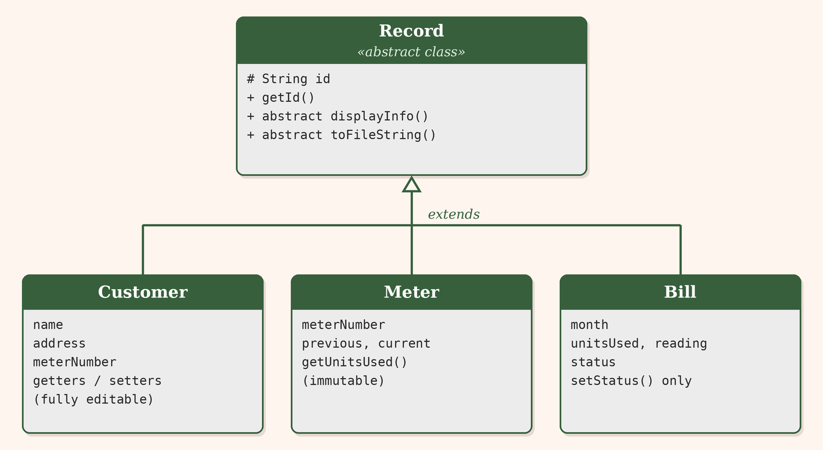
Figure 1: Class hierarchy of the domain model

5.5 Workflow
- Register: the operator fills four fields. FileManager checks isCustomerIdTaken(id). If free, the row is added to customers.txt and the form clears.
- Search / Update: findCustomerById() matches column 0 of customers.txt. "Load Current Info" fills the form and the line is rewritten after editing.
- Add Meter Reading: the customer must exist. Previous reading is the last saved current reading (0 for the first). A lower current reading is rejected. A valid one is added to meters.txt.
- Add Monthly Bill: findNextUnbilledMeter(id) gives the oldest reading with no bill. Status must be Paid or Unpaid (any case). Amount = unitsUsed × 5.0 is saved in bills.txt.
- Update / Delete Bill: change payment status or remove a bill by month.
- Annual Report: findBillsByCustomerId() collects all bills and shows monthly rows with total units, billed, paid and due.
- Delete Customer: after a YES/NO confirmation, the customer line is removed and meter and bill rows are deleted too (cascade).
Billing logic in FileManager:
public Meter findNextUnbilledMeter(String id) {
List<Bill> bills = findBillsByCustomerId(id);
List<Meter> meters = findAllMetersByCustomerId(id);
for (Meter meter : meters) {
if (!isBilled(meter, bills))
return meter;
}
return null;
}
// a reading is billed when a Bill has the same reading value:
// bill.getReading() == meter.getCurrentReading()

Example: customer 1001 (Bayazid, Cumilla), two paid bills.
Month | Units | Reading | Amount (×5) | Status
July 2026 | 450 | 2450 | 2250.0 | Paid
September 2026 | 450 | 5700 | 2250.0 | Paid

Total billed 4500.0 Taka, paid 4500.0 Taka, due 0.0 Taka. Each current reading becomes the next previous reading.

5.6 Java / OOP Concepts Used
Concept | Where | How
Encapsulation | Customer, Meter, Bill | Private fields with getters; Meter has no setters (immutable); Bill only has setStatus(); id is protected in Record
Abstraction | Record, FileManager | Record declares abstract methods without code; FileManager hides all file I/O behind simple method names
Inheritance | Customer, Meter, Bill extend Record | Subclasses call super(id) and reuse getId()
Polymorphism | displayInfo(), toFileString() | Each subclass overrides them; a Record reference calls the right version at runtime
Custom exceptions | Duplicate..., CustomerNotFound... | Thrown by FileManager on rule violations, caught in GUI handlers
try-catch | Main event listeners | Catches custom exceptions, NumberFormatException and IOException; shows message in output area
File handling | FileManager | readLines, writeLines, appendLine, readRowsForCustomer, removeAllForCustomer
Collections / generics | List<Bill>, List<Meter> | Lists hold records loaded from files
Swing and events | Main extends JFrame | CardLayout, JPanel, JTextField, JTextArea, JScrollPane, JButton, JOptionPane with ActionListeners
Design patterns | Whole project | Facade (FileManager), Page Template (buildPageFrame), Data Mapper (toFileString ⇄ toMeter/toBill), Navigator (showPage)

Custom exception messages:
Exception | Message
DuplicateCustomerException | Error: Customer ID ... already exists.
CustomerNotFoundException | Error: Customer with ID ... was not found.

6. Tools & Technologies
The whole project is built with standard Java tools. No external database, framework or server is needed.
Area | What we used
Language | Java; runs on any machine with a JDK
GUI | Swing: JFrame, CardLayout, JPanel, JTextField, JTextArea, JScrollPane, JButton, JOptionPane
IDE | IntelliJ IDEA
Data storage | Plain text CSV files: customers.txt, meters.txt, bills.txt
Java features | Abstract classes, custom checked exceptions, collections and generics, file I/O

7. Output / Results

7.1 Screenshots of the Developed System
This section shows the main screens of the system in the order a user would normally meet them. Each figure has a short note on what the panel does.
The home screen opens first. It has nine buttons for customer, meter and bill tasks, plus an Exit button.
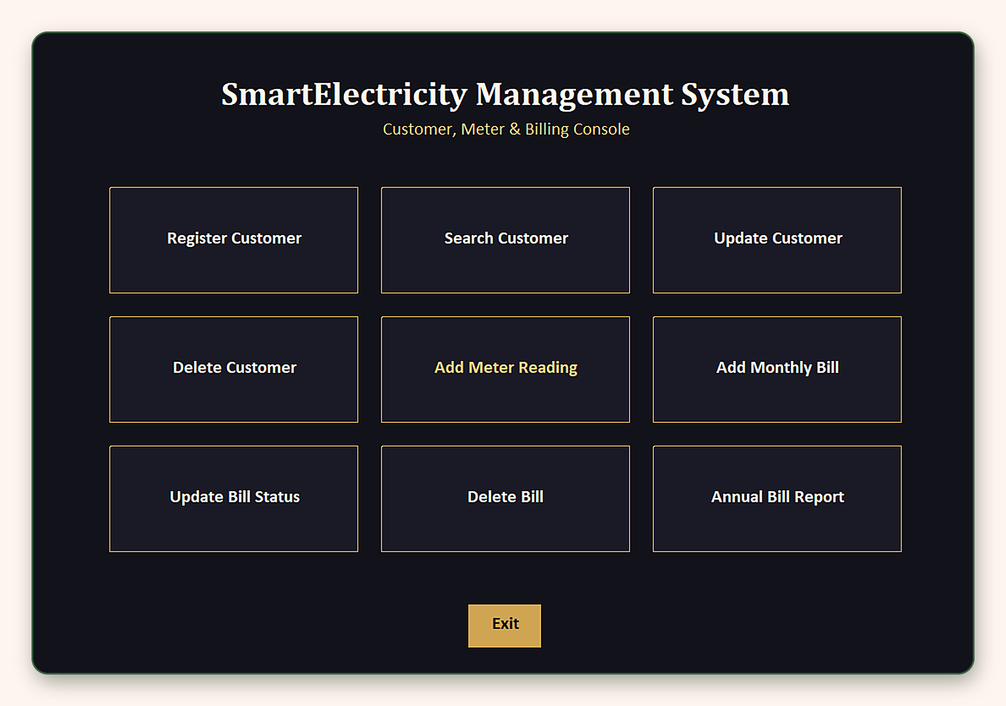
Figure 2: Home Screen
The Register Customer panel takes a customer ID, name, address and meter number. After clicking Register, the output box confirms the new record and the form clears.
(a) Form filled in
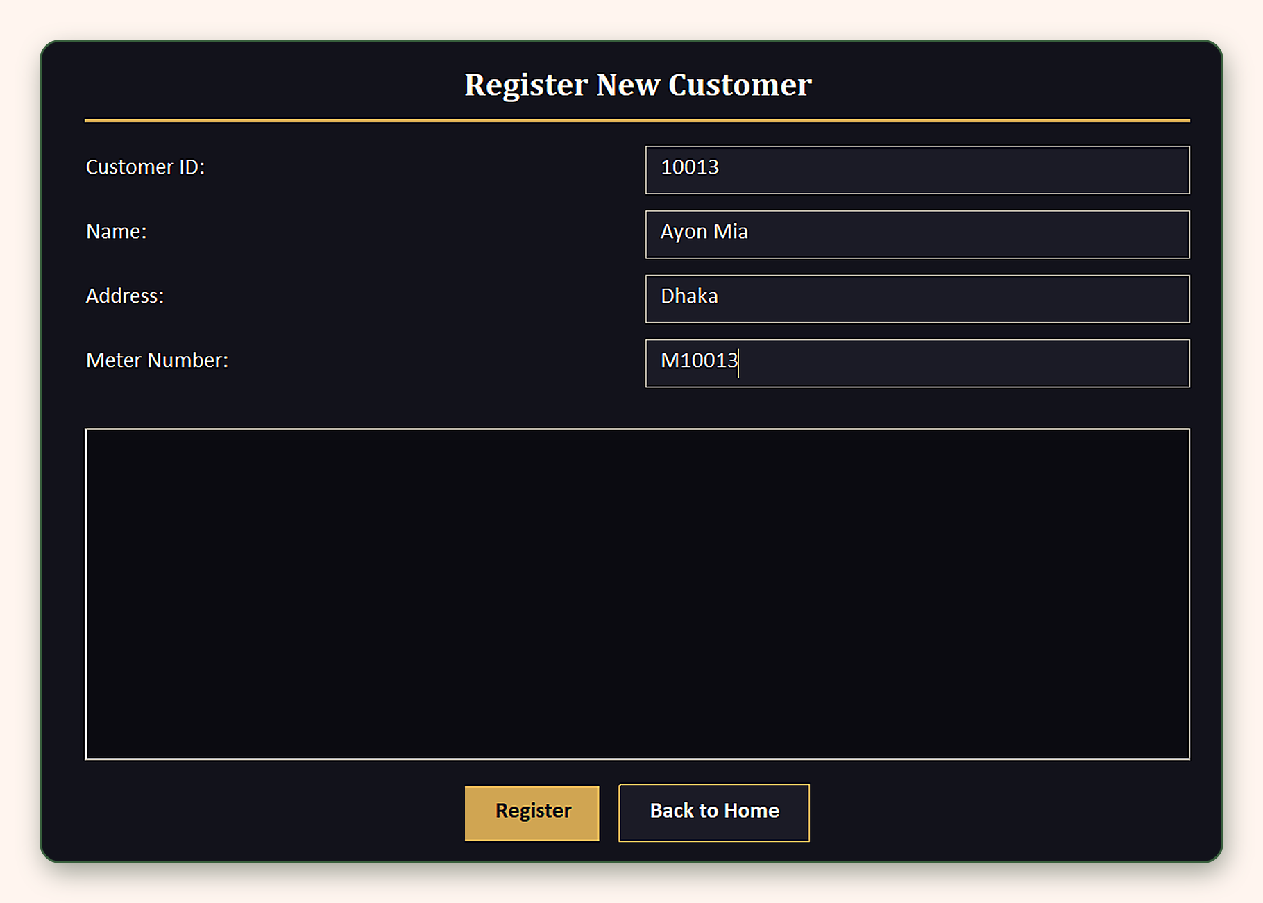
(b) After registering
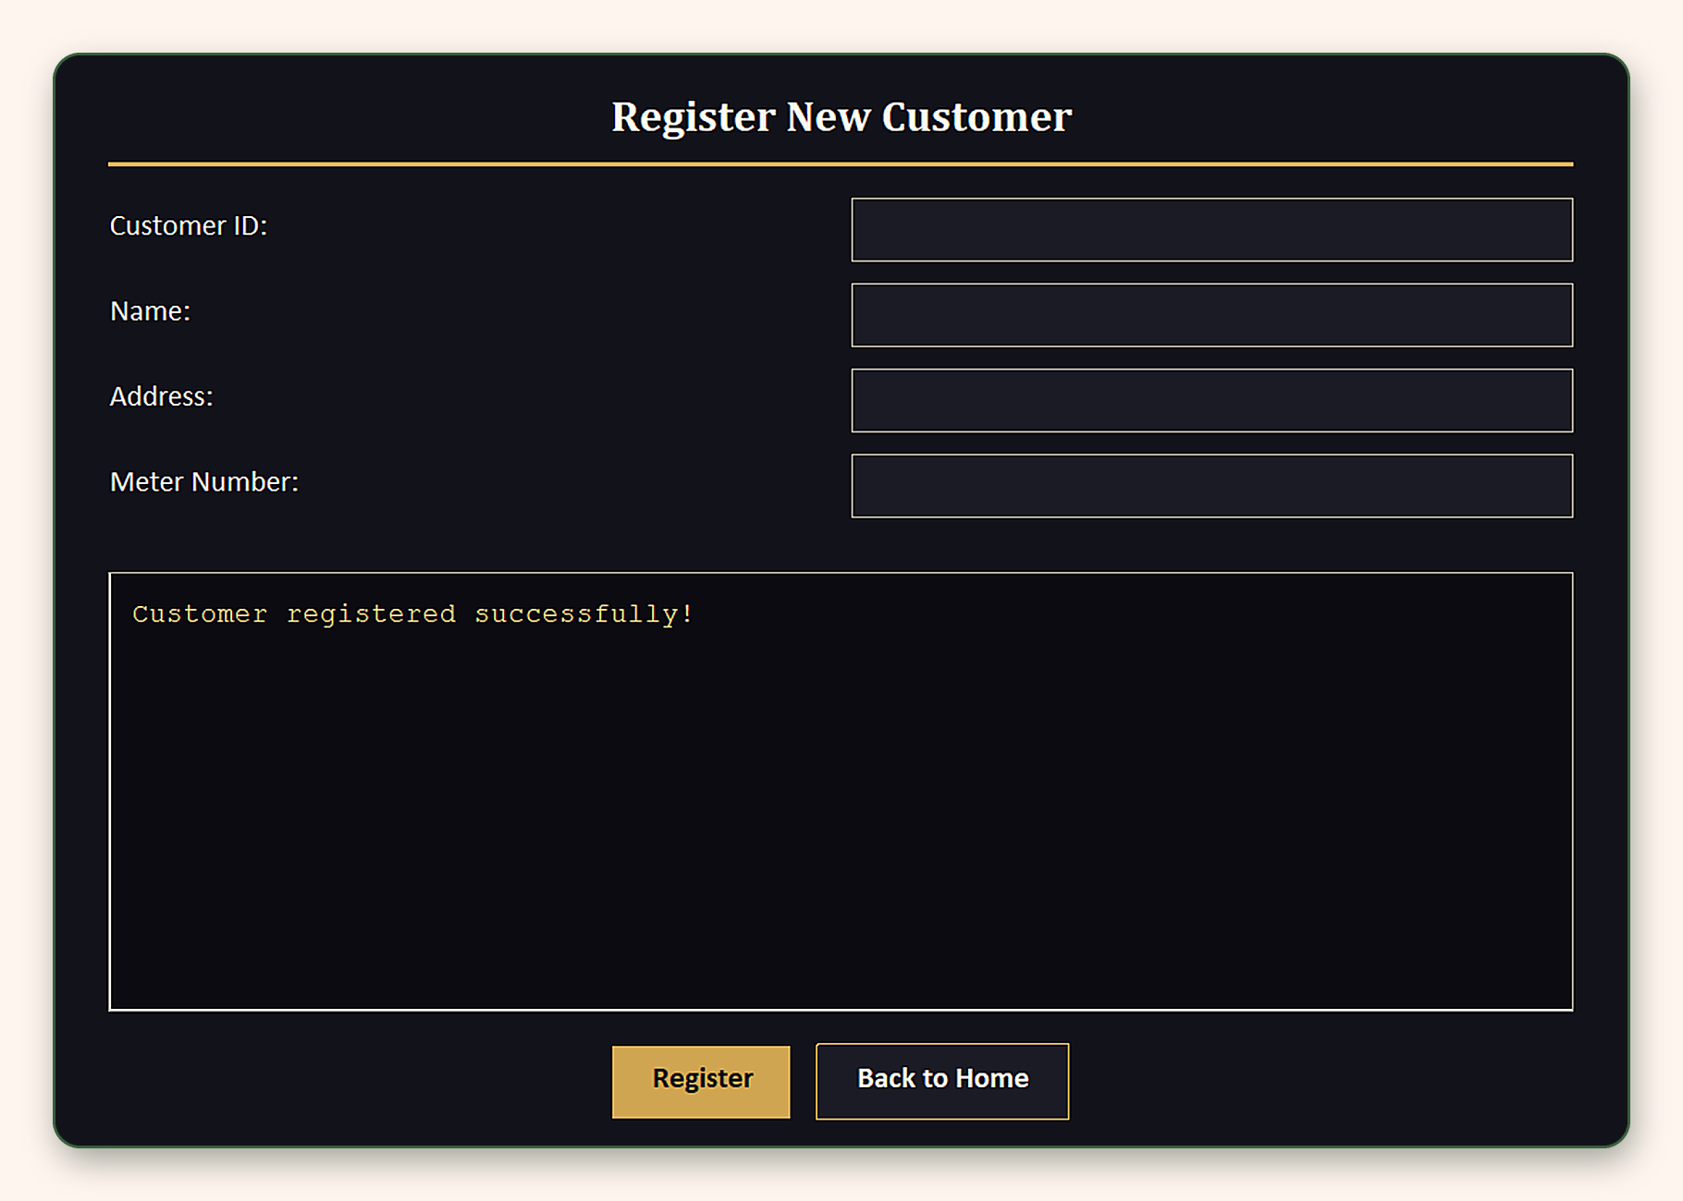
Figure 3: Register Customer Panel
The Search Customer panel finds a customer by ID and shows the name, address and meter number.
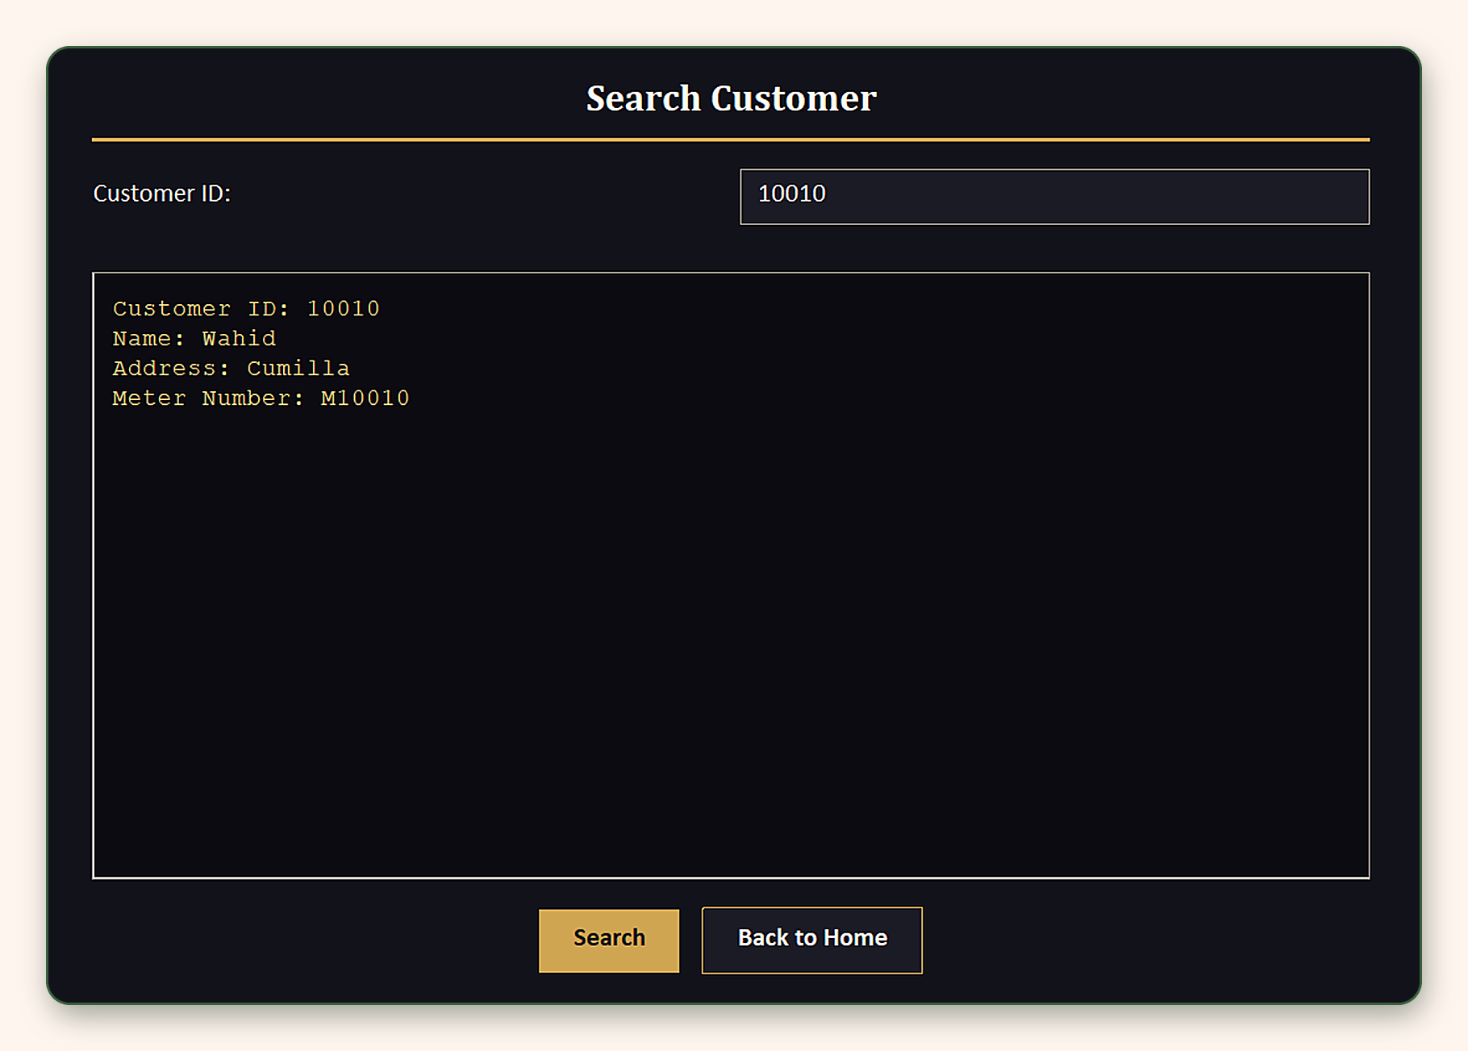
Figure 4: Search Customer Panel
The Update Customer panel changes a customer's details. The user enters the ID and the new values, then clicks Update.
(a) New details entered
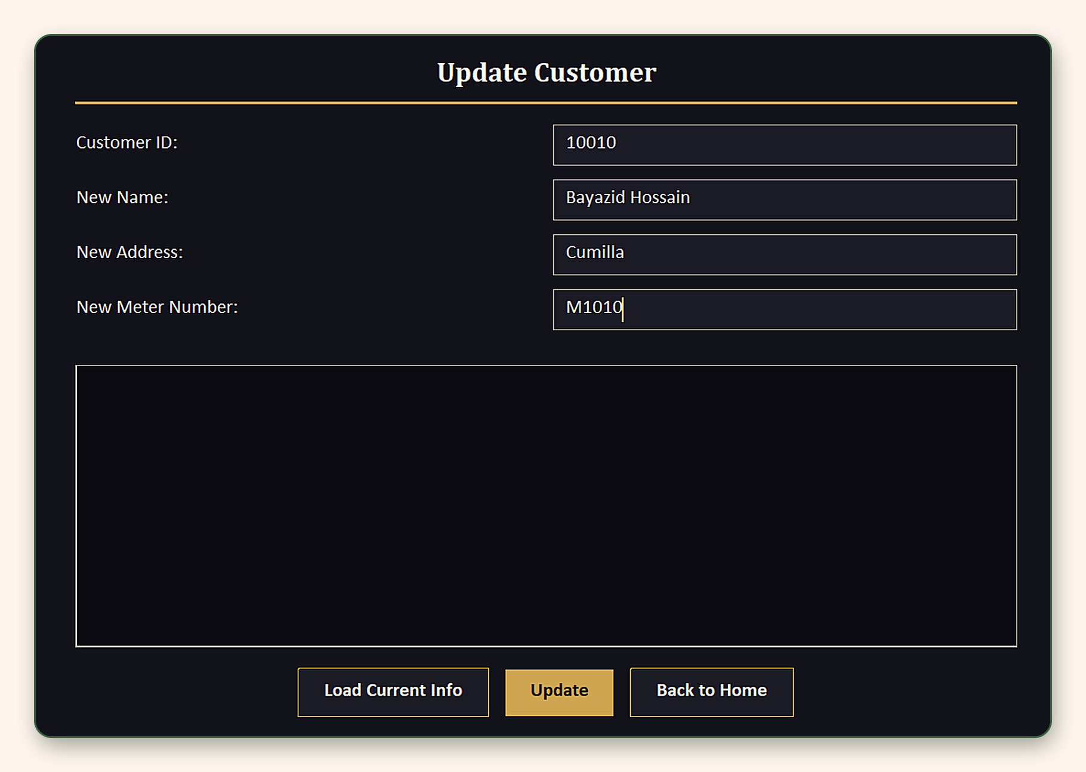
(b) After updating
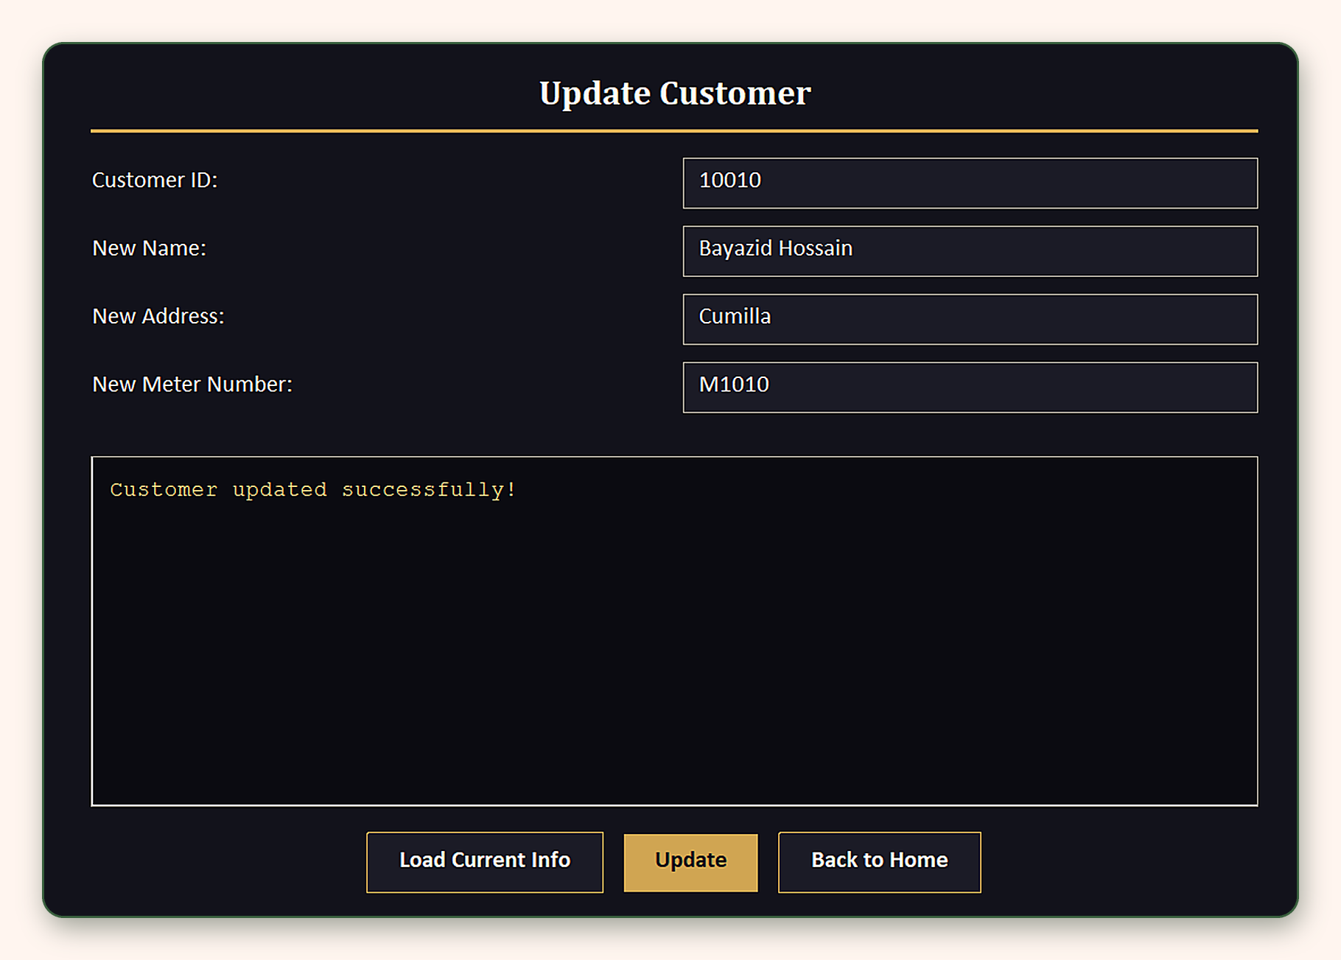
Figure 5: Update Customer Panel
The Delete Customer panel removes a customer after asking for confirmation. The customer's meters and bills are removed with it.
The Add Meter Reading panel stores a new reading. The system works out the units used from the previous reading.
The Add Monthly Bill panel creates a bill from the latest unbilled reading. The user only enters the ID, the month and the payment status.
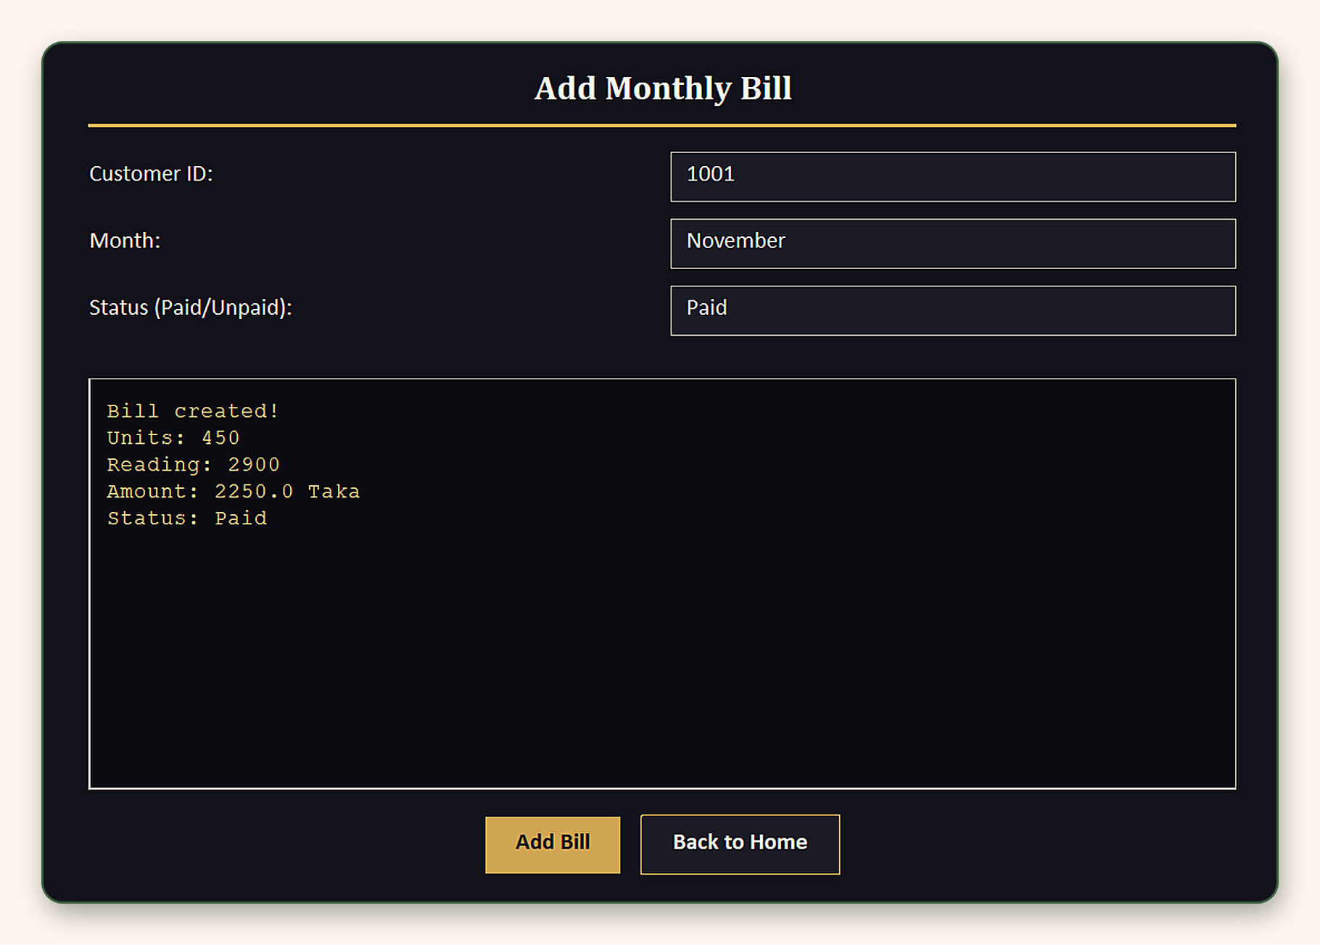
Figure 6: Add Monthly Bill Panel
The bill panels let the user change a bill's payment status or delete a bill. The screenshot below shows the Delete Bill panel.
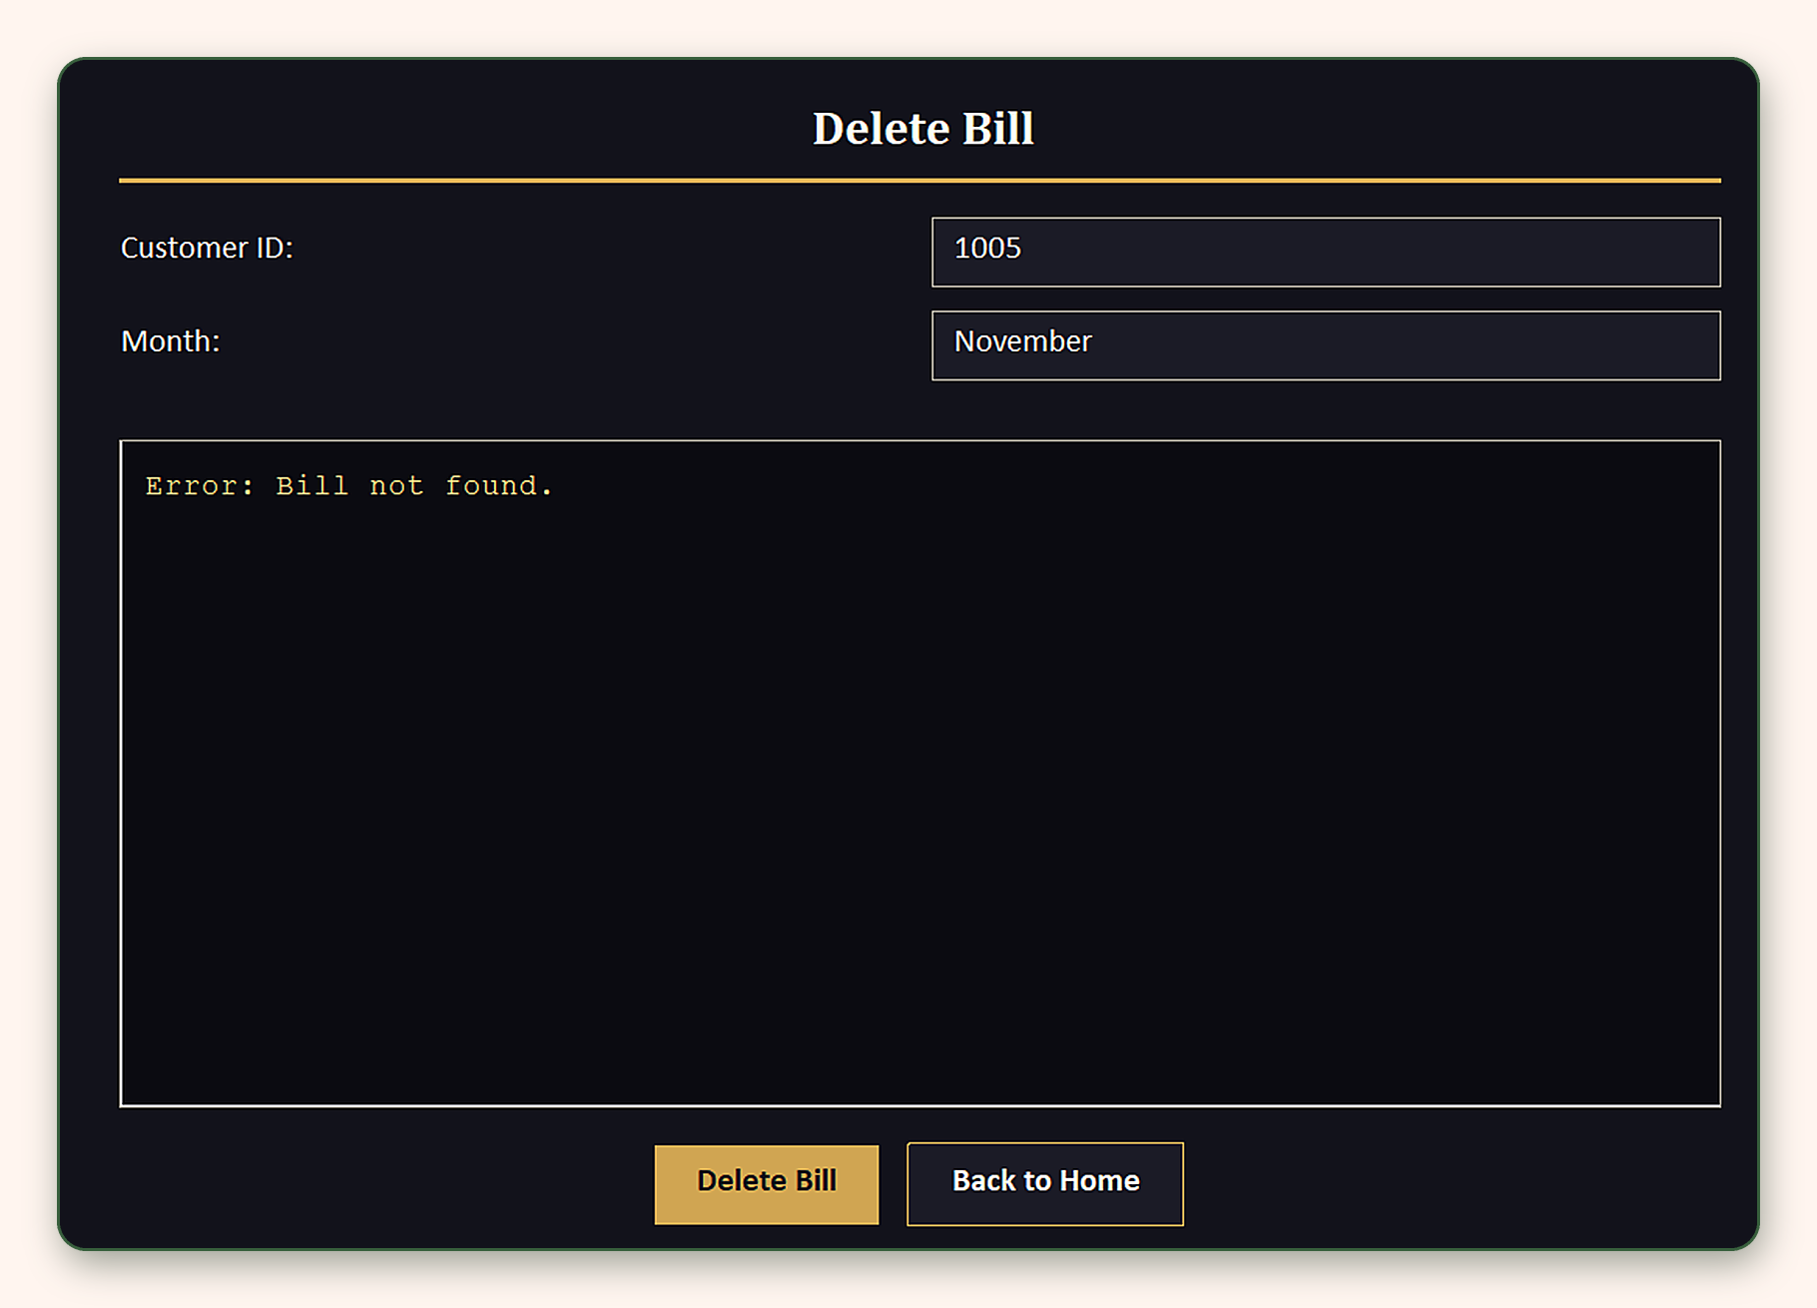
Figure 7: Update / Delete Bill Panels
The Annual Bill Report panel lists every bill for one customer and adds up the units, the amount billed, the amount paid and the amount due.
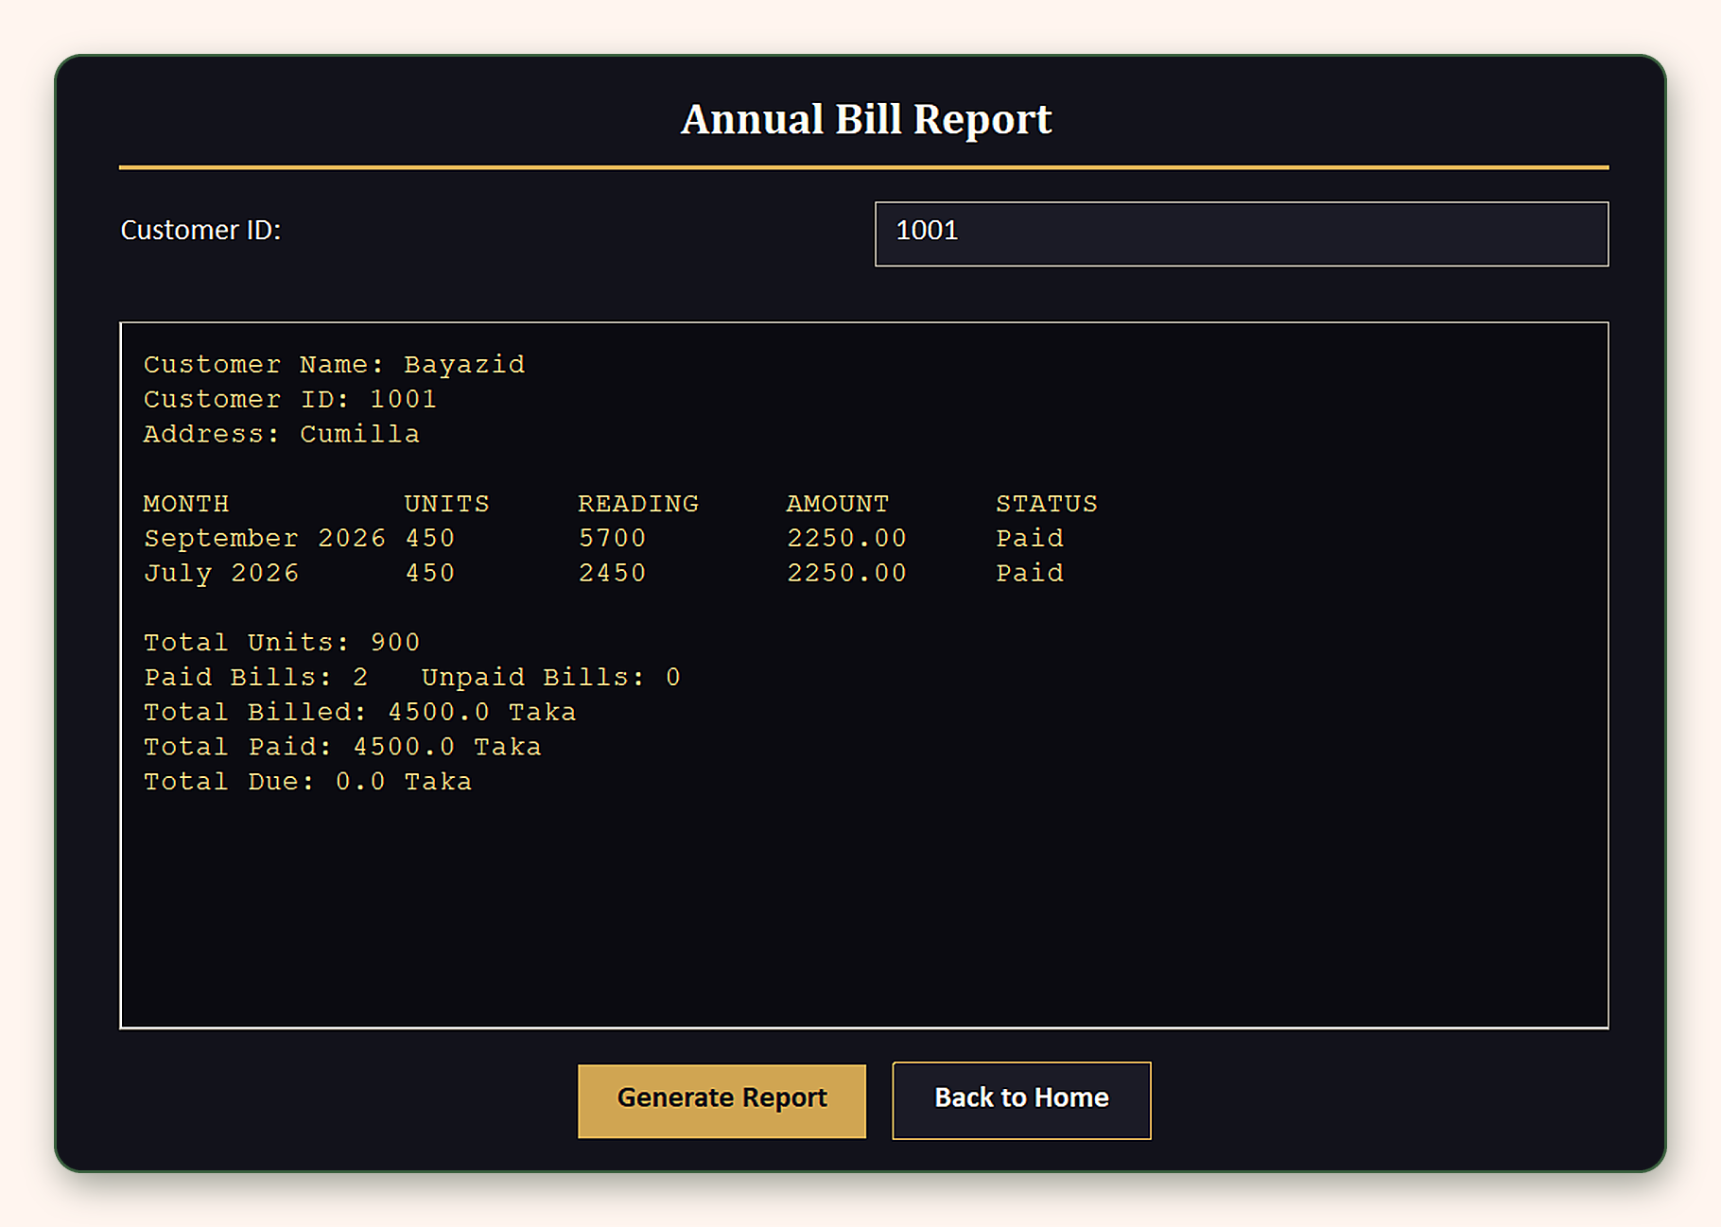
Figure 8: Annual Bill Report Panel

7.2 Sample Inputs and Outputs
Sample 1: Register Customer
Input field | Value
Customer ID | 10013
Name | Ayon Mia
Address | Dhaka
Meter Number | M10013

Output
Customer registered successfully!

Sample 2: Search Customer
Input field | Value
Customer ID | 10010

Output
Customer ID: 10010
Name: Bayazid
Address: Cumilla
Meter Number: M10010

Sample 3: Update Customer
Input field | Value
Customer ID | 10010
New Name | Bayazid Hossain
New Address | Cumilla
New Meter Number | M1010

Output
Customer updated successfully!

Sample 4: Add Meter Reading
Input field | Value
Customer ID | 1001
Current Reading | 2900

Output
Previous = 2450, Current = 2900, Units Used = 450

Sample 5: Add Monthly Bill
Input field | Value
Customer ID | 1001
Month | November
Status (Paid/Unpaid) | Paid

Output
Bill created!
Units: 450
Reading: 2900
Amount: 2250.0 Taka
Status: Paid

Sample 6: Annual Bill Report
Input field | Value
Customer ID | 1001

Output
Customer Name: Bayazid
Customer ID: 1001
Address: Cumilla

MONTH UNITS READING AMOUNT STATUS
September 2026 450 5700 2250.00 Paid
July 2026 450 2450 2250.00 Paid

Total Units: 900
Paid Bills: 2 Unpaid Bills: 0
Total Billed: 4500.0 Taka
Total Paid: 4500.0 Taka
Total Due: 0.0 Taka

7.3 Error Handling and Output
Every failure shows a clear message in the output area of the panel. A wrong entry never crashes the program or damages a data file.
Trigger | Panel | Message shown
Duplicate customer ID | Register | Error: Customer ID ... already exists.
Unknown customer | Meter, Add Bill, Report | Error: Customer does not exist.
Reading below previous | Meter | Error: Current reading cannot be less than previous reading (n).
Non-numeric reading | Meter | Error: Please enter a valid number for the reading.
Everything already billed | Add Bill | Error: No unbilled meter reading found.
Status not Paid / Unpaid | Add Bill, Update Bill | Error: Status must be 'Paid' or 'Unpaid'.
Bill month not found | Update Bill, Delete Bill | Error: Bill not found.
Delete declined | Delete | Delete cancelled.

Test plan. Each case can be run by hand in the GUI and checked by opening the three text files.
Scenario | Input | Expected result | Result
Duplicate ID | Register 10013 twice | Already exists error on the second try | Pass
Backwards reading | Previous 2450, enter 2400 | Rejected, message shows previous (2450) | Pass
Bad number | Enter abc as reading | Please enter a valid number | Pass
Nothing to bill | Add bill when all readings are billed | No unbilled meter reading found | Pass
Invalid status | Enter Pending | Status must be Paid or Unpaid | Pass
Cascade delete | Delete 1001, open report | Customer, meters and bills are gone | Pass
Report totals | Two bills of 2250.0, both Paid | Billed 4500.0, Paid 4500.0, Due 0.0 | Pass

The Delete Bill panel below shows one of these messages, an error for a bill that does not exist.
Figure 9: Error messages displayed in the output area

8. Conclusion
The Electricity Management System is a complete, working desktop application for customer, meter and bill management. It uses an abstract Record class with three subclasses, a FileManager class that handles three flat files, and a ten-panel Swing interface.
Customers can be created, found, changed and removed. Meter readings and bills are added with strict checks, payment status is tracked, and the annual report totals the units and amounts.

9. References
[1] CSE282 Complex Engineering Project brief, Summer 2026.
[2] Oracle. The Java Tutorials: Creating a GUI with Swing. docs.oracle.com/javase/tutorial/uiswing
[3] Oracle. The Java Tutorials: Exceptions. docs.oracle.com/javase/tutorial/essential/exceptions
[4] Oracle. Java Platform, Standard Edition API Specification.
[5] JetBrains. IntelliJ IDEA Documentation. jetbrains.com/help/idea

