SOUTHEAST UNIVERSITY
Department of Computer Science and Engineering
Complex Engineering
Final Project Report
ELECTRICITY MANAGEMENT SYSTEM

Field | Details
Course Title | Introduction to Programming Language II (Java)
Course Code | CSE282
Semester | Summer 2026
Lab Section | 6
Project Title | Electricity Management System
IDE Used | IntelliJ IDEA
Submitted To | Md. Ayon Mia [Lecturer, Southeast University]
Submission Date | 30/09/ 2026

Prepared By
Name | Student ID
Bayazid Hossain Parvez ©  https://github.com/Hey-zid | 2024200000324
Md Mahidur Rahman  https://github.com/mdmahidurrahman-346 | 2024200000346
Samia Afroz  https://github.com/samiaafroz331 | 2024200000331
MD SADIQUZZAMAN  https://github.com/sadiq1030 | 2024200000223
Sameer Hossain  https://github.com/sameerhossain | 2024200000209

Table of Contents

1. Introduction 2
2. Objectives 2
2.1 Aim of the Project 2
2.2 Specific Goals 2
2.3 Key Functionalities 3
3. Motivation 3
3.1 Why This Project Was Selected 3
3.2 Problem and Real-World Need 3
4. Applications 4
4.1 Where the Project Can Be Used 4
4.2 Potential Users 4
4.3 Practical Uses and Benefits 4
5. Project Description 4
5.1 Overall System Diagram 4
5.2 Main Features and Functionalities 5
5.3 Major Modules and Classes 5
5.4 Class Hierarchy 6
5.5 Workflow of the System 6
5.6 Java / OOP Concepts Used 7
6. Tools & Technologies 8
7. Output / Results 9
7.1 Screenshots of the Developed System 9
7.2 Sample Inputs and Outputs 14
7.3 Error Handling and Output 15
8. Contribution 16
8.1 Individual Contribution 16
8.2 Shared Responsibilities 16
9. Conclusion 16
9.1 Summary of the Completed Project 17
9.2 Were the Objectives Achieved? 17
9.3 Limitations 17
9.4 Challenges Faced and Reflection 17
10. References and Appendix 17
10.1 References 17
Appendix A: OOP Concept Skeleton 18

1. Introduction
Utility companies must record consumption, calculate charges and track payments for a large number of customers every month. Doing this by hand is slow and error-prone: readings are mistyped, customers are registered twice and payment history is lost. The Electricity Management System is a desktop application that automates this workflow for a small utility office.
The system is written in Java with a Swing graphical user interface. It lets an operator register customers, record meter readings, generate monthly bills, update payment status and produce an annual bill report. All data is stored in three human-readable flat files (customers.txt, meters.txt and bills.txt), so no database server is required.
The project was built to satisfy the CSE282 complex engineering project brief. It demonstrates all four Object-Oriented Programming principles (encapsulation, abstraction, inheritance and polymorphism), structured exception handling with try-catch and custom checked exceptions, file-based persistence, and full CRUD operations behind a multi-panel GUI. The codebase is compact and consists of six core classes, ten GUI panels and three data files, with electricity charged at a flat rate of 5.0 Taka per unit.

Metric | Value
Core classes | 6 (Record, Customer, Meter, Bill, FileManager, Main)
GUI panels | 10 (CardLayout cards)
Data files | 3 (customers.txt, meters.txt, bills.txt)
Tariff | 5.0 Taka per unit
Custom exceptions | 2 (DuplicateCustomerException, CustomerNotFoundException)

2. Objectives

2.1 Aim of the Project
The aim is to design and implement a reliable, easy-to-use billing and record-management system for electricity customers, using core Java concepts taught in CSE282 without relying on any external database or framework.

2.2 Specific Goals
- Manage customers safely: register, search, update and delete customers with duplicate-ID protection.
- Keep readings consistent: reject any current reading that is lower than the previous reading before it is saved.
- Bill every reading exactly once: link each new bill to the oldest unbilled reading and compute amount = units × 5.0 Taka.
- Track payments: store a Paid/Unpaid status per bill and allow it to be updated.
- Report instantly: produce an annual report with monthly rows and totals for units, billed, paid and due amounts.
- Demonstrate OOP: show encapsulation, abstraction, inheritance and polymorphism through a clear class hierarchy.
- Handle errors gracefully: validate every input and display clear messages instead of crashing.

2.3 Key Functionalities
# | Functionality | Type
1 | Register Customer | Create
2 | Search Customer | Read
3 | Update Customer | Update
4 | Delete Customer (cascade) | Delete
5 | Add Meter Reading | Create
6 | Add Monthly Bill | Create
7 | Update Bill Status | Update
8 | Delete Bill | Delete
9 | Annual Bill Report | Read / Report

3. Motivation

3.1 Why This Project Was Selected
Electricity billing is a familiar, real-world domain that naturally contains several related entities (customer, meter reading, bill) with clear relationships and business rules. This makes it an excellent fit for showing class hierarchies, abstraction and polymorphism. It also involves meaningful validation, such as non-decreasing readings and unique IDs, which gives real purpose to custom exceptions.
Bangladesh has millions of electricity consumers, and billing accuracy is an everyday concern for both households and providers. Building a system around this domain let us solve a problem we all understand while practising software engineering skills.

3.2 Problem and Real-World Need
Real-world problem | How the system addresses it
Duplicate customer records | isCustomerIdTaken() check throws DuplicateCustomerException
Readings going backwards due to typing errors | Meter guard rejects current < previous with a clear message
Manual unit and amount arithmetic | getUnitsUsed() and unitsUsed × RATE_PER_UNIT are computed automatically
Lost payment history | Every bill stores a Paid/Unpaid status in bills.txt
Slow report preparation | Annual report totals everything with one click
Need for costly infrastructure | Flat text files, no database server or login required

4. Applications

4.1 Where the Project Can Be Used
- Small electricity distribution offices and local billing counters
- Housing societies, apartment complexes and residential estates that sub-meter tenants
- Industrial parks, markets and shopping malls that bill individual shops
- University and school campuses billing hostels or departments
- Training labs, as a teaching example of OOP with file persistence

4.2 Potential Users
User | Use of the system
Billing clerk / operator | Registers customers, enters readings, generates bills
Accounts officer | Updates payment status and reviews annual reports
Building or estate manager | Tracks consumption and dues of tenants
Students and instructors | Studies OOP, exceptions, file I/O and Swing in one project

4.3 Practical Uses and Benefits
- Accuracy: automatic calculation removes manual arithmetic mistakes.
- Data integrity: cascade delete and checked exceptions keep the three files consistent.
- Transparency: CSV files are human-readable and can be opened in any text editor or spreadsheet.
- Low cost and portability: runs on any machine with a JDK; no server setup.
- Speed: paid versus due totals are available instantly.

5. Project Description

5.1 Overall System Diagram
The application follows a four-layer design in which every request flows top-down: interface, data access, domain model and flat-file storage.
LAYER 1  PRESENTATION | Main extends JFrame using CardLayout with 10 panels (650 × 500)  showPage(name) switches screens; collects input and shows results; never touches files
LAYER 2  DATA ACCESS | FileManager: single gateway for every read and write  saveCustomer · findCustomerById · findNextUnbilledMeter · changeBill
LAYER 3  DOMAIN MODEL | abstract Record → Customer, Meter, Bill  id lives in Record; each entity adds its own state
LAYER 4  STORAGE | customers.txt · meters.txt · bills.txt  Flat CSV rows built by toFileString()
Figure 1: Four-layer architecture of the Electricity Management System

5.2 Main Features and Functionalities
The home screen offers nine feature buttons and an Exit button. Each button opens a panel that calls one specific FileManager method:
Screen | Panel | FileManager call | Result shown
Register Customer | register | saveCustomer | Customer registered successfully!
Search Customer | search | findCustomerById | ID, name, address, meter number
Update Customer | update | findCustomerById → updateCustomer | Customer updated successfully!
Delete Customer | delete | deleteCustomer (cascade) | Confirm dialog, then records removed
Add Meter Reading | meter | findMeterByCustomerId → saveMeter | Previous, current, units used
Add Monthly Bill | billAdd | findNextUnbilledMeter → saveBill | Units, reading, amount, status
Update Bill Status | billUpdate | updateBillStatus | Bill status updated.
Delete Bill | billDelete | deleteBill | Bill deleted.
Annual Bill Report | report | findBillsByCustomerId | Monthly rows plus totals

Every panel shares one page template created by buildPageFrame(title, form, output, buttons…): a bold 18 pt title in the NORTH region, a GridLayout form plus a scrollable JTextArea for output in the CENTER, and action buttons together with a Back to Home button in the SOUTH.

5.3 Major Modules and Classes
Class | Kind | Responsibility
Record | abstract class | Holds protected String id; declares abstract displayInfo() and toFileString()
Customer | extends Record | Stores name, address and meterNumber; fully editable
Meter | extends Record | Stores meterNumber, previous and current readings; immutable; getUnitsUsed() = current − previous
Bill | extends Record | Stores month, unitsUsed, reading and status; only status can change via setStatus(String)
FileManager | data-access class | Facade for all file I/O, cascade deletion and bill lookups; defines RATE_PER_UNIT = 5.0
Main | GUI class (extends JFrame) | Builds ten panels, handles events, shows results and error messages
DuplicateCustomerException | custom checked exception | Thrown when a customer ID already exists
CustomerNotFoundException | custom checked exception | Thrown when an ID cannot be found for update or delete

File formats (one CSV row per record):
File | Row format | Example
customers.txt | id,name,address,meterNumber | C1042,Rahim Uddin,22 Gulshan Ave Dhaka,M-77120
meters.txt | id,meterNumber,prev,current | C1042,M-77120,1000,1120
bills.txt | id,month,units,reading,status | C1042,Jan,120,1120,Paid

5.4 Class Hierarchy
+----------------------------------+
| abstract class Record |
|----------------------------------|
| # String id |
| + Record(String id) |
| + getId() |
| + abstract displayInfo() |
| + abstract toFileString() |
+----------------+-----------------+
^ extends
+-----------------------+-----------------------+
| | |
+---------------+ +----------------+ +----------------+
| Customer | | Meter | | Bill |
|---------------| |----------------| |----------------|
| name | | meterNumber | | month |
| address | | previous | | unitsUsed |
| meterNumber | | current | | reading |
|---------------| |----------------| | status |
| getters/set. | | getUnitsUsed() | |----------------|
| @Override x2 | | @Override x2 | | setStatus(..) |
+---------------+ +----------------+ | @Override x2 |
Fully editable Immutable reading +----------------+
Only status changes
Figure 2: Class hierarchy: one abstract base and three entity subclasses

5.5 Workflow of the System
The normal life of a customer moves through the following steps:
- Register: the operator fills four text fields; FileManager checks isCustomerIdTaken(id); if free, the row is appended to customers.txt and the form clears.
- Search / Update: findCustomerById() matches column 0 of customers.txt. Load Current Info fills the form for editing; the matching line is rewritten.
- Add Meter Reading: the customer must exist. The previous reading is the last saved current reading (0 for the first entry). A current reading lower than previous is rejected. A valid reading is appended to meters.txt.
- Add Monthly Bill: findNextUnbilledMeter(id) returns the oldest reading that has no bill. Status is validated as Paid or Unpaid (case-insensitive) and amount = unitsUsed × 5.0 is stored in bills.txt.
- Update / Delete Bill: the operator changes payment status or removes a bill by month.
- Annual Report: findBillsByCustomerId() gathers all bills and displays monthly rows with total units, billed, paid and due amounts.
- Delete Customer: after a YES/NO confirmation, the customer line is removed and meter and bill rows are cascade-deleted.

Billing logic (from FileManager):
public Meter findNextUnbilledMeter(String id) {
List<Bill> bills = findBillsByCustomerId(id);
List<Meter> meters = findAllMetersByCustomerId(id);

for (Meter meter : meters) {
if (!isBilled(meter, bills))
return meter;
}
return null;
}

// a reading is billed when a Bill exists with the same reading value:
// bill.getReading() == meter.getCurrentReading()

Worked example, customer C1042 (Rahim Uddin), first quarter:
Month | Previous | Current | Units | Amount (×5) | Status
Jan | 1000 | 1120 | 120 | 600.0 | Paid
Feb | 1120 | 1254 | 134 | 670.0 | Paid
Mar | 1254 | 1352 | 98 | 490.0 | Unpaid
Total billed 1760.0 Taka, paid 1270.0 Taka, due 490.0 Taka. Each current reading becomes the next previous reading.

5.6 Java / OOP Concepts Used
Concept | Where used in the project | How it is demonstrated
Encapsulation | Customer, Meter, Bill | Private fields with getters; Meter has no setters so readings are immutable; Bill exposes only setStatus(String); id is protected in Record
Abstraction | abstract class Record; FileManager | Record declares abstract displayInfo() and toFileString() without implementation; FileManager hides all file I/O behind intent-named methods
Inheritance | Customer, Meter, Bill extend Record | Subclasses pass their customerId to super(id) and reuse getId()
Polymorphism | @Override displayInfo() and toFileString() | Each subclass implements the two methods differently; a Record reference calls the correct version at runtime
Custom checked exceptions | DuplicateCustomerException, CustomerNotFoundException | Thrown by FileManager on business-rule violations and caught in GUI handlers with try-catch
try-catch handling | Main event listeners | Catches custom exceptions, NumberFormatException and IOException and shows messages in the output area
File handling | FileManager | readLines, writeLines, appendLine, readRowsForCustomer, removeAllForCustomer over three CSV files
Collections and generics | List<Bill>, List<Meter> | Lists hold records loaded from files
Swing and event handling | Main extends JFrame | CardLayout, JPanel, JTextField, JTextArea, JScrollPane, JButton, JOptionPane with ActionListeners
Design patterns | Whole codebase | Facade (FileManager), Page Template (buildPageFrame), Data Mapper (toFileString ⇄ toMeter/toBill), Navigator (showPage)

Custom exception messages:
Exception | Message
DuplicateCustomerException | Error: Customer ID … already exists.
CustomerNotFoundException | Error: Customer with ID … was not found.

6. Tools & Technologies
Category | Details
Programming language | Java (JDK 17 or later recommended) [confirm your installed version]
IDE | IntelliJ IDEA
GUI toolkit | Java Swing (javax.swing) and AWT layout and event classes (java.awt)
Layouts and components | CardLayout, BorderLayout, GridLayout, JFrame, JPanel, JLabel, JTextField, JTextArea, JScrollPane, JButton, JOptionPane
File handling | java.io (BufferedReader, BufferedWriter, FileReader, FileWriter, File) or java.nio.file
Collections | java.util (List, ArrayList)
Data storage | Plain-text CSV files: customers.txt, meters.txt, bills.txt
External libraries | None; the standard Java library only
Presentation | PowerPoint deck of 16 slides for project design walkthrough
Operating system | Windows / Linux / macOS (platform independent)

IntelliJ IDEA was used for writing, running and debugging the code. Its code completion, refactoring tools, error highlighting and integrated debugger made it easier to organise the six classes and find logic errors in file handling.

7. Output / Results

7.1 Screenshots of the Developed System
Replace each placeholder below with a real screenshot taken from your running application in IntelliJ IDEA.
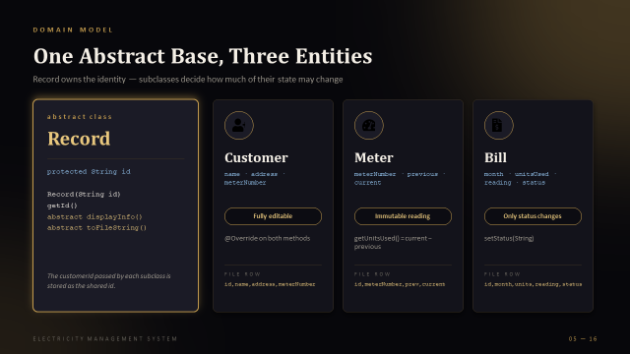
Figure 3: Home Screen
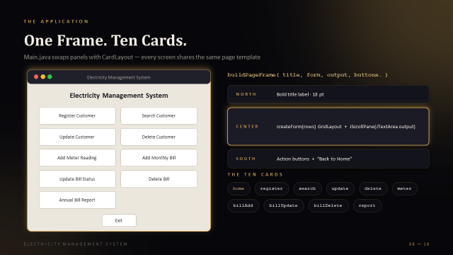
Figure 4: Register Customer Panel
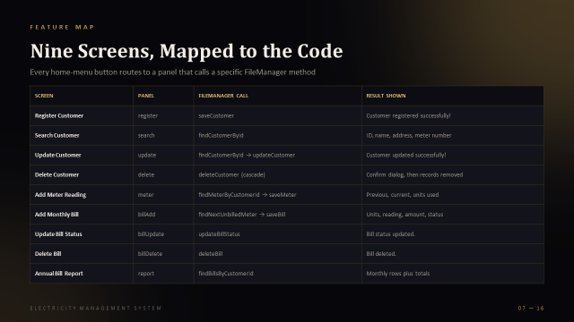meter number
Figure 5: Search Customer Panel
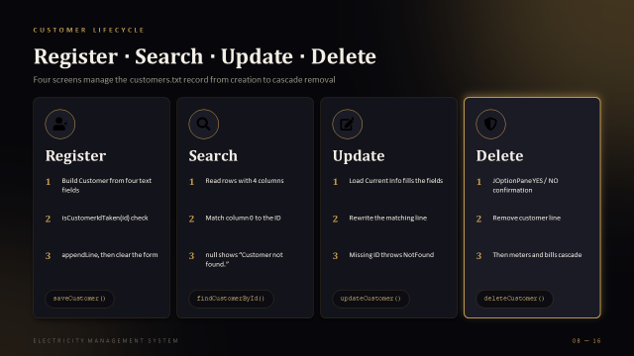
Figure 6: Delete Customer Panel

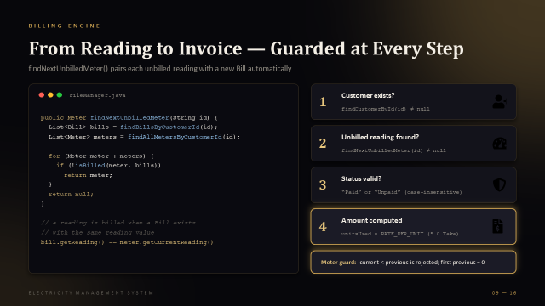
Figure 7: Add Meter Reading Panel
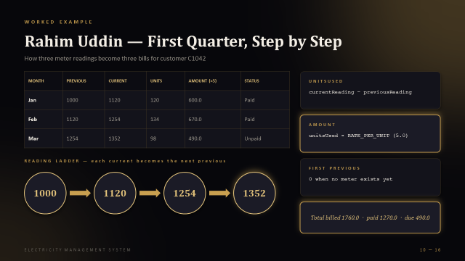
Figure 8: Add Monthly Bill Panel
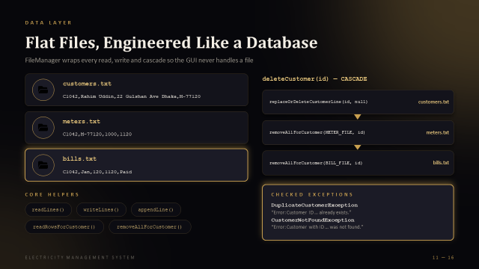
Figure 9: Update / Delete Bill Panels
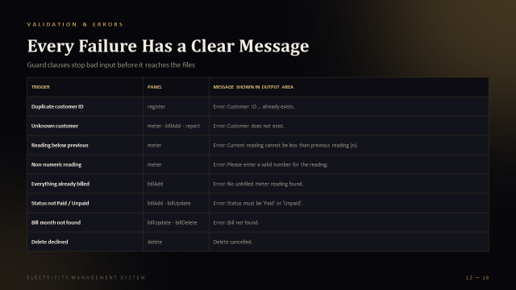
Figure 10: Annual Bill Report Panel
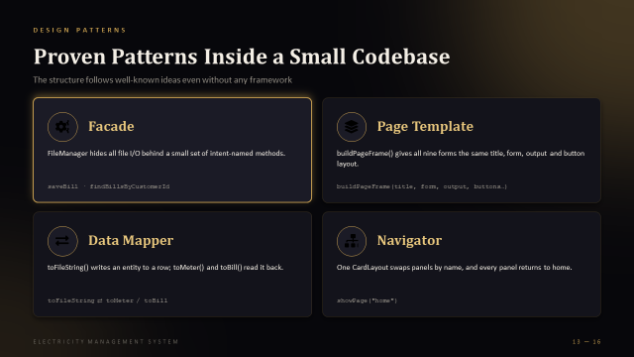
Figure 11: Proven Patterns Inside Framework Panel
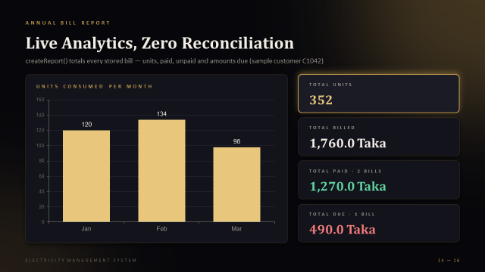
Figure 12: Data files in IntelliJ project view

7.2 Sample Inputs and Outputs
Sample 1: Register Customer
Input field | Value
Customer ID | C1042
Name | Rahim Uddin
Address | 22 Gulshan Ave Dhaka
Meter Number | M-77120
Output: Customer registered successfully!

Sample 2: Add Meter Reading (January)
Input : Customer ID = C1042, Current Reading = 1120
Output: Previous = 1000, Current = 1120, Units Used = 120

Sample 3: Add Monthly Bill
Input : Customer ID = C1042, Month = Jan, Status = Paid
Output: Units = 120, Reading = 1120, Amount = 600.0, Status = Paid

Sample 4: Annual Bill Report for C1042
Month | Units | Amount | Status
Jan | 120 | 600.0 | Paid
Feb | 134 | 670.0 | Paid
Mar | 98 | 490.0 | Unpaid
Total Units : 352
Total Billed : 1760.0 Taka
Total Paid : 1270.0 Taka (2 bills)
Total Due : 490.0 Taka (1 bill)

7.3 Error Handling and Output
Every failure produces a clear message in the output area of the panel. No invalid action crashes the program or corrupts a file.
Trigger | Panel | Message shown
Duplicate customer ID | register | Error: Customer ID … already exists.
Unknown customer | meter · billAdd · report | Error: Customer does not exist.
Reading below previous | meter | Error: Current reading cannot be less than previous reading (n).
Non-numeric reading | meter | Error: Please enter a valid number for the reading.
Everything already billed | billAdd | Error: No unbilled meter reading found.
Status not Paid / Unpaid | billAdd · billUpdate | Error: Status must be 'Paid' or 'Unpaid'.
Bill month not found | billUpdate · billDelete | Error: Bill not found.
Delete declined | delete | Delete cancelled.

Test plan (each case can be run by hand in the GUI and verified by opening the three text files):
Scenario | Input | Expected result | Result
Duplicate ID | Register C1042 twice | Already exists error on second attempt | Pass
Backwards reading | Previous 1120, enter 1100 | Rejected, message shows previous (1120) | Pass
Bad number | Enter abc as reading | Please enter a valid number | Pass
Nothing to bill | Add bill when all readings billed | No unbilled meter reading found | Pass
Invalid status | Enter Pending | Status must be Paid or Unpaid | Pass
Cascade delete | Delete C1042, open report | Customer, meters and bills gone | Pass
Report totals | 600 Paid, 670 Paid, 490 Unpaid | Billed 1760.0 · Paid 1270.0 · Due 490.0 | Pass

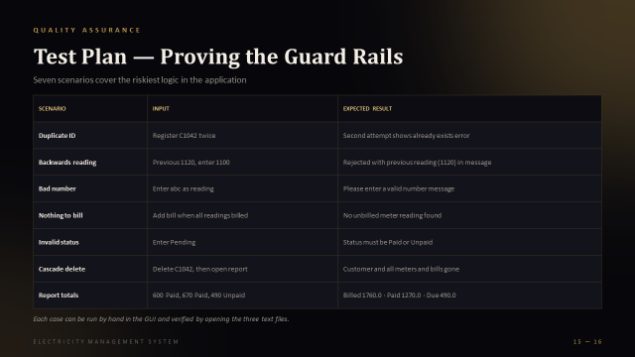
Figure 13: Error messages displayed in the output area

8. Contribution
Fill in the real names and IDs of your group members. The suggested split below follows the natural modules of the project and can be edited to match who actually did what.

8.1 Individual Contribution
Member | ID | Tasks completed
Bayazid | 324 | Conceived the idea, created the blueprint/roadmap, made the first draft, worked on all classes (Record, Customer, Meter, Bill, FileManager, Main), and reviewed/checked all teammates' work
Samia | 331
  Simplified the project approach, co-designed the roadmap with Bayazid, fixed bugs in the codes.
Mahid | 346 | Built the presentation (PPTX), also commited on Customer.java,file.java and other class, also created the Report file with leader.
Sadiquzzaman | 223 | GUI development — fixed syntax issues in Record.java, worked on RecordData.java, further updates to Record.java
Sameer | 209 | GUI development — added abstract methods to Record, fixed an output label, refactored displayInfo() to use getUnitsUsed()

8.2 Shared Responsibilities
- Requirement analysis and system design (all members)
- Integration testing using the seven-scenario test plan (all members)
- Preparation of the presentation slides and this report (all members)

9. Conclusion

9.1 Summary of the Completed Project
The Electricity Management System is a complete, working desktop application for customer, meter and billing management. It uses an abstract Record class with three subclasses, a FileManager facade over three flat files, and a ten-panel Swing interface. Customers can be created, found, changed and removed; meter readings and bills are added with strict validation; payment status is tracked; and an annual report totals units and amounts.

9.2 Were the Objectives Achieved?
Objective | Status | Evidence
All four OOP principles | Achieved | Record hierarchy, private fields, @Override methods (Section 5.6)
Full CRUD with file persistence | Achieved | Nine screens over customers.txt, meters.txt, bills.txt
Validation and custom exceptions with try-catch | Achieved | Two custom exceptions and eight handled error cases
Multi-panel Swing GUI | Achieved | CardLayout with ten panels
Documentation report | Achieved | This report

9.3 Limitations
- Comma delimiter problem: an address containing a comma breaks split(","), since fields are not escaped.
- Flat text files do not support transactions, indexing or concurrent access.
- The tariff is a fixed 5.0 Taka per unit with no slabs, taxes or late fees.
- A bill is linked to a meter by matching the reading value, not by a unique id.
- No login or role-based access, and no printing or PDF export of bills.

9.4 Challenges Faced and Reflection
- Designing the hierarchy: deciding what belongs in Record versus the subclasses took several revisions before id was placed in the base class and each entity kept its own state.
- Keeping three files consistent: deleting a customer had to remove rows from all three files, which led to the cascade helper removeAllForCustomer().
- Avoiding double billing: because bills are matched to readings by value, we had to carefully write the isBilled() logic so each reading is billed once.
- Separating GUI from data: early versions mixed file access with button code. Moving everything into FileManager made the GUI simpler and easier to test.
- Error messages: catching the right exception in the right place, and showing friendly text instead of stack traces, taught us the value of structured try-catch.

10. References and Appendix

10.1 References
- CSE282 Complex Engineering Project brief, Summer 2026.
- Oracle. The Java Tutorials: Creating a GUI with Swing. docs.oracle.com/javase/tutorial/uiswing
- Oracle. The Java Tutorials: Exceptions. docs.oracle.com/javase/tutorial/essential/exceptions
- Oracle. Java Platform, Standard Edition API Specification.
- JetBrains. IntelliJ IDEA Documentation. jetbrains.com/help/idea
- Project presentation: Electricity Management System (16 slides).

Appendix A: OOP Concept Skeleton
public abstract class Record {
protected String id; // Encapsulation
public Record(String id) { this.id = id; }
public String getId() { return id; }
public abstract void displayInfo(); // Abstraction
public abstract String toFileString();
}

public class Customer extends Record { // Inheritance
private String name, address, meterNumber;
public Customer(String id, String name, String address, String meterNumber) {
super(id); ...
}
@Override public void displayInfo() { ... } // Polymorphism
@Override public String toFileString(){ return id+","+name+","+address+","+meterNumber; }
}
// Meter: immutable readings, getUnitsUsed() = current - previous
// Bill : only setStatus(String) can modify state

Note: the skeleton above reflects the structure documented in the project design. Replace it with your exact source code if you wish to include listings.

