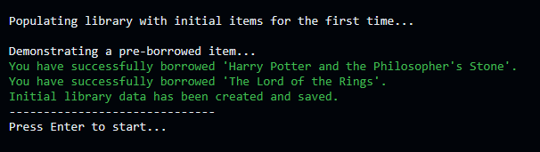

First time run canned demonstration ^

Pressing any key other than enter does nothing

Pressing W and up arrow returns to top menu

Pressing w or up arrow again makes menu wrap around

Add a new book item:

Pressing q returns the home menu

Error handling shown below:

Add a new DVD item

Error handling shown below:

Add new Magazine

Error handling shown below:

List all items

List available items

List borrowed items

Borrow item

Return an item

Search for item via ID



Pressing enter again

Searching for item via name

