SMART HOSTEL ENERGY MANAGEMENT SYSTEM
A Sustainable Living Campaign for Student Hostels

Course Code: 25UCI-203 – Social Internship
Project Category: Social Impact / Sustainability / Smart Campus
Submitted To: Chandigarh University
Submitted By: Gurmanpreet Singh
University ID: 25BCS10091
Submission Date: 08 Nov. 26

1. Executive Summary
Energy and water conservation are important aspects of sustainable institutional infrastructure. Student hostels, due to their high occupancy and shared living arrangements, often experience inefficient resource consumption. Lights, fans and other electrical appliances may remain operational even when rooms or common areas are unoccupied. The absence of individual responsibility in multi-occupancy rooms further complicates resource management.
The project, Smart Hostel Energy Management System, was undertaken as part of the 25UCI-203 Social Internship to study resource consumption patterns in student hostels and propose practical interventions for improving sustainability.
The project focused on Zakir C Hostel at Chandigarh University. Existing electricity sub-metering infrastructure across its 11 floors was used to collect daily electricity consumption readings. A baseline monitoring exercise recorded a total weekly electricity consumption of 20,550 kWh.
Field engagement included a student survey that received more than 40 responses, an awareness video addressing unnecessary electricity consumption, and an assessment of existing water-management infrastructure.
The investigation identified opportunities for improvement through automated lighting, occupancy detection, efficient electrical appliances, water-saving fixtures and greater student awareness.
Based on these findings, a software simulation of a Smart Hostel Energy Management System was proposed. The system is designed around an ESP32-based IoT architecture, mmWave human-presence sensors and relay modules. Its software prototype is intended to demonstrate room occupancy monitoring, appliance control, energy analytics, activity logging and administrative monitoring without requiring physical hardware.
The project also recognizes existing sustainability measures, including wastewater recycling and rainwater harvesting, and recommends targeted improvements rather than duplicating infrastructure that is already operational.
Overall, the project combines community engagement, resource monitoring, behavioural awareness and technology-driven recommendations to support the development of a more energy-efficient and environmentally responsible hostel environment.
2. Introduction
Educational institutions consume substantial quantities of electricity and water to support their daily operations. Hostel buildings are particularly challenging environments for resource management because they accommodate large populations with different schedules, habits and levels of awareness.
In shared hostel rooms, responsibility for switching off appliances is distributed among multiple occupants. This often results in lights, fans and other electrical devices being left operational unnecessarily. Conventional manual monitoring is difficult to maintain across large residential buildings.
Furthermore, monitoring solutions that depend on individual mobile devices or wearable technology introduce privacy concerns and additional adoption barriers.
The Smart Hostel Energy Management System addresses these challenges through a combination of sustainability awareness, resource-consumption analysis and an IoT-inspired automation model.
The project was designed with two complementary objectives:
- Understand existing resource-consumption patterns and identify opportunities for conservation through field engagement.
- Develop a scalable software simulation demonstrating how occupancy-based automation and centralized monitoring could reduce unnecessary energy consumption.
The project adopts a practical approach in which technology supports, rather than replaces, responsible student behaviour and institutional resource management

Smart Hostel Energy Management System: Project Proposal
Introduction
Electricity consumption is a significant operational expense in educational institutions, particularly in hostel settings where communal living often leads to the unnecessary operation of appliances like lights and fans. Traditional manual monitoring methods are often inefficient or impractical for multi-occupancy environments, while mobile-tracking solutions present privacy concerns and reliability issues.
The Smart Hostel Energy Management System is proposed as an IoT-inspired solution designed to minimize human intervention through automated occupancy detection and intelligent appliance management. This project focuses on developing a software simulation prototype that demonstrates the system's full functionality, establishing a scalable architecture for future hardware deployment.
Problem Statement
Hostel rooms, which typically accommodate four to five students, face persistent issues with electricity wastage due to appliances being left on in empty rooms. The consequences include:
- Significant electricity wastage and increased institutional costs.
- Higher carbon emissions.
- Difficulties in manually supervising hundreds of rooms and a lack of centralized occupancy monitoring.

Proposed Solution & Objectives
The system utilizes ESP32 microcontrollers, mmWave human presence sensors, and relay modules to automate electricity management without requiring mobile devices or wearables.
Primary Objectives:
- Reduce electricity consumption through intelligent, occupancy-based automation.
- Develop a modern, responsive dashboard for real-time monitoring and remote control.
- Simulate IoT communication and visualize energy savings/analytics without requiring physical hardware.
- Create a scalable architecture for future hardware integration.

Project Scope
In Scope (Simulation Prototype):
- Simulation of multiple hostel rooms and occupancy using generated data.
- Real-time monitoring dashboard with role-based access for students and administrators.
- Remote appliance switching (lights/fans) and automatic shutdown.
- Energy consumption analytics, historical logs, and a notification system.
Out of Scope:
- Physical hardware components (ESP32 programming, sensors, relay operation, or wiring).
- Mobile application development, cloud deployment, and production-grade infrastructure.

Stakeholders & Benefits
Stakeholder | Key Responsibilities | Primary Benefits
Hostel Students | Monitor status, switch appliances, view stats | Convenience, reduced waste
Administration | Monitor rooms, analyze usage, generate reports | Cost reduction, resource management
Maintenance | Monitor relays, detect sensor/room failures | Faster response, less effort
Institution | N/A | ]Sustainability, smart campus development

System Architecture (Hardware & Software)
Hardware Architecture (Future Deployment)
- ESP32 Board: Dual-core, Wi-Fi enabled controller for sensor data and relay logic.
- mmWave Sensors (LD2410/C1001): High-precision detection of stationary and moving humans.
- Relay Module: Electronic switch to control appliance power.
Software Stack
- Frontend: React, TypeScript, Tailwind CSS, Framer Motion, and React Router.
- Backend (Simulation): Node.js and Express.js.
- Database: PostgreSQL, SQLite, or Firebase Firestore.
- Data Visualization: Recharts.

Key Features
- Real-Time Dashboard: Displays occupancy status, energy usage, and active alerts.
- Automated Control: Automatic light/fan shutdown with configurable timers and manual overrides.
- Energy Analytics: Tracks usage, estimates savings, and calculates 𝐶𝑂2 emission reductions.
- Activity Logs: Full records of occupancy changes and user actions.

Conclusion
The Smart Hostel Energy Management System offers a scalable, intelligent approach to energy sustainability in campus infrastructure.While the current project utilizes software simulation, the architecture is designed to transition seamlessly to a fully functional IoT system, significantly improving energy efficiency and operational management.

Baseline Utility Report
Hostel : Zakir C

Day | Electricity (kWh)
Monday | 2,650
Tuesday | 2,700
Wednesday | 2,680
Thursday | 2,620
Friday | 2,800
Saturday | 3,250
Sunday | 3,850
WEEKLY TOTAL | 20,550 kWh

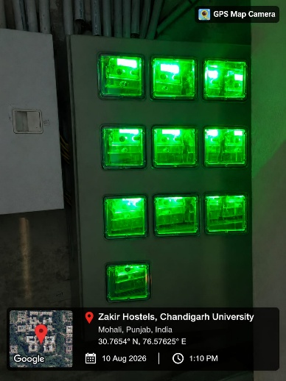
Electricity Consumption :
We utilized the building’s existing smart sub-meters located at the distribution boards on each of the 11 floors. Readings were logged daily at 5 PM to capture precise 24-hour kilowatt-hour (kWh) usage.
We realized that a large amount of electricity is being used for fufiling the demand of idle devices which are left unplugged like chargers, adapters etc.
Electricity Sub-meters

Consumption is highly spiked around weekends due to holidays. Due to 5 students living in the same room responsibility is highly diffused and dispersed making it difficult to manage and perform as expected.
Water Consumption :.
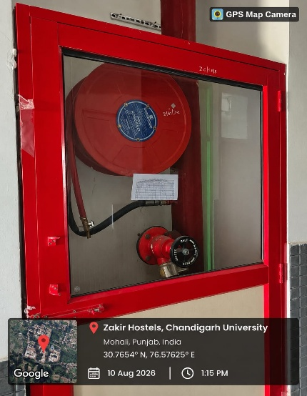
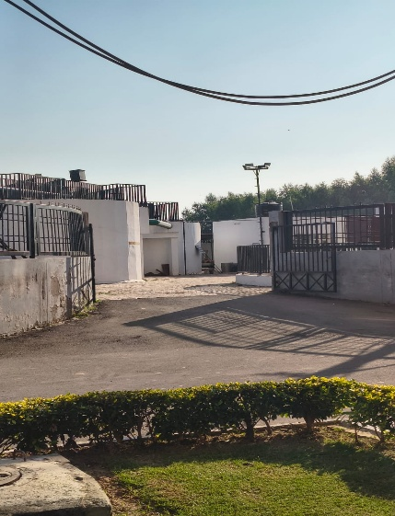
The hostel water system was actively recycling waste water in a water treatment plant located just alongside the hostels, We discovered that rain water harvesting in also being utilised to fulfill water demands making the system much more environment friendly than expected.
Water outlets in hostels
Field-Visit Water treatement plant
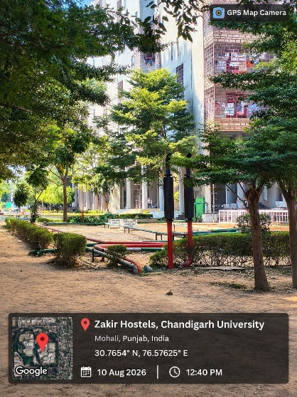
Rainwater-harvesting
Steps Taken :
- Survey form was shared in the hostel group fetching 40+ reponses .
- Short video aimed to make people aware about the consumption of idle devices was also developed and circulated.
- Video link : https://drive.google.com/file/d/1R3qXNRDygWxJpQ2iNSLa7hfO_hx_jtxf/view?usp=sharing

Drafts for Upgrade Requests

To: University Estate Management & Hostel Administration
From: Sustainability Campaign Committee
Date: August 5, 2026
Subject: Formal Infrastructure Upgrade Request: Resource Optimization & Hardware Retrofits
Executive Summary :
Following the baseline monitoring phase, I have identified specific infrastructural bottlenecks that limit the hostel's natural resource efficiency. While the building's existing underground rainwater harvesting and wastewater recycling systems are working excelently, potable water and electricity are suffering from hardware inefficiencies that behavioral nudges alone cannot fix. I request the following hardware retrofits to improve environmental friendliness.
Priority 1: Electrical & Lighting Retrofits
Baseline data revealed that common area lighting and idle devices contribute heavily to our 19,250 kWh weekly consumption, particularly during daylight hours.
- Corridor & Washroom Motion Sensors:
  - The Issue: Audits showed that lights on several floors (notably Floor 8) are frequently left running 24/7.
  - The Solution: Install passive infrared (PIR) motion sensors in all hallways, common rooms, and communal washrooms to ensure lights only activate upon occupancy.
- LED Transition Completion:
  - The Solution: Replace any remaining fluorescent tube lights in student rooms and lobbies with high-efficiency 12W to 18W LED battens.
Priority 2: Potable Water Interventions
Because the hostel already recycles wastewater for flushing and landscaping, our upgrades strictly target the reduction of freshwater used at the sink and shower level (currently averaging 820 kL per week).
- Push-Type (Metering) or Sensor Taps:
  - The Issue: Worn-out traditional threaded taps are causing persistent leaks (heavily documented on Floor 4), and students frequently leave taps running while brushing teeth.
  - The Solution: Retrofit all communal bathroom sinks with push-button timed taps (delivering water for 8-10 seconds per press) or infrared sensor taps to eliminate user-end waste completely.
- Low-Flow Shower Aerators:
  - The Solution: Install inexpensive aerators on all showerheads. This mixes air with the water flow, maintaining perceived pressure for the user while reducing actual liter-per-minute consumption by up to 30%.

Software Development and System Implementation
Overview
As part of the Smart Hostel Energy Management System, a software-based simulation prototype was developed to demonstrate how technology can be used to improve energy monitoring, appliance management and resource efficiency in student hostels.
The software component serves as the central interface between hostel residents, administrators and the proposed IoT infrastructure. Rather than relying on physical sensors and controllers during the current development phase, the prototype uses a software-driven architecture to simulate room occupancy, appliance states and system activities.
The primary objective was to develop a functional and scalable application that demonstrates the core capabilities of a smart hostel management platform while maintaining compatibility with future hardware integration.
Technology Stack
The application utilizes modern web development technologies to create a responsive frontend and a structured backend.
Component | Technology | Purpose
Frontend | React.js | Interactive user interface
Styling | Tailwind CSS | Responsive interface and visual design
Routing | React Router | Navigation between application pages
Backend | Node.js | Server-side application environment
API Framework | Express.js | Backend API development
Database | PostgreSQL | Persistent data storage
Data Visualization | Recharts | Energy statistics and analytics

Application Interface and Dashboard
The frontend was designed to provide a centralized interface for monitoring and managing hostel resources.
The application follows a component-based architecture, allowing individual interface elements to be developed, maintained and reused independently.
The interface is intended to provide:
- An overview of hostel energy consumption.
- Room-wise occupancy information.
- Appliance status and control interfaces.
- Historical consumption statistics.
- System notifications and alerts.
- Administrative monitoring capabilities.
The use of responsive layouts allows the dashboard to adapt to different screen sizes.
User Authentication and Access Management
The application incorporates a user authentication system to provide controlled access to the platform.
Separate user roles are designed for students and administrators, allowing functionality to be organized according to user permissions.
The authentication workflow includes:
- User registration.
- User login.
- Credential validation.
- Session or token-based authentication, depending on the implemented approach.
- Protected application routes.
- Role-based access restrictions.
This structure provides a foundation for secure access to hostel monitoring and management functionalities.
Backend and API Development
The backend was developed using Node.js and Express.js to handle application logic and communication between the frontend and database.
A REST-based API architecture was adopted to organize application functionality into individual endpoints.
The backend is responsible for:
- Processing incoming client requests.
- Managing user-related operations.
- Handling room and appliance information.
- Storing and retrieving application data.
- Processing occupancy and appliance-status updates.
- Providing data required by the dashboard and analytics components.
This separation between frontend and backend improves maintainability and provides a structured foundation for future IoT integration.
Database Management
PostgreSQL is used as the relational database for organizing and maintaining application data.
The database is designed to support structured information related to users, hostel rooms, appliance states and system activities.
A relational database approach allows information to be organized into interconnected tables while maintaining data consistency.
The database layer provides the foundation for persistent storage, historical records and future analytical operations.
Simulated IoT Communication
Since the current development phase does not involve physical ESP32 controllers or installed sensors, the application uses simulated data to represent IoT operations.
Generated occupancy and appliance-status information can be used to demonstrate how the system would respond to changes in room conditions.
The intended simulation workflow includes:
- Generating or updating room occupancy information.
- Processing occupancy changes through the backend.
- Applying predefined automation rules.
- Updating simulated appliance states.
- Recording relevant system activities.
- Displaying updated information on the dashboard.
This approach makes it possible to demonstrate the software architecture and application logic without requiring physical hardware.
Energy Analytics and Data Visualization
The application is designed to present resource-consumption information through graphical visualizations and historical statistics.
Using Recharts, the dashboard can display energy trends, comparisons and usage summaries in an accessible format.
The analytical component is intended to support:
- Daily and weekly consumption comparisons.
- Room-wise energy usage.
- Historical consumption trends.
- Estimated energy savings.
- Estimated CO₂ emission reductions.
These visualizations can help hostel administrators understand consumption patterns and identify areas requiring attention.
Scalability and Future Integration
The software architecture has been designed with future IoT integration in mind.
The current simulation provides a foundation for connecting physical ESP32 controllers and mmWave presence sensors through an appropriate communication layer.
Future versions could replace generated occupancy information with actual sensor readings and connect simulated appliance controls to physical relay modules.
This would allow the application to evolve from a software simulation into a practical hostel energy-management platform.
Development Outcome
The software development component establishes a technical foundation for centralized hostel resource monitoring and intelligent appliance management.
By combining a component-based frontend, REST API architecture, relational database and simulated IoT workflows, the project demonstrates how modern software technologies can be applied to address practical sustainability challenges.
Although physical hardware deployment remains outside the current scope, the developed software prototype provides a basis for future experimentation, testing and integration.
Software Demonstration: https://s-07-sustainable-living-campaign-fo-ashy.vercel.app
Source Code Repository: https://github.com/HeyImGurman/S-07-Sustainable-Living-Campaign-for-Student-Hostels


