## **安装依赖**

yum -y install pcre-devel openssl openssl-devel zip wget yasm

## **安装nginx**

**（1）下载第三方扩展模块nginx-rtmp-module**

# mkdir module && cd module 　　//创建一个存放模块的目录

# wget https://github.com/arut/nginx-rtmp-module/archive/master.zip //下载模块

# unzip master.zip 　　　　　　　　//解压

# ls nginx-rtmp-module-master/ //查看模块目录

**（2）编译安装nginx**

# wget http://nginx.org/download/nginx-1.19.0.tar.gz //下载nginx包

# tar xf nginx-1.19.0.tar.gz

# ./configure --prefix=/usr/local/nginx-1.19.0 --add-module=/usr/local/packages/nginx-rtmp-module-master --with-http\_ssl\_module //编译安装nginx，并指定上面下载的模块路径

# make

# make install

**（3）修改nginx配置文件，添加如下内容并重新载入配置文件**

# vim nginx.conf

rtmp {

server {

listen 1935; #监听的端口号

application myapp { #自定义的名字

live on;

}

application hls {

live on;

hls on;

hls\_path /tmp/rtmp/hls;

hls\_fragment 1s;

hls\_playlist\_length 3s;

}

}

}

# /etc/init.d/nginx reload

**完整nginx.conf**

user root;

worker\_processes 4;

worker\_cpu\_affinity 1000 0100 0010 0001;

worker\_rlimit\_nofile 30000;

#error\_log logs/error.log warn;

pid /var/run/nginx.pid;

events {

worker\_connections 30000;

use epoll;

}

rtmp {

server {

listen 1935;

application myapp {

live on;

}

application hls {

live on;

hls on;

hls\_path /tmp/rtmp/hls;

hls\_fragment 1s;

hls\_playlist\_length 3s;

}

}

}

http {

limit\_req\_zone $binary\_remote\_addr zone=req\_one:10m rate=1r/s;

autoindex off;

include /usr/local/nginx-1.19.0/conf/mime.types;

default\_type application/octet-stream;

log\_format main '$remote\_addr [$time\_local] "$request" '

'$status $body\_bytes\_sent "$http\_referer" '

'"$http\_user\_agent" $http\_x\_forwarded\_for $request\_length $request\_time "$upstream\_response\_time" "$upstream\_addr" $host $server\_addr';

#access\_log logs/access.log main;

server\_tokens off;

sendfile on;

#tcp\_nopush on;

keepalive\_timeout 65;

gzip on;

gzip\_min\_length 1K;

gzip\_buffers 4 16K;

gzip\_comp\_level 8;

gzip\_http\_version 1.0;

gzip\_types application/json text/javascript text/plain application/x-javascript text/css application/xml text/xml;

#gzip\_types application/json text/javascript text/plain application/x-javascript text/css application/xml text/xml image/jpeg image/gif image/png;

gzip\_disable "MSIE [1-6]\.";

client\_max\_body\_size 500M;

#server {

# listen 80 default;

# return 500;

#}

include /usr/local/nginx-1.19.0/conf/conf.d/\*.conf;

}

## **安装ffmpeg**

ffmpeg命令参考这位朋友的文章：[https://www.jianshu.com/p/049d03705a81](https://www.jianshu.com/p/049d03705a81" \t "https://www.cnblogs.com/yanjieli/archive/2019/03/28/_blank)

**（1）下载ffmpeg并安装**

# git clone https://git.ffmpeg.org/ffmpeg.git ffmpeg //下载ffmpeg# cd ffmpeg

# ./configure --prefix=/usr/local/ffmpeg

# make

# make install

**（2）拷贝命令到/usr/bin（方便后面调用）**

# ls /usr/local/ffmpeg/ //查看安装目录生成的文件bin include lib share

# cp /usr/local/ffmpeg/bin/\* /usr/bin/

## **测试[#](https://www.cnblogs.com/yanjieli/archive/2019/03/28/10615638.html" \l "1783980861)**

**（1）启用ffmpeg进行推流**

[IMG_256](https://www.cnblogs.com/yanjieli/archive/2019/03/28/javascript:void(0);)

# ffmpeg -i rtsp://192.168.1.175:554/11 -acodec aac -strict experimental -ar 44100 -ac 2 -b:a 96k -r 25 -b:v 500k -s 640\*480 -f flv rtmp://192.168.1.11:1935/myapp/23

-i 要处理视频文件的路径，此处地址是一个监控摄像头-s 像素

rtmp://192.168.1.11:1935/myapp/23 说明：rtmp://IP:PORT/ myapp指nginx配置文件中自定义的，23指输出文件的名字

-f 强迫采用flv格式

ffmpeg -re -i /tmp/rtmp/hls/管道公司交流视频.mp4 -vcodec copy -acodec copy -b:v 800k -b:a 32k -f flv rtmp://192.168.1.188:1935/myapp/888888

**2）打开VLC 媒体——>流——>网络**

[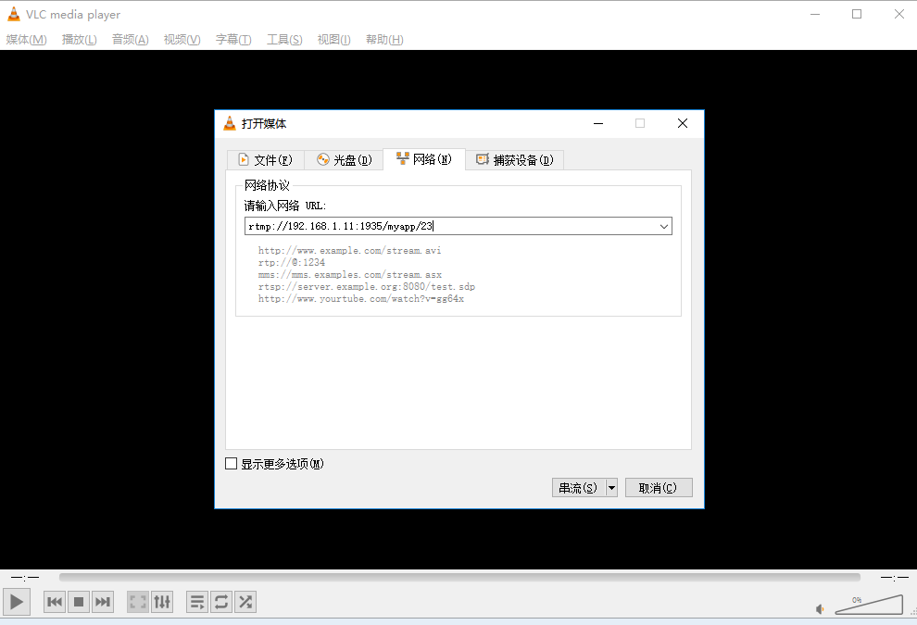](https://img2018.cnblogs.com/blog/1210730/201903/1210730-20190328163940470-52170983.png)

[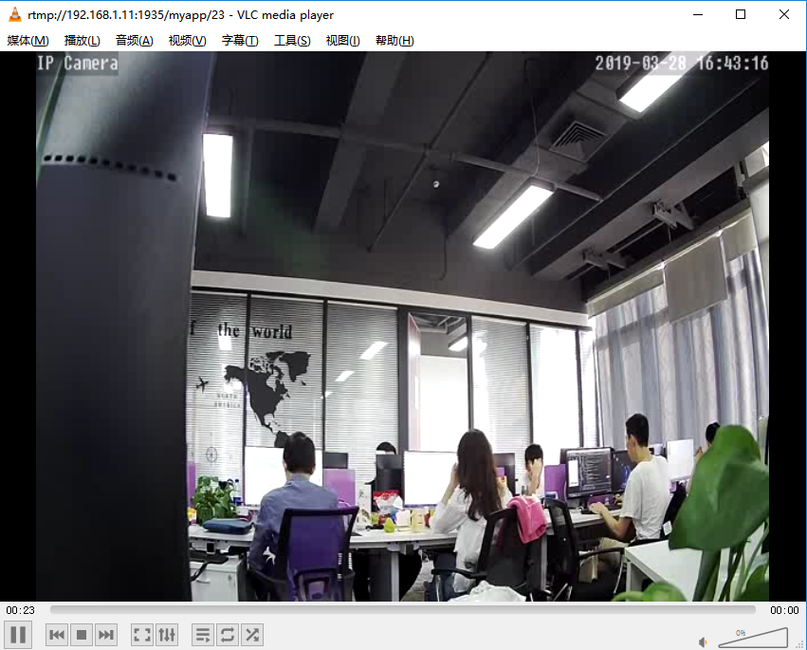](https://img2018.cnblogs.com/blog/1210730/201903/1210730-20190328170042369-1748920126.png)

**（3）进入服务器查看输出的位置可以发现已生成文件**

# ll /tmp/hls/

total 1636

-rw-r--r-- 1 root root 500644 Mar 28 17:05 22-1955.ts-rw-r--r-- 1 root root 384460 Mar 28 17:05 22-1956.ts-rw-r--r-- 1 root root 413036 Mar 28 17:05 22-1957.ts-rw-r--r-- 1 root root 366036 Mar 28 17:05 22-1958.ts-rw-r--r-- 1 root root 154 Mar 28 17:05 22.m3u8

**（4）还可以使用浏览器这样访问 http://192.168.1.11/hls/22.m3u8**

[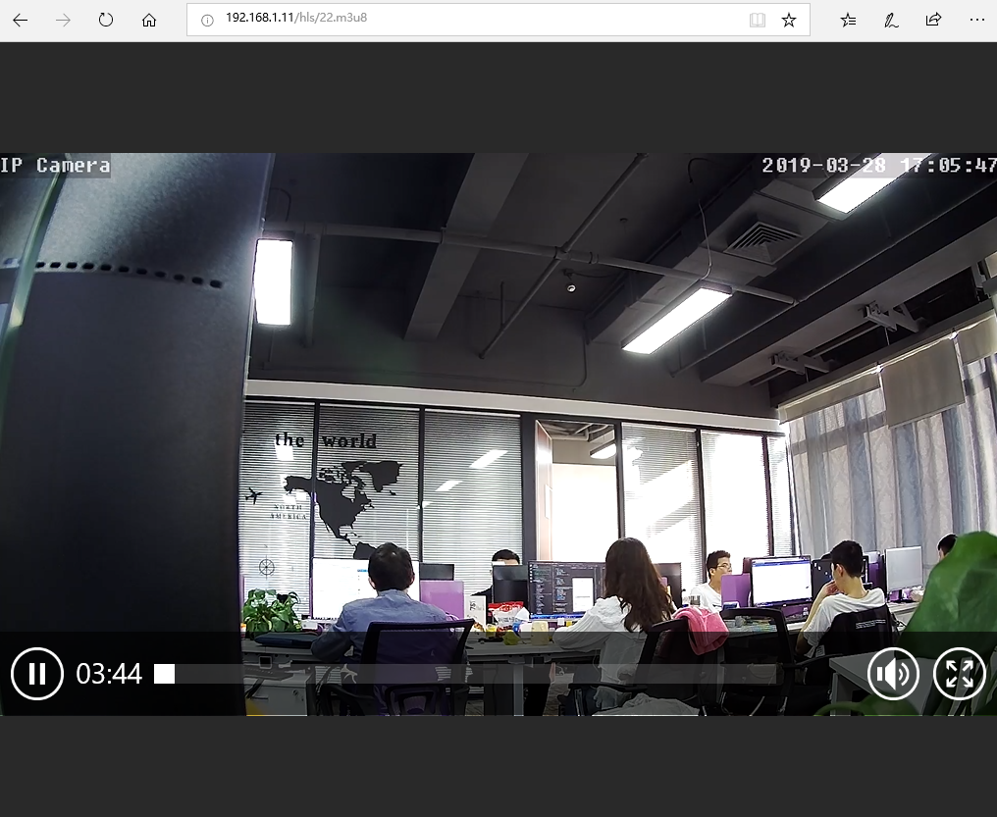](https://img2018.cnblogs.com/blog/1210730/201903/1210730-20190328214813618-1563382617.png)

Link:<https://www.cnblogs.com/yanjieli/archive/2019/03/28/10615638.html>