**Summary of Major Findings:**

Question #1: What is the likelihood that more doctors would be located in higher populated areas?

From the analyzed data, it does indicate that doctors do tend to be located more within higher populated areas. This isn’t too surprising given the fact that areas with larger amounts of individuals would require more doctors to provide the necessary amount of healthcare services desired.

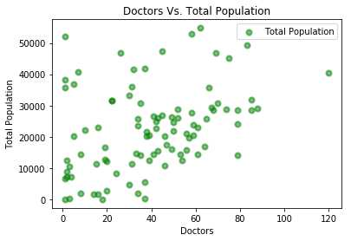

Question #2: Would hospital facilities be located more within higher income or lower income areas?

When comparing hospital facility locations to higher and lower income areas, it was interesting to see how the locations tended to primarily be at either the higher or lower end and not as much within areas with medium income per capita. However, lower income per capita areas were much more likely to have hospital facilities. One reason for this finding could be due to it costing less to build facilities in areas with lower property values. Additionally, lower income areas also tend to have larger amounts of outpatient mental health facilities. In contrast, higher income communities are more likely to have access to specialty healthcare treatment facilities than individuals living in lower income per capita areas.

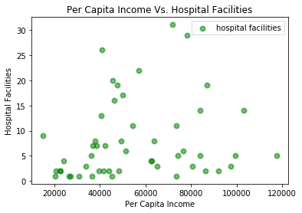

Question #3: Is the unemployment rate higher in lower income areas?

As evidenced by the chart below, it is easy to conclude that unemployment rate is much higher within lower income per capita areas. This can largely be attributed to the fact that employment opportunities with fewer necessary qualifications don’t pay as much as those that require higher levels of education. In effect, it is more difficult for individuals to obtain those positions given the increased size of the population that is also competing for the same job.

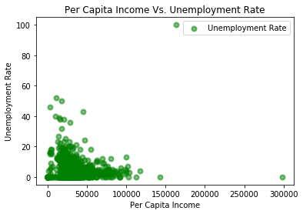

Question 4: Does per capita income influence the percentage of individuals possess healthcare insurance?

Although healthcare coverage has become much easier to obtain in recent years, it is still safe to conclude that individuals located in lower income areas are less likely to have healthcare coverage compared to those in higher income areas. Another factor that contributes to this conclusion can be attributed to the issue of unemployment previously discussed above.

