## What are three conclusions we can make about Kickstarter campaigns given the provided data?

***(1) The Kickstarter platform benefitted from increased traffic from publicity revolving around two specific Kickstarter campaigns that occurred in 2013 (Figure 1).*** A 3d Printing Pen project that went viral, 3Doodle (26,457 backers). And a campaign run by the NPR Podcast/Radio Segment *Planet Money* (20,242 backers). These two campaigns account for over 10% of total overall counted backers included within the dataset.

[https://www.npr.org/series/248799434/planet-moneys-t-shirt-project]

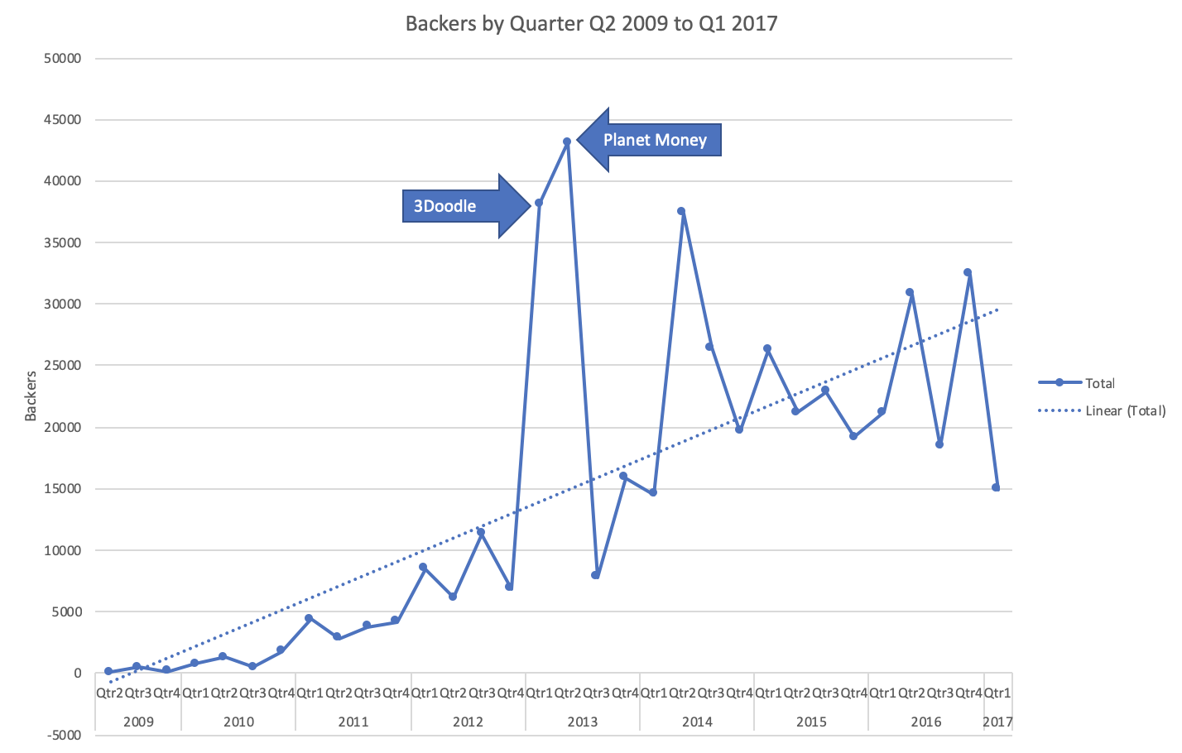

Figure 1

***(2) Despite the outliers, the data show an upward, though unsteady trend in Kickstarter supporters. Though the data demonstrate a downward trend in the number of campaigns being started across all categories since 2016 (Figure 2). (3) Given the scope of the provided data set, we also find that Kickstarter campaigns saw significantly increased popularity among the Theater Community beginning in 2014. However, it is difficult to determine whether this is truly accurate given the incomplete nature of the data set***

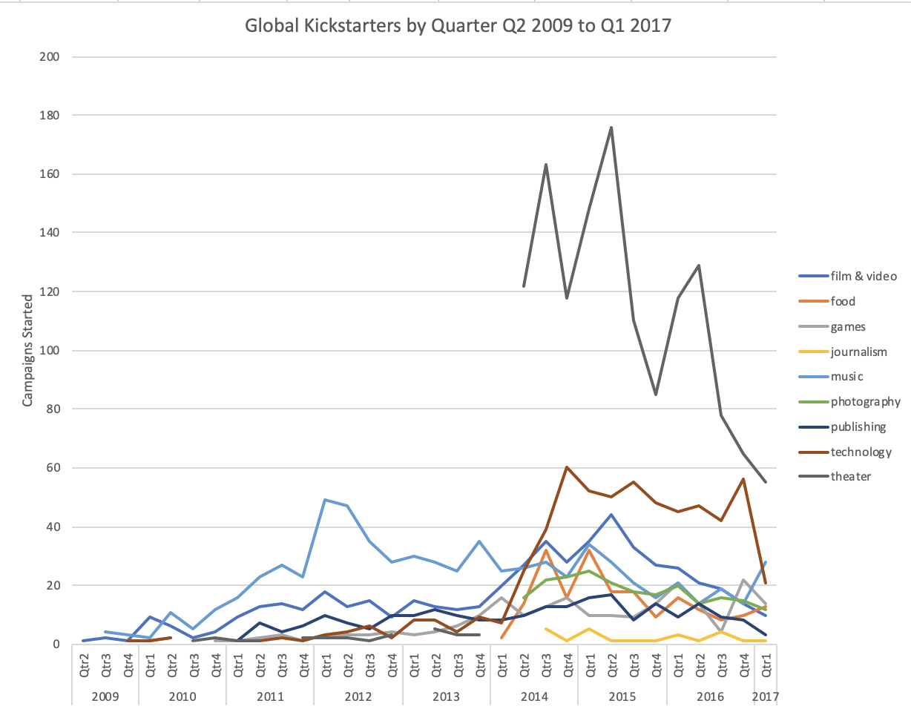

Figure

## What are some of the limitations of this dataset?

The provided dataset does not provide a count of unique backers. This prevents the ability to measure the occurrence of unique vs. repeat backers.

The provided dataset is an incomplete list. A quick google search will show that this data set omits every one of the top-10 most successful Kickstarter campaigns.

## What are some other possible tables/graphs that we could create?

Further analysis could be done on the relationship between the success of a campaign and whether or not the Kickstarter organization had helped promote that campaign. (Staff Pick and/or Spotlight vs. Success Rate).