**University of Jordan**

**King Abdullah II School of Information Technology**



**Simulation and modeling of the bank**

**Waiting system**

**Supervisor:**

**Prof. Ahmad Sharieh**

**Team members:**

|  |  |
| --- | --- |
| **Student name** | **Student ID number** |
| **Rania Yousef Al-Qdoumi** | **0172653** |
| **Heyam Basem Al-Mahmoud** | **0173645** |

**Abstract**

One of the major factors influencing the success of organizations in today’s competitive world is to increase customer satisfaction through the improvement of service quality. In any service organization, managers are mostly concerned about the time that customers are required to wait for receiving their service

Our Simulation Project is all about how to create simulation for the Bank waiting system.

**1-Problems and Objective:**

Banks in particular pay special attention to service quality as the most significant core competence. The queue length and waiting time are two significant factors which play important roles in customer perception about the quality of service in banks. Therefore, banks' managers are concerned about providing the optimal service configuration that can satisfy both customers and service providers. Among different approaches which are useful to evaluate different alternatives, simulation has proven its high capability in modeling and evaluating such situations.

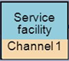

** **

**2-Brief description of the Bank's services**

A bank is a financial institution provides several services such as:

- Receive deposits and make loans.

- Wealth management.

- Currency exchange.

- Safe deposit boxes.

**3-Define System Model:**

There are many type of bank system model. For example, there is a sample for one counter, and other samples with more than one counter. We choose the sample for three counters to stimulate the bank waiting system. Naturally, bank system is queuing system. It means that when customers arrive they always take a number and wait in line if the employee is busy, but if the employee is available, they will start the service. We build simulations to minimize the number of customers waiting in the queue and win more customers in service. In practice, the simulation in the bank is to know the average waiting for the customer in the queue, the average time they wait for service, and the percentage of employee busy. With three counters, we choose a multi-server queue system to simulate this system.

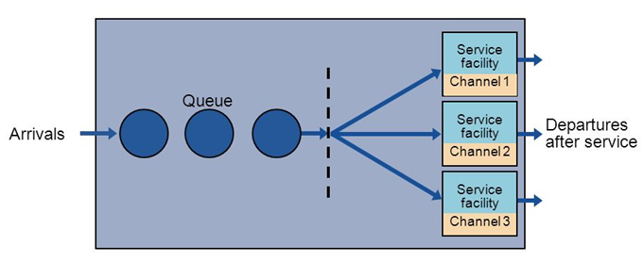

**4- Collect Data:**

We need to collect data to get the sample input parameters such as, inter-arrival time and service time. We take a sample from the Cairo Amman Bank- University of jordan a whole two day.

To build our simulation model, the details of the work should be known so we should consider the following conditions:

* The bank works 5 days a week.
* The bank opens in the morning at 08:30am and closes at 03:00p
* Combine the first day times with the second day so the time from 08:30am  
  to 09:00pm
* Number of customers: 73 customers

* arrival time (minute): 08.35 , 08.50 , 09.17 , 09.35 , 09.40 , 10.15 , 10.30, 10.40 , 11.17 11.15 , 11.35 , 12.17, 12.10 , 12.16 , 12.17 , 12.23 , 12.25 , 12.37 , 12.49 , 12.53, 13.10 , 13.25 13.33, 13.55 , 13.59 , 14.00 , 14.17 , 14.15, 14.15 , 14.18 ,14.25 , 14.27 ,14.30, 14.35 , 14.37 14.43 , 14.58 , 15.28 , 15.33 , 16.20,16.20 , 16.28 , 16.33 , 16.36 , 16.55 , 17.18 , 17.13 , 17.20

17.28 , 17.46 , 17.58 ,18.09 , 18.25 , 18.34 , 18.34 ,18.48 ,18.57 ,19.12 ,19.16, 19.23 , 19.29 19.37 , 19.49 , 19.57, 20.17, 20.20, 20.13, 20.20 ,20.23 , 20.28, 20.33, 20.40 , 20.48.

* departure time (minute): 08:38, 08:55, 09:09, 09:47, 09:45, 10:23, 10:33, 10:50, 11:09, 11:18, 11:37, 12:10, 12:17, 12:26, 12:25, 12:30, 12:35, 12:41, 12:59, 13:17, 13:15, 13:32, 13:40,

14:00, 14:17, 14:20, 14:10, 14:23, , 14:20, 14:25, 14:30, 14:33, 14:35, 14:45, 14:41, 14:48, 15:17, 15:32, 15:37, 16:14, 16:26, 16:34, 16:39, 16:40, 17:14, 17:14, 17:17, 17:24, 17:35, 17:56, 18:17, 18:29, 18:45,18:41, 18:42, 18:54, 19:17, 19:19, 19:20, 19:34, 19:38, 19:43,

19:55, 20:16, 20:12, 20:21, 20:21, 20:24, 20:27, 20:34, 20:43, 20:45, 20:54.

Service time (minute): 3 , 5 , 3 , 9, 4, 6, 3, 7, 3 , 3, 2, 4, 5, 8, 6, 5, 8, 3, 7, 6, 4, 5, 7, 5, 6, 17, 5, 8,

5, 7, 4, 6, 3, 8, 4, 5, 6, 4, 3, 5, 6, 4, 5, 3, 7, 6, 4, 4, 5, 8, 7, 17, 18, 5, 6, 4, 7, 5, 3, 9, 7, 5, 4, 6, 5, 10, 7, 3, 4, 5, 8, 4, 3.

Arrival time:

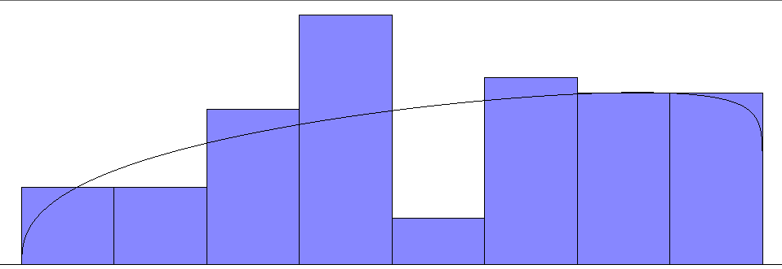

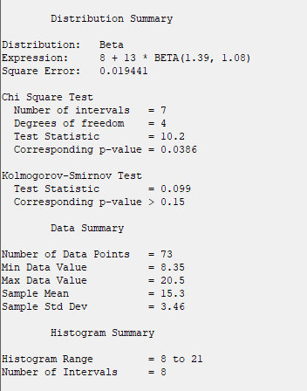

Service time:

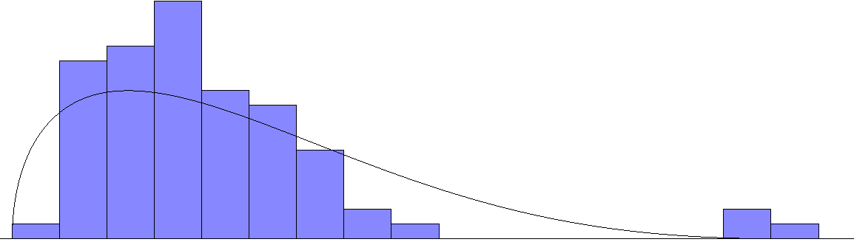

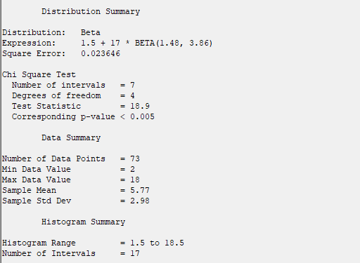

**5-Conceptual Model:**

In the bank, when a customer arrives first time of a day he is ready to be served because the counters are avaliable.after a while During the counter’s employees are busy that's because other customer have been arrived, so they wait for the service in line (queue).We assume that the arrival times and service times of each customer are randomly, and the times are discrete. First, identify about:

* System model: multi-server queuing system
* Events: there are two events occur in the bank that is event of student’s arrival and event of student’s departure.
* System States: define the number of customers waiting for service and number of customer served at any moment.
* Random realization: generate the random number of each inter-arrival times and service times to define the next arrival time and departure time.
* Components or System variables
* Server status: defines the server (barber) is busy or idle.
* Number in queue: defines the number of customer waiting in queue.
* List of arrival time: stores the arrival time of customers are being waiting in queue. The time in list, use to calculate the delay time before they start service.
* Time of last event: stores the time of event just occur at moment whether the times are arrival or departure.
* Event list: store the next arrival time and next departure time to define the simulation clock.
* Simulation clock: identifies the time simulation time.
* Statistic counter: uses to estimate the system, such as find the mean of customer waiting in queue, the mean of time that customer wait for service, find the percentage of server busy. There are four elements of statistic counter to be calculated.
* Number of delay: number of customers served at any moment. Number of delay increase one (Number of delay=Number of delay + 1) when customer starts of service.
* Total delay: total the delay time of each customer from the arrival time to startservice time.If the customer waiting in queue then:

Total delay=Total Delay + (Start Service Time-First Arrival Time in List).

* Area under Q(t): total time of all customer waiting in queue until now.

Q(tn)=Q(tn-1)+(nq)*(tn-tn-1)

Q(tn): Area under Q(t) current event

Q(tn-1): Area under Q(t) of previous event

nq: Number of customer waiting in queue at now

tn: time of current event (now)

tn-1: time of previous event

* Area under B(t): total time of server that serve the service __ server is busy.If server busy at the occurrence of current event then

B(tn)=B(tn-1)+( tn-tn-1)

B(tn): Area under B(t) of current event

B(tn-1): Area under B(t) of previous event

tn: time of current event (now)

tn-1: time of previous event

* Specify what to do at each event. At event of arrival, create next arrival. If the servers is free or idle, send the customers to start service, then servers become busy. Otherwise, it joins the queue. At event of service end, then server become free. If any customers waiting in queue remove first customer from the queue; send it for start of service.
* When three customers arrive, the server become occupied, the number of delay increase one. Define the next event whether customer arrival or customer departure, is to generate the random number of inter-arrival time and service time between the minimum and maximum of inter-arrival and service time that have been given.
* Define the next event: arrival or departure then move the simulation clock the next event time. The event occur, update system state (server status, number in queue, time of last event), statistic counter. Generate the next arrival time or next departure time according to the event occur. Then practice this step again until the number of delays equal to the number of required customers.
* After the simulation end, we get all the value of statistic counter, and the time of simulation end. Then we can calculate the mean of customer waiting in queue, mean of delay time, and percentage of server utilization to estimate of simulation on system.

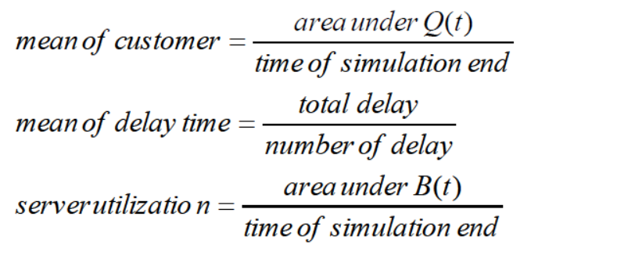

**6-Flowchart for program:**

- Initialize routine (initial clock,

System state, statistic counter)

- Generate the first inter-arrival and arrival time

Number of delay<number of customer?

-Define next event

- Call timing routine (move the clock to the next event time)

- Event occur (arrival or departure)

Update statistic counter

- update system state

- generate the next event time

(Arrival time and departure time)

**7-Java code for program**

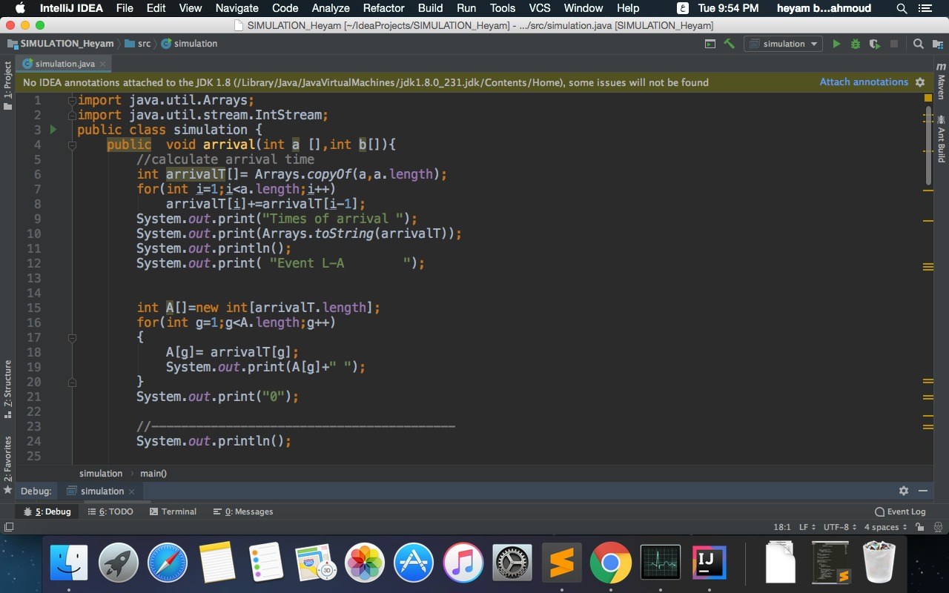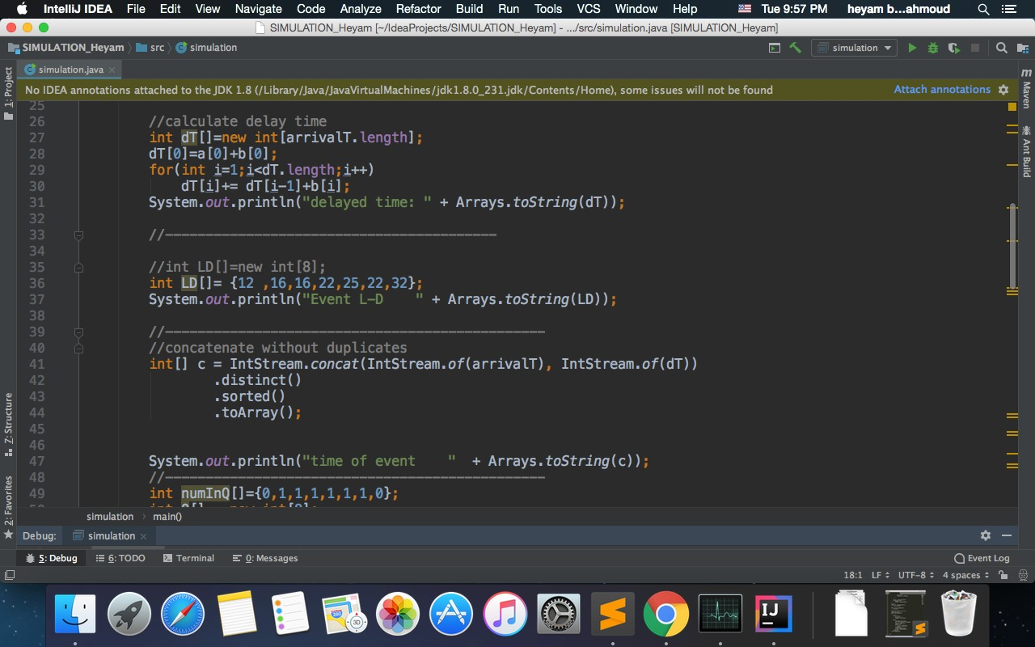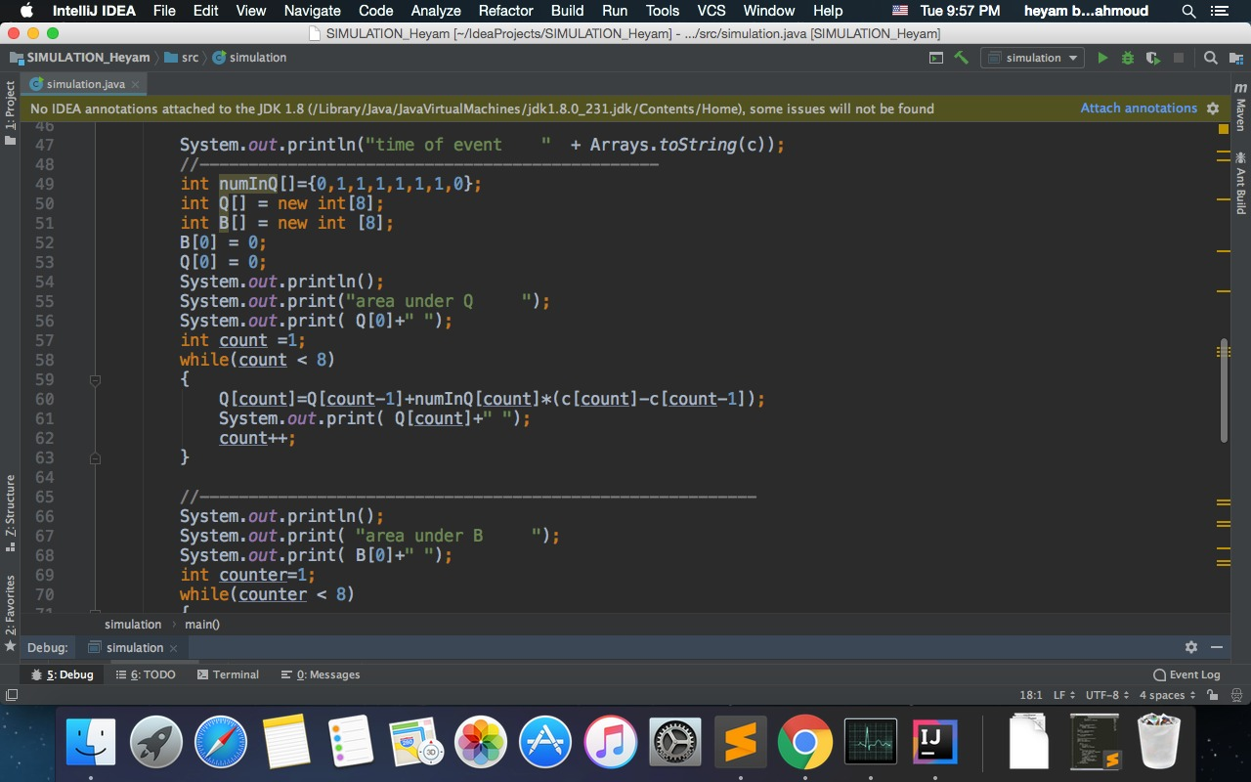

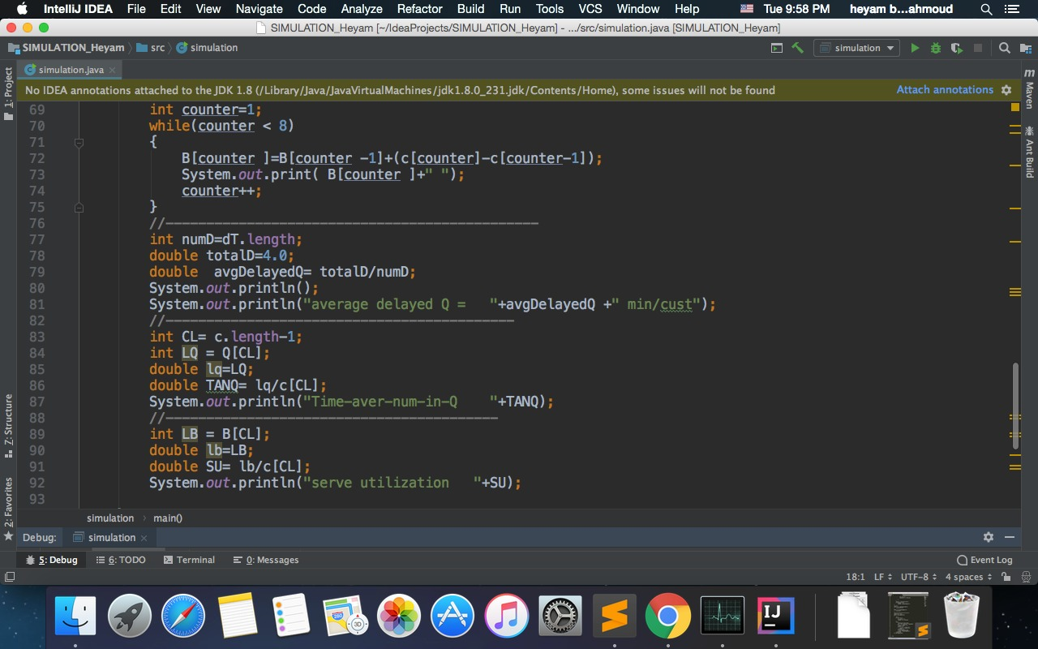

**8- Development of the models:**

Three counters to stimulate the bank waiting system 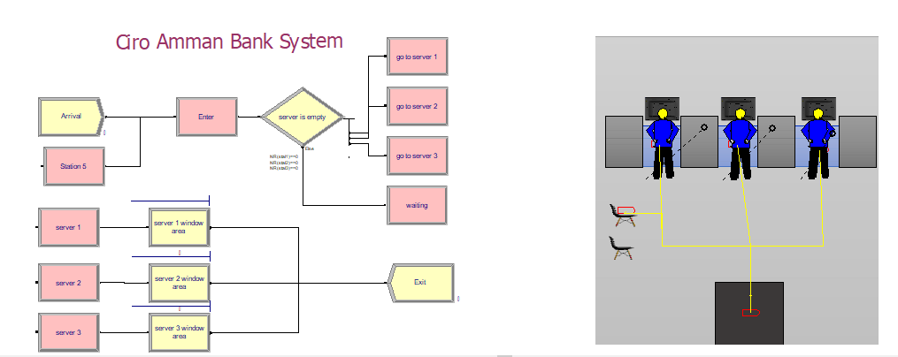

Arena Report:

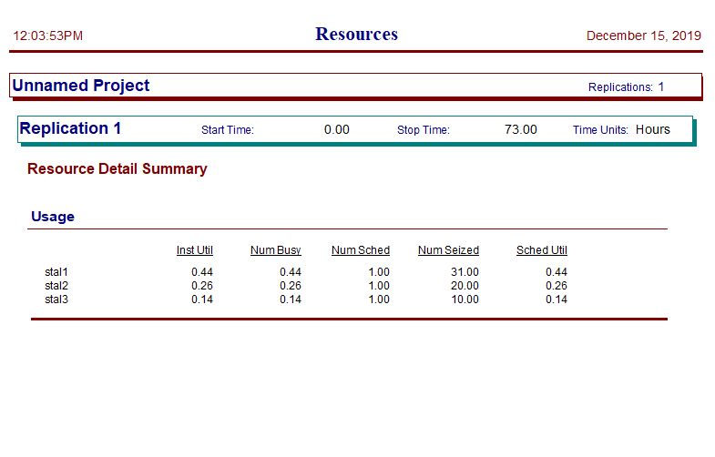

Two counters to stimulate the bank waiting system

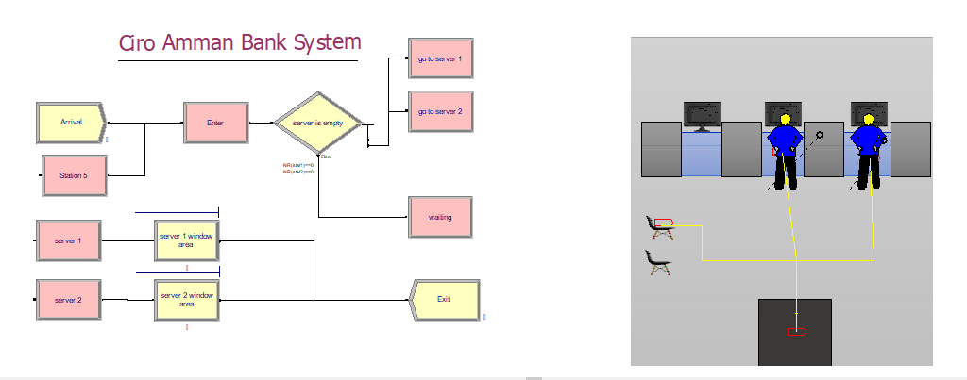

Arena Report:

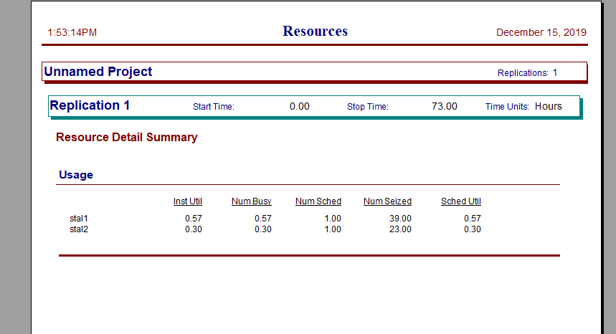

One counter to stimulate the bank waiting system

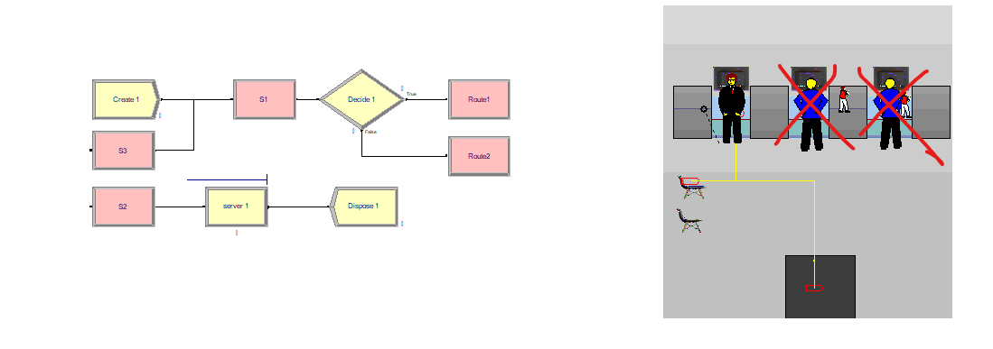 Arena Report:

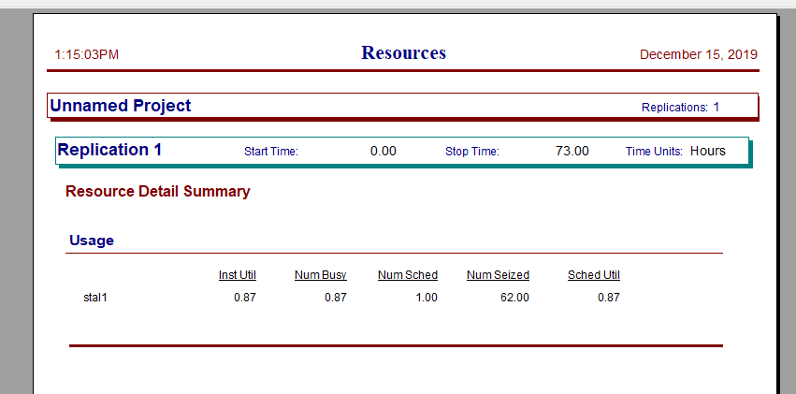

The simulation of system over 3 months:

-Number of Replications is 90, (Using three counters).

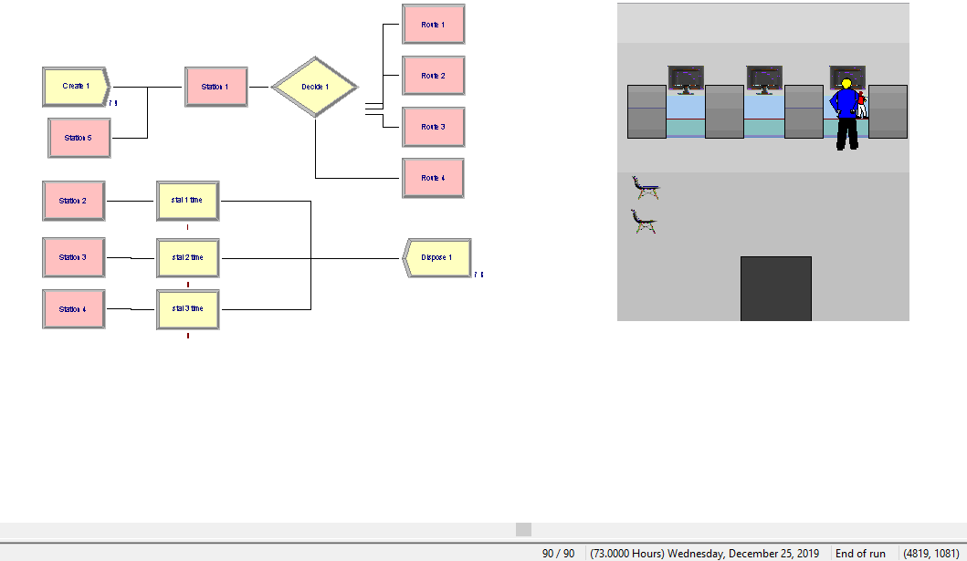

Arena report:

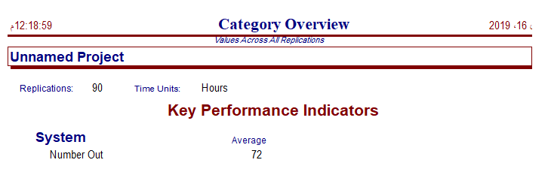

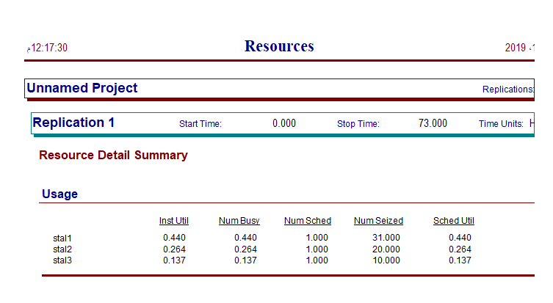

The simulation of system over 1 year:

-Number of Replications is 365, (Using three counters).

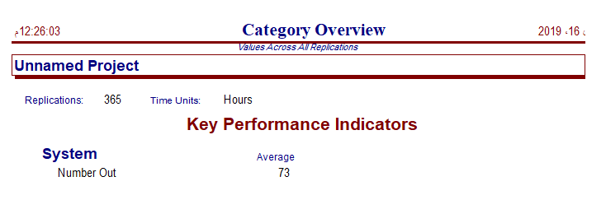

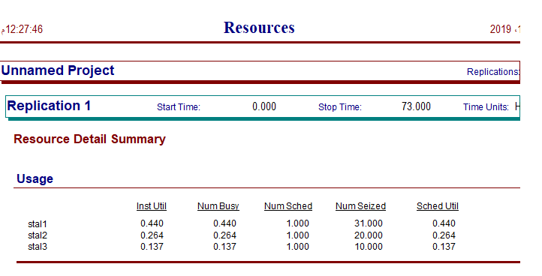

The simulation of system over 1 year:

-Number of Replications is 365, (Using two counters).

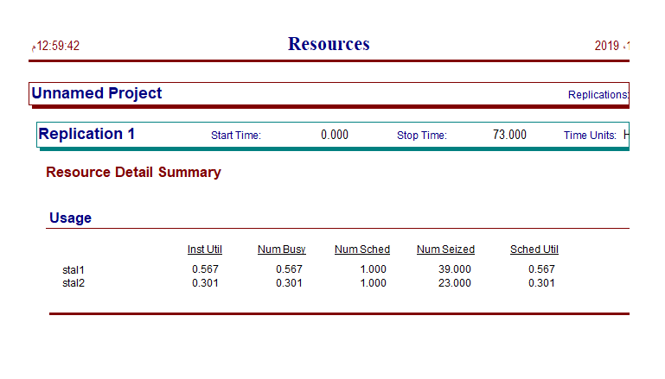

The simulation of system over 1 year:

-Number of Replications is 365, (Using one counter).

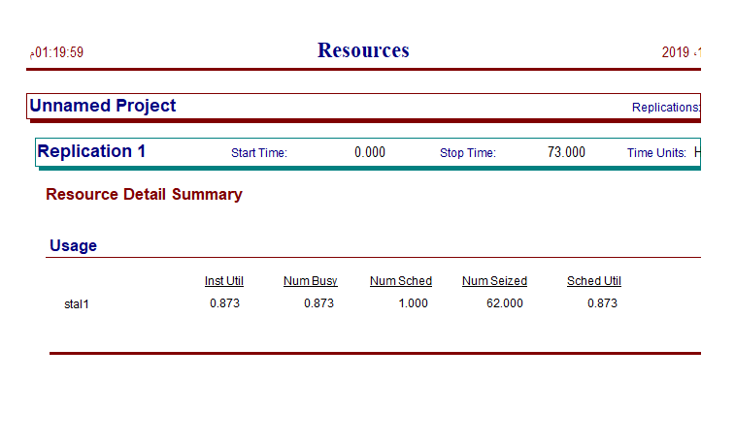

**Waiting Average in queue in case (Three counters in the bank):**

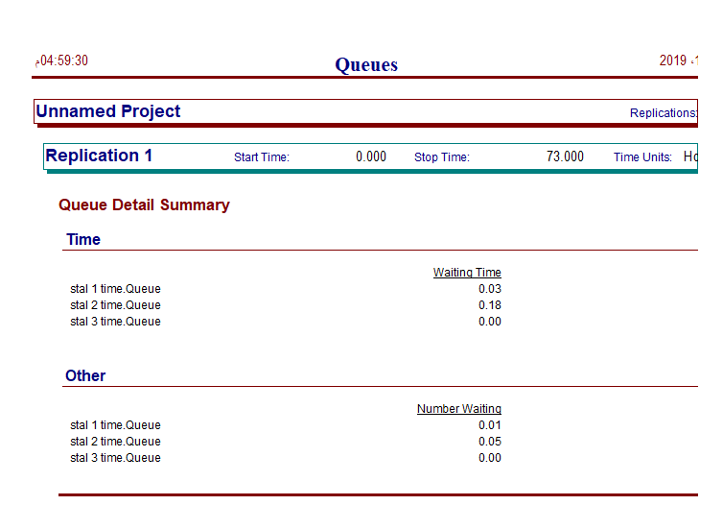

**Waiting Average in queue in case (Two counters in the bank):**

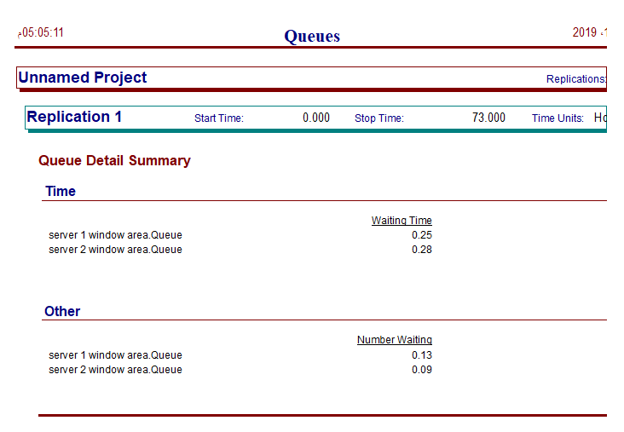

**Waiting Average in queue in case (One counter in the bank):**

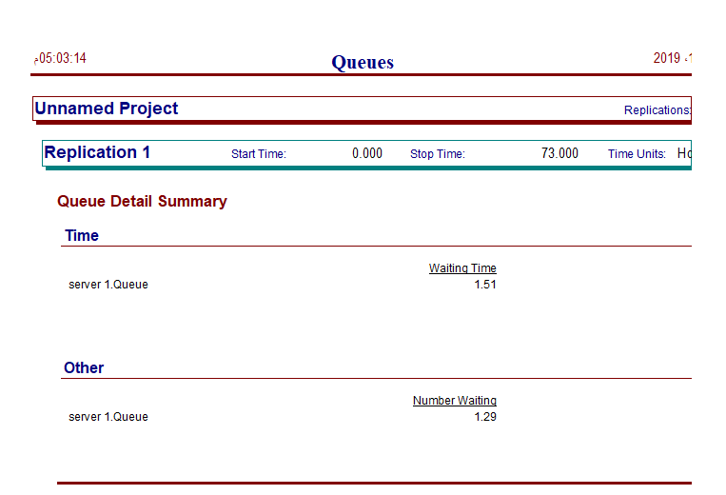

**Conclusion**:

When we use multi-server queuing system (Three counters to simulate bank waiting system ) the average utilization was 0.28 , when we use (Two counters to simulate bank waiting system ) the average utilization was 0.435 ,And when we try to use a single counter the utilization was 0.87 .

Refer to the information above the utilization in all cases was good enough, which means the system we chosen has no work pressure, but we can say that the optimal number of counters in this bank is two counters, no need for more counters.