|  |  |  |
| --- | --- | --- |
| **Problem Chosen** C | **2022 MCM/ICM Summary Sheet** | **Team Control Number** 2228187 |

**Teach You To Get Rich:**

**Risk Asset Portfolio Allocation Based An LSTM**

**Summary**

|  |
| --- |
| With the development of financial technology, more and more new currencies have entered people's field of vision. How to predict the price trend of different types of risk assets scientifically and find out the best holding combination are the concerns of many traders. In the 20th century, some scholars proposed models such as the mean-variance model to solve the static portfolio problem. After that, Cover optimized their methods and proposed a more general dynamic asset portfolio allocation model. There are many financial products available today. Classical theories seem powerless in practice. The improvement of computer computing power has brought new vitality to this problem.  We use the powerful learning ability of neural networks to learn the historical data of risk assets in order to seek laws that are difficult to find with the naked eye. We use the LSTM neural network model and input a certain amount of historical data to train the model. We also continuously tune the parameters of the model to match the real data. A model that is successfully trained can predict the price direction in the next month from recent data. It improves the deficiencies of the original classic model, lengthens the forecast period, and improves the accuracy.  In the decision-making part of the asset portfolio, we successively consider the universal portfolio strategy including transaction costs and the intuitive and wise prospective strategy. From the perspective of income effect, we retain the latter as the best solution .  Starting from two models of price forecasting and portfolio decision-making, this paper solves the portfolio investment problem of two risky assets. It has important reference significance for traders to make portfolio investment of risk assets. |

**Keywords**: LSTM; portfolio investment; risk assets; trading decision; discrete time; gold; bitcoin;

Contents

1 Introduction 3

1.1 Problem Background 3

1.2 Restatement of the Problem 3

1.3 Literature Review 4

2 Assumptions and Justifications 5

3 Notations 6

**4 Dynamic portfolio investment models of two assets..................................... .6**

4.1 Part one: LSTM price prediction model 7

4.1.1 Data description: 7

4.1.2 Model establishment 8

4.1.3 Model results: 10

4.2 Part two:Investment decision model 8

4.2.1 Initial investment decision model...........................................................................12

4.2.2 Model Summary......................................................................................................12

4.2.3 The final investment decision model.......................................................................13

5 Sensitivity Analysis 15

6 Model Evaluation and Further Discussion 15

6.1 Strengths 16

6.2 Weaknesses 17

7 Conclusion 17

References 22

# Introduction

## Problem Background

Market traders profit by buying and selling assets with volatile prices.And each transaction costs. How to make decisions to maximize the benefits is a problem that traders are very concerned about. In order to make the best buying and selling decisions, traders usually search a variety of information to predict the price trend of assets, and then dynamically adjust their combination. [1]With the development of economy and technology, scientists have proposed many models which are applicable to portfolio assets. The powerful mathematical computing ability of computers also made them start to shine in venture capital investment. Quantitative investing means selecting and trading securities using mathematical models. These mathematical models are often based on economic theories or laws observed in the market. They have been tested by a lot of data, and are compiled into programs and traded by computers almost without human intervention. [2]Programmatic trading can be divided into two levels: decision generation and decision execution. Decision generation refers to the process of calculating transaction decisions through pre-designed algorithms using various real-time and historical data as input. Decisions include which assets to buy and sell at what time and at what price, and how much to buy or sell. Decision execution is the process of using computer algorithms to optimize the execution of trading orders.[3] By establishing a mathematical model with a computer, we can calculate the optimal allocation ratio among assets with different risks, in order to obtain the maximum return under a certain risk.

## Restatement of the Problem

**problem limit**

There are two assets in the existing market, Gold and Bitcoin. The trader is holding $1000 from September 11, 2016. The transaction period is five years in total. Bitcoin can be traded on a daily basis, but gold can only be traded on days when the gold market is open. The trader's portfolio consists of cash, gold, and bitcoin, with an initial state of [1000, 0, 0], in dollars, troy ounces, and bitcoin, respectively. Gold’s transaction fee is 1% of the transaction amount, while Bitcoin’s is 2%. Each asset only needs to be paid when it is traded, and there is no charge for holding the asset.

Now need to solve the problem:

• Develop mathematical models that use only past price data to determine the best daily trading strategy, i.e. whether traders should buy, hold or sell their assets.

• What is the value of the initial $1000 investment by September 10, 2021 using the developed model?

• How can you prove that the model provides the best policy?

• Consider the sensitivity of the strategy to transaction fees, i.e. how do transaction fees affect investment strategy and outcomes?

• Explain trading strategies, models and results to traders.

## Literature Review

In 1952, Markowitz mean-variance model solved the ratio of optimal asset allocation, and was the pioneer in the field of portfolio investment.[4] Later, Fisher Black and Robert Litterman proposed the Black-Litterman model considering historical returns and the influence of investors' views on various assets. In order to facilitate practical application, scholars have proposed the CAMP model. However, these models have a series of assumptions, such as the normal distribution of returns, etc. What’more, they are all static investment models, which cannot actively make decisions based on market changes. In 1991, Cover proposed a universal dynamic portfolio strategy in discrete time in his paper. [5]After that, some experts proposed models such as index update algorithm. However, these models have inaccurate predictions of future prices or errors in iterative solutions, resulting in poor strategies. With the development of computer technology, some teams have begun to use genetic algorithms, ant colony algorithms, particle swarm algorithms and other intelligent algorithms to solve portfolio investment problems, and have achieved good results.[6]

In the price prediction of a certain asset, some scholars used the ARMA model to predict the stock price, and achieved good results in empirical analysis. There are also teams using traditional BP neural networks, recurrent neural networks, LSTM neural networks, etc. to predict stock prices. [7]Their research not only considers the historical data of the stock, but also thinks about many factors such as market information. It also has a good forecasting effect.

# Assumptions and Justifications

# 1. Gold and Bitcoin price movements can be predicted.

Gold has both commodity properties and financial properties. Gold's movements are not completely random. A variety of factors such as oil prices, dollar trends, political situations, inflation, etc. will affect the price of gold. Knowing about all kinds of information can help people predict the price trend of gold to a certain extent. As a digital currency, the price of Bitcoin is related to factors such as industry information and investor behavior. Similarly, it can be predicted.

2. Decentralized investment has low risk, high returns, and is more in line with actual behavior.

Many classic finance textbooks show that not putting all your eggs in one basket is a wise investment. It can significantly reduce the risk of investment, while also increasing the rate of return to a certain extent. Decentralized investing is also a widely used investment strategy in today's stock market. Specifically, when the price of a currency falls (not plummets), most people tend not to sell them all.

3. During the non-trading days of gold, Bitcoin does not trade.

Gold's non-trading days are short in duration, usually just two days. In the past two days, the price of Bitcoin has stabilized, and there is no sharp rise or fall. Therefore, from the perspective of simplifying the design of the model, it can be prohibited to operate on Bitcoin on non-trading days of gold.

# Notations

Table 1: Notations used in this paper

|  |  |  |
| --- | --- | --- |
| **Symbol** | **Description** | **Unit** |
|  | The share of the i-th asset value in the total asset value on day k | % |
|  | The transaction rate for the i-th asset | % |
|  | Total asset value on day k | Dollar |
|  | Total transaction fee on day k | Dollar |
|  | A very small constant | \ |
|  | Coefficient to balance maximizing wealth growth and minimizing transaction fees | \ |
|  | The return on the i-th asset on day k | % |
|  | Gold Yield | % |
|  | Bitcoin Yield | % |
|  | Gold transaction rates | % |
|  | Bitcoin transaction rates | % |
|  | Model Evaluation Parameter | \ |
|  | The actual price of the i-th asset | Dollar |
|  | Predicted price of the i-th asset | Dollar |
|  | total time | \ |

**4 Dynamic portfolio investment models of two assets**

In this part, we divide the investment model of gold and bitcoin into two parts, one is the prediction model of bitcoin and gold prices, and the other is the model of investment decision-making under the premise of known price trends.

**4.1 Part one: LSTM price prediction model**

## 

## **4.1.1** Data Description

Figure 1:Real price of gold over time line

Figure 2:Real and predicted price of bitcoin over time line

**Analysis:** As a long-established currency with financial attributes, the price of gold is relatively stable Bitcoin, as a digital currency, has gained popularity in recent years. Its price is not as stable as gold, and there will be larger ups and downs. But after observation, it is not difficult to find that price fluctuations are usually measured in months.

**Enlightenment:** This shows that we cannot rely too much on the previous data when training the model, and there must be a forgetting period.

**4.1.2 Model establishment**

In this section, we use a neural network to learn historical price data of a risky asset. Neural networks have powerful learning and thinking abilities, and they can learn the laws that are hard to find with the naked eye in the data. [8]The input in this model is a series of time price series, and the output is the predicted price one or more days in the future. The price prediction process requires the neural network to retain some of the past learning memory and apply it to the prediction process. Considering the characteristics mentioned earlier, we choose Long Short-Term Memory networks (LSTM ,in short) to build this model.[9]

We train the neural network using the following method:

Step1: Randomly select several consecutive price sequences of length 15 from the historical data of the past 730 days, and use these sequences to train the initial LSTM.

Step2: Input the price data of the last 14 days into the LSTM network to get the feature value of this time. Then pass the eigenvalues through the sigmoid function and a linear layer to get the predicted price for the next day.

Step3: If you need to predict prices for multiple days, use the next day's price predicted in step2 as the known data, then clear the LSTM model, and go back to step1 to start again until the predicted price data is enough.

Step4: Clear the LSTM to prepare for the next prediction.

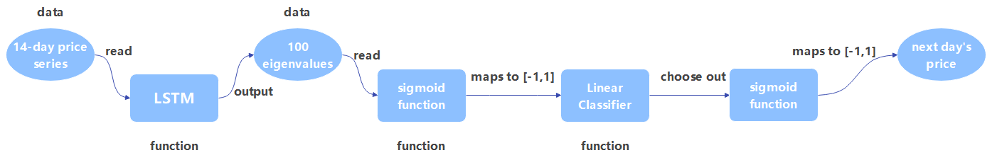

Figure 3:Neural network structure diagram

**Description of the figure:** *The price prediction model is mainly composed of four parts, which are the LSTM neural network layer, two sigmoid functions and a linear layer. The role of LSTM is to learn the laws of past data and output one hundred feature values based on recent data. The main function of the sigmoid function is to map a large range of price data to the [-1,1] interval to improve the simulation effect of the model. The function of the linear layer is to linearly map 100 eigenvalues to a value.*

Considering the timeliness of training data, we specially set the forgetting mechanism when designing the model. The forgetting mechanism is reflected in two aspects.[10] First, the training data only selects the data of the last two years, and discards the data two years ago. The second is that whenever the time is delayed by one day and new data is added, we clear and reset the LSTM and retrain. In this way, in theory, all input data almost have the same weight in training, and practice has also proved that this method can achieve better training results.

## **4.1.3** The Solution of Model 1

In order to evaluate the quality of the model under different parameters, a model evaluation function is introduced：

 (1)

where gold's model evaluation function  is 93.98% and bitcoin's model evaluation function  is 95.72%.

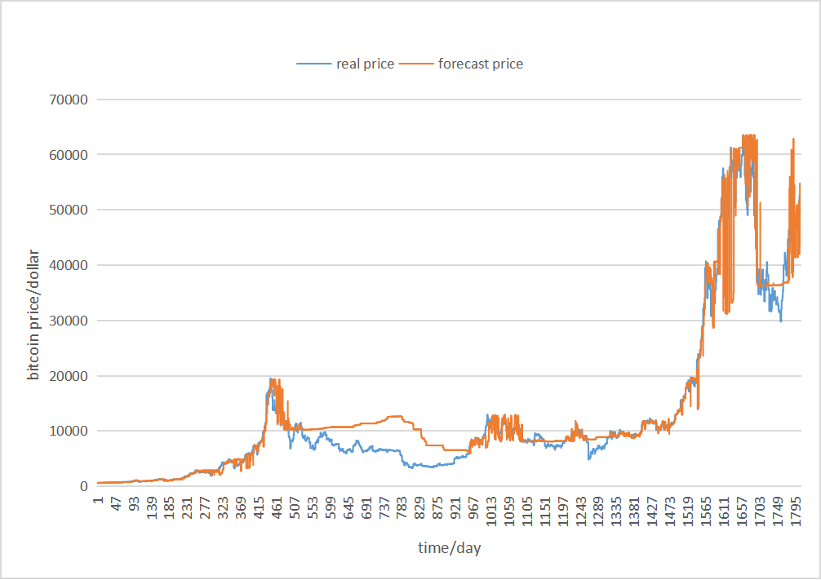

Figure 4:Real and predicted price of bitcoin over time line

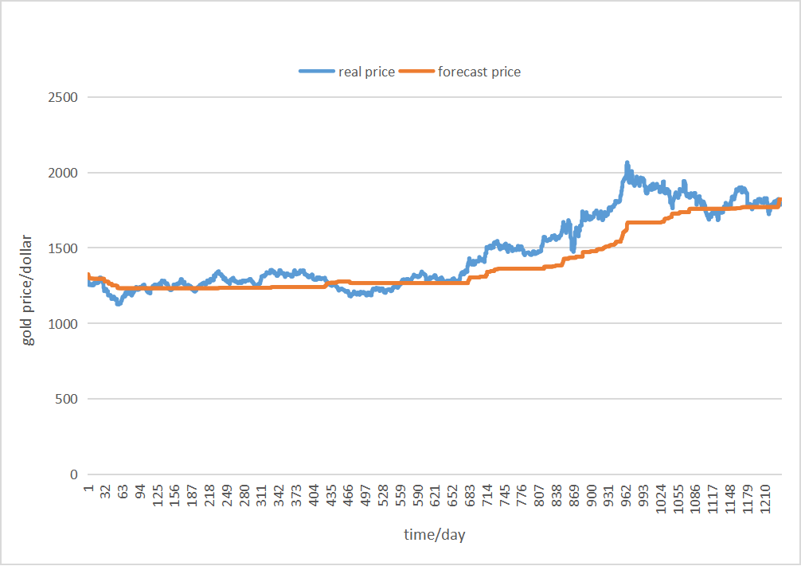

Figure 5:Real and predicted price of gold over time line

**4.2.1 Initial investment decision model**

Investors' purpose is how to choose  to maximize F, where

 (2)

 (3)

 (4)

In the above formula,is a linear function of ，is a concave function of ，so is a concave function of , The local maximum of is the global maximum.It can be obtained according to the Lagrange maximum likelihood method：

 (5)

**4.2.2 Model Summary**

strength

1) The model takes into account transaction costs and expected prices. It is suitable for use in combination with other models that predict prices. This model is a universal investment strategy.

weaknesses

1) The Tk+1 equation contains an absolute value, which is difficult to solve. The algorithm using brute force search can obtain an approximate solution when the step size is 0.1 USD. However, the existence of this approximate solution will further increase the uncertainty of the model, and eventually lead the trading strategy to be far from the ideal situation.

2) The asset ratio of day k+1 solved by this model is not much different from that of day k in many cases. This leads to its decision to buy or sell a small amount every day, making it difficult to make money.In our simulations, the model ended up losing money.

**4.2.3 The final investment decision model**

Drawing lessons from the initial decision model in 4.2.1, in this section we adopt a more intuitive investment decision. We give up the idea of ​​short-term investment and make medium- and long-term investment instead. That is to say, the investment ratio of assets is no longer changed frequently every day. Transactions are carried out every half month. When it is predicted that there will be slight fluctuations in the market, no transaction will be carried out. The trading operation will only be carried out when a relatively large change is predicted. In order to be able to predict the market price trend, the model in 4.1 needs to predict the price in the next 30 days.

At the same time, we also combine the idea of ​​diversification to make decisions. Whether it is the investment practice in the financial market or many books on finance, they all tell us a truth--don't put all your eggs in the same basket. An obvious example is that for two stocks with equal returns and risks, buying two stocks is less risky than buying one. To learn this idea, when an asset is expected to decline significantly, we do not sell all of the asset, but a larger portion. The sell scale factor is 0.8, which is a good empirical value used in the modeling process.

As a wise decision maker with a long-term view, we should be good at using the model instead of blindly trusting it in order to make more money. When the deviation between the predicted price and the actual price is found to be greater than a certain threshold, we discard the policy specified by the model. The addition of this hedging mechanism can reduce the risk.

Our specific trading strategy is

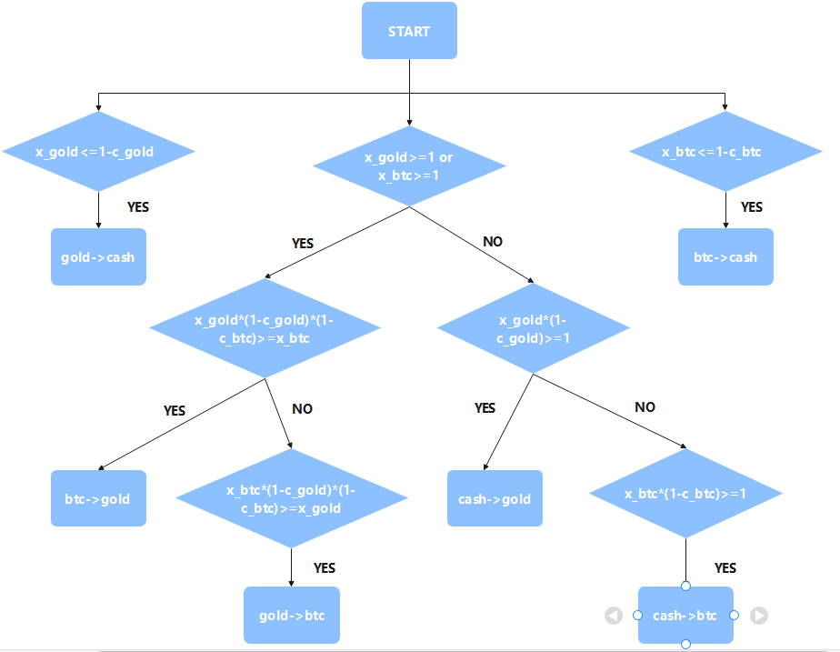

Figure 6: Specific trading strategy

1) If the gold yield is less than or equal to 1-gold transaction rate, it means that gold is more valuable. So we exchange gold for cash.Bitcoin is the same as gold.

2) If the gold yield or Bitcoin yield is greater than or equal to 1, we need to consider whether to transfer the asset to the party with the higher yield. So we calculate the gold rate of return*(1-gold transaction rate)*(1-bitcoin transaction rate), and judge whether it is greater than or equal to the bitcoin rate of return.If so, replace bitcoin with gold, otherwise judge bitcoin in the same way . And if so, exchange gold for bitcoin.

3) If the gold yield or bitcoin yield is less than 1, then judge whether the gold yield * (1-gold transaction rate) is greater than or equal to 1. If so, it means that gold is making money, then exchange cash for gold. Otherwise ,in the same way to judge Bitcoin, if so, exchange cash for Bitcoin.

**5.sensitivity analysis**

When the internal parameters of the model change, the output of our model changes greatly. This reflects the high sensitivity of our model.

Example 1: When changing the sell-off ratio in decision-making, we take the values 0.8, 0.5 and 1 respectively, and finally found that when the sell-off ratio is 0.8, the effect is the best and the most money is made

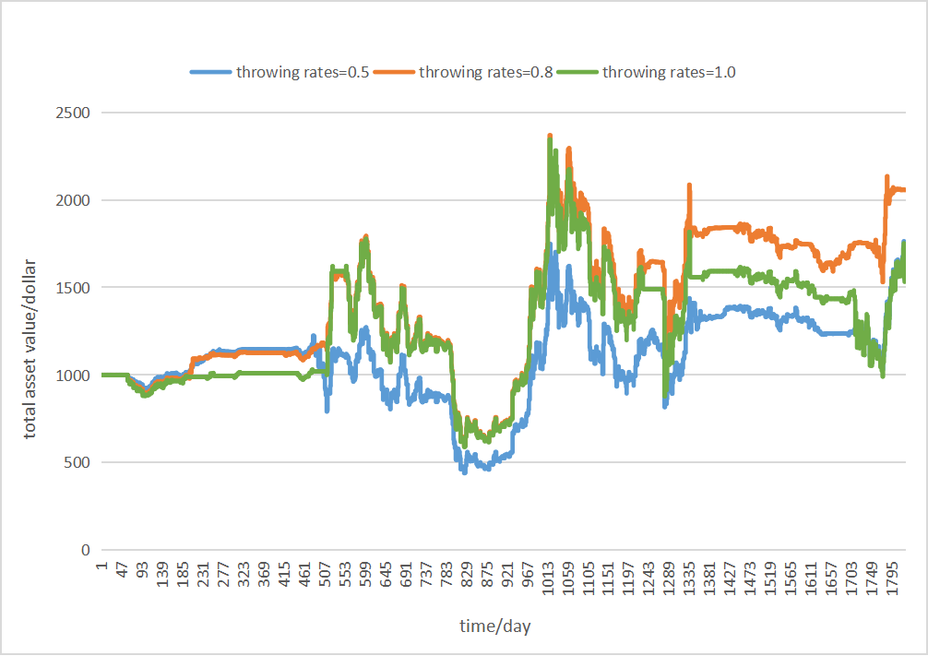

Figure 7:Polyline of total asset value change over time under three throwing rates

Example 2: When the number of eigenvalues of LSTM is reduced to 8, the obtained price is expected to be too different from the real value. This shows that too few eigenvalues cannot accurately predict the price movement of an asset.

Example 3: When the transaction fee becomes 10 times or 0.1 times, the final income will decrease.

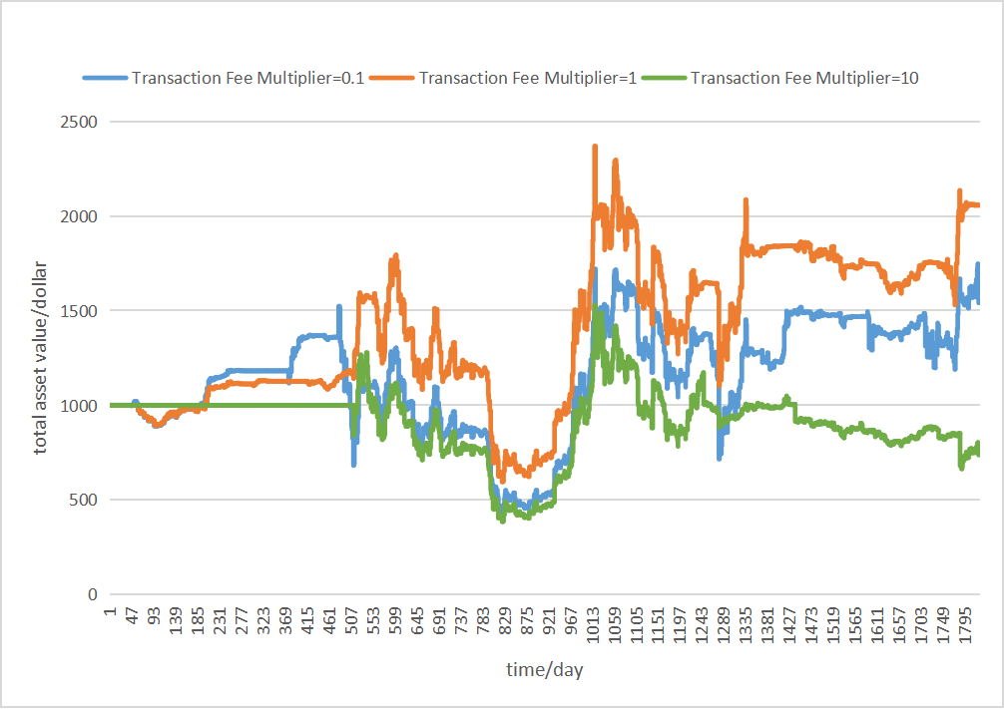

Figure 8:Polyline of total asset value change over time under three transaction expense ratios (throwing rate=0.8)

**6. Model Evaluation and Further Discussion**

**The pros and cons of the model**

**6.1 Strengths**

1) The LSTM used to predict future prices has strong learning ability and long prediction time. The parameters we set, such as sequence length, etc., can play a better role in the prediction of Bitcoin and gold.

2) The decision-making model is intuitive and effective. It is decision-oriented rather than investment ratio-oriented, which is convenient for investors to calculate the transaction amount.

**6.2 Weaknesses**

1) The predicted prices cannot all fit the real data perfectly. This is because Bitcoin or gold is affected by other factors that cannot be accounted for in the model.

**7.Conclusion**

1. It is not difficult to obtain from the modeling calculation results in 4. The $1000 on September 11, 2016 has become $2055.359865 by September 10, 2021. The growth rate reached about 106%. At this point all assets are almost entirely in cash.

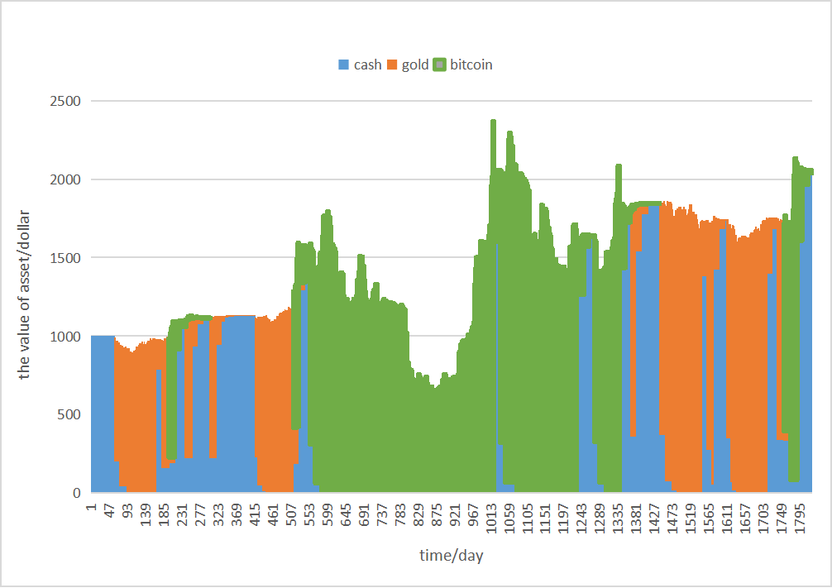

Figure 9: Polyline of the value of the three assets over time(throw rate=0.8)

2. Our strategy can be shown to be optimal in many ways. When building the LSTM neural network, we selected up to 100 eigenvalues to strive for prediction accuracy. We also take into account real market behavior to reduce the impact of forecast bias when making trading decisions .

To give a simple example: the empirical value of 0.8 for the sell-off rate in the investment decision model is the best in practice.

We experimented with a range of values, and for the sake of clarity and visibility of the chart, we only plotted the sell-off ratios of 0.5, 0.8, and 1.



Figure 10:Polyline of total asset value change over time under three throwing rates

From the image, it is obvious that the sell-off ratio of 0.8 has the most total assets, which fully justifies our strategy.

3. Our model is sensitive to changes in transaction rates. We changed the transaction rate to the original 0.1 times and 10 times and then tested results respectively. The result is shown in the figure below.



Figure 11:Polyline of total asset value change over time under three transaction expense ratios (throwing rate=0.8)

It can be seen from the figure that if the ratio of gold and bitcoin transaction rates remains unchanged, and the transaction rate is increased or decreased at the same time, the income will decrease. The decrease is more obvious when the transaction rate increases than when the transaction rate decreases. This shows that the model is more sensitive to the increase in transaction rates. When the trading rate is expanded tenfold, there will also be losses in the simulation.

**Letter**

Dear Trader,

Hello! It is an honor to develop a trading model for you. We analyzed data from the past nearly five years. Based on your needs, we have developed a dynamic investment model for gold and bitcoin using LSTM neural networks. In our experiment, the yield of this model is as high as 105%, and the yield is relatively stable, which you can trust. I believe this model can help you reduce a lot of workload.

We can't wait to introduce our models and decisions to you.

The model is mainly composed of a price prediction model and an investment decision model.

1) A price prediction model can predict where the price will go one month in the future (could be longer whenever you want). Of course, you can also adjust the length of the forecast time. The model is implemented based on LSTM neural network, which has strong learning ability. We use these five years of data for training, and continuously adjust the values ​​of related parameters to the optimum. We also set up a forgetting mechanism according to the transaction characteristics of gold and bitcoin to make the fitting curve closer to the real value. On the basis of price prediction, you can trade based on your wealth of experience, or you can trust our investment decision model, which will give you a smart strategy.

2) Our investment decision model is guided by investment behavior, and you can intuitively understand the operation of the transaction according to the model results. In the model, we adopt the method of medium and long-term investment, and abandon short-term investment (in the simulation, the transactions are frequent and cannot make money). At the same time, we have also incorporated the idea of diversifying investment to further reduce the risk of investment. Finally, we also added a prediction and compensation mechanism. If there is a big difference between the expected and the actual, immediate measures will be taken. You don't have to worry about losing too much.

Our trading strategy is as follows.

1) If the gold yield is less than or equal to 1-gold transaction rate, it means that gold is more valuable. So we exchange gold for cash.Bitcoin is the same as gold.

2) If the gold yield or Bitcoin yield is greater than or equal to 1, we need to consider whether to transfer the asset to the party with the higher yield. So we calculate the gold rate of return*(1-gold transaction rate)*(1-bitcoin transaction rate), and judge whether it is greater than or equal to the bitcoin rate of return.If so, replace bitcoin with gold, otherwise judge bitcoin in the same way . And if so, exchange gold for bitcoin.

3) If the gold yield or bitcoin yield is less than 1, then judge whether the gold yield * (1-gold transaction rate) is greater than or equal to 1. If so, it means that gold is making money, then exchange cash for gold. Otherwise ,in the same way to judge Bitcoin, if so, exchange cash for Bitcoin.

Thank you for your trust. Hope our model can help you

Yours

Sincerely,

# 

# References

[1]Time Hierarchical Decision Matrix Algorithm Based on T.Cover Model [J]. Zheng Xiaowei, Gong Zhaoren. Computer Engineering. 2002(02)

[2]Zheng Xiaowei, Liu Qingkun, Li Tianqi. Parallel Research on T.cover Optimal Investment Decision Model in Cluster Environment [J]. Computer Engineering and Applications, 2006(06):107-109.

[3]Zheng Xiaowei, Gong Zhaoren. Time Hierarchical Decision Matrix Algorithm Based on T.Cover Model [J]. Computer Engineering, 2002(02):142-143+151.

[4]Chen Jiesi, Ye Han. Comparison of the effectiveness of risk parity strategy and mean variance strategy [J]. Fortune Times, 2021(05):231-233+236.

[5]Wang Dong. Application of mean-variance model in asset allocation under the framework of investment clock [J]. Journal of Anyang Normal University, 2020(05):76-80.DOI:10.16140/j.cnki.1671-5330.2020.05.020 .

[6]Zhao Yuanying, Hou Ying, Gu Dagang, Xu Dengke. Bayesian Variable Selection for Joint Mean and Variance Models [J]. Statistics and Decision Making, 2019, 35(15): 10-13. DOI: 10.13546/j. cnki.tjyjc.2019.15.002.

[7]Xu Heyue. Application of Mean Variance Model and Consumption Function in Personal Finance Issues [J]. Curriculum Education Research, 2018(40):248-249.

[8]Fang Yiqiu, Lu Zhuang, Ge Junwei. Stock Price Prediction of Combined RMSE Loss LSTM-CNN Model [J/OL]. Computer Engineering and Applications:1-10[2022-02-22].http://kns.cnki.net/kcms/detail/11.2127.TP.20220217.1644.008.html.

[9]Liu Ying, Yang Chaoyu. LSTM gas concentration prediction model based on multi-factors [J]. China Safety Production Science and Technology, 2022, 18(01): 108-113.

[10]Nie Qian, Yang Lihua, Hu Bo, Ren Lulu. Time-varying channel prediction method based on LSTM neural network under the base extension model.http://kns.cnki.net/kcms/detail/11.2422.TN.20220128.1438.004.html.