2 perspectives for evaluating a classification:
Macro perspective: accuracy_score, classification_report,precision_score, recall_score
Micro perspective: confusion matrix

1, accuracy_score
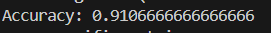
2,classification report
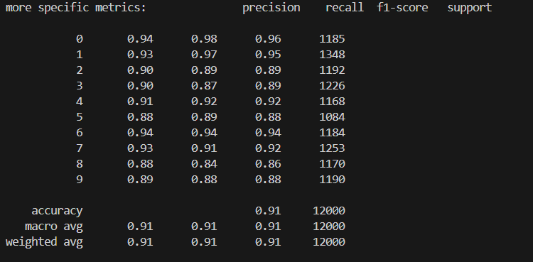

3, confusion matrix
