My Name Is Heyi. If I Were a Package I’d Be NumPy
Heyi Cao
2026-09-13
Abstract
This manuscript introduces who I am, my interests, and what I hope to learn from this course.
Table of contents

1. Who I Am
I’m Heyi Cao, a student at UW–Madison studying computer science. Although computer science is my main academic focus, many of my interests also involve visual and creative work, especially photography, aviation, and 3D design.
I am taking this course because I want to build the skills necessary for future research. In particular, I hope to learn how to approach problems in a more systematic way: identifying a question, collecting and organizing evidence, testing possible explanations, and communicating results clearly. I also want to become more comfortable with tools and workflows that support reproducible research, so that my work can be understood, checked, and built upon by others.

2. If I Were a Package
If I were a Python package, I would be NumPy. According to the official NumPy documentation, NumPy is a fundamental package for scientific computing in Python (NumPy Developers 2026).
- I identify with it because it provides a foundation for many different kinds of work:
  - data analysis
  - scientific computing
  - machine learning.
- NumPy has also become an important foundation for scientific computing in the Python ecosystem (Harris et al. 2020). I also value building strong fundamentals and creating something that others can use as a foundation for their own work.
 Why NumPy?
I like the idea of creating tools that can become a foundation for other people’s work.

3. NumPy Demonstration
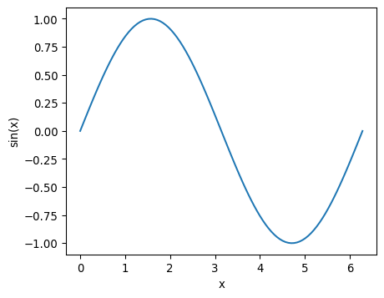
Figure 1: A sine wave generated using NumPy.
As shown in Figure 1, NumPy can generate and transform numerical data that can then be visualized clearly.

3.1 Working with Arrays
Table 1: Summary statistics calculated using NumPy.
 | Statistic | Value
0 | Mean | 9.4
1 | Minimum | 4.0
2 | Maximum | 15.0

Table 1 shows the max, mean, and min values of the given array.
Harris, Charles R., K. Jarrod Millman, Stéfan J. van der Walt, et al. 2020. “Array Programming with NumPy.” Nature 585 (7825): 357–62. https://doi.org/10.1038/s41586-020-2649-2.
NumPy Developers. 2026. What Is NumPy? https://numpy.org/doc/stable/user/whatisnumpy.html.

The original values are not shown.

