Name | Surti Keyur
Roll No. | 25MCE026
Branch | M.Tech (CSE)

Experiment 4

Aim: To implement the Make-Change problem using the Greedy approach

Overview
The task is to determine the minimum number of coins/notes needed to make a given amount using available denominations.
In this practical, we implement the solution using the Greedy approach, which works by always choosing the largest possible denomination that does not exceed the remaining amount. This strategy is efficient and works optimally for most real-world currency systems (like Indian Rupees or US Dollars).
This experiment helps to:
- Understand the concept of Greedy algorithms.
- Learn how to apply Greedy logic to real-world problems.

Source Code

#include <iostream>
#include <algorithm>
#include <vector>
using namespace std;

// Function to find minimum number of coins/notes
void makeChange(int amount, vector<int> denominations) {
// Sort denominations in descending order
sort(denominations.rbegin(), denominations.rend());

cout << "Amount to be changed: " << amount << endl;
cout << "Coins/Notes used: ";

int totalCoins = 0;
for (int coin : denominations) {
if (amount >= coin) {
int count = amount / coin; // how many coins of this type
amount -= count * coin; // reduce the remaining amount
totalCoins += count; // add to total coin count

for (int i = 0; i < count; i++) {
cout << coin << " ";
}
}
}

cout << "\nTotal coins/notes used = " << totalCoins << endl;
}

int main() {

vector<int> denominations = {1, 2, 5, 10, 20, 50, 100, 500, 2000};

int amount;
cout << "Enter amount: ";
cin >> amount;

makeChange(amount, denominations);

return 0;
}

Output

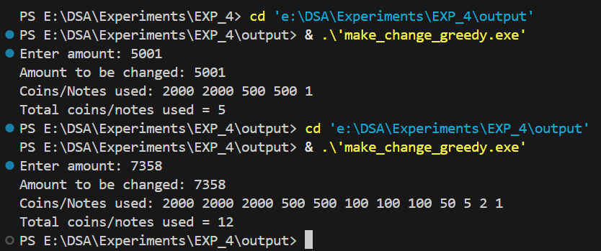

Time and Space Complexity
- Time Complexity:
  - Sorting denominations: O(d log d) (but if already sorted → O(d))
  - Iterating through denominations: O(d)
  - Overall: O(d log d) or O(d) if predefined sorted
- Space Complexity:
  - Uses only a few variables and the denominations array.
  - O(d) for denominations, O(1) extra space.

Conclusion
The Greedy algorithm for the Make-Change problem is simple and efficient when applied to real-world currency systems. It provides an optimal solution in O(d) time by always selecting the largest possible denomination first. Although Greedy may fail for arbitrary coin sets, it works perfectly in practice for commonly used denominations, making it a practical and effective method.

