Name | Surti Keyur
Roll No. | 25MCE026
Branch | M.Tech (CSE)

Experiment 5

Aim: Implement Kruskal's algorithm to find MST using greedy approach

Overview
Kruskal’s Algorithm is a Greedy Algorithm for finding the MST.
- It sorts all edges in non-decreasing order of weights.
- Iteratively, the shortest edge is selected, provided it does not form a cycle with the edges already included in MST.
- Cycle detection is efficiently handled using Disjoint Set Union (DSU).
- The algorithm stops when the MST contains exactly V – 1 edges (where V is the number of vertices).

Source Code

#include <bits/stdc++.h>
using namespace std;

// Structure to represent an edge
struct Edge {
int u, v, w;
bool operator<(const Edge& other) const {
return w < other.w; // sort by weight
}
};

// Disjoint Set Union (Union-Find) with path compression
class DSU {
vector<int> parent, rank;
public:
DSU(int n) {
parent.resize(n);
rank.resize(n, 0);
for (int i = 0; i < n; i++) parent[i] = i;
}

int find(int x) {
if (parent[x] != x)
parent[x] = find(parent[x]); // path compression
return parent[x];
}

bool unite(int x, int y) {
int xr = find(x), yr = find(y);
if (xr == yr) return false; // cycle
if (rank[xr] < rank[yr]) swap(xr, yr);
parent[yr] = xr;
if (rank[xr] == rank[yr]) rank[xr]++;
return true;
}
};

// Kruskal’s Algorithm
void kruskalMST(int V, vector<Edge>& edges) {
sort(edges.begin(), edges.end()); // step 1: sort by weight

DSU dsu(V);
vector<Edge> mst;
int totalWeight = 0;

for (auto& e : edges) {
if (dsu.unite(e.u, e.v)) { // if no cycle
mst.push_back(e);
totalWeight += e.w;
}
}

// Print result
cout << "Edges in MST:\n";
for (auto& e : mst) {
cout << e.u << " -- " << e.v << " == " << e.w << "\n";
}
cout << "Total Weight of MST = " << totalWeight << endl;
}

// Driver Code
int main() {
int V, E;
cout << "Enter number of vertices and edges: ";
cin >> V >> E;

vector<Edge> edges(E);
cout << "Enter edges (u v w):\n";
for (int i = 0; i < E; i++) {
cin >> edges[i].u >> edges[i].v >> edges[i].w;
}

kruskalMST(V, edges);
return 0;
}

Output

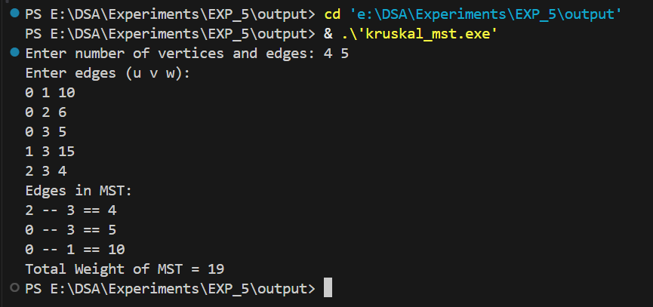
Time Complexity
- Sorting edges: O(E log E)
- Union-Find operations: Nearly O(E) (amortized)
- Total Complexity: O(E log E)
Space Complexity
- Storing edges: O(E)
- DSU parent and rank arrays: O(V)
- Total Space: O(V + E)

Conclusion
- Kruskal’s Algorithm successfully finds the Minimum Spanning Tree (MST) using the Greedy Approach.
- The Disjoint Set Union (DSU) efficiently avoids cycles during edge selection.
- The MST guarantees the minimum total weight required to connect all vertices of the graph.
- Time complexity of O(E log E) makes it suitable for sparse graphs (where E is much less than V²).

