Name | Surti Keyur
Roll No. | 25MCE026
Branch | M.Tech (CSE)

Experiment 8

Aim: To implement the Matrix Chain Multiplication (MCM) algorithm using Dynamic Programming, print the DP cost table, and calculate the minimum number of scalar multiplications required to multiply a sequence of matrices.

Problem Statement
Given a chain of matrices A1, A2, A3, ..., An where matrix Ai has dimensions p[i−1] × p[i], determine the most efficient order to multiply the matrices so that the total number of scalar multiplications is minimized.

Theory
Matrix multiplication is associative; however, different parenthesizations yield different multiplication costs. Dynamic Programming is used because the problem contains optimal substructure and overlapping subproblems.

Algorithm
1. Read number of matrices.
2. Store matrix dimensions in p[].
3. Create DP table dp[n+1][n+1].
4. Initialize dp[i][i] = 0.
5. For chain length L = 2 to n:
For each valid i:
Compute j = i + L − 1
For each k from i to j−1:
Compute cost = dp[i][k] + dp[k+1][j] + p[i−1] × p[k] × p[j]
Choose minimum.
6. Print DP table.
7. Final result = dp[1][n].

Source Code
#include <iostream>
#include <vector>
#include <iomanip>
#include <climits>
using namespace std;

void matrixChainOrder(const vector<int>& p) {
int n = p.size() - 1;
vector<vector<int>> dp(n + 1, vector<int>(n + 1, 0));

for (int L = 2; L <= n; L++) {
for (int i = 1; i <= n - L + 1; i++) {
int j = i + L - 1;
dp[i][j] = INT_MAX;
for (int k = i; k < j; k++) {
int cost = dp[i][k] + dp[k + 1][j] + p[i - 1] * p[k] * p[j];
dp[i][j] = min(dp[i][j], cost);
}
}
}

// Print DP Table in matrix-style format
cout << "\nMatrix Chain Multiplication DP Table:\n";
cout << "--------------------------------------\n\n";

// Print column headers
cout << setw(6) << " ";
for (int j = 1; j <= n; j++)
cout << setw(6) << j;
cout << "\n";

// Print rows
for (int i = 1; i <=n; i++) {
cout << setw(3) << i << " "; // row index
for (int j = 1; j <= n; j++) {
if (i > j)
cout << setw(6) << "-";
else
cout << setw(6) << dp[i][j];
}
cout << "\n";
}

cout << "\nMinimum number of multiplications is: " << dp[1][n] << endl;
}

int main() {
// Example: 6 matrices
// Dimensions: A1(30x35), A2(35x15), A3(15x5), A4(5x10), A5(10x20), A6(20x25)
vector<int> p = {30, 35, 15, 5, 10, 20, 25};

matrixChainOrder(p);

return 0;
}

Output
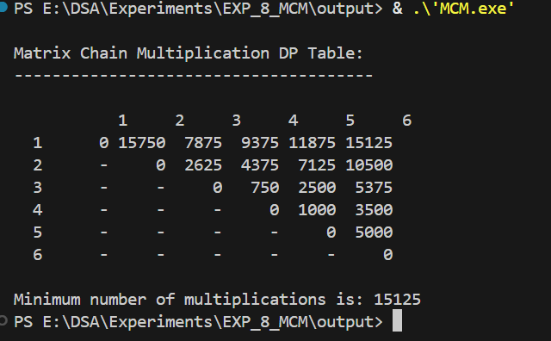
The minimum number of multiplications for the example input is 15125.

Time & Space Complexity
Time Complexity: O(n³)
Space Complexity: O(n²)

Conclusion
Matrix Chain Multiplication demonstrates how Dynamic Programming reduces computation by dividing the problem into smaller overlapping subproblems and combining their solutions efficiently.

