AI Usage DISCLOSURE FORM

1. Team Details
Team Name: SRM_4bidden_Theme1
Project / Product Name: Agentic Code Intelligence
Organization / Institution (if any): SRM Institute of Science and Technology (SRMIST)
Submission Date: 30 September 2026

2. AI Usage Declaration
Did your team use any Artificial Intelligence (AI) in developing this project? Yes / No
Yes

3. Purpose of AI Usage ( Brief Details)
Idea generation / brainstorming: Used ChatGPT to discuss possible approaches for code retrieval and project structure.
Code generation or assistance: Used ChatGPT for help with implementation ideas, code explanations, and troubleshooting.
UI / UX design: Used ChatGPT to discuss layout and interface improvements.
Content creation: Used ChatGPT to help draft and refine the README, presentation content, and demo script.
Data analysis: No AI-generated analysis was used as a substitute for measured project results.
Testing / debugging: Used ChatGPT to help investigate errors and understand test output. Used Antigravity to help resolve some bugs. All changes were checked in the project.
Other: Help with documentation and explaining technical concepts.

4. Feature Origin Classification ( Please add/delete based on the number of the feature)
1. Feature Name: Hybrid code retrieval (dense and sparse search)
2. Self-Generated/AI-Generated/Both: Both
3. Description: The team designed and implemented the retrieval pipeline. ChatGPT was used for implementation guidance, explanations, and debugging suggestions. Example prompt: "Help me understand and troubleshoot the hybrid retrieval pipeline combining embeddings, FAISS, and BM25." The team reviewed the suggestions and adapted the code to the project.

1. Feature Name: Code structure exploration and user interface
2. Self-Generated/AI-Generated/Both: Both
3. Description: The team developed the code parsing, structural exploration, backend integration, and frontend workflow. ChatGPT was used to discuss implementation options, troubleshoot issues, and improve documentation and presentation wording. The team reviewed and modified suggestions to fit the working prototype.

5. Ethical & Compliance Confirmation
AI usage complies with guidelines and policies. Yes
No proprietary or copyrighted data misused. I Agree

6. Declaration & Sign-Off
Name of Team Representative: Yarraguntla Mithun Reddy
Role: Team Representative
Signature: 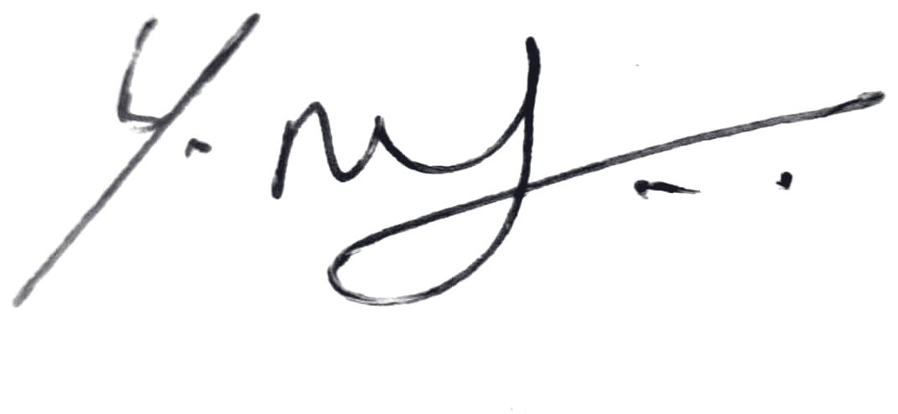
Date: 30 September 2026

