* 总体设计框图：

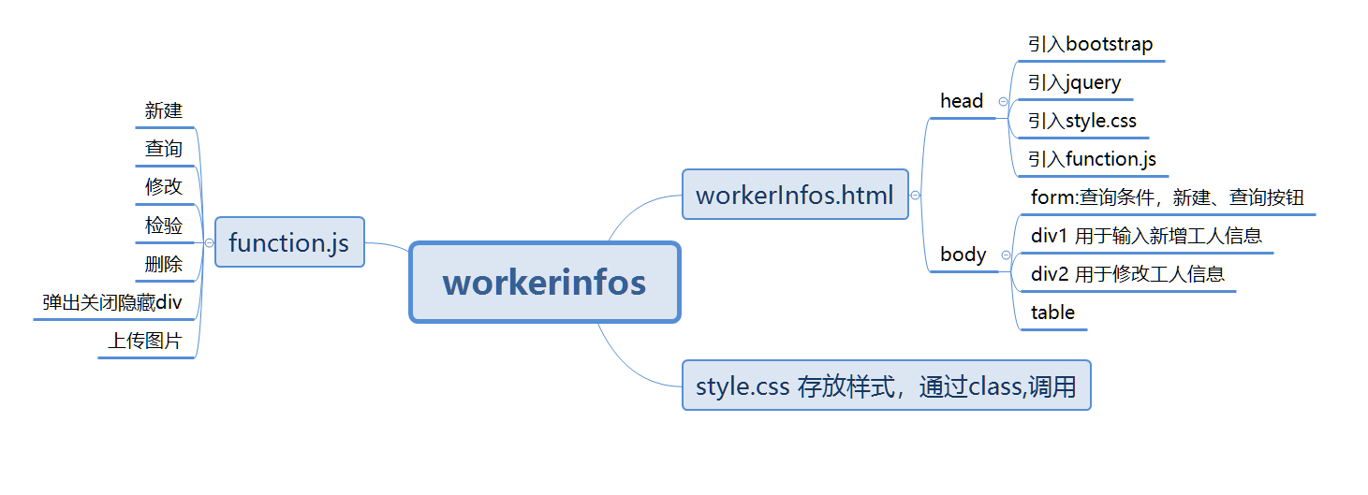

* Worker对象

var worker = {

"siteName": siteName.value,

"workerId": workerId.value,

"workerName": workerName.value,

"sex": sex.value,

"birth": birth.value,

"phone": phone.value,

"address": address.value,

"workType": workType.value,

"duty": duty.value,

"registerDate": registerDate.value,

"avatar": avatar,

"state": state

};

用Workers[]数组存放工人对象

* Function.js的结构：

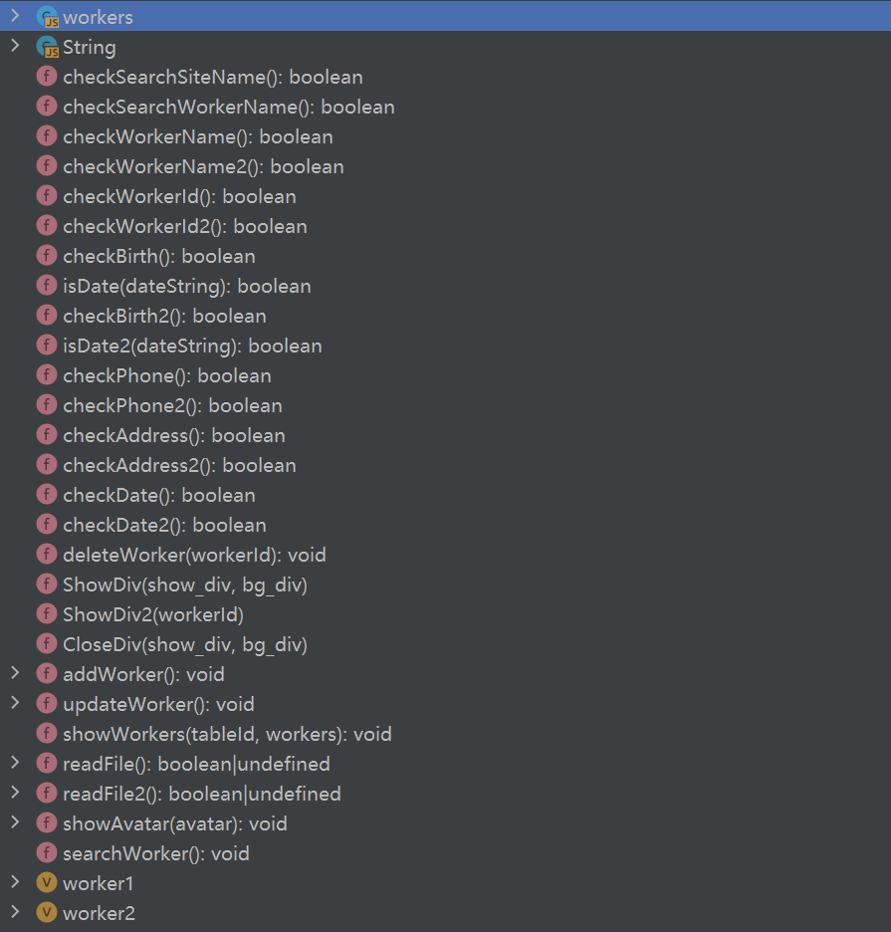

* workInfos.html结构：

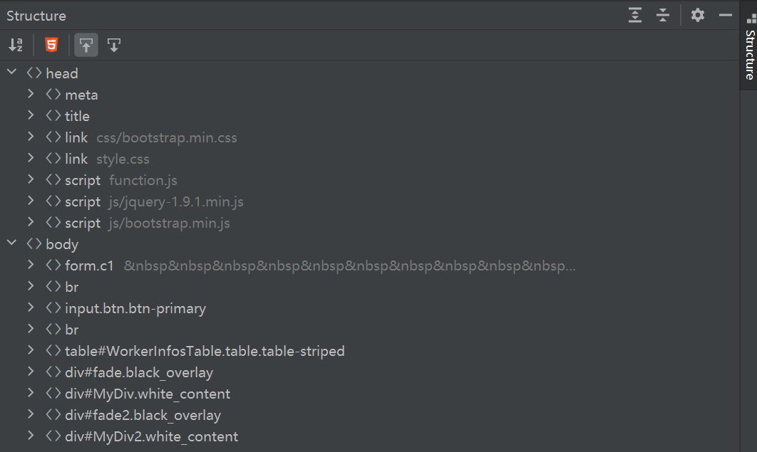

* style.css的结构

