WORKFLOW DIAGRAM - AUTOMATO

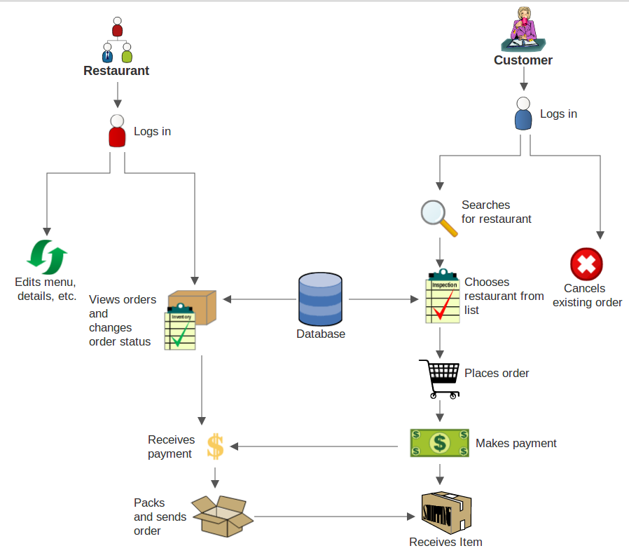

LIST OF TOOLS USED

List of Tools Used:

1. Front end:
   1. HTML
   2. CSS
   3. Jinja 2 template Engine
   4. Javascript
   5. Bootstrap
2. Back end:
   1. Flask framework in Python
   2. Python Libraries:
      1. pdfkit
      2. pymysql
      3. hashlib
      4. uuid
      5. re