­

**DATABASE SYSTEMS**

**MIDTERM PROJECT**

LIBRARY SYSTEM

SQLovers2 </3

Chua, John Patrick G.

Coroza, Christian Kyle M.

Guerrero, Drennix Jean-Roe E.

Rizan, Hezekiah John V.

CS0005 DATABASE SYSTEMS

FINAL PROJECT SPECIFICATIONS

Project: Library System

Using the EERD that you have created on your midterm project, create a working Library database system using any programming language that supports Oracle database. The Library system should be able to:

* add, delete and edit users,
* let users borrow, return and compute and pay dues for overdue books (for rules refer below),
* and can search for books in the system showing their status.

The following are the requirements for the database:

1. The database should contain all the tables stated on the EERD. It should be complete with attributes, primary and foreign key, and it should be normalized
2. Create a stored procedure to:
   * Add, edit, delete a user (this option is available for librarian, patrons are not allowed to change information except the librarian)
   * Add, edit details and delete a book (see detail number 7)
   * Withdraw or return a book (Status should be shown as in shelf, withdrawn and other applicable attributes)
   * Return the book (If the book is overdue, it should show the fine applicable for the overdue)
3. The database should contain information about each valid patron of the system: loginid, name, password, address, unpaid fines and the identity of each book the patron has currently withdrawn. The system shall contain information about each librarian: loginid, name, password and address.
4. The database should contain information about each book in the library: isbn number, title, author name(s), year (of publication), copy number, shelfid, current status, the date on which the book entered loan and/or hold status.
5. The database should contain information about each shelf in the library: shelfId, *capacity* (the maximum number of books that the shelf can hold).
6. The database should contain information about the author of the book: authorid, authorname.
7. A user can either be a librarian or patron, but a librarian can be a patron at the same time. A patron can borrow a maximum of two books per transaction and only when the books are return, he/she can have another transaction. The maximum days a patron can borrow a book is 1 week. It will incur a penalty charge when the books are borrowed beyond 1 week. The penalty is P20 per day of delay.
8. The books should have a designated bookshelf. Each book can be authored by one or more authors.

Requirements:

Documentation (This should be submitted on Canvas)

* The EERD you have created
* Screenshots of the tables and records inside the tables
* Source codes of the procedures

Presentation

* Present the database that you have created in class

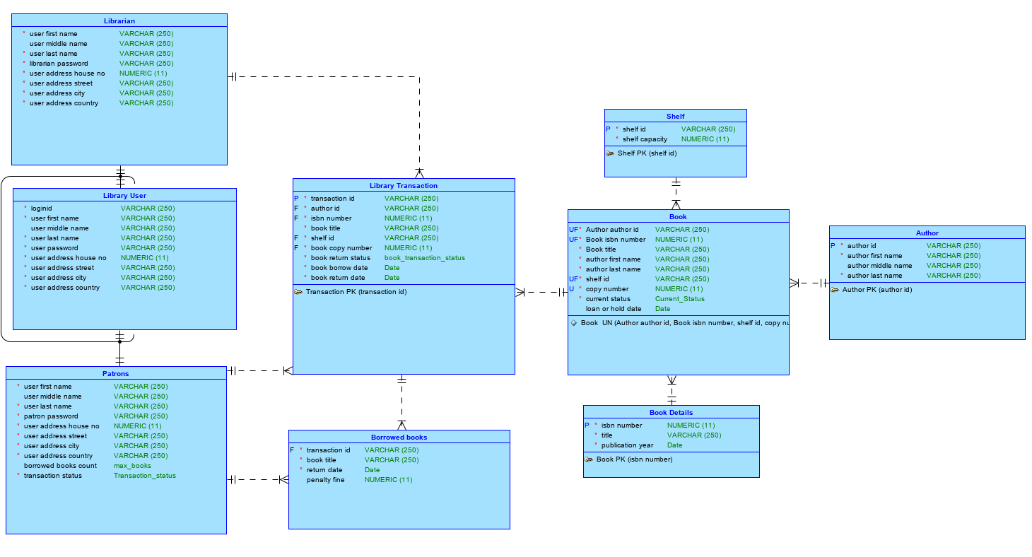

EERD Logical Model

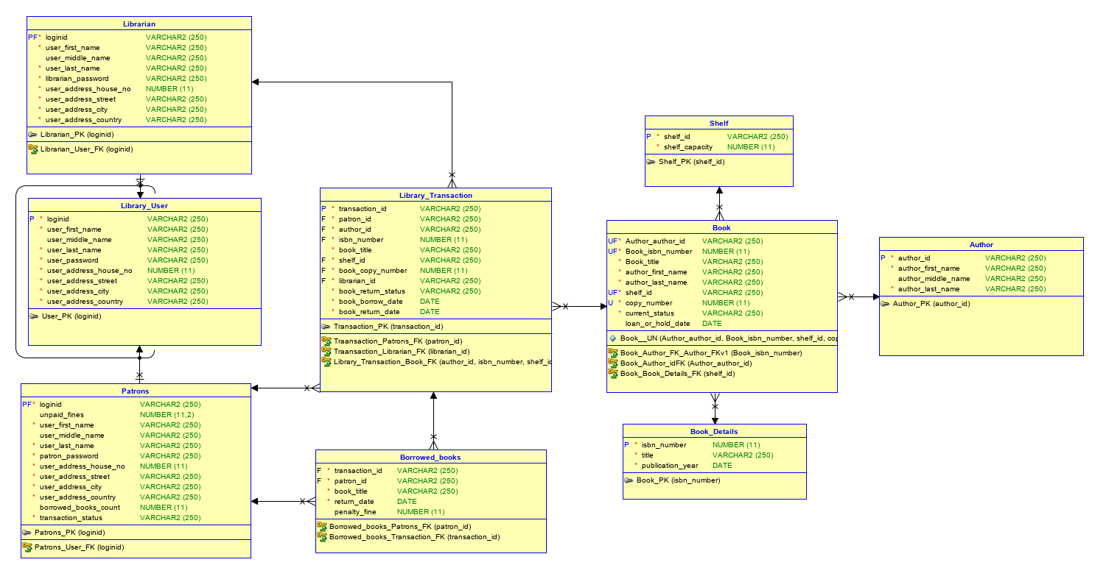

EERD Relational Model

--add user procedure

create or replace PROCEDURE add_user(user_name IN library_user.loginid%TYPE,

fName IN library_user.user_first_name%TYPE,

mName IN library_user.user_middle_name%TYPE,

lName IN library_user.user_last_name%TYPE,

user_pass IN library_user.user_password%TYPE,

hNo IN library_user.user_address_house_no%TYPE,

hStreet IN library_user.user_address_street%TYPE,

hCity IN library_user.user_address_city%TYPE,

hCountry IN library_user.user_address_country%TYPE,

isLib IN NUMBER)

IS

BEGIN

INSERT INTO Library_user VALUES(user_name,fName, mName, lName, user_pass,

hNo, hStreet, hCity, hCountry);

IF isLib = 1 THEN

INSERT INTO Librarian VALUES(user_name,fName, mName, lName, user_pass,

hNo, hStreet, hCity, hCountry);

END IF;

INSERT INTO Patrons VALUES(user_name, 0, fName, mName, lName, user_pass,

hNo, hStreet, hCity, hCountry, 0, 'Allowed');

END;

--change shelf procedure

create or replace PROCEDURE change_shelf(book_isbn IN book_details.isbn_number%TYPE,

cpyNo IN book.copy_number%TYPE, newshelf IN book.shelf_id%TYPE)

IS

oldshelf book.shelf_id%TYPE;

max_shelf_cap shelf.shelf_capacity%TYPE;

e_max_shelf_cap EXCEPTION;

BEGIN

SELECT shelf_capacity INTO max_shelf_cap FROM shelf WHERE shelf_id = newshelf;

IF max_shelf_cap = 20 THEN

RAISE e_max_shelf_cap;

ELSE

SELECT shelf_id INTO oldshelf FROM book

WHERE book.book_isbn_number = book_isbn

AND book.copy_number = cpyNo

AND ROWNUM = 1;

UPDATE shelf SET shelf_capacity = shelf_capacity + 1 WHERE shelf_id = oldshelf;

UPDATE shelf SET shelf_capacity = shelf_capacity - 1 WHERE shelf_id = newshelf;

UPDATE book SET shelf_id = newshelf

WHERE book.book_isbn_number = book_isbn

AND book.copy_number = cpyNo;

UPDATE library_transaction

SET shelf_id = newshelf

WHERE isbn_number = book_isbn

AND book_copy_number = cpyNo;

END IF;

END;

--change title procedure

create or replace PROCEDURE change_title(book_isbn IN book_details.isbn_number%TYPE,

new_title IN book_details.title%TYPE)

IS

e_no_book_exist EXCEPTION;

book_count NUMBER;

BEGIN

SELECT COUNT(*) INTO book_count FROM book_details WHERE isbn_number = book_isbn;

IF book_count = 0 THEN RAISE e_no_book_exist;

END IF;

UPDATE book_details SET title = new_title

WHERE book_details.isbn_number = book_isbn;

UPDATE book SET book_title = new_title

WHERE book.book_isbn_number = book_isbn;

UPDATE library_transaction

SET book_title = new_title

WHERE isbn_number = book_isbn;

UPDATE borrowed_books

SET book_title = new_title

WHERE book_title = new_title;

END;

--check reserve procedure

create or replace PROCEDURE check_reserve

IS

patID library_transaction.patron_id%TYPE;

isbn_num library_transaction.isbn_number%TYPE;

shlf_id library_transaction.shelf_id%TYPE;

cpy_no library_transaction.book_copy_number%TYPE;

BEGIN

SELECT patron_id, isbn_number, shelf_id, book_copy_number

INTO patID, isbn_num, shlf_id, cpy_no

FROM library_transaction

WHERE SYSDATE > book_return_date

AND book_return_status = 'on-loan';

UPDATE library_transaction

SET book_return_status = 'returned'

WHERE SYSDATE > book_return_date

AND book_return_status = 'on-loan';

UPDATE book

SET current_status = 'on-shelf',

loan_or_hold_date = null

WHERE book_isbn_number = isbn_num

AND shelf_id = shlf_id

AND copy_number = cpy_no;

UPDATE patrons

SET borrowed_books_count = borrowed_books_count - 1

WHERE loginid = patID;

EXCEPTION

WHEN OTHERS THEN

DBMS_OUTPUT.PUT_LINE('Reservation checked.');

END;

--check user procedure

create or replace PROCEDURE checkUser

IS

usercount NUMBER;

e_no_user EXCEPTION;

BEGIN

SELECT COUNT(*) INTO usercount FROM library_user;

IF usercount = 0 THEN

RAISE e_no_user;

END IF;

END;

--delete books procedure

create or replace PROCEDURE delete_books(book_isbn IN book.book_isbn_number%TYPE,

title IN book.book_title%TYPE, cpyNo IN book.copy_number%TYPE)

IS

shlf_id shelf.shelf_id%TYPE;

book_in_trans NUMBER;

e_book_in_transaction EXCEPTION;

book_status book.current_status%TYPE;

BEGIN

SELECT COUNT(*) INTO book_in_trans FROM library_transaction

WHERE isbn_number = book_isbn

AND book_copy_number = cpyNo

AND book_return_status <> 'returned';

IF book_in_trans > 0 THEN RAISE e_book_in_transaction;

END IF;

SELECT current_status INTO book_status FROM book

WHERE book_isbn_number = book_isbn

AND copy_number = cpyNo;

IF book_status = 'on-loan' OR book_status = 'on-hold' THEN

RAISE e_book_in_transaction;

END IF;

SELECT shelf_id INTO shlf_id

FROM book WHERE book.book_isbn_number = book_isbn

AND book.book_title = title

AND book.copy_number = cpyNo

AND ROWNUM = 1;

UPDATE shelf SET shelf_capacity = shelf_capacity + 1

WHERE shelf_id = shlf_id;

DELETE FROM book WHERE book.book_isbn_number = book_isbn

AND book.book_title = title AND book.copy_number = cpyNo;

END;

--delete user procedure

create or replace PROCEDURE delete_user(userID IN library_user.loginid%TYPE)

IS

has_books NUMBER;

e_user_hasBooks EXCEPTION;

BEGIN

SELECT borrowed_books_count INTO has_books FROM patrons

WHERE loginid = userID;

IF has_books > 0 THEN RAISE e_user_hasBooks;

END IF;

DELETE FROM library_user WHERE loginid = userID;

END;

--insert author procedure

create or replace PROCEDURE insert_author(author_id IN author.author_id%TYPE,

fName IN author.author_first_name%TYPE,

mNane IN author.author_middle_name%TYPE,

lName IN author.author_last_name%TYPE) IS

BEGIN

INSERT INTO author VALUES(author_id, fName, mNane, lName);

END;

--insert book details procedure

create or replace PROCEDURE insert_book_details(isbn_num IN book_details.isbn_number%TYPE,

bkTitle IN book_details.title%TYPE,

pub_date IN book_details.publication_year%TYPE) IS

BEGIN

INSERT INTO book_details(isbn_number, title, publication_year)

VALUES(isbn_num, bkTitle, pub_date);

END;

--insert books procedure

create or replace PROCEDURE insert_books(auth_id IN book.author_author_id%TYPE,

book_isbn IN book.book_isbn_number%TYPE,

shf_id IN book.shelf_id%TYPE,

cpyNo IN book.copy_number%TYPE)

IS

book_title book.book_title%TYPE;

auth_fName book.author_first_name%TYPE;

auth_lName book.author_last_name%TYPE;

max_shelf_cap shelf.shelf_capacity%TYPE;

book_isThere NUMBER;

e_max_shelf_cap EXCEPTION;

exist_shelf book.shelf_id%TYPE;

inp_shelf book.shelf_id%TYPE;

anyrows NUMBER;

BEGIN

SELECT COUNT(*) INTO anyrows FROM book WHERE book.book_isbn_number = book_isbn

AND book.copy_number = cpyNo;

IF anyrows <> 0 THEN

SELECT shelf_id INTO exist_shelf FROM book WHERE book.book_isbn_number = book_isbn

AND book.copy_number = cpyNo;

inp_shelf := exist_shelf;

ELSE

SELECT shelf_capacity INTO max_shelf_cap FROM shelf WHERE shelf_id = shf_id;

IF max_shelf_cap = 0 THEN

RAISE e_max_shelf_cap;

ELSE

UPDATE shelf SET shelf_capacity = shelf_capacity - 1

WHERE shelf_id = shf_id;

END IF;

inp_shelf := shf_id;

END IF;

SELECT title INTO book_title FROM book_details

WHERE book_details.isbn_number = book_isbn;

SELECT author_first_name, author_last_name INTO auth_fName, auth_lName

FROM author WHERE author.author_id = auth_id;

INSERT INTO book (author_author_id, book_isbn_number,

book_title, author_first_name, author_last_name,

shelf_id, copy_number, current_status)

VALUES(auth_id, book_isbn, book_title, auth_fName,

auth_lName, inp_shelf, cpyNo, 'on-shelf');

END;

--insert shelf

create or replace PROCEDURE insert_shelf(shelf_id IN shelf.shelf_id%TYPE,

shelf_capacity IN shelf.shelf_capacity%TYPE) IS

BEGIN

INSERT INTO shelf VALUES (shelf_id, shelf_capacity);

END;

--pay fines procedure

create or replace PROCEDURE pay_fines(patID patrons.loginid%TYPE,

paid_fine patrons.unpaid_fines%TYPE)

IS

userFine patrons.unpaid_fines%TYPE;

e_no_fine EXCEPTION;

BEGIN

SELECT unpaid_fines INTO userFine FROM patrons

WHERE loginid = patID;

IF userFine = 0 OR userFine IS NULL THEN

RAISE e_no_fine;

END IF;

UPDATE patrons SET

unpaid_fines = unpaid_fines - paid_fine

WHERE loginid = patID;

END;

--reserve book procedure

create or replace PROCEDURE reserve_book

( patID IN patrons.loginid%TYPE,

isbnNum IN book.book_isbn_number%TYPE,

shf_ID IN book.shelf_id%TYPE,

cpyNo IN book.copy_number%TYPE

)

IS

pat_books patrons.borrowed_books_count%TYPE;

book_status book.current_status%TYPE;

bkTitle book.book_title%TYPE;

auth_id book.author_author_id%TYPE;

e_book_on_loan EXCEPTION;

e_max_books EXCEPTION;

BEGIN

SELECT current_status INTO book_status FROM book

WHERE book_isbn_number = isbnNum

AND copy_number = cpyNo

AND shelf_id = shf_ID;

IF book_status = 'on-loan' OR book_status = 'on-hold' THEN

RAISE e_book_on_loan;

ELSE

SELECT borrowed_books_count INTO pat_books FROM patrons WHERE patrons.loginid = patID;

IF pat_books <> 2 THEN

UPDATE book

SET current_status = 'on-hold',

loan_or_hold_date = SYSDATE

WHERE book_isbn_number = isbnNum

AND copy_number = cpyNo

AND shelf_id = shf_ID;

SELECT author_author_id, book_title INTO auth_id, bkTitle

FROM book

WHERE book_isbn_number = isbnNum

AND shelf_id = shf_ID

AND copy_number = cpyNo

AND ROWNUM = 1;

INSERT INTO library_transaction VALUES(transaction_id.nextval, patID, auth_id,

isbnNum, bkTitle, shf_ID, cpyNo, 'admin', 'on-hold', SYSDATE, SYSDATE+7);

UPDATE patrons

SET borrowed_books_count = borrowed_books_count + 1

WHERE loginid = patID;

IF pat_books = 2 THEN

UPDATE patrons

SET transaction_status = 'Not Allowed'

WHERE patrons.loginid = patID;

END IF;

ELSE

RAISE e_max_books;

END IF;

END IF;

END;

--return book procedure

create or replace PROCEDURE return_book

( patID IN library_transaction.patron_id%TYPE,

isbn_num IN library_transaction.isbn_number%TYPE,

cpyNo IN library_transaction.book_copy_number%TYPE,

libID IN library_transaction.librarian_id%TYPE

)

IS

isLib NUMBER;

noOfDays NUMBER;

e_not_librarian EXCEPTION;

transID library_transaction.transaction_id%TYPE;

ret_date library_transaction.book_return_date%TYPE;

pen_fine borrowed_books.penalty_fine%TYPE;

BEGIN

SELECT COUNT(*) INTO isLib FROM librarian

WHERE loginid = libID;

IF isLib <> 0 THEN

SELECT transaction_id INTO transID FROM library_transaction

WHERE patron_id = patID

AND isbn_number = isbn_num

AND book_copy_number = cpyno

AND book_return_status <> 'returned';

UPDATE library_transaction

SET book_return_date = SYSDATE,

book_return_status = 'returned'

WHERE transaction_id = transID;

SELECT return_date INTO ret_date FROM borrowed_books WHERE patron_id = patID AND

transaction_id = transID;

IF SYSDATE > ret_date THEN

UPDATE borrowed_books

SET penalty_fine = (SYSDATE - return_date) *20,

return_date = SYSDATE

WHERE patron_id = patID

AND transaction_id = transID;

END IF;

SELECT penalty_fine INTO pen_fine FROM borrowed_books

WHERE transaction_id = transID;

UPDATE Patrons

SET borrowed_books_count = borrowed_books_count - 1,

transaction_status = 'Allowed',

unpaid_fines = unpaid_fines + pen_fine

WHERE loginid = patID;

UPDATE book

SET current_status = 'on-shelf',

loan_or_hold_date = null

WHERE book_isbn_number = isbn_num

AND copy_number = cpyNo;

ELSE

RAISE e_not_librarian;

END IF;

END;

--update user procedure

create or replace PROCEDURE update_user(uname IN library_user.loginid%TYPE,

firName IN library_user.user_first_name%TYPE,

midName IN library_user.user_middle_name%TYPE,

lastName IN library_user.user_last_name%TYPE,

upass IN library_user.user_password%TYPE,

houseNo IN library_user.user_address_house_no%TYPE,

houseStreet IN library_user.user_address_street%TYPE,

houseCity IN library_user.user_address_city%TYPE,

houseCountry IN library_user.user_address_country%TYPE)

IS

any_rows NUMBER;

BEGIN

SELECT COUNT(*) INTO any_rows FROM Librarian WHERE loginid = uname;

UPDATE library_user SET

user_first_name = firName,

user_middle_name = midName,

user_last_name = lastName,

user_password = upass,

user_address_house_no = houseNo,

user_address_street = houseStreet,

user_address_city = houseCity,

user_address_country = houseCountry

WHERE loginid = uname;

IF any_rows <> 0 THEN

UPDATE librarian SET

user_first_name = firName,

user_middle_name = midName,

user_last_name = lastName,

librarian_password = upass,

user_address_house_no = houseNo,

user_address_street = houseStreet,

user_address_city = houseCity,

user_address_country = houseCountry

WHERE loginid = uname;

END IF;

UPDATE patrons SET

user_first_name = firName,

user_middle_name = midName,

user_last_name = lastName,

patron_password = upass,

user_address_house_no = houseNo,

user_address_street = houseStreet,

user_address_city = houseCity,

user_address_country = houseCountry

WHERE loginid = uname;

END;

--withdraw book procedure

create or replace PROCEDURE withdraw_book(patID IN patrons.loginid%TYPE,

libId IN librarian.loginid%TYPE,

bkTitle library_transaction.book_title%TYPE,

shlfID IN library_transaction.shelf_id%TYPE,

cpyNo IN book.copy_number%TYPE,

bkStatus IN library_transaction.book_return_status%TYPE)

IS

auth_id library_transaction.author_id%TYPE;

isbn_num library_transaction.isbn_number%TYPE;

pat_books patrons.borrowed_books_count%TYPE;

book_status book.current_status%TYPE;

trans_ID library_transaction.transaction_id%TYPE;

e_no_reserved EXCEPTION;

isAvailable NUMBER;

BEGIN

SELECT COUNT(*) INTO isAvailable FROM library_transaction

WHERE patron_id = patID

AND book_title = bkTitle

AND shelf_id = shlfID

AND book_copy_number = cpyNo

AND book_return_status = 'on-hold';

SELECT transaction_id INTO trans_ID FROM library_transaction

WHERE patron_id = patID

AND book_title = bkTitle

AND shelf_id = shlfID

AND book_copy_number = cpyNo

AND book_return_status = 'on-hold';

IF isAvailable = 1 THEN

UPDATE library_transaction

SET book_return_status = 'on-loan',

book_borrow_date = SYSDATE,

book_return_date = SYSDATE + 7,

librarian_id = libID

WHERE patron_id = patID

AND book_title = bkTitle

AND shelf_id = shlfID

AND book_copy_number = cpyNo

AND book_return_status = 'on-hold';

UPDATE book

SET current_status = 'on-loan',

loan_or_hold_date = SYSDATE

WHERE book_title = bkTitle

AND copy_number = cpyNo

AND shelf_id = shlfID;

INSERT INTO borrowed_books(transaction_id, patron_id, book_title, return_date)

VALUES(trans_ID, patID, bkTitle, SYSDATE+7);

ELSE

RAISE e_no_reserved;

END IF;

END;

Rubrics

|  |  |  |
| --- | --- | --- |
| Choice of system | The system should be made from scratch and are not an previous existing system | 10% |
| Entity Relationship Diagram/Enhanced Entity Relationship Diagram | The ERD/EERD of the database should be complete and should match with the existing database chosen | 20% |
| Tables and sample records | The sample table should be at least 6 with at least 6 records inside. | 10% |
| GUI | The GUI of the system should be working, complete and appropriate for the system chosen | 20% |
| Working System | The system should be properly working | 20% |
| Errors | The system should have been thoroughly tested, and minimal errors are found during testing of the system | 10% |
| Documentation | The document should show what the system is, how does it work and the screen shots | 10% |
| Total |  | 100% |