**Introduction**

MaxScore consists of a graphical user interface (GUI) and an application program interface (API).

* The MaxScore object is an API and it has the role of the ‘brain’ of MaxScore. If you would like to get to know the MaxScore object go here: http://…….
* The MaxScore.Editor is the visual part of MaxScore or a GUI and it is designed for editing MaxScore scores directly in a Max Window.

**During this tutorial we will focus on the MaxScore.Editor and examine its functions.**

Let’s start by opening Max.

There are two ways to start a score with the MaxScore.Editor.

First, use the MaxScore. Editor object.

- Open the Editor window by clicking on the “Open Editor” button inside the bpatcher.

- Or use a message box as the input order and connect it to the left inlet of the MaxScore Editor.

By using the message openWindow and clicking on it, the Editor window will pop up.

Take a look at the help file of MaxScore.Editor. Here you can find some additional messages which can be found from the ‘Dictionary’ (go to “Extras” section of the menu, find Max Score and select “Dictionary”)

- Go to “File” on the left corner of the window and choose “New Score”. By default, the tempo is set to 60 BPM, the time signature is a 4/4 and the clef is a G-clef.

To change this, go to ‘Tools’ and chose the clef you want by clicking in the corresponding section. To modify the tonality (add sharps or minors) click on the ‘Key Signature’ section on the right of the ‘clef’ section.

- If you need to change the time signature, click on the ‘Meter’ button right bellow the clef box and type the numbers you wish in the window that appears. Use a gap between the two numbers (e.g for 3/4 type 3 4). Use the same procedure for adjusting the tempo by using the button right next to the ‘Meter’ button.

- In order to add notes double click or ctrl-click (Mac) or option-click (Windows) on the pentagram. If you want to transpose notes use cmd-drag (Mac) or ctrl-drag (Windows).

- If you want to add rest notes, create a new note and then chose from the tools first the note value and then the rest symbol (3d symbol on the first row).

- To add dynamics or articulation, select a note and then chose from the Tools bar thecorresponding symbols. e.g for dynamics check the 5th column.

If you wish to add a crescendo or decrescendo to your score, select the passage or notes and click the Crescendo or Decrescendo symbol from the Tools.

- If you want to add tuplets, select the section or notes and then choose the corresponding symbols from the Tools bar (5th and 6th column, ‘3’, ‘5’, ‘7’, ‘9’, etc.)

- To add repeats or barlines, select the measure and then click on the corresponding symbols at the bottom of the Tools bar.

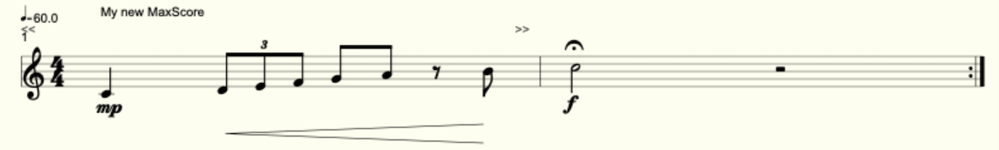

You can always use the Shortcuts and work fast and efficiently. Go to ‘Edit’ on the left corner of the window and choose ‘Shortcuts’. A window with all the different shortcuts will then pop up.