Contents
Flow Charts 4
Log In Function 4
Register Function 5
Add Item to basket 6
Create an Order 7
8
Database Design 9
Data Dictionaries 11
AspNetUsers 11
AspNetRoles 11
AspNetUserRoles 11
AspNetUserClaims 12
AspNetRoleClaims 12
AspNetUserLogins 12
AspNetUserTokens 12
Producers 12
Products 13
Orders 13
OrderProducts 13
Basket 14
BasketProducts 14
Stamps 14
ProductStamps 14
DiscountCodes 15
Site map 15

Flow Charts

Log In Function
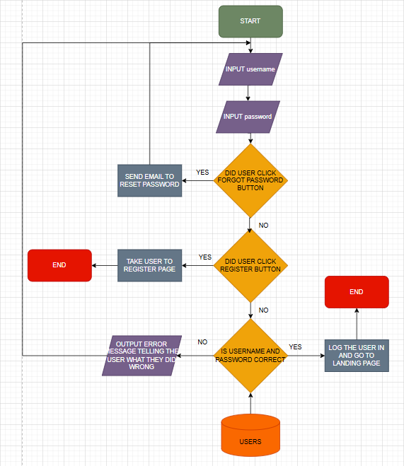
The user will be prompted to enter their username and password the system will then check if the user clicked other options like forgot password or register if they did it will take the appropriate actions like sending a reset email link or taking the user to the register page if not the system will check if the username and password match the ones in the database and if not, not, it will send an error message telling the user what they did wrong if its correct the system will log the user in return them to the landing page.

Register Function
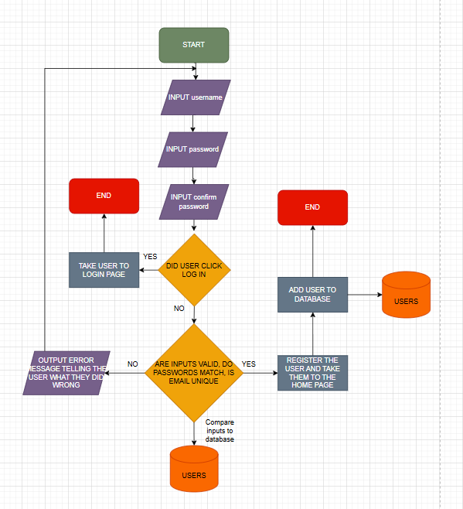
The user will be prompted to enter their username and password and password again to confirm it, the system then checks if the two passwords match and if the email is unique to any other account from the database, then they can proceed to add the user to the database if everything is good but if there are any issues the system prompts the user with an error message explaining what they have done wrong and asks them to try again.

Add Item to basket
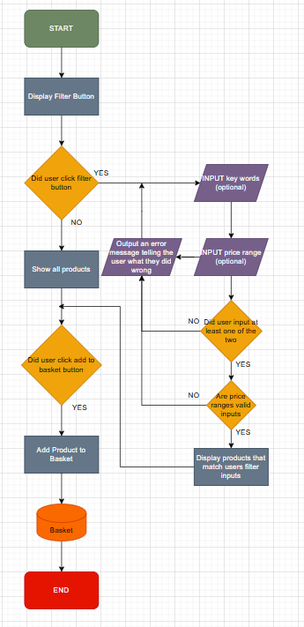
The user being on the main shopping page with all products will be given the option to either browse the full length on products or filter to give more specific results, if the user manages to enter invalid characters or data types to the filter fields, they are prompted on what they have done wrong and are allowed to try again. Once they have found the results they want or if they didn’t filter at all, they can then click the “add to basket button” located below the item and this will prompt the web app to add that specific item to the user’s basket.

Create an Order
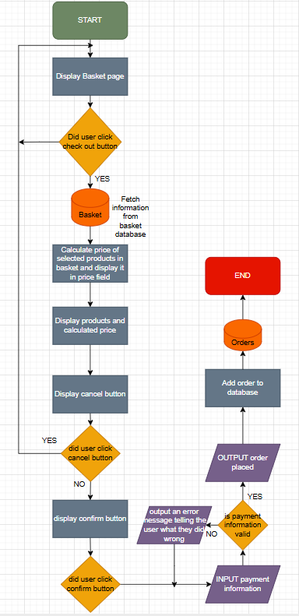
From the basket page the user is given the option to checkout their selected items, if the user click the checkout button the application displays the products and calculates the price and then they can either cancel or confirm their order, if they cancel their order they are redirected to the basket page and if they confirm the order they are prompted to enter their payment details, the web app checks if the payment details are valid or not, if not they are told what they have done wrong and are asked to try again and I they are right and the payment goes through then the order is accepted and posted to the database for further actions.

Updating Products
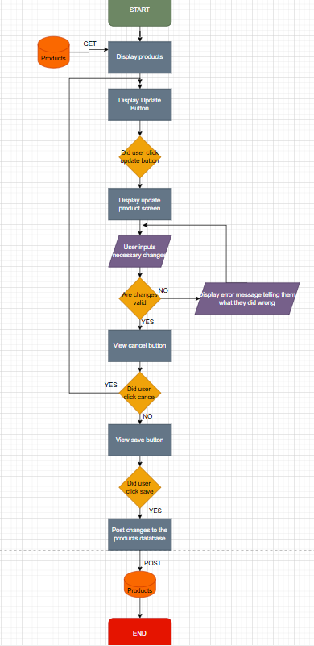
When a producer needs to make an update to their stock or products they have listed from the producer dashboard page they can see their products they’ve listed, there they can click the update button next to the product, this button redirects them to the edit page for the selected product and there they can make the necessary changes, the application then checks if the changes they’ve made are valid, and if not it prompts them to try again and if the changes are valid it posts the changes to the database making them permanent till updated again.

Database Design
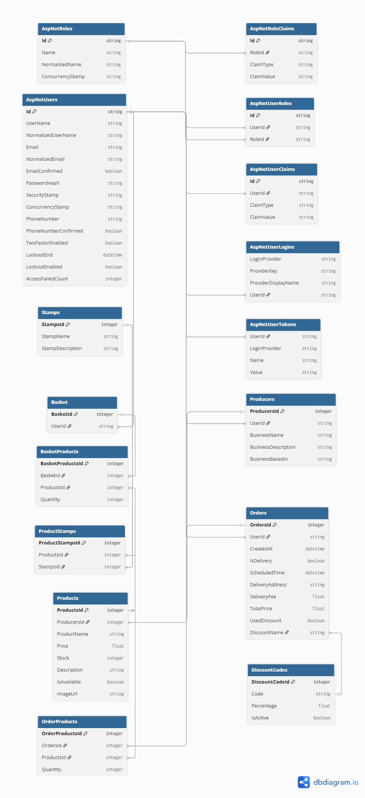

Data Dictionaries

AspNetUsers

Column | Data Type | Required | Default | Validation | Key Type
Id | String | Yes |  |  | Primary
UserName | String | Yes |  |  | None
NormalizedUserName | String | Yes |  |  | None
Email | String | Yes |  | Must include @, valid email structure, domain name | None
NormalizedEmail | String | Yes |  |  | None
EmailConfirmed | Bool | Yes |  | Users must confirm their email | None
PasswordHash | String | Yes |  |  | None
SecurityStamp | String | No |  |  | None
ConcurrencyStamp | String | No |  |  | None
PhoneNumber | String | No |  |  | None
PhoneNumberConfirmed | Bool | No |  |  | None
TwoFactorEnabled | Bool | No |  |  | None
LockoutEnd | DateTime | No |  |  | None
LockoutEnabled | Bool | No |  |  | None
AccessFailedCount | Int | No |  |  | None

AspNetRoles

Column | Data Type | Required | Default | Validation | Key Type
Id | String | Yes |  |  | Primary
Name | String | Yes |  |  | None
NormalizedName | String | Yes |  |  | None
ConcurrencyStamp | String | Yes |  |  | None

AspNetUserRoles

Column | Data Type | Required | Default | Validation | Key Type
Id | Int | Yes |  |  | Primary
UserId | String | Yes | Users Id |  | Foreign
RoleId | String | Yes | Roles Id |  | Foreign

AspNetUserClaims

Column | Data Type | Required | Default | Validation | Key Type
Id | Int | Yes |  |  | Primary
UserId | String | Yes | Users Id |  | Foreign
ClaimType | String | No |  |  | None
ClaimValue | String | No |  |  | None

AspNetRoleClaims

Column | Data Type | Required | Default | Validation | Key Type
Id | Int | Yes |  |  | Primary
RoleId | String | Yes | Roles Id |  | Foreign
ClaimType | String | No |  |  | None
ClaimValue | String | No |  |  | None

AspNetUserLogins

Column | Data Type | Required | Default | Validation | Key Type
LoginProvider | String | Yes |  |  | Primary
ProviderKey | String | Yes |  |  | None
ProviderDisplayName | String | No |  |  | None
UserId | String | Yes | Users Id |  | Foreign

AspNetUserTokens

Column | Data Type | Required | Default | Validation | Key Type
UserId | String | Yes | Users Id |  | Foreign
LoginProvider | String | Yes |  |  | None
Name | String | Yes |  |  | None
Value | String | No |  |  | None

Producers

Column | Data Type | Required | Default | Validation | Key Type
ProducersId | Int | Yes |  |  | Primary
UserId | String | Yes | Users Id |  | Foreign
BusinessName | String | Yes |  |  | None
BusinessDescription | String | No |  |  | None
BusinessBasedIn | String | Yes |  |  | None

Products
Column | Data Type | Required | Default | Validation
ProductsId | Int | Yes
ProducersId | Int | Yes | Producers Id
ProductName | String | Yes
Price | Float | Yes |  | Must be greater than 0
Stock | Int | Yes | 0 | Must be 0 or greater
Description | String | No
IsAvailable | Bool | Yes | false
ImageUrl | String | No

Orders

Column | Data Type | Required | Default | Validation | Key Type
OrdersId | Int | Yes |  |  | Primary
UserId | String | Yes | Users Id |  | Foreign
CreatedAt | DateTime | Yes | Current timestamp |  | None
IsDelivery | Bool | Yes |  |  | None
ScheduledTime | DateTime | No |  | Must be a future date | None
DeliveryAddress | String | No |  | Required if IsDelivery is true | None
DeliveryFee | Float | No | 0 | Required if IsDelivery is true, must be 0 or greater | None
TotalPrice | Float | Yes |  | Must be greater than 0 | None
UsedDiscount | Bool | Yes | false |  | None
DiscountName | String | No |  | Required if UsedDiscount is true | None

OrderProducts

Column | Data Type | Required | Default | Validation | Key Type
OrderProductsId | Int | Yes |  |  | Primary
OrdersId | Int | Yes | Orders Id |  | Foreign
ProductsId | Int | Yes | Products Id |  | Foreign
Quantity | Int | Yes |  | Must be greater than 0 | None

Basket

Column | Data Type | Required | Default | Validation | Key Type
BasketId | Int | Yes |  |  | Primary
UserId | String | Yes | Users Id |  | Foreign

BasketProducts

Column | Data Type | Required | Default | Validation | Key Type
BasketProductsId | Int | Yes |  |  | Primary
BasketId | Int | Yes | Basket Id |  | Foreign
ProductsId | Int | Yes | Products Id |  | Foreign
Quantity | Int | Yes |  | Must be greater than 0 | None

Stamps

Column | Data Type | Required | Default | Validation | Key Type
StampsId | Int | Yes |  |  | Primary
StampName | String | Yes |  |  | None
StampDescription | String | No |  |  | None

ProductStamps

Column | Data Type | Required | Default | Validation | Key Type
ProductStampsId | Int | Yes |  |  | Primary
ProductsId | Int | Yes | Products Id |  | Foreign
StampsId | Int | Yes | Stamps Id |  | Foreign

DiscountCodes

Column | Data Type | Required | Default | Validation | Key Type
DiscountCodeId | Int | Yes |  |  | Primary
Code | String | Yes |  | Must be unique | None
Percentage | Float | Yes |  | Must be between 1 and 100 | None
IsActive | Bool | Yes | true |  | None

Site map
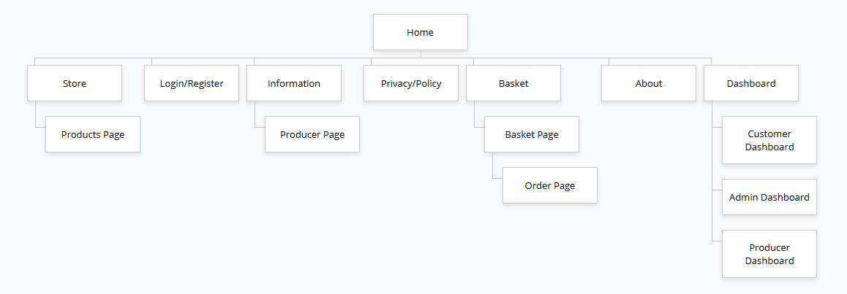

Test Strategy

