
Website Visual Design
For Greenfield Local Hub (GLH)


Contents
Sitemap 2
Styles 3
Dark Mode 3
Background 3
Font 3
Interactive 4
Light Mode 4
Background 4
Font 4
Interactive 4
Buttons/Cards 4
Accent Colours 4
Website Pages 4
Navigation Bar 5
Footer 5
Register 5
Log in 5
Privacy Policy 5
Home 5
Database 6
Entity Relationship Diagram 6
Data Dictionaries 7
AspNetUsers 7
AspNetUserRoles 7
AspNetRoles 8
AspNetRoleClaims 8
AspNetUserClaims 8
AspNetUserLogins 8
AspNetUserTokens 8
Products 9
Orders 9
OrderProducts 10
Basket 10
BasketProducts 10
Producers 11
Algorithm Design 12
Register 12
Login 13
Filter products by price 14
Change product availability as a producer 14
Add a product to basket 15
Test Strategy 16

Sitemap

Home = The landing page containing the hero section, products section, benefits of buying locally section and “Our Producers” section
Products = Shows products that are sold by the various producers with a search bar and filter menu
Product = Shows all the details of a specific product
My basket = Contains the products that the user has added to their basket with a checkout button to order all the products in the basket
Order = The checkout page where the user can fill the order details and order their products
My orders = Contains all the orders made by a user
Our producers = Shows all the producers selling their products on the website
Dashboard = A page for users with a role of “Producer”, shows all the products of the producer and pending orders containing the products of the producer
Create product = A page for users with a role of “Producer” to add a new product
Edit product = A page for users with a role of “Producer” to edit their product’s details
Delete product = A page for users with a role of “Producer” to remove their product
Policy = Outlines the loyalty scheme’s policies
Privacy = Outlines how the user’s data is being used and protected
Register = Allows to register the user
Login = Allows to log in the user

Styles
Font Family = “Inter”

Dark Mode

Background
- Body: #1F2A24
- Foreground Elements: #2F3E35
ef

Font
- Normal: #F5F5F5
ef
- Lighter: #C8D5C0
ef

Interactive
- Normal: #6BBF59
ef
- Hover/Selected: #4F9F4A
ef

Light Mode

Background
- Body: #FAF7F2
- Foreground Elements: #FFFFFF
ef

Font
- Normal: #2B2B2B
ef
- Lighter: #6B6B6B
ef

Interactive
- Normal: #2F6F4E
ef
- Hover/Selected: #1F4F36
ef

Buttons/Cards
- Corners = Rounded (30px +- 10px Radius)
- Background = Drop shadow (10px Blur)
- No outline

Accent Colours
- Discounts/loyalty offers: #F4A259
ef
- Success messages: #4CAF50
ef
- Warnings: #E9B44C
ef
- Errors: #D9534F
ef

Website Pages
Link (If it does not work, see images below or contact my college to resolve any issues):
https://www.figma.com/design/PyGwdGUsLN4wLZJQRJ5s1q/GLH-Website-Design?m=auto&t=pxJRoZc7zHxV4A4C-6

Navigation Bar

Footer

Register

Log in

Privacy Policy

Home

Database

Entity Relationship Diagram
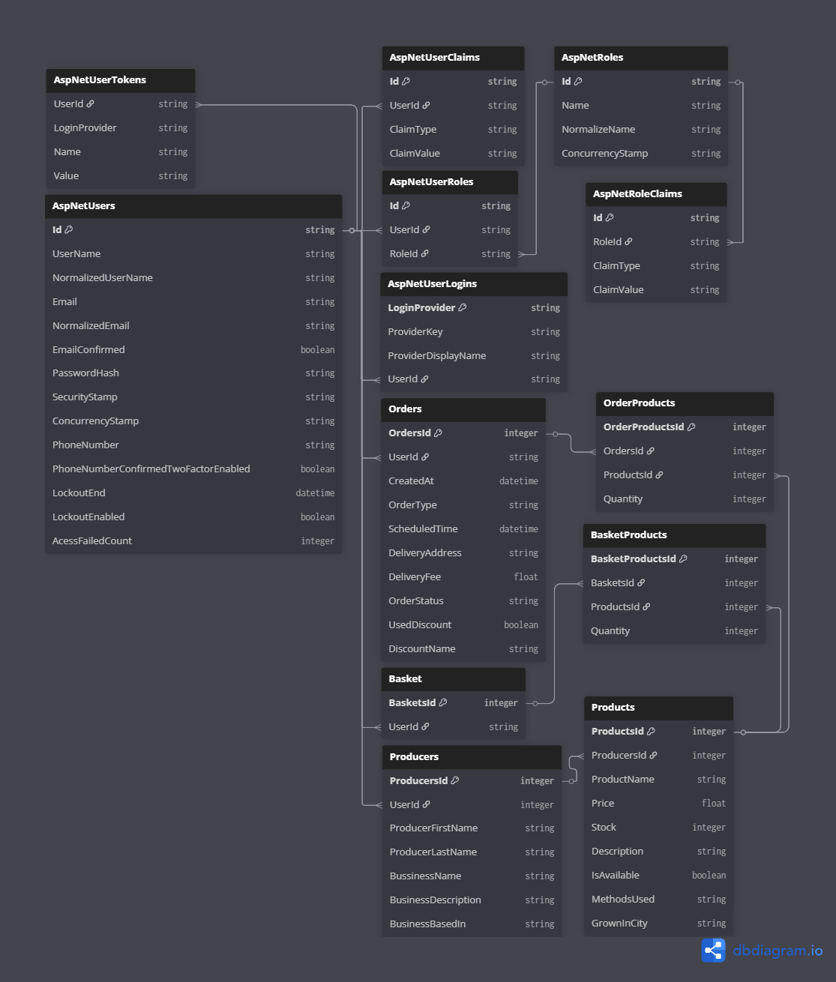

Data Dictionaries

AspNetUsers
Column | Data Type | Required | Default | Validation | Key Type
Id | String | Yes |  |  | Primary
UserName | String | Yes |  |  | None
NormalizedUserName | String | Yes |  |  | None
Email | String | Yes |  | Must include a valid email structure, must have a “@” symbol, must have a domain name | None
NormalizedEmail | String | Yes |  |  | None
EmailConfirmed | Bool | Yes |  | Users must confirm their email | None
PasswordHash | String | Yes |  |  | None
SecurityStamp | String |  |  |  | None
ConcurrencyStamp | String |  |  |  | None
PhoneNumber | String |  |  |  | None
PhoneNumberConfirmed  TwoFactorEnabled | Bool |  |  |  | None
LockoutEnd | DateTime |  |  |  | None
LockoutEnabled | Bool |  |  |  | None
AcessFailedCount | Int |  |  |  | None

AspNetUserRoles
Column | Data Type | Required | Default | Validation | Key Type
Id | Int | Yes |  |  | Primary
UserId | String | Yes | Users Id |  | Foreign
RoleId | String | Yes | Roles Id |  | Foreign

AspNetRoles
Column | Data Type | Required | Default | Validation | Key Type
Id | String | Yes |  |  | Primary
Name | String | Yes | Users Id |  | None
NormalizeName | String | Yes |  |  | None
ConcurrencyStamp | String | Yes |  |  | None

AspNetRoleClaims
Column | Data Type | Required | Default | Validation | Key Type
Id | Int | Yes |  |  | Primary
RoleId | String | Yes | Roles Id |  | Foreign
ClaimType | String | No |  |  | None
ClaimValue | String | No |  |  | None

AspNetUserClaims
Column | Data Type | Required | Default | Validation | Key Type
Id | Int | Yes |  |  | Primary
UserId | String | Yes | Users Id |  | Foreign
ClaimType | String | No |  |  | None
ClaimValue | String | No |  |  | None

AspNetUserLogins
Column | Data Type | Required | Default | Validation | Key Type
LoginProvider | String | Yes |  |  | Primary
ProviderKey | String | Yes |  |  | None
ProviderDisplayName | String | No |  |  | None
UserId | String | Yes | Users Id |  | Foreign

AspNetUserTokens
Column | Data Type | Required | Default | Validation | Key Type
UserId | String | Yes | Users Id |  | Foreign
LoginProvider | String | Yes |  |  | None
Name | String | Yes |  |  | None
Value | String | No |  |  | None

Products
Column | Data Type | Required | Default | Validation | Key Type
ProductsId | Int | Yes |  |  | Primary
ProducersId | Int | Yes |  |  | Foreign
ProductName | String | Yes |  |  | None
Price | Float | Yes |  | Cannot be less than or equal to 0 | None
Stock | Int | Yes |  | Cannot be less than 0 | None
Description | String | Yes |  |  | None
IsAvailable | Bool | Yes |  |  | None
MethodsUsed | String | Yes |  |  | None
GrownInCity | String | Yes |  | Can only be cities that are in England | None

Orders
Column | Data Type | Required | Default | Validation | Key Type
OrdersId | Int | Yes |  |  | Primary
UserId | String | Yes | Users Id |  | Foreign
CreatedAt | DateTime | Yes | Today |  | None
OrderType | String | Yes |  | Can only be “Delivery” or “Collection” | None
ScheduledTime | DateTime | Yes |  | Cannot be a date before the current date | None
DeliveryAddress | String | No |  | Only available to use if “OrderType” is “Delivery” | None
DeliveryFee | Float | No |  | Only available to use if “OrderType” is “Delivery” | None
OrderStatus | String | No | Pending | Can only be a set order status option | None
UsedDiscount | Bool | Yes | False |  | None
DiscountName | String | No | None |  | None

OrderProducts
Column | Data Type | Required | Default | Validation | Key Type
OrderProductsId | Int | Yes |  |  | Primary
OrdersId | Int | Yes | OrdersId |  | Foreign
ProductsId | Int | Yes | ProductsId |  | Foreign
Quantity | Int | Yes | 1 | Cannot be less than 1 and cannot be more than in stock | None

Basket
Column | Data Type | Required | Default | Validation | Key Type
BasketsId | Int | Yes |  |  | Primary
UserId | String | Yes | Users Id |  | Foreign

BasketProducts
Column | Data Type | Required | Default | Validation | Key Type
BasketProductsId | Int | Yes |  |  | Primary
BasketsId | Int | Yes | BasketsId |  | Foreign
ProductsId | Int | Yes | ProductsId |  | Foreign
Quantity | Int | Yes | 1 | Cannot be less than 1 | None

Producers
Column | Data Type | Required | Default | Validation | Key Type
ProducersId | Int | Yes |  |  | Primary
UserId | String | Yes | Users Id |  | Foreign
ProducerFirstName | String | Yes |  |  | None
ProducerLastName | String | Yes |  |  | None
BusinessName | String | Yes |  |  | None
BusinessDescription | String | Yes |  |  | None
BusinessBasedIn | String | Yes |  | Can only be cities that are in England | None

Algorithm Design

Register
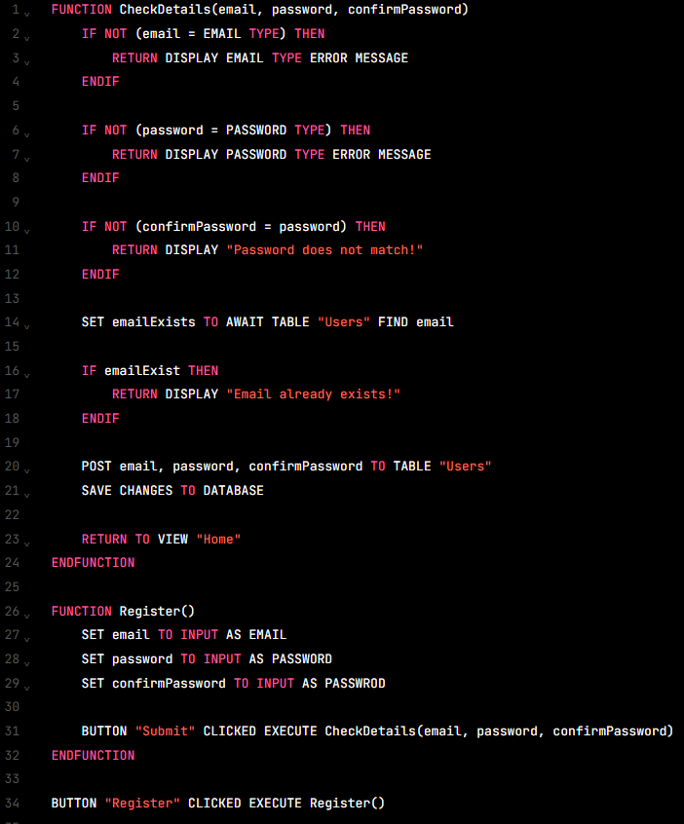
When the user clicks register, get their email, password and confirmation password. Check the information given by the user for email format, password format and if confirmation password matches password. If the information is incorrect give them an error message on their screen for the specific information field. If the information is correct send it to the table called “Users” and save the changes made to database.

Login
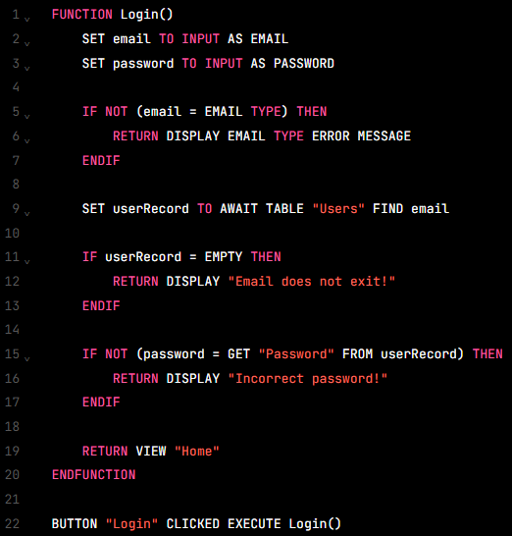
When the user clicks login, get the user’s email address and password. Check the information given by the user for email format, if the email address exists in the “Users” table and if the password matches the password in the record found in the “Users” table using the email address. If the information is incorrect display an error message on the user’s screen for the specific information field. If the information is correct, then send the user to the home page with their account logged in.

Filter products by price
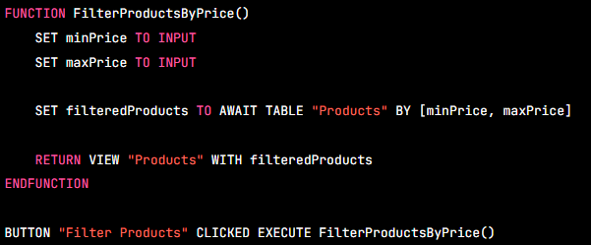
When the user clicks the filter button, filtered products are found from the table “Rooms” by the minimum price and maximum price inputted by the user. The filtered products are sent to the “Products” page to be displayed and then the user is sent to the “Products” page.

Change product availability as a producer
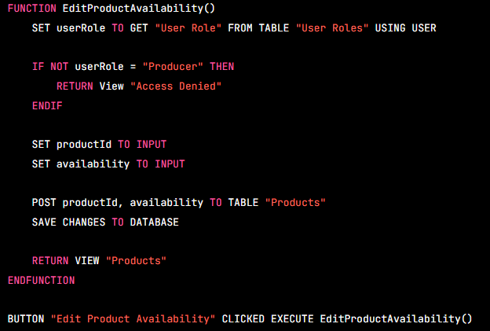
When the user clicks the “Edit Product Availability” button, the user’s role is taken from the “User Roles” table and checked for if it is a “Producer” role. If the user role is not a “Producer” role then the user is denied access and sent to the “Access Denied” page. If the user has access to page, then the product that’s availability is going to change is taken, and the new availability status from the user. This new data is sent to the “Products” table and then saved to the database. Finally, the user is sent to the “Products” page.

Add a product to basket
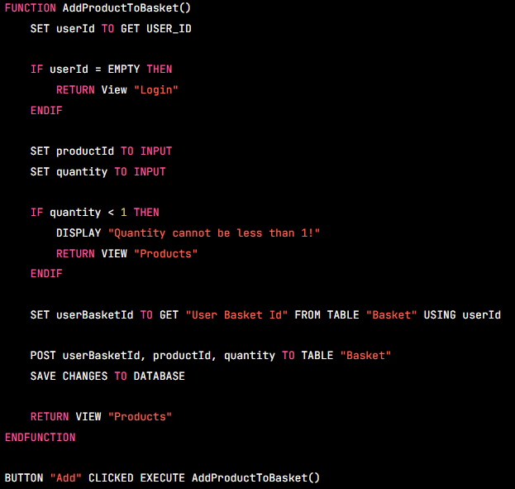
When the user clicks the “Add” button the user’s identification is checked to see if they are logged in, if they are not then they are redirected to the log in page. The product identification and quantity are inputted by the users for the product to be added to the basket. The quantity is checked for if it is less than 1, if that is true then a relevant error message is shown to the user and the user is redirected to the products page without no product being added to the basket. If the quantity is not less than 1, then the user’s basket identification is retrieved from the table “Basket” using the user’s identification. The user identification, product identification and quantity are sent to the table “Basket” and then the changes are saved to the database. Finally, the user is sent to the products page with the product being added to the basket.

Test Strategy
Date of Test | Component to be Tested | Type of Test to be carried out | Prerequisites and dependencies
 | Register | White box  Black box  Functionality  Security  Integration | The register function should be fully functional and implemented.  Migrations and update database must be applied.  The controller logic should be completed to handle user and error handling for incorrect inputs, duplicate accounts and password completely must be set up.  Test Data:  Normal  Email: test@gmail.com  Password: Password123!  Confirm Password:  Password123!  Erroneous  Email: bademail  Password: 111  Confirm Password:  222  Extreme  Email: test@testemail.com  Password: QwE12?  Confirm Password:  QwE12?
 | Log in | White box  Black box  Functionality  Security  Integration | The log-in page must be created.  Migrations and update database must be applied.  The controller logic must work correctly.  Test Data:  Normal  Email: test@gmail.com  Password: Password123!  Erroneous  Email: bademail  Password: 111  Extreme  Email: test@testemail.com  Password: QwE12?
 | Log out | Black box  Functionality  Security  Integration | Log in system must be fully functional and allow users to create accounts.  Log out button must work and be visible to the users.  No test data needed.
 | Remember Me check box on the log in page | White box  Black box  Functionality  Integration | Log in system must be fully functional.  Valid account should exist.  Tester must click the remember me check box when logging in, leave the page, open the page on the same device and check if site kept the user logged in.  No test data needed.
 | Forgot password button on the log in page | White box  Black box  Functionality  Integration | Log in system must be fully functional.  Valid account should exist.  Forgotten system must be fully functional.  Tester should click forgot password, and a reset email should be sent to reset password.  No test data needed.
 | Link buttons on the navigation bar | Black box  Functionality  Integration | All the pages for each link should be made and the controller logic for each link must work correctly.  The navigation bar should be made and be fully functional.  Tester must check each link to see if it leads to the correct page.  No test data needed.
 | Logo on the navigation bar and the footer | Black box  Functionality  Integration | Home page should be made and be fully functional.  The navigation bar should be made and be fully functional.  The footer should be made and be fully functional.  Tester should click the logo to check if they are taken to the home page.  No test data needed.
 | Links on the footer | Black box  Functionality  Integration | All the pages for each link should be made and the controller logic for each link must work correctly.  The footer should be made and be fully functional.  Tester must check each link to see if it leads to the correct page.  No test data needed.
 | Basket button on the navigation bar | White box  Black box  Functionality  Integration | Home page should be made and be fully functional.  Log in system must be fully functional.  Valid account should exist.  Migrations and update database must be applied.  Basket controller should be made and fully functional.  The tester must click on the basket button located on the navigation bar and check if a side bar shows up containing all the products that have been added to the basket with a checkout button.  No test data needed.
 | Close basket button on the basket side bar | White box  Black box  Functionality  Integration | Home page should be made and be fully functional.  Basket side bar should be made and fully functional.  The tester must open the basket by pressing the basket button on the navigation bar and click the “X” on the side bar to check if the side bar closes or disappears.  No test data needed.
 | Basket items number text on the navigation bar | White box  Black box  Functionality  Integration | Home page should be made and be fully functional.  Log in system must be fully functional.  Valid account should exist.  Migrations and update database must be applied.  Basket controller should be made and fully functional.  The tester must add and remove products to their basket and check if the text showing the number of items in the basket changes accurately to the number of items in the current basket.  No test data needed.
 | “Previous Baskets” button on basket side bar | White box  Black box  Functionality  Integration | Home page should be made and be fully functional.  All baskets’ page should be made and be fully functional.  Basket side bar should be made and fully functional.  Log in system must be fully functional.  Valid account should exist.  Migrations and update database must be applied.  Tester must click the “Previous Baskets” button to check if they get redirected to the all-baskets’ page.  No test data needed.
 | Checkout using the “CHECKOUT” button on the basket side bar | White box  Black box  Functionality  Integration | Home page should be made and be fully functional.  Order page should be made and be fully functional.  Log in system must be fully functional.  Valid account should exist.  Migrations and update database must be applied.  Basket controller should be made and fully functional.  No test data needed.  The tester must add some products to the basket and click the checkout button to check if they get redirected to the order page.  No test data needed.
 | Items and subtotal text on the basket side bar | White box  Black box  Functionality  Integration | Home page should be made and be fully functional.  Basket side bar should be made and fully functional.  Basket controller should be made and fully functional.  Log in system must be fully functional.  Valid account should exist.  Migrations and update database must be applied.  The must login using a “Customer” role account and add different items to the basket. Afterwards the tester must change the quantity of different products, and check if the items count and the subtotal changes accordingly.  No test data needed.
 | Accessibility features | Black box  Functionality  Integration | Accessibility system must be fully functional and accessible by users.  Tester should test each accessibility feature to see if it works. For example, colour mode, text resize and text-to-speech.  No test data needed.
 | Cookies functionality | Black box  Functionality  Integration | Cookies UI must be made.  Tester must check if the cookies show/pop up when new users enter the site.  No test data needed.
 | Accept all and decline all buttons on the cookies pop up. | White box  Black box  Functionality  Integration | Cookies must be fully functional and must pop up using JavaScript.  Testers must check if the cookies disappear after either one of the buttons on the cookies is clicked.  No test data needed.
 | Products section on the home page | White box  Black box  Functionality  Integration | Home page should be made and be fully functional.  Products page should be made and be fully functional.  Tester must be able to view some of the existing products on the rooms section on the homepage and view more using the “BROWSE ALL PRODUCE” button.  No test data needed.
 | “ADD” button on the products’ section on the home page | White box  Black box  Functionality  Integration | Home page should be made and be fully functional.  Log in system must be fully functional.  Valid account should exist.  Migrations and update database must be applied.  Basket controller should be made and fully functional.  Tester must login using a “Customer” role account. Then the tester must click the “ADD” button for any product on the products section and check if that product is added to the basket with right amount of quantity.  No test data needed.
 | Quantity change buttons on the products’ section on the home page | White box  Black box  Functionality  Integration | Home page should be made and be fully functional.  Log in system must be fully functional.  Valid account should exist.  Migrations and update database must be applied.  Basket controller should be made and fully functional.  Quantity changing functionality should be made.  Tester must login using a “Customer” role account. Then the tester must use the plus and minus buttons to change the quantity to be added to the basket when clicked “ADD”. Afterwards the quantity has changed the tester must add the product with the changed quantity to the basket and check if the correct amount of quantity for the specific product was added to the basket.  No test data needed.
 | “BROWSE ALL PRODUCE” button on the products’ section on the home page | White box  Black box  Functionality  Integration | Home page should be made and be fully functional.  Products page should be made and be fully functional.  Migrations and update database must be applied.  The tester must click the “BROWSE ALL PRODUCE” button and must check if they are redirected to the products’ page.  No test data needed.
 | “Our Producers” section on the home page | White box  Black box  Functionality  Integration | Home page should be made and be fully functional.  Producers’ page should be made and be fully functional.  Migrations and update database must be applied.  Tester must check if they can view some of the producers that sell their products using the platform. The details of the producers should be shown using a card and an image of the producer or their farm.  No test data needed.
 | “ALL PRODUCERS” button on the “Our Producers” section on the home page | White box  Black box  Functionality  Integration | Home page should be made and be fully functional.  Producers’ page should be made and be fully functional.  Migrations and update database must be applied.  The tester must click the “ALL PRODUCERS” button and must check if they are redirected to the producers’ page.  No test data needed.
 | “BROWSE ALL PRODUCE” button on the call-to-action section of the homepage | White box  Black box  Functionality  Integration | Home page should be made and be fully functional.  Products page should be made and be fully functional.  Migrations and update database must be applied.  The tester must click the “BROWSE ALL PRODUCE” call-to-action button and must check if they are redirected to the products’ page.  No test data needed.
 | Filter products on the products’ page | White box  Black box  Functionality  Integration | Home page should be made and be fully functional.  Products’ page should be made and be fully functional.  All models should be made.  Migrations and update database must be applied.  Tester must go on the products’ page and change the various fields provided in the filters section. Then wait for the products to be changed according to the specific filters applied. Tester must check if the products have been filtered according to the specific filters applied.  No test data needed.
 | Search rooms on the rooms page | White box  Black box  Functionality  Integration | Home page should be made and be fully functional.  Products’ page should be made and be fully functional.  All models should be made.  Migrations and update database must be applied.  Tester must go on the products’ page and then use the search bar to search different products by their names. Then the tester must check if only the products that match the search query roughly are shown.  No test data needed.
 | Pagination buttons on the products’ page | White box  Black box  Functionality  Integration | Products’ page should be made and be fully functional.  All models should be made.  Migrations and update database must be applied.  Tester must use the pagination buttons to see the other products that have been not shown on the products’ page, to allow for better performance of the website.  No test data needed.

