Contents
FLOWCHARTS 3
Log in 3
Register 4
Making a booking 5
Staff confirming or denying bookings 6
Editing room availability 7
Database Design 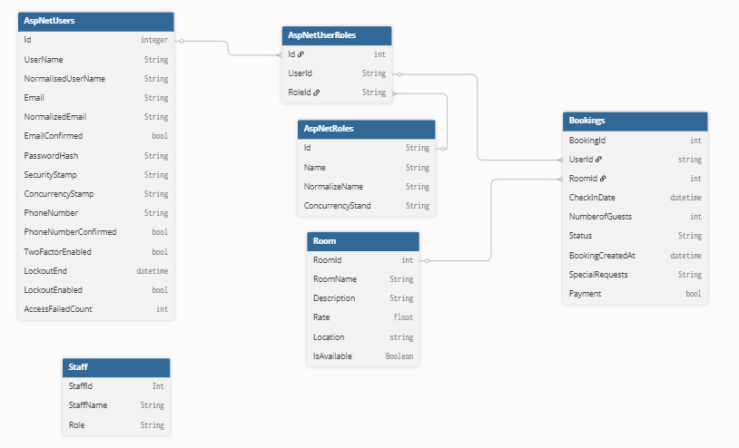 8
Data Dictionary 8
AspNetUsers 8
AspUserRoles 9
Bookings 9
Rooms 9
Staff 10
Sitemap 10
WireFrames 11
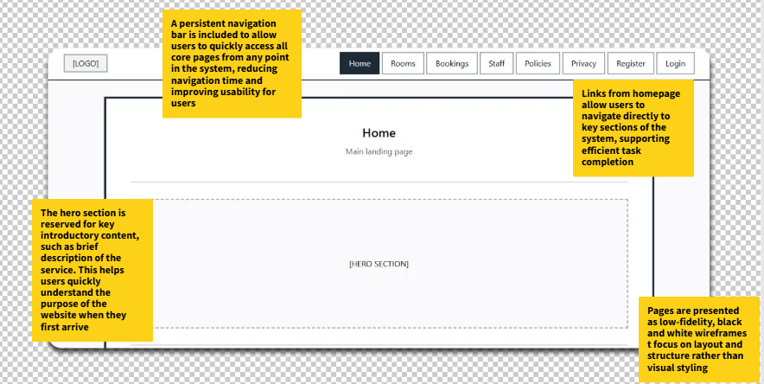 11

FLOWCHARTS

Log in
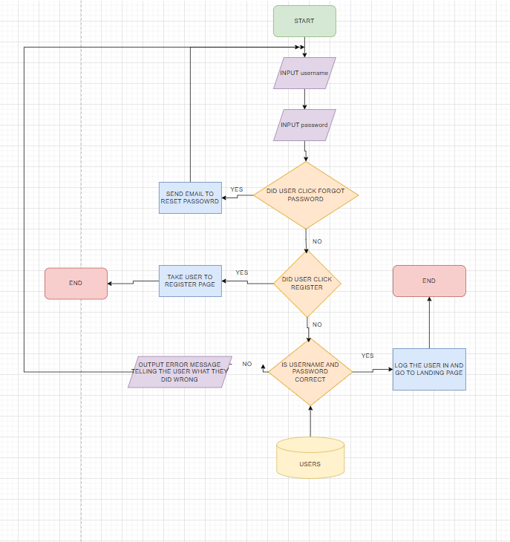
The user will be prompted to enter their username and password the system will then check if the user clicked other options like forgot password or register if they did it will take the appropriate actions like sending a reset email link or taking the user to the register page if not the system will check if the username and password match the ones in the database and if not, not, it will send an error message telling the user what they did wrong if its correct the system will log the user in return them to the landing page.

Register
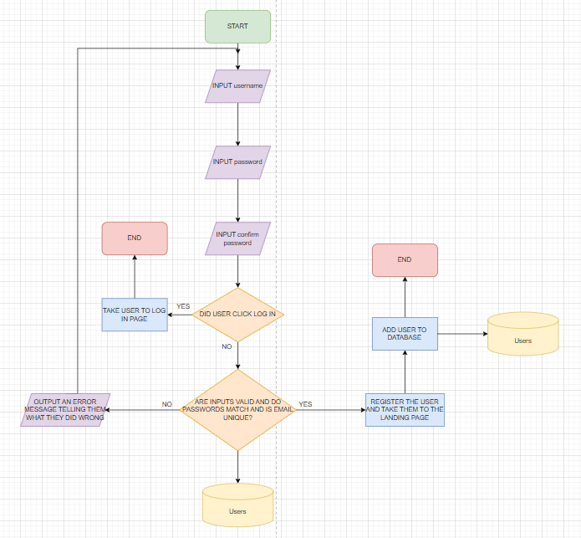
The user will be prompted to enter their username and password and password again to confirm it, the system then checks if the two passwords match and if the email is unique to any other account from the database, then they can proceed to add the user to the database if everything is good but if there are any issues the system prompts the user with an error message explaining what they have done wrong and asks them to try gaain.

Making a booking
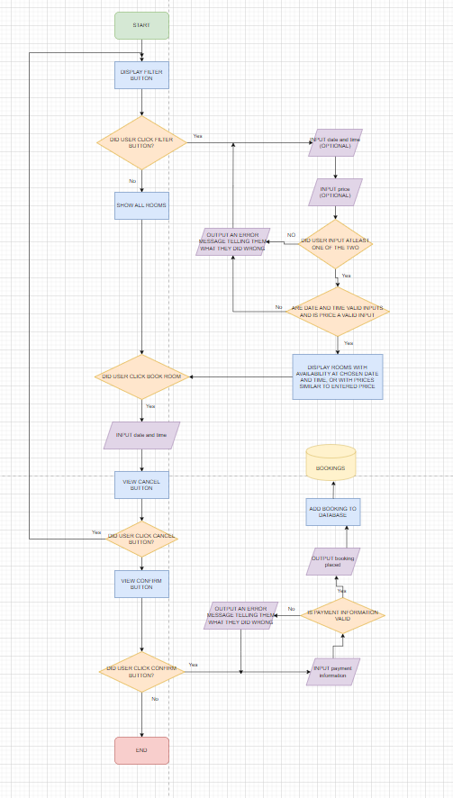
The page loads up showing all rooms available to book and also a filter button, tif the user chooses to filter the rooms they are asked to filter by price or by availability at a certain date and time, the user must choose one of the two and the system displays the necessary rooms in which they have filtered to. When the user finds the room that they want they can click the book room button, enter the details of their booking and click confirm, there they will be asked to pay and if their payment is successful, they will receive a booking confirmation message and the booking will be added to the database. The system is quipped with fail safes meaning if the user enters the wrong things at any time the user is given an error message explaining what went wrong and are prompted to try again.

Staff confirming or denying bookings
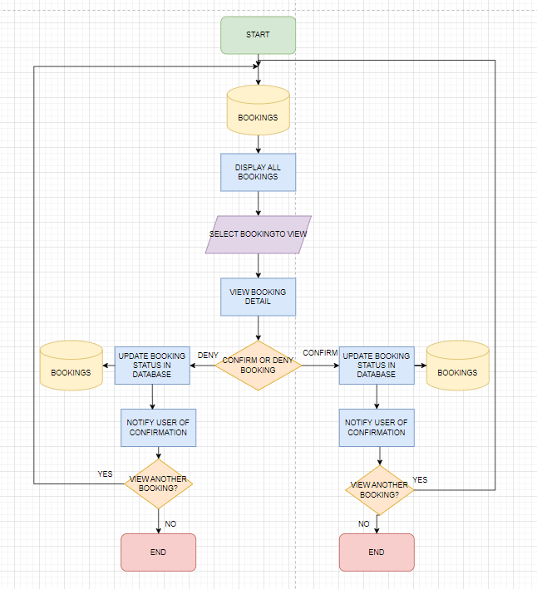
Staff are allowed to confirm and deny bookings, so this function makes that possible by accessing the database to be able to display the full list of all the bookings onto the web page, the staff member then finds a booking they want to see and selects it. The eb page displays the details of the booking that they have selected and they are presented with two buttons, a confirm or deny button, clicking either will update the booking information on the database, notify the user that their booking has either been accepted or denied and then the system asks the staff member if they would like the move on to another booking, clicking yes will take them back to the page with the full list of all bookings made.

Editing room availability
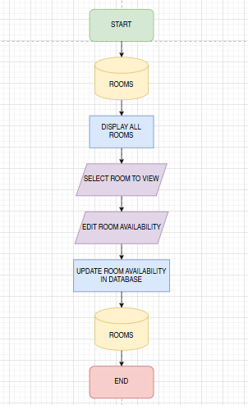

Database Design

Data Dictionary

AspNetUsers
Column | Data Type | Required | Default | Validation | Key Type
Id | String | Yes |  |  | Primary
UserName | String | Yes |  |  | None
NormalizedUserName | String | Yes |  |  | None
NormalizedEmail | String | Yes |  | Must include a valid email structure, must have a”@” symbol, must have a domain name | None
EmailConfirmed | String | Yes |  |  | None
PasswordHash | Bool | Yes |  | Users must confirm their email | None
SecurityStamp | String | Yes |  |  | None
ConcurrencyStamp | String |  |  |  | None
PhoneNumber | String |  |  |  | None
PhoneNumberConfirmed  twoFactorEnabled | String |  |  |  | None
LockoutEnd | Bool |  |  |  | None
LockoutEnabled | DateTime |  |  |  | None
AccessFailedCount | Int |  |  |  | None

AspUserRoles
Column | Data Type | Required | Default | Validation | Key Type
Id | Int | Yes |  |  | Primary
UserId | String | Yes | Users  Id |  | Foreign
RolesId | String | Yes |  |  | None

Bookings
Column | Data Type | Required | Default | Validation | Key Type
BookingId | Int | Yes | BookingId | Must be a numerical value | Primary
UserId | String | Yes | UserId |  | Foreign
RoomId | Int | Yes |  |  | Foreign
CheckInDates | DateTime | Yes |  | Must be a valid date and time | None
NumberOfGuests | Int | Yes |  | Must be a numerical value, CAN NOT BE LESS THAN 0 | None
Status | String | Yes |  |  | None
BookingCreatedAt | DateTime | Yes |  | Must be a valid date and time | None
SpecialRequests | String | No |  | Can not be more than 500 characters | None
Payment | Boolean | Yes |  |  | None

Rooms
Column | Data Type | Required | Default | Validation | Key Type
RoomId | Integer | Yes | RoomId |  | Primary
RoomName | String | Yes |  |  | None
Description | String | Yes |  |  | None
Rate | Float | Yes |  | Must be a numerical value, Must be a float value, Must have a currency | None
Location | String | Yes |  |  | None
IsAvailable | Bool | Yes |  |  | None

Staff
Column | Data Type | Required | Default | Validation | Key Type
StaffId | int | Yes | StaffId |  | Primary
Name | String | Yes |  |  | None
Role | String | Yes |  |  | None

Sitemap

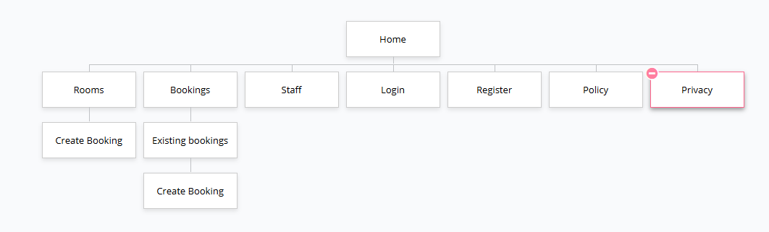

WireFrames
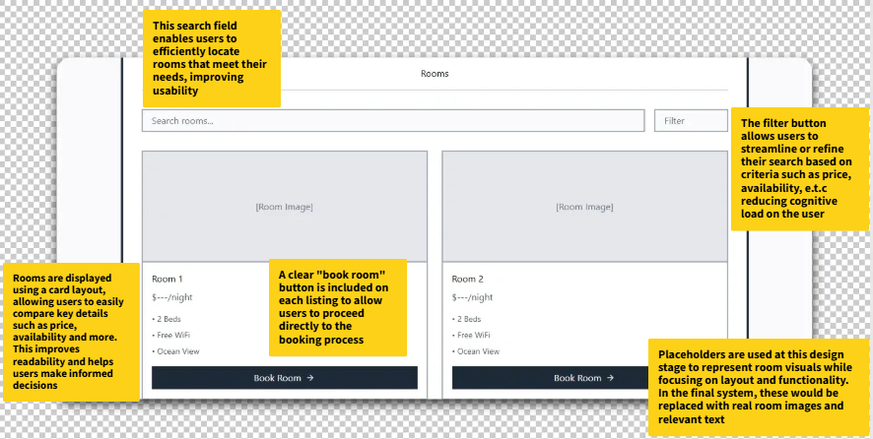
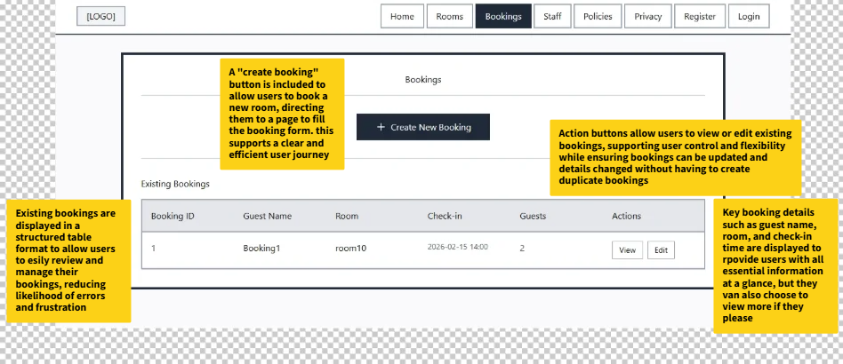
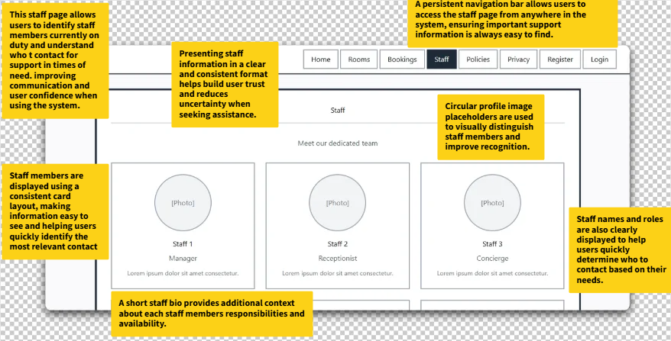
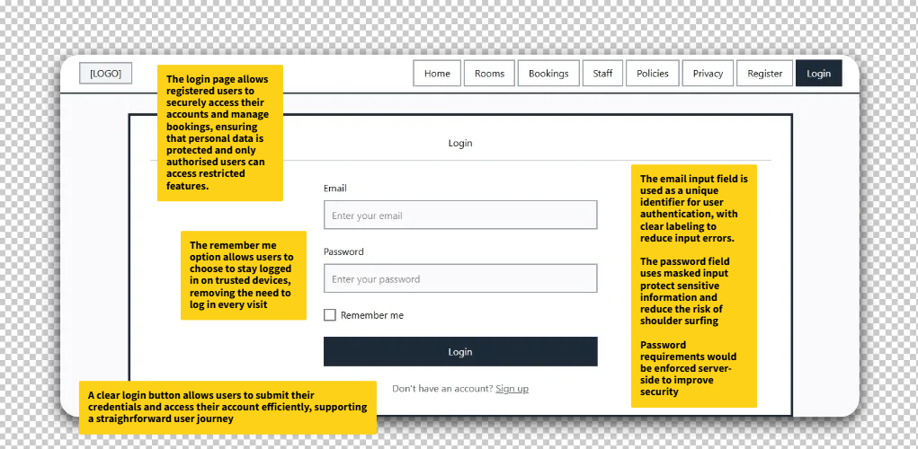
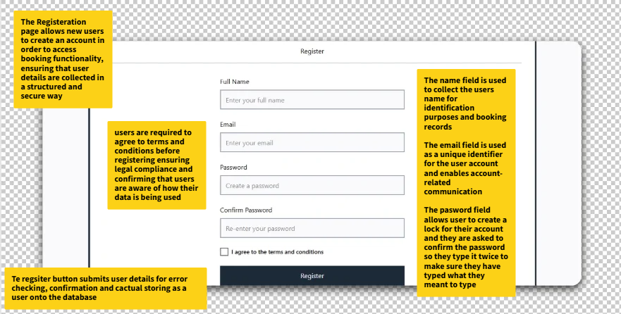
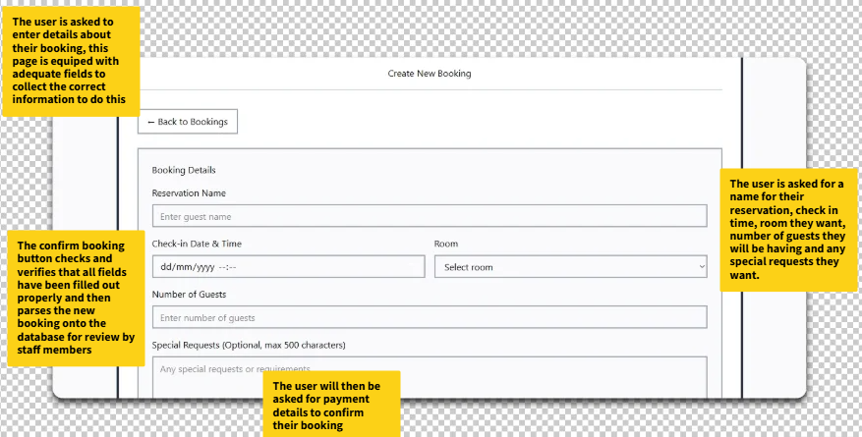
(part of booking page above)
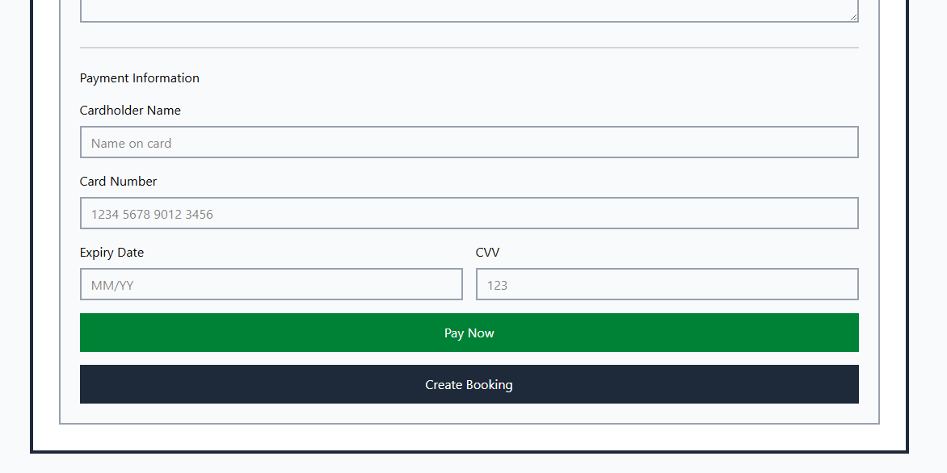
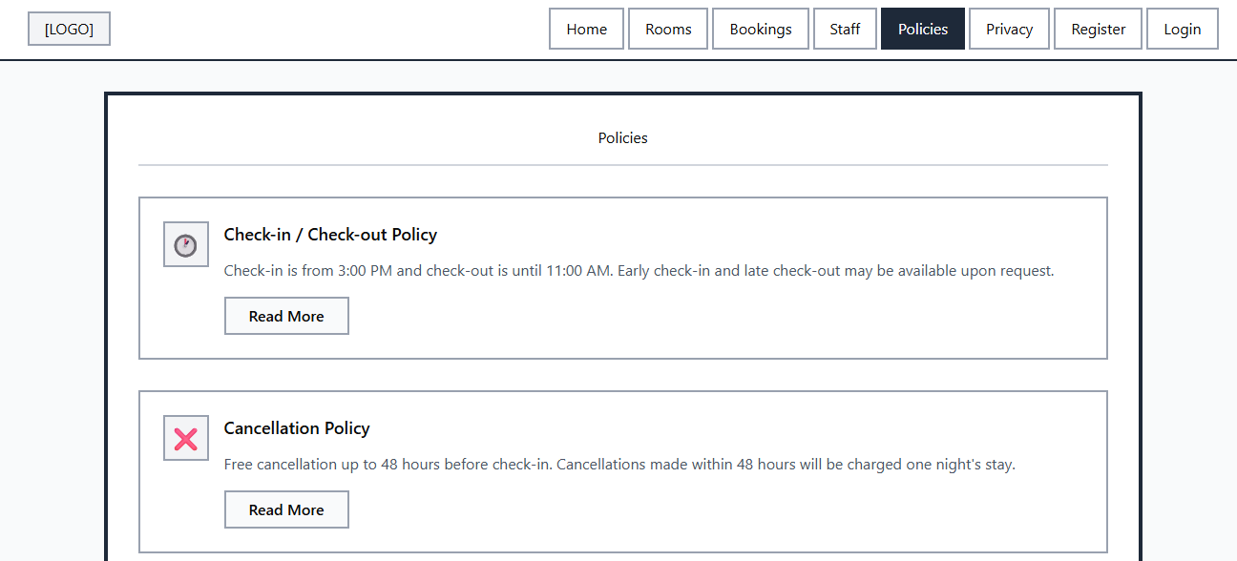
The policies page allows users to be able to read in on the poliies of the company so they know what to expect, these policies could include things like refund policies, checkin and check out policies and many more
This page features different policies in a card format, has a general image to explain the policy, a body of text stating the policy and a read more button if they choose to find out more about that specific policy. This page helps build user to company trust as they now have better communications about “rules and regulations” and how things work and are carried out in the company.

Test Strategy
Date of Test | Component to be tested | Type of test to be carried out | Prerequisites and dependencies
30/01/2026 | User Register system | White box testing, black box testing, functionality testing, Security testing, Integration Testing. | The register function should be fully functional and implemented. Migrations and update database must be applied. The controller logic should be completed to handle user registration and error handling for incorrect inputs duplicate accounts and password complexity must be set up. Tests should include valid/invalid Test data needed. The log-in page must be created, and the migration and update database must be completed. There must be working controller logic. Testers must test valid/invalid credentials, session management, variability's (SQL injection) and password encryption. Example of test data: - Normal: Email: “Test@teste mail.com,” Password: "Password123 ?”, Confirm Password: “Password123 ?” - Erroneous: Email: “falseemail” (Should contain a “@ symbol”, Should contain a domain e.g. “.com”), Password: “111” (Should be longer, should be a string, should have a capital letter and a symbol), Confirm Password: “1er” (Dose not match original password) - Extreme: test@testema il.com, Password: “QwE12?” (Exactly 6 characters which is the minimum and includes 1 symbol which is the minimum)
2/02/2026 | User log in system | White box testing, black box testing, functionality testing, Security testing, Integration Testing | Test data needed. The log-in page must be created, and the migration and update database must be completed. There must be working controller logic. Testers must test valid/invalid credentials, session management, variability's (SQL injection) and password encryption. Example of test data: - Normal: Email: “Test@teste mail.com”, Password: “Password123 ?” - Erroneous: Email: “falseemail” (Should contain a “@ symbol”, Should contain a domain e.g. “.com”), Password: “pass” (Should be longer, should be a string, should have a capital letter and a symbol) - Extreme: “test@testem ail.com”, Password: QwE12? (Exactly 6 characters which is the minimum)
03/02/2026 | log out function | Black box testing, Functionality testing, Security testing, Session management testing. | No test data required, the log in system must be fully functional and allow users to create accounts and save their data to a database and the log out button should be clear and easily visible.
19/02/2026 | Log in button on the top right of the home page on the navigation bar | Black box testing, Functionality Testing, Intergration Testing | No test data required. The register page and form should have been created and fully functional. The tester should click the button to ensure it loads the correct page.
23/02/2026 | Book a room | Black box testing, White box testing, Functionality testing, Security testing, Session management testing. | Test data required. The models and controller logic must have been created and there must be a logged in user to test it. The tester should book a room and fill out all fields and make sure it successfully logs the booking and displays it in the correct place. They should be able to edit, delete and view the details of the booking.  Normal: Name: “John Doe”, Check-in: “2026-02-15 14:00”, Room: “Room 1”, Special Requests: “High floor, near elevator”, Number of Guests: “2” - Erroneous: Name: “12345” (Should contain letters), Check-in: “15-02-26” / “yesterday” (Wrong format / Past date not allowed), Room: “Room 999” (Non-existent), Special Requests: >500 characters (Should be ≤500), Number of Guests: “0” / “-1” / “abc” (Minimum 1, must be numeric) - Extreme: Name: “A…A” (100 characters), Check-in: “2100-12-31 23:59” (Far future), Room: “999999999” (Very large ID), Special Requests: Exactly 500 characters (Maximum), Number of Guests: “50” (Maximum allowed)
27/02/2026 | Pay for booking | Black box testing, White box testing, Functionality testing, Security testing, Session management testing. | Test data required. The models and controller logic must have been created and there must be a logged in user to test it. The tester should book a room and fill out all fields and try to pay for a booking to test if the payment functions work properly. The payment should go through and finances should be transferred successfully.  Normal: Name: “John Doe”, Credit Card Number: “4111 1111 1111 1111”, CVV: “123” - Erroneous: Name: “12345” (Should contain letters), Credit Card Number: “1234 5678 9012 345” / “abcd efgh ijkl mnop” (Too short / Non-numeric), CVV: “12” / “abcd” / “1234” (Should be exactly 3 numeric digits) - Extreme: Name: 100-character string, Credit Card Number: “9999 9999 9999 9999” (Max digits), CVV: “000” (Edge case, technically valid)

