HGBlog Manual Tecnhical

HGBlog is composed by 3 differents projects which are located in https://github.com/Hgaray/HGBlog2

1. HGBlogDB
2. Api
3. HGBlogClient

Please, follow strict order to use the app once Files are downloaded

# HGBlogDb

1. It is a sql project (2016) that was created on VS 2019
2. Make sure that you have installed sqlserver 2016 to publish this db
3. Open solution HGBlogDB solution 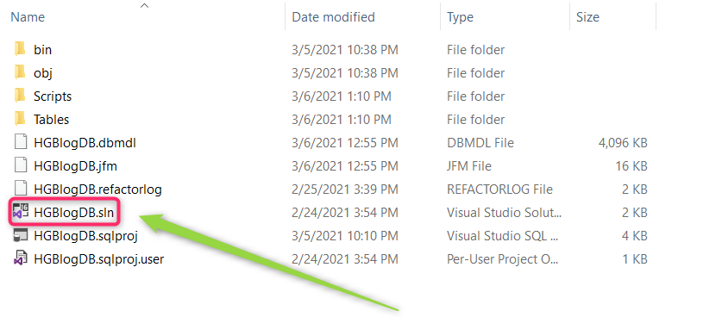
4. When solution is opened , HGBlogDB has to be published on sqlserver and named to DB “HGBlogDB”
   1. 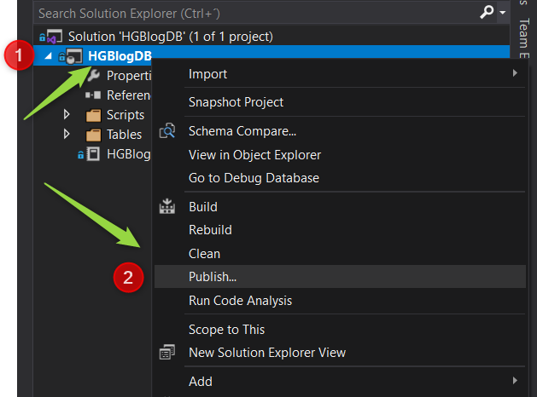
   2. 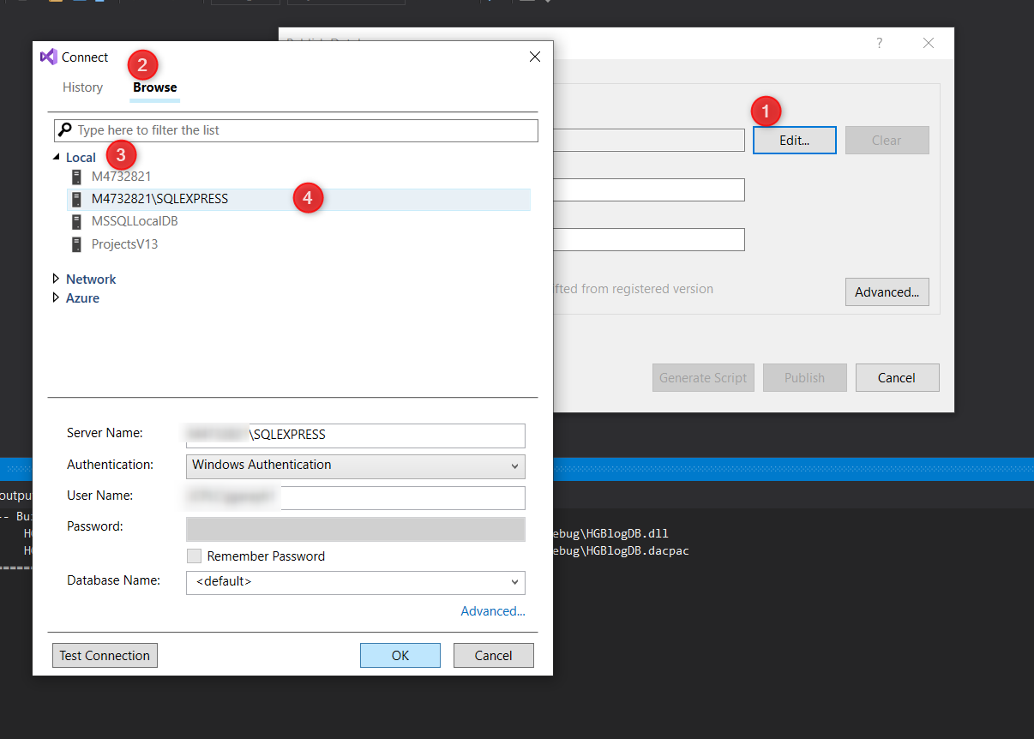
   3. Make sure to named DB as “HGBlogDB” , finally pick “Publish”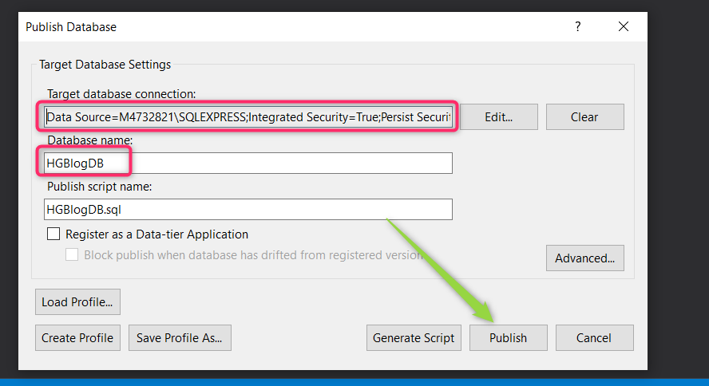
   4. The ouput should be 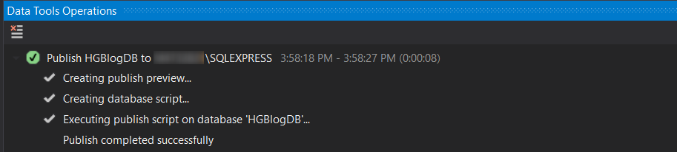
   5. You should be able to see HGBlogDB on your sql server 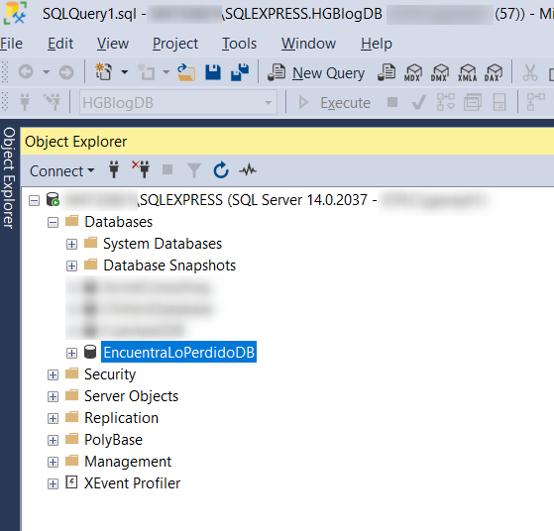

# Api

Api folder contains a .netcore 3.1 project that was created on VS 2019

1. Open HGBlogAPI/ HGBlogApi.sln 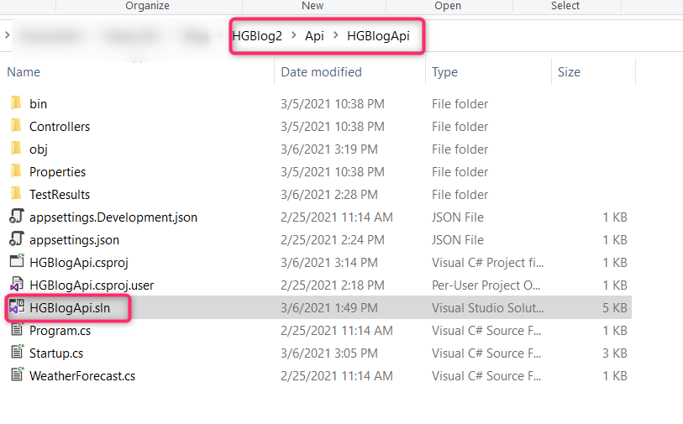
2. Once solution is completely loaded , you must see something like this 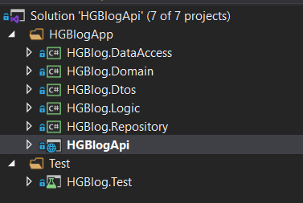
3. On HGBlogApi project , you have to modify Appsettings.json , and change sql server name by your sql server name where published HGBlogDB (previous step) 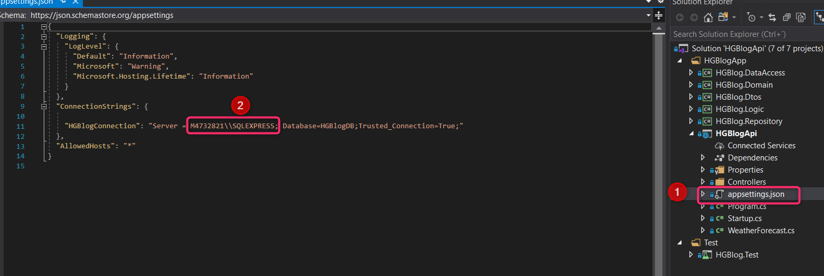
4. Run de application 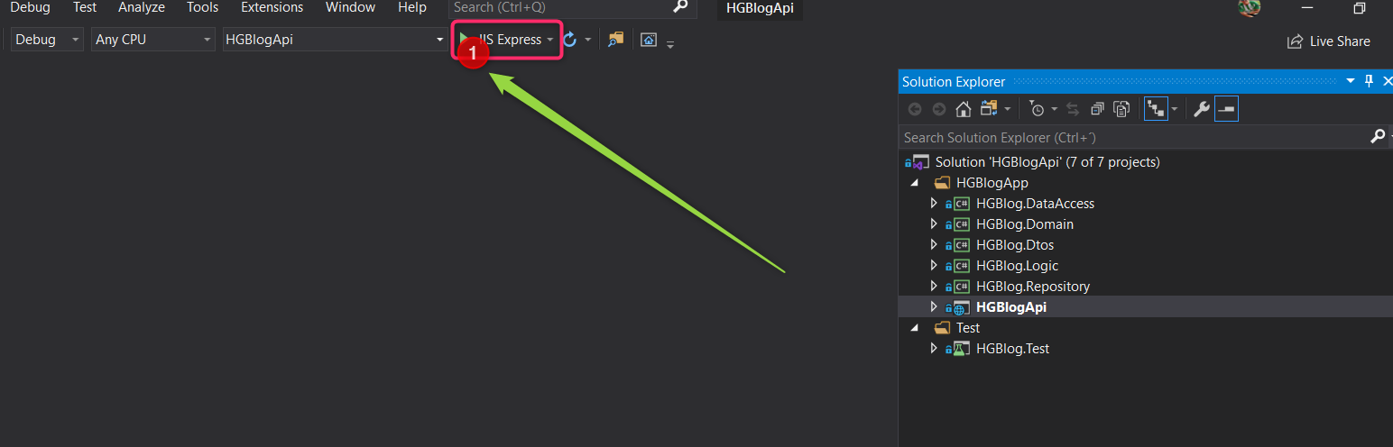
5. Once the app is run , type in your url “swagger” right after your local server address, in my case , my local server address is <https://localhost:44326/> and the comlete url to test api would be “https://localhost:44326/swagger”. 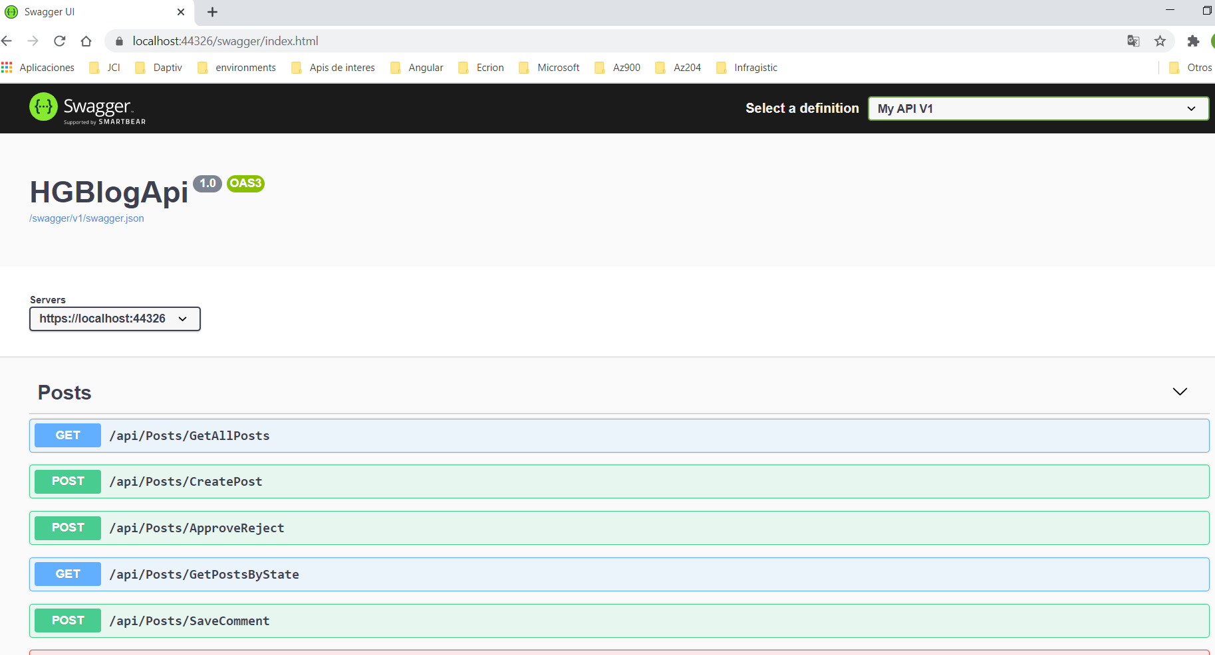
6. You can performance any endpoint on swagger to double check the Api is working well
7. Let The Api running to complete the next step.

# HGBlogClient

HGBlogClient contains a simple files which are concentrated on index.html file.

1. Be sure previous steps are completed and HGBlogApi is running
2. Just in case that your base local url is no equal to <https://localhost:44326> , please performace sub-step
   1. Open index.js file 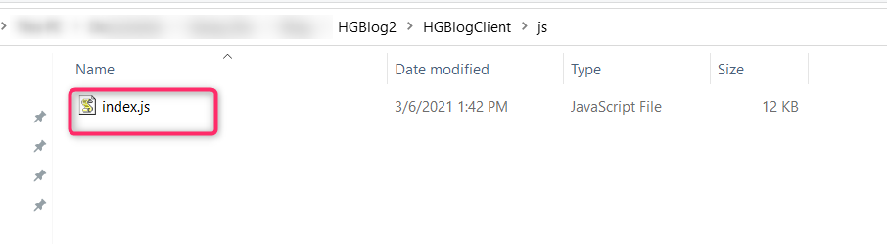
   2. Modify base URL value on localStorage by your local url ,save and close this file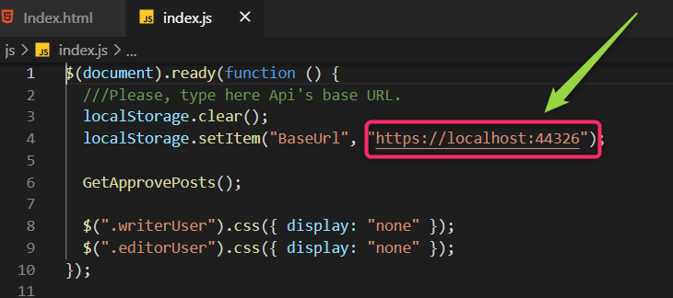
3. Open index.html file 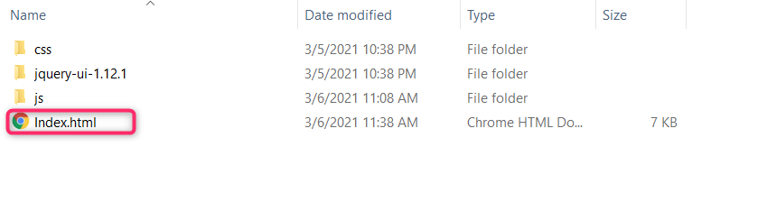
4. You must see something like this 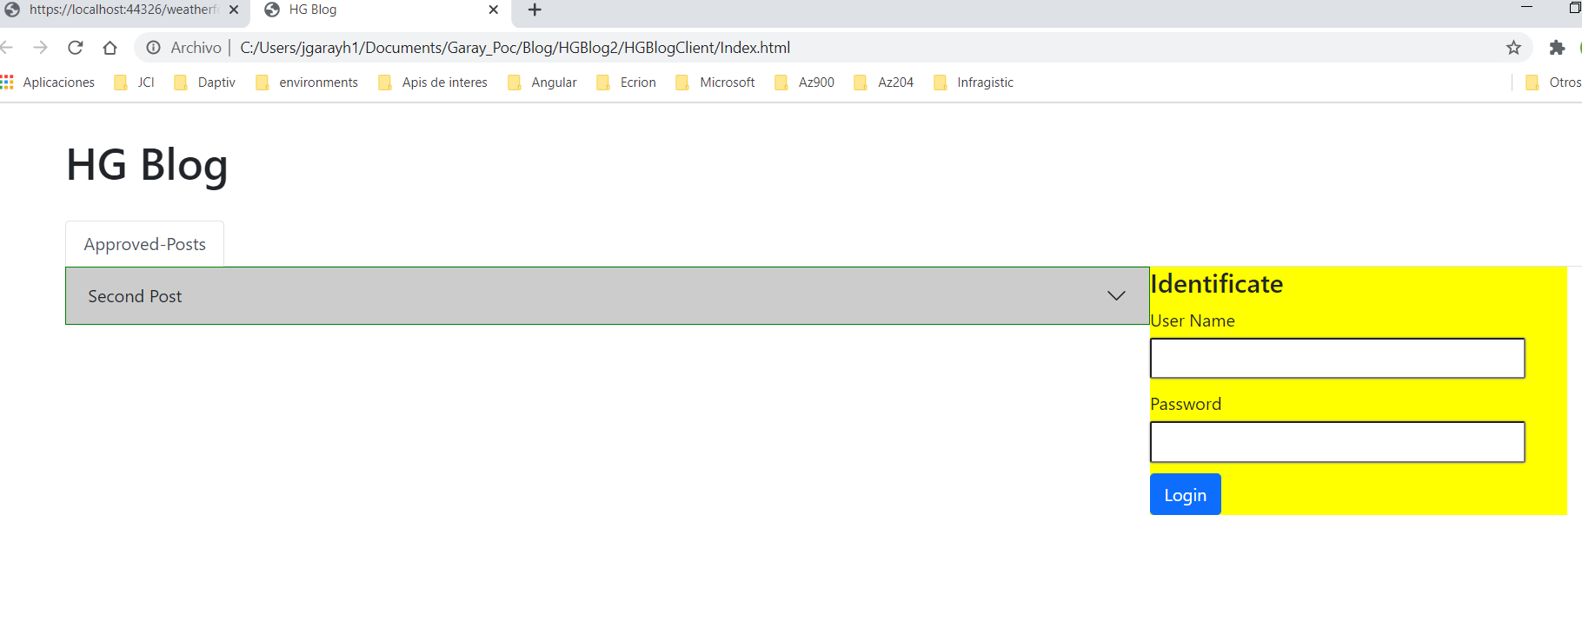
5. Database project contains scripts with initial information
6. Users to test app are:
   1. User name:writer , pass:123
   2. User name:editor , pass:123
7. User no auth. 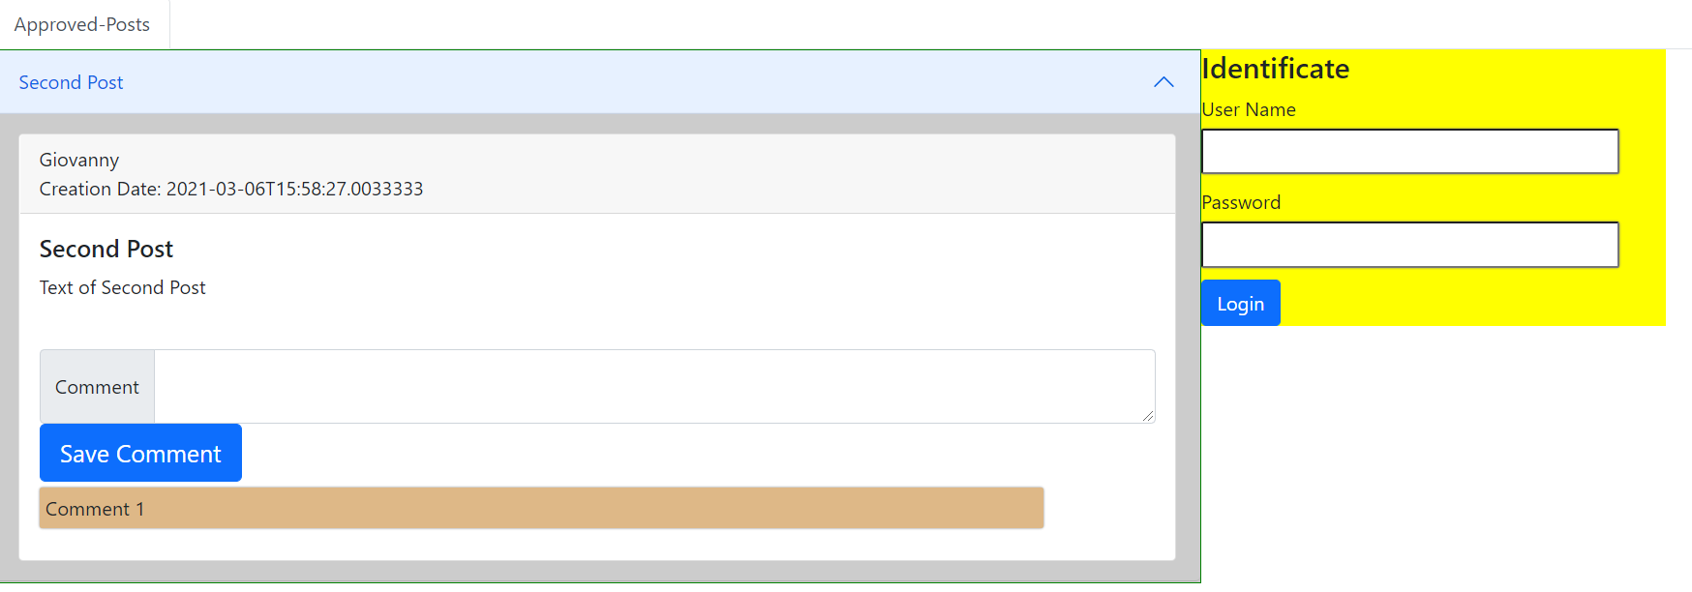
8. Editor auth 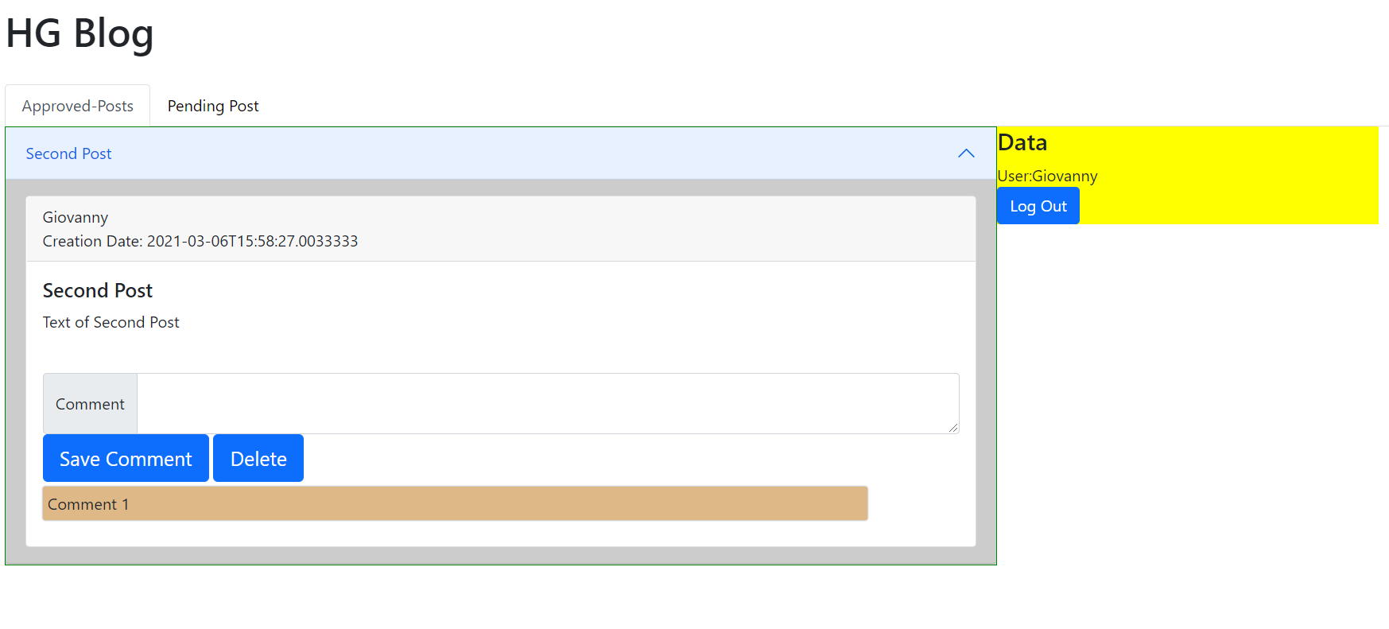 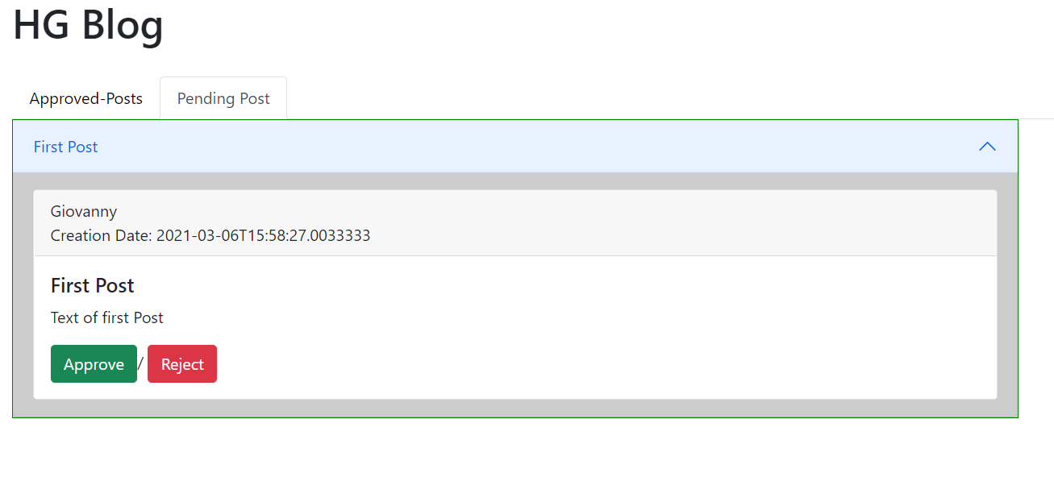
9. Writer auth 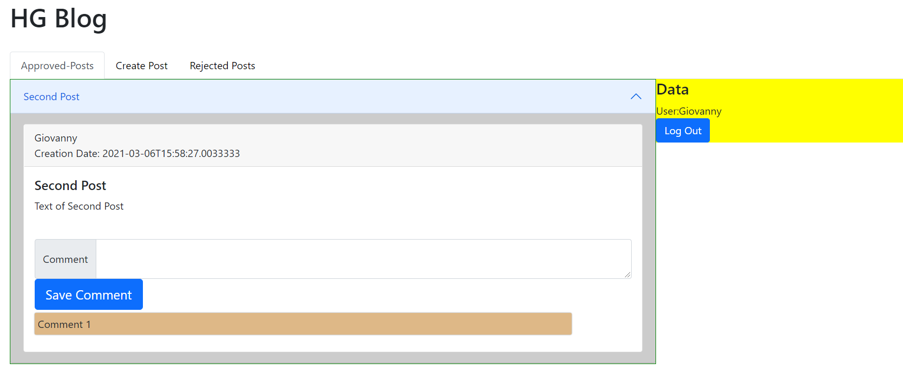
10. 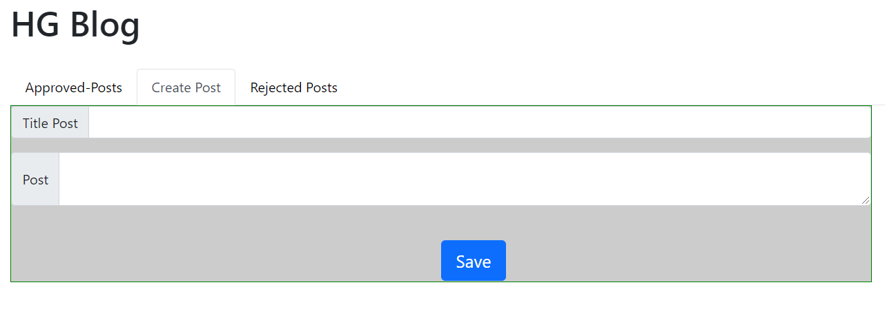 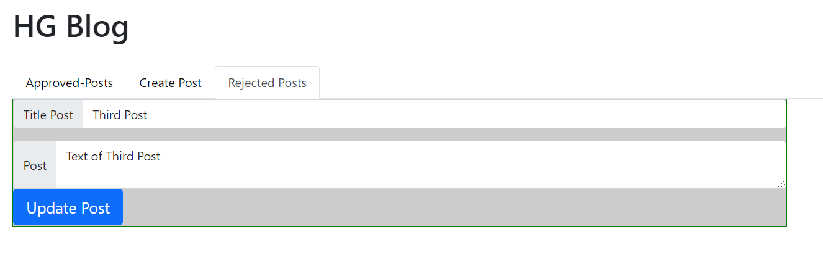
11. The solution contains unit testing project with several uni tests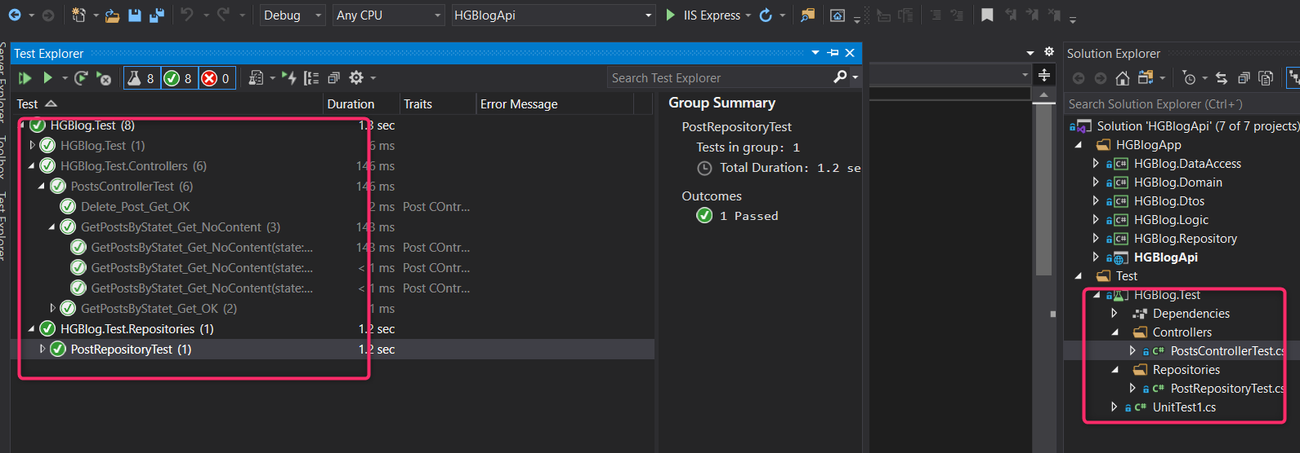

NOTE: All requirements are included