**School of Information and Communication Technology**

**Agile Cycle 2 Group Report**

Team Name:

PO3 Legends

Team Members:

Samuel Woolrich 577872 | Lachlan Milligan 540572 | Iluka Wighton 542142

Poorvika Kamberkavi 641799 | Darcie Keil 587894

Client:

Shape Policy

Date:

19th September 2025

Executive Summary

1. Introduction 3

2. System Development 4

2.1. UI Components 4

2.2. Design and Development Principles 4

3. Testing and Quality Assurance 4

3.1. Testing Strategies 4

3.2. Testing Activities 4

3.3. Quality Assurance and User Needs 4

4. User Mapping 4

4.1. User Mapping Methodology 4

4.2. Data Collected from User Mapping 5

4.3. User Mapping Results Analysis 5

5. Client Feedback 5

5.1. Feedback Methodology 5

5.2. Feedback Analysis 5

6. Progress Review 5

6.1. Agile Cycle Outcomes 5

6.2. Change Log 5

6.3. Gantt Chart Changes 5

7. Conclusion 5

8. References 5

9. Appendix 5

# Introduction

# System Development

Substantial evidence of research undertaken, reference to previous units, and application of best practice to thoroughly describe relevant decisions in system development and design.

## UI Components

What UI components, features and/or functions have been developed in the current Agile cycle? Provide examples and supporting evidence of development activities, such as UIs, design diagrams, code or pseudocode, model comparisons, and other relevant materials.

## Design and Development Principles

What principles guided the design and development decisions?

# Testing and Quality Assurance

Clear descriptions of the strategy and methodology used to guide test design and quality control activities. Clear descriptiopns of the testing methods applied, results obtained, and any necessary follow-up actions.

## Testing Strategies

What strategies and principles were applied in directing the testing and quality control activities?

## Testing Activities

What testing and quality control activities have been conducted in the current Agile cycle? Provide examples and supporting evidence of the testing activities, such as test cases, testing results, and result analysis.

## Quality Assurance and User Needs

How do the tetsing and quality assurance activities support user needs?

# User Mapping

Applying best practice user centered design principles, undertake a detailed analysis of the requirements of your system’s user. Describe these needs as augmentations to the requirements of your project schedule. Clear descriptions of the methods used for user mapping and data analysis activities. Clear descriptions of the analysis results and necessary follow-up actions.

## 4.1 User Mapping Methodology

Methods used in user mapping. Explain the techniques and approaches applied in mapping user needs and interactions.

## 4.2 User Personas

To ensure the Living Repository Project aligns with the needs of its intended audience, three user personas were developed including a Policy Analysts, a Policy officer, and a Policy and Planning Manager. These roles were selected due to their integral involvement across the policy development lifecycle; from data analysis and evidence-based decision-making to document drafting and strategic oversight. Additionally, the persons span junior, mid, and senior roles to capture the distinct needs of each level seniority within policy development.

Each persona was designed to represent a typical individual working in these roles, informed by demographic and occupational data sourced from public Australian government resources. This approach supports user-centered design by grounding functionality and interface decisions in realistic user expectations and workflows.

### Policy Analyst Persona

The first persona focuses on the Policy Analyst, a key stakeholder in the early stages of policy formulation. This profile was developed using a research-driven approach to reflect the average characteristics and responsibilities of professionals in this role.

* **Demographics:** The median age of policy analysts is 38. Approximately 66% are female, and the majority are employed in the Australian Capital Territory (Jobs and Skills Australia, 2024).
* **Role Overview:** Policy Analysts are responsible for interpreting complex data, conducting research, and providing evidence-based recommendations to inform policy decisions. Identifying them as a key user and target audience for the Living Repository Project.
* **Source Data:** Role descriptions, pain points, and daily tasks were derived from YourCareer (2023), an initiative by the Australian Government that outlines occupational expectations and career pathways. Helping to create a meaningful profile that captures a specific point-of-view that can help inform development of the project’s interface.

This persona helps guide design decisions by highlighting the analytical mindset, data literacy, and workflow needs typical of users in this role.

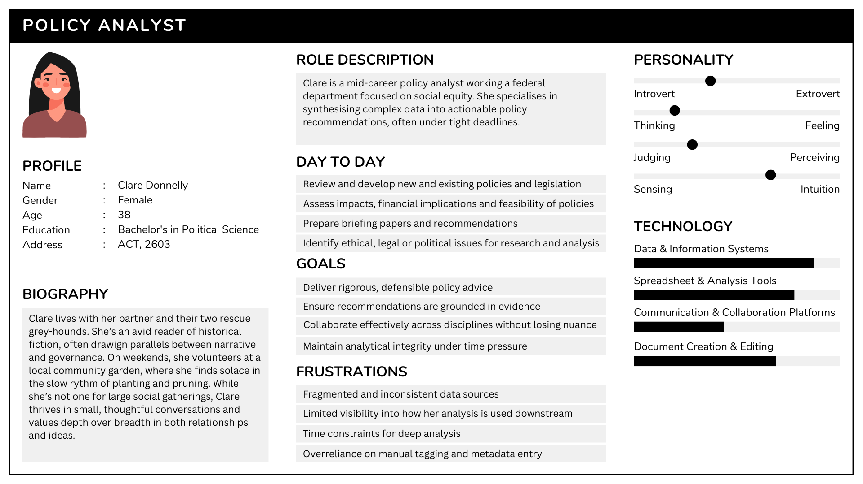

### Policy Officer Persona

This persona draws on the role definitions and expectations outlined by SEEK (n.d.), the Department of Home Affairs (2022), and Safe Work Australia (2022), which emphasizes the importance of written communication, stakeholder coordination, and policy documentation in junior roles. It also reflects operational realities described in APS-level guidance, including frustrations around unclear task briefs, inconsistent document formats, and limited visibility into downstream policy impact.

Ben’s inclusion in this User Mapping section of the Agile cycle report supports the repository’s goal of improving usability for junior staff who often manage document registers, prepare meeting notes, and assist with policy artifact ingestion. His needs highlight the importance of intuitive interfaces, structured workflows, and access to historical context. Helping to ensure that even early-career officers can contribute confidently and accurately to policy development.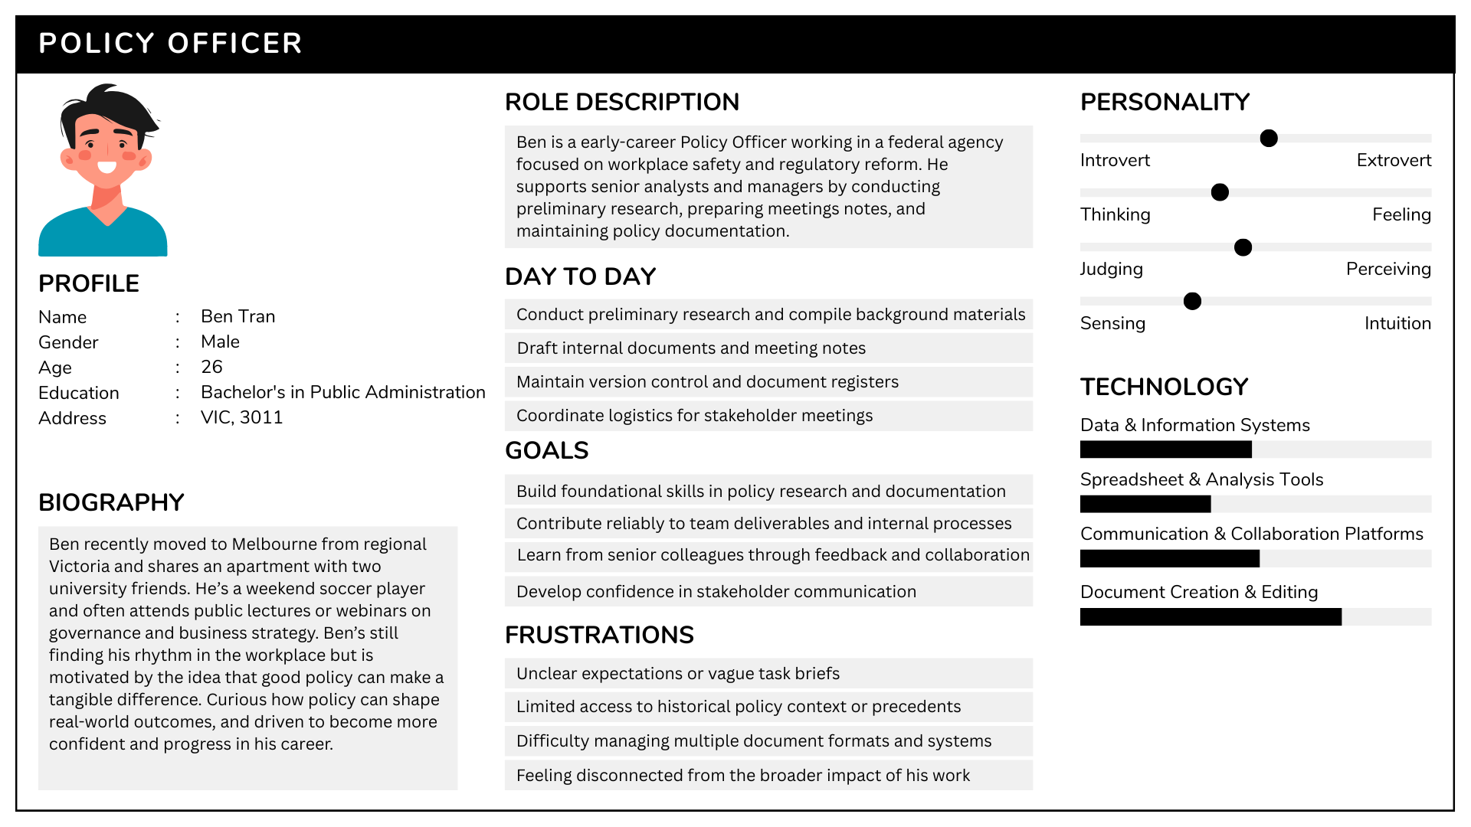

### Policy and Planning Manager Persona

The third persona focuses on the Policy and Planning Manager, a senior stakeholder responsible for strategic oversight and cross-sector coordination in policy development. This profile was developed uising a research-iinformed approach to reflect the leadership responsibilities, demographic trends, and workplace realities of professionals in this role.

* **Demographics:** Policy and Planning Managers typically hold postgraduate qualifications and have over a decade of experience in public administrations or strategic planning. The majority are employed in New South Wales and the Australian Capital, with a median age of 44 and strong representation in government and infrastructure sectors (Jobs and Skills Australia, n.d.).
* **Role Overview:** These professionals lead the design and implementation of policy frameworks, manage stakeholder relationships, and ensure alignment between policy initiatives and organizational goals. Their strategic influence and decision-making authority position them as key stakeholders in the Living Repository Project.
* **Source Data:** Role Expectations and workplace context were derived from Jobs and Skills Australia (n.d.) and YourCareer(n.d.), both Australian government initiatives that outline occupational profiles and career pathways. These sources helped shape a persona that reflects the high-level priorities and frustrations typical of policy managers.

This persona supports design decisions by emphasizing the need for executive-level functionality, strategic reporting tools, and collaborative workflows that accommodate complex policy lifestyles.

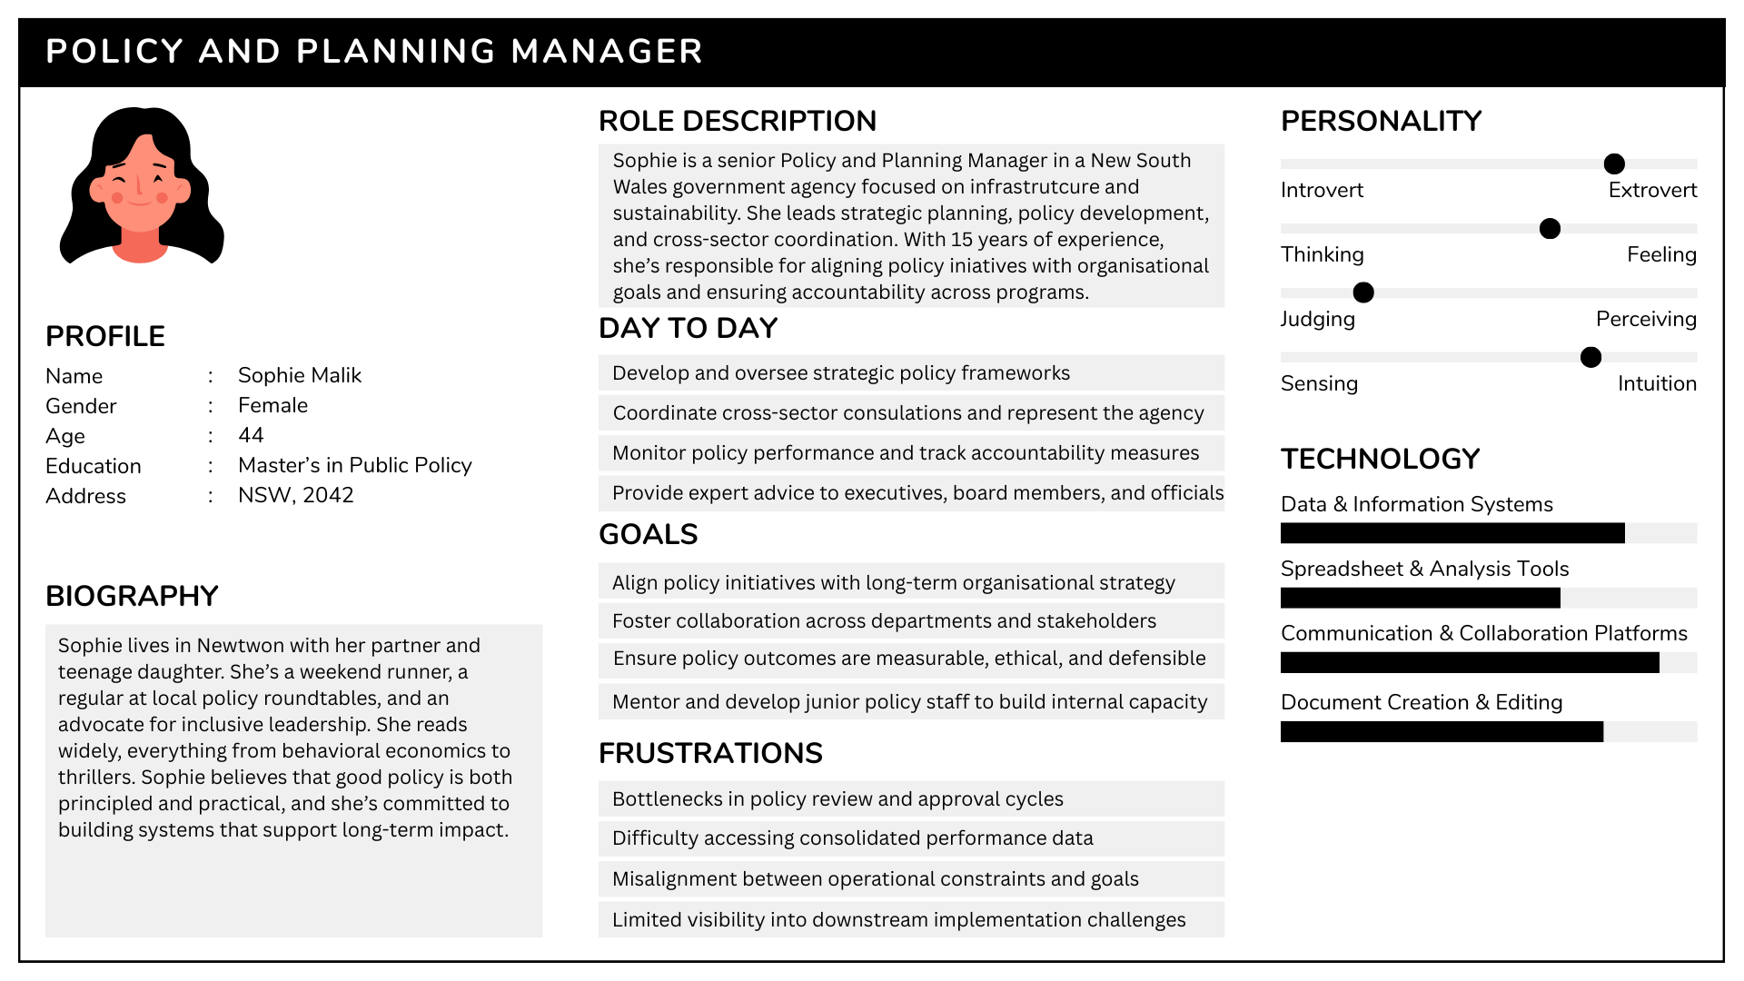

## 4.3 Journey Mapping

## Data Collected from User Mapping

Specify the types of data gathered, such as user feedback, analytics, or survey responses.

## User Mapping Results Analysis

Present the findings derived from the collected data, including insights, pain points, and recommendations for improvement.

# Client Feedback

Clear descriptions of the methodology used to elicit feedback from your client on the progress made. Clear descriptions of the feedback and follow-up actions for addressing the feedback.

## Feedback Methodology

Explanation of the methods and principles used for feedback elicitation and analysis.

## Feedback Analysis

Analysis of client feedback and corresponding follow-up actions.

# Progress Review

A clear assessment of whether the outcomes of Agile Cycle 2 align with those outlined in the Project Schedule and Miletsones. Any chanegs to requiremetns or the schedule resulting from development and client feedback are clearly documented in an updated Gantt chart and a change log.

## Agile Cycle Outcomes

Describe whether the outcomes of the current agile cycle align with those described in the Project Schedule and Milestones.

## Change Log

Represent any changes to requirements that have arisen in this agile cycle in a change log.

## Gantt Chart Changes

Updated Gantt chart in preparation for the next agile cycle, with any schedule changes incorporated.

# Conclusion

# References

Department of Home Affairs. (2022). *Policy officer role profile*. Australian Government. <https://www.homeaffairs.gov.au/careers-subsite/files/policy-officer-role.pdf>

Jobs and Skills Australia. “Policy Analysts.” Jobs and Skills Australia, 4 Oct. 2024, [www.jobsandskills.gov.au/data/occupation-and-industry-profiles/occupations/224412-policy-analysts](https://www.jobsandskills.gov.au/data/occupation-and-industry-profiles/occupations/224412-policy-analysts).

Jobs and Skills Australia. (n.d.). *Occupation profile: Policy and planning managers (1324)*. Australian Government. https://www.jobsandskills.gov.au/data/occupation-and-industry-profiles/occupations/1324-policy-and-planning-managers

Safe Work Australia. (2022). *Applicant information kit – APS4/5/6 – Chem policy and WES review section*. [https://www.safeworkaustralia.gov.au/sites/default/files/2022-05/applicant_information_kit_-*aps4_5_6*-_chem_policy_and_wes_review_section.pdf](https://www.safeworkaustralia.gov.au/sites/default/files/2022-05/applicant_information_kit_-aps4_5_6-_chem_policy_and_wes_review_section.pdf)

SEEK. (n.d.). *Policy officer job description*. <https://www.seek.com.au/career-advice/role/policy-officer>

YourCareer. “Policy Analyst.” Yourcareer.gov.au, 2023, [www.yourcareer.gov.au/occupations/224412/policy-analyst](https://www.yourcareer.gov.au/occupations/224412/policy-analyst).

YourCareer. (n.d.). *Policy and planning manager (132411)*. Australian Government. https://www.yourcareer.gov.au/occupations/132411/policy-and-planning-manager

# Appendix