# 登录和首页

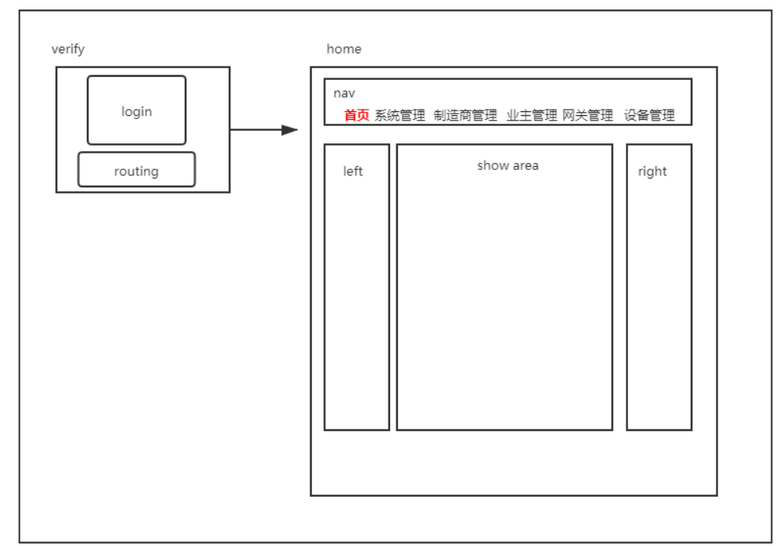

返回信息格式

Result{

    code: number;

    data? : any;

    message?: any;

    obj?: any;

}

登录接口：

<http://106.12.148.165:8080/manage/admin/login>

{

"account":"",

"password":""

}

获取设备接口：

<http://106.12.148.165:8080/manage/equipment/list2>