**Abstract**

Recent studies on animals, insects, and mammals have resulted in numerous bio inspired robotic designs to solve modern day technical problems. Nature’s insight can sometimes provide more efficient solutions in fact, such robots have aided in military defense applications saving the cost of human casualties. Currently, few robots have the capability to address the problem of inclined or vertical surface terrain. Enervate has studies the looping gait mechanism of an inch worm combined with the adhesive nature of a gecko to develop a robot with the ability to scale inclined surfaces addressing this issue. Enervate achieved the desired result through Dynamixel actuators, adhesive grips, and an unhinging method to mimic the inchworms natural gait. The inch worm robot was tested on flat and inclined angles ranging from (0-55) degrees where it was determined the robot was able to achieve a velocity of 1 inch per second for both surface environments. Further implementation beyond the scope of our design will incorporate a video feedback camera and wireless Bluetooth controller further enhancing the capability of the robot. This project was inspired by Dr. Bhounsule as a preliminary prototype illustration in a DOD proposal, which will lead to further development in disaster management reconnaissance.

**Table of Acronyms**

* = Torque
* = Torque required to stall a motor
* = Applied Current
* = The current being drawn into the motor while performing no action
* = Current required to stall a motor
* = Angular Velocity
* = The angular velocity of the motor when no load is applied
* = Radius of object being rotated
* = Weight parallel to the surface
* = Weight perpendicular to the surface
* = Polylatic Acid
* = The force of friction.
* UTSA = The University of Texas at San Antonio
* RAM = Robotics and Motion

**Table of Contents**

1. Introduction and Background 9

2. Purpose 9

3. Objectives 9

4. Specifications 9

4.1 Performance Specifications 9

4.2 Physical Specifications 10

5. Concept Designs 10

5.1 Concept 1: Smart Memory Alloy 10

5.2 Concept 2: Three Segment Robot 11

5.3 Concept 3: Suction Cup Robot 13

5.4 Selection Process 14

6. Prototype Design 16

6.1 Analytical Methods 16

6.1.1 Lifting 16

6.1.2 Speed 17

6.2 Product Safety/Failure Analysis 18

6.2.1 Stall Torque 18

6.2.2 Stall Current 18

6.2.3 Inclination Safety 19

6.3 Design Refinements for Optimization 21

6.3.1 Overall Dimensions 21

6.3.2 Bottom and Top Block Connection 21

7. Prototype Fabrications 21

7.1 Fabrication Method 21

7.2 Assembly method 22

7.3 Drawings 23

7.4 Bill of Materials 23

8. Prototype Testing 23

8.1 Test Plan Summary 23

8.2 Test Setup 24

8.2.1 Motor Tests 24

8.2.2 Leveled Testing 25

8.2.3 Inclination Testing 27

8.3 Test Results 28

9. Program Management 29

9.1 Personnel 29

9.2 Overall Schedule (including ME 4812 and ME 4813) 30

9.2.1 Assigned Tasks 30

9.2.2 Overall percent complete 39

9.3 Financial Performance (Including Senior 1 and Senior 2) 41

9.3.1 Overall Planned Cost vs. Time Compared to Actual Cost vs. Time 41

9.3.2 Planned Labor Cost by Task vs. Actual Labor Cost by Task 41

9.3.3 Planned Material Cost vs. Actual Material Cost 42

10. Conclusion 43

11. Appendix A – Operations Manual 44

12. Appendix B – Test Plan 44

13. Appendix C – Test Report 44

14. Appendix D – Assembly Design 44

**List of Figures**

**Figure 1:** Concept 1, SMA Robot 11

**Figure 2:** Concept 2, Three-Segment Robot 11

**Figure 3:** Concept 3, Exploded View 12

**Figure 4:** Flowchart of the Movement 13

**Figure 5:** Concept 3, Suction Cup Robot 14

**Figure 6:** Torque Evaluation 16

**Figure 7:** Inclination Analysis 20

**Figure 8:** Tapping Holes on Bottom Block 22

**Figure 9:** Code to Lift 24

**Figure 10:** Motor Testing 25

**Figure 11:** Full Cycle Code 26

**Figure 12**: Inch Increments for Linear Speed Tests 27

**Figure 13:** Incline Testing Apparatus 27

**Figure 14:** Inclined Foot Marks 28

**Figure 15:** Assigned Tasks for Total Gant Chart 38

**Figure 16:** Overall Percent Complete of Each Tasks 40

**Figure 17:** Planned Cost vs Time Compared to Actual Cost vs Time Graph 41

**Figure 18:** Planed Labor vs Actual Labor 42

**Figure 19:** Actual Material Cost vs. Planned Material Cost 43

**List of Tables**

**Table 1:** Comparison Matrix 15

**Table 2:** Speed Rating System 15

**Table 3:** Analytical Calculations for Velocity 17

**Table 4:** Weight vs Torque 18

**Table 5:** Load vs Current 19

**Table 6:** Friction Force vs Parallel Weight 20

**Table 7**: Bill of Materials 23

**Table 8:** Overall Test Results 28

**Table 9:** Physical and Functional Test Matrix 29

**Acknowledgments**

The engineers of Enervate would like to acknowledge the following, as without the leadership and mentorship this project would not be possible:

* Christian Emil Wahrmund
* Dr. Pranav Bhounsule
* Dr. John Simmons
* Dr. James Johnson
* Dr. Gold Hood

# ****Introduction and Background****

Inchworms, named for their size usually being an inch, are worms who lack appendages in their middle body. This absence has made this species devise a creative way for propelling itself forward. To do so, the worm hinges its middle portion upward to draw in its backside. Once this has been accomplished the front side will then propel itself forward, and then the process is repeated. Alongside its unique movement, the inchworm also possesses the ability to scale a variety of inclined surfaces. The combination of the two has drawn Dr. Bhounsule's, of the Robotic and Motions Laboratory, attention.

# ****Purpose****

Dr. Bhounsule is devising new ways to tackle problems being faced by our armed forces through robotics. His focus is particularly in indoor search and rescue missions, in which sending in humans can be dangerous due to the presence of criminals. Since most buildings these days hold air ducts, he intends on utilizing these as the means of searching. To do this, a robot must be small enough to fit inside these ducts as well as contain the ability to scale the various inclines.

# ****Objectives****

The first objective of this project is to design, analyze, build, and test an inchworm robot to be delivered to RAM Labs. This robot overall must function and operate as an inchworm does. This includes its abilities to scale various inclinations, and in the case of this project an inclination of at least 45 degrees. The robot must also be able to move at a speed of .4 inches per second. This has since been increased to one inch per second to reach rescues quicker. The robot must also not have a hinge greater than six inches, this is to keep it small enough to move in various sized ducts. Finally, the robot must be able to move to at least three ft.

# ****Specifications****

## ****Performance Specifications****

* + Highest angle of incline: 45 degrees
  + Minimum speed: 0.4 in/sec
  + Cover a minimum distance of 3 feet
  + Robot must be capable of contracting with a load of 2 lbs.

## ****Physical Specifications****

* + Max Segment Height: 5 inches
  + Max Segment Length: 5 inches
  + Max Segment Width: 4 inches
  + Max Total Length: 3 ft.
  + Maximum weight (For entire robot): 8 lbs.
  + Hinged Height of Robot: 6 inches

# ****Concept Designs****

## Concept 1: Smart Memory Alloy

Shape memories alloys have just begun to show potential progress in the field of robotics. This robot makes use of the transformation process from the SMA material properties as it turns from martensite to austenite with change in temperature. Flexinol will be used for this specific concept design in the actuation process of our inchworm robot. The material, when heated above 90 degrees Celsius, reverts back to its original shape. The body will be made of 3 mm thick carbon fiber sheets. Flexinol ribbon will be used to actuate the robot to take the desired omega motion. Three flexure ribbons at the middle segments of the robot will be used to attach both front and back pieces together. The Flexinol material will be Copper Laminated Kapton Film. Two separate 1750 mAH, 3.7 V battery power sources will be placed at the front and back. An Arduino microcontroller will be utilized to send current to the SMA initializing the actuation process of the Flexinol. The entirety of the concept is illustrated in fig. 1 below.

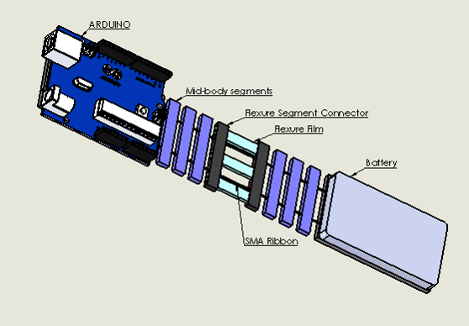

**Figure 1:** Concept 1, SMA Robot

Based on battery life specifications, the robot should be able to perform 800 cycles until a new battery will be needed for replacement. The adhesive will consist of a rubber silicon pad that will allow the robot to grip and when motion is taking place. The robot will be small and lightweight to maneuver between tight spaces and throughout different pipe systems.

## Concept 2: Three Segment Robot

This concept is a 3-segment robot manufactured from Polylactic Acid (PLA) through the work of a 3D printer shown in Fig. 2.

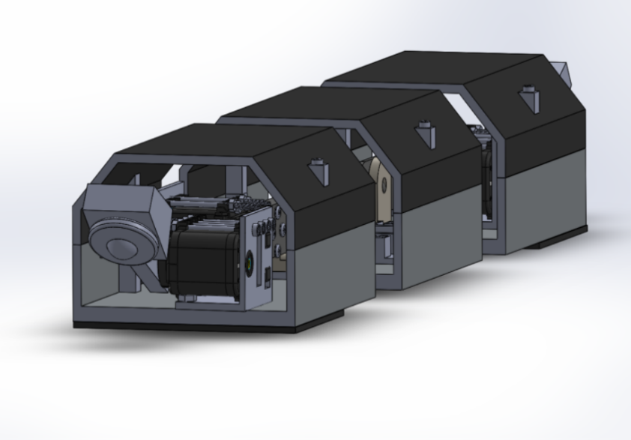

**Figure 2:** Concept 2, Three-Segment Robot

The robot will be tethered to an external AC/DC power source converter supplying approximately 11.1 Volts rather than battery powered. The tether will be connected to an OpenCM9.04 Robotics Microcontroller which will be coded to achieve the inchworm gait motion. Four Dynamixel Ax-12A servo motors will be daisy chained together and ultimately connected to the microcontroller to complete the electrical circuit. An exploded view of the three-body segment and all of the parts included are shown below in Fig. 3.

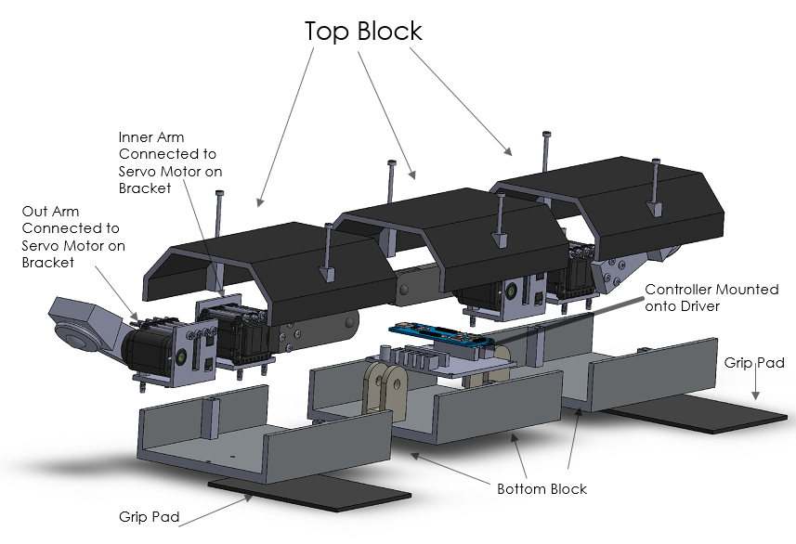

**Figure 3:** Concept 3, Exploded View

The servos will be able to interpret signals given from the microcontroller through I2C processing. Each motor has its own PID control to ensure that there is a steady motion with no overshooting or errors. The servos will be attached to servo arms shown in fig. 3. The middle segment of the robot will house not only the microcontroller but two hinge mechanisms attached to the inner servo arms. To start the actuation process of lifting the middle segment, the Dynamixel motors will work together with the servo arms attached to the body of the robot to achieve the gait of the inchworm. Fig. 4 shows the flowchart of the logic process that will enable the forward movement of the robot and the process each servo will perform to achieve forward motion.

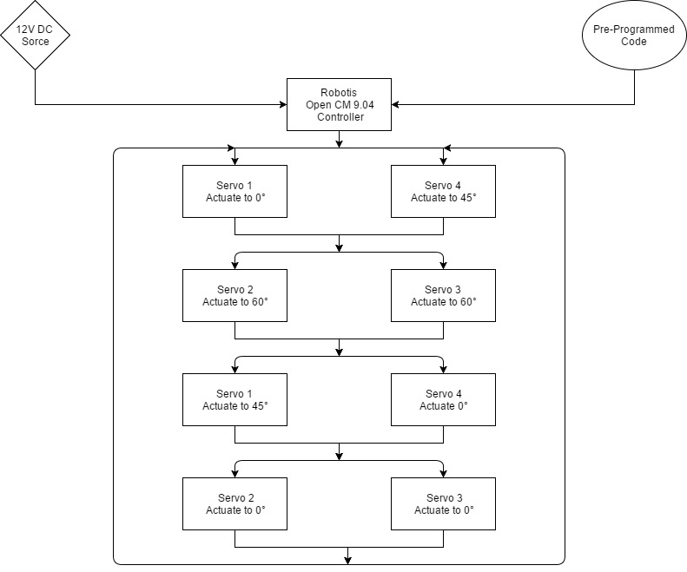

**Figure 4:** Flowchart of the Movement

A ball bearing attached to the front and rear servo arms will allow for the desired break of the grip from the adhesion pads on the anchoring segments. The adhesive pads will be micro-fabricated silicon pads that resemble the natural mechanics of a gecko's feet, otherwise known as gecko style adhesive.

## Concept 3: Suction Cup Robot

This two-segment robot concept design allows for operations on both horizontal and vertical planes. The robot is made from PLA similar to concept 2. It accomplishes grip with the use suction cups of diameter 0.787 inches which can provide enough force to hold the total weight of the robot on both a level and inverted surface. The length was set in each segment to accommodate the five-inch 50 ml syringe that would be housed inside. The 50 ml syringe was chosen as it can consume enough air to provide effective suction force provided by the plungers to the suction cups to hold the robot. To actuate the syringes, small DC motors capable of operating between 3 – 6 Volts with 16500 RPM were chosen. Servo motors attached to rods would provide the actual motion of the robot. Three-inch rods were implemented in the design to allow a little over an inch in displacement with an angle change of 60 degrees from the servo motor. Finally, an Arduino Microcontroller would be programmed and tethered to an AC/DC converter to control the servos and dc motors in order to achieve the desired motion. A SolidWorks rendering of the third concept is illustrated below in fig. 5.

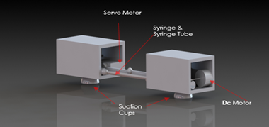

**Figure 5:** Concept 3, Suction Cup Robot

## Selection Process

In selecting the final concept, different aspects needed to be considered. To do this, a table was created to compare each concept with essential requirements demanded from the client. In table 1 the requirements can be seen which include categories such as speed, length, weight, etc. As seen in this table, below each category lies a value that corresponds to a predetermined numbering system to rank these concepts fairly.

**Table 1:** Comparison Matrix

|  |  |  |  |  |  |  |  |
| --- | --- | --- | --- | --- | --- | --- | --- |
|  | Weight | Speed | Length | Cost | Durability | Modifiability | Total: |
| Concept 1 | 9 | 2 | 6 | 8 | 9 | 2 | 36 |
| Concept 2 | 7 | 10 | 2 | 5 | 8 | 8 | 40 |
| Concept 3 | 6 | 2 | 3 | 6 | 9 | 2 | 28 |

The numbering system was created to be fair for all concept designs and to help decide which would be the best decision. An example of this can be seen in table 2 which depicts speed. The left side possess values of speed that correlate to the right side of the table which holds values. The faster the speed, the higher the number. Each concept had its speed calculated and then was assigned the corresponding number to which the speed was determined to be. This was done for each category and finally each concept was tallied to find the total of points generated.

**Table 2:** Speed Rating System

|  |  |
| --- | --- |
| Speed [in/sec] | Rating |
| .4 | 1 |
| .8 | 2 |
| 1.2 | 3 |
| 1.6 | 4 |
| 2 | 5 |
| 2.4 | 6 |
| 2.8 | 7 |
| 3.2 | 8 |
| 3.6 | 9 |
| 4 | 10 |

# ****Prototype Design****

## Analytical Methods

Servo motors are the muscles of this design, so it was important to ensure proper sizing of the motors. To do this, small calculations pertaining to what was expected from the servo motors were conducted. This involved lifting various loads, as well as the speed that could be emitted from these motors.

### Lifting

In regards to lifting, the motors would have to be capable of lifting at least 2 lbs. That means that the team needed to find the torque that would be produced from this. Torque is found by multiplying force and the perpendicular lever arm to the rotation, the equation can be seen below:

The team decided that these servo motors would be attached to servo arms measuring about two and three-quarter inches, this will be added to the location of the center of mass two inches away from the end. The team then added one pound to the two pounds needing to be lifted to take account for the mass of the block. The resulting torque came to be 14.25 lb.*in, seen in fig. 6, so the servo motor had to possess a stall torque greater than this value. This led the team to choose a motor possessing a stall torque of roughly 16 lb.*in.

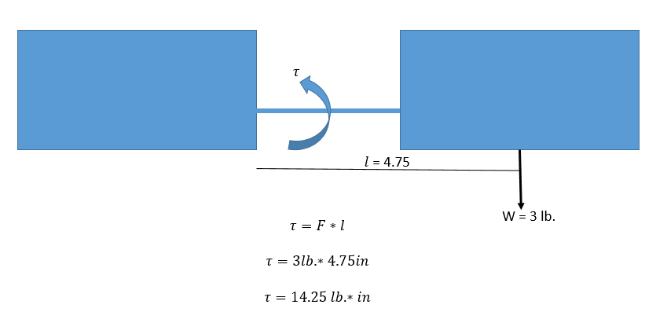

**Figure 6:** Torque Evaluation

### Speed

The team decided that the robot should be capable of moving a minimum speed of .4 inches per second. Since the robot does not move via wheels, finding speed meant finding how fast the servo motors could displace one block. This meant the team first needed to solve for a minimum angular velocity to then find the corresponding linear velocity. Since this angular velocity will be affected by torque, the equation below was used.

Previously, a minimum torque of 14.25 lb.*in was found, so this value will take the place of . From the motors selected based off the calculations done in the section prior, was given to be 16 lb.*in, and to be 10.16 rad/sec [2]. After plugging in these values, an angular velocity of 1.11 rad/sec was found. To be safe other calculations were performed for a variety of loads, and can be seen in table 3. With this newly found value, a linear velocity can be found with the equation seen below.

The final result was shown to be 3.05 inches per second, meaning the team selected a motor not only capable of producing the torque needed but also capable of producing a speed greater than the goal.

**Table 3:** Analytical Calculations for Velocity

|  |  |  |
| --- | --- | --- |
| Load [lb.*in] | Angular Velocity | Linear Velocity [in/sec] |
| 1.375 | 9.3 | 25.5 |
| 2.75 | 8.4 | 23.1 |
| 4.125 | 7.5 | 20.7 |
| 5.5 | 6.7 | 18.3 |
| 6.875 | 5.8 | 15.9 |
| 8.25 | 4.9 | 13.5 |
| 9.625 | 4.0 | 11.1 |
| 11 | 3.1 | 8.6 |
| 12.375 | 2.3 | 6.2 |
| 13.75 | 1.4 | 3.8 |

## Product Safety/Failure Analysis

Product safety is very important, as the team does not what the robot to stop working due to malfunctions. Since servo motors are the main attribute in this design, they were evaluated to determine what could stop them from working. The team also decided to analyze when the slipping point of the robot to prevent falling and breaking.

### Stall Torque

Stall torque is the torque required to stall the motor. This means any torque greater than the motors rated stall torque will result in failure. The motors rated stall torque is roughly 16 lb.*in, and since the lever arms value is fixed, we can solve for what weight would cause this occurrence. Performing this calculation gives a weight of four pounds. To prevent failure, the team will ensure the motors do not exceed lifting this weight. This calculation was also conducted for a variety of weights to determine torques being experienced, this can be seen in the table below.

**Table 4:** Weight vs Torque

|  |  |
| --- | --- |
| Weight [lb.] | Torque [lb.*in] |
| 0.5 | 1.375 |
| 1 | 2.75 |
| 1.5 | 4.125 |
| 2 | 5.5 |
| 2.5 | 6.875 |
| 3 | 8.25 |
| 3.5 | 9.625 |
| 4 | 11 |
| 4.5 | 12.375 |
| 5 | 13.75 |

### Stall Current

Stall current is the current that would cause failure of the motor. The rated stall current for the chosen motor is 2.2 amperages. Since the motors will lifting various loads, current must be found in terms of torque. The following equation below was used for all calculations.

The team decided to do calculations for a variety of loads that could be experienced to determine when this stall current would be reached. The table below depicts the results of these calculations.

**Table 5:** Load vs Current

|  |  |
| --- | --- |
| Load [ lb.*in] | Current [Amps] |
| 1.375 | 0.24 |
| 2.75 | 0.42 |
| 4.125 | 0.61 |
| 5.5 | 0.79 |
| 6.875 | 0.98 |
| 8.25 | 1.16 |
| 9.625 | 1.35 |
| 11 | 1.53 |
| 12.375 | 1.72 |

The values above relate an experienced torque to the resulting current. The final load measured is a result of having to lift a 4.5 pound weight, which is above the motors capabilities. From this data, the team is confident that the motors will not stall as the current value never reaches 2.2 amperages.

### Inclination Safety

Since the robot is to scale inclined surfaces, calculations needed to be done to protect the robot from attempting an inclination that would result in slipping and potentially breaking of materials. To do this, first a grip pad needed to be selected. The first choice grip pad proved to be too difficult to obtain so the backup pad was purchased through eGrips. Unfortunately, the manufacture did not include the coefficient of static friction, so tests were used to find this value. After finding the angle in which the grip pad begin slipping, the tangent was taken and determined the friction value to be roughly 1.3.

The next step was to analyze the robot at an inclination. A free body diagram of this can be seen in fig. 7. The diagram is simplified showing the parallel and vertical weight summed for all three blocks.

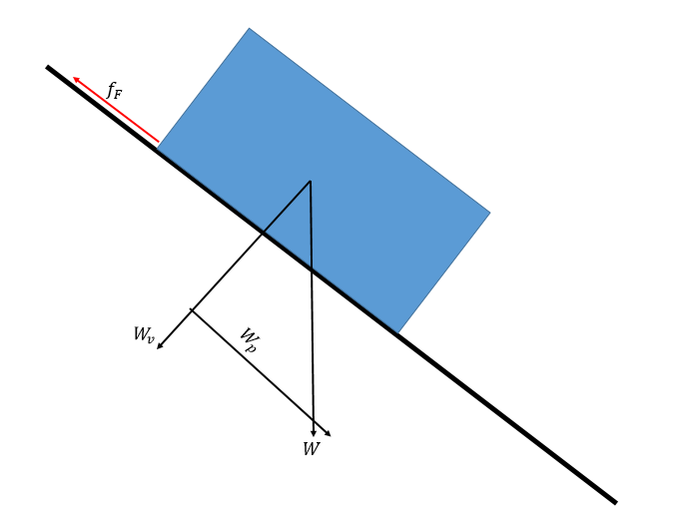

**Figure 7:** Inclination Analysis

It was determined that the force of friction would have to be greater than the parallel weight in order to keep the block from slipping. The team decided to analyze a variety of angles to determine when this would occur, and can be seen in table 6.

**Table 6:** Friction Force vs Parallel Weight

|  |  |  |
| --- | --- | --- |
| Angle | [lb.] | [lb.] |
| 40 | 4.4 | 3.1 |
| 41 | 4.3 | 3.1 |
| 42 | 4.2 | 3.2 |
| 43 | 4.2 | 3.2 |
| 44 | 4.1 | 3.3 |
| 45 | 4.0 | 3.4 |
| 46 | 3.9 | 3.4 |
| 47 | 3.9 | 3.5 |
| 48 | 3.8 | 3.5 |
| 49 | 3.7 | 3.6 |
| 50 | 3.6 | 3.7 |
| 51 | 3.6 | 3.7 |
| 52 | 3.5 | 3.8 |
| 53 | 3.4 | 3.8 |
| 54 | 3.3 | 3.9 |
| 55 | 3.2 | 3.9 |

As seen in this table, the parallel weight becomes greater than the friction force at roughly 50 degrees. This is when we can expect slippage, so the team will avoid having the robot climb an inclination equal to or greater than this value.

## Design Refinements for Optimization

### Overall Dimensions

In the beginning of this project the team decided each block would have the dimensions of 4” x 4” x 3”. After choosing the motors the team realized that the width of the outer blocks would have to be extended an inch to have enough room to house the servo motors as well has a place to hold a load. The team also realized that the length of the middle block would have to be extended an inch due to the dimensions of the expansion board. Since all blocks were to be equal in overall dimensions they all underwent these changes. This left the overall dimensions of each block to be 5” x 5” x 3”.

### Bottom and Top Block Connection

Connecting the top and bottom blocks was first designed to be a snap fitting. This was later changed to a screw design to prevent the snap fittings from breaking when putting on and taking off the top block. The screw design also underwent some changes as far as how many screws would be used to connect the blocks. It was first drawn out to hold four screws, one for each corner, but was then realized that having screws placements on the corners would interfere with the servo motors center position. To avoid this, the team decided to have two screw locations at the center of the block on the inside of the walls.

# ****Prototype Fabrications****

## Fabrication Method

Many of the parts implemented in this design were 3D printed out of PLA and were printed via an Ultimaker 3D printer. The printing of these parts depended on size and took anywhere from 2 to 15 hours for completion. Roughly 20% of these parts needed to be filed down with sandpaper to meet tolerances and specifications. This is due to a set feature within the 3D printer that prints braces to help stabilize the desired part.

The only parts not fabricated were the servo motors, microcontroller, expansion board, Bluetooth receiver, grip pads, and ball transfer units. The servo motors, microcontroller, Bluetooth receiver, and expansion board were all purchased through Robotis. The ball transfer unit was purchased and manufactured by a company called Omnitrack. Finally, the grip pads were purchased through the cell phone parts manufacturing company eGrips.

## Assembly method

All three lower block segments had to be tapped to ensure a quality bind when screwing into the block. The figure below demonstrates how this process was done.

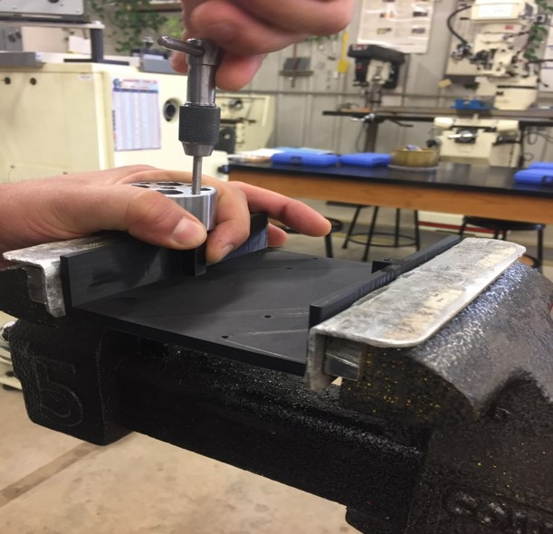

**Figure 8:** Tapping Holes on Bottom Block

With the holes tapped, the top and bottom block can now be connected when need be. Other assembly involved screwing in the servo brackets into bottom blocks. Once this was accomplished the servo motors could then be attached to the brackets to prevent movement during operation. Connecting the servo arms to the servo motors was done by screwing in screws through the arm to connect to the holes on the servo motor. Finally, the servo arms could be connected to the hinges of the middle block by press fits. A detailed outline of how assembly is accomplished can be read in Appendix A.

## Drawings

A detailed drawing package can be seen in Appendix D. This appendix displays the overall assembled robot, subassemblies, and each manufactured part. Each manufactured part located in this appendix gives detailed instructions on how each part is to be created. This also contains tolerances that need to be met to ensure proper movement of the robot. The subassembly section presents two subassemblies, one for the lifting of the robot and the other for disengaging of the grip pads. In these subassemblies detailed instructions are given on what parts are needed as well as how to assemble each assembly.

## Bill of Materials

**Table 7**: Bill of Materials

|  |  |
| --- | --- |
| Part | Cost |
| Dynamixel Servo Motors | $379.6 |
| Motor Shield | $29.90 |
| Roller Bearings | $7.00 |
| OpenCm9.04 Microcontroller | $19.90 |
| Grip Pads | $13.95 |
| 3D Printed Parts | $15 |
| BT-210 Bluetooth Receiver | $32.90 |
| Test Apparatus | $20.00 |
| Total: | $418.25 |

# ****Prototype Testing****

## Test Plan Summary

All testing took place in the RAM Laboratory, located on the main campus of UTSA. Various tests were performed to determine if the prototype was capable of delivering all set goals made prior to building. This included testing on both leveled and inclined surfaces as well as motor performance. These tests were performed over a two week interval and a detail overview of all test results can be seen in Appendix C. Meanwhile Appendix B describes why these tests were conducted and how the team had intended on performing these tests.

## Test Setup

### Motor Tests

The Dynamixel AX-18A's was mainly evaluated on lifting a load of 2lbs or more. To test this parameter, the engineers wrote a script on the Robotis IDE to rotate the bar hinge up and down, and example can be seen in fig. 9. The engineers began testing the motor load capacity at a fairly light load up to fail state, where the Dynamixel servos could not perform the written task under a higher load.

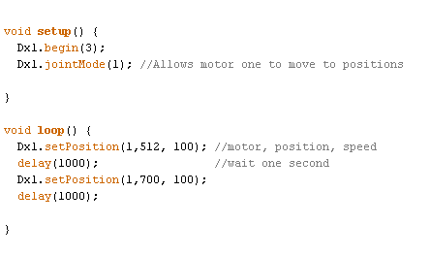

**Figure 9:** Code to Lift

To test this load, a container was utilized so that additional weight could be added periodically. A string was then attached from the bucket to the servo motor through a hole on the servo arm. Once the desired weight was added, the motor was turned on to determine if the motor was strong enough carry that set load. This set up can be observed in the figure below.

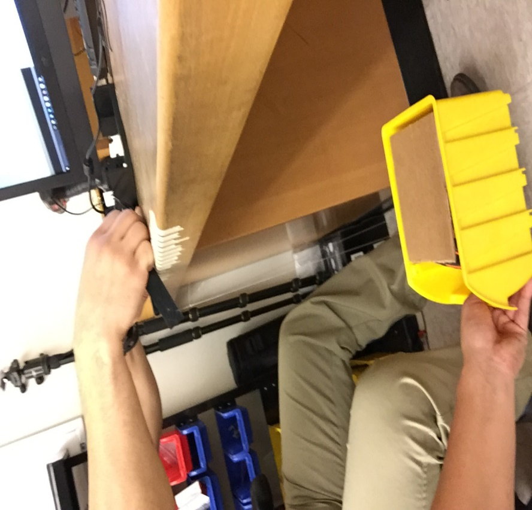

**Figure 10:** Motor Testing

### Leveled Testing

To ensure that the forward movement of the robot met the required velocity, the engineers of Enervate tested the robot's speed on a leveled table using a timer and a labeled surface. To test the speed, a code that can be seen in fig. 11, was utilized.

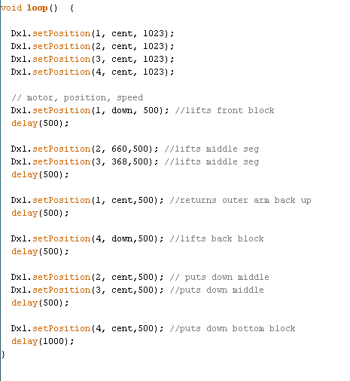

**Figure 11:** Full Cycle Code

The surface that was used to test the linear velocity is labeled by increments of one inch up to 12 inches as shown in fig. 12.  The end block of the robot was placed on the starting side of the labeled table and was ran until the same end block crossed the one-foot indicator. As the inchworm robot crossed the first indicator till the last indicator, a timer was recording the time to calculate the velocity. These procedures were repeated ten more times to obtain the average linear velocity.

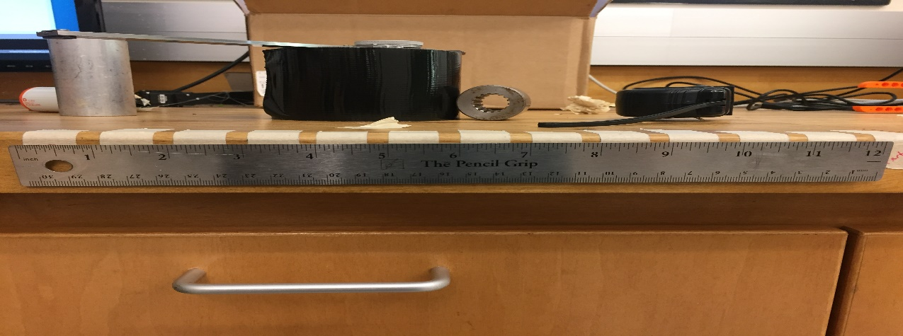

**Figure 12**: Inch Increments for Linear Speed Tests

### Inclination Testing

The robot's capabilities of scaling incline was also evaluated along with the examinations done on a level surface. Following the same procedures for testing linear velocity and range, the inchworm robot went under a series trials on an incline apparatus, shown in fig. 13, to test the robot's speed, range and capability on an incline surface.

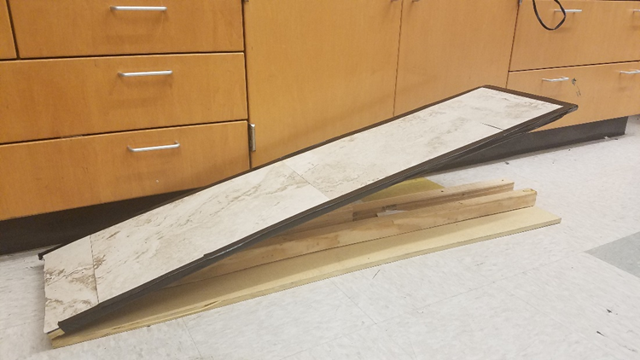

**Figure 13:** Incline Testing Apparatus

Before tests were started, the apparatus was marked on one-foot, seen in fig. 13. Then, the robot was placed on the incline surface and controlled to move forward to the edge of the apparatus. This process was done over steps of inclination until the robot was not capable of scaling any further.  The apparatus possessed foot marks to help determine the overall speed and can be seen on fig. 14.

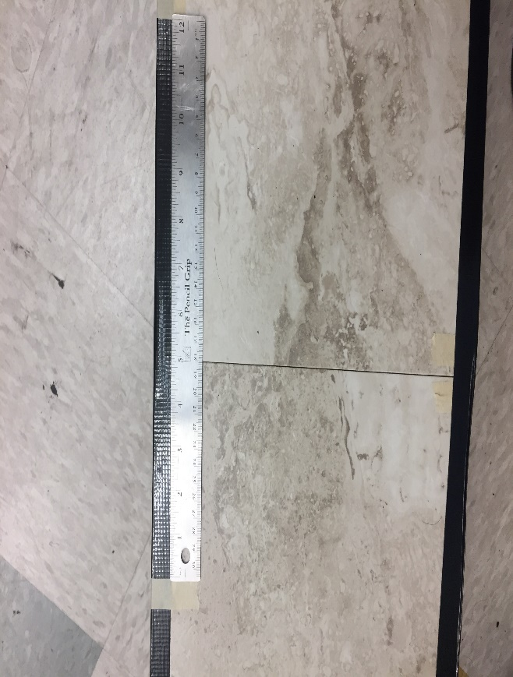

**Figure 14:** Inclined Foot Marks

## Test Results

Observed in table 8, it can be seen that Enervate passed all testing except for one, inclination testing. Table 9 shows the recorded values for each test and if this was an acceptable outcome. A detailed table of all other tests that were conducted can be seen in Appendix C.

**Table 8:** Overall Test Results

|  |  |  |  |  |
| --- | --- | --- | --- | --- |
| Item  No. | Feature to be Tested | Specification Ref. in Appendix A | Testing or Verification Procedure | Pass or Fail |
| 1 | Segment Length | 1 | Ruler (Pass or Fail) | Pass |
| 2 | Overall Length | 4 | Ruler (Pass or Fail) | Pass |
| 3 | Segment Width | 2 | Ruler (Pass or Fail) | Pass |
| 4 | Segment Height | 3 | Ruler (Pass or Fail) | Pass |
| 5 | Lifted Height | 6 | Ruler (Pass or Fail) | Pass |
| 6 | Overall Weight | 5 | Scale (Pass or Fail) | Pass |
| 7 | Inclination | 7 | Incline Apparatus (Pass or Fail) | Fail |
| 8 | Minimum speed | 8 | Speed Apparatus (Pass or Fail) | Pass |
| 9 | Distance | 9 | Ruler (Pass or Fail) | Pass |

**Table 9:** Physical and Functional Test Matrix

|  |  |  |  |
| --- | --- | --- | --- |
| Parameters | Recorded Value | Required Value | Pass/Fail |
| Overall Length |  | 3 feet | pass |
| Segment Width | 4 inches | 4 Inches | pass |
| Segment Height | 5 inches | 5 Inches | pass |
| Segment Length | 5 inches | 5 Inches | pass |
| Lift Power | 4 lbs. | 2 lbs. | pass |
| Range | 10 feet | 3 Feet | pass |
| Min. Inclination | 20 Degrees | 45 Degrees | fail |
| Min. Speed | 4 inches per Sec | 0.4 Inches per Sec | pass |
| Max. Weight | 1 lb. 9 oz. | 8 lbs. | pass |

# ****Program Management****

## Personnel

* **Anthony Abundis** – *Design Engineer*

Anthony was in charge of overseeing the design of this project. He ensured all designs made or changed did not affect the robot’s ability to perform.

* **Flavio Moreira –** *Project Engineer*

Flavio was in charge of the overall project. This meant assigning duties to each member as well holding them labial to completion. Although the team may vote on a particular subject, his vote can over throw a tie.

* **Justin Castillo –** *Analyst Engineer*

Justin is in charge of all analysis for the project. His job is to analytically determine how the robot will perform based off various parameters. He also took charge of the scheduling and is the reason the team stayed on schedule.

* **Michael Aguirre –** *Production Engineer*

Michael is in charge of all production dealing with the project. He was dealt with the fabrication and assembly of the robot to make certain the robot functions as a whole unit.

## Overall Schedule (including ME 4812 and ME 4813)

### Assigned Tasks

Below is a complete view of our Gantt chart for senior design 1 & 2. Critical deliverables are shown with the percent complete for each task. Important key resources for the success of our project can be seen below. Each resource was allocated depending on the task and had a corresponding cost per unit time.

* Engineer
* Engineer A
* Engineer F
* Engineer J
* Engineer M
* Laborer
* Machine Shop
* Polylactic Acid
* Secretary
* Senior Project Manager
* Technician
* Senior Engineer

The Engineer was a general resource used for the purpose of completing analysis, research, and design for the project. Engineer (A, F, J, M) correspond to the different engineers working on the project. Engineer A-Anthony Abundis, F-Flavio Moreira, J-Justin Castillo, M-Michael Aguirre. During the course of senior design 1, the Engineer resource was used on allocated tasks where the success was driven by all team members. During senior design 2, at the bottom of the Gantt chart, we see individual representation of engineer assigned to different tasks. The laborer was responsible for purchasing and transporting materials where needed. The UTSA Machine shop resource was used when professional help or tools were needed for our project. Polylactic Acid was the primary material used for our projects body shell. The secretary was used to provide support on timesheets, reports, and scheduling. The technician was used to provide help during the assembly and mock drawings for concept designs. The senior engineer (Dr. Bhounsule) was used to tackle the responsibility of providing support and feedback for our project when needed. The final resource was the senior project manager (Dr. James Johnson). Also, this resource was used to provide lecture support and guidance on our project, feedback on progress, major key deliverables grading, presentation feedback, and meeting updates, which were all key elements to the success of our project.

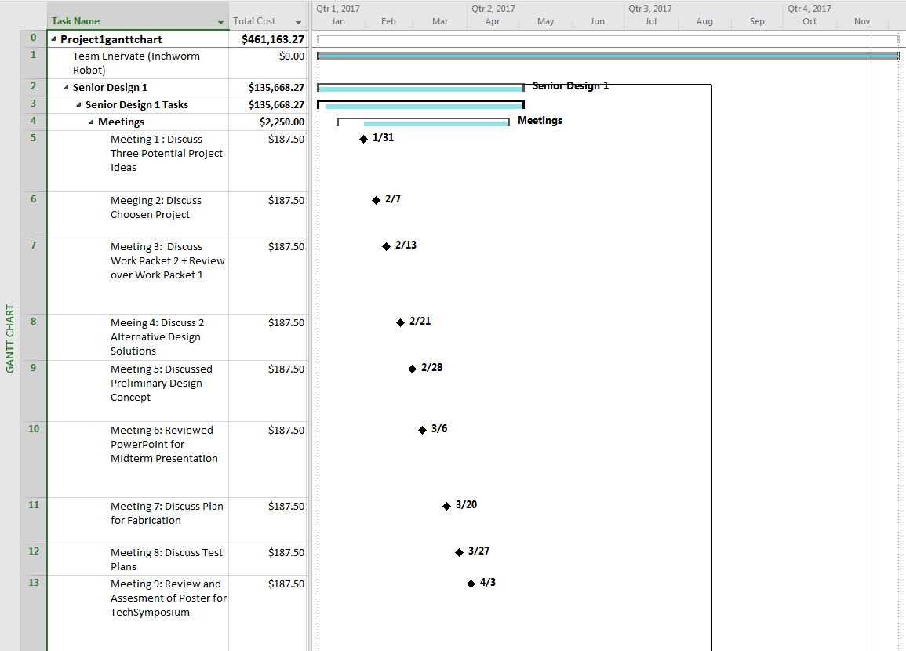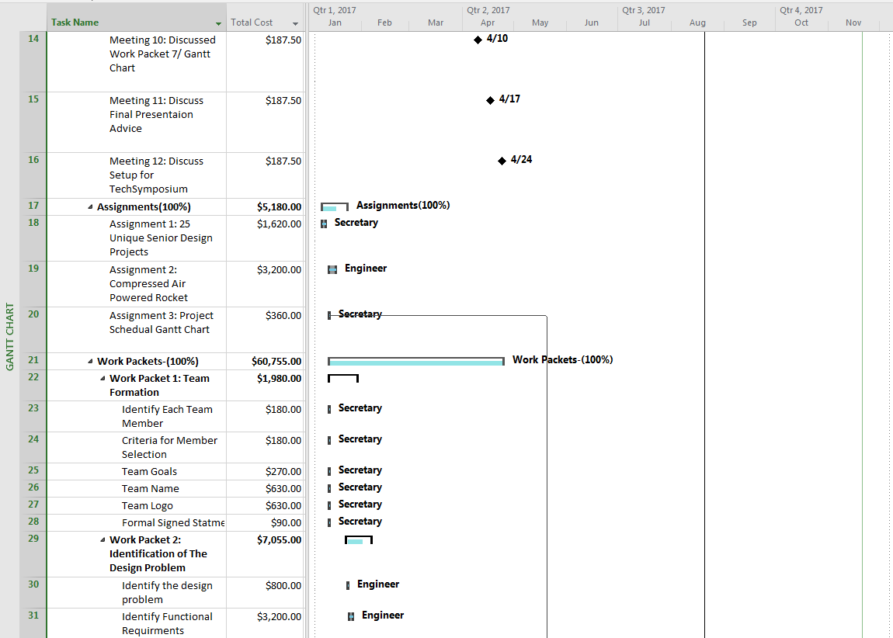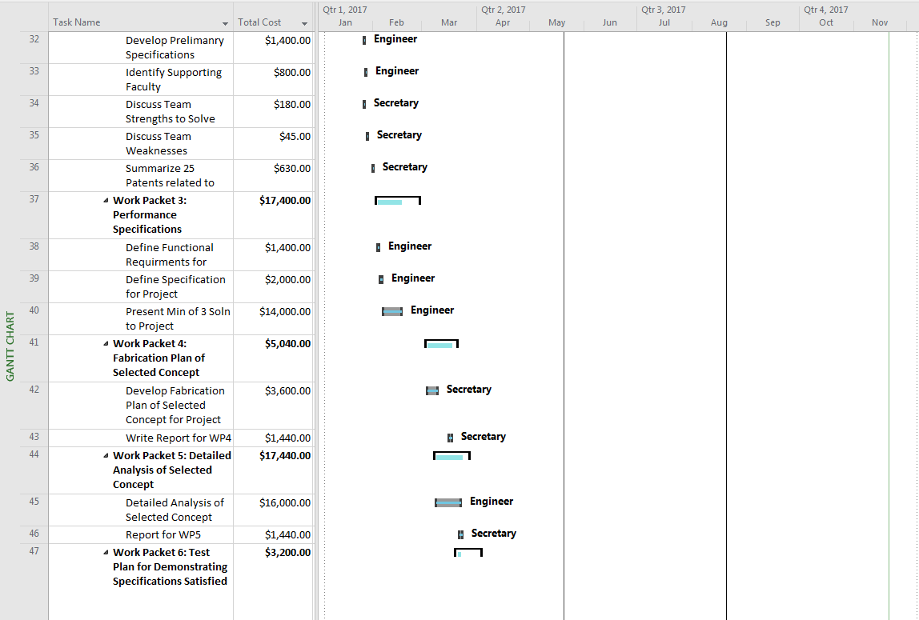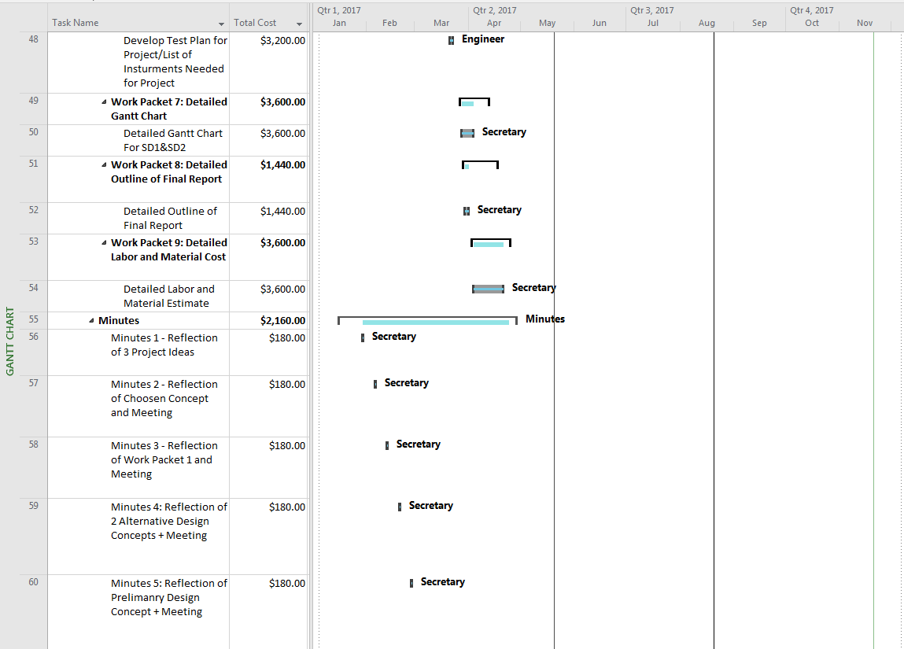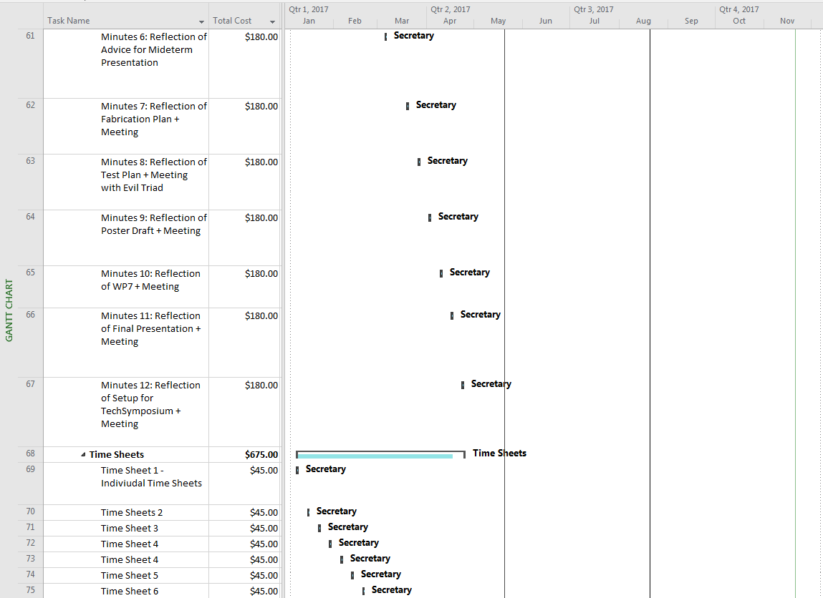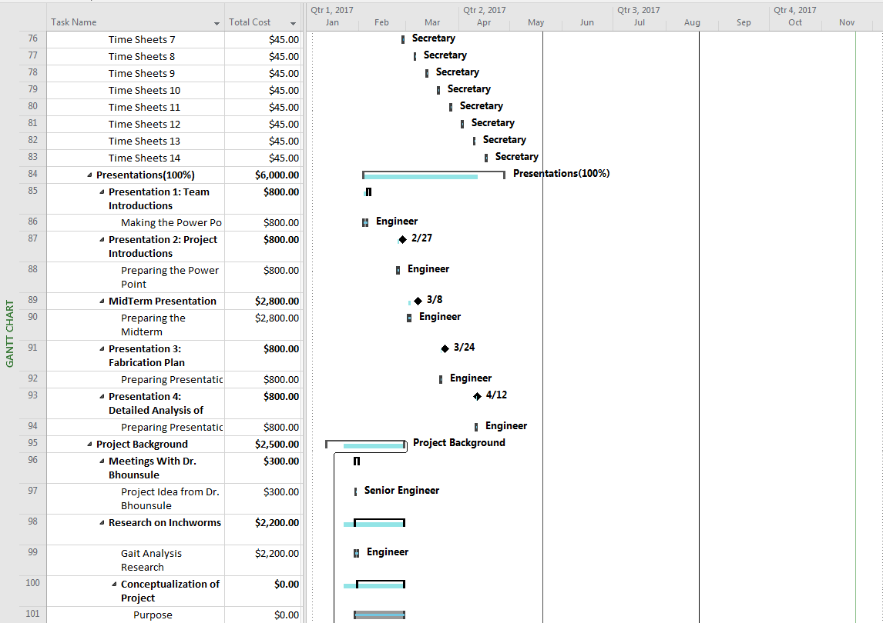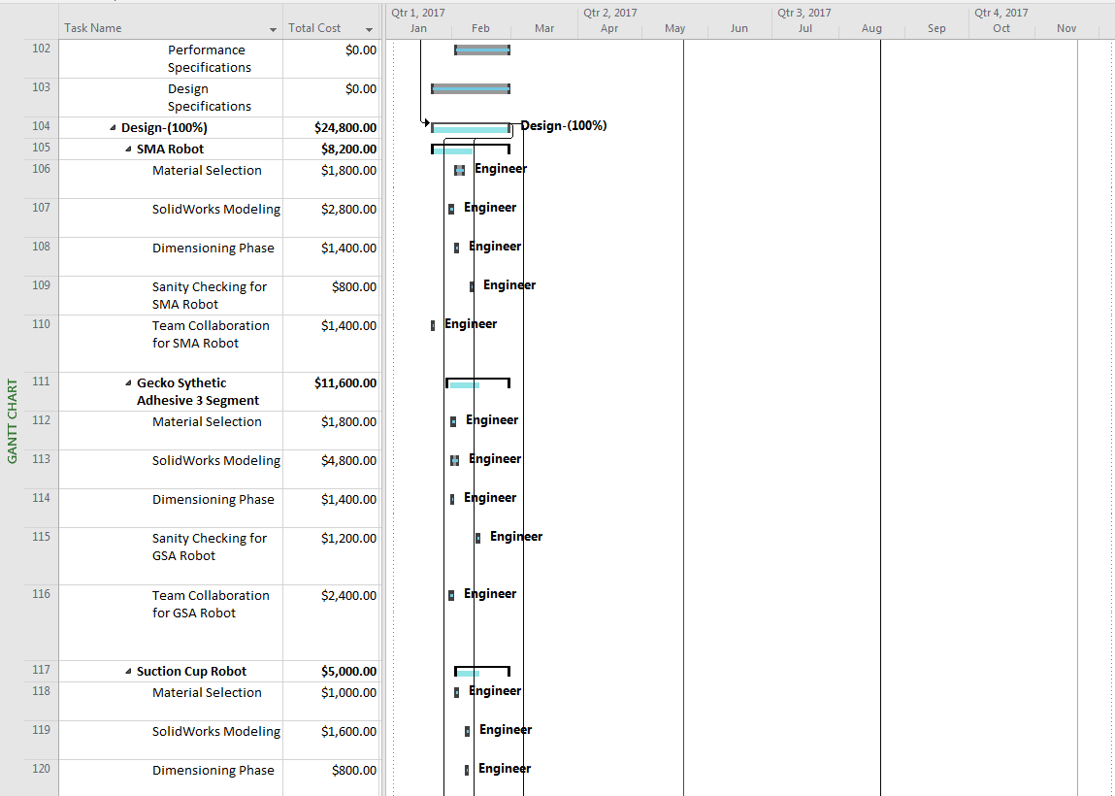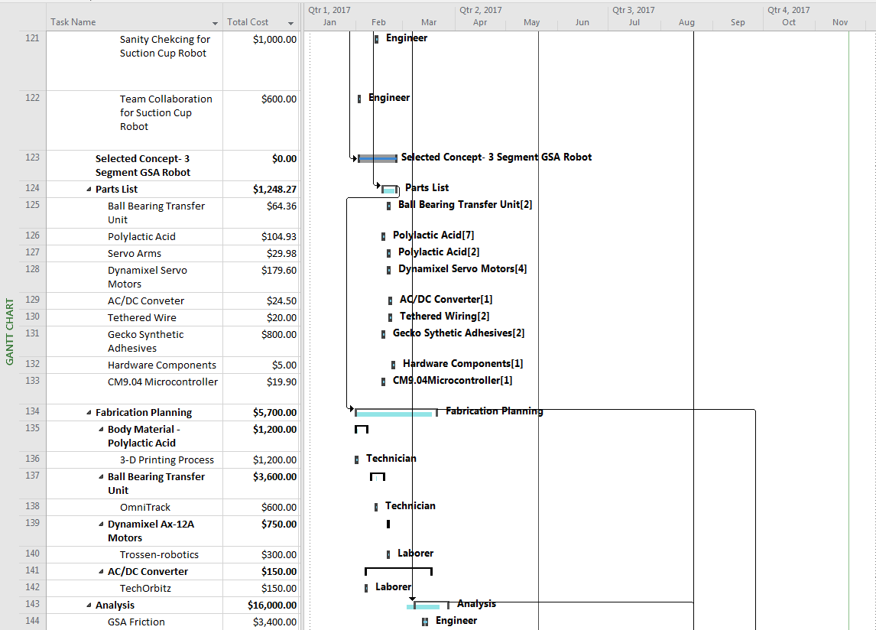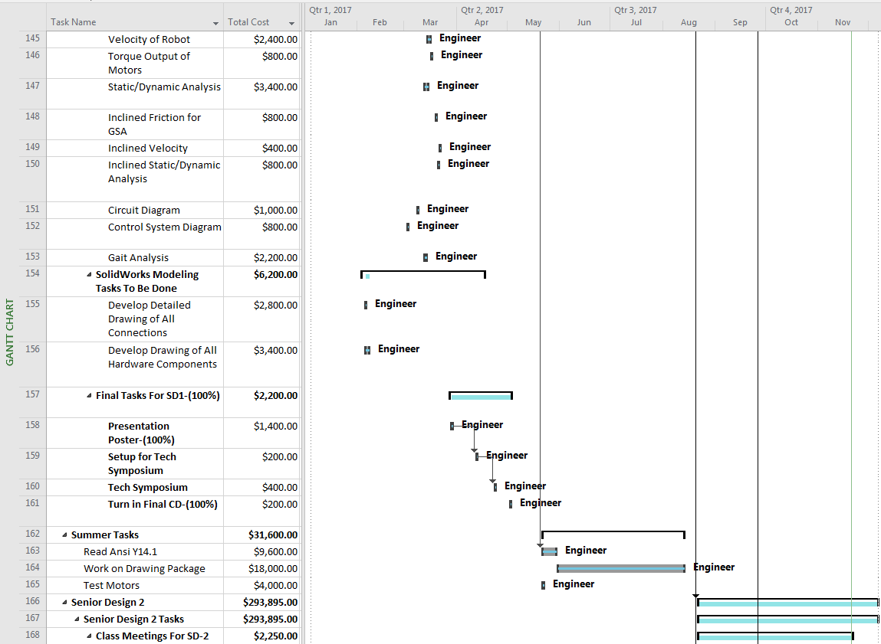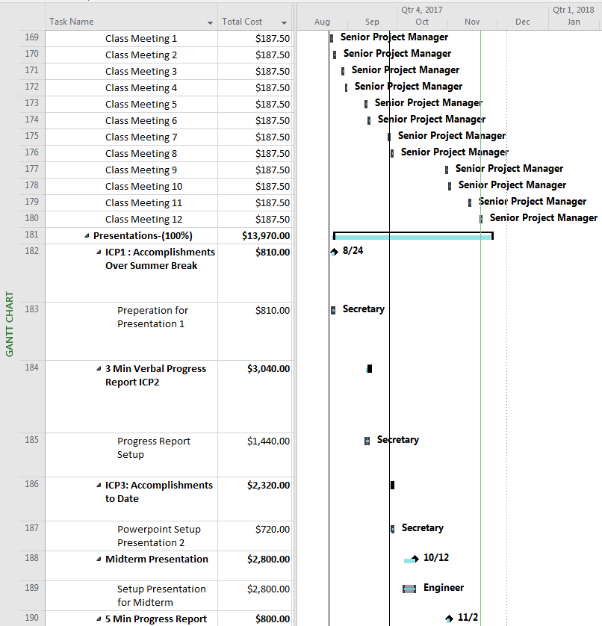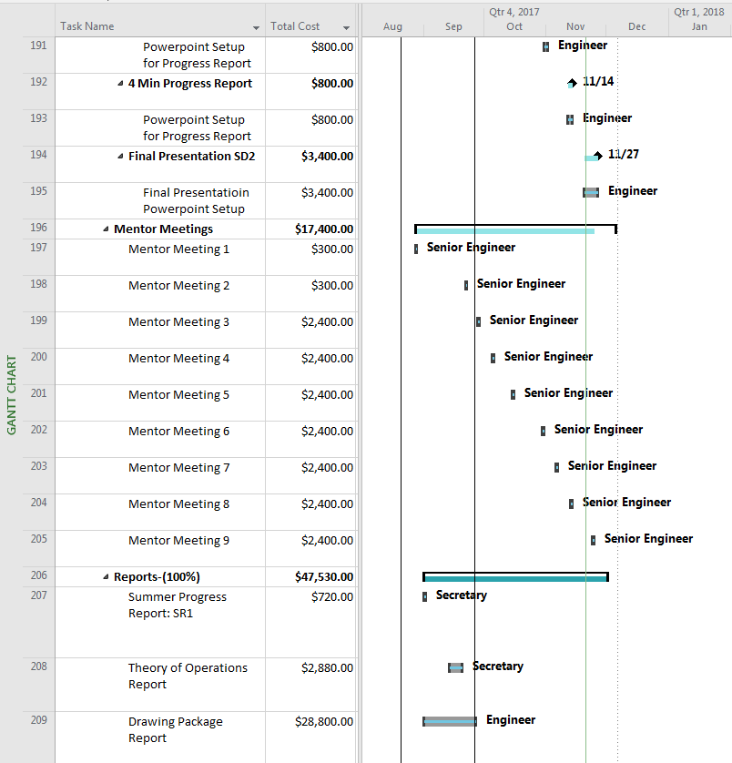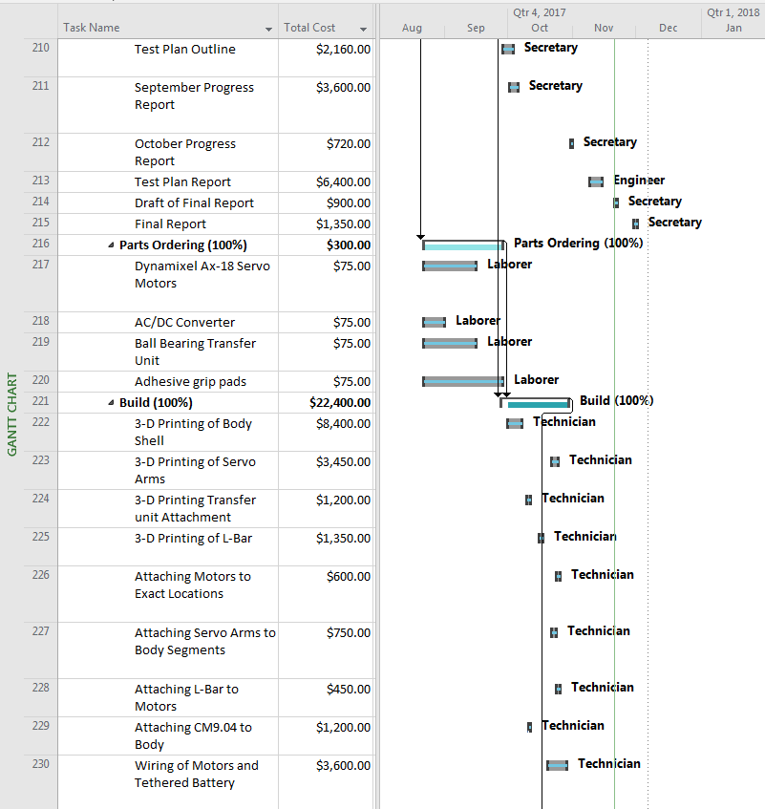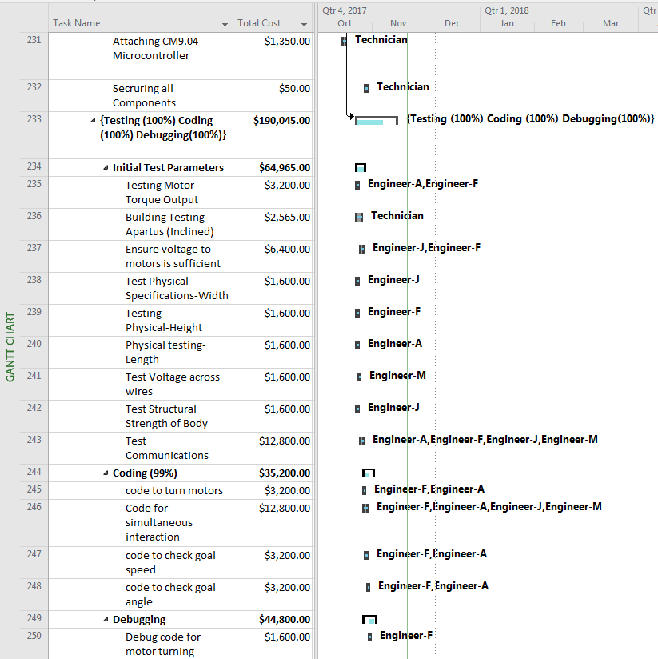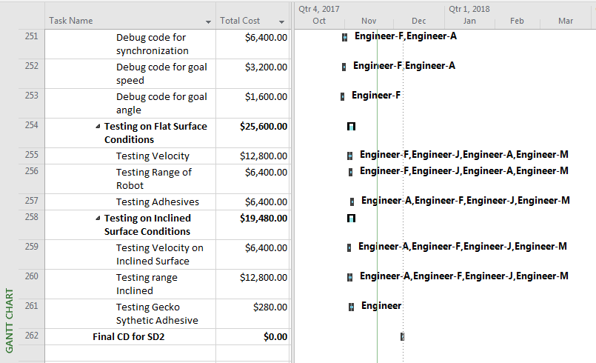

**Figure 15:** Assigned Tasks for Total Gant Chart

### Overall percent complete

The overall percent complete is shown below for the entirety of our project and on critical deliverables necessary for the completion of the project. Senior design 1 is shown on the Gantt chart and all the subtasks associated with this phase of the project. Summer and Senior 2 tasks can also be seen showing each major key task associated with the project. Each task below seen on the Gantt chart is determined to be 100% complete to date.

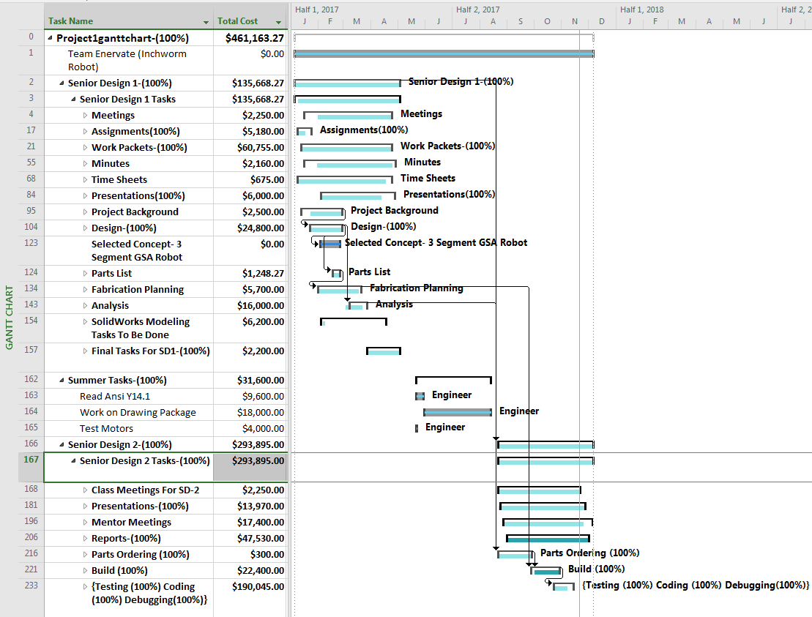

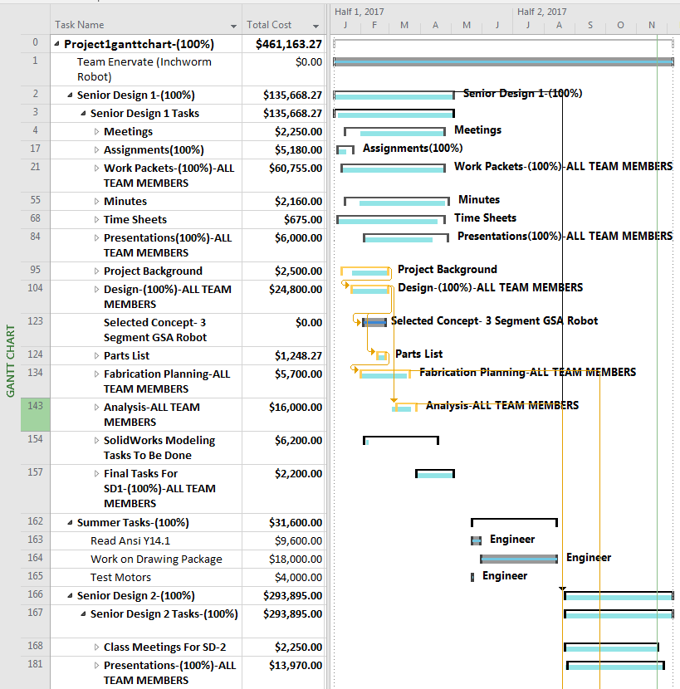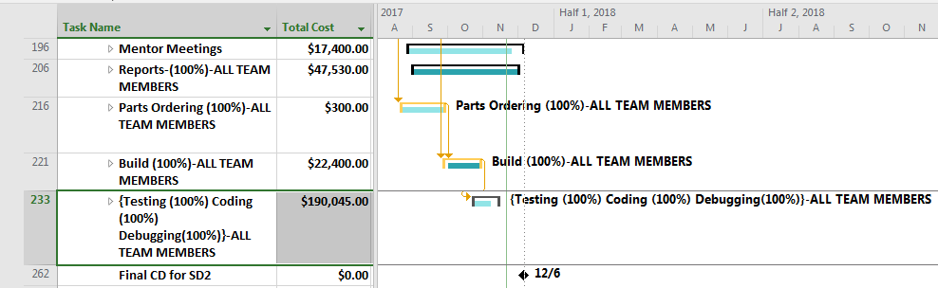

**Figure 16:** Overall Percent Complete of Each Tasks

## Financial Performance (Including Senior 1 and Senior 2)

### Overall Planned Cost vs. Time Compared to Actual Cost vs. Time

The overall planned cost vs time compared to the actual cost vs time, essentially represents the accuracy of our monetary prediction for the project. The X and Y axis represent the time and cost of our project on the graph below, respectively. The actual cost is represented in blue as the determined cost of Senior-1, summer, and Senior-2. The grey line represents the baseline cost or the cost associated with the predication expense of our project. The yellow line is the representation of the actual cost of the work for three major phases in the project. The remaining cost is indicated in the key cannot be seen since there was no remaining cost for the project necessary for its completion.

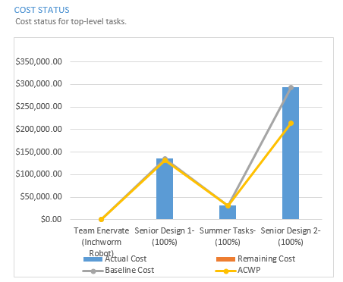

**Figure 17:** Planned Cost vs Time Compared to Actual Cost vs Time Graph

### Planned Labor Cost by Task vs. Actual Labor Cost by Task

Below is the planned labor cost vs. the actual labor cost. This graph, basically represents the quarterly expenditure amount for the planned and actual labor cost. It is shown in the graph below that the planned labor cost exceeded the actual labor cost, indicating we were under budget for each quarter in the project.

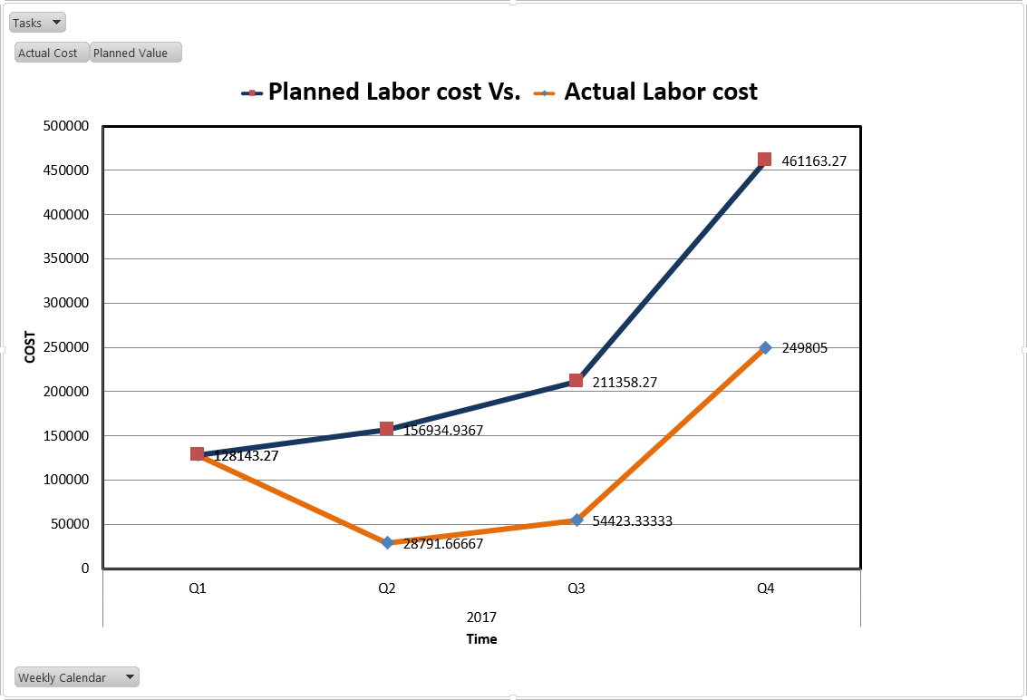

**Figure 18:** Planed Labor vs Actual Labor

### Planned Material Cost vs. Actual Material Cost

The graph below represents the actual cost vs the planned cost associated with each material necessary for the construction of our robot. It can be seen how the actual material cost for the robot is far less than the predicted planned material cost. This is mostly due to finding alternative, less expensive solutions to achieve the same desired result.

The difference in the 3D printed parts are due to Dr. Bhounsule providing Polylactic Acid necessary for the 3D printing process. The only material cost associated to be higher than the planned cost were the motors. Since our client was worried about the motor output, he wanted stronger motors to ensure a properly functioning device we switched to slightly more expensive motors to mitigate this problem. The ball bearing transfer units were planned to be larger than the actual units used on the robot, which reduced the cost of this material parameter.

The major difference which caused our project to me much less than expected were the grip pads. Originally, we were going to use a gecko synthetic adhesive process estimated to cost $500. Since we found we could achieve our desired result with grip pads which were far less expensive, we opted for the transition. The other material roughly followed the same cost estimation which can be seen on the graph where the lines are close together.

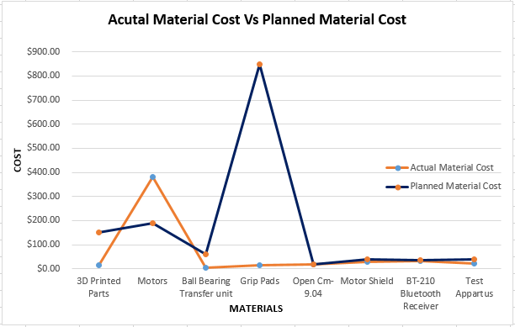

**Figure 19:** Actual Material Cost vs. Planned Material Cost

# ****Conclusion****

Enervate has successfully built an inchworm robot that has met and exceeded eight of out the nine specifications. Although this one test was failed, the team’s client is still very happy with the test results. Enervate prides themselves on being one of the few teams to design and create a robot capable of scaling vertical surfaces without utilizing pneumatics, magnets, or wheels.

# ****Appendix A – Operations Manual****

# ****Appendix B – Test Plan****

# ****Appendix C – Test Report****

# ****Appendix D – Assembly Design****

**References**

[1] Autumn, Kellar. "Properties, Principles, and Parameters of the Gecko Adhesive System." *Biological Adhesives* (2006): 225-56. Web.

**[2]** Robotis. “Dyanamixel AX-18A Servo Motors.” *AX-18A*, 1 Jan. 2010, www.robotis.us/dynamixel-ax-18a/