Contents

1. Introduction 4

2. Scope 4

3. Features to be tested 5

3.1. Features to be evaluated 5

3.2. Compliance Matrix 5

4. Test Facility 6

4.1. Configuration 6

4.2. Data Acquisition 6

4.3. Calibration 6

5. Testing 7

5.1. Test Preparations 7

5.2. Test conditions 7

5.3. Test Parameters 8

5.4. Test Matrix 9

6. Data Analysis 9

6.1. Torque Analysis 10

6.2. Power Analysis 11

6.3. Amperage Analysis 11

6.4. Presentation of Results 12

7. Schedule 13

8. Program Risk 13

9. Communications 14

10. Appendix A Specifications 15

**TABLES**

Table 1: Compliance Matrix 5

Table 2: Physical/Performance Test Matrix 9

Table 3: Software Test Matrix 9

Table 4: Analytical Testing 12

Table 5: Experimental Testing 12

**FIGURES**

Figure 1: Force Distribution of Servo Arm 10

Figure 2: Free-Body Diagram of end segment 11

# Introduction

Testing is the act of ensuring a created product is capable of meeting pre-determined parameters. It can involve a number of different testing procedures all eventually leading up to two possible outcomes, pass or fail. Determining whether a product has passed or failed can be a little complicated depending on the product being manufactured. When products have the potential of affecting the wellbeing of species, there are strict guidelines. If the device isn’t so life threating, the outcome is in the hands of the creator and the goals set performance wise. The reason society cares so much about testing products is in reliability. When purchasing a product, the first couple questions that come to mind is will this do the job, how long will this last, and how reliable is this product. This is because people enjoy getting the best bang for their buck. If the product purchased ends up failing too soon or not working properly the customer then loses interest in the product eventually letting other customers know the product is a sham. This leads to the manufacture of the product losing credibility as well as money.

# Scope

The testing of this product will require different procedures to be conducted as well as a varying attendance of personal. In regards to testing location, an indoor environment would be sufficient, but testing can be conducted outside in a dry environment so long as the robot is still connected to a power source of 12 volts. The required amount of personal per test will vary but no more than two will ever be needed. A testing apparatus will also need to be built to test the robot's capability of scaling inclined surfaces. This will be built from wood as it is cheaper and easier to work with, but can be made with any material so long as it is still capable of changing angles. Ceramic tile will then be glued onto the incline apparatus to test the robot’s ability to meet the specification of climbing an incline tile surface.

Equipment needed for testing procedures will change per test. For instance, a multimeter will be needed to measure voltage across the servo motors. All equipment needed should already be found in the RAM engineering lab so there shouldn’t be a need to purchase any outside products.

# Features to be tested

## Features to be evaluated

The most important features to be tested first and foremost are the product specifications. These are the claims that enervate says the robot will meet. Other than the physical and functional specifications, Team Enervate will also do extensive testing with the software of the robot. Different code sequences such as synchronized movements, movement speeds, and timing of motion need to be tested and tweaked to insure proper gait motion of the robot. The coding of the robot is arguably the most important part of the robot. Ensuring the code is bug-free and operational will lead to a better final product. Along with code testing, a data analysis utilizing the software serial print data will be done to find values of power, voltage, torque, and other electrical parameters.

## Compliance Matrix

Table 1: Compliance Matrix

|  |  |  |  |
| --- | --- | --- | --- |
| **Item**  **No.** | **Feature to be Tested** | **Specification Ref. in Appendix A** | **Testing or Verification Procedure** |
| 1 | Segment Length | 1 | Ruler (Pass or Fail) |
| 2 | Overall Length | 4 | Ruler (Pass or Fail) |
| 3 | Segment Width | 2 | Ruler (Pass or Fial) |
| 4 | Segment Height | 3 | Ruler (Pass or Fail) | |
| 5 | Lifted Height | 6 | Ruler (Pass or Fail) |
| 6 | Overall Weight | 5 | Scale (Pass or Fail) |
| 7 | Inclination | 7 | Incline Apparatus (Pass or Fail) |
| 8 | Minimum speed | 8 | Speed Apparatus (Pass or Fail) |

# Test Facility

All testing will be done in the Robotics and Motion (RAM) Laboratory at the University of Texas at San Antonio. Enervate and Dr. Bhounsule are in a partnership that allows the team to utilize the RAM laboratory and any equipment available in that particular lab. While, the Arduino IDE will be the developing environment to code the robot.

## Configuration

Majority of the evaluation for the specifications will be done on an apparatus that will be built by the engineers of enervate inside the RAM Lab. The apparatus will allow the team to measure the robot's adhesive ability as well as the inchworm's capability of scaling incline surfaces. To do so, the team will build a flat surface, resembling the properties of ceramic tile, with the ability to adjust the levels of inclination. To measure velocity, a black and white background with marked inch increments will be placed perpendicular to the robot as it moves in one direction. While Physical specifications will be measured by a ruler or digital caliper provided by RAM Lab. The software setup will be the Arduino IDE and can be accessed on any computer or laptop that has the program installed.

## Data Acquisition

To make sure that the robot will get the proper power to move forward and lift it's three body segments, measurement of the voltage and amperage will need to be acquired. This will be done using a digital multi-meter. Dr. Bhounsule has went ahead and agreed to let us use the multi-meter in the lab. Photography and Video recording will be used to determine speed as well as the maximum angle of incline that robot will be able to move forward. Record of all measurements and evaluation will be inputted on a excel spreadsheet and be compared to the various tests that will done on the robot.

## Calibration

Using a protractor, the engineers will measure the incline angle and confirm that the incline apparatus has the correct level inclination that it will need to properly test the robot's incline capabilities. Calibrating the multimeter can be done by following the instructions on the multimeter's manual to accurately configure the measuring device. In addition, another multimeter will be used to compare the readings to the voltage and amperage readings from the device that the engineers will use. There is no need to calibrate the camera as long as the engineers will use the same recording device.

# Testing

## Test Preparations

To commence assessment on the robot's performance and physical specifications the following equipment or software will need to be prepared:

* + Incline apparatus
  + Speed-tracking background
  + Camera (with video recording capabilities)
  + OpenCM IDE
  + Digital multimeter
  + Caliper
  + Ruler

## Test conditions

Verification that each evaluation task is meet, constraints are applied when testing for each application. Physical and performance measurements should meet or not exceed the specifications listed in appendix A. While the conditions for the software are listed below:

* No movement if controller is not on.
* Dynamixel Motors must go to preprogrammed goal position with goal speed, once controller is being used.
* Code will loop instructions until microcontroller is off.
* Code will loop until Bluetooth controller ceases movement
* Two servo motors must attain simultaneous movement to programmed angle position when initiate by Bluetooth controller.
* OpenCM microcontroller must be active with Bluetooth communications with the controller.

## Test Parameters

All Parameters that will be tested are listed on Table 2 and Table 3.

## Test Matrix

|  |  |  |  |
| --- | --- | --- | --- |
| **Parameters** | **Recorded Value** | **Required Value** | **Pass/Fail** |
| Overall Length |  | 3 feet |  |
| Segment Width |  | 4 Inches |  |
| Segment Height |  | 5 Inches |  |
| Segment Length |  | 5 Inches |  |
| Lift Power |  | 2 lbs |  |
| Range |  | 3 Feet |  |
| Min. Inclination |  | 45 Degrees |  |
| Min. Speed |  | 0.4 Inches per Sec |  |
| Max. Weight |  | 8 lbs |  |

Table 2: Physical/Performance Test Matrix

|  |  |  |  |
| --- | --- | --- | --- |
| **Parameters** | **Recorded Value** | **Required Value** | **Pass/Fail** |
| **Overall Length** |  | 3 feet |  |
| **Segment Width** |  | 4 Inches |  |
| **Segment Height** |  | 5 Inches |  |
| **Segment Length** |  | 5 Inches |  |
| **Lift Power** |  | 2 lbs |  |
| **Range** |  | 3 Feet |  |
| **Min. Inclination** |  | 45 Degrees |  |
| **Min. Speed** |  | 0.4 Inches per Sec |  |
| **Max. Weight** |  | 8 lbs |  |

The software test matrix only evaluates if the parameter was meet by the programmed code or fails to meet the specific task as illustrated in Table 3.

Table 3: Software Test Matrix

|  |  |  |
| --- | --- | --- |
| **Parameters** | **Pass** | **Fail** |
| **Movement when Bluetooth controller is active** |  |  |
| **Simultaneous Movement (From Dynamixel motors 2 & 3)** |  |  |
| **Movement in the same direction as controller indicates** |  |  |
| **Movement of rear motors as controller is active** |  |  |
| **Servo motors move to predetermined goal position** |  |  |

# Data Analysis

Data analysis will first need to be performed analytically to ensure the robot is not producing any torque, power, or amperage greater than the servo motors abilities. This must be conducted before performing any movement from the servo motors to prevent failure. After this has been managed, the procedure can be executed. While the procedure is in motion the Robotis software can serial print the actual torque, power, and amperage each servo motor is producing, which can then be compared to the analytical calculations. Below is a detailed description of how each analysis will be conducted manually.

## Torque Analysis

Torque, represented by tau (TAU), plays a huge role in the functionality of this robot, and as seen below is the product of force and lever arm in units of lb.*in.

$$τ=F*l$$

Four Dynamixel AX-18A servo motors will be the muscles of this robot, granting it movement. These motors all possess a stall torque of 15.93 lb.*in, meaning any torque produced greater than this number will result in failure. Two of these servo motors will be used to lift the middle block upward while the other two will be used to lift the outer blocks upward. These two actions will be split up and analyzed differently to determine the torque being generated.

For the inner servo arms, the torque being produced will differ slightly in regards to force. Here, the force being created will be due to gravity rather than an outside applied force. To calculate this the robot will be weighed and the number on the scale will take the place of force. This force will be used as an even distribution, basically giving a resultant force centered on the block. Since the hinges are located on the edges of the block, reaction forces will need to be calculated to determine the weight being lifted from each inner servo arm. A visual aid of this force distribution can be seen in the figure below.

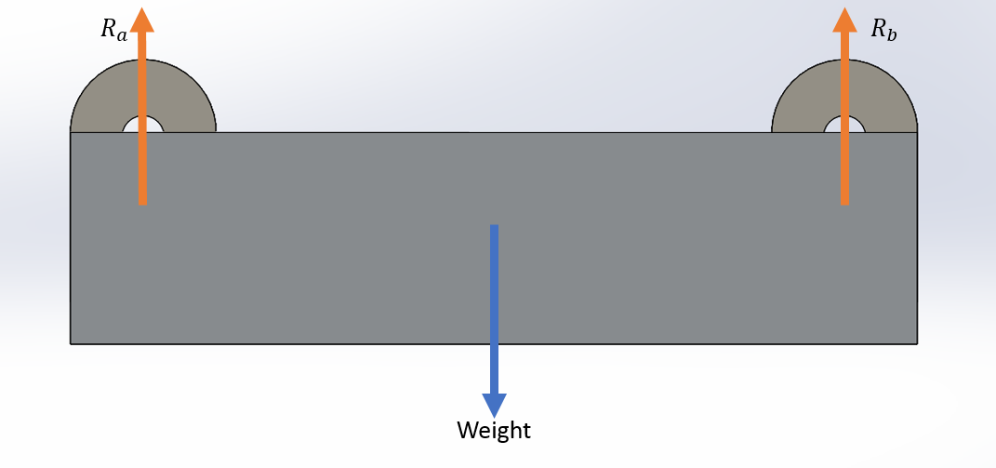

Figure 1: Force Distribution of Servo Arm

The outer servo arms will again differ in the force being used for torque. In this case a portion of the weight of the outer block as well as the reaction force from the inner servo arm will now take the place of this reaction force. This force can be observed on the roller bearing on the outer servo arm. This is done by a force balance between the roller bearing, inner servo arm, and the weight of the robot. A visual aid can be seen in the figure below.

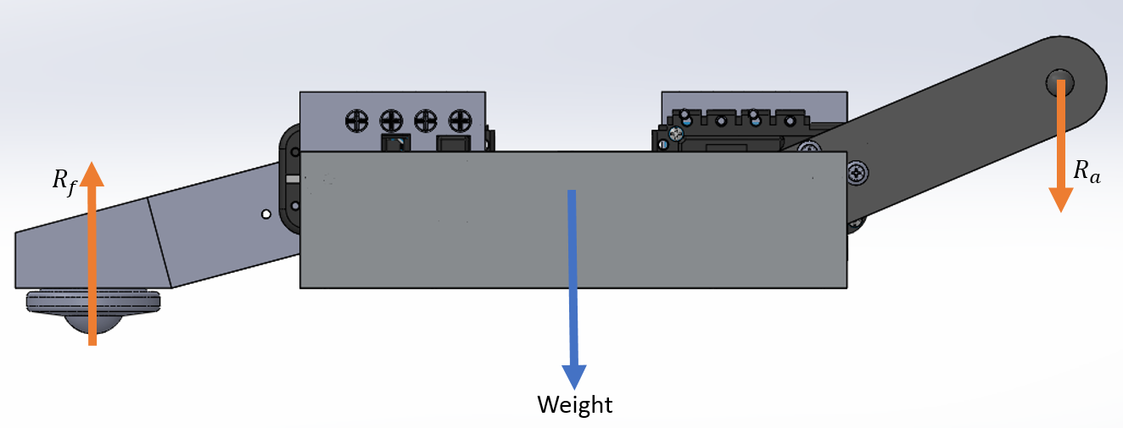

Figure 2: Free-Body Diagram of end segment

In the case of this project the lever arm will be the perpendicular distance from the force being used to the center of the servo motors rotational wheel. Since the servo motor will be rotating throughout the robots' movement, the value of the lever arm will change. The maximum value the lever arm will be is from the initial lifting of the both outer and inner blocks, here is also where the maximum torque is experienced.

## Power Analysis

Power in regards to electrical components, as seen below, is the product of angular velocity [OMEGA] and torque.

$$P=ω*τ$$

Since the servo motors will be controlled via software coding, the angular velocity can be manipulated to create a desired speed. This speed is inputted in the OpenCM IDE as rotations per minute, so this will be converted to radians per second so that when multiplied by torque produces watts. Since both angular velocity and torque are proportional to power, the maximum power will again be experienced in the initial lifting of both blocks.

## Amperage Analysis

When measuring amperage two different factors come into play, power and supplied voltage. Amperage is the amount of current being supplied to each servo motor and is the quotient, as seen below, of power to voltage.

$$A=\frac{P}{V}$$

Voltage should not change as each servo motor should be receiving roughly 12 volts since they are connected in series. Power will change as torque changes due to the angular movement of the servo arms. The servo motors being utilized all contain a stall currant of 2.2 amps meaning a current equal to or greater than this number will result in no movement. It is important to ensure that the amperage does not equal or exceed this value before operating these motors to prevent damaging their circuit boards.

## Presentation of Results

Below are two testing tables, one analytical and the other experimental. The analytical table is to be filled out before experimental to insure the safety of each servo motor.

Table 4: Analytical Testing

|  |  |  |  |  |  |  |  |
| --- | --- | --- | --- | --- | --- | --- | --- |
| **Motor** | **Weight Lifted** | **Lever Arm** | **Torque** | **Angular Velocity** | **Power** | **Supplied Voltage** | **Amperage** |
|  |  |  |  |  |  |  |  |
|  |  |  |  |  |  |  |  |
|  |  |  |  |  |  |  |  |
|  |  |  |  |  |  |  |  |

Table 5: Experimental Testing

|  |  |  |  |  |  |  |  |
| --- | --- | --- | --- | --- | --- | --- | --- |
| **Motor** | **Weight** | **Lever Arm** | **Torque** | **Angular Velocity** | **Power** | **Supplied Voltage** | **Amperage** |
|  |  |  |  |  |  |  |  |
|  |  |  |  |  |  |  |  |
|  |  |  |  |  |  |  |  |
|  |  |  |  |  |  |  |  |

# Schedule

The detailed testing schedule consist of 18 working days. Within the time frame of October 23 through November 9 of 2017 the following major tasks listed below will be conducted with respect to specification testing.

1. Test Plan Outline
2. Initial Test Parameters
3. Coding
4. Debugging
5. Testing on Flat Surface Conditions
6. Testing on Inclined Surface Conditions

The test plan outline seen in this document is a necessary guideline to be followed for proper testing evaluations. Each major task has several subsections that must be tested to ensure a properly working device. From initial test parameters to testing on inclined surface conditions there are a total of 23 test to be conducted. The engineers of Enervate can be seen on the working Gantt chart. Each test conducted has an assigned engineer which will conduct the respective test.

The engineers of Enervate strongly agree the successful specification testing will produce a properly working device to be presented during the final tech symposium.

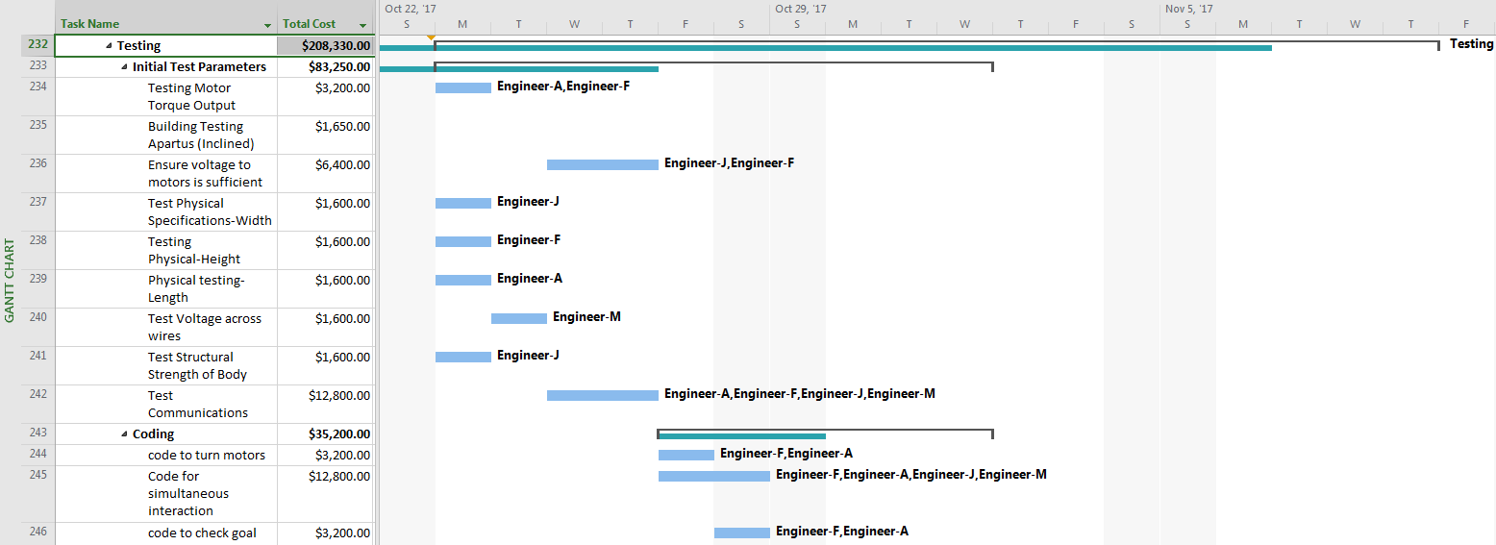

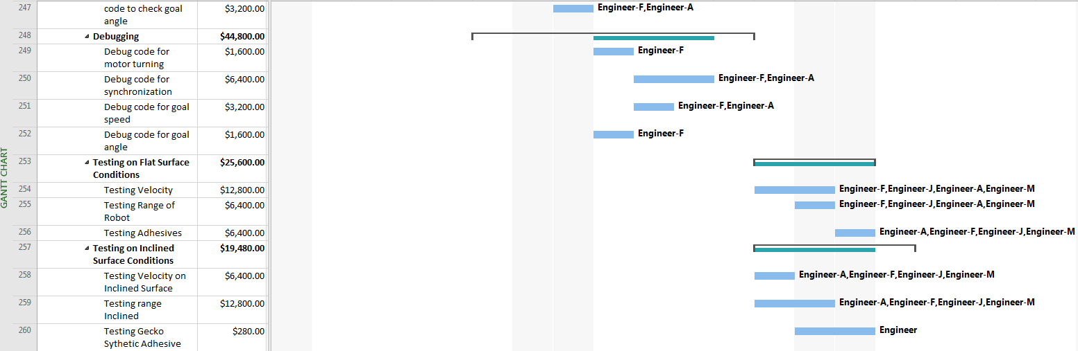

# Program Risk

There are several program risks that must be discussed. The first risk is associated with the 3-D printed components of the body segments and hinge connections. Enervate must ensure areas of minimum thickness on the body segments will be rigid enough to support the load acting upon them. Hinge connections must also be analyzed to ensure they are a proper fit. The result of the thickness being too small could cause failure of that component leading to a malfunctioning device. Another program risk is associated with the ball bearing transfer unit. This is the component that allows the forward propagation of the robot. We must ensure the surface contact area around the lip of the ball bearing will have enough area to make contact with the surface and break adhesion from the grip pads. The consequence of an improper contact with the roller bearing and surface will not allow the robot to traverse forward. The last major risk is toward the programming issues that may arise. Since the robot motors will be daisy chained together, the motors will have to work simultaneously to achieve the desired result. Enervate will have to invest a fair amount of time to ensure the four motors are working in unison to achieve looping gait desired.

# Communications

Communications on all aspects of the test program on a regular basis are encouraged. The primary technical contact at Enervate is Flavio T. Moreira, Project Manager, (561) 414-9767. Moreiraft@gmail.com

# Appendix A Specifications

|  |  |  |
| --- | --- | --- |
| Appendix A | | |
| **Ref. #** | ***Functional Specifications*** | ***Value*** |
| 1. | Max segment length | 5 Inches |
| 2. | Max segment width | 4 Inches |
| 3. | Max segment height | 5 Inches |
| 4. | Max total length | 3 Feet |
| 5. | Max Weight | 8 lbs |
| 6. | Max Height on forward movement | 6 inches |
| 7. | Min. Inclination angle | 45 degrees |
| 8. | Min. Speed | 0.4 in/sec |