**Proceedings of the 1st International Conference on ASME FORMAT**

**ICOAF1**

**June 17-20, 2016, San Antonio, Texas, USA**

**Paper number: 123**

**HOW TO WRITE AN AMERICAN SOCIETY OF MECHANICAL ENGINEERS STYLE REPORT ME 3113**

Kyle Lamoureux

Undergraduate UTSA

8803 Chulan Pass

San Antonio, Texas, 78255, USA

(210) 563-1989 kyle.lamoureux@yahoo.com

Abstract

The American Society of Mechanical Engineers (ASME) has set the bar for professional engineers throughout the United States since 1880. Their goal is to maintain, “…a not-for-profit membership organization that enables collaboration, knowledge sharing, career enrichment, and skills development across all engineering disciplines, toward a goal of helping the global engineering community develop solutions to benefit lives and livelihoods.”(ASME)[1] Part of ensuring collaboration between engineers from all walks of life is a clear definition of communication channels. Journals and written reports stand among the most important ways engineers record and make available the knowledge and data they acquire. The ASME has set forth a format by which reports should adhere. This report attempts to encapsulate the whole of the details which an ASME report should entail, and when appropriate, it will attempt to provide example to better the understanding of the reader as to how to write an ASME report proficiently.

Nomenclature

The Nomenclature section of the report is necessary to define symbology used by the author. Nomenclature used throughout the report should be listed in this section in alphabetical order starting with uppercase letter, followed by lowercase, followed by Greek symbols, and ending with superscripts and subscripts. Each symbol is identified with a heading followed by their respective definition. Older versions of the ASME format along with all the examples provided place the nomenclature after the abstract, but new templates on the ASME website place the nomenclature section near the end of the paper after acknowledgements. A seemingly less useful position than at the beginning to set forth the standard for the rest of the paper.

EXAMPLE:

|  |  |
| --- | --- |
| *A* | area of cross section |
| *C* | circumference |
| *E* | modulus of elasticity |
| *L* | length of graphic |
| *W* | width of graphic |
| *SS* | sum of squares |
| *a* | acceleration |
| *f* | friction factor |
| *r* | radius |
| *α* | thermal diffusivity |
| *β* | hardness |
| γ | reflection coefficient |
| ( )’ | prime first derivative |
| ( )WG | within groups |
| ( )BG | between groups |
|  |  |

INTRODUCTION

The American Society of Mechanical Engineers has created a report format for its members to follow. This format will ensure clear and concise transmission of ideas, knowledge, and collected data internally between members of the ASME and outwardly towards others interested in their findings. A clear format ensures consistency in the manner in which reports are written. When reports are written in a consistent format they collectively become easier to decipher. A standard format ensures that a reader, once familiar with the ASME format, can quickly and more easily digest the content of a report or journal. Navigation of a report, repeatability of a process, and understanding of a report are critical in the successful communication between engineers and the rest of society.

In order to ensure easy navigation of a report, the format set forth must clearly define how text, information, pictures, and figures are to be organized. The ASME format does this down to every conceivable detail. This report will demonstrate adherence to these specifications to act as an example or even a template for readers seeking to learn and emulate the ASME format. A detailed list of specifications exists in the body of the report.

The writer of a report must keep in mind that their findings may hold value for a future generation of engineers. Whether that future generation is seeking to prove or disprove the writer’s findings, it is important to leave behind a report that not only displays the collected data, but any and all inferences or details which led to the findings in the report. In doing this the writer ensures repeatability of his process. Future endeavors can thus efficiently scrutinize a report and glean information from it while soundly speculating on the circumstances in which it was obtained.

Whether a reader is simply skimming through a report for fun or delving into its deepest details, it is important that the report makes every effort to ensure the reader understands the process behind the ideas or subjects included in the paper. Relevant information should be clearly referenced and, when necessary, covered by the writer. It may be impossible to decipher a report if common symbols are used for variables inconsistently. The nomenclature section must clearly define what each symbol and variable stands for. Similarly an equations section in the appendix can provide a bank of referenced equations used by the writer. This can help the reader to understand relationships between the variables relevant to the ideas or conventions in the report. A writer may choose to include required perquisite knowledge crucial to the subject in their report for the convenience of the reader, but the writer cannot fail to mention perquisite knowledge. Mention of perquisite knowledge would allow the reader to educate themselves before diving into advanced concepts in a report. Failure to mention perquisite knowledge could result in the reader’s loss of understanding or, worse, misinterpretation of the report’s findings.

Formating Specifications

The first criteria mentioned for a good ASME report is its adherence to a standardized format. The ASME website and manual both update their format yearly. The American Society of Mechanical Engineers post a detailed list of specifications to be met in font, layout, sizing, graphics, and organization.

Fonts fall into two categories. They are either Title/Headings or text. Titles, headings, headers, page numbers, author information, and other non-body text should have a sans serif typeface. Recommended common san serif typefaces include Helvetica, Arial, Geneva, and Univers. This paper’s titles and headings are Arial to exemplify san serif typeface. Body Text should be Time Roman medium or an equivalent type face. The body text exemplified by this paper is Times New Roman.

Sizing of Text is important along with its font. Body text should be 9 or 10 pt. justified with single spacing. This is easily achieved in Microsoft Word by highlighting a selection and selecting the font and paragraph tab to alter the selection to desired specifications.

**Header**

Headers should appear in 10 pt. boldface and flush to the right. They should adhere to 12 pt. line spacing and be a ½ in. form the top edge of the paper. Headers should only appear on the first page of a paper as exemplified by the conference title/description on this paper. The paper number should be 18 pt. boldface font flush right. It should only appear on the first page two lines below the header.

**Title**

The Title of a paper should be all uppercase, 11 pt. boldface font, and centered on the full width of the page. It should appear 3 lines below the paper number which has been labeled for convenience in this paper but should normally just appear as a number.

**Author Information**

Author information appears below the title. To lines of spacing are required between the title and author information. The author’s name should appear in 10 pt. boldface using upper and lowercase letters unlike the title. The information and name should be centered with 12 pt. leading below the title. The information lines should be single spaced 10 pt. medium font. Lines of information should be organized as shown. Affiliation, Street Address, City/State/Country/zip, and contact information should be seen as basic author information that should be required. In the case of two authors two lines of spacing should be provided between authors. In the case of multiple authors, ASME recommends using one’s own discretion two fit the formatted author name and information cells in the same area it would take to put two authors. A common solution is to place authors in an alternating stack pattern. An example is provided in the appendix under Formating1!

**Abstract**

The Abstract is a somewhat special case in formatting. Templates provided by ASME are somewhat conflicting. Most adhere to the same specifications as other body text while some frame worker templates make the abstract italicized. To conform with the majority this paper recommends leaving the abstract in the same formatting as the rest of the paper.

**Headings**

A heading’s format in an ASME paper are sort of a hierarchy. All headings are boldface san serif as before mentioned. A major section heading or Heading1 should be 10 pt. font all caps. They should be flush left and on their own line. Heading2 or second tier headings within sections should be title case (upper and lower), flush left, and on their own line. Heading3 or third tier headings can be title case, flush left, and run with the text. Spacing around a heading should simply reflect the hierarchy the author wishes to organize his body text by. Here is an example of how headings work.

**HEADING TIER1**

Body text

**Heading Tier2**

Body text

**Heading Tier3** Body text

**Footnotes**

Footnotes, if required, should be in 8 pt. text with 1 line of spacing below the body text. Footnotes should be flush left and numbered consecutively using superscript numbers. Here is an Example[2] footnote so that the reader can see how they might be useful to reference something in their text.

**Equations**

Equations that are relevant to the report may need to appear as they are introduced within the body text. Equations should be set apart from the body text by 2-3 lines of spacing. They need to be centered to the body text and numbered consecutively so that they may be easily referenced in the body text. Their numbering should be flush right in Arabic numerals enclosed in parentheses along the final base line of the equation.

$Average=\frac{\sum_{i=1}^{n}{(x_{i})}}{n}$ (1)

Now the equation can be easily referenced in the body of the text. Example… The average of the values in question can be found using Equation (1).

**Graphics**

Graphics are a fantastic way to convey information in a report. Graphics include photographs, graphs, or hand drawings. Importing from excel or other modeling programs to display your findings in a visual manner adds depth to and supports the ideas of the report. Graphics can also muddle up the written content of a paper if they are not properly placed within the text and labeled for convenient referencing. The American Society of Mechanical Engineers has specified how to successfully integrate graphics into a report. All graphics should be numbered consecutively and captioned in 9 pt. bold face sans serif type face. Captions should be uppercase and centered below the graphic. Callouts within the graphic should be no less than 7 pt. font. The graphic should appear within the body of the paper after it is first referenced. Or at the end of the text portion of the paper.

Graphics can be sized in four ways depending on how they are to be implemented into the paper. The first option is to fit it in the column as shown in Figure1. Its width is set to 3 9/16”. Notice that the graphic is not oversized or pixilated. It is clear and crisp. The second option is to fit your graphic across the page thus taking up both columns. Figure2 shows this at a width setting of 7 ½”. The author should avoid using a graphic like Figure2. It is oversized and blurry, and graphics should not contain borders. The third option is to fit the graphic to the entire page as shown by Figure3 at a (LxW) 9x7 ½”. The fourth option for graphics is to turn the graphic on its side to take up the width of the page as if it was in landscape. This graphic is the largest possibility at 8 ½ X 6 ½” as shown in Figure4.

**Tables**

Tables follow the same specifications as graphics in sizing all aspects. The only difference is that they must also be captioned and numbered separately as shown in Table 1 and Table 2. Notice that these tables meet the same dimensional requirements as the graphics, however their captions are above the item and read table # rather than graphic #.

Table

|  |  |
| --- | --- |
| x | y |
| 1 | 1 |

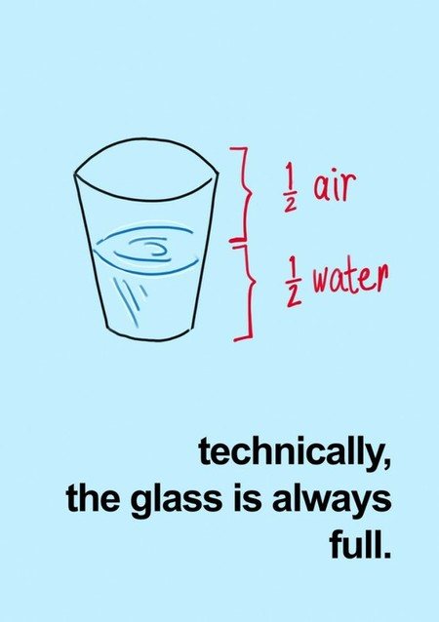**Figure 1**

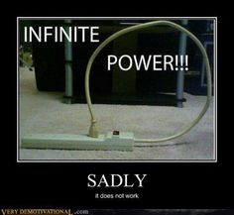

Figure 2

Table

|  |  |  |  |  |  |  |  |  |  |
| --- | --- | --- | --- | --- | --- | --- | --- | --- | --- |
|  |  |  |  |  |  |  |  |  |  |
|  |  |  |  |  |  |  |  |  |  |
|  |  |  |  |  |  |  |  |  |  |
|  |  |  |  |  |  |  |  |  |  |
|  |  |  |  |  |  |  |  |  |  |
|  |  |  |  |  |  |  |  |  |  |
|  |  |  |  |  |  |  |  |  |  |
|  |  |  |  |  |  |  |  |  |  |

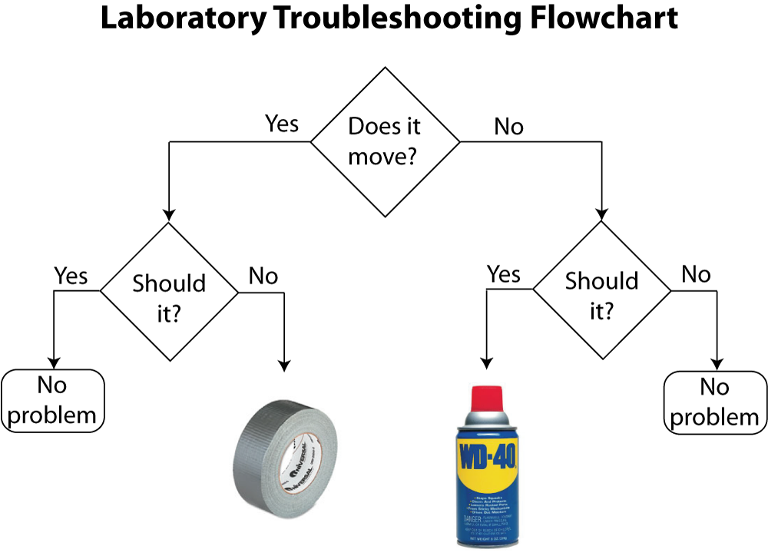

Figure 3

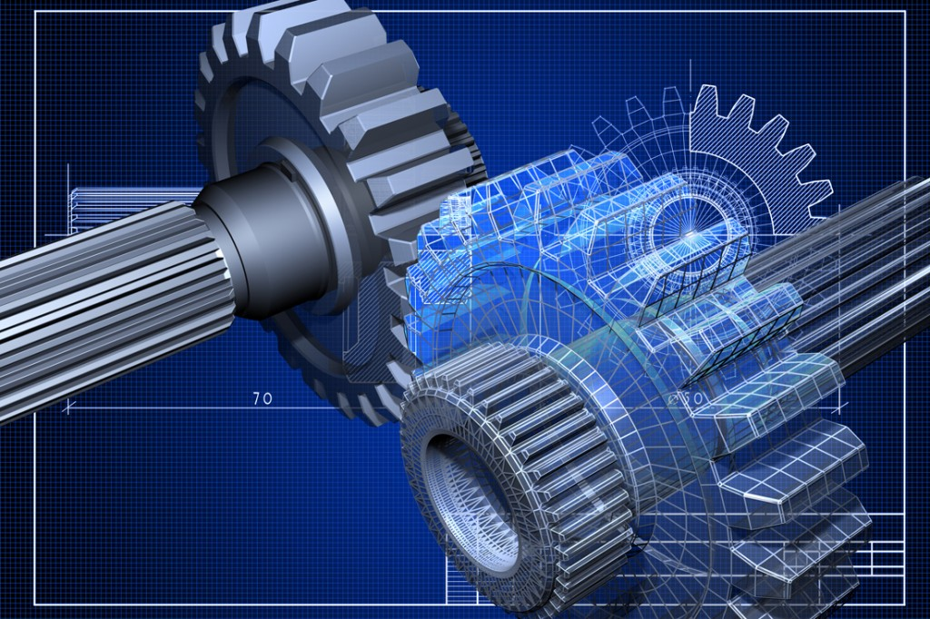

Figure

**Page Layout**

The page layout for an American society of Mechanical Engineers style paper is exemplified as closely as possible by this paper. A visual aid is given by ASME to help the author better understand how to format their paper. They will be Figure5 and Figure6 in the appendix. The first page is unique from the other pages in some regards. The Title starts 2” below the top edge of the paper. Margins on either side are to be set at .5”. The first page text is split into 2 columns each being 3.56” across and no more than 5.5” tall to accommodate 1” between the text and the bottom of the page. Separation between the columns should be about .38”

For a normal text page, the title does not have to be accounted for. Thus, the text will fall into two 9” tall columns with the same .38” separation. Margins will remain at .5” on either side, but there should only be 1” separating the text from the top and bottom edge of the page.

A footer should include page number centered at the bottom of the page and ©ASME YYYY (e.g. 2016)

**Organization**

Formatting an ASME paper correctly is vital to the author for many reasons. An author’s paper will not be accepted or published by ASME if it is not correctly formatted. This would result in all the ideas, knowledge, and findings of a project failing to find their way an author’s peers. Without this transmission the work they put into their research may all be for not.

When a paper is formatted correctly by meeting a set of common standards it results in a level of comfort for the reader. When the reader becomes accustomed to the ASME style they can more quickly navigate, digest, and understand the content of a report. Formatting a report in a consistent manner could make all the difference in the reader’s ability to gain the full depth of knowledge the author wishes to portray.

Elements Of a Paper

The American Society of Engineers have supplied a list of basic paper elements and the order by which they should appear in an online workshop. These elements may not be the only sections the author wishes to put in the paper and some may not be applicable for different types of papers. However, they do come into a nice outline for a good report and should be considered.

**First Page**

The formatting section goes into depth about what should appear on the first page, but it is restated here for emphasis. A conference title is necessary for the paper to be sorted, filed, and otherwise recorded among other papers. A page number is often used by an institution to identify the paper in their file or database. This page number would be a unique code assigned to the paper after acceptance for retrievability purposes. Papers submitted to ASME will be automatically assigned such a code upon submission through the ASME Conference ToolBox[3]. A title for the paper should be concise and to the subject matter discussed in the paper. Author(s) are also mentioned with their information on the first page.

**Abstract**

The Abstract is a quick introduction to the subject of the paper. It should clearly define the scope and objective of the paper so that the reader may decide ahead of time if it is something they are interested in. A good strategy for writing a good abstract is to write it after the report is complete. Once the author has a full understanding of their report they can more efficiently encapsulate it into the abstract. The abstract should not surpass 150 words or it becomes too lengthy. Key words may be included in the abstract to assist search engines in locating the paper in a database.

**Introduction**

It is common practice to open the body of a paper with an introduction. Though not required, an introduction or background can familiarize the reader with history behind the subject or the origin of the problem. Other ASME papers have used the introduction to do things like propose the purpose of their experiment, show the need for the data they collect, or to state a hypothesis. The introduction should not repeat the abstract but encompass a good road map of what is to come in the report.

**Body of Paper**

The separation of sections in the body of an ASME paper is left up to the author. As long as they adhere to the hierarchy of headings in their organization they are left to their own devices. This paper will provide some basic building blocks of a paper that an author may find helpful.

**Theory**

The theory section of a paper is a good place for an author to describe the working knowledge behind an experiment or process. In earlier sections perquisite knowledge has been identified as a necessary part of a good paper. The theory section can help the author to bring the reader up to speed on the subject(s) utilized in the paper. For example: a reader with an electrical engineering background may need to be brought up to speed on statics before being introduced to dynamics concepts in a paper. A reader with a mechanical engineering background may need to be brought up to speed on circuit analysis before reading a report about the circuitry of a new controller. A list of working equations is sometimes displayed and defined in a theory section as well. However, some prefer an equations section or to introduce equations as they need them, but either way they should adhere to ASME equation formatting requirements.

**Apparatus/Set Up/Procedure**

In the case of an experiment being conducted, it is very helpful to the reader to understand the setup of equipment and organization or samples. It is crucial that a future engineer, seeking to scrutinize ideas laid forth in an author’s paper, be able to reconstruct the circumstances of the experiment. This can help them to identify and control unaccounted variables. Overall repeatability should be an issue on any researcher’s mind thus their paper should reflect importance on consistency.

Description of tools and materials used can be listed within the procedure section or as a stand-alone “bill of materials” type section.

**Analysis**

An Analysis section in a report is a standard occurrence. An author can utilize this section to explain the calculations that took them from raw data collected to results. To bridge the gap an author should give sample calculations with a smaller sample of data, or simply describe the different tools that were used. Explanation of Microsoft Excel, MATLAB, hand, or other calculations should be shown to give the reader an idea of how the author came to their findings. The author may also want to explain why certain methods were used over others if alternatives exist.

An analysis may be a tempting place to paste code or raw data from excel, but the author should refrain from doing so. A good paper references such things from the appendices of a paper. Referencing code or excel data by line or row, column respectively lets the reader decide if they want to interrupt their reading to sort through the thick of the author’s data or coding to see what’s going on, or if they would rather take the author’s word for it and read on.

**Results**

A results section is a good place for the author to display trends and inferences found and made from the raw data through analysis. It’s not hard to tell by the name that this is where the results of all the number crunching go. If the raw data has been organized and graphed, those which show trends supporting the author’s ideas and findings belong in the results section. Some readers may skim the majority of the report to get to the results section simply to find out if the results support the stance of the author on the subject. The results section should simply display the unbiased findings of the author which pertain to the subject of the report. It is a good idea to keep everything as accurate and factual as possible.

**Discussion**

The discussion section is often found attached to the end of the results section, but some authors may choose to put it in its own section. The discussion sections exist to take the results one step further. Here digestion of findings can be turned into inferences. An author, without claiming something completely off topic, can make inferences towards larger trends based on the data collected. This is where the author gets to put their own spin on it. A little bias doesn’t hurt here as a good discussion section should be near argumentative. This is where an author can go a step further to try to convince a reader of his train of thought and inferences based on the sound backing of the data and results. A bit of persuasion in the discussion could ignite the motivation of a reader to go out and try to prove the author right or wrong. Good discussion between engineers is key to the development of untested theories and ideas into the solid building blocks of working knowledge and facts. This development in understanding of the rules that dictate how our environment works lead directly to our ability to manipulate it. (Has this discussion section convinced the reader to include a discussion section in their own paper?)

**Conclusion**

The conclusion section of the report is a stumbling block for many authors. It may be more relevant to mention what should be omitted from the conclusion rather than what should be included. The conclusion should not include any new unsupported claims, it should not restate a hypothesis word for word, and it definitely shouldn’t rattle on about the extreme importance of the experiment for the good of the human race or universe.

A good conclusion should round off the body of a report by rephrasing any hypothesis along with a statement of success or failure to prove it. The conclusion offers a section for the author to reflect about challenges involved in the experiment along with the need for future testing. A solid conclusion can be achieved in roughly 5-6 sentences.

The conclusion for this paper is simply that the ASME provides a bounty of easily accessible information pertaining to the writing of an ASME style report. Examples from earlier standards may have changed challenging an author to seek out the most recent information on formatting from the ASME website or manual. This proved to be a real challenge, however, the difficulty is in the tiny details. This paper has meticulously attempted to adhere perfectly to ASME standards, but finds that even after many hours of review it is a complete possibility that some small detail may have been overlooked.

Varrying Forms

Before moving to the closing remarks, it is worth mentioning some ASME recommendations as to the length of different report styles. A short description is also included to assist in selection of an appropriate paper type.

**Technical Papers**

A technical paper is usually used to display the findings of the author to a conference. Therefore, it must be the complete and final representation of the author’s work at 10 pages or more fully formatted to spec. This is a serious paper that displays the refined knowledge, ideas, and well supported findings of the author.

**Poster Papers**

A poster paper is similar to a technical paper in the maturity of its argument and level of refinement. However it appeals more to a visual display as the entirety of the report is to be displayed in the form of a poster at a conference or event. The poster paper should include a greater number of graphics and visual learning aids to communicate ideas to a reader reading them on a display at a conference.

**Short/Forum Papers**

Forum, or short, papers are more relaxed than technical papers. They are 4-6 pages in length and offer a way for peers to communicate and trade information and theories about current areas of development. The idea here is that free sharing of ideas and thoughts may one day culminate into a more refined or proven idea which can thus be archived through the writing of a technical paper. These papers are still fully formatted to ASME requirements.

**Extended Abstract**

An extended abstract is a 2 page fully formatted paper that exist as a very short way to transmit an data, graph, charts, or photos accompanied by a short explanation. This seems to be the fastest way to transmit a simple idea between peers at a conference, but doesn’t hold much weight when trying to capture a more complex or multifaceted idea which would require a lengthy explanation.

Acknowledgments

An acknowledgements section comes back to the recommended ASME report basic element list. An acknowledgements section simply acknowledges individuals, institutions, groups, or organizations who have made a significant contribution to the report. These entities may still deserve credit or deserving mention even if their work was not directly referenced by the author.

Example:

The author would like to thank Andrew for posting a link to the ASME digital collection. This service proved useful in locating necessary reference material.

References

1999, “ASME Template Sample” [Online]. Available: https://www.asme.org/getmedia/3df72b8c-3984-46fa-a4eb-8b118ed8a69b/author-templates-asmetemplate-sample.aspx. [Accessed: 20-Jun-2016].

2016, “Formatting the Paper,” Guide to Conference Publications [Online]. Available: https://www.asme.org/shop/proceedings/conference-publications/formatting-the-paper. [Accessed: 20-Jun-2016].

Arioui, H., Nehaoua, L., Hima, S., Séguy Nicolas, and Espié Stephane, 2010, “Mechatronics, Design, and Modeling of a Motorcycle Riding Simulator,” IEEE/ASME Transactions on Mechatronics IEEE/ASME Trans. Mechatron., **15**(5), pp. 805–818.

Drost, U., Bölcs, A., and Hoffs, A., 1997, “Utilization of the Transient Liquid Crystal Technique for Film Cooling Effectiveness and Heat Transfer Investigations on a Flat Plate and a Turbine Airfoil,” Volume 3: Heat Transfer; Electric Power; Industrial and Cogeneration.

Freeman, J. L., 2011, Compressor Performance Map Generation and Testing per SAE J1723, San Luis Obispo, California.

Johnston, J. D., and Zuber, B. V., 1982, “Sound Field Created By Explosive Entry Through Doors,” NASA.

La, H. M., Lim, R. S., Basily, B. B., Gucunski, N., Yi, J., Maher, A., Romero, F. A., and Parvardeh, H., 2013, “Mechatronic Systems Design for an Autonomous Robotic System for High-Efficiency Bridge Deck Inspection and Evaluation,” IEEE/ASME Transactions on Mechatronics IEEE/ASME Trans. Mechatron., **18**(6), pp. 1655–1664.

Appendex

|  |  |
| --- | --- |
| Author Name  Affiliation  City, State, Country | Author Name  Affiliation  City, State, Country |

|  |  |  |
| --- | --- | --- |
| Author Name  Affiliation  City, State, Country | Author Name  Affiliation  City, State, Country | Author name  Affiliation  City, State, Country |

Example of multi author

Formating1 1

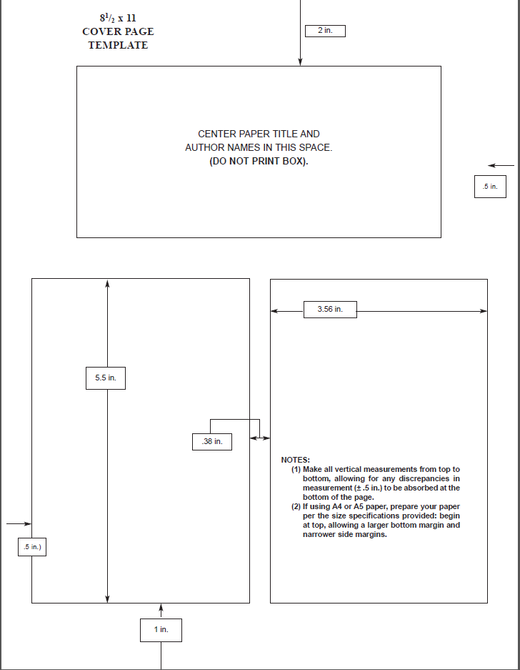

Figure 5

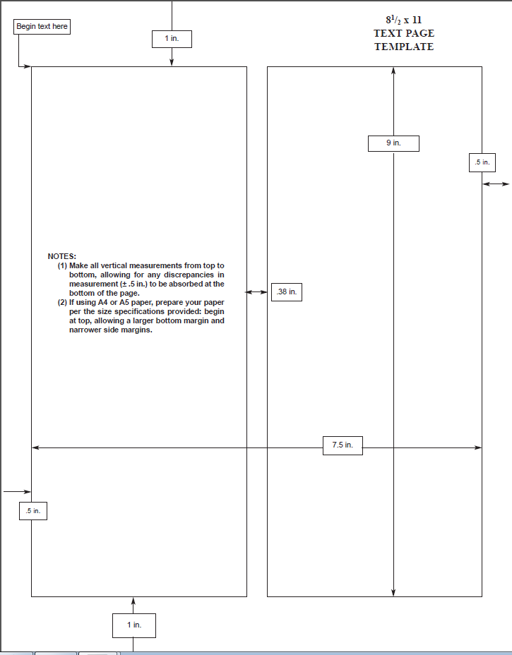

Figure 6

$$V_{out}=\left( \frac{R_{f}}{R_{in}}+1\right)*V_{in}$$

$$V_{out}=\left( \frac{R_{f}}{R_{in}}\right)*V_{in}$$

1. https://www.asme.org/about-asme
2. Example footnote reference.
3. More information can be found at this link http://www.asmeconferences.org/conference-home/index.cfm