

Sri Lanka Institute of Information Technology

SERVICE-FILLING STATION
MANAGEMENT SYSTEM
Project Proposal
Information Technology Project 2015

Project ID: ITP-15-B2-02

Submitted by:

- IT14119118– T.K.H.Nimeshika
- IT14118746– L.A.Ranasinghe
- IT14127342– K.B.P.Thabrew
- IT14118296– A.A.M.A.S.S.Perera
- IT14124990– K.S.N.Sucharitharathne
- IT14130762– R.S.K.I.P.Perdinandis
- IT14118364– R.C.P.Dissanayaka
- IT14105012– H.D.Welikala

Submitted to:
(Supervisor’s signature)
…………………………..
Name of the supervisor
Ms.Asanthika Imbulpitiya
Date of submission

Abstract

Our client is A.P.Gunawardhana and Company (Pvt) Ltd. It is a Service Station with a combination of a Filling Station in Ja-Ela. This Service-Filling Station currently uses a manual system for management and maintenance of critical information. The current system requires numerous paper forms with data stores spread throughout the station infrastructure. The information (on forms) is incomplete, or does not follow management standards. Multiple copies of the same information exist in the station and may lead to inconsistencies in data in various data stores.

By considering all these facts, and for the continuous daily functioning, our team selected the A.P.Gunawardhana and Company (Pvt) Ltd Service-Filling Station to implement an effective Service-Filling Station Management System.

The station carries out all its operations daily on file based system largely, which is handled manually and much less focus is given on computerization. Therefore this manual based system can greatly effect in erroneous situations and time management. Our main goal is to make this situation less precarious and much more efficient by developing effective automated software to the station and also implement a desktop application. We are planning to use JAVA as the programming language to implement this automated system. The software Net Beans IDE will be used to implement the source code here. We use MySQL database system to implement the database

Table of Contents
Abstract
1.0 Introduction...............................................................................................................................1
1.1 Problem Specification 2
1.2 Solution Outline 3
1.3 Key Benefits 5
2.0 Objectives 6
2.1 General Objectives 6
2.1.1 To increase the efficiency and automate the functions of filling and service station 6
2.2 Specific Objectives 6
2.2.1 To Implement interfaces for permission controls and allow administration handling. 6
2.2.2 To create interfaces for entering Employee, Stock and Suppliers details and to retrieve data by Managers and Administrator. 7
2.2.3 To Create interfaces for entering stock details, supplier details and other relevant operations. 7
2.2.4 To Implement an In-Out system, emailing system, and a printing facility. 7
2.2.5 To Implement Employee payroll management system 8
2.2.6 To Implementing General Accounts Management System 8
3.0 Procedure 9
3.1 Flow of the project 9
3.2 Project Plan 12
4.0 Personnel and Facilities 14
5.0 Software and Hardware Requirements 16
6.0 Budget 17
7.0 References 18
Appendix 19

Table of Figures

Figure 1.2.1 High-level Architecture Diagram……………………………………………………4

Figure3.2.1 Project Plan Cycle ………………………………………………………………........13

Figure 3.2.2 Gantt Chart ……………………………………………………………………….....13

1.0 Introduction

Our project is based on creating a system for a Filling station combine with a service station. A Filling station facilitates selling fuel and lubricants for motor vehicles and a service station provide the facility to repair and maintain motor vehicles. Since there is a heavy work load to be done daily, having an efficient system is a necessity. At present all functionalities are done manually. Therefore the process is much time consuming. Hence there exists a great importance in having an automated system for our client.

In a filling station there is lots of work that has to be done within a day. Every day it is necessary to calculate the oil amount that stored in tank. If the oil level of a tank is low then that tank should be refilled. In such a situation ordering new stock is necessary. Hence the fuel stock is supplied by the government of Sri Lanka the fuel sellers has to give more accurate information to the suppliers. That information includes how much of fuel amount they need and how much of amount they have in their tanks.
In the service station employees have to deal with lot of vehicles daily. The services that are providing to a vehicle can be varying. Therefore it is necessary to reserve works for employees in the service station. Customers have to pay according to the service they had from the service station.

Other than these tasks both filling station and the service station have more tasks such as selling lubricants and spare parts, managing employees etc. Since there exist more tasks, it is important to have an efficient system to handle those tasks. At present these tasks handle manually and it is not efficient. In order to avoid inefficiency automated system is required.

We are planning to develop a desktop application using Java Programming language where we will design to store, insert, search, and delete data of the system in an efficient and user-friendly way. Through this automated system we plan to maintain records of the client for years and manage stock, order, accounts, and invoice with backups and daily/monthly reports. Overall idea of this system that we are planning is a more effective automated system which our client can use it for handle all of tasks in his filling station and service station and by using this system our client can enhance his businesses further more.
  - Problem Specification

Since all the functions are done manually it is time consuming. Inserting all the day to day records, updating existing records and also eliminating certain information are done by hand. In the process of inserting information there are several log books that needs the same information to be inserted and in the process of updating records, if the same record is exists in the different places of the log it is inefficient to update them manually. Because of the employee who deals with updating has to update each and every relevant record in the log. Also the process of deleting has the same functionalities as same as inserting and updating.

When searching particular detail client has to search each and every log respectively. These manually done tasks can lead into a lot of time consumption and mislead to certain decisions, since existing data could be incorrect. Because of entering data manually will provide lots of incorrect and incomplete records. Since the each manager who deal with the task of the Filling Station as well as the Service Station are performing different activities , when integrating each tasks it will also lead to a heavy time consumption and to an inaccuracy.

Company expects to generate various kinds of reports for several purposes. For an example salary detail report for salary payments, income reports for taxing purposes etc. So if it is done manually, performing calculations and obtaining documents consumes time and it will lead into misjudgments.

This company deals with lots of outward people daily. These outward people include suppliers and customer etc. When interacting with these people the system should be more efficient. Especially when dealing with customers it is very important to have a system which provides quick results.

When the company tasks are performed there is a need of big workforce. That will also consumes time and create other problems too. But through an automated system in the absence of certain workers a single manager can perform chosen number of tasks. Other than these problems we identified that our client does not have much knowledge of using computer for his business purposes. Therefore the system we are going to implement has to be simple and user-friendly

1.2 Solution Outline

We are planning to design a desktop application using java language which will provide all functionalities required by our client. My SQL database system is used to store all the necessary information. Graphical user interfaces of our system will provide user friendly environment to our client where he can have a better understanding about the system.

We also concern about the security of our system. There are many levels of employees in this company. Therefore access levels to the system are specified. E-mail service is also facilitating through this system by using internet.

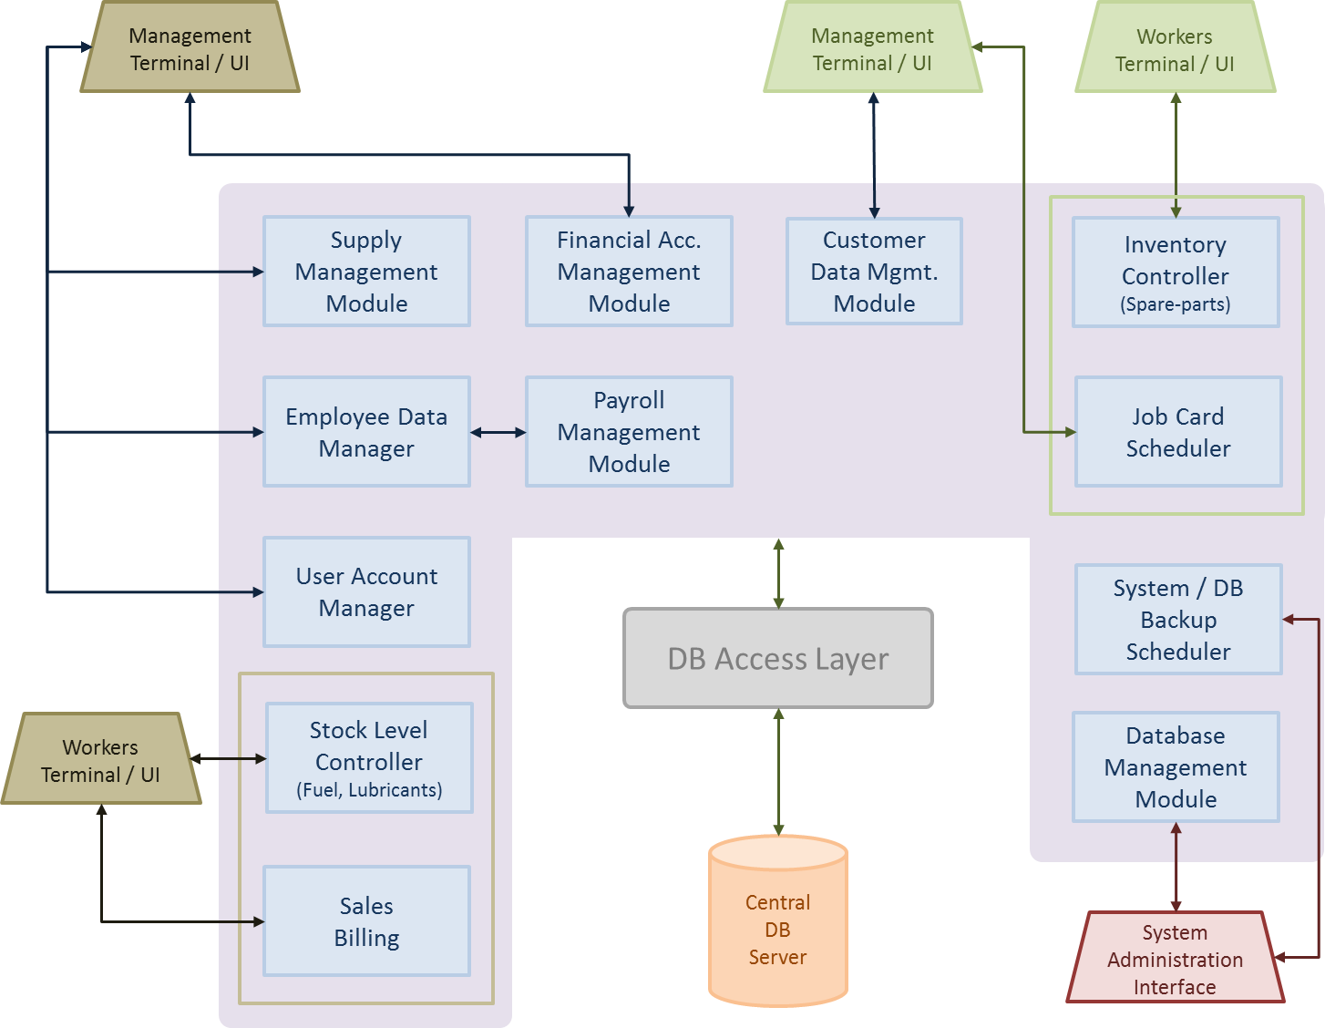

Figure 1.2.1 High-level Architecture Diagram

1.3 Key Benefits

One of the main benefits of having this system will be improvement of the efficiency and productivity. Through this client can upgrade their record maintaining system in a beneficial and productive manner. Client will have the opportunity of retrieve the information using effective indexes. The time will spent on searching missing records manually will be saved. This system will facilitate the retrieval of the information to the user as quickly as they needed. And also this system will improve company’s efficiency by doing automated processes. In turn employees are free to work on other things while the system runs their tasks

Through this system client will accomplish in controlling the growth and the creation of the records. It will reduce the generation of records or their copies which are not required to operate the business. And also it will destroy the useless records and stabilize the unnecessary growth of records.

This system will provide the information which will be needed to the customer to make decisions or take actions looking at the overall picture of the functionalities rather than digging the information out of the paper system, which may produce more cost and more time. Client could have an idea about weekly/monthly sales, purchases, other expenses glancing at a graphical interface.
This system will create an electronic storage to protect company’s valuable records. Information will be saved by limiting allowing the user access to the system. Only certain users can access some functionality and will be able to do changes to the records.

Obviously this system allows the client to work more efficiently and to maximum productivity, and control the growth and creation of the records. By providing an electronic storage, information of the company will be stored in a more organized manner with the facility of searching records more efficiently and secure that information from unauthorized access. Following are the key benefits we want accomplish for our client through this system.

2.0 Objectives

2.1 General Objectives

2.1.1 To increase the efficiency and automate the functions of filling and service station

Our main objective of this software is to offer a mechanism by which all the operations of the Service station and filling station are executed reliably without any errors. It ensures that the operations carried out daily by the relevant personnel are continuously reviewed by the owner of the company.
In order to achieve such review notification systems are developed. To reduce the huge amount of time waste by deviating from the document based file management.

To make the system much more efficient by upgrading the manual system of the filling station and service station to a computerized system.

2.2 Specific Objectives

2.2.1 To Implement interfaces for permission controls and allow administration handling.

The system is fully maintained and managed by the Client. Therefore, login controls are to be implemented and for administration purposes employee accounts and document generation are managed through implementation of interfaces to enter data. Also for maintenance purposes, databases can be backed up and restoration of the data is made possible. For example, lost password can be recovered; details can be viewed and controlled

2.2.2 To create interfaces for entering Employee, Stock and Suppliers details and to retrieve data by Managers and Administrator.

Considering that the owner(administrator) and other Managers would find it difficult to make adjustments directly to databases, interfaces are provided to fill forms to enter employee details, stock details and order purchasing details etc.. And make data retrieval of above details by the use of a customizable search option whenever necessary.

2.2.3 To Create interfaces for entering stock details, supplier details and other relevant operations.

There need to be interfaces as requested by the client to make entry details of registration of employees, managing stock details, managing supplier details, managing order details etc. The layout of the interfaces will be made similar to the paperwork so that the Managers would be better adapted to the newly implemented system.

2.2.4 To Implement an In-Out system, emailing system, and a printing facility.

As requested by the client, an In -Out time attendance system will be initialized to identify and keep track of each and every employee attendance, working hours and over time. A printing option will also be implemented to the Filling-Service Station Management System to generate documents, forms, employee identity cards, job cards, salary slips etc. For better efficiency and faster communication with employees and managers, emailing system will be provided for communication between the employees and managers and suppliers to send stock ordering requests, loan approvals/rejections, and other company related information.

2.2.5 To Implement Employee payroll management system

In this function we calculates the amount we give our employees based on factors such as the time they worked, their hourly wages or salaries, whether they took vacation time during the pay period. System adjusts gross pay by calculating and subtracting taxes and other withholding amounts. On pay day system provide our employees with paper checks or a salary slip.

2.2.6 To Implementing General Accounts Management System

In order to focus on company’s expenses and profit details account managements system will be implemented. Through account management client could generate automate reports rather than manual time consuming processes.

He could maintain sales and purchase ledger accounts, changes in assets, liabilities, income and expenditures, Manage major and mandatory expenses such as taxes, electricity, water bills, pump and tank maintenance, welfare and etc., Set profit margins and sales targets to compare with actual figures.

3.0 Procedure

3.1 Flow of the project

- Requirement gathering and analysis.

We are planning to implement a system for a filling station combined with a service station. The process of this company is expanded through a wide range. At the beginning of this project we did not have a clear idea about the system which is required for the company.

Therefore we visited to our client premises and gathered all the information which can be used to implement our system. We gathered more and more information until we find sufficient requirements for the system.

After gathering necessary and sufficient information our team members get together and discussed with each other about the requirements. By going through the information again and again we analyzed our problem thoroughly. Then we modularized our system into eight sub systems and divided those sub systems among each group members. And the each member decided what are the software and hardware to be used in their process. All members have already decided to use Java as programming and My SQL as database and Net beans as the software to be used for the creation of the system.

- Designing of the system.

After gathering and analyzing the sub systems we suggest starting the design of the database. For this purpose we are using Enhanced Entity Relationship (EER) diagram. In this step we are deciding the structure, behavior and what the views customer requested.

Then we plan what are the suitable inputs and outputs of the system. And we decide how the inputs and outputs are verified, how they are processed and how they should be displayed.

Then we are concerning how the GUI should be designed and how the system presents information back to them. In designing interfaces we are planning to provide simplified and user friendly interfaces in this system using Net beans IDE. A common look and feel will be applied to all the GUIs. Then coding and algorithms will be created by members for the assigned function(s).

Then our step will be designing the data structures and how the data is represented and stored within the system. And designing how data moves through the system and where data should be validated. Other than that we are deciding what the functions that have a connection with internet are.

- Implementation.

After designing step we will be implementing executable computer program for our system. In that situation we will translate generated algorithms to a programming language. To write the source code we will use java as the programming language. The software Net Beans IDE will be used to implement the source code here. We use MySQL database system to implement the database. We will find sequence of instructions that will automate to perform a specific task.

During the coding part we will use field validators in order to prevent the insertion of inconsistent data into the system database. User-friendly error messages will be displaying in such cases.
After designing the EER diagram we implement the database of our system. There will be implemented code according to the drawn EER. Next the coding for the functionalities will be tested.

- Testing.

Testing will start at the end the implementation phase. Before the system testing we have to conduct the unit testing. Firstly, each module will be separately unit tested for proper functioning. Once no flaws or errors are found, the separately created modules by the members will be integrated.
Next the fully integrated system will be tested to detect any faults or bugs in the system.
Then the system will be tested for stress to assure high and accurate performance.
After the completion of all the testing, the product will be completed and delivered to the Client.
Finally the acceptance testing will be performed by the manager himself after the product delivery to determine whether to accept or reject the project. In any case where the system is not meeting up with the requirements of the client, functions will be redesigned built according to the satisfaction of the management of the filling-service station.

3.2 Project Plan
In order to accomplish the targets of our project we hope to develop the system and its components in
the following order.

In first seven days we gathered the requirements, analyze them and specify those requirements. Then in next seven days we prepared the project proposal. In the beginning of the 3rd week we hope to do the project proposal presentation and then the latter part of the 3rd week and during the 4th week and 5th week we hope to decide the project and prepare the SRS document.

And starting from the 6th week we allocate 14 days for the development phase of the system in order to achieve the principle goals of the project.

Then we will be doing the prototype presentation in 8th and 9th weeks. Then again starting from the 10th week throughout 14 days we plan to do the development of the system for the finishing of the system. In the process of development each and every component should be unit tested by the developer.

In the 12th week we hope to integrate the individually developed and unit tested components and to implement the system. In the last 14 days we have allocated for the testing phase.
And also we hope to prepare the final project report during the last 21 days.

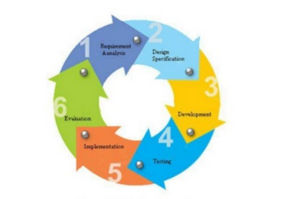

Figure3.2.1 Project Plan Cycle

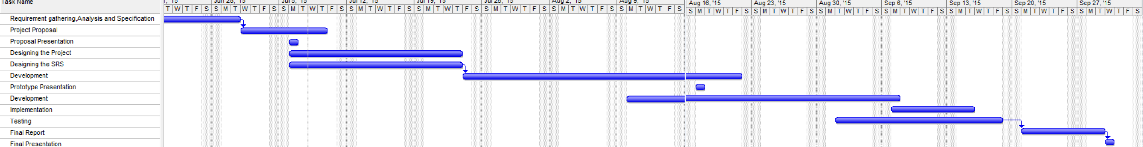

Figure 3.2.2 Gantt chart

4.0 Personnel and Facilities

PERSONNEL | FACILITIES
T.K.H.Nimeshika | Human resource management  Leave management and employee information management.  Apply leaves, loans and Medical claim requests.  Approve /reject leaves, requests.  Handle remaining medical amounts.  Employee registration. And Employee details, Job details  Report generating(employee wise leave summaries as pending,approved,rejected,no-pay and remaining)  User account and user role management.
L.A.Ranasinghe | Fuel sales and stock management  Sales billing details management.  Tank level management. And Message alerting.  Fuel type product details management and Lubricant stock management.  Inventory report management
K.B.P.Thabrew | Service station services type details management and billing  Create job /tasks for the employees relevant to the services.  Services billing and discounts.  Resource planning for the services.  Generate job card for service station employees for each customer.
H.D.Welikala | Customer and vehicle management  Register new customers and customer details.  Customer service order details and booking, Product order details and delivery.  Credit customer credit details management
A.A.M.A.S.S.Perera | Payroll management, Daily attendance.  Employee category wise and shift wise salary details including overtime, bonus and no-pay.  Issue salary slip with EPF, ETF.
K.S.N.Sucharitharathna | Supply controlling management, Supplier details and order management.  Replenishment management.  Machine maintenance, Warranty claims.  Backup scheduling
R.S.K.I.P.Perdinandis | Generate account management  Managing and maintaining the expenses (tax, electricity/water .etc.) And total sales income.  Set daily targets and profit margins to compare differences, Final account report.
R.C.P.Dissanayaka | Spare parts management  Managing stock level and ordering the spare parts and message alerting at critical levels.  Spare parts sales details and purchase order and supplier details management.  Spare parts reports.
.

5.0 Software and Hardware Requirement

- Software Requirements
After gathering all the requirements and information we achieve next state which is quite important for the project. At the beginning first thing to decide is general structure. We decide to build the system having desktop application for every user instead of browser based because the system is not going to be used by large number of users. And we decided to use Java to code the system. We use MySql database.

Operating System | Microsoft Windows XP (32-bit or 64-bit)  Windows Vista ((32-bit or 64-bit)  Windows 7 ((32-bit or 64-bit)  Windows 8 ((32-bit or 64-bit)
Browser | Internet explorer, Chrome or any other recommended browser

Software Tools – Java, MySql, phpMyAdmin

- Hardware Requirements

Hardware requirements of PC. (Minimum configuration client workstation only.)

Machine | X86 (32-bit) | X86-64 (64-bit)
CPU | Operation system dependent | Operation system dependent
Memory | 1GB | 2GB
Video | 1024x768, 16-bit color | 1024x768, 16-bit color
Mouse | Microsoft or compatible | Microsoft or compatible
Hard Disk | 200 MB (no local data set) | 200 MB (no local data set)

Fax machine and Printer – Email fax services are one of the part in our system, with this when submitting the document from user to the client we will send the fax to the destination. When we issue bills to the customers, we will use a normal desk jet printer.

6.0 Budget

- Selection Process

Transportation Costs | 6,000.00
Other Expenses | 5,000.00
Total | 11,000.00

- Implementation Process

Software Costs
Application Software
NetBeans IDE 8.0 | -
MySQL | -
Operating System
Microsoft Windows 7 Professional | -
Hardware Costs
Network Cables | -
Desktop & Laptops | -
Miscellaneous implementation costs | -
Fax Machine & Printer | -
Total | -

- Human Resources

 | Person Name | No. of man hours | Rate for one man per hour (Rs.) | Cost
1. | T.K.H.Nimeshika | 300 | 150.00 | 45,000.00
2. | L.A.Ranasinghe | 300 | 150.00 | 45,000.00
3. | K.B.P.Thabrew | 300 | 150.00 | 45,000.00
4. | A.A.M.A.S.S.Perera | 300 | 150.00 | 45,000.00
5. | K.S.N.Sucharitharathne | 300 | 150.00 | 45,000.00
6. | R.S.K.I.P.Perdinandis | 300 | 150.00 | 45,000.00
7. | R.C.P.Dissanayake | 300 | 150.00 | 45,000.00
8. | H.D.Welikala | 300 | 150.00 | 45,000.00
 | Total |  |  | 360,000.00

TOTAL COST = 11,000.00 + 360,000.00
= 371,000.00
7.0 References

- Timothy C. Lethbridge & Robert Laganière.
Object-Oriented Software Engineering: Practical Software Development using UML and Java (Second Edition) McGraw-Hill, 2005.
- Java The Complete Reference (Seventh Edition) Herbert Scheldt

Appendix

Appendix 1
Appendix to clause
Service details management
- Create job/tasks relevant to each employee.
- Reserve employees to tasks that are requested by each customer.
- Reserving process is done according to the highest priority.
Appendix 2
Appendix to clause
Customer and Vehicle management
- Customer relationship management.
- Customer can request services from the company.
- Then according to the services customer will have a date and a time
- Product order and delivery.
- Customer can order lubricants or spare parts from the company.
- Credit customer details management.
- Customer can have a deposit.
- Then he will get services from the company until that deposit amount.

Appendix 3
