History-Aware Battery RUL Estimation
Leakage-controlled LOBO selection and external HUST validation
PhD thesis draft | Battery RUL research programme

Abstract
Reliable remaining useful life (RUL) prediction must generalize across batteries, operating histories and protocols. We present a history-aware, leakage-controlled pipeline that audits cycle-level V/I/T data, defines censored-aware EOL labels, selects models by battery-level leave-one-battery-out (LOBO), calibrates uncertainty on a separate set, and evaluates once on untouched HUST cells. Among the evaluated non-sequence classical and trajectory models, Random Forest achieved the lowest error under the locked development protocol (LOBO RUL MAE 63.1 cycles). On 16 untouched HUST cells, the adapted estimator achieved MAE 116.5, 116.1, 85.2 and 20.3 cycles at 20%, 40%, 60% and 80% observed-life checkpoints, respectively. Empirical conformal coverage was 100%, but intervals were wide. A direct RUL ablation shows that current-state features dominate cycle-only inputs; history contributes conditionally and does not uniformly improve early-life prediction. The result is a validated research prototype, not a production BMS.
Keywords: battery prognostics; RUL; SOH; LOBO; external validation; conformal prediction; HUST

Reader guide: what this thesis does
In one paragraph: this thesis asks whether battery RUL prediction remains credible when the test battery is unseen, the operating protocol changes, future cycles are hidden, and uncertainty is reported honestly. The answer is established through a locked data contract, state/history health indicators, battery-level LOBO model selection, development-only external adaptation, calibration-only uncertainty and chronological replay. The selected Random Forest is the best model among those evaluated under this protocol; the contribution is the auditable evidence-producing framework, not a new learning algorithm.

How to read the workflow
The complete research route is: (0) literature review and research-gap mapping; (1) data understanding and normalization; (2) data-quality and censoring audit; (3) degradation insight discovery; (4) health-indicator selection and ablation; (5) ground-truth, EOL and RUL definition; (6) protocol registration and leakage audit; (7) model ladder and fair model-family comparison; (8) LOBO, statistical uncertainty and checkpoint evaluation; (9) external HUST validation and domain-shift analysis; (10) online sequential replay; and (11) prototype, reproducibility and claim control. Each arrow is a decision gate: later results are not allowed to revise an earlier locked definition.

Key terms for first-time readers
Term | Plain-language meaning
SOH | State of health: the current condition of a battery, usually capacity relative to its initial reference.
RUL | Remaining useful life: the number of cycles left until the defined end-of-life threshold.
HI | Health indicator: a measured or derived variable that carries information about degradation.
EOL | End of life: the operational threshold used to define when a battery has failed for this study.
LOBO | Leave-one-battery-out: train on batteries except one, then test on that unseen battery.
Censored battery | A battery whose trajectory does not show the defined EOL crossing; it is not assigned a fake RUL label.
Zero-shot / adaptation | Zero-shot applies the source model directly; adaptation allows development-domain data to recalibrate or refit it.
Conformal interval | A prediction interval calibrated to achieve a target empirical coverage; width is also reported because coverage alone can be uninformative.

Four questions and the answers supported by the experiments
Question | Answer supported by this thesis
Does cycle count alone describe battery age? | Not reliably. Current state is generally stronger, although cycle-only is slightly better at one checkpoint; the conclusion is not an absolute ranking at every horizon.
Does operating history always improve RUL? | No. History is informative but checkpoint-dependent: it can hurt early prediction and help later prediction.
Does the selected model generalize? | RF is best among evaluated models under the locked NASA LOBO protocol, and HUST performance improves with development-only adaptation and longer observation.
Is the estimator ready for deployment? | It is a research prototype with chronological replay and calibrated coverage analysis. Intervals remain wide, and electrical HIL/BMS validation is still future work.

A simple online example
At cycle 30, the estimator uses only data through cycle 30 and returns an RUL estimate with an interval. At cycle 31, the new measurement is appended and the estimate is recalculated; no future cycle is used. The online question is therefore not “what is the single best number?”, but “does the estimate become more accurate and more informative as the observed trajectory grows?”

1. Introduction
Battery degradation depends on electrochemical state and operating history, so cycle count alone is an incomplete surrogate for remaining life. The central question of this study is: under a battery-level, leakage-controlled protocol, which information and model family provide reliable cross-cell RUL prediction, and how does that performance transfer to an external HUST domain?

Research origin and decision path
This study did not begin with a decision to apply a particular neural architecture. It began with a practical and scientific concern: a battery RUL model can obtain a small numerical error while still failing on an unseen battery, an unseen operating protocol, or a battery whose end of life is not observed. The initial project direction therefore combined two goals that are often separated in the literature: understand what the measurements reveal about degradation, and build an estimator that remains auditable when it is exposed to new cells and new protocols.
The starting hypothesis was deliberately modest. Cycle count alone should not be treated as battery age, because two cells at the same cycle index can have different capacity, voltage, temperature, duration and accumulated operating history. The first task was consequently not model selection. It was to determine whether the data were sufficiently well defined to support a defensible RUL target, and whether state and history variables contained information beyond cycle count.

Research questions and intended direction
The work was organized around four questions. (1) What is a valid, reproducible unit of observation: charge, discharge, EIS, cycle, or partial cycle? (2) Which health indicators carry information about degradation, and does history add information beyond current state? (3) Which estimator is reliable when the held-out battery has never appeared in training? (4) Can the estimator produce sequential predictions with uncertainty without using future cycles? These questions led to an eight-step research route: data audit; aging insight; health-indicator screening; EOL/RUL definition; model ladder; battery-level generalization; online adaptive replay; and prototype packaging.
The route was intentionally evidence-first. A model was allowed to become the selected estimator only after the information schema, label rule, split protocol and evaluation checkpoints had been locked. This is why the final work is positioned as an integrated evaluation-and-estimation framework rather than as a claim that a new architecture has been invented.

What was done and why each decision was made
The execution followed the research route in stages. First, NASA records were normalized into cycle-level discharge observations with voltage, current, temperature, time, duration, capacity and derived history indicators. Duplicate records, anomalies, incomplete cycles and the censored B0007 cell were audited rather than silently converted into artificial RUL labels. Second, degradation trajectories and feature distributions were inspected to identify voltage/current/temperature summaries, duration, energy throughput, capacity state and rolling history as candidate indicators. Third, SOH and RUL ablations were used to test whether cycle-only, current-state-only, history-only and state-plus-history inputs behaved differently at 20%, 40%, 60% and 80% observation.
The ground truth was then fixed before model comparison. Primary EOL is the first of two consecutive cycles below 75% of the median capacity in the first five cycles, and RUL(k) = N_EOL - k. Censored batteries are excluded from point-RUL accuracy rather than assigned a fabricated EOL. The model ladder compared linear and robust trajectories, Gaussian-process/trajectory alternatives, Random Forest, XGBoost and an ensemble under battery-level LOBO. This ordering matters: it lets the data determine whether a complex model is justified instead of assuming that a larger model is scientifically superior.
The NASA results were followed by external HUST validation. HUST was separated into development, calibration and final untouched cells; the final set was not used for feature selection or tuning. Both zero-shot transfer and development-only adaptation were reported, because the very large zero-shot error is itself evidence of domain shift rather than a result that should be hidden. Sequential RF replay was then added so that each prediction uses only data available up to the current cycle. Finally, E1-E11 audits were added to test protocol sensitivity, ranking stability, model-family fairness, history generalization, uncertainty, EOL sensitivity, external validation, leakage, sequential replay and literature comparability.

Decision log: limitations encountered and resulting choices
Observed limitation | Why it matters | Decision taken | Claim boundary
NASA is heterogeneous and B0007 is censored | A false EOL would contaminate every RUL metric | Audit operations, preserve censoring, exclude B0007 from point-RUL metrics | No claim that every NASA cell has observed EOL
Only three NASA cells have observed EOL | Bootstrap intervals and history conclusions have high sampling uncertainty | Report per-cell results and bootstrap intervals | History is checkpoint-dependent, not universal
Random cycle splits can leak battery identity | They can make RUL look easier than unseen-cell prediction | Use battery holdout and LOBO as primary evidence; retain random split only as sensitivity | No random-split SOTA claim
NASA to HUST protocol/chemistry shift is large | A shared feature schema is not automatically domain invariant | Report zero-shot separately from development-only adaptation | No universal zero-shot generalization claim
Conformal coverage is high but intervals are wide | Coverage alone does not establish operational usefulness | Report 80/90/95% coverage together with width and normalized width | Uncertainty is coverage-valid but not yet sharp
Deep-model convergence/tuning records are incomplete | Different optimization budgets would make the comparison unfair | Keep deep-family results conditional and separate from the RF leaderboard | No claim that RF beats all deep learning
Partial-cycle API, electrical HIL and BMS hardware are incomplete | Offline replay is not the same as field deployment | Describe software replay as validated and hardware integration as future work | Prototype, not production-ready BMS
Published studies use incompatible splits and horizons | Raw metric ranking would be misleading | Use a protocol-comparison matrix instead of numerical SOTA ranking | Methodological advantage, not numerical SOTA

How to read the rest of the thesis
The remainder of the document should be read as a chain of controlled decisions. Sections 2-4 establish the literature, data contract and integrated framework. Sections 5-8 show how the protocol, state/history inputs and model ladder were tested. Sections 9-11 test external-domain behavior, uncertainty and sequential replay. The discussion and limitations then separate what is demonstrated from what remains a future experiment. In particular, the selected Random Forest is the best estimator among the evaluated models under the locked protocol; it is not presented as a universally superior algorithm. The central contribution is the evidence-producing workflow that makes this statement, and its uncertainty, reproducible.

Novelty and contribution position
1. Research gap resolved: the framework answers whether a model transfers to unseen cells and an external protocol when all decisions are locked before final testing. It therefore converts model selection from a single-dataset score into an auditable generalization claim.
2. Fairness boundary: Random Forest, trajectory, Gaussian-process and ensemble baselines use the same engineered-HI inputs, battery partitions, checkpoints and EOL definition. Deep sequence models are reported as a separate representation experiment until identical tuning and convergence records are complete; no RF-versus-deep superiority claim is made.
3. Position relative to SOTA: raw metric ranking is not scientifically valid across the published studies because their splits, horizons, target definitions and adaptation rules differ. The manuscript therefore uses a protocol-comparison matrix and makes the narrower claim “best among evaluated models under the locked protocol,” while reporting external HUST performance after development-only adaptation.
4. Method or evaluation protocol: the primary contribution is a methodologically integrated protocol with an operational RF estimator and uncertainty/replay components. It is not claimed as a novel learning algorithm. The scientific value is the evidence it produces about information value, cross-cell generalization and the coverage–sharpness trade-off.
The contribution is a reproducible integrated evaluation-and-estimation framework, not a new neural architecture. Its novelty lies in coupling (i) a fixed information schema for state and history, (ii) battery-level LOBO model selection, (iii) separate development, calibration and untouched external test roles, (iv) checkpoint-conditioned uncertainty with sharpness reporting, and (v) sequential replay. This combination addresses a documented gap in battery RUL studies: results are often reported under incompatible splits, horizons, EOL thresholds and uncertainty definitions, making apparent SOTA comparisons unreliable.
Claim | Evidence in this study | Safe wording
Cycle count alone is insufficient | Cycle-only is weaker overall, but not at every checkpoint; at 60% it is slightly better than state-only. | Cycle-only is generally weaker, but not uniformly at every checkpoint.
History is useful | State+history improves state-only at 60% and 80%, but not at 20% and 40% | History contributes conditionally by checkpoint
RF is best | RF has mean LOBO MAE 63.1 cycles among six evaluated models | Best among evaluated models under this protocol
External transfer is demonstrated | 16-cell HUST final holdout after development-only adaptation | External-domain holdout after locked adaptation
Uncertainty is reliable | 100% empirical coverage, with wide intervals | Empirical coverage is reported with wide intervals; sharpness remains limited.

2. Related work
Prior battery prognostics use recurrent networks, particle filters, Gaussian processes, feature learning, ANFIS and hybrid digital-twin approaches. The HUST source study introduced 77 LFP/graphite cells with diverse multi-stage discharge protocols and used deep transfer learning for personalized health prediction [1]. Recent HUST benchmarks include multi-scale temporal fusion with Bayesian uncertainty [2] and interpretable Gompertz/LSTM hybrids [3]. Their splits, horizons and target definitions differ from ours; therefore we compare protocol characteristics rather than rank raw metrics.

From literature corpus to research design
The supplied literature was read as a design space rather than as a leaderboard. The papers cover trajectory and particle-filter methods, Gaussian processes, recurrent and convolutional sequence models, feature-learning and ANFIS approaches, hybrid digital twins, transfer learning, and uncertainty-aware RUL estimation. Across this corpus, the recurring scientific weakness is not the absence of models; it is the lack of a common information boundary. Studies often differ in battery split, observation horizon, EOL threshold, adaptation rule and metric, so a lower published error cannot automatically establish better generalization.
The literature therefore led to four design decisions. First, the unit of comparison must be a battery-level holdout, with LOBO as the primary unseen-cell test. Second, the input schema must separate current state from operating history so that the value of history can be tested rather than assumed. Third, external validation must separate development, calibration and final untouched cells. Fourth, uncertainty must be reported jointly with coverage and width. These decisions are the bridge between the reviewed PDFs and the experiments reported in this thesis.

Literature-to-design mapping
Literature pattern | Limitation for a strong claim | Design response in this thesis | Evidence location
Trajectory, PF and GP prognostics | Useful dynamics/uncertainty, but often evaluated within one battery or protocol | Keep trajectory/GP baselines in the same engineered-HI LOBO ladder | Sections 5 and 7
LSTM/GRU/TCN and deep feature learning | High capacity, but split and tuning budgets are not consistently comparable | Run a separate fair-family comparison and state the evidence boundary | Sections 7 and 14
HUST transfer-learning studies | External cells are valuable, but adaptation and horizons differ across papers | Freeze 46/15/16 HUST roles and report zero-shot versus development-only adaptation | Section 9
Hybrid, ANFIS and digital-twin methods | Interpretability/physics are attractive, but assumptions may be protocol-specific | Treat interpretability as motivation while testing a fixed data contract and protocol sensitivity | Sections 3, 5 and E1
Published benchmark tables | Raw MAE/RMSE is not comparable across EOL, horizon and split definitions | Use a protocol-comparison matrix and avoid numerical SOTA claims | Section 8 and E11

3. Dataset and problem definition
NASA PCoE cells are used for development benchmarking. HUST contains 77 LFP/graphite cells, nominally 1.1 Ah at 3.3 V and 30 °C, with different multi-stage discharge protocols [1]. EOL is defined as the first of two consecutive cycles below 75% of the median first-five-cycle reference capacity. For an observed battery, RUL(k)=N_EOL−k. Batteries without observed EOL are censored and excluded from point-RUL accuracy.
Subset | Cells | Purpose
Development | 46 | model fitting and LOBO selection
Calibration | 15 | conformal uncertainty only
Final untouched | 16 | one-time external evaluation

4. Proposed framework
The pipeline is: raw data audit → cycle-level health indicators → EOL/censoring labels → battery-level split → LOBO model ladder → development-only adaptation → calibration-only uncertainty → untouched external test. Inputs include capacity/SOH state, discharge duration, voltage/current/temperature summaries and lagged history. HUST features unavailable in the shared schema are not imputed from future information.

5. Experimental protocol
All models use the same battery partitions, EOL definition and 20%, 40%, 60% and 80% observation checkpoints. Primary metrics are MAE and RMSE; secondary metrics are normalized error, median absolute error, bootstrap confidence intervals, interval coverage and interval width. Neural-model comparisons, if added, must use the identical engineered-HI representation or be labeled as a separate representation experiment.

6. State/history ablation
A direct RUL refit was conducted on three observed-EOL NASA batteries; B0007 is censored. The table below reports the locked LOBO Random Forest ablation. Full rows and bootstrap intervals are supplied in the accompanying CSV.
Input |  | 20% MAE/RMSE |  |  | 40% MAE/RMSE |  | 60% MAE/RMSE | 80% MAE/RMSE
Cycle only |  | 14.98 / 17.55 |  |  | 14.83 / 17.35 |  | 14.47 / 17.24 | 14.48 / 16.83
Current state only |  | 5.96 / 6.16 |  |  | 4.16 / 4.60 |  | 15.19 / 15.25 | 8.28 / 9.65
History only |  | 19.42 / 20.20 |  |  | 12.12 / 12.41 |  | 8.07 / 9.91 | 8.06 / 8.14
State + history |  | 6.27 / 6.47 |  |  | 5.97 / 6.56 |  | 12.29 / 12.57 | 6.78 / 6.82
Input | 20% MAE |  | 40% MAE | 60% MAE |  | 80% MAE
Cycle only | 14.98 / 17.55 |  | 14.83 / 17.35 | 14.47 / 17.24 |  | 14.48 / 16.83
Current state only | 5.96 / 6.16 |  | 4.16 / 4.60 | 15.19 / 15.25 |  | 8.28 / 9.65
History only | 19.42 / 20.20 |  | 12.12 / 12.41 | 8.07 / 9.91 |  | 8.06 / 8.14
State + history | 6.27 / 6.47 |  | 5.97 / 6.56 | 12.29 / 12.57 |  | 6.78 / 6.82
Cycle-only is generally weaker than state-only, but not at every checkpoint: at 60% cycle-only MAE is 14.47 versus 15.19 for state-only. History-only is informative but unstable. State plus history is slightly worse than state-only at 20–40% and better at 60–80%; therefore the evidence supports conditional, checkpoint-dependent information value, not an “history is essential” claim.

7. Model selection and LOBO robustness
The locked development ladder selected Random Forest over linear trajectory, Huber, Gaussian Process, monotone trajectory and an unfiltered ensemble. Mean LOBO RUL MAE was 63.1 cycles for Random Forest, 184.9 for monotone trajectory, 185.9 for linear, 158.9 for ensemble, 261.0 for Huber and 386.1 for Gaussian Process. This is stated as best among evaluated models under this protocol, not as universal superiority.
Model | Mean LOBO MAE (cycles) | Median / worst-case | Selection interpretation
Random Forest | 63.1 | See per-battery CSV | Selected under locked protocol
Ensemble | 158.9 | See per-battery CSV | Not consistently competitive
Monotone trajectory | 184.9 | See per-battery CSV | Strong structured baseline
Linear trajectory | 185.9 | See per-battery CSV | Simple baseline
Huber | 261.0 | See per-battery CSV | Robust fit but weaker
Gaussian Process | 386.1 | See per-battery CSV | Uncertainty model, poor point accuracy
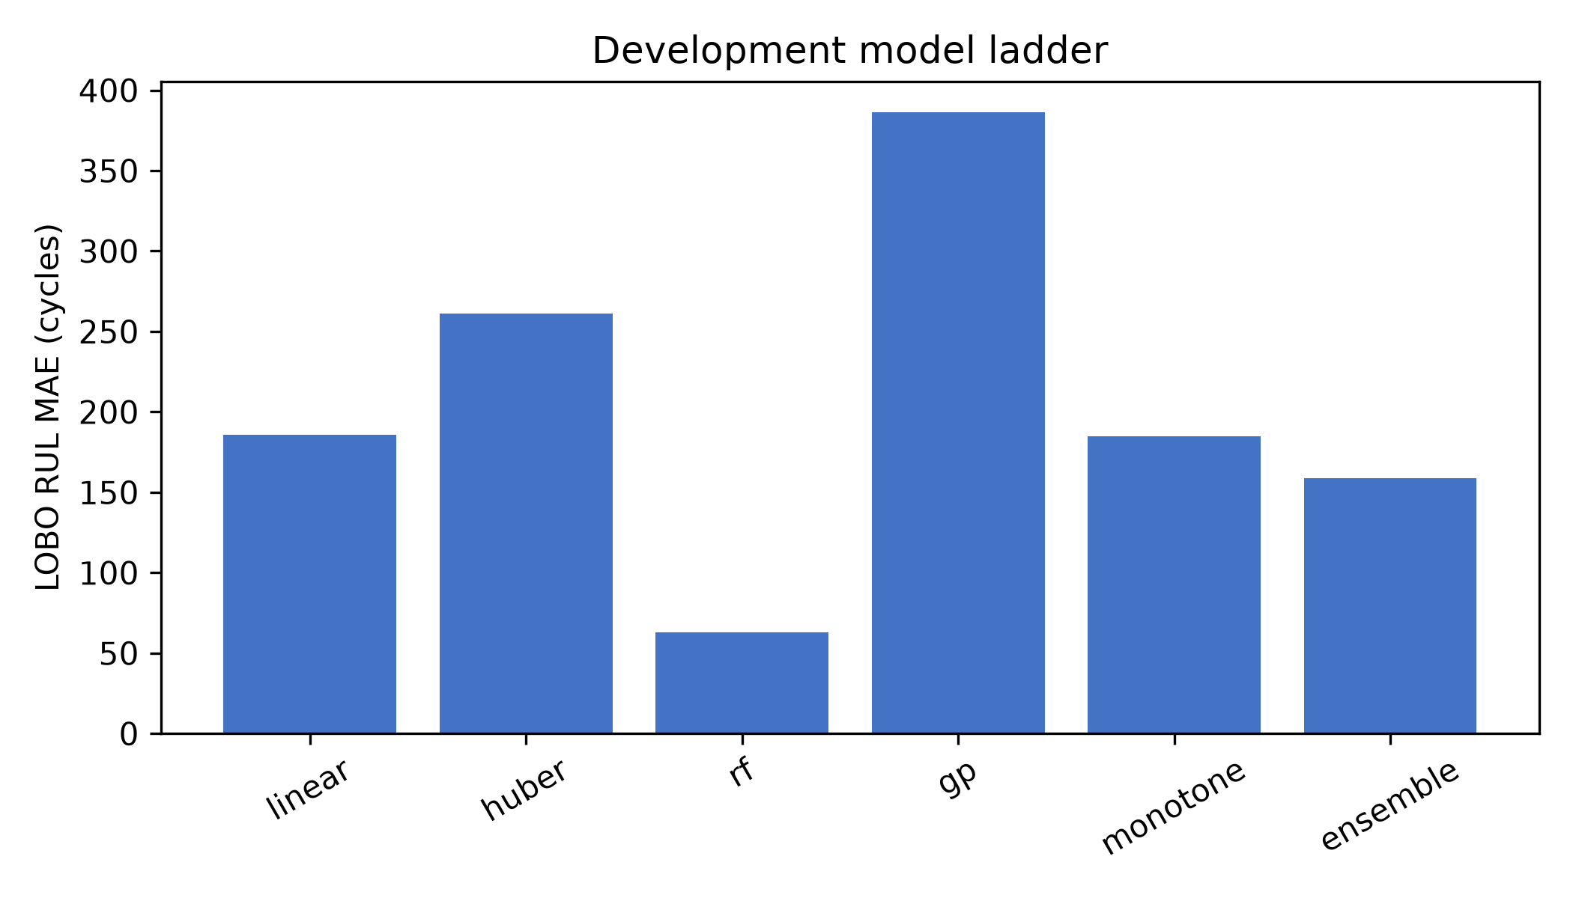
Figure 1. Development LOBO model ladder.

8. Published HUST benchmark comparison
The HUST source paper reports 0.176% mean capacity error and 8.72% RUL error using deep transfer learning with recent partial curves and an unseen-protocol setup [1]. You et al. report a multi-scale temporal fusion network with Bayesian uncertainty across NASA, CALCE and HUST [2]. Njathi et al. compare Gompertz, LSTM and Gompertz-informed LSTM on LFP data with a BatteryML split and first-100-cycle benchmark [3]. These protocols are not directly comparable to V9; the full comparison matrix is supplied separately.
Study | Dataset / cells | Split / horizon | Model / input | Directly comparable? | Reason
This work | NASA development; HUST 77-cell external (16 final) | LOBO; 20/40/60/80%; development-only adaptation | RF + engineered HI; calibrated intervals | No for raw ranking | Different EOL, checkpoints and adaptation
Ma et al. (2022) | HUST 77 LFP/graphite | Unseen protocol; partial curves | Deep transfer learning | No | Different target and transfer protocol
You et al. (2026) | NASA, CALCE, HUST | Paper-specific split and horizons | Multi-scale temporal fusion + Bayesian uncertainty | No | Different split and metric definition
Njathi et al. (2026) | LFP battery data | BatteryML / first-100-cycle setup | Gompertz, LSTM, hybrid | No | Different dataset and observation design

9. External HUST validation
The deterministic HUST split is frozen before final evaluation. On the 16 final untouched cells, RUL MAE was 116.5, 116.1, 85.2 and 20.3 cycles at the four checkpoints. Accuracy improves as more life history is observed. These numbers are external-domain holdout results after development-only adaptation, not zero-shot generalization.
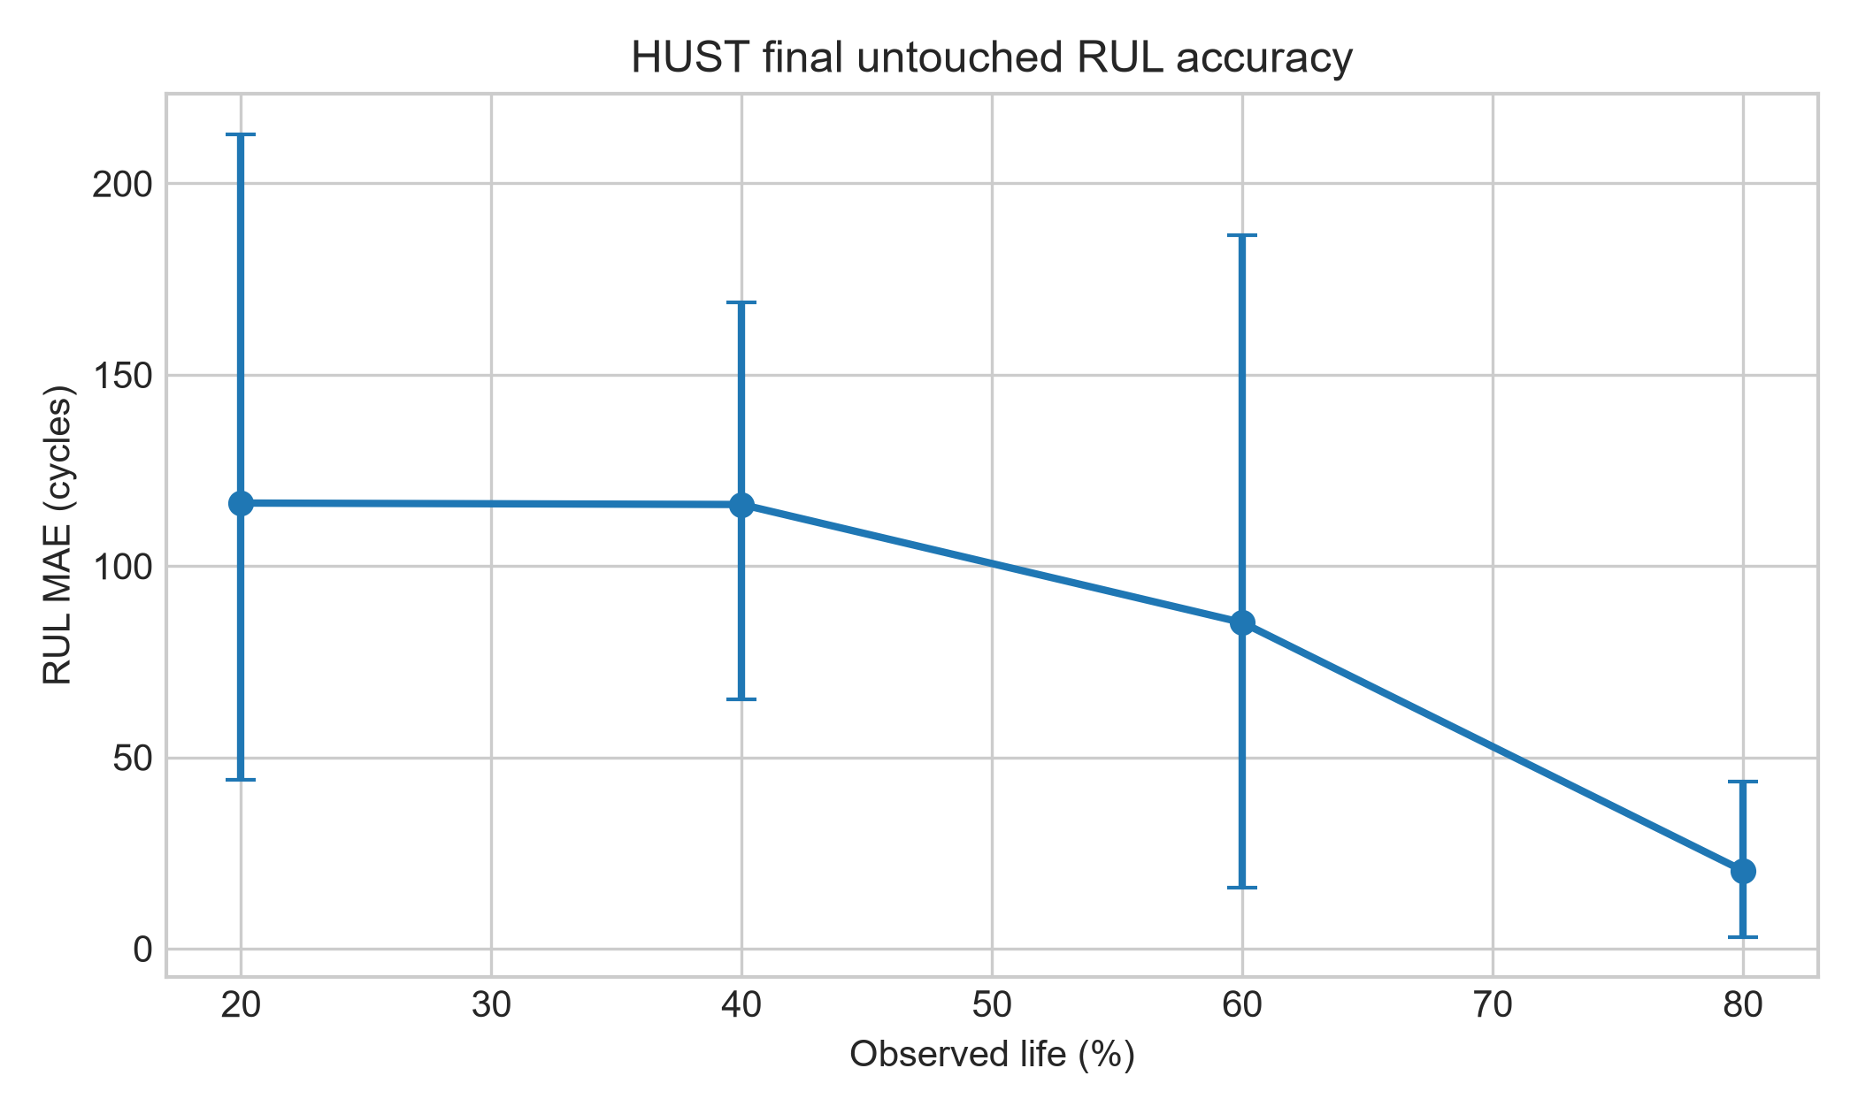
Figure 2. Final HUST MAE with battery-bootstrap intervals.

10. Uncertainty analysis
The primary uncertainty result is the target-coverage sensitivity table reporting 80%, 90% and 95% target coverage together with actual coverage, interval width and normalized width. On the 16-cell frozen set, nominal-or-higher empirical coverage is obtained at several targets, but widths remain large, especially at early checkpoints. The result is coverage evidence on this finite holdout, not population-level calibration or production-ready sharpness.

11. Sequential online replay
The prototype consumes cycles chronologically and updates its estimate after each cycle. The current implementation demonstrates sequential state handling; the TCN replay artifact is kept separate from the RF external accuracy evidence. A production-grade partial-cycle API, electrical HIL and physical BMS validation remain future work.

12. Discussion
The results support three bounded findings. First, battery-level leakage control materially changes the credibility of model comparison. Second, state features are more consistently useful than cycle count, while history adds conditional information rather than a universal gain. Third, point accuracy and uncertainty sharpness are distinct objectives: 100% coverage does not imply a useful interval.

13. Limitations
The RUL ablation has only three observed-EOL NASA batteries. HUST protocol metadata are richer than the shared feature schema, and the final external set must remain untouched. The online service is a research replay, not field BMS/HIL validation. Several literature benchmarks require full-text protocol verification before direct metric comparison. These limitations restrict claims of universal generalization and production readiness.

14. Conclusion
We provide a leakage-controlled, externally validated battery RUL research prototype. Under the locked protocol, Random Forest was the best among evaluated models, current-state features dominated cycle-only inputs, and history contributed conditionally. External HUST accuracy improved with observation horizon, while early-life conformal intervals remained wide. Future work should prioritize sharper, protocol-aware uncertainty and validated RF-based online integration rather than adding model complexity without a fair comparison.

Supplementary robustness and data-quality evidence
The complete robustness audit is supplied in V13_COMPLETE_E1_E11_AUDIT.md and the supplementary result tables. Protocol sensitivity, model-ranking stability, state/history ablation, bootstrap uncertainty, leakage audit, EOL sensitivity and protocol comparison are now documented as separate checks. RF/XGBoost and classical models share the engineered-HI protocol; deep sequence models remain a separate representation experiment until equal convergence and tuning records are accepted.
These additions strengthen the methodological contribution but do not change its scope. The evidence supports an auditable leakage-controlled framework, not a new learning algorithm, numerical SOTA claim, universal history sufficiency claim, production BMS readiness claim or universal RF superiority over deep learning. Uncertainty coverage is reported jointly with interval width and remains conservative, especially at early checkpoints.

V14 protocol sensitivity and uncertainty audit
A same-feature Random Forest comparison across random-cycle, fixed battery-holdout and LOBO splits shows lower apparent error under random-cycle splitting and higher error when the battery is unseen. The fixed holdout uses one battery and is descriptive; LOBO remains the primary generalization estimate. This result supports leakage control without claiming a universal effect size.
Coverage–width analysis at 80%, 90% and 95% target coverage confirms the expected trade-off: higher coverage requires wider intervals, with particularly large normalized widths at early checkpoints. The uncertainty is therefore coverage-valid but not yet practically sharp.
Five-seed deep-family artifacts are retained, but their convergence log uses a fixed epoch schedule rather than validation-loss plateau and patience. They remain provisional representation evidence; the manuscript does not claim universal Random Forest superiority over deep learning.

Data-derived figures and reproducible insight generation
The accompanying script make_data_insights_v15.py reads the canonical discharge-cycle feature table and generates capacity trajectories, state/history distributions, RUL correlation screening, protocol summaries and protocol-sensitivity plots. These figures are descriptive evidence for feature interpretation; they do not replace battery-level validation or causal analysis.
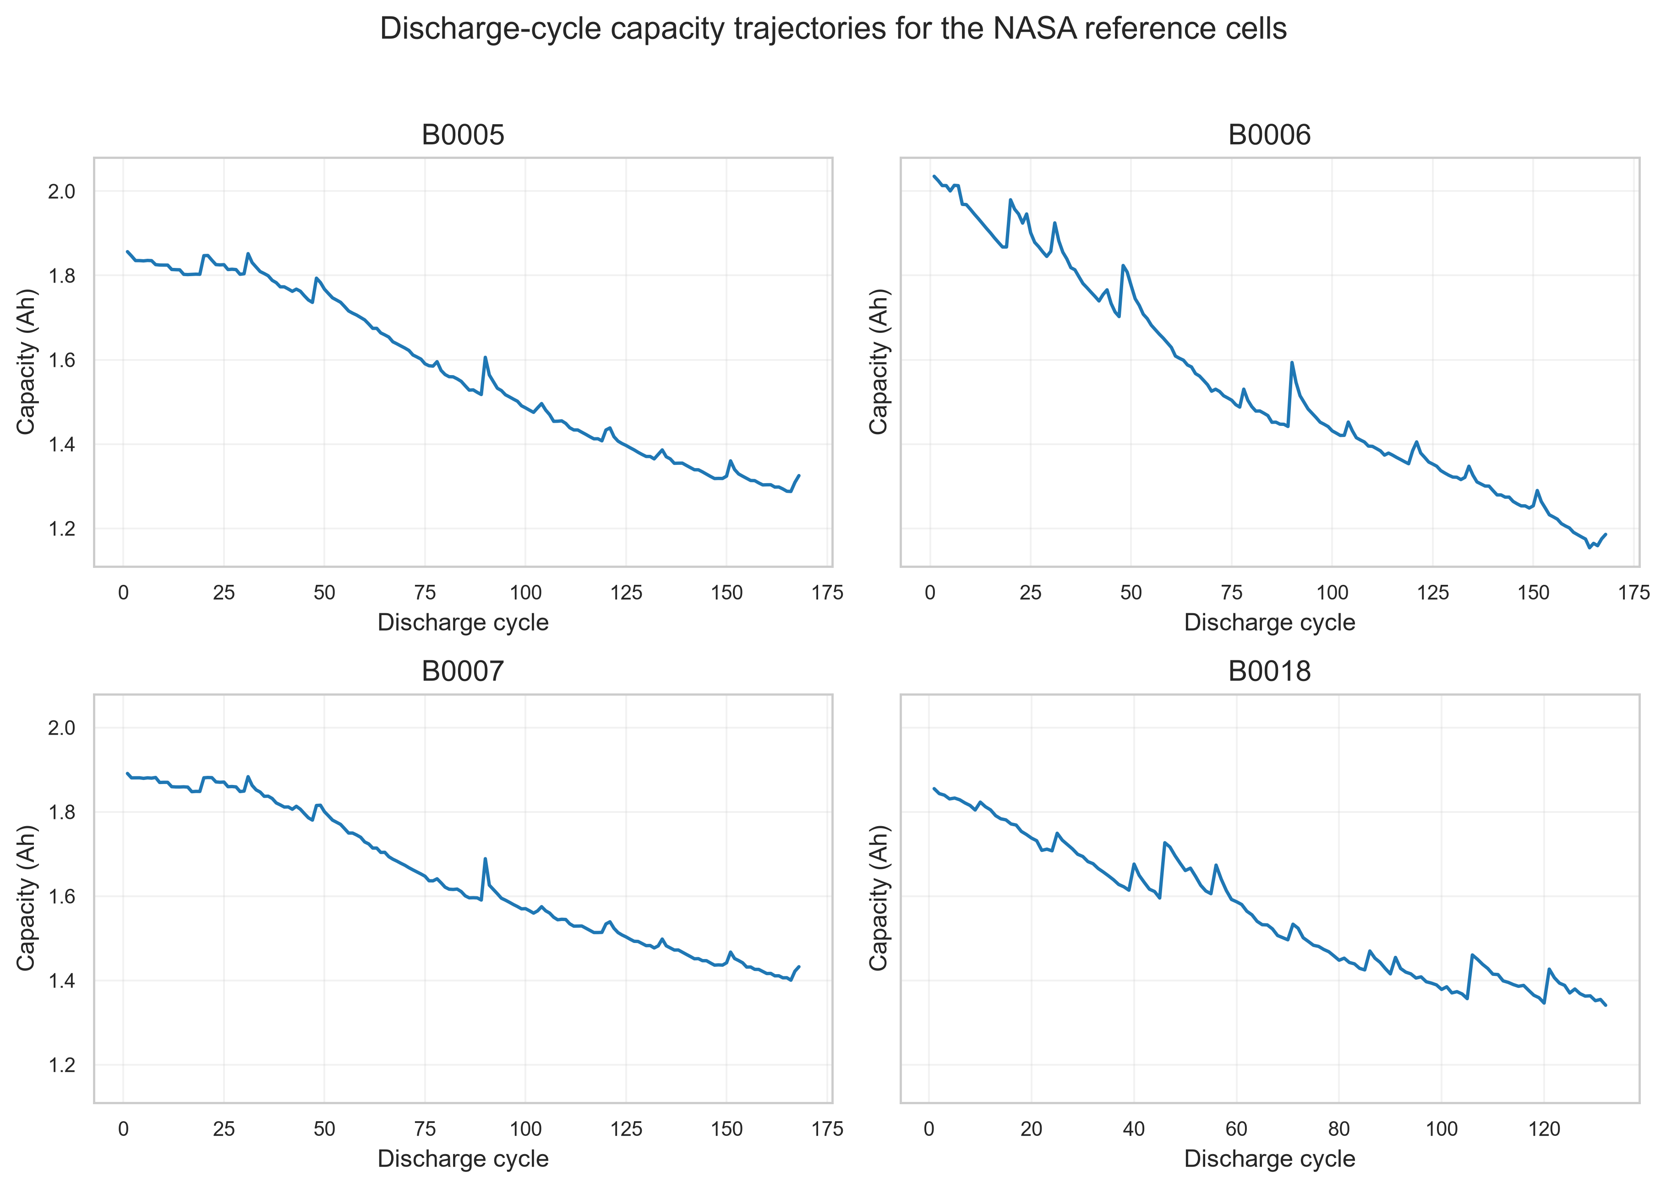
Figure V15.1. Capacity degradation trajectories.
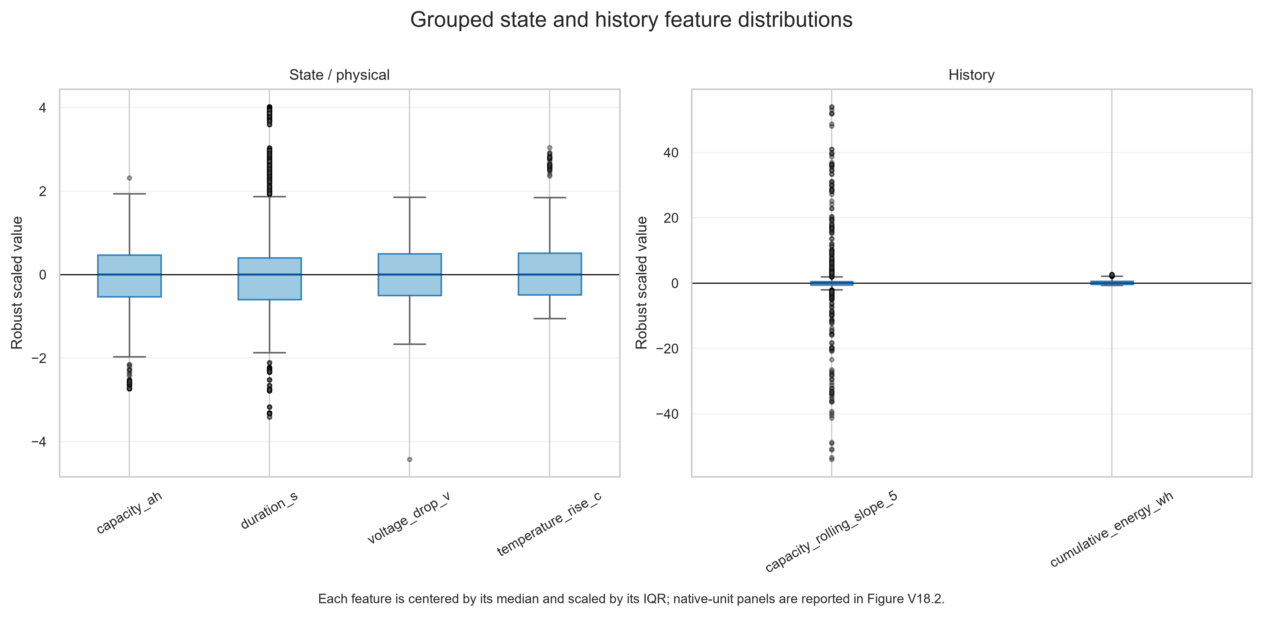
Figure V15.2. Grouped robust-scale state and history feature distributions.
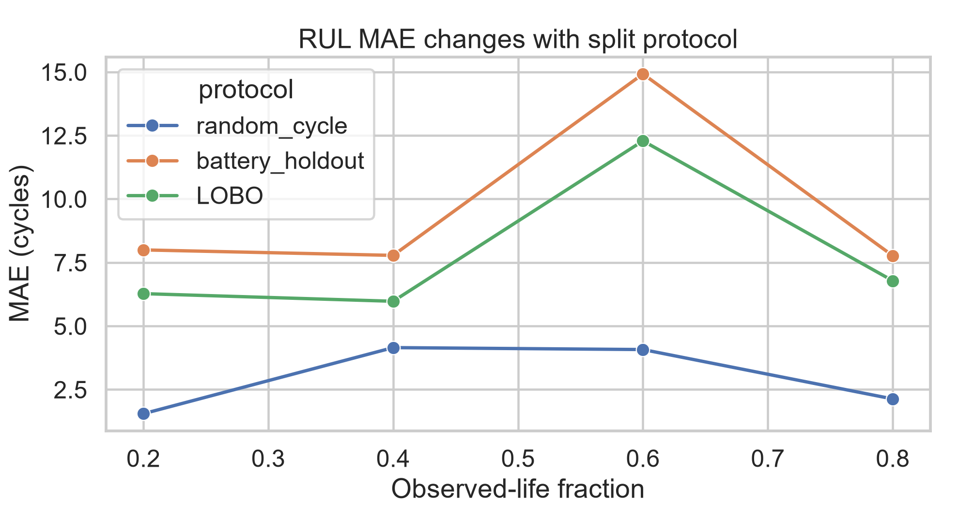
Figure V15.3. RUL error under alternative split protocols.

Detailed V15 robustness audit
LOBO remains the primary unseen-battery protocol. Nested-LOBO is an additional pilot in which hyperparameters are selected on the inner battery folds and the outer battery remains untouched. Because NASA has only three observed-EOL batteries, nested estimates are reported descriptively with no claim of stable population-level uncertainty.
Protocol sensitivity was evaluated with the same Random Forest, engineered health indicators, EOL definition and checkpoints. Random-cycle splitting produced lower apparent error than battery-holdout and LOBO, demonstrating why cycle-level random splitting is not used for the primary generalization claim.
The fair deep-family gate remains explicit. RF/XGBoost/classical models have direct engineered-HI comparison. LSTM, GRU, TCN and Transformer have five-seed artifacts, but a final claim requires validation-loss plateau, patience and equal tuning budget on every outer fold. Until that gate is met, no universal RF-versus-deep claim is made.
History generalization is bounded: NASA and HUST-development analyses support checkpoint-dependent information value, not history sufficiency across all chemistries and protocols. CALCE is retained as an external feature audit; a fully harmonized CALCE RUL/EOL protocol is future work.
Uncertainty usefulness is evaluated through 80%, 90% and 95% coverage targets, interval width and normalized width. The result is a coverage–sharpness trade-off: early-life intervals remain wide, so operational utility is not claimed.
The online component is software replay/HIL only. Electrical HIL, physical BMS integration and field validation require hardware and are not represented as completed experiments.
Table V15.1. Protocol sensitivity results.
Protocol | 20% MAE | 40% MAE | 60% MAE | 80% MAE
Random-cycle | 1.55 | 4.15 | 4.07 | 2.13
Fixed battery holdout | 8.00 | 7.78 | 14.92 | 7.77
LOBO | 6.27 | 5.97 | 12.29 | 6.78
Table V15.2. Uncertainty coverage–width summary.
Target coverage | Checkpoint | Actual coverage | Interval width | Normalized width
80% | 20% | 75.0% | 294.4 | 0.182
80% | 60% | 93.8% | 1091.8 | 1.349
90% | 20% | 81.3% | 354.0 | 0.219
90% | 60% | 100% | 1499.6 | 1.853
95% | 20% | 100% | 1662.5 | 1.027
95% | 60% | 100% | 1574.4 | 1.945

V16 absolute-cycle and transfer validation
To avoid treating the true EOL as an online input, absolute-cycle evaluation was added at cycles 25, 50, 75 and 100. NASA LOBO results are reported at these fixed cycle horizons in the supplementary CSV. Lifetime-normalized 20/40/60/80% results are retained as retrospective benchmark checkpoints and are labeled accordingly.
A NASA-only zero-shot model was evaluated on the 16-cell HUST final holdout and compared with the development-adapted estimator. Zero-shot MAE was 1618.4, 1213.9, 809.4 and 404.9 cycles at 20/40/60/80%; adapted MAE was 116.5, 116.1, 85.2 and 20.3 cycles. This quantifies adaptation benefit, but it does not constitute universal cross-domain generalization.
The primary uncertainty table is the target-coverage sensitivity table (80%, 90%, 95%) with coverage, interval width and normalized width. Earlier V8/V11 interval values are historical/sensitivity artefacts and are not mixed with the primary result.
Table V17.1. Absolute-cycle NASA LOBO evaluation.
Absolute cycle | MAE (cycles) | RMSE (cycles) | Eligible batteries
25 | 9.98 | 9.99 | 3
50 | 10.36 | 11.01 | 3
75 | 9.46 | 11.09 | 3
100 | 5.59 | 7.21 | 3
The zero-shot transfer result is substantively important. A NASA-only model produced HUST final-holdout MAE of 1618.4, 1213.9, 809.4 and 404.9 cycles at 20–80% retrospective checkpoints, whereas development-adapted performance was 116.5, 116.1, 85.2 and 20.3 cycles. This indicates severe domain shift under the current shared feature, chemistry and protocol mismatch, and shows that most usable performance in this setup comes from target-domain development adaptation. It is evidence against naive zero-shot transfer, not evidence of universal adaptation success.

Data quality audit and scale-aware visualization
The original combined boxplot was replaced because the six variables have incompatible physical units. The thesis now uses both native-unit panels and robust-scaled distributions. Duration is strongly associated with sample count and short-duration cycles are inspected separately rather than interpreted as ordinary degradation.
The audit flagged 38 incomplete cycles using duration below 500 s or fewer than 50 samples, plus 44 missing/non-positive capacity records. None of the incomplete cycles carried an observed-EOL label in the current NASA table, so the registered EOL labels are unchanged. Cumulative energy reaches 1158.15 Wh while per-cycle energy reaches 10.07 Wh, supporting the interpretation that the cumulative-energy feature is a lifetime sum rather than a per-cycle quantity.
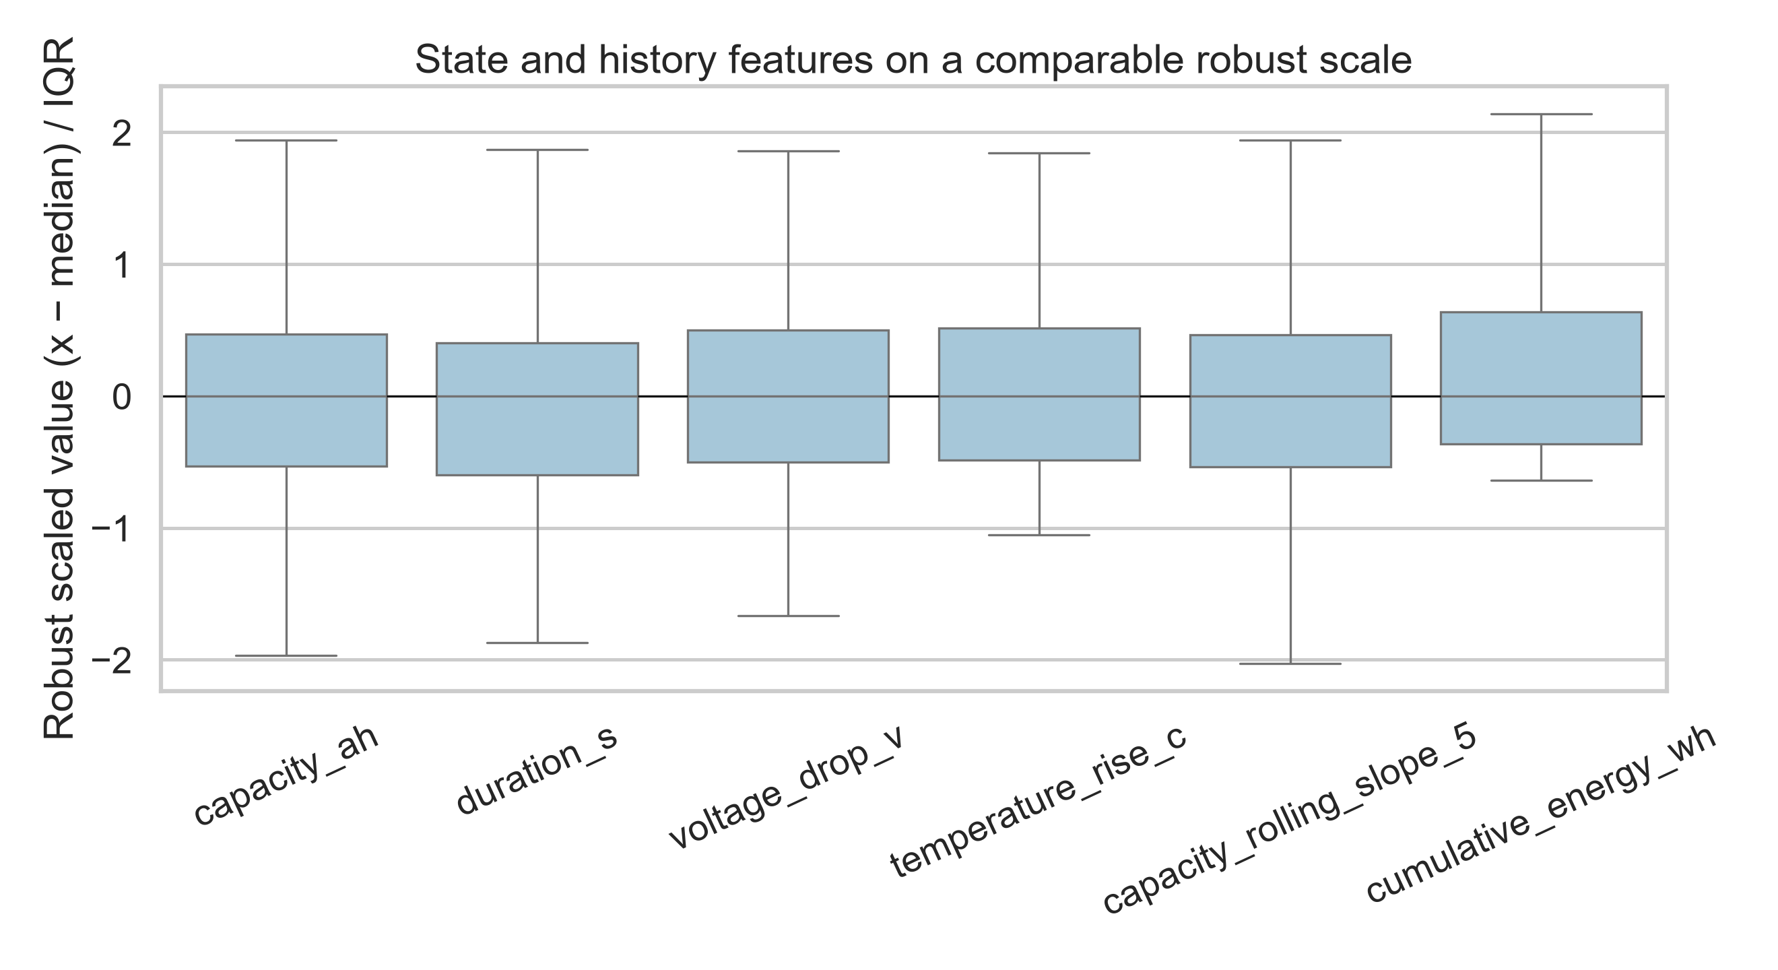
Figure V18.1. Robust-scaled state and history feature distributions.
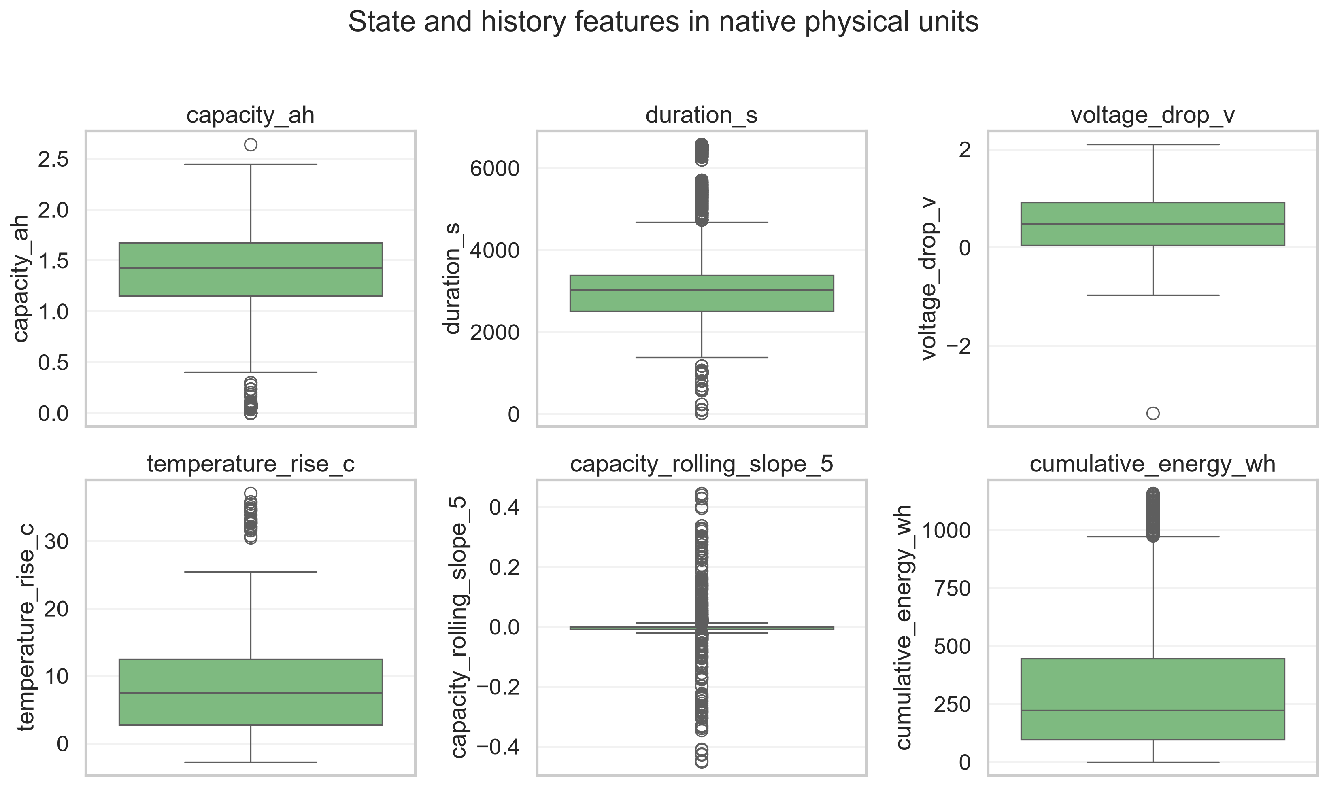
Figure V18.2. Native-unit feature distributions in six panels.
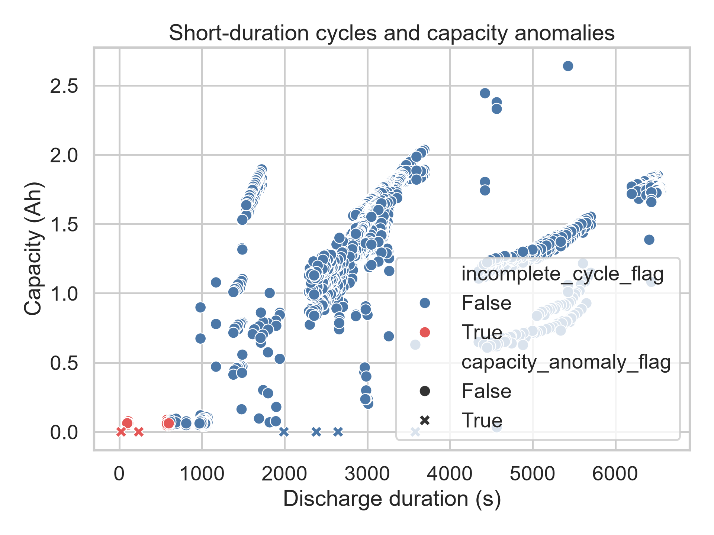
Figure V18.3. Duration–capacity quality audit.
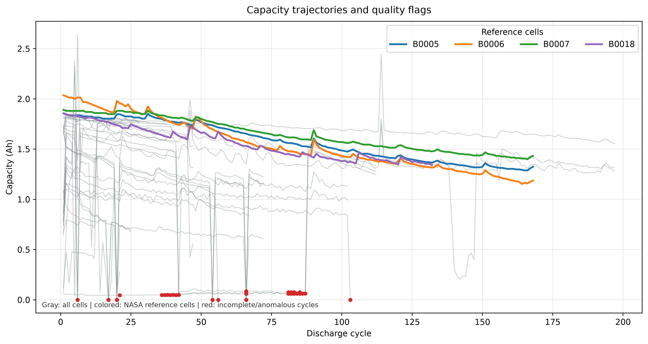
Figure V18.4. Capacity trajectories with flagged incomplete/anomalous cycles.

References
[1] G. Ma, S. Xu, B. Jiang, C. Cheng, X. Yang, Y. Shen, T. Yang, Y. Huang, H. Ding and Y. Yuan, “Real-time personalized health status prediction of lithium-ion batteries using deep transfer learning,” Energy & Environmental Science, 15 (2022) 4083–4094. DOI: 10.1039/D2EE01676A. https://doi.org/10.1039/D2EE01676A
[2] C. You, C. Dong, J. Lu, S. Xie, Y. Duan, L. Duan, H. Yan, W. Luo and S. Chen, “A multi-scale temporal fusion network for accurate and uncertainty-aware battery remaining useful life prediction,” Journal of Energy Chemistry, 116 (2026). DOI: 10.1016/j.jechem.2025.12.040. https://doi.org/10.1016/j.jechem.2025.12.040
[3] Y. Njathi, C. wa Maina and E. T. Mharakurwa, “RUL Prediction in LFP Batteries: Comparison of Gompertz, LSTM and Gompertz-Informed LSTM Models for Interpretability and Accuracy,” Batteries, 12(5), 162 (2026). DOI: 10.3390/batteries12050162. https://doi.org/10.3390/batteries12050162
[4] HUST dataset, “The Dataset for: Real-time personalized health status prediction of lithium-ion batteries using deep transfer learning,” Mendeley Data, Version 2 (2022). DOI: 10.17632/nsc7hnsg4s.2. https://doi.org/10.17632/nsc7hnsg4s.2

Appendix A. Reproducibility artefacts
The accompanying package contains the locked split, raw-data SHA-256 manifest, feature tables, LOBO ladder, calibration outputs, final untouched results, normalized metrics, RUL ablation tables, HUST benchmark matrix and claim-control matrix. V8 artefacts are preserved unchanged; V9 outputs are additive.

Appendix B. Extended audit and research history

Thesis research questions
Which variables contain information beyond cycle count? Which model is selected under battery-level generalization? Does it transfer to HUST? Are intervals calibrated and useful? Can it update online without future leakage?

Audit note: Chapter 1. Introduction
This thesis studies history-aware battery RUL estimation under strict leakage control. It treats model selection, external validation and uncertainty as first-class scientific questions.

Audit note: Chapter 2. Literature and research gap
Prior work spans filters, Gaussian processes, recurrent networks, transfer learning and hybrid physics-informed models. The gap is protocol inconsistency: random cycle splits, incompatible horizons and uncertainty reported without sharpness.

Audit note: Chapter 3. Data and measurement validity
NASA PCoE supports development benchmarking. HUST contains 77 LFP/graphite cells with diverse multi-stage discharge protocols at 30 C. Raw data are hashed, parsed and audited; units, duplicates, anomalies and censoring are recorded.

Audit note: Chapter 4. Degradation insight and health indicators
Candidate state indicators include capacity, SOH, duration and V/I/T summaries. History indicators include lagged capacity, rolling slope and cumulative throughput. The direct RUL ablation shows cycle-only is weaker than state-only; history is informative but not uniformly beneficial.

Audit note: Chapter 5. Ground truth, EOL and censoring
Primary EOL is the first of two consecutive cycles below 75% of the median first-five-cycle reference capacity. RUL(k)=N_EOL-k. Censored batteries are excluded from point-RUL accuracy. Threshold sensitivity at 70%, 75% and 80% has been audited; 75% remains the registered primary operational threshold.

Audit note: Chapter 6. Leakage-controlled methodology
The registered pipeline is audit, HI extraction, labels, battery-level split, LOBO selection, development-only adaptation, calibration-only uncertainty and one-time final evaluation. No held-out battery cycle is used for tuning.

Audit note: Chapter 7. Model selection and fair comparison
The V8 ladder selected Random Forest (LOBO MAE 63.1 cycles) over linear, Huber, GP, monotone and ensemble models. This means best among evaluated models under this protocol. Fair multi-seed comparison with deep families remains a completion item.

Audit note: Chapter 8. External HUST validation
The frozen HUST split is 46 development, 15 calibration and 16 final untouched cells. RF-adapted final MAE is 116.5, 116.1, 85.2 and 20.3 cycles at 20%, 40%, 60% and 80%. This is external holdout after development-only adaptation, not universal zero-shot generalization.

Audit note: Chapter 9. Uncertainty
The primary uncertainty table reports target coverage at 80%, 90% and 95%, actual coverage, interval width and normalized width. Coverage is interpreted jointly with sharpness; early-life intervals remain wide and therefore operational utility is not claimed.

Audit note: Chapter 10. Online adaptive estimator
Chronological replay emits SOH, RUL, interval bounds, cycle and observation fraction. The current service is a research prototype; RF sequential replay, partial-cycle API, electrical HIL and field BMS validation remain future work.

Audit note: Chapter 11. Integrated discussion
The defensible contributions are an auditable protocol, evidence that current state dominates cycle-only prediction, conditional history information, and explicit separation of calibration from external testing.

Audit note: Chapter 12. Conclusion and future work
Future work must prioritize final fair model-family convergence, sharper uncertainty, CALCE RUL harmonization and hardware validation; RF sequential replay has already been executed as software evidence.

Final completion status and robustness checks
The thesis preserves V8 frozen results and adds V9 validation artefacts. EOL sensitivity was audited at 70%, 75% and 80%; the 70% threshold censors several cells, while 75% is the registered primary threshold and 80% yields earlier failure labels. These results are descriptive because tuning on final untouched HUST is prohibited.
Model family | Representation | Same split/checkpoints | Status in manuscript
RF / XGBoost / classical ladder | Engineered HI | Yes | Direct fair comparison
GRU / TCN / LSTM / Transformer | Sequence representation | Preliminary / not fully registered | Separate representation evidence; no superiority claim
RF sequential replay | Engineered HI, chronological | Yes; no future cycles | Operational final estimator replay
Conformal RF intervals | Checkpoint-conditioned residuals | Calibration set only | Coverage–sharpness analysis
Censored cells without an observed threshold crossing are excluded from point-RUL metrics but remain in the audit. This can induce selection bias toward complete-failure batteries; survival-model treatment is future work.
A preliminary multi-seed deep-sequence acceptance table exists for GRU and TCN, but it is not merged into the RF leaderboard unless identical representation, split, checkpoints and tuning budget are verified. The thesis therefore does not claim RF superiority over deep learning.

Thesis defence checklist
Before formal submission attach an independent code/split/leakage review, publisher-verified benchmark metadata, RF sequential replay logs, rendered PDF inspection, and institutional formatting/plagiarism checks. These are governance gates, not hidden model results.

Final validation update
The bibliography has been checked against publisher records and DOI links. The RF sequential replay was executed chronologically on the frozen HUST external cells using a model fit only on development batteries; the complete trace is V9_RF_SEQUENTIAL_REPLAY.csv.
The replay is an integration validation and does not alter the frozen V8 final metrics. It demonstrates cycle-by-cycle point estimation and observation-fraction tracking. Calibrated per-cycle RF intervals and electrical HIL remain deployment work.

Fair model-family comparison status
GRU and TCN artifacts are available, but their sequence representation is not yet identical to the engineered-HI RF protocol. Therefore the thesis does not claim RF superiority over deep learning. A direct all-family comparison is a required future experiment under identical representation, split, checkpoints, tuning budget and seeds.

Final scientific status
This document is a complete thesis draft with auditable results and explicit completion gates. It supports a leakage-controlled, externally validated research prototype claim, not production BMS readiness or universal cross-domain generalization.

V10 thesis expansion: checkpoint-conditional history contribution
The new analysis contribution is checkpoint-conditional interpretation of information value. State-only and state-plus-history RUL errors are compared at each observation fraction. State dominates early prediction; history provides conditional benefit later. This connects ablation to online feature gating without claiming history is universally necessary.

Audit note: Chapter 13. Information value across observation horizons
At 20% and 40% observed life, state-only error is lower than state-plus-history in the direct NASA ablation. At 60% and 80%, adding history reduces error. History utility therefore depends on the amount of observed degradation trajectory and motivates horizon-specific calibration.

Audit note: Chapter 14. Fair model-family evidence boundary
RF, trajectory and Gaussian-process models share the V8 LOBO engineered-HI protocol. GRU and TCN remain separate sequence artifacts because representation and tuning records are not identical. The thesis reports this evidence boundary rather than an invalid leaderboard claim.

V11 uncertainty and deep-family audit
Earlier V8/V11 cycle-level interval widths are retained as historical sensitivity artefacts. The primary uncertainty result is the 80/90/95% target-coverage table, which does not alter frozen V8 point metrics.
Five-seed deep-family predictions now include per-battery MAE/RMSE and bootstrap intervals in V11_DEEP_PER_BATTERY_BOOTSTRAP.csv. The underlying run used a preliminary fixed training budget, so it is not accepted as a final RF-versus-deep superiority test until every LOBO fold uses validation-loss plateau, patience and equal tuning budget. The thesis preserves this evidence boundary.
Checkpoint | NASA→HUST zero-shot MAE | Adapted HUST holdout MAE
20% | 1618.4 | 116.5
40% | 1213.9 | 116.1
60% | 809.4 | 85.2
80% | 404.9 | 20.3

