服务器创建git工程

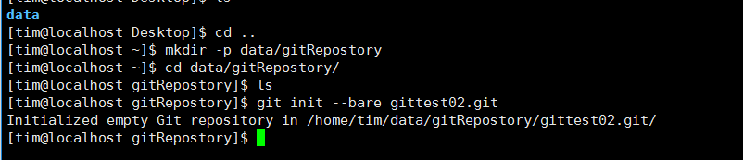

客户端第一次clone工程

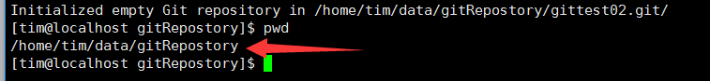

Clone的工程地址为 git@IP:服务器git地址。

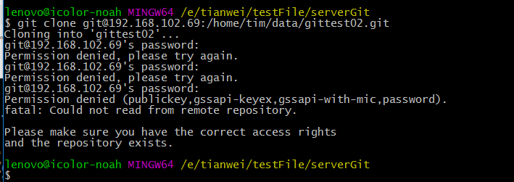

提示没有访问的权限，设置SSH。

客户端生成SSH密钥

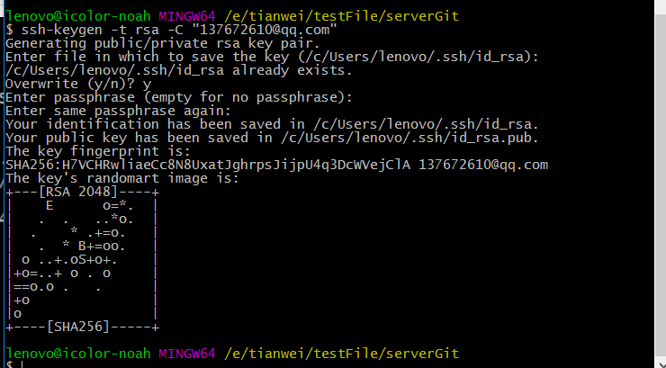

生成位置

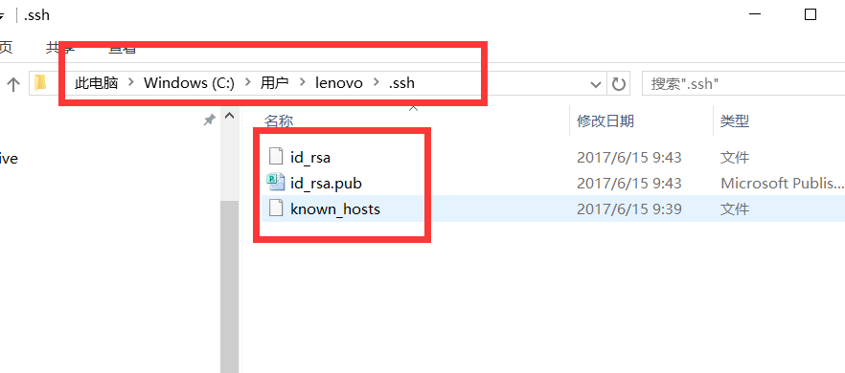

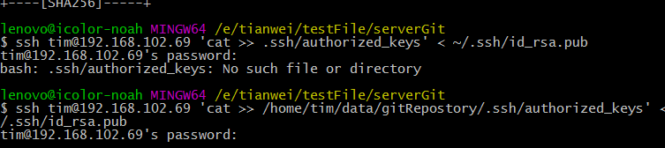

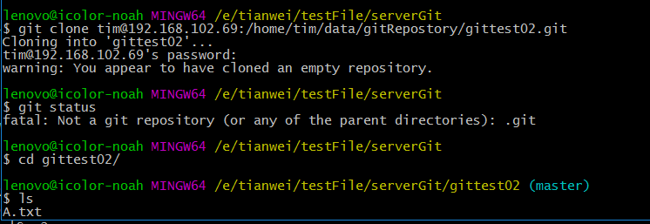

服务器下载安装git CentOS7.0

|  |
| --- |
| [centos7@localhost Desktop]$ su root  Password:  [root@localhost Desktop]# yum install git  Loaded plugins: fastestmirror, langpacks  Loading mirror speeds from cached hostfile  * base: centos.ustc.edu.cn  * extras: mirror.bit.edu.cn  * updates: mirrors.nwsuaf.edu.cn  Resolving Dependencies  --> Running transaction check  ---> Package git.x86_64 0:1.8.3.1-6.el7_2.1 will be installed  --> Processing Dependency: perl-Git = 1.8.3.1-6.el7_2.1 for package: git-1.8.3.1-6.el7_2.1.x86_64  --> Processing Dependency: perl(Term::ReadKey) for package: git-1.8.3.1-6.el7_2.1.x86_64  --> Processing Dependency: perl(Git) for package: git-1.8.3.1-6.el7_2.1.x86_64  --> Processing Dependency: perl(Error) for package: git-1.8.3.1-6.el7_2.1.x86_64  --> Running transaction check  ---> Package perl-Error.noarch 1:0.17020-2.el7 will be installed  ---> Package perl-Git.noarch 0:1.8.3.1-6.el7_2.1 will be installed  ---> Package perl-TermReadKey.x86_64 0:2.30-20.el7 will be installed  --> Finished Dependency Resolution  Dependencies Resolved  ================================================================================  Package Arch Version Repository Size  ================================================================================  Installing:  git x86_64 1.8.3.1-6.el7_2.1 base 4.4 M  Installing for dependencies:  perl-Error noarch 1:0.17020-2.el7 base 32 k  perl-Git noarch 1.8.3.1-6.el7_2.1 base 53 k  perl-TermReadKey x86_64 2.30-20.el7 base 31 k  Transaction Summary  ================================================================================  Install 1 Package (+3 Dependent packages)  Total download size: 4.5 M  Installed size: 22 M  Is this ok [y/d/N]: y  Downloading packages:  warning: /var/cache/yum/x86_64/7/base/packages/perl-TermReadKey-2.30-20.el7.x86_64.rpm: Header V3 RSA/SHA256 Signature, key ID f4a80eb5: NOKEY  Public key for perl-TermReadKey-2.30-20.el7.x86_64.rpm is not installed  (1/4): perl-TermReadKey-2.30-20.el7.x86_64.rpm | 31 kB 00:00  (2/4): perl-Error-0.17020-2.el7.noarch.rpm | 32 kB 00:03  (3/4): git-1.8.3.1-6.el7_2.1.x86_64.rpm | 4.4 MB 00:06  (4/4): perl-Git-1.8.3.1-6.el7_2.1.noarch.rpm | 53 kB 00:09  --------------------------------------------------------------------------------  Total 479 kB/s | 4.5 MB 00:09  Retrieving key from file:///etc/pki/rpm-gpg/RPM-GPG-KEY-CentOS-7  Importing GPG key 0xF4A80EB5:  Userid : "CentOS-7 Key (CentOS 7 Official Signing Key) <security@centos.org>"  Fingerprint: 6341 ab27 53d7 8a78 a7c2 7bb1 24c6 a8a7 f4a8 0eb5  Package : centos-release-7-2.1511.el7.centos.2.10.x86_64 (@anaconda)  From : /etc/pki/rpm-gpg/RPM-GPG-KEY-CentOS-7  Is this ok [y/N]: y  Running transaction check  Running transaction test  Transaction test succeeded  Running transaction  Installing : 1:perl-Error-0.17020-2.el7.noarch 1/4  Installing : perl-TermReadKey-2.30-20.el7.x86_64 2/4  Installing : git-1.8.3.1-6.el7_2.1.x86_64 3/4  Installing : perl-Git-1.8.3.1-6.el7_2.1.noarch 4/4  Verifying : perl-Git-1.8.3.1-6.el7_2.1.noarch 1/4  Verifying : perl-TermReadKey-2.30-20.el7.x86_64 2/4  Verifying : 1:perl-Error-0.17020-2.el7.noarch 3/4  Verifying : git-1.8.3.1-6.el7_2.1.x86_64 4/4  Installed:  git.x86_64 0:1.8.3.1-6.el7_2.1  Dependency Installed:  perl-Error.noarch 1:0.17020-2.el7 perl-Git.noarch 0:1.8.3.1-6.el7_2.1  perl-TermReadKey.x86_64 0:2.30-20.el7  Complete!  [root@localhost Desktop]# git version  git version 1.8.3.1  [root@localhost Desktop]# |

创建git用户（mygit），初始化一个git仓库

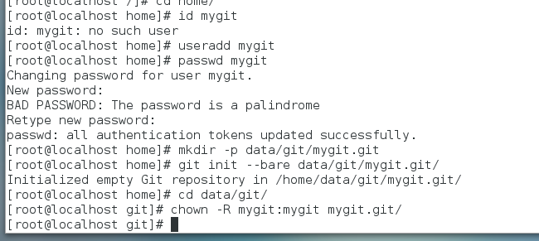

客户端第一次下载git内容：

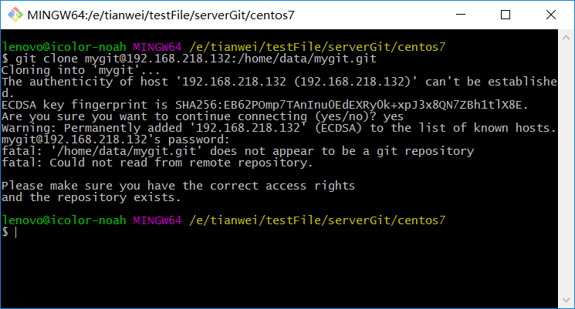

因为没有正确的访问权限。

客户端生成RSA密钥

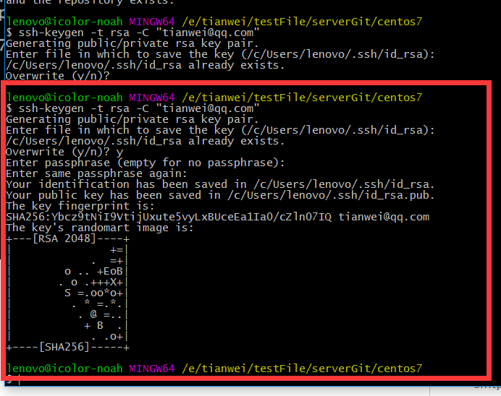

直接回车， 加 y 就可以。

服务器端打开RSA认证。 Vi 进入 /etc/ssh sshd_config文件，找到以下三行，把他的注释删除

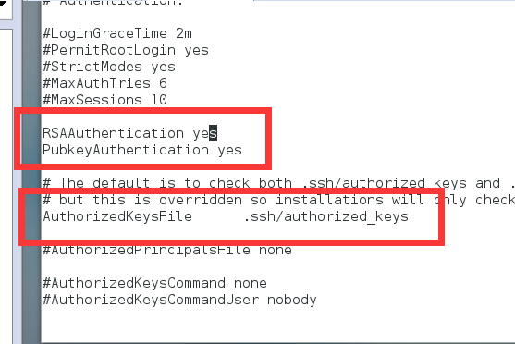

重启sshd服务

systemctl restart sshd.service

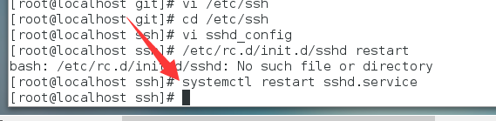

6.6，6.7 版本重启方式

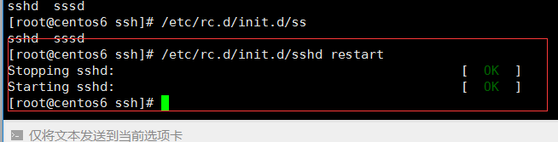

在mygit用户下，创建 .ssh文件夹，存放客户端的公钥文件

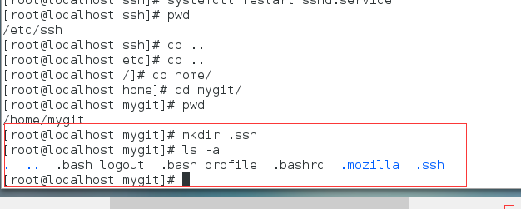

把用root用户创建的这个文件的权限修改为mygit用户

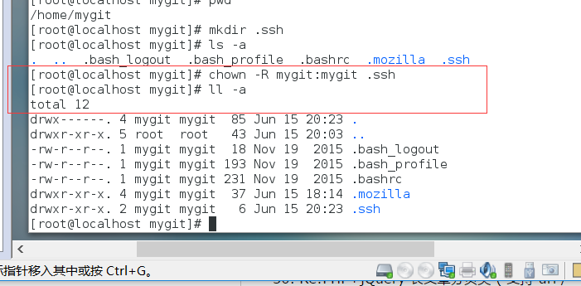

客户端公钥导入到服务器

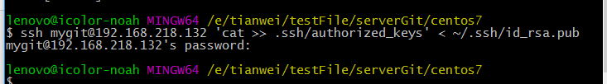

服务器设置ssh文件的访问权限

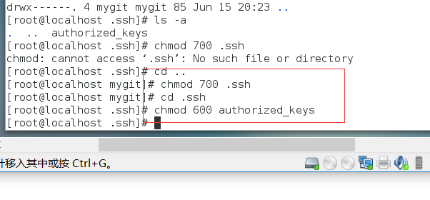

客户端拉取服务器代码：

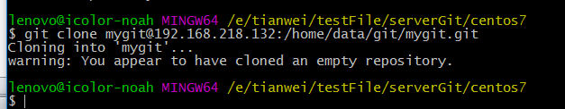

Git clone [icolorgit@192.168.13.50](mailto:icolorgit@192.168.13.50):/home/icolorgit/data/gitRepostory/icolor.git