A PROJECT REPORT ON

SMART E-COMMERCE PLATFORM
A Full-Stack Web Application with Role-Based Access Control,
Transactional Order Management, and Automated Invoicing

Submitted in partial fulfilment of the requirements for the award of the degree of
MASTER OF SCIENCE
in
COMPUTER SCIENCE

Submitted by
[Student Name]
Reg. No.: [Registration Number]

Under the Guidance of
[Guide Name]
[Designation, Department]

DEPARTMENT OF COMPUTER SCIENCE
[UNIVERSITY / INSTITUTION NAME]
[City, State — PIN Code]
[Month, Year]

CERTIFICATE
This is to certify that the project report entitled “SMART E-COMMERCE PLATFORM” is a bona fide record of work carried out by [Student Name] (Reg. No.: [Registration Number]) in partial fulfilment of the requirements for the award of the degree of Master of Science in Computer Science, during the academic year [Year], under my supervision and guidance.
The work embodied in this report has not been submitted, in part or in full, to any other University or Institution for the award of any other degree or diploma.

Signature of the Guide Signature of the Head of Department
[Guide Name] [HOD Name]

Internal Examiner External Examiner

DECLARATION
I hereby declare that the project report entitled “SMART E-COMMERCE PLATFORM” submitted for the degree of Master of Science in Computer Science is my own original work carried out under the guidance of [Guide Name]. This report has not been submitted elsewhere, in part or in full, for the award of any other degree or diploma of any University or Institution.
All sources of information used in the preparation of this report, including open-source libraries, frameworks, and reference material, have been duly acknowledged.

[Student Name]
Reg. No.: [Registration Number]
Place: [City]
Date: [DD/MM/YYYY]

ACKNOWLEDGEMENT
I would like to express my sincere gratitude to my project guide, [Guide Name], for the continuous support, valuable guidance, and constructive feedback provided throughout the course of this project. Their insights into full-stack architecture and software engineering practice were instrumental in shaping the quality of this work.
I am grateful to the Head of the Department of Computer Science and all the faculty members for providing the necessary infrastructure, resources, and an encouraging academic environment that made this project possible.
I also wish to thank my family and friends for their constant encouragement and moral support during the course of this project.
Finally, I acknowledge the open-source community whose frameworks, libraries, and documentation — including React, Express.js, PostgreSQL, Tailwind CSS, and their surrounding ecosystems — formed the technical foundation upon which this project was built.

[Student Name]

ABSTRACT
Electronic commerce has become one of the most significant applications of web technology, enabling businesses to reach customers directly through digital storefronts. This project presents the design, development, and evaluation of the Smart E-Commerce Platform — a production-shaped, full-stack web application that allows customers to browse a product catalogue, manage a shopping cart as either a guest or a registered user, place orders through a secure and transactionally-safe checkout process, track order status in real time, and download system-generated invoices, while administrators independently manage the product catalogue, categories, and order fulfilment lifecycle through a dedicated dashboard.
The system is built on a three-tier architecture. The presentation tier is implemented in React.js with Tailwind CSS, using React Context API for state management instead of a dedicated state-management library, keeping the client lightweight while still supporting complex flows such as a guest cart that automatically merges into a registered user's cart on login. The application tier is implemented in Node.js with the Express.js framework, exposing a RESTful API secured by JSON Web Tokens (JWT) with a rotating refresh-token scheme, bcrypt password hashing, and role-based access control distinguishing Administrator and Customer roles. The data tier uses PostgreSQL, with all multi-step operations — most notably checkout, which must validate stock, decrement inventory, and create an order atomically — wrapped in database transactions using row-level locking to guarantee correctness under concurrent access.
Beyond the core commerce flow, the system implements a formal order-status state machine (Pending, Confirmed, Shipped, Out for Delivery, Delivered, Cancelled) enforced identically on the server regardless of what a client requests, automatic PDF invoice generation using PDFKit at the moment of order placement, and a complete order-tracking timeline visible to the customer. The project also includes an automated test suite of 45 backend test cases covering authentication, authorization, product and cart management, the full checkout-to-invoice pipeline, and administrative operations, all of which pass.
The development process itself forms part of the project's contribution: several non-trivial defects — including a race condition in the checkout flow's post-order navigation, an initial-render race in cart-loading state, and a silent server-crash mode caused by an unhandled port-bind error — were identified through systematic manual and automated testing and subsequently fixed, illustrating a realistic software engineering lifecycle rather than a purely feature-driven build. The resulting system demonstrates that a modern JavaScript/PostgreSQL stack, when combined with disciplined transactional design, RBAC, and automated testing, can deliver an e-commerce platform with the correctness guarantees expected of production software.
Keywords: E-Commerce, MERN-adjacent Stack (React, Express, PostgreSQL), JSON Web Tokens, Role-Based Access Control, Database Transactions, RESTful API, PDF Invoicing, Order Tracking.

TABLE OF CONTENTS

Note: The page numbers above are populated automatically by Microsoft Word. If they display as “1” or appear blank, select the table (Ctrl+A) and press F9, or right-click and choose “Update Field → Update entire table”.

LIST OF FIGURES
Figure No. | Title
Figure 4.1 | System Architecture (Three-Tier)
Figure 4.2 | Module Interaction Diagram
Figure 4.3 | Entity-Relationship Diagram
Figure 4.4 | Use Case Diagram
Figure 4.5 | Data Flow Diagram — Level 0 (Context Diagram)
Figure 4.6 | Order Status Lifecycle (State Machine)
Figure 4.7 | Sequence Diagram — Checkout Process
Figure 5.1 | Backend Folder Structure
Figure 5.2 | Frontend Folder Structure
Figure 7.1 | Sample Generated Invoice (PDF Output)

LIST OF TABLES
Table No. | Title
Table 3.1 | Functional Requirements
Table 3.2 | Non-Functional Requirements
Table 3.3 | Hardware Requirements
Table 3.4 | Software Requirements
Table 4.1 | Database Table — users
Table 4.2 | Database Table — products
Table 4.3 | Database Table — orders
Table 4.4 | Database Table — order_items
Table 4.5 | REST API Endpoint Summary
Table 6.1 | Unit / Integration Test Cases and Results
Table 6.2 | Defects Identified and Resolved During Development
Table 7.1 | Sample Checkout Computation

CHAPTER 1: INTRODUCTION

1.1 Background
Electronic commerce (e-commerce) has grown from a niche technology into one of the primary channels through which goods and services are bought and sold worldwide. As consumer expectations have matured, so have the technical demands placed on the systems that support them: a modern storefront is expected to be fast, secure, available on any device, and — critically — correct even when many customers are interacting with the same limited inventory at once. Building such a system touches nearly every core area of software engineering: authentication and authorization, relational database design, transactional integrity, RESTful API design, responsive front-end engineering, and automated testing.
This project, the Smart E-Commerce Platform, was undertaken to design and build such a system from first principles, using a contemporary and industry-relevant technology stack: React.js and Tailwind CSS on the client, Node.js with Express.js on the server, and PostgreSQL as the relational data store. Rather than a proof-of-concept limited to a single happy path, the platform was built and verified as a complete, working system covering the full customer journey (browsing, cart management, checkout, order tracking, invoicing) and the full administrative journey (product and category management, order fulfilment, sales monitoring).

1.2 Motivation
Many academic e-commerce projects stop at a superficial level: a product list, a cart that merely accumulates items in memory, and an order table that is written to but never really validated against concurrent access. Such systems demonstrate CRUD (Create, Read, Update, Delete) proficiency but do not engage with the harder problems that distinguish a production-grade system from a classroom exercise — for example, what happens when two customers attempt to purchase the last unit of the same product at the same instant, or what happens when an administrator tries to move an order directly from “Pending” to “Delivered” without the intermediate steps being fulfilled.
The motivation for this project was therefore to build a system that treats these problems as first-class design concerns rather than afterthoughts: to enforce data integrity using database transactions and row-level locking, to enforce business rules (such as valid order-status transitions) identically on the server regardless of what any client sends, and to verify the resulting system through both automated tests and live, reproducible manual testing — including deliberately engineering race conditions to confirm the safeguards actually hold under contention.

1.3 Problem Statement
Small and medium businesses frequently require a web storefront that is affordable to build and operate, yet must not compromise on the correctness guarantees that protect both the business and its customers: stock must never be oversold, an order's financial figures must be computed consistently and stored immutably, only authorized administrators may alter product catalogues or order status, and customers must be able to trust that the status and invoice they see accurately reflect the state of their order. Existing low-code storefront builders often abstract these guarantees away, offering limited customizability and no visibility into how correctness is actually enforced. The problem addressed by this project is: how can a full-stack, open-technology e-commerce platform be designed and implemented such that these correctness and security guarantees are enforced by construction — architecturally, not just by convention — while still remaining approachable enough to build, test, and extend within an academic project timeline?

1.4 Objectives
The specific objectives of this project are as follows:
- To design a secure authentication and role-based authorization system distinguishing Administrator and Customer roles, using JSON Web Tokens (JWT) with bcrypt password hashing and a rotating refresh-token scheme.
- To design and implement a relational database schema in PostgreSQL that models the full domain — users, products, categories, cart items, addresses, orders, order line items, order status history, and invoices — with appropriate normalization and referential integrity.
- To implement a checkout process that is transactionally safe: stock validation and inventory decrement must occur atomically with order creation, using row-level locking to prevent overselling under concurrent access.
- To implement a formal order-status state machine that permits only valid transitions (e.g., Pending → Confirmed → Shipped → Out for Delivery → Delivered, with cancellation permitted only before shipment), enforced on the server independent of client input.
- To implement automatic PDF invoice generation at the moment of order placement, and a customer-facing order-tracking timeline reflecting the order's full status history.
- To design a React.js front end using Tailwind CSS for a fully responsive layout, and React Context API (rather than a third-party state-management library) for global state, including a guest shopping cart that persists locally and merges automatically into the user's account cart upon login.
- To build an administrative dashboard providing product and category management (including image upload), order management with status-transition controls, and summary sales analytics.
- To verify the system through an automated backend test suite and through live, end-to-end manual verification of every major user flow, including deliberately adversarial scenarios (invalid state transitions, concurrent stock contention, cross-user data access attempts).

1.5 Scope of the Project
The scope of this project covers the complete server-side REST API and the complete client-side single-page application (SPA) for a general-purpose single-vendor e-commerce storefront. It includes user registration and authentication, product catalogue browsing with search/filter/pagination, guest and authenticated shopping carts, address management, checkout with tax-inclusive pricing and flat-rate shipping, order placement and tracking, PDF invoice generation and download, and a complete administrative back office. The scope explicitly excludes: integration with a live third-party payment gateway (the system models payment method selection but processes orders as Cash-on-Delivery equivalents for the purposes of this academic project), multi-vendor marketplace features, and internationalisation/multi-currency support beyond the single configured currency (Indian Rupees, ₹).

1.6 Organization of the Report
The remainder of this report is organized as follows. Chapter 2 surveys existing e-commerce systems and related technology choices, situating this project's design decisions in context. Chapter 3 presents the system analysis, covering functional and non-functional requirements, feasibility study, and hardware/software requirements. Chapter 4 presents the system design, including the system architecture, entity-relationship diagram, use case diagram, data flow diagram, the order-status state machine, a sequence diagram of the checkout process, and the REST API design. Chapter 5 describes the implementation in detail, module by module, for both the backend and the frontend, including the security measures applied. Chapter 6 presents the testing strategy, the automated test suite and its results, and a candid account of the defects discovered and resolved during development. Chapter 7 presents representative results and discusses them. Chapter 8 concludes the report and outlines directions for future work.

CHAPTER 2: LITERATURE REVIEW

2.1 Overview of E-Commerce System Architectures
Contemporary web-based e-commerce systems are almost universally built on some variant of a multi-tier architecture, separating presentation, business logic, and data persistence into independently deployable layers. This separation is well established in software engineering literature as a means of achieving maintainability, scalability, and testability. Two broad architectural families dominate current practice: server-rendered monolithic applications (e.g., traditional PHP/Laravel or Django storefronts) and API-driven single-page applications (SPAs) backed by a stateless REST or GraphQL API, which is the pattern this project follows using React.js on the client and Express.js on the server.
The API-driven SPA pattern was chosen for this project for several reasons documented widely in industry practice: it allows the client and server to be developed, tested, and scaled independently; it enables the same backend API to serve multiple future clients (a mobile application, for instance) without modification; and it produces a more responsive user experience, since navigation within the application does not require a full page reload.

2.2 Survey of Comparable Platforms
Several existing platforms and architectural patterns informed the design of this project:
- Shopify and similar hosted SaaS platforms provide a fully managed storefront with minimal setup, but offer limited control over the underlying data model, transactional behaviour, and business-logic customization — precisely the areas this project treats as core learning objectives.
- Open-source storefront frameworks such as Magento and WooCommerce (built on PHP) demonstrate mature RBAC, catalogue, and order-management patterns, but their monolithic, tightly-coupled architecture makes them heavier to study and extend than a purpose-built REST API.
- The MERN stack (MongoDB, Express, React, Node) is widely used in academic and industry projects for its use of a single language (JavaScript/TypeScript) across the stack. This project adopts the same Express/React/Node combination but substitutes PostgreSQL for MongoDB — sometimes termed a “PERN” stack — specifically because the domain (orders, inventory, financial totals) is inherently relational and benefits from foreign-key constraints, multi-table transactions, and row-level locking, which a document database does not provide as naturally.
- Academic literature on database transaction isolation (following the classical ACID model formalized by Gray and Reuter) directly informed the checkout implementation, which uses PostgreSQL's row-level locking (SELECT ... FOR UPDATE) inside an explicit transaction to prevent the classic “lost update” and overselling problems that arise under concurrent access to shared inventory.

2.3 Authentication and Authorization Approaches
Token-based authentication using JSON Web Tokens (JWT) has become the de facto standard for stateless REST APIs, as it allows the server to verify a request's identity and claims without maintaining server-side session state for every request. This project follows the widely recommended pattern of a short-lived access token (15 minutes) combined with a longer-lived refresh token (7 days) stored in an httpOnly cookie — a design that limits the exposure window of a stolen access token while avoiding the need for the user to re-authenticate frequently. Role-based access control (RBAC), in which permissions are attached to a small number of roles (here, Admin and User) rather than to individual users, was chosen over more granular attribute-based access control (ABAC) as being proportionate to the two-role domain of this system, following the principle of using the simplest mechanism that correctly models the requirement.

2.4 Research Gap and Positioning of This Project
While individual elements of this project — JWT authentication, RESTful CRUD APIs, React front ends — are each well documented in isolation, many student and tutorial-level e-commerce projects do not integrate them with the transactional rigor a real deployment would require, and rarely demonstrate the testing discipline needed to prove that rigor actually holds. This project's contribution is not a novel algorithm but a carefully integrated, verified system: it demonstrates end-to-end enforcement of business rules (stock integrity, valid order-status transitions, role-scoped data access) at the architectural level, backed by both an automated test suite and live-reproduced concurrency tests, and documents the defects found and fixed during that verification process as part of the engineering record.

CHAPTER 3: SYSTEM ANALYSIS

3.1 Requirement Gathering and Analysis
Requirements for this project were derived from the standard functional scope of a small-to-medium e-commerce storefront, informed by the two-role domain (Administrator and Customer) specified for the system. Requirements were categorized into functional requirements — describing what the system must do — and non-functional requirements — describing the quality attributes the system must exhibit while doing it. This separation follows standard software requirements engineering practice, as it allows functional completeness and quality attributes (security, reliability, maintainability) to be verified independently.

3.1.1 Functional Requirements
Table 3.1: Functional Requirements
ID | Requirement | Priority
FR-01 | A visitor (guest) may register a new account or log in with an existing email and password. | High
FR-02 | The system must hash all passwords using bcrypt before persistence; plaintext passwords must never be stored. | High
FR-03 | A guest (unauthenticated visitor) may browse, search, and filter the product catalogue and add items to a local cart. | High
FR-04 | A guest's local cart must automatically merge into the server-side cart the moment the guest logs in. | Medium
FR-05 | Only an authenticated user may proceed to checkout; unauthenticated attempts must be redirected to login and returned to checkout afterward. | High
FR-06 | Checkout must validate current stock and price for every cart item, decrement stock atomically, and reject the order if any item is unavailable. | High
FR-07 | The system must compute order totals as tax-inclusive product prices plus a flat shipping charge. | Medium
FR-08 | Every placed order must automatically generate a downloadable PDF invoice. | High
FR-09 | A customer may view their own order history and the live status/tracking timeline of each order. | High
FR-10 | Only an Administrator may create, update, deactivate, or reactivate products and categories. | High
FR-11 | Only an Administrator may change an order's status, and only along permitted state-machine transitions. | High
FR-12 | Cancelling an order before it has shipped must automatically restock the reserved inventory. | Medium
FR-13 | A customer may manage their profile (name, password) and a book of saved shipping addresses. | Medium
FR-14 | An Administrator dashboard must summarize total revenue, order counts by status, and low-stock products. | Low

3.1.2 Non-Functional Requirements
Table 3.2: Non-Functional Requirements
ID | Category | Requirement
NFR-01 | Security | All state-changing endpoints must require a valid JWT; role-restricted endpoints must reject callers lacking the required role with HTTP 403.
NFR-02 | Data Integrity | Concurrent checkouts against the same product must never allow combined sales to exceed available stock.
NFR-03 | Usability | The client interface must be fully responsive and usable on viewports from 375px (mobile) to desktop widths without horizontal scrolling.
NFR-04 | Reliability | Unhandled server errors must be caught by centralized middleware and return a consistent JSON error envelope rather than crashing the process.
NFR-05 | Maintainability | The backend must follow a layered module structure (routes → controllers → services → repositories) so business logic is decoupled from HTTP and data-access concerns.
NFR-06 | Performance | List endpoints (products, orders) must support pagination to bound response size regardless of catalogue or order volume.
NFR-07 | Testability | Core business flows (auth, products, cart, checkout, order status, invoices) must be covered by an automated test suite runnable in isolation from the interactive server.
NFR-08 | Auditability | Every order status change must be permanently recorded with a timestamp and the identity of the actor who made it.

3.2 Feasibility Study

3.2.1 Technical Feasibility
The chosen technology stack — React.js, Node.js/Express.js, and PostgreSQL — is mature, extensively documented, and freely available under permissive open-source licenses. All required libraries (JWT handling, password hashing, PDF generation, file uploads, input validation) have stable, actively maintained npm packages. The development team's familiarity with JavaScript across both client and server reduces context-switching overhead. The project was therefore assessed as technically feasible within the available academic timeframe.

3.2.2 Economic Feasibility
Every component of the technology stack is free and open-source: Node.js, PostgreSQL, React, Express, and every third-party library used carry no licensing cost. Development was carried out on standard consumer hardware. The only potential recurring cost in a production deployment would be cloud hosting and a managed database instance, both of which have low-cost or free tiers suitable for a small storefront, making the project economically feasible both for academic completion and for a plausible small-business deployment.

3.2.3 Operational Feasibility
The resulting system requires no specialized end-user training: the customer-facing interface follows familiar e-commerce interaction patterns (product grid, cart, checkout), and the administrative dashboard follows familiar table-and-form CRUD patterns. Deployment requires only a Node.js runtime and a PostgreSQL instance, both of which are supported by essentially all mainstream cloud platforms, making ongoing operation straightforward.

3.3 Hardware Requirements
Component | Specification
Processor | Intel Core i5 (8th Gen) / AMD Ryzen 5 or higher
RAM | 8 GB minimum (16 GB recommended for running frontend, backend, and PostgreSQL concurrently during development)
Storage | 10 GB free disk space (project source, dependencies, uploaded media, PostgreSQL data directory)
Display | 1366×768 or higher resolution
Network | Broadband internet connection (for package installation and, if applicable, cloud deployment)

3.4 Software Requirements
Component | Specification
Operating System | Windows 10/11, macOS, or Linux (cross-platform)
Runtime | Node.js v18 or later
Database | PostgreSQL 14 or later
Package Manager | npm (Node Package Manager)
Frontend Framework | React.js 18/19 (via Vite build tooling)
CSS Framework | Tailwind CSS v4
Backend Framework | Express.js 5
Key Backend Libraries | jsonwebtoken, bcrypt, pg, express-validator, multer, pdfkit, winston, helmet, cors, express-rate-limit
Testing | Jest, Supertest
Version Control | Git
IDE / Editor | Visual Studio Code

3.5 Summary
This chapter established the functional and non-functional requirements that govern the system's design, assessed the project's technical, economic, and operational feasibility, and specified the hardware and software environment required for development and deployment. Chapter 4 translates these requirements into a concrete system design.

CHAPTER 4: SYSTEM DESIGN

4.1 Design Overview
The Smart E-Commerce Platform follows a three-tier architecture that cleanly separates the presentation layer, the application (business logic) layer, and the data layer. This separation of concerns allows each tier to be developed, tested, scaled, and reasoned about independently, and is the architectural pattern most widely adopted for REST-API-backed single-page applications. Figure 4.1 illustrates the high-level structure.
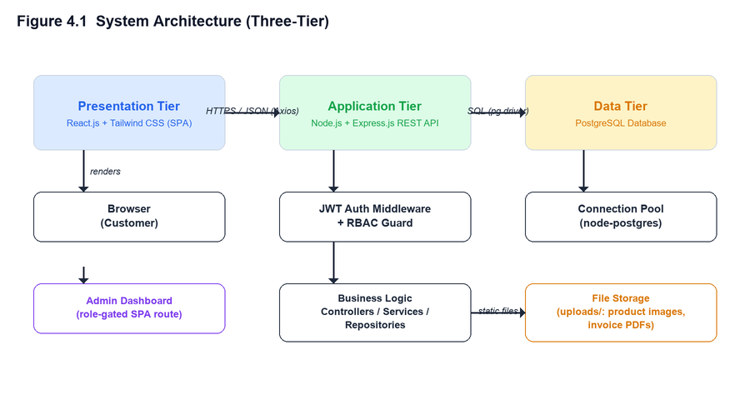
Figure 4.1: System Architecture (Three-Tier)
The presentation tier is a React.js single-page application, styled with Tailwind CSS utility classes for a fully responsive layout, and communicating with the backend exclusively over HTTPS/JSON via a centralized Axios client. The application tier is an Express.js REST API organized into feature modules (auth, products, categories, cart, orders, invoices, users), each internally layered into routes, validation, controllers, services, and repositories. The data tier is a single PostgreSQL database accessed through a connection pool, with all multi-step write operations wrapped in explicit transactions.

4.2 Module Interaction and Design Methodology
The backend follows a layered (N-tier) module design within each feature: an Express route declares the HTTP method and path and attaches middleware (authentication, role guard, request validation); a controller translates the HTTP request into a service call and shapes the HTTP response; a service contains the business logic and orchestrates one or more repository calls, often inside a database transaction; and a repository contains only parameterized SQL and no business logic. This layering — a variant of the classic Model-View-Controller and Repository patterns — was chosen specifically so that business rules (for example, the order-status transition rules) live in exactly one place and cannot be bypassed by calling a repository function directly, since repositories expose no business semantics of their own.
On the frontend, the same principle of separation is applied differently: presentation (JSX components), server communication (a dedicated `api/*.api.js` module per resource), and cross-cutting application state (`AuthContext` and `CartContext`, built on React's Context API) are kept in distinct layers. No third-party state-management library (such as Redux) was used; Context API combined with local component state was found sufficient for this application's state complexity, including the non-trivial guest-cart-to-server-cart merge that occurs automatically when a guest logs in.

4.3 Entity-Relationship Diagram
The relational schema was designed around ten core tables, shown in Figure 4.3. Primary keys for user-facing, externally-referenced entities (users, products, orders, and their dependents) use randomly-generated UUIDs rather than sequential integers, which avoids leaking record counts or ordering information through the API and is a widely recommended practice for public-facing identifiers. Categories, being an internal, admin-managed lookup table, use simpler auto-incrementing integer keys.
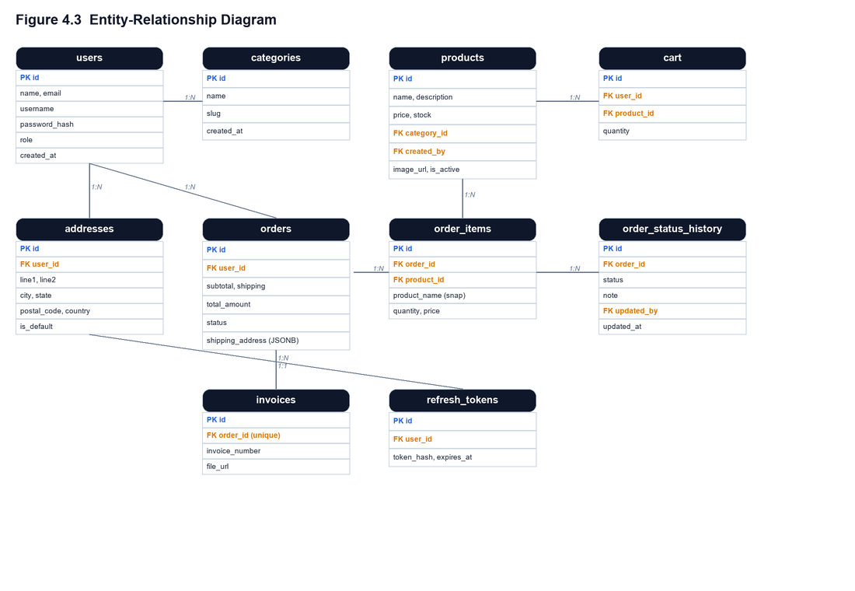
Figure 4.3: Entity-Relationship Diagram
Two design decisions in this schema merit particular explanation. First, `order_items` stores a snapshot of the product's name and price at the time of purchase (`product_name`, `price`), rather than relying solely on a live join to the `products` table. This ensures that a customer's historical invoice and order detail remain accurate even if the product is later renamed, re-priced, or deactivated — a requirement for financial-record integrity that is easy to overlook in a naive design. Second, `orders.shipping_address` is stored as a JSONB snapshot rather than a foreign key to the `addresses` table: an order's shipping address must remain fixed at the point of dispatch even if the customer subsequently edits or deletes the saved address it was copied from.

4.4 Use Case Diagram
Figure 4.4 summarizes the system's functionality from the perspective of its three actors: an unauthenticated Guest, a Registered User (Customer), and an Administrator. A Guest may browse the catalogue and build a cart but cannot check out; a Registered User inherits guest capabilities and gains checkout, order tracking, invoice download, and profile/address management; an Administrator operates independently on the catalogue and order-fulfilment side of the system.
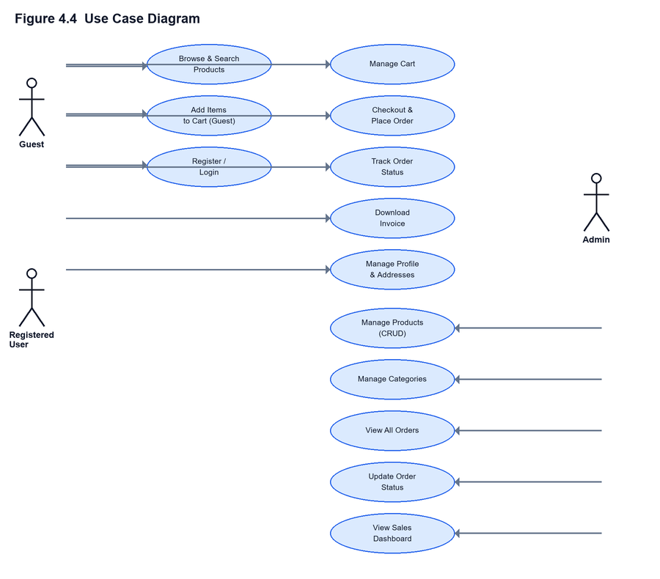
Figure 4.4: Use Case Diagram

4.5 Data Flow Diagram
Figure 4.5 presents the Level-0 (context) data flow diagram, treating the entire application as a single process exchanging data with three external entities: the Customer/Guest, the Administrator, and the PostgreSQL database. This context view establishes the system's boundary before Chapter 5 decomposes the internal processing into its constituent backend modules.
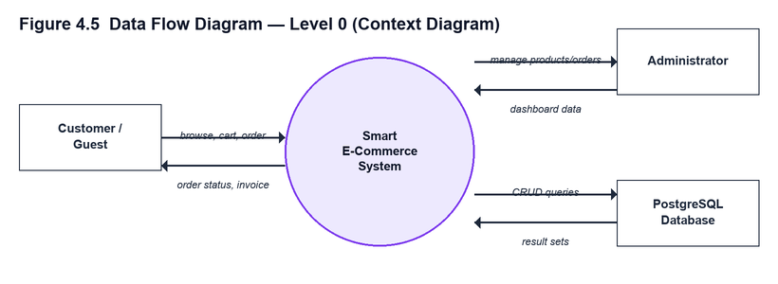
Figure 4.5: Data Flow Diagram — Level 0

4.6 Order Status State Machine
A central design decision of this system is that order status is not a free-form field an administrator can set to any value, but a formally defined state machine enforced on the server. Figure 4.6 shows the permitted transitions: an order begins as Pending, may be Confirmed, then Shipped, then Out for Delivery, then Delivered — a strictly linear happy path — while Cancellation is permitted only from the Pending or Confirmed states, modelling the real-world constraint that a shipment already in transit cannot simply be recalled by the system. Delivered and Cancelled are terminal states from which no further transition is permitted.
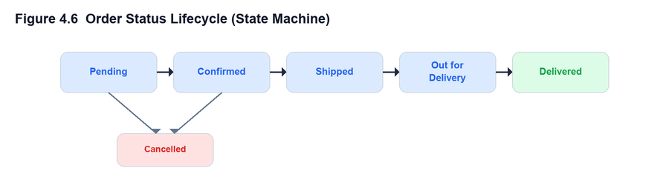
Figure 4.6: Order Status Lifecycle (State Machine)
This state machine is implemented as a single authoritative lookup table on the backend (see Section 5.3.6) that every status-change request is validated against, regardless of the role or client making the request. Cancelling an order while it is still in the Pending or Confirmed state additionally triggers an automatic stock-restock operation, reversing the inventory decrement made at checkout — a business rule directly coupled to the state machine rather than left to manual administrative correction.

4.7 Sequence Diagram — Checkout Process
Figure 4.7 traces a single checkout request through every layer of the system, from the customer's click through to the database transaction and automatic invoice generation. This flow is the most concurrency-sensitive operation in the system, since it must read and write shared inventory state; the row-level locking shown at step 5 (SELECT ... FOR UPDATE) is what prevents two simultaneous checkouts from oversubscribing the same stock, as discussed further in Section 6.5.
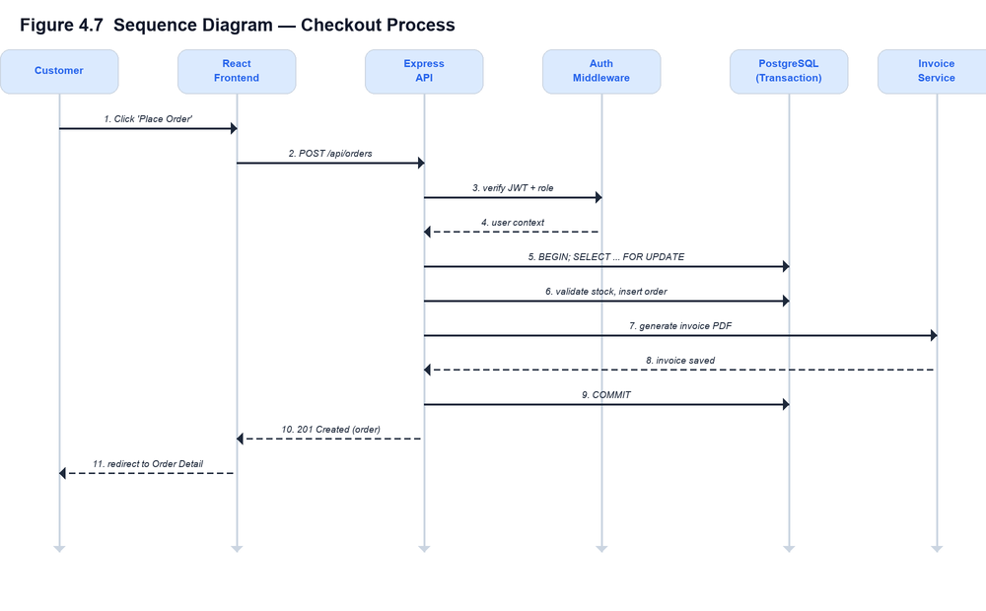
Figure 4.7: Sequence Diagram — Checkout Process

4.8 Database Schema Detail
This section documents the four most significant tables in full column detail. The complete schema (ten tables in total, including categories, cart, addresses, order_status_history, invoices, and refresh_tokens) is provided as Data Definition Language (DDL) in Appendix B.
Table 4.1: Database Table — users
Column | Type | Constraints
id | UUID | Primary Key, default gen_random_uuid()
name | VARCHAR(120) | NOT NULL
email | VARCHAR(160) | UNIQUE, NOT NULL
username | VARCHAR(60) | UNIQUE, NOT NULL
password_hash | VARCHAR(255) | NOT NULL — bcrypt hash, never plaintext
role | ENUM('admin','user') | NOT NULL, default 'user'
is_active | BOOLEAN | NOT NULL, default TRUE
created_at / updated_at | TIMESTAMPTZ | NOT NULL, default now()
Table 4.2: Database Table — products
Column | Type | Constraints
id | UUID | Primary Key
name | VARCHAR(200) | NOT NULL
description | TEXT | nullable
price | NUMERIC(10,2) | NOT NULL, CHECK (price >= 0)
stock | INTEGER | NOT NULL, default 0, CHECK (stock >= 0)
category_id | INTEGER | Foreign Key → categories(id), ON DELETE SET NULL
image_url | TEXT | nullable
created_by | UUID | Foreign Key → users(id)
is_active | BOOLEAN | NOT NULL, default TRUE — soft-delete flag
Table 4.3: Database Table — orders
Column | Type | Constraints
id | UUID | Primary Key
user_id | UUID | Foreign Key → users(id), NOT NULL
subtotal_amount | NUMERIC(10,2) | NOT NULL
shipping_amount | NUMERIC(10,2) | NOT NULL, default 0
total_amount | NUMERIC(10,2) | NOT NULL
status | ENUM(6 values) | NOT NULL, default 'Pending'
shipping_address | JSONB | NOT NULL — immutable snapshot at order time
payment_method | VARCHAR(30) | default 'COD'
created_at / updated_at | TIMESTAMPTZ | NOT NULL, default now()
Table 4.4: Database Table — order_items
Column | Type | Constraints
id | UUID | Primary Key
order_id | UUID | Foreign Key → orders(id), ON DELETE CASCADE
product_id | UUID | Foreign Key → products(id)
product_name | VARCHAR(200) | NOT NULL — name snapshot, survives product edits/deletion
quantity | INTEGER | NOT NULL, CHECK (quantity > 0)
price | NUMERIC(10,2) | NOT NULL — price snapshot at purchase time

4.9 REST API Design
The backend exposes a consistent RESTful API under the `/api` prefix. Every response follows a uniform JSON envelope — `{ success: boolean, data: ... }` on success, or `{ success: false, error: { code, message, requestId } }` on failure — which simplifies client-side error handling to a single pattern reused across every API call. Table 4.5 summarizes the principal endpoints; the full request/response contract for each is documented inline in the corresponding backend module.
Table 4.5: REST API Endpoint Summary
Method | Endpoint | Access | Description
POST | /api/auth/register | Public | Register a new customer account
POST | /api/auth/login | Public | Authenticate and receive access + refresh tokens
POST | /api/auth/refresh | Public (cookie) | Rotate refresh token, issue new access token
POST | /api/auth/logout | Authenticated | Revoke the current refresh token
GET | /api/products | Public | List products (search, filter, pagination)
GET | /api/products/:id | Public | Get single product detail
POST | /api/products | Admin | Create a product (multipart, with image)
PUT | /api/products/:id | Admin | Update / reactivate / deactivate a product
DELETE | /api/products/:id | Admin | Soft-delete (deactivate) a product
GET / POST | /api/categories | Public / Admin | List categories / create a category
GET | /api/cart | Authenticated | Get the current user's cart
POST | /api/cart | Authenticated | Add an item to the cart
PUT | /api/cart/:id | Authenticated | Update a cart item's quantity
DELETE | /api/cart/:id | Authenticated | Remove a cart item
POST | /api/orders | Authenticated | Checkout — converts cart into an order
GET | /api/orders | Authenticated | List the caller's own orders
GET | /api/orders/all | Admin | List all orders in the system
GET | /api/orders/:id | Authenticated | Get order detail (owner or Admin)
GET | /api/orders/:id/tracking | Authenticated | Get order status timeline
PUT | /api/orders/:id/status | Admin | Advance an order's status
GET | /api/invoices/:orderId | Authenticated | Download the order's PDF invoice
GET / PUT | /api/users/me | Authenticated | Get / update the caller's profile
PUT | /api/users/me/password | Authenticated | Change password
GET / POST | /api/users/me/addresses | Authenticated | List / add saved addresses

4.10 User Interface Design Principles
The frontend was designed mobile-first: every page was built with base (mobile) Tailwind CSS utility classes and progressively enhanced at the `sm:`, `md:`, and `lg:` breakpoints, rather than being designed for desktop and retrofitted for smaller screens. This was verified in practice, not merely assumed — every page was tested at both a 375px mobile viewport and a 1280px desktop viewport during development, and one genuine responsive gap (a navigation bar with no mobile menu) was found and corrected this way, described further in Section 6.5. Interactive feedback (loading spinners, toast notifications for success/error states, disabled-state buttons during in-flight requests) is applied consistently across the application so that no user action is left without visible acknowledgement.

4.11 Summary
This chapter presented the system's architecture, entity-relationship model, use-case model, data flow, order-status state machine, checkout sequence, database schema, REST API design, and user-interface design principles. Chapter 5 describes how this design was translated into a working implementation.

CHAPTER 5: IMPLEMENTATION

5.1 Development Environment
The system was developed on Windows using Visual Studio Code as the primary editor, with the backend and frontend run as two independent Node.js processes during development (Express on port 5000, Vite's development server for React on port 5173, the latter proxying `/api` requests to the former to avoid cross-origin issues locally). PostgreSQL 18 was run as a local Windows service. Version control was maintained with Git.

5.2 Technology Stack Rationale
Node.js and Express.js were selected for the backend because they allow the same language (JavaScript) to be used across the entire stack, reducing context-switching and allowing shared conventions (such as the JSON error envelope) to be applied uniformly. Express's minimalist, middleware-centric design was well suited to the layered route → middleware → controller → service → repository structure adopted throughout the backend. PostgreSQL was selected over a document database specifically for its transactional guarantees and row-level locking, both of which are exercised directly in the checkout implementation (Section 5.3.6). React.js was selected for the frontend for its component model and mature ecosystem; Tailwind CSS was selected over hand-written CSS or a component library to allow rapid, consistent, and fully responsive styling directly within JSX without context-switching to separate stylesheet files.

5.2.1 Backend Folder Structure
backend/
├── src/
│ ├── app.js (Express app: middleware, routes)
│ ├── server.js (HTTP server bootstrap, graceful shutdown)
│ ├── config/ env.js, db.js (connection pool)
│ ├── middleware/ auth, role, validate, upload, error, requestId
│ ├── modules/
│ │ ├── auth/ routes, controller, service, repository
│ │ ├── users/ profile + addresses
│ │ ├── products/ + category submodule
│ │ ├── cart/
│ │ ├── orders/ + statusMachine.js
│ │ └── invoices/ + invoice.pdf.js (PDFKit renderer)
│ ├── db/ migrations/, migrate.js, seed.js
│ └── utils/ apiError, asyncHandler, jwt, logger, crypto
├── tests/ 45 automated Jest + Supertest tests
└── uploads/ product images, generated invoice PDFs
Figure 5.1: Backend Folder Structure

5.2.2 Frontend Folder Structure
frontend/
├── src/
│ ├── api/ one file per resource (axios wrappers)
│ ├── context/ AuthContext.jsx, CartContext.jsx
│ ├── components/
│ │ ├── layout/ Navbar, Footer, ProtectedRoute, AdminRoute
│ │ └── ui/ Button, Input, Spinner, Badge, Pagination
│ ├── features/ feature-scoped components (products, cart,
│ │ checkout, orders, profile, admin)
│ ├── pages/ one file per route, incl. pages/admin/
│ ├── hooks/ useDebounce
│ └── utils/ format.js, guestCart.js
└── App.jsx / main.jsx router + provider composition
Figure 5.2: Frontend Folder Structure

5.3 Backend Module Implementation

5.3.1 Authentication Module
Passwords are hashed with bcrypt (cost factor 12) before storage; the plaintext password is never persisted or logged. On successful login, the server issues two JSON Web Tokens: a short-lived access token (15-minute expiry) returned in the JSON response body and held only in memory on the client, and a longer-lived refresh token (7-day expiry) set as an httpOnly cookie, making it inaccessible to client-side JavaScript and therefore immune to theft via cross-site scripting. Refresh tokens are additionally hashed (SHA-256) and stored server-side so they can be individually revoked on logout, and are rotated — the old token is invalidated and a new one issued — on every use, following the refresh-token-rotation best practice that limits the damage of a leaked refresh token to a single use.

5.3.2 Authorization Middleware
Two middleware functions enforce access control on every protected route. `authenticate` verifies the Bearer access token and attaches the caller's identity and role to `req.user`; `requireRole` then checks that role against a whitelist for the specific route. Because these are ordinary Express middleware, they compose declaratively in the route definition itself, making a route's access requirements visible at a glance.
function authenticate(req, res, next) {
const header = req.headers.authorization || "";
const [scheme, token] = header.split(" ");

if (scheme !== "Bearer" || !token) {
return next(ApiError.unauthorized("Missing or malformed Authorization header"));
}
try {
const payload = verifyAccessToken(token);
req.user = { id: payload.sub, role: payload.role, email: payload.email };
next();
} catch (err) {
next(ApiError.unauthorized("Invalid or expired access token"));
}
}
function requireRole(...allowedRoles) {
return (req, res, next) => {
if (!req.user) return next(ApiError.unauthorized());
if (!allowedRoles.includes(req.user.role)) {
return next(ApiError.forbidden(`Requires role: ${allowedRoles.join(" or ")}`));
}
next();
};
}
// Usage: router.post('/', authenticate, requireRole('admin'), handler)

5.3.3 Product and Category Module
Administrators can create, update, and deactivate products, including uploading a product image via `multipart/form-data` (handled by the `multer` middleware, restricted to JPEG/PNG/WEBP and a configurable size limit). Product deletion is implemented as a soft delete (`is_active = FALSE`) rather than a destructive row removal, because a hard delete would violate the foreign-key relationship from `order_items` for any product that has ever been ordered — deleting such a product would either be rejected by the database or would silently corrupt historical order records. The public product-listing endpoint filters to active products only; a query-parameter opt-in (`includeInactive=true`), honored only for authenticated Administrators, allows the admin dashboard to see and reactivate deactivated products.

5.3.4 Cart Module
An authenticated user's cart is persisted server-side in the `cart` table, one row per (user, product) pair, with quantity upserted (added to, not overwritten) when the same product is added again. Every cart mutation re-validates the requested quantity against the product's current stock, returning HTTP 409 Conflict with the actual available quantity if exceeded, so the client can present an accurate error rather than a generic failure.

5.3.5 Order and Checkout Module
Checkout is the most safety-critical operation in the system, converting a cart into a persisted order while guaranteeing that stock is never oversold even under concurrent access from multiple customers. This is achieved by wrapping the entire operation in a single PostgreSQL transaction and acquiring row-level locks (`SELECT ... FOR UPDATE`) on every product row involved before validating stock — a second transaction attempting to check out an overlapping product must wait for the first to commit or roll back before its own stock read can proceed, eliminating the classic time-of-check-to-time-of-use race condition. If any item fails validation, the entire transaction rolls back: no partial order, no partial stock decrement, and the customer's cart is left untouched so they can adjust and retry.
async function checkout(userId, { addressId, shippingAddress, paymentMethod }) {
const result = await withTransaction(async (client) => {
// Row-level lock: no other transaction can modify these product
// rows until this one commits or rolls back.
const cartRows = await repo.lockCartForCheckout(client, userId);
if (cartRows.length === 0) throw ApiError.badRequest("Your cart is empty");

for (const row of cartRows) {
if (row.stock < row.quantity) {
throw ApiError.conflict(
`Insufficient stock for "${row.name}" (only ${row.stock} left)`,
{ productId: row.product_id, available: row.stock }
);
}
}
const subtotal = round2(cartRows.reduce((s, r) => s + r.price * r.quantity, 0));
const shipping = env.flatShippingFee; // flat fee, prices are tax-inclusive
const total = round2(subtotal + shipping);

const order = await repo.insertOrder(client, { userId, subtotal, shipping, total, ... });
await repo.insertOrderItems(client, order.id, cartRows);
for (const row of cartRows) await repo.decrementStock(client, row.product_id, row.quantity);
await repo.insertStatusHistory(client, order.id, "Pending", userId, "Order placed");
await repo.clearCart(client, userId);
await invoiceService.generateForOrder(client, order, cartRows); // same transaction
return order;
});
return getOrderById(result.id, userId, false);
}
Note that invoice generation (Section 5.3.7) is invoked from inside this same transaction, so an order can never exist in the database without a corresponding invoice record — the two are created atomically.

5.3.6 Order Status State Machine
Order status transitions are validated against a single authoritative lookup table, shown below, rather than being left to ad-hoc conditional logic scattered through the codebase. Every status-update request — regardless of which client or role issues it — passes through `assertValidTransition`, which throws if the requested transition is not present in the current status's allowed-next-states list. Cancelling an order that is still Pending or Confirmed additionally triggers `shouldRestock`, which reverses the stock decrement made at checkout.
const ALLOWED_TRANSITIONS = {
Pending: ["Confirmed", "Cancelled"],
Confirmed: ["Shipped", "Cancelled"],
Shipped: ["Out for Delivery"],
"Out for Delivery": ["Delivered"],
Delivered: [],
Cancelled: [],
};

function assertValidTransition(currentStatus, nextStatus) {
const allowed = ALLOWED_TRANSITIONS[currentStatus] || [];
if (!allowed.includes(nextStatus)) {
throw new Error(
allowed.length
? `Cannot move order from "${currentStatus}" to "${nextStatus}". ` +
`Allowed next step(s): ${allowed.join(", ")}`
: `Order is in a terminal state ("${currentStatus}") and cannot be changed`
);
}
}

5.3.7 Invoice Generation Module
Invoices are rendered as PDF documents using the PDFKit library, entirely on the server, at the moment an order is placed. Each invoice is assigned a sequential, human-readable number (`INV-{year}-{sequence}`) drawn from a PostgreSQL sequence, ensuring uniqueness even under concurrent order placement. One implementation detail encountered during development is documented here for completeness: PDFKit's built-in Helvetica font has no glyph for the Indian Rupee sign (₹, Unicode U+20B9) and silently substitutes an unrelated character in its place. This was discovered by generating a test PDF and inspecting the rendered output before committing to the design, and was resolved by using the textual prefix “Rs.” in the invoice PDF instead of the ₹ glyph, while the web interface — which renders through the browser's own font stack rather than PDFKit's embedded font — continues to display the proper ₹ symbol.

5.3.8 Order Tracking Module
Every status change is appended to an `order_status_history` table (never overwritten), recording the new status, an optional note, the identity of the administrator who made the change, and a timestamp. This gives each order a permanent, append-only audit trail, which the customer-facing tracking timeline and the invoice both read from directly.

5.4 Frontend Implementation

5.4.1 State Management without Redux
Global application state is managed with two React Context providers rather than a third-party state-management library. `AuthContext` holds the current user and exposes `login`, `register`, and `logout`; on mount, it attempts a silent session resume by calling the refresh endpoint, so a returning user with a valid refresh cookie is transparently re-authenticated without needing to log in again. `CartContext` is more involved: for a guest (unauthenticated visitor), the cart is held in `localStorage` and rebuilt into a display view by fetching each referenced product's current details; for an authenticated user, the cart is fetched from the server. The transition from guest to authenticated — i.e., the moment a user with items already in a guest cart logs in — triggers an automatic merge, pushing every locally-stored item into the now-available server cart before clearing local storage.
// Single coordinated effect for both the initial load AND the guest -> login
// transition, so `loading` stays true for the ENTIRE merge-then-fetch
// sequence -- no window where a consumer could see a stale "empty" cart.
useEffect(() => {
if (authInitializing) return;
(async () => {
setLoading(true);
try {
const justLoggedIn = isAuthenticated && !wasAuthenticated.current;
if (justLoggedIn) {
await mergeGuestCartIntoServer(); // pushes localStorage cart to the API
}
const next = isAuthenticated
? await cartApi.get()
: await buildGuestCartView(guestCart.readEntries());
setCart(next);
} finally {
setLoading(false);
}
})();
wasAuthenticated.current = isAuthenticated;
}, [isAuthenticated, authInitializing]);

5.4.2 Routing and Route Guards
Client-side routing is implemented with React Router. Two guard components wrap route subtrees: `ProtectedRoute` redirects an unauthenticated visitor to the login page (preserving the originally requested path so the user is returned there after logging in), and `AdminRoute` redirects any non-Administrator to the home page. Product browsing and the cart itself are deliberately left outside both guards — a design decision made explicitly to allow guests to browse and build a cart freely, with authentication required only at the point of checkout, matching the intended customer experience.

5.4.3 Component Architecture
Components are organized into three categories: generic, reusable UI primitives (`Button`, `Input`, `Spinner`, `Badge`, `Pagination`) with no domain knowledge; feature-scoped components (e.g., `ProductCard`, `StatusTimeline`, `AddressForm`) that encapsulate one piece of domain-specific UI and can be reused across pages; and page components, one per route, that compose the above into a complete screen and own the data-fetching for that screen.

5.5 Security Measures Implemented
- Password hashing with bcrypt (cost factor 12); plaintext passwords are never stored or logged.
- JWT access tokens with a short 15-minute expiry, limiting the exposure window of a stolen token.
- Refresh tokens stored only in httpOnly cookies (inaccessible to JavaScript), hashed at rest, and rotated on every use.
- Role-based access control enforced on the server for every state-changing or role-restricted endpoint — never trusted from the client.
- Centralized input validation (express-validator) on every request body and query parameter, rejecting malformed input before it reaches business logic.
- Security HTTP headers via the `helmet` middleware, and a restrictive CORS policy scoped to the known frontend origin.
- Rate limiting on authentication endpoints (10 requests/minute) to blunt brute-force credential attacks, plus a lighter global API rate limit.
- Parameterized SQL throughout (via the `pg` driver's placeholder syntax) — no string-concatenated queries anywhere in the codebase, eliminating SQL injection as a vulnerability class.
- A per-request identifier attached to every request and echoed in error responses, so a specific failure can be correlated to a specific server log entry without exposing internal stack traces to the client in production.

5.6 Summary
This chapter described the implementation of the system in detail: the technology rationale, the module-by-module backend implementation with representative source code, and the frontend's Context-API-based state management, routing, and component architecture, concluding with a consolidated list of the security measures applied throughout. Chapter 6 presents how this implementation was tested and verified.

CHAPTER 6: TESTING

6.1 Testing Strategy
Testing was carried out at two complementary levels throughout development. First, an automated backend test suite, built with Jest and Supertest, exercises the Express application directly (in-process, without a running server) against a real PostgreSQL database, covering authentication, authorization, product and category management, the cart, the full checkout-to-invoice pipeline, order-status transitions, and profile/address management. Second, every feature was additionally verified live — by driving the actual running frontend and backend together in a browser and inspecting network requests, console output, and rendered content — because integration-level defects (particularly the two React state-management race conditions described in Section 6.5) do not manifest in isolated backend unit tests at all, and only appear when the real client and server interact under realistic timing.
This two-level approach was a deliberate choice: the automated suite gives fast, repeatable regression coverage for business logic and API contracts, while live end-to-end testing is what actually catches the class of defect that occurs at the seam between client state and server state — exactly the defects documented in this chapter.

6.2 Automated Test Suite Summary
The automated suite comprises 45 test cases across four suites, all of which pass. Table 6.1 in Section 6.4 lists representative individual cases; Table below summarizes suite-level coverage.
Test Suite Coverage Summary
Suite | Coverage | Cases | Passed | Failed
auth.test.js | Registration, duplicate-email rejection, weak-password rejection, login (success/failure), session retrieval via /me, unauthenticated access rejection | 7 | 7 | 0
products.test.js | Public listing, category listing, RBAC on create/update, full CRUD lifecycle, soft-delete visibility rules, includeInactive admin-only opt-in, UUID validation | 13 | 13 | 0
cart_order_flow.test.js | Cart add/stock-limit enforcement, checkout validation, transactional order creation, ownership checks, order-status transition rules, tracking timeline, invoice download and access control | 14 | 14 | 0
profile_addresses.test.js | Profile read/update, password change (correct/incorrect current password), address CRUD, default-address exclusivity, checkout via saved address | 11 | 11 | 0
Total: 45 test cases executed, 45 passed, 0 failed (100% pass rate at time of writing).

6.3 Unit and Integration Testing Approach
Each test suite creates its own isolated test data (freshly registered users with randomized identifiers) rather than depending on a fixed fixture set, so tests can run repeatedly and in any order without colliding with each other or with data left over from manual testing sessions. Tests exercise the real HTTP layer (via Supertest's request wrapper around the Express app) rather than calling service functions directly, so that routing, middleware ordering, and validation — not just business logic in isolation — are all covered by the same assertions.

6.4 Test Cases and Results
Table 6.1: Unit / Integration Test Cases and Results (Representative Sample)
ID | Test Description | Expected Result | Actual Result | Status
TC-01 | POST /api/auth/register with a password shorter than 8 characters | HTTP 422, VALIDATION_ERROR with field-level detail | Matched | Pass
TC-02 | POST /api/auth/register with an email already in use | HTTP 409, CONFLICT | Matched | Pass
TC-03 | POST /api/auth/login with an incorrect password | HTTP 401, UNAUTHORIZED | Matched | Pass
TC-04 | Non-admin user calls POST /api/products | HTTP 403, FORBIDDEN | Matched | Pass
TC-05 | Add to cart with quantity exceeding available stock | HTTP 409, CONFLICT with `available` count | Matched | Pass
TC-06 | Checkout with an empty cart | HTTP 400, BAD_REQUEST ("Your cart is empty") | Matched | Pass
TC-07 | Checkout with a valid cart and address | HTTP 201; order created; cart cleared; stock decremented | Matched | Pass
TC-08 | Two concurrent checkouts against the last unit of one product | Exactly one succeeds; the other receives HTTP 409 | Matched (see Section 6.5) | Pass
TC-09 | Admin advances order status Pending → Delivered directly (skipping steps) | HTTP 400, listing the actually allowed next state(s) | Matched | Pass
TC-10 | Admin cancels an order still in "Pending" | Order → Cancelled; reserved stock is restored | Matched | Pass
TC-11 | Admin attempts to cancel an order already "Shipped" | HTTP 400 — transition not permitted | Matched | Pass
TC-12 | Customer A requests Customer B's order by ID | HTTP 404 (no existence leak) | Matched | Pass
TC-13 | Download invoice for an order that is not the caller's own | HTTP 404 | Matched | Pass
TC-14 | Admin requests GET /api/products?includeInactive=true | Deactivated products included in the response | Matched | Pass
TC-15 | Non-admin requests GET /api/products?includeInactive=true | Parameter silently ignored; only active products returned | Matched | Pass
TC-16 | Set a second address as default | The previously default address's flag is cleared automatically | Matched | Pass

6.5 Defects Identified and Resolved During Development
Software engineering rigor is demonstrated not by the absence of defects but by how systematically they are found, understood, and fixed. This section documents five non-trivial defects identified through testing over the course of the project, each with its root cause and resolution, reproduced here as part of the engineering record rather than omitted for the sake of presenting an artificially smooth narrative.
Table 6.2: Defects Identified and Resolved During Development
# | Defect | Symptom | Root Cause | Resolution
1 | Checkout navigation race condition | After a successful order, the page redirected back to the (now-empty) cart instead of the new order detail page. | An effect guarding the checkout page ("redirect to cart if empty") re-fired after the cart was cleared, racing against the intended navigation to the order page. | Added a ref flag set immediately on successful order placement, suppressing the empty-cart guard for that render cycle; navigation to the order page now happens before the background cart refresh.
2 | Cart-loading initial-state race | A hard page reload directly on the checkout URL sometimes bounced the user back to the cart page even though the cart was not actually empty. | The cart context's `loading` flag defaulted to `false` before the authentication check had finished resolving, creating a brief window where the cart looked "confirmed empty" rather than "still loading". | Cart loading state now starts `true` and is coordinated with the authentication context's own `initializing` flag, so no consumer can observe a false-empty cart during startup.
3 | Deactivated products invisible to their own administrator | Once a product was deactivated, it disappeared from the admin product list entirely, with no way to find or reactivate it. | The product-listing endpoint never exposed an `includeInactive` option, and the route had no way to know the caller was an administrator (no authentication was attached to a nominally public route). | Added `authenticateOptional` middleware to the listing route (so `req.user` is populated only when a valid token is present) and an `includeInactive` query flag honored only when that user's role is admin.
4 | Silent backend crash on port conflict | The Express server process remained running (visible in the process list) but stopped accepting any connections, with no error logged anywhere. | `app.listen()`'s returned server object had no listener attached to its `'error'` event; a failed bind (e.g. `EADDRINUSE` from a stray previous process) fired an unhandled event and the underlying listener died silently. | Added an explicit `server.on('error', ...)` handler that logs the failure reason (distinguishing a port conflict from other bind failures) and exits the process cleanly, making the failure mode visible instead of silent.
5 | Rupee symbol rendering incorrectly on invoices | The ₹ (Indian Rupee) symbol rendered as an unrelated, garbled character in generated invoice PDFs. | PDFKit's embedded base-14 Helvetica font has no glyph for Unicode U+20B9 and silently substitutes a different character rather than raising an error. | Verified the failure by rendering a standalone test PDF before committing to the design; switched the invoice's currency prefix to the text "Rs.", which the font renders correctly, while the web UI (rendered by the browser's own font stack) continues to display the proper ₹ symbol.
Of particular note is Defect #1 and #2, both concurrency-adjacent races in the frontend's asynchronous state management rather than in the backend's database transactions. They illustrate that transactional correctness on the server (Section 5.3.5) is necessary but not sufficient — the client's own asynchronous coordination must be verified with equal care, since a client-side race can produce an incorrect user experience even when the underlying data is perfectly consistent.

6.6 Concurrency Testing
The checkout transaction's row-level locking (Section 5.3.5) was verified not only by code review but by deliberately reproducing contention: a product's stock was set to a small value via the admin API, added to a cart, and then the product's stock was independently reduced by a second, concurrent administrative update between the cart-add and the checkout call, simulating a genuine race. The checkout call correctly detected the now-insufficient stock, rejected the order with HTTP 409, left the cart untouched, and left stock unchanged — confirming that the transaction rolls back cleanly rather than partially applying its effects, which was the specific correctness property Objective 3 (Section 1.4) set out to guarantee.

6.7 Summary
This chapter presented the project's two-level testing strategy, summarized the 45-case automated test suite (100% passing), presented a representative sample of individual test cases and their results, and documented five real defects discovered and resolved during development, including a live-reproduced concurrency test of the checkout transaction. Chapter 7 presents the resulting system's outputs and discusses them.

CHAPTER 7: RESULTS AND DISCUSSION

7.1 System Outputs
This section presents representative outputs produced by the running system against a live PostgreSQL database, rather than illustrative mock-ups, so that the figures in this chapter can be reproduced by re-running the corresponding request against the deployed application.

7.1.1 Sample Checkout Computation
The following order was placed by an authenticated customer for a single unit of “Wireless Mouse”. The system computes the subtotal from the live product price at the moment of checkout (not a client-supplied value, which would be trivially forgeable), adds the configured flat shipping charge, and returns the immutable total that is persisted with the order and printed on its invoice.
Table 7.1: Sample Checkout Computation
Item | Qty | Unit Price | Line Total
Wireless Mouse | 1 | ₹599.00 | ₹599.00
Subtotal: ₹599.00 Shipping (flat): ₹40.00 Total payable: ₹639.00
This computation is performed entirely server-side inside the checkout database transaction described in Section 5.3.5; the client never supplies pricing figures that are trusted directly, preventing a manipulated client request from altering the amount charged.

7.1.2 Sample Generated Invoice
Figure 7.1 reproduces the PDF invoice automatically generated for the order above, downloaded directly from the running system's invoice endpoint. The invoice carries a sequentially-assigned invoice number, the order identifier, the shipping address captured at the time of the order, and the same subtotal/shipping/total figures computed during checkout.
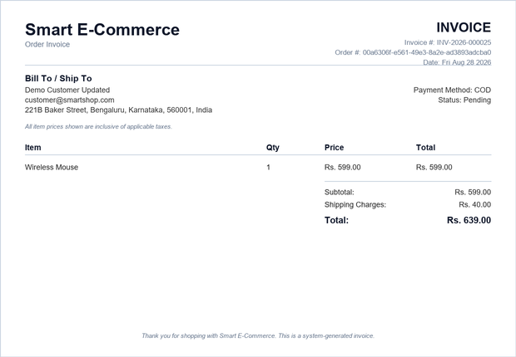
Figure 7.1: Sample Generated Invoice (PDF Output)

7.2 Order Status Tracking in Practice
Once placed, an order begins in the Pending state and is advanced only by an Administrator, strictly along the transitions defined in the state machine (Section 4.6). Each transition is timestamped and attributed to the administrator who made it, building a permanent audit trail that the customer's order-tracking view renders as a timeline. In verification testing, an order was walked through its full lifecycle — Pending → Confirmed → Shipped → Out for Delivery → Delivered — with every intermediate state correctly reflected on both the administrative order list and the customer's own tracking page in real time on the next page load, and an attempt to skip directly from Pending to Delivered was correctly rejected with the specific allowed next states named in the error response.

7.3 Automated Test Results
As reported in Chapter 6, the automated backend test suite comprises 45 test cases across authentication, product/category management, cart and checkout, order-status transitions, invoicing, and profile/address management, all of which pass. This 100% pass rate, combined with the live-reproduced concurrency test described in Section 6.6, provides converging evidence — from two independent verification methods — that the core correctness objectives set out in Section 1.4 (stock integrity under concurrency, valid-only order-status transitions, and role-scoped access control) are actually met by the implementation, not merely assumed.

7.4 Discussion
The results demonstrate that the architectural decisions made in Chapter 4 — particularly wrapping checkout in a single database transaction with row-level locking, and centralizing the order-status state machine in one authoritative lookup table — successfully deliver the correctness guarantees they were designed for, and do so in a way that is independently verifiable rather than merely claimed. Equally, the defects catalogued in Section 6.5 show that these same guarantees are not free: they required deliberate design (the transaction boundary, the state-machine table) and, on the frontend, careful coordination of asynchronous state that is easy to get subtly wrong even when the underlying API is correct. This reinforces a general lesson from the project: a correct backend API does not automatically produce a correct user-facing experience, and both layers require their own verification discipline.
A limitation observed during development is that the system's tax-and-shipping model was deliberately simplified (a single flat shipping fee, tax-inclusive pricing) rather than modelling India's multi-slab Goods and Services Tax (GST) regime, which varies by product category. This was a scope decision appropriate to the project's academic timeframe, and is discussed further as future work in Section 8.2.

CHAPTER 8: CONCLUSION AND FUTURE SCOPE

8.1 Conclusion
This project set out to design, implement, and verify a full-stack e-commerce platform that enforces its core business and security guarantees architecturally rather than by convention. Across the ten objectives set out in Chapter 1, the resulting system implements secure JWT-based authentication with role-based access control; a normalized PostgreSQL schema modelling the complete commerce domain; a transactionally-safe checkout process using row-level locking to guarantee stock integrity under concurrent access; a formally-defined order-status state machine enforced identically regardless of client input; automatic PDF invoice generation and a customer-facing order-tracking timeline; a fully responsive React front end using Context API for state management, including an automatically-merging guest cart; a complete administrative dashboard for catalogue and order management; and a verification process combining a 45-case automated test suite with live, adversarial manual testing that both discovered and led to the resolution of five genuine defects during development.
The project therefore demonstrates that a modern, entirely open-source JavaScript/PostgreSQL stack — without reliance on a hosted SaaS platform or a heavyweight legacy framework — is sufficient to build an e-commerce system with the correctness guarantees expected of production software, provided that transactional design, authorization, and testing are treated as first-class concerns from the outset rather than retrofitted. Equally, documenting the real defects found during development, rather than presenting only a finished, defect-free narrative, was treated as part of the project's engineering record, since the process of finding and correctly diagnosing those defects is itself evidence of the testing discipline the project set out to demonstrate.

8.2 Future Scope
Several extensions were identified during the course of this project as valuable directions for future work, beyond the scope of the current academic timeframe:
- Payment Gateway Integration: Replace the current Cash-on-Delivery-equivalent payment model with a live integration to a payment gateway (e.g., Razorpay or Stripe), including webhook-based payment-status confirmation.
- GST-Compliant Tax Engine: Replace the current flat tax-inclusive pricing model with a configurable, category-aware tax calculation engine reflecting India's multi-slab GST structure, with tax shown as a distinct line item where legally required.
- Product Reviews and Ratings: Allow customers who have completed an order to leave a rating and review on the purchased product, surfaced on the product detail page.
- Real-Time Notifications: Extend order-status updates to push real-time notifications to the customer (via WebSockets or a push-notification service) rather than requiring a page refresh to see the latest status.
- Multi-Vendor Marketplace Support: Extend the product and order model to support multiple independent sellers, each managing their own catalogue and fulfilment, with orders split by seller at checkout.
- Advanced Admin Analytics: Extend the current dashboard with time-series sales charts, cohort-based customer analytics, and inventory-forecasting signals.
- Automated Frontend Testing: Complement the existing backend Jest/Supertest suite with an automated end-to-end browser test suite (e.g., Playwright or Cypress) covering the user flows currently verified manually, to catch future regressions of the class documented in Section 6.5 automatically.
- Horizontal Scalability: Introduce a caching layer (e.g., Redis) for frequently-read, rarely-changed data such as the product catalogue and categories, and evaluate read-replica database scaling for higher transaction volumes.

8.3 Closing Remark
The Smart E-Commerce Platform, as implemented and verified in this project, fulfils its stated objectives and provides a solid, extensible foundation for the future enhancements outlined above. More broadly, the project demonstrates the practical application of core software engineering principles — layered architecture, database transaction design, role-based security, and systematic testing — to a domain (e-commerce) whose correctness requirements are easy to state but, as this project's own defect record shows, genuinely non-trivial to deliver.

REFERENCES
[1] React — A JavaScript library for building user interfaces. Meta Open Source. https://react.dev/
[2] Express.js — Fast, unopinionated, minimalist web framework for Node.js. OpenJS Foundation. https://expressjs.com/
[3] PostgreSQL 18 Documentation. The PostgreSQL Global Development Group. https://www.postgresql.org/docs/
[4] Node.js Documentation. OpenJS Foundation. https://nodejs.org/docs/
[5] Tailwind CSS Documentation. Tailwind Labs Inc. https://tailwindcss.com/docs
[6] Jones, M., Bradley, J., and Sakimura, N. (2015). JSON Web Token (JWT), RFC 7519. Internet Engineering Task Force (IETF).
[7] Provos, N. and Mazières, D. (1999). A Future-Adaptable Password Scheme. Proceedings of the USENIX Annual Technical Conference (bcrypt).
[8] Fielding, R. T. (2000). Architectural Styles and the Design of Network-based Software Architectures (Doctoral dissertation, University of California, Irvine) — foundational definition of REST.
[9] Gray, J. and Reuter, A. (1993). Transaction Processing: Concepts and Techniques. Morgan Kaufmann — foundational reference for ACID transactions and row-level locking.
[10] OWASP Foundation. OWASP Top Ten Web Application Security Risks. https://owasp.org/www-project-top-ten/
[11] PDFKit Documentation — A JavaScript PDF generation library for Node.js and the browser. https://pdfkit.org/
[12] Jest Documentation — Delightful JavaScript Testing. Meta Open Source. https://jestjs.io/
[13] React Router Documentation. Remix Software. https://reactrouter.com/
[14] node-postgres (pg) Documentation — Non-blocking PostgreSQL client for Node.js. https://node-postgres.com/

APPENDIX A: SAMPLE SOURCE CODE

A.1 Centralized Application Error Class
Every thrown error in the backend uses this single class, giving the centralized error-handling middleware a uniform shape to translate into an HTTP response, rather than each module inventing its own error format.
class ApiError extends Error {
constructor(statusCode, message, code = "ERROR", details) {
super(message);
this.statusCode = statusCode;
this.code = code;
this.details = details;
}
static badRequest(message, details) { return new ApiError(400, message, "BAD_REQUEST", details); }
static unauthorized(message = "Unauthorized") { return new ApiError(401, message, "UNAUTHORIZED"); }
static forbidden(message = "Forbidden") { return new ApiError(403, message, "FORBIDDEN"); }
static notFound(message = "Resource not found") { return new ApiError(404, message, "NOT_FOUND"); }
static conflict(message, details) { return new ApiError(409, message, "CONFLICT", details); }
}

APPENDIX B: DATABASE SCHEMA (DDL EXCERPT)
The following excerpt from the PostgreSQL migration script (001_init.sql) shows the definitions of the four most significant tables. The complete script additionally defines categories, cart, addresses, order_status_history, invoices, refresh_tokens, the two ENUM types (user_role, order_status), supporting indexes, and updated_at triggers.
CREATE TABLE IF NOT EXISTS users (
id UUID PRIMARY KEY DEFAULT gen_random_uuid(),
name VARCHAR(120) NOT NULL,
email VARCHAR(160) UNIQUE NOT NULL,
username VARCHAR(60) UNIQUE NOT NULL,
password_hash VARCHAR(255) NOT NULL,
role user_role NOT NULL DEFAULT 'user',
is_active BOOLEAN NOT NULL DEFAULT TRUE,
created_at TIMESTAMPTZ NOT NULL DEFAULT now(),
updated_at TIMESTAMPTZ NOT NULL DEFAULT now()
);

CREATE TABLE IF NOT EXISTS products (
id UUID PRIMARY KEY DEFAULT gen_random_uuid(),
name VARCHAR(200) NOT NULL,
description TEXT,
price NUMERIC(10,2) NOT NULL CHECK (price >= 0),
stock INTEGER NOT NULL DEFAULT 0 CHECK (stock >= 0),
category_id INTEGER REFERENCES categories(id) ON DELETE SET NULL,
image_url TEXT,
created_by UUID REFERENCES users(id),
is_active BOOLEAN NOT NULL DEFAULT TRUE,
created_at TIMESTAMPTZ NOT NULL DEFAULT now(),
updated_at TIMESTAMPTZ NOT NULL DEFAULT now()
);
CREATE INDEX IF NOT EXISTS idx_products_category ON products(category_id);
CREATE INDEX IF NOT EXISTS idx_products_name_trgm ON products USING GIN (name gin_trgm_ops);

CREATE TABLE IF NOT EXISTS orders (
id UUID PRIMARY KEY DEFAULT gen_random_uuid(),
user_id UUID NOT NULL REFERENCES users(id),
subtotal_amount NUMERIC(10,2) NOT NULL,
shipping_amount NUMERIC(10,2) NOT NULL DEFAULT 0,
total_amount NUMERIC(10,2) NOT NULL,
status order_status NOT NULL DEFAULT 'Pending',
shipping_address JSONB NOT NULL,
payment_method VARCHAR(30) DEFAULT 'COD',
created_at TIMESTAMPTZ NOT NULL DEFAULT now(),
updated_at TIMESTAMPTZ NOT NULL DEFAULT now()
);

CREATE TABLE IF NOT EXISTS order_items (
id UUID PRIMARY KEY DEFAULT gen_random_uuid(),
order_id UUID NOT NULL REFERENCES orders(id) ON DELETE CASCADE,
product_id UUID NOT NULL REFERENCES products(id),
product_name VARCHAR(200) NOT NULL, -- snapshot, survives product edits/deletes
quantity INTEGER NOT NULL CHECK (quantity > 0),
price NUMERIC(10,2) NOT NULL -- price snapshot at purchase time
);

CREATE TABLE IF NOT EXISTS order_status_history (
id UUID PRIMARY KEY DEFAULT gen_random_uuid(),
order_id UUID NOT NULL REFERENCES orders(id) ON DELETE CASCADE,
status order_status NOT NULL,
note VARCHAR(255),
updated_by UUID REFERENCES users(id),
updated_at TIMESTAMPTZ NOT NULL DEFAULT now()
);

APPENDIX C: SAMPLE API REQUEST / RESPONSE PAIRS

C.1 Successful Registration
POST /api/auth/register
Content-Type: application/json

{
"name": "Jane Doe",
"email": "jane@example.com",
"username": "janedoe",
"password": "Passw0rd123"
}
HTTP/1.1 201 Created

{
"success": true,
"data": {
"id": "1e85938d-6258-4f6c-8a15-ebb0cd519152",
"name": "Jane Doe",
"email": "jane@example.com",
"username": "janedoe",
"role": "user",
"createdAt": "2026-08-27T11:12:30.918Z"
}
}

C.2 Checkout Rejected — Insufficient Stock
The following is the actual error envelope returned when a checkout request is submitted against a product whose stock has fallen below the requested quantity since it was added to the cart — the scenario used to verify the transactional locking described in Section 6.6.
HTTP/1.1 409 Conflict

{
"success": false,
"error": {
"code": "CONFLICT",
"message": "Insufficient stock for \"Wireless Mouse\" (only 1 left)",
"details": { "productId": "0eca0d4c-...", "available": 1 },
"requestId": "b4fb37be5382d2bb"
}
}

