A PROJECT REPORT
ON
ONLINE EVENT BOOKING & SMART TICKETING PLATFORM

A web platform for event discovery, seat-level ticket booking, online payment, QR-based entry verification and settlement
Submitted in partial fulfilment of the requirements for the award of the degree of
MASTER OF SCIENCE
[Specialisation]
Submitted by
[STUDENT NAME]
Register Number: [Register Number]
Under the guidance of
[GUIDE NAME], [Designation]
[DEPARTMENT NAME]
[COLLEGE NAME]
[University Affiliation]
[Month] [Year]

[COLLEGE NAME]
[DEPARTMENT NAME]
CERTIFICATE

This is to certify that the project report entitled “Online Event Booking & Smart Ticketing Platform” is a bonafide record of the work carried out by [Student Name], Register Number [Register Number], submitted in partial fulfilment of the requirements for the award of the degree of Master of Science in [Specialisation] during the academic year [Year].
The work presented in this report was carried out by the candidate under my supervision. To the best of my knowledge, the content of this report has not been submitted earlier, in whole or in part, for the award of any other degree or diploma.

______________________  [Guide Name]  Project Guide | ______________________  [Head of Department]  Head of the Department

Submitted for the viva-voce examination held on ____________________
______________________  Internal Examiner | ______________________  External Examiner

DECLARATION

I hereby declare that the project report entitled “Online Event Booking & Smart Ticketing Platform” submitted to [College Name], [University Affiliation], in partial fulfilment of the requirements for the award of the degree of Master of Science in [Specialisation], is the result of the work carried out by me under the guidance of [Guide Name].
I further declare that the design, implementation and testing described in this report were performed by me, that all external sources and libraries used have been acknowledged in the references, and that this work has not been submitted previously, in whole or in part, for the award of any other degree or diploma of this or any other institution.

Place: ____________________ [Student Name]
Date: ____________________ Register Number: [Register Number]

ACKNOWLEDGEMENT

I take this opportunity to express my sincere gratitude to everyone who supported me through the course of this project.
I am deeply grateful to my guide, [Guide Name], [Designation], for the guidance, patience and constructive criticism offered at every stage of this work. The suggestions received during the design and testing phases shaped several of the decisions recorded in this report.
I extend my thanks to [Head of Department], Head of the Department of [Department Name], and to the faculty members of the department, for providing the academic environment and the facilities that made this project possible.
I am thankful to [Principal Name], Principal, [College Name], for the encouragement extended to project work in the department.
Finally, I thank my family and my classmates for their support, their willingness to test the platform, and the feedback that improved it.

[Student Name]

ABSTRACT

Small and mid-sized event organisers in India still sell tickets through spreadsheets, informal payment collection and printed entry lists. That practice produces a predictable set of failures: the same seat is committed twice, passes are copied and reused, entry queues move slowly, collections cannot be reconciled with tickets sold, and refunds are settled by conversation with no record. This project addresses those failures with a single web platform that covers the complete life cycle of a ticketed event.
The system is implemented as a React.js client styled with Tailwind CSS and a Node.js with Express.js REST API over a PostgreSQL database, with no Redux; server data is cached with a query library and the session is held in React context. It serves three roles. An administrator approves organisers, moderates events, decides refund disputes, sets commission and releases payouts. An event organizer defines venues and reusable seat layouts, publishes events with multiple ticket types, tracks sales, scans tickets at the gate and receives settlement. An attendee searches events, selects seats or ticket quantities, pays online, and carries a digitally signed QR ticket.
The engineering emphasis of the project is correctness where money and finite inventory meet concurrency. Reservations are made inside database transactions using row-level locking and conditional updates, so inventory cannot be oversold; payment confirmation is idempotent, so a duplicated or reordered gateway notification cannot issue a second set of tickets; entry is a conditional update on the ticket, so a QR code admits exactly one person; and all monetary arithmetic is performed in integer paise and derived from one shared calculation, so earnings, payouts and analytics agree exactly. Gate operation continues without a network through an offline manifest and queued scan synchronisation.
The delivered system comprises 15,947 lines of application code: 93 API endpoints over a 24-table schema, and 36 responsive screens. It was validated by 254 automated checks, all passing, together with deliberate concurrency experiments - ten simultaneous buyers competing for three tickets produced exactly three bookings, and ten simultaneous scans of one ticket produced exactly one admission - and scripted interface verification at desktop and mobile widths. Twelve defects found during testing are documented with their causes and fixes.

Keywords: event ticketing, seat reservation, concurrency control, transaction isolation, idempotent payment processing, QR verification, offline check-in, React, Node.js, Express, PostgreSQL, responsive web design.

TABLE OF CONTENTS

If the entries below are not visible, click anywhere in this list, press Ctrl+A then F9, and choose “Update entire table”.
Chapter 1 Introduction 1
1.1 Overview 1
1.2 Problem Statement 2
1.3 Objectives of the Project 2
1.4 Scope of the Project 3
1.5 Significance of the Work 3
1.6 Organisation of the Report 3
Chapter 2 Literature Review and Study of Existing Systems 5
2.1 Purpose of the Review 5
2.2 Study of Existing Platforms 5
2.3 Comparative Analysis 5
2.4 Technical Background Studied 6
2.5 Identified Gaps and Design Response 6
Chapter 3 System Analysis 7
3.1 Analysis of the Existing System 7
3.2 Proposed System 7
3.3 Feasibility Study 7
3.4 Functional Requirements 8
3.5 Non-Functional Requirements 9
3.6 Use Case Analysis 10
3.7 System Requirements 11
Chapter 4 System Design 13
4.1 Design Goals 13
4.2 System Architecture 13
4.3 Module Decomposition 14
4.4 Data Flow Design 15
4.5 Process Design of the Critical Flows 16
4.6 Interface Design Approach 17
4.7 API Design Conventions 18
Chapter 5 Database Design 19
5.1 Design Principles 19
5.2 Entity Relationship Design 19
5.3 Table Catalogue 20
5.4 Constraints, Integrity and Indexing 22
5.5 Migration Strategy 22
Chapter 6 Technology Stack 23
6.1 Overview of the Stack 23
6.2 Rationale for Key Choices 23
6.3 Development Environment and Tooling 24
6.4 Project Statistics 24
Chapter 7 Backend Implementation 26
7.1 Implementation Approach 26
7.2 Phase 1 - Foundation and Identity 26
7.3 Phase 2 - Events, Venues and the Public Catalogue 27
7.4 Phase 3 - The Booking Engine 27
7.5 Phase 4 - Payments, Tickets and Invoices 28
7.6 Phase 5 - QR Check-in 29
7.7 Phase 6 - Finance, Analytics and Notifications 29
Chapter 8 Frontend Implementation 31
8.1 Implementation Approach 31
8.2 Application Shell and Session Handling 31
8.3 Public Catalogue 31
8.4 Attendee Journey 32
8.5 Organiser Workspace 32
8.6 Gate Scanner 32
8.7 Administrative Console 32
8.8 Responsive Implementation 33
8.9 Performance Measures 33
Chapter 9 Security Implementation 34
9.1 Security Objectives 34
9.2 Authentication Security 34
9.3 Authorisation 34
9.4 Input Validation and Injection Defence 34
9.5 Ticket and Payment Integrity 35
9.6 Data Protection and Auditability 35
9.7 Known Security Limitations 35
Chapter 10 Testing and Validation 36
10.1 Test Strategy 36
10.2 Test Environment 36
10.3 Backend Test Results 36
10.4 Correctness Tests of Critical Behaviour 37
10.5 Defects Found and Resolved 38
10.6 Interface and Responsive Verification 39
10.7 Build Verification 40
Chapter 11 User Interface and Operating Flow 41
11.1 Screen Inventory 41
11.2 Attendee Operating Flow 41
11.3 Organizer Operating Flow 42
11.4 Administrator Operating Flow 42
11.5 Accessibility and Usability Considerations 42
Chapter 12 Results and Discussion 43
12.1 Objectives Against Outcomes 43
12.2 Discussion of Key Results 43
12.3 Quantitative Summary 44
Chapter 13 Limitations and Future Enhancements 45
13.1 Limitations of the Present Build 45
13.2 Planned Enhancements 45
Chapter 14 Conclusion 46
References 47
Appendix A API Reference 48
A.1 Authentication and account 48
A.2 Catalogue, venues and events 48
A.3 Booking, payment and tickets 48
A.4 Check-in 49
A.5 Finance and administration 49
Appendix B Configuration and Accounts 50
B.1 Environment configuration 50
B.2 Setup commands 50
B.3 Demonstration accounts 50
Appendix C Project Structure 51
C.1 Backend 51
C.2 Frontend 51
C.3 Documentation 51

LIST OF FIGURES

Figure 1.1 The platform at a glance - the three user roles and the order in which they use the system 1
Figure 3.1 Development sequence followed during the project 8
Figure 3.2 Use case diagram of the platform 10
Figure 4.1 Four-tier architecture of the platform 13
Figure 4.2 Backend module structure 14
Figure 4.3 Level 0 data flow diagram (context diagram) 15
Figure 4.4 Level 1 data flow diagram 15
Figure 4.5 Sequence diagram - reserving seats and creating a pending order 16
Figure 4.6 Sequence diagram - payment confirmation from either direction 17
Figure 4.7 Sequence diagram - single-use QR verification at the gate 17
Figure 5.1 Entity relationship diagram of the principal entities 19
Figure 7.1 Authentication and session refresh, including reuse detection 26
Figure 7.2 How the money from a booking is divided 30
Figure 8.1 Frontend structure 31
Figure 8.2 The three possible outcomes of a scan, as shown at the gate 32
Figure 8.3 Order in which an administrator uses the console 33
Figure 10.1 Automated checks per backend phase 37
Figure 11.1 Attendee flow from first visit to entry at the gate 41
Figure 11.2 The two ways an attendee can recover money, and where each one ends 41
Figure 11.3 Organizer flow from registration to tickets on sale 42
Figure 11.4 Organizer flow on the day of the event 42

LIST OF TABLES

Table 1.1 Structure of this report 3
Table 2.1 Comparison of existing approaches with the proposed platform 5
Table 2.2 Gaps found in the review and how the project responds 6
Table 3.1 Existing system compared with the proposed system 7
Table 3.2 Functional requirements - Attendee 8
Table 3.3 Functional requirements - Event Organizer 9
Table 3.4 Functional requirements - Administrator 9
Table 3.5 Non-functional requirements 9
Table 3.6 Use case: Book tickets for an event 11
Table 3.7 Use case: Verify a ticket at the gate 11
Table 3.8 Use case: Approve an organiser application 11
Table 3.9 Software requirements 11
Table 3.10 Hardware requirements 12
Table 4.1 Tier responsibilities 13
Table 4.2 Backend modules and their responsibilities 14
Table 4.3 Processes, inputs and outputs 16
Table 4.4 Interface conventions applied across all screens 18
Table 4.5 API conventions 18
Table 5.1 Principal relationships and their meaning 19
Table 5.2 Identity and access tables 20
Table 5.3 Catalogue and inventory tables 20
Table 5.4 Booking and payment tables 21
Table 5.5 Entry and settlement tables 21
Table 5.6 Integrity mechanisms used in the schema 22
Table 5.7 Migration files 22
Table 6.1 Technology stack with exact versions used 23
Table 6.2 How each kind of state is handled 24
Table 6.3 Development environment 24
Table 6.4 Size of the delivered system 24
Table 7.1 Backend phases and outcomes 26
Table 7.2 Event states and transitions 27
Table 7.3 Cases the confirmation path handles 28
Table 7.4 Scheduled jobs 30
Table 8.1 Frontend phases 31
Table 8.2 Responsive techniques applied 33
Table 9.1 Authentication measures 34
Table 9.2 Data protection measures 35
Table 10.1 Levels of testing applied 36
Table 10.2 Test environment 36
Table 10.3 Backend test results by phase 37
Table 10.4 Concurrency test results 37
Table 10.5 Monetary calculation tests 38
Table 10.6 Defect log 38
Table 10.7 Interface verification summary 39
Table 10.8 Production build result 40
Table 11.1 Screens by role 41
Table 12.1 Achievement of the stated objectives 43
Table 12.2 Summary of delivered work 44
Table 13.1 Known limitations 45
Table 13.2 Enhancement roadmap in priority order 45
Table A.1 Authentication and account endpoints 48
Table A.2 Catalogue, venue and event endpoints 48
Table A.3 Booking, payment and ticket endpoints 48
Table A.4 Check-in endpoints 49
Table A.5 Finance and administration endpoints 49
Table B.1 Backend environment variables 50
Table B.2 Accounts created by the seed scripts 50
Table C.1 Documents delivered with the project 51

Chapter 1 Introduction

1.1 Overview
Live events are one of the largest organised entertainment sectors in India, covering concerts, stand-up comedy, theatre, sports, workshops, exhibitions and cultural festivals. Almost every step of attending such an event has moved online - discovering what is on, choosing a seat, paying, and carrying the ticket - yet a large number of small and mid-sized organisers still run their ticketing on spreadsheets, printed passes, informal payment collection and manual entry registers at the gate. The result is familiar to anyone who has stood in a slow entry queue: duplicate passes, seats sold twice, lost payment records, and no reliable count of how many people actually walked in.
This project, the Online Event Booking and Smart Ticketing Platform, is a complete web application that covers the entire life cycle of a ticketed event on a single system. An organiser registers, is approved by a platform administrator, defines a venue and its seating plan, publishes an event with one or more ticket types, and sells tickets online. An attendee discovers the event, reserves specific seats or a number of general-admission tickets, pays through a payment gateway, and receives a ticket that carries a digitally signed QR code. At the venue, the organiser's own phone becomes the entry scanner: each QR code is verified against the server and can be admitted exactly once. After the event, the platform computes the organiser's earnings after commission and records the payout made to them.
The platform is built as two independent applications that communicate only over a documented REST interface - a React.js single page application styled with Tailwind CSS for every user-facing screen, and a Node.js with Express.js API backed by a PostgreSQL database for all business logic and persistence. The separation was a deliberate design decision: the API can be consumed later by a native mobile application or a partner website without any change, and the web client can be redesigned without touching business rules.
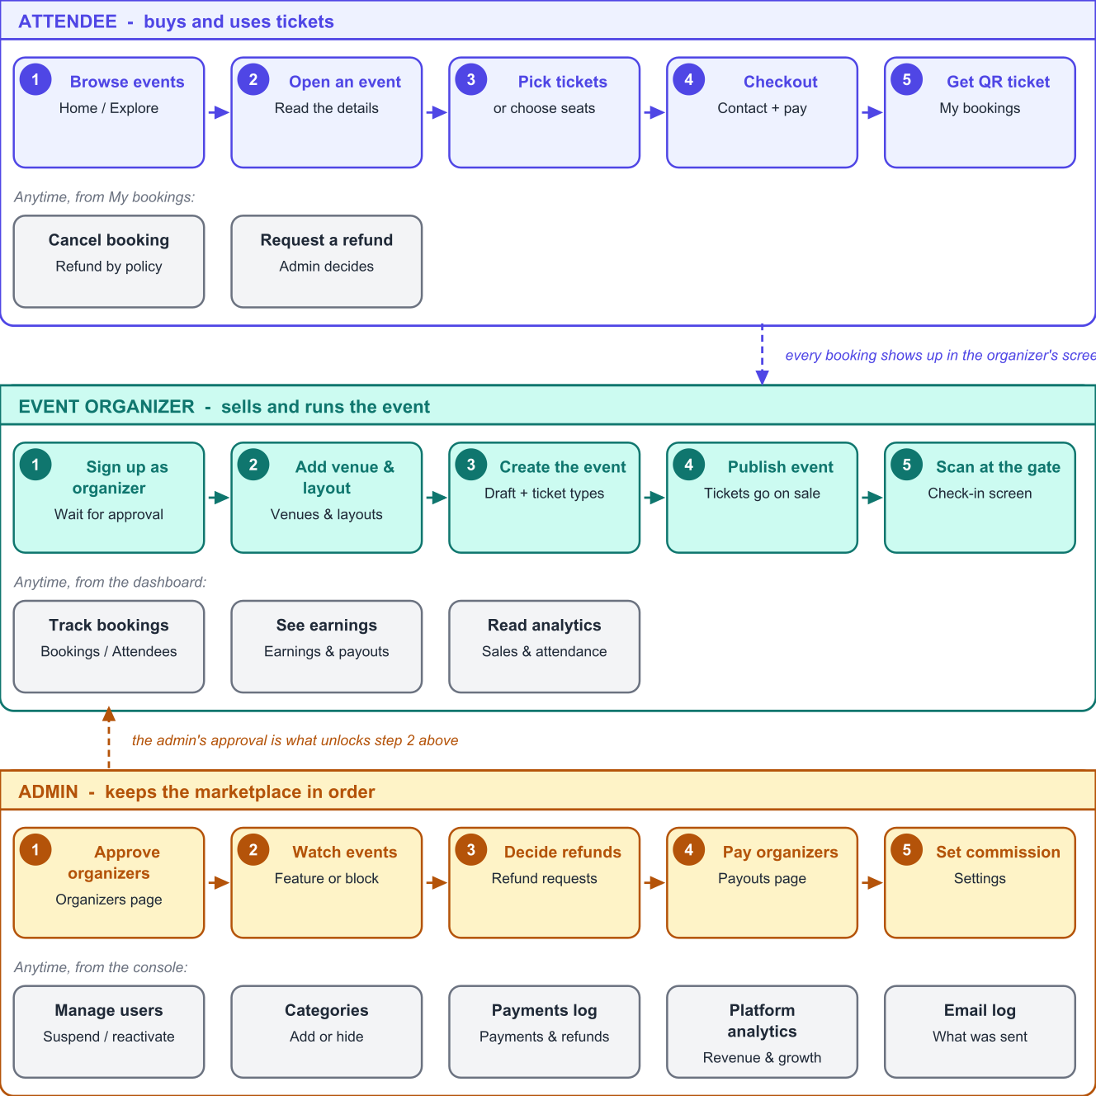
Figure 1.1: The platform at a glance - the three user roles and the order in which they use the system

1.2 Problem Statement
Manual and semi-digital ticketing suffers from a small set of problems that repeat across almost every organiser, and each of them has a direct financial or reputational cost:
1. Double selling of inventory. When two customers are served at the same moment from a spreadsheet or from two different counters, the same seat can be sold twice. The error surfaces only at the gate, when a paying customer has to be turned away.
2. Unverifiable tickets. A printed pass, a PDF or a screenshot can be photocopied or forwarded any number of times. Without a server-side check there is no way for gate staff to know whether a ticket has already been used.
3. Slow, unmeasured entry. Checking names against a printed list takes time per person, produces queues, and leaves the organiser with no trustworthy attendance figure afterwards.
4. Opaque money trail. Collections through several informal channels are hard to reconcile with the number of tickets sold, and harder still to reconcile with refunds given, commissions due and the final amount payable to the organiser.
5. Refunds handled by conversation. Cancellation terms differ per event and are applied inconsistently, because no rule is enforced by a system; disputes are settled over phone calls with no record.
6. No single source of truth. Sales, attendance and revenue live in different files, so the organiser cannot answer simple questions such as which ticket type sells fastest or what share of buyers actually attended.
A platform that solves these problems must therefore do more than display a list of events and accept a payment. It must guarantee that inventory can never be oversold even under simultaneous load, issue tickets that cannot be reused, work at the gate even when the venue has poor internet, and keep an auditable record of every rupee collected, refunded and paid out.

1.3 Objectives of the Project
The project was undertaken with the following concrete objectives, each of which is revisited in Chapter 12 to check whether it was met:
1. To design and implement a role-based platform serving three distinct roles - Attendee, Event Organizer and Administrator - from one code base, with the boundaries between them enforced on the server and not merely hidden in the interface.
2. To implement an inventory model for both reserved seating and general admission that makes overselling impossible, using database transactions and row-level locking rather than application-level checks.
3. To integrate an online payment flow that remains correct when the browser callback and the gateway webhook arrive in any order, more than once, or not at all.
4. To generate a digitally signed QR ticket for every seat sold, and to verify it at the gate in a way that permits exactly one successful entry per ticket.
5. To support gate operation on an unreliable network by allowing scans to be recorded offline on the device and reconciled with the server afterwards.
6. To compute all money in integer paise, so that commission, refunds and payouts are exact to the rupee and can be audited.
7. To provide organisers with sales, earnings and attendance analytics, and administrators with marketplace-wide moderation, dispute resolution and payout tools.
8. To make every screen usable on a mobile phone, since both attendees and gate staff work primarily from phones.
9. To validate the finished system through automated backend checks and manual interface testing, including deliberate concurrency tests.

1.4 Scope of the Project

1.4.1 Within scope
- Account registration and login for attendees and organisers, administrator-created admin accounts, role-based access control, and account self-service (profile, organisation details, payout details, password).
- Organiser workspace: venues, reusable seat layouts, events with a status life cycle, multiple ticket types with independent prices and sale windows, banner images, and event level sales dashboards.
- Attendee experience: search with multiple filters, event details, ticket and seat selection, time-limited reservation, checkout, payment, QR tickets, downloadable ticket and invoice documents, booking history, cancellation and refund requests.
- Payment handling through a provider abstraction, with a mock provider for development and demonstration and a real gateway integration (Razorpay-compatible) for production, including signature verification, webhook de-duplication and refunds.
- Gate operations: signed QR verification, single-use check-in, manual code entry, offline manifest and queued scan synchronisation, live attendance statistics and scan logs.
- Finance: per-order financial breakdown, commission (platform-wide and per-organiser override), organiser earnings, payout generation and settlement recording, refund request workflow, and sequential GST-style invoice numbering per financial year.
- Administration: organiser approval, user suspension, event moderation, category management, full payment and refund registers, platform analytics, commission settings, an activity log of every administrative action, and a log of every email the platform queued.

1.4.2 Outside scope
- Physical printing of tickets, turnstile hardware integration and RFID wristbands; the platform assumes a camera-equipped phone or laptop at the gate.
- Native Android and iOS applications. The web client is responsive and installable-ready, but no store-distributed application was built.
- Live seat-map collaboration between several simultaneous buyers (a reserved seat becomes unavailable on the next load or selection attempt rather than instantly for every open browser).
- Dynamic or surge pricing, seasonal discount engines, promotional coupon campaigns and loyalty points.
- Automated bank transfers to organisers. The platform computes and records payouts; the actual transfer is performed by the administrator through their bank and then recorded with its reference number.
- Multi-language and multi-currency operation. The interface is in English and all money is in Indian rupees.

1.5 Significance of the Work
The value of the platform is best seen from the point of view of each participant. For the attendee, the ticket is on the phone, the seat is guaranteed, the refund rule is stated before payment, and entry takes a single scan. For the organiser, the system removes both the fear of overselling and the manual effort of reconciling money, and replaces the entry register with a live attendance counter. For the platform administrator, every organiser is vetted before they can sell, every rupee is traceable, and disputes are decided on recorded evidence rather than recollection.
From an academic point of view, the project is a study in the correctness problems that appear the moment money and finite inventory meet concurrency: lost updates, double spending, duplicate side effects from retried network calls, and floating-point drift in financial arithmetic. Each of these is addressed explicitly in Chapters 7 and 10 rather than assumed away.

1.6 Organisation of the Report
Table 1.1: Structure of this report
Chapter | Contents
1 Introduction | Overview, problem statement, objectives, scope and significance.
2 Literature Review | Study of existing ticketing platforms and published work, with the gaps this project addresses.
3 System Analysis | Existing versus proposed system, feasibility study, functional and non-functional requirements, use cases, and system requirements.
4 System Design | Architecture, module decomposition, data flow diagrams, sequence diagrams for the critical flows, and interface design approach.
5 Database Design | Entity relationship design, table catalogue, constraints, indexing and the migration strategy.
6 Technology Stack | Every technology used, with the reason it was chosen over the alternatives.
7 Backend Implementation | The six backend phases, module by module, including the inventory, payment and check-in algorithms.
8 Frontend Implementation | The six frontend phases, the state management approach without Redux, and the responsive strategy.
9 Security Implementation | Authentication, authorisation, input validation, token signing, and the protections applied at each layer.
10 Testing and Validation | Test strategy, phase-wise results, concurrency and money correctness tests, the defect log and interface verification.
11 User Interface and Operating Flow | Screen inventory and the step-by-step operating flow for each of the three roles.
12 Results and Discussion | Objectives against outcomes, measured results and observations.
13 Limitations and Future Enhancements | Honest limitations of the present build and a prioritised enhancement roadmap.
14 Conclusion | Closing summary of the work.
References and Appendices | Sources consulted, the complete API reference, configuration reference and project structure.

Chapter 2 Literature Review and Study of Existing Systems

2.1 Purpose of the Review
Event ticketing is a mature commercial field, so the review was not aimed at finding an unsolved research problem. It was aimed at answering three practical questions: which features are treated as standard by established platforms and therefore must be present; which technical problems are known to be difficult and need an explicit design decision; and which needs of small and mid-sized Indian organisers are served poorly by the existing options.

2.2 Study of Existing Platforms

2.2.1 Large aggregator platforms
Aggregators such as BookMyShow and Ticketmaster operate at national scale with reserved-seat inventory, integrated payment, and QR or barcode entry. Their strengths are discovery - an attendee already visits them to see what is on - and trust. Their limitation, from an organiser's point of view, is control: listing decisions, commission terms, customer data and payout timelines are set by the platform, and a small organiser running four events a year has little visibility into the entry data or the sales funnel of their own event.

2.2.2 Self-service event platforms
Eventbrite and similar self-service platforms address exactly that gap. An organiser signs up, publishes an event and sells tickets within minutes, with a dashboard of sales and a check-in application. The model - self-service publishing with a percentage commission - is the model this project follows. Their weaknesses for the target user are that reserved-seat layouts are limited or paid-tier features, and that the finance view is tuned to card-based Western markets rather than to rupee settlement, GST-style sequential invoicing and manual bank transfers.

2.2.3 Venue box-office and in-house systems
Cinema and auditorium box-office systems handle seat maps and fast entry extremely well, because the seating plan is fixed and known. They are, however, tied to one venue and are not marketplaces: they have no concept of multiple independent organisers, of approving a new seller, or of commission and payouts. This project borrows their seat-map thinking and places it inside a multi-organiser marketplace.

2.2.4 Informal tools
The system this project most often replaces in practice is not software at all: a spreadsheet of bookings, a payment collected through a UPI handle, a message containing a pass image, and a printed list at the gate. This combination has no inventory guarantee, no duplicate-use detection and no financial reconciliation, which is precisely why the three guarantees in Section 2.5 were treated as non-negotiable.

2.3 Comparative Analysis
Table 2.1: Comparison of existing approaches with the proposed platform
Capability | Large aggregators | Self-service platforms | Box-office systems | Spreadsheet + messaging | This project
Multiple independent organisers | Yes | Yes | No | Not applicable | Yes
Organiser vetting before selling | Manual, opaque | Light or none | Not applicable | None | Explicit approval workflow
Reserved seat maps | Yes | Limited | Yes | No | Yes, organiser-built
Guaranteed no overselling | Yes | Yes | Yes | No | Yes, verified by test
Single-use verified entry | Yes | Yes | Yes | No | Yes, signed QR
Works offline at the gate | Partly | Partly | Usually wired | Not applicable | Yes, queued sync
Commission and payout records | Platform-controlled | Yes | Not applicable | Manual | Per event, auditable
Sequential invoice numbering | Yes | Partly | Yes | No | Per financial year
Organiser-visible attendance data | Limited | Yes | Yes | Manual count | Live and post-event
Self-hostable / owned data | No | No | Yes | Yes | Yes

2.4 Technical Background Studied
Four technical topics were studied before implementation, because each maps directly on to a failure mode identified in Section 1.2.

2.4.1 Concurrency control for finite inventory
The reservation problem is a textbook lost-update problem. Standard literature on transaction isolation describes three practical remedies: pessimistic row locking (SELECT ... FOR UPDATE), optimistic concurrency with a version column, and conditional updates whose WHERE clause re-states the pre-condition. This project uses pessimistic locking of the affected inventory rows combined with conditional updates, so that the pre-condition is re-checked by the database itself at the moment of writing rather than by application code that read the row earlier.

2.4.2 Idempotency in payment integrations
Every payment gateway documents the same warning: notifications may be delivered more than once, out of order, or simultaneously with the browser redirect. The accepted remedy is an idempotency key plus a record of processed notification identifiers, so that repeating a request produces the same result instead of a second effect. The project stores every webhook event identifier and treats confirmation as an operation that can be attempted any number of times with only the first one having an effect.

2.4.3 Signed tokens for offline-verifiable tickets
A QR code that contains only a ticket identifier can be guessed or enumerated; a QR code that contains a signature computed with a server-held secret cannot be forged without that secret. The project therefore encodes a compact token carrying a version marker, the ticket and event identifiers and a keyed hash (HMAC-SHA256). The signature proves authenticity without a database lookup, which is what makes offline gate operation possible; the database is still consulted, when reachable, to enforce single use.

2.4.4 Monetary arithmetic
Representing currency in binary floating point introduces small errors that accumulate across commission and refund calculations. The established practice, followed here, is to compute in the smallest currency unit as integers - paise - and to convert to rupees only for display and for storage in fixed-precision decimal columns.

2.5 Identified Gaps and Design Response
Table 2.2: Gaps found in the review and how the project responds
Gap identified | Design response in this project
Small organisers cannot get reserved seating without enterprise tooling | A reusable seat-layout builder attached to the organiser's own venue, free to use for every event held there.
Anyone can start selling on light-touch platforms, exposing attendees to risk | An organiser cannot publish or sell until an administrator approves the account; the rejection reason is emailed.
Entry breaks down when the venue network is weak | The gate screen can download the event manifest and keep scanning offline, then synchronise, with the earliest scan winning any conflict.
Money reconciliation is manual and error-prone | One financial calculation shared by sales reports, payouts and analytics, computed in paise, with commission frozen on each order at the moment of confirmation.
Refund terms are applied inconsistently | A machine-enforced cancellation policy per event, plus a recorded dispute workflow for everything outside it.
Organisers cannot see how many buyers actually attended | Attendance rate per event derived from scan records, shown to both the organiser and the administrator.

Chapter 3 System Analysis

3.1 Analysis of the Existing System
The existing system, in the environment this project targets, is a combination of a spreadsheet, a messaging application and a printed list. Its workflow is: the organiser announces the event on social media; interested attendees send a message; the organiser replies with a payment handle; the attendee pays and sends a screenshot; the organiser notes the name in a spreadsheet and sends back a pass image; at the venue a volunteer checks names against a printout.

3.1.1 Limitations of the existing system
- No inventory control. Two volunteers confirming bookings at the same time can commit the same seat twice, and there is no mechanism that prevents it.
- No authenticity check. A forwarded pass image is indistinguishable from the original.
- Manual effort scales linearly. Every booking costs the organiser several messages, a payment verification and a spreadsheet entry.
- Reconciliation is retrospective and unreliable. Totals are computed by hand after the event and rarely match the bank statement exactly.
- No analytics. Questions such as which ticket type sold out first, or how many buyers attended, cannot be answered from the records kept.
- No audit trail. There is no record of who changed a price, cancelled a booking or approved a refund.

3.2 Proposed System
The proposed system replaces the whole chain with one platform in which each role operates its own workspace and the database is the single source of truth. Inventory, money and entry are enforced by the server; the interface only presents what the server permits.
Table 3.1: Existing system compared with the proposed system
Aspect | Existing manual process | Proposed platform
Discovery | Social media posts, word of mouth | Searchable catalogue with category, city, date and price filters
Seat selection | Verbal or first-come at the gate | Interactive seat map, or quantity per ticket type
Reservation | An informal promise | A time-limited hold enforced by the database
Payment | Direct transfer, verified from a screenshot | Gateway checkout with server-verified confirmation and stored references
Ticket | Pass image, freely copyable | Signed QR ticket, verified and usable once
Entry | Name checked against a printed list | Scan in about a second, with live counters and offline support
Refunds | Negotiated per case | Automatic within the stated policy, recorded dispute workflow outside it
Settlement | Manual arithmetic after the event | Commission and earnings computed per order; payout recorded with a bank reference
Reporting | None, or a manual tally | Sales, revenue, refund and attendance analytics for organiser and administrator
Accountability | None | Audit log of every administrative and organiser action

3.3 Feasibility Study

3.3.1 Technical feasibility
Every capability required by the platform is available in mature, freely licensed technology. React and Tailwind CSS cover the interface including the seat map; Express on Node.js provides the API; PostgreSQL provides transactional guarantees, row-level locking and the relational integrity the finance model depends on. QR generation, PDF generation, keyed hashing and camera access in the browser are all solved problems with well-maintained libraries. The one genuinely delicate area - preventing oversold inventory - is solved by facilities the database provides directly. The project is therefore technically feasible without any proprietary component, and it was implemented and verified on ordinary developer hardware.

3.3.2 Economic feasibility
The entire stack is open source, so there is no licence cost. A single modest virtual server with a managed PostgreSQL instance is sufficient for the target load of small and mid-sized events. The only unavoidable running costs are the domain name, the server, transactional email delivery and the payment gateway's percentage, which is recovered through the platform commission that the system itself computes. For the purpose of this academic project the entire system runs on a local machine at zero cost.

3.3.3 Operational feasibility
The three interfaces were designed around what each role already knows. An attendee uses a flow that mirrors any e-commerce checkout. An organiser fills a form and presses a publish button, with a readiness checklist that states exactly what is still missing. Gate staff point a camera and read a green or red result - deliberately the simplest screen in the system, because it is used by temporary volunteers under time pressure. No training material beyond the operating guide is required.

3.3.4 Schedule feasibility
The work was planned as twelve incremental phases - six on the backend followed by six on the frontend - each ending in a testable increment rather than a partially working layer. This kept every phase independently verifiable and is the reason the defects listed in Chapter 10 were found early, while the affected code was still fresh.
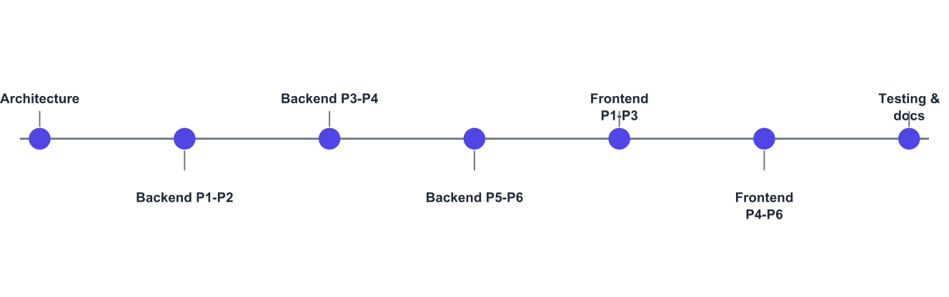
Figure 3.1: Development sequence followed during the project

3.4 Functional Requirements
Requirements are numbered by role so that they can be traced to the modules in Chapter 7 and to the test results in Chapter 10.

3.4.1 Attendee requirements
Table 3.2: Functional requirements - Attendee
ID | Requirement
FR-A1 | Register with name, email, phone and password; log in and log out; recover the session automatically on return.
FR-A2 | Browse published events and search by keyword, with filters for category, city, date range, price band and featured status, and sorting by date, price or relevance.
FR-A3 | View an event's full details: schedule, venue and address, organiser, description, ticket types with prices and availability, and the cancellation policy.
FR-A4 | Select a quantity per ticket type for general admission events, or select specific seats from a seat map for reserved seating events.
FR-A5 | Hold the chosen inventory for a limited period while completing payment, with the remaining time visible.
FR-A6 | Complete payment through the gateway and receive confirmation, with the booking confirmed exactly once even if the payment result is delivered twice.
FR-A7 | Receive one QR ticket per seat or per ticket, view it enlarged for scanning, and download the ticket and the tax invoice as PDF documents.
FR-A8 | View all bookings split into upcoming and past, and open any booking for its tickets, order summary and payment reference.
FR-A9 | Cancel a booking within the event's policy and receive the corresponding refund automatically.
FR-A10 | Raise a refund request with a reason when cancellation is no longer permitted, and be informed of the decision.
FR-A11 | Maintain profile details and change the account password; sign out of all devices.

3.4.2 Event Organizer requirements
Table 3.3: Functional requirements - Event Organizer
ID | Requirement
FR-O1 | Register as an organiser with organisation details and be informed that the account awaits approval; be unable to sell until approved.
FR-O2 | Create and maintain venues with address, city and capacity.
FR-O3 | Build a reusable seat layout for a venue as sections, rows and seats per row, and reuse it for any number of events at that venue.
FR-O4 | Create an event as a draft with title, description, category, schedule, venue and seating mode; upload a banner image; edit it while it is a draft.
FR-O5 | Define any number of ticket types per event, each with its own price, quantity, and sale start and end time; map tiers to seat sections for reserved events.
FR-O6 | See a readiness checklist and publish the event only when it is complete; close and reopen ticket sales; cancel an event with automatic refunds to all buyers.
FR-O7 | View bookings, the attendee list and sales performance per event, and export the attendee list for the gate.
FR-O8 | Operate check-in for an event: verify QR codes with the device camera or by typed code, see live scanned-versus-sold counters, review the scan log and undo a mistaken scan.
FR-O9 | Continue scanning without network access and synchronise the recorded scans afterwards.
FR-O10 | View earnings per event - gross sales, refunds, commission and net payable - and the status of each payout.
FR-O11 | View analytics: sales over time, ticket type performance and attendance rate.
FR-O12 | Maintain organisation profile and bank payout details.

3.4.3 Administrator requirements
Table 3.4: Functional requirements - Administrator
ID | Requirement
FR-D1 | See a dashboard of items needing attention and of platform performance over a chosen period.
FR-D2 | Review organiser applications with their organisation details, approve them, or reject them with a reason that is emailed to the applicant.
FR-D3 | List all users with role and status filters and search; suspend an account to block its access and reactivate it later; create additional administrator accounts.
FR-D4 | List every event on the platform; feature an event on the home page; block an event so attendees can no longer see or book it, while existing tickets stay valid.
FR-D5 | Manage event categories: create, hide from organisers, and delete when unused.
FR-D6 | Search every booking on the platform and inspect its tickets and payment.
FR-D7 | Inspect the complete register of payments and of refunds with reasons and statuses.
FR-D8 | Decide refund requests: approve a full or partial amount, choosing whether to cancel the tickets, or decline with a note; the attendee is emailed either way.
FR-D9 | Generate payouts for events that have finished and record settlement with a bank reference number.
FR-D10 | Set the platform commission percentage and override it for an individual organiser.
FR-D11 | View platform-wide analytics for revenue, booking value, tickets, refund rate and attendance.
FR-D12 | Inspect the activity log of all administrative actions and the log of every email the platform queued.

3.5 Non-Functional Requirements
Table 3.5: Non-functional requirements
Category | Requirement | How it is addressed
Correctness | Inventory must never be oversold, and a ticket must admit exactly one person. | Row-level locking with conditional updates inside transactions; single-use check-in through a conditional update. Verified by concurrency tests (Chapter 10).
Correctness | Monetary values must be exact. | All arithmetic in integer paise; storage in fixed-precision decimal columns.
Security | Only the right role may perform an action. | Signed access tokens with a rotating refresh token, plus role checks on every protected route, enforced on the server.
Security | Tickets must not be forgeable. | QR payload signed with a server-held secret using HMAC-SHA256.
Usability | Every screen must be usable on a phone. | Mobile-first layouts verified at 375 pixels width with no horizontal scrolling.
Performance | Listing and search pages should respond quickly under normal load. | Paginated queries, 72 database indexes, cached server state on the client, and route-level code splitting so each page downloads only its own code.
Reliability | A failed email or refund must not be lost. | Persistent outbox and refund retry with bounded attempts, driven by a background scheduler.
Availability | Gate operation must survive a network outage. | Offline manifest and queued scan synchronisation on the device.
Auditability | Every privileged action must be traceable. | Audit log rows recording actor, action, entity, metadata and time.
Maintainability | A new feature should touch one area only. | One module per domain with a routes / service / repository split; 15,947 lines of application code in 160 files.
Portability | The system should run on any ordinary server. | Only open-source runtime dependencies; all configuration through environment variables.

3.6 Use Case Analysis
Figure 3.2 shows the actors and the principal use cases. Gate staff are modelled as a separate actor because in practice a volunteer operates the scanner on the organiser's behalf, using the organiser's session on the device.
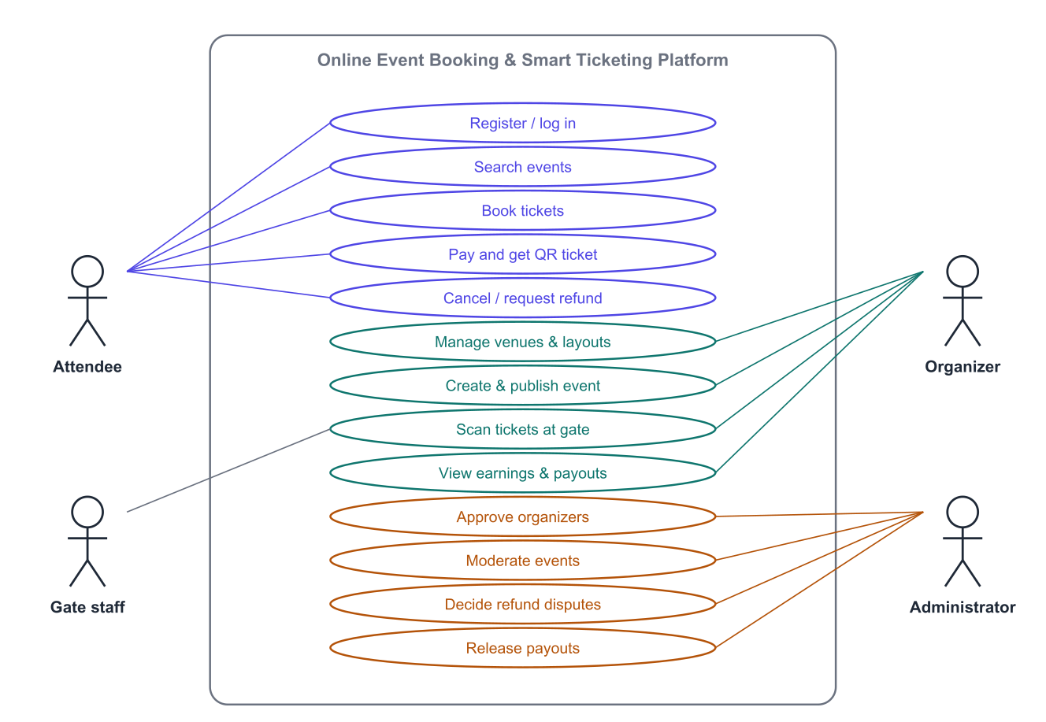
Figure 3.2: Use case diagram of the platform

3.6.1 Principal use case descriptions
Table 3.6: Use case: Book tickets for an event
Field | Description
Actor | Attendee (authenticated)
Pre-condition | The event is published, ticket sales are open, and the requested inventory is available.
Main flow | 1. Attendee opens the event page. 2. Selects seats or ticket quantities. 3. System reserves the inventory and creates a pending order with an expiry. 4. Attendee reviews contact details and the amount, and proceeds to pay. 5. The gateway reports success. 6. System confirms the order, issues one ticket per seat, assigns an invoice number and queues the confirmation email. 7. Tickets with QR codes are displayed.
Alternative flows | 3a. The inventory was taken in the meantime - the request is rejected and the selection refreshed. 5a. Payment fails - the order stays pending and may be retried until it expires. 5b. The hold expires before payment - inventory is released and the order is marked expired. 5c. Payment succeeds after expiry - the payment is recorded and refunded automatically.
Post-condition | Exactly one confirmed order exists with one valid ticket per seat, and the inventory count has decreased by exactly that number.

Table 3.7: Use case: Verify a ticket at the gate
Field | Description
Actor | Event Organizer or gate staff
Pre-condition | The event's check-in window is open and the operator is signed in for that event.
Main flow | 1. Operator opens the check-in screen for the event and names the gate. 2. The camera reads the attendee's QR code. 3. System verifies the signature and that the ticket belongs to this event. 4. System marks the ticket used only if it has not been used already. 5. A green result with the attendee's name and ticket type is shown and the counters update.
Alternative flows | 3a. Signature invalid or ticket belongs to another event - a red result is shown. 4a. The ticket was already scanned - an amber result is shown with the time and gate of the earlier scan. 2a. No camera or unreadable code - the operator types the ticket code instead. Network unavailable - the scan is queued on the device and uploaded later.
Post-condition | The ticket is recorded as used exactly once, with the gate name, the operator and the timestamp.

Table 3.8: Use case: Approve an organiser application
Field | Description
Actor | Administrator
Pre-condition | An organiser account exists with status awaiting approval.
Main flow | 1. Administrator opens the awaiting-approval list. 2. Reviews the organisation details. 3. Presses Approve. 4. System activates the account, records the action in the audit log and queues an approval email.
Alternative flows | 3a. The application is unsuitable - the administrator presses Reject and must supply a reason, which is stored and emailed. The organiser remains unable to publish events.
Post-condition | The organiser is either active and able to publish, or rejected with a recorded reason.

3.7 System Requirements

3.7.1 Software requirements
Table 3.9: Software requirements
Component | Requirement used in this project
Operating system (development) | Windows 11; the stack is equally supported on Linux and macOS
Runtime | Node.js 26.4 (any release from 20 onwards satisfies the declared engine)
Database | PostgreSQL 18
Package manager | npm 11
Browser | Any current Chrome, Edge, Firefox or Safari; camera check-in additionally requires an https or localhost address
Editor / tooling | Visual Studio Code, Git, psql command line
Email delivery | Any SMTP service; in development messages are written to disk as .eml files
Payment gateway | Razorpay-compatible provider; a built-in mock provider is used for development and demonstration

3.7.2 Hardware requirements
Table 3.10: Hardware requirements
Role | Minimum | Used during development
Development machine | Dual-core processor, 4 GB RAM, 5 GB free disk | Quad-core processor, 16 GB RAM, SSD
Application server | 1 vCPU, 1 GB RAM | Local machine
Database server | 1 vCPU, 1 GB RAM, storage proportional to ticket volume | Local PostgreSQL instance
Attendee device | Any smartphone or computer with a modern browser | Desktop browser and a 375-pixel-wide mobile viewport
Gate device | Smartphone with a rear camera | Browser camera on localhost, plus manual code entry

Chapter 4 System Design

4.1 Design Goals
Four goals shaped every design decision in this chapter. First, the server owns the truth: the interface may hide a button, but the rule behind it is always enforced again in the API, so a crafted request cannot bypass it. Second, correctness under concurrency is a database concern, not an application concern, so the design places every inventory and money decision inside a transaction. Third, modules are replaceable: the payment provider, the email transport and the file storage are all reached through a thin abstraction so that any one of them can be swapped without touching business logic. Fourth, every consequential action leaves a record, which is why audit, payment, refund, scan and email tables exist alongside the operational tables.

4.2 System Architecture
The platform follows a four-tier arrangement: browser clients, the React application, the Express API, and the data tier. The client and the API are deployed separately and share nothing but the REST contract; in development a proxy makes them appear on one origin so that cookies behave exactly as they will in production.
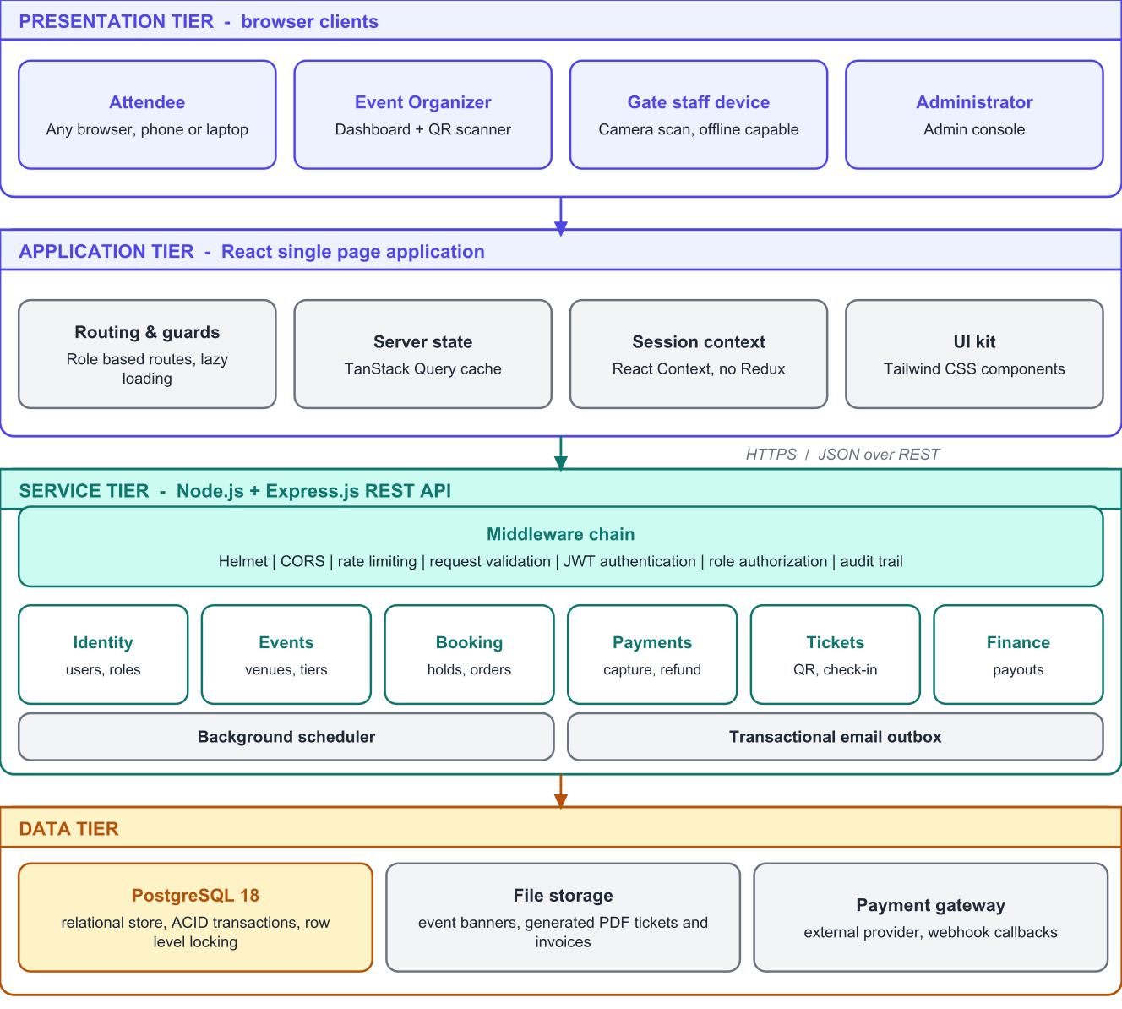
Figure 4.1: Four-tier architecture of the platform

4.2.1 Responsibilities of each tier
Table 4.1: Tier responsibilities
Tier | Responsibility | Explicit non-responsibility
Browser clients | Rendering, camera access for scanning, local caching of the offline gate manifest. | No business rule, no secret, no price calculation.
React application | Routing and role-based navigation, forms and validation feedback, server-state caching, session refresh, presentation of money and dates in Indian conventions. | Never the final authority on permissions or amounts.
Express API | Authentication, authorisation, validation, all business rules, transactions, document generation, scheduled jobs, integration with the gateway and the mail transport. | No rendering, no session state held in process memory.
Data tier | Durable storage, relational integrity, row-level locking, uniqueness and check constraints, aggregate queries. | No application logic beyond constraints and triggers for timestamps.

4.2.2 Why a modular monolith
The API is organised as a modular monolith rather than as microservices. The decisive argument is transactional integrity: holding inventory, recording a payment, issuing tickets and assigning an invoice number must either all happen or none happen. Inside one process with one database this is a single transaction; split across services it would require a distributed saga with compensating actions, which would add considerable complexity and new failure modes for no benefit at the scale this platform targets. The module boundaries are nevertheless strict, so any module could later be extracted if load ever justified it.

4.3 Module Decomposition
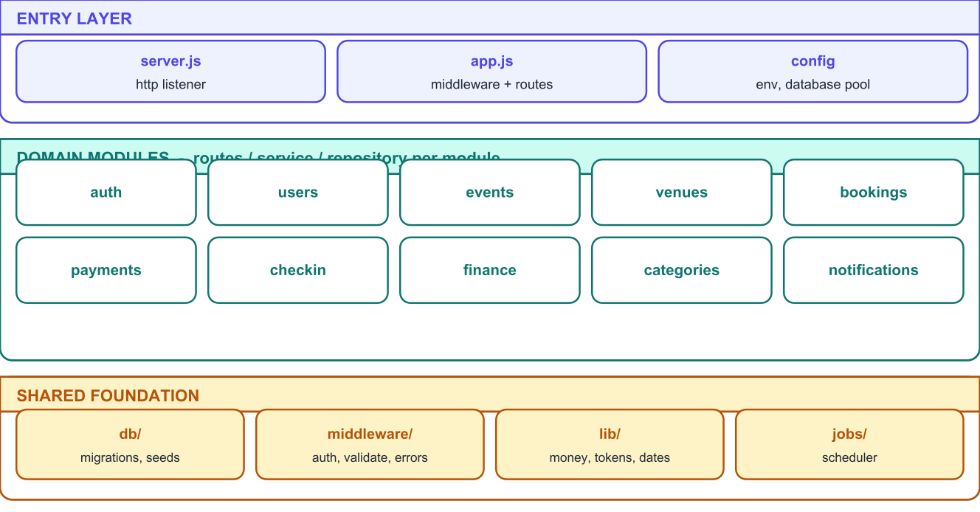
Figure 4.2: Backend module structure
Every domain module has the same internal shape, which makes the code base predictable: a routes file that declares endpoints and attaches validation and role guards, a service file that holds the business rules and owns transactions, a repository file that holds SQL, and a validation file that declares the accepted shape of every request. Nothing outside a module reaches into its repository.
Table 4.2: Backend modules and their responsibilities
Module | Endpoints | Responsibility
auth | 6 | Registration, login, logout, token refresh with rotation, password change.
users | 2 | Current user profile and profile updates.
events | 22 | Categories in context, event life cycle, ticket tiers, banner upload, public catalogue with search and filters, seat map, administrative moderation.
venues | 10 | Venues and reusable seat layouts, including layout generation into individual seats.
bookings | 14 | Inventory holds, order creation and cancellation, order documents, attendee booking history, organiser booking views.
payments | 8 | Checkout intent, browser callback, gateway webhook, capture recording, refund initiation and retries.
checkin | 8 | QR verification, single-use scan, offline manifest, queued scan synchronisation, undo, live statistics and scan log.
finance | 11 | Order financial breakdown, sales summaries, organiser earnings, payout generation and settlement, refund requests, platform analytics, commission settings.
categories | 4 | Category catalogue and administrative maintenance.
notifications | - | Template rendering and the transactional email outbox consumed by the scheduler.

4.3.1 Cross-cutting concerns
- Middleware chain - security headers, cross-origin policy, request logging, rate limiting, cookie parsing, JSON parsing, schema validation, authentication, authorisation, and a single error handler that converts every failure into the same response envelope.
- Money library - conversion to and from paise and percentage calculation, used by every module that touches an amount, so that rounding happens in exactly one place.
- Token library - access token signing, refresh token hashing and the signed QR ticket token.
- Scheduler - an in-process timer that expires stale holds, dispatches the email outbox, retries refunds, generates payouts for finished events and sends event reminders.
- Audit writer - a single helper used by every privileged operation, so the activity log cannot be forgotten by an individual service.

4.4 Data Flow Design

4.4.1 Context level (level 0)
At the context level the platform is one process exchanging data with four external entities: the attendee, the organiser, the administrator and the payment gateway. All persistent state lives in the single relational store.
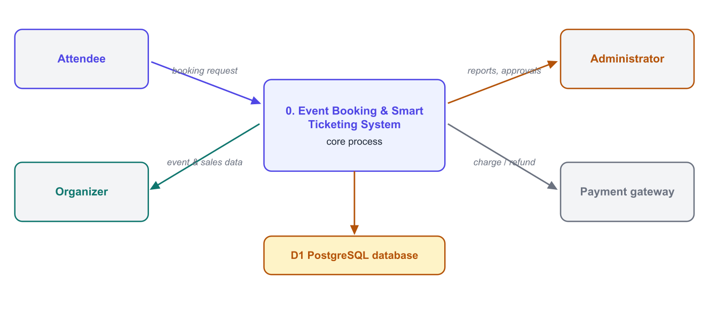
Figure 4.3: Level 0 data flow diagram (context diagram)

4.4.2 Level 1 decomposition
Decomposing the single process yields the six functional areas shown in Figure 4.3. The areas are deliberately aligned with the backend modules so that the design maps one to one on to the implementation.
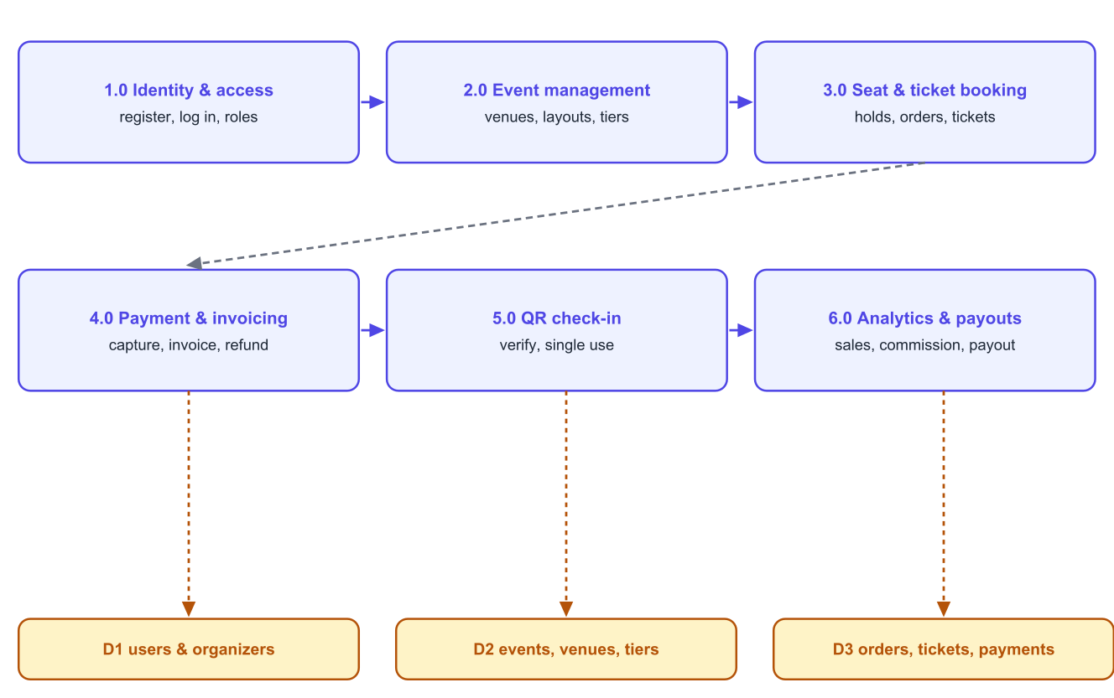
Figure 4.4: Level 1 data flow diagram
Table 4.3: Processes, inputs and outputs
Process | Principal inputs | Principal outputs
1.0 Identity and access | Credentials, registration details, administrator decisions | Session tokens, role and status, audit entries, account emails
2.0 Event management | Venue, layout, event and tier definitions, banner image | Published catalogue entries, seat inventory, seat map
3.0 Seat and ticket booking | Seat or quantity selection, cancellation requests | Held and confirmed orders, released inventory, order documents
4.0 Payment and invoicing | Gateway callbacks and webhooks, refund decisions | Payment records, tickets, invoices, refunds, confirmation emails
5.0 QR check-in | Scanned tokens, typed codes, queued offline scans | Entry decisions, scan log, live attendance counters
6.0 Analytics and payouts | Confirmed orders, refunds, scans, commission settings | Sales summaries, earnings, payouts, platform analytics

4.5 Process Design of the Critical Flows
Three flows carry the entire risk of the platform: reserving inventory, confirming a payment, and admitting a ticket holder. Each is designed so that the worst case - two simultaneous requests, a duplicated notification, a repeated scan - produces a correct result rather than a plausible-looking wrong one.

4.5.1 Reserving inventory
The reservation transaction locks the affected rows, re-checks availability in the WHERE clause of the update, and rolls back entirely if the number of affected rows does not equal the number requested. Because the re-check happens inside the database at write time, two concurrent buyers cannot both succeed for the same seat.
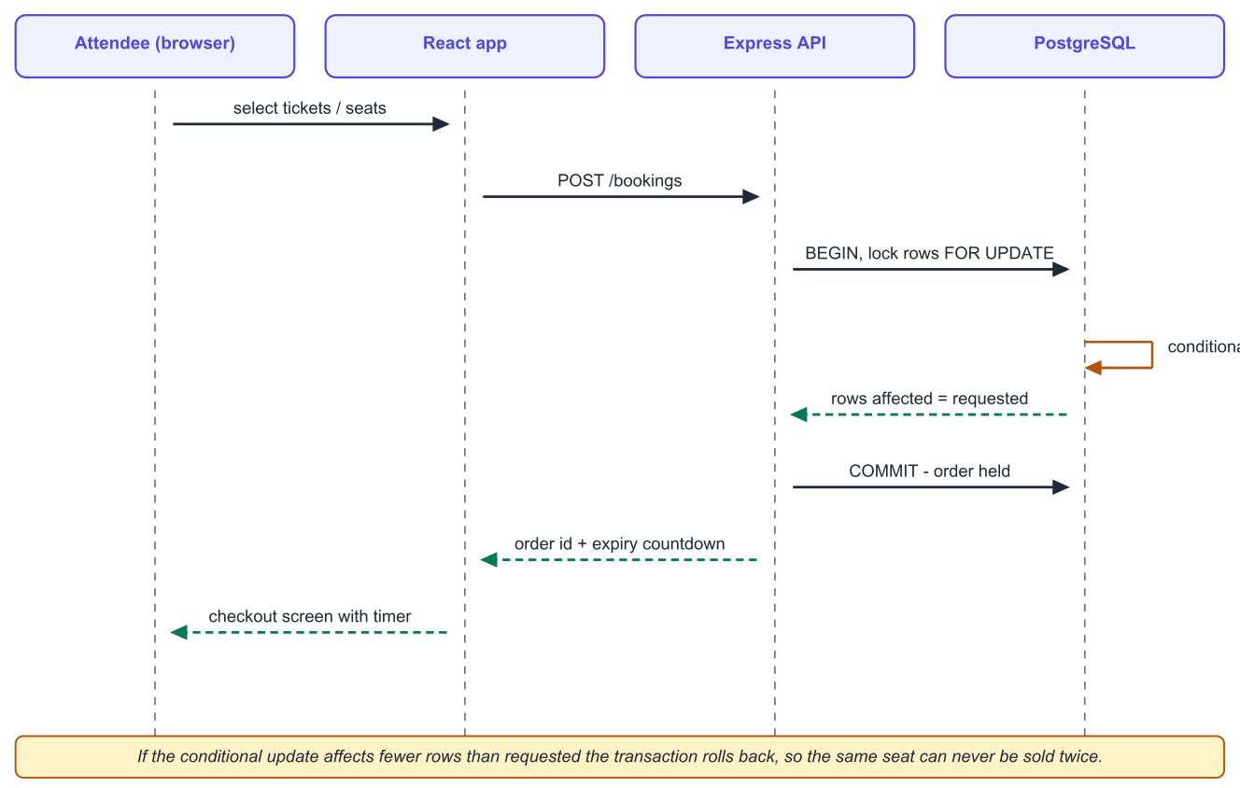
Figure 4.5: Sequence diagram - reserving seats and creating a pending order

4.5.2 Confirming a payment
Confirmation can be triggered by the browser returning from the gateway or by the gateway's server-to-server webhook, and either may arrive first, twice, or not at all. The design makes confirmation idempotent: the signature is verified, the event identifier is recorded in a de-duplication table, the order is locked, and the confirmation work - status change, ticket issue, invoice number, commission freeze, email queue - happens only if the order is not already confirmed.
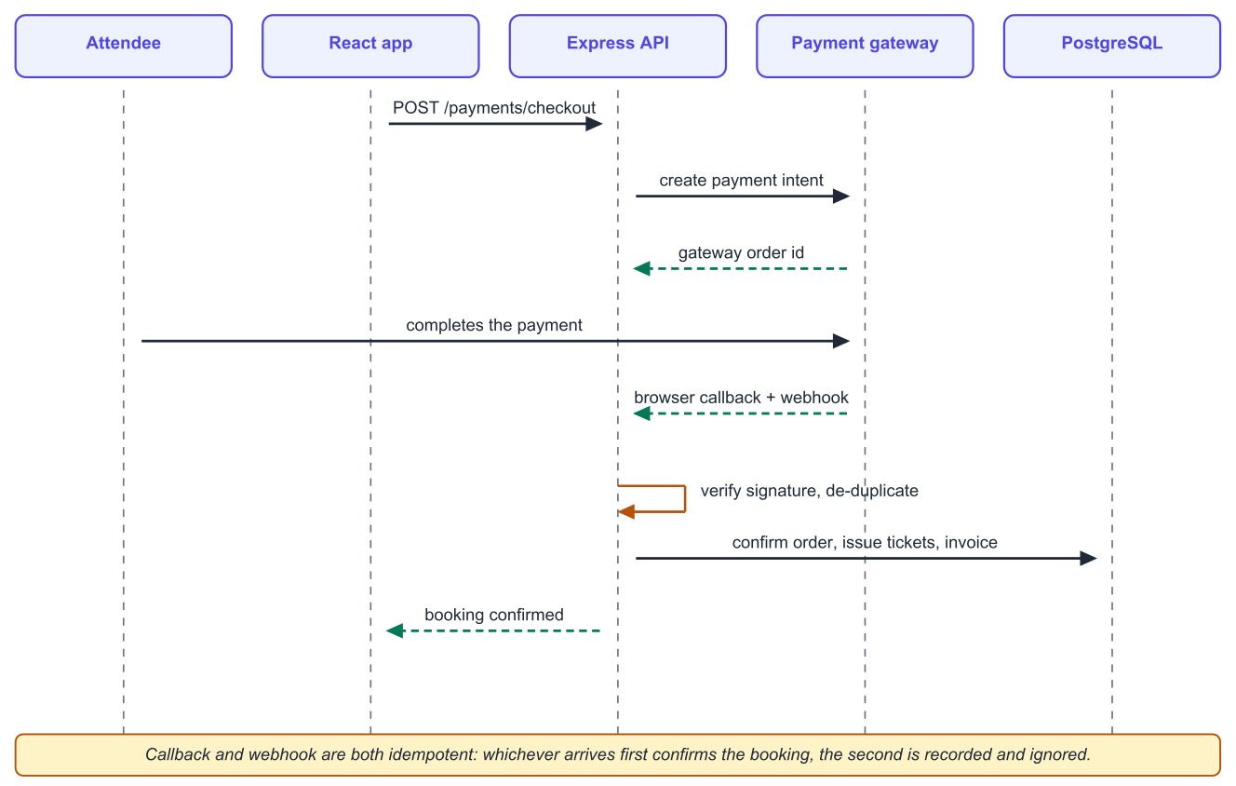
Figure 4.6: Sequence diagram - payment confirmation from either direction

4.5.3 Admitting a ticket holder
A scan decides entry in two stages. The signature in the token proves the ticket is genuine and belongs to this event; a conditional update that sets the check-in timestamp only where it is currently empty decides whether this is the first scan. The database, not the application, arbitrates between two gates scanning the same code at the same instant.
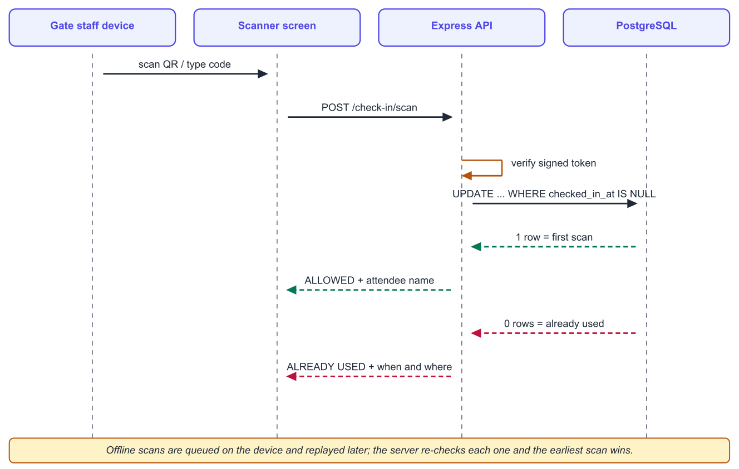
Figure 4.7: Sequence diagram - single-use QR verification at the gate

4.5.4 Offline gate operation
When the network is unavailable the gate screen works from a manifest of valid tickets downloaded in advance and stores each scan locally with its own timestamp. On reconnection the queued scans are uploaded together; the server re-applies every rule and, where the same ticket was scanned at two gates, keeps the earliest scan and reports the conflict. This keeps the offline path convenient without making it authoritative.

4.6 Interface Design Approach

4.6.1 Information architecture
Each role has its own navigation shell. Attendees use a public top bar, because they move between browsing and their own bookings. Organisers and administrators use a left-hand dashboard menu grouped by task - for the administrator, Marketplace, Finance and System - because their work is a set of parallel responsibilities rather than a linear journey. On narrow screens the same menu collapses into a drawer.

4.6.2 Visual language
Table 4.4: Interface conventions applied across all screens
Element | Convention
Colour | One indigo brand colour for primary actions; green, amber and rose reserved strictly for success, caution and danger, so a scan result or a booking status is readable at a glance.
Status | Every entity that has a life cycle - event, order, payment, payout, refund request - renders as a coloured badge with the same vocabulary everywhere.
Money | Always formatted in Indian rupee grouping; free tickets show as "Free" rather than a zero amount.
Dates | Always in India Standard Time with the time zone applied on entry and display, so an organiser in another time zone cannot accidentally publish a shifted schedule.
Tables | A dense table on wide screens becomes a stack of labelled cards on a phone, instead of forcing horizontal scrolling.
Feedback | Loading skeletons for first loads, inline field errors for validation, and toast notifications for the result of an action.
Empty states | Every list explains what would appear there and offers the action that creates the first item.

4.6.3 Responsive strategy
Layouts were written mobile-first: the single-column arrangement is the base, and wider breakpoints add columns. Three screens needed special treatment. The seat map scrolls horizontally inside its own container with an explicit hint, because a seating plan cannot be reflowed. The checkout summary moves from a sticky sidebar to a block above the pay button. The gate scanner keeps the camera surface mounted while its result overlay is shown, so switching views never restarts the camera.

4.7 API Design Conventions
The API is REST over JSON with a single response envelope, so that the client has exactly one success path and one error path to handle. Every list endpoint is paginated and returns its total; every error carries a machine-readable code and a message written for an end user.
{ "success": true, "data": { ... }, "meta": { "page": 1, "total": 42 } }
{ "success": false, "message": "Only 2 tickets are left in this category",
"code": "INSUFFICIENT_INVENTORY", "errors": { ... } }
Table 4.5: API conventions
Concern | Convention
Versioning | Every route is mounted under /api/v1, so a future incompatible change can live beside it.
Naming | Plural resource nouns and sub-resources, for example /events/:id/tiers; actions that are not CRUD use a verb segment such as /events/:id/publish.
Status codes | 200 success, 201 created, 400 validation, 401 unauthenticated, 403 forbidden, 404 not found, 409 conflict (for example inventory taken), 422 business rule violation, 429 rate limited.
Validation | Declared per route as a schema for body, query and parameters; failures return field-level messages that the client maps directly on to form fields.
Authentication | Bearer access token in the Authorization header; the refresh token travels only as an http-only cookie.
Idempotency | Payment confirmation, check-in and refund initiation are safe to repeat; duplicate webhook deliveries are recorded and ignored.
Pagination | page and limit query parameters with a bounded maximum, and a total count in the meta block.

Chapter 5 Database Design

5.1 Design Principles
The schema was designed around four rules. Money is stored in fixed-precision decimal columns and never in floating point. Status values are real database enumerated types, so an invalid state cannot be written even by a direct SQL statement. Historical financial facts are frozen on the row that records them - the commission percentage applicable to an order is stored on that order, so a later change of the platform rate cannot retroactively alter past earnings. Finally, records that carry legal or financial meaning, such as payments, refunds, invoices and scans, are append-only in practice: they are superseded by a new row rather than edited.

5.2 Entity Relationship Design
Figure 5.1 shows the principal entities and their relationships. The full schema contains 23 application tables; the diagram omits purely operational tables such as the refresh token store, the webhook de-duplication table, the email outbox and the audit log, which are described in Section 5.3.
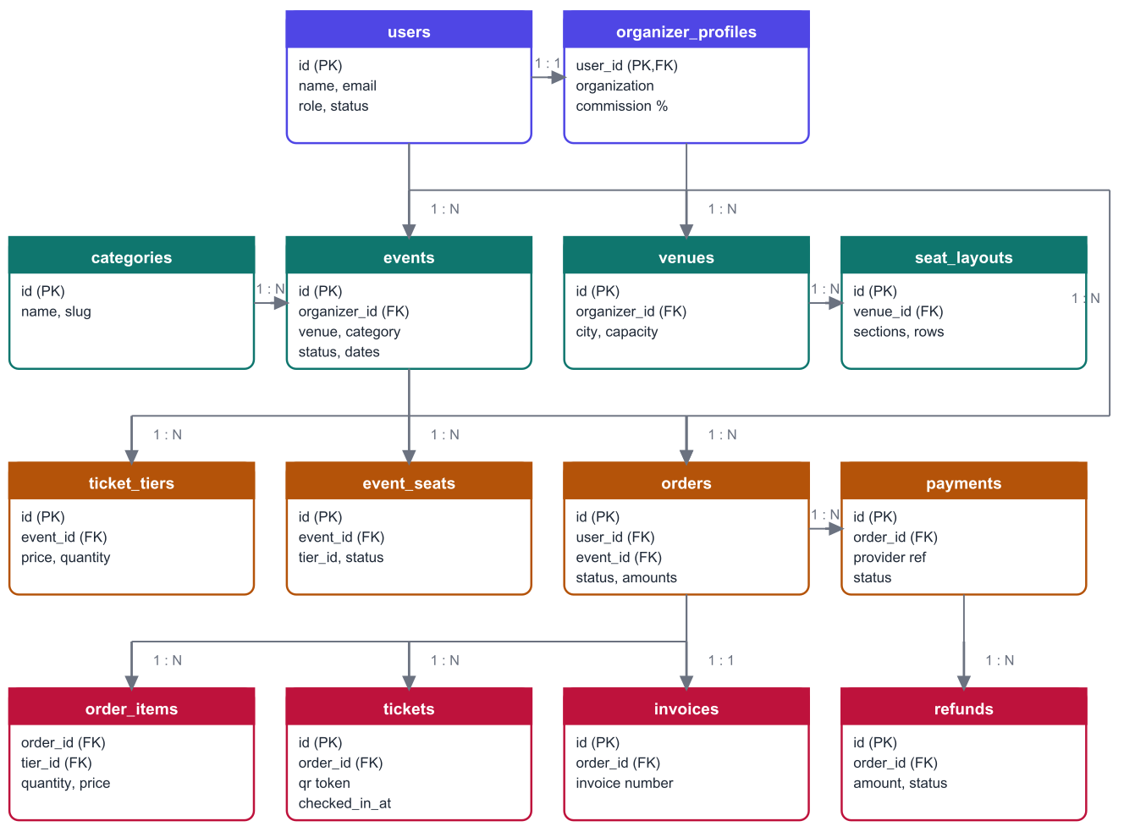
Figure 5.1: Entity relationship diagram of the principal entities

5.2.1 Relationship summary
Table 5.1: Principal relationships and their meaning
Relationship | Type | Meaning
users - organizer_profiles | 1 : 1 | An organiser account carries one organisation profile holding the display name, city, contact details, bank payout details and an optional commission override.
users - events | 1 : N | An approved organiser owns many events.
organizer_profiles - venues | 1 : N | Venues belong to the organiser who created them and are private to that organiser.
venues - seat_layouts | 1 : N | A venue may have several layouts, for example a seated and a standing configuration.
categories - events | 1 : N | Each event belongs to exactly one category, which drives browsing and colour coding.
events - ticket_tiers | 1 : N | Each event has one or more priced ticket types with independent quantities and sale windows.
events - event_seats | 1 : N | For a reserved-seating event the layout is expanded into one row per physical seat, each carrying its own status.
events - orders | 1 : N | All bookings for an event.
orders - order_items | 1 : N | The quantity and unit price captured per ticket type within one booking.
orders - payments | 1 : N | A booking may involve several payment attempts; at most one capture matters.
orders - tickets | 1 : N | One ticket per seat or per admission, each with its own signed QR token and check-in state.
orders - invoices | 1 : 1 | A confirmed booking receives exactly one sequentially numbered invoice.
orders - refunds | 1 : N | Full or partial refunds, each with a reason and a processing status.
events - payouts | 1 : 1 | One payout per finished event, enforced by a unique constraint on the event.

5.3 Table Catalogue
The 23 application tables fall into five groups. Column lists below are abbreviated to the columns that carry design intent.

5.3.1 Identity and access
Table 5.2: Identity and access tables
Table | Key columns | Notes
users | id, name, email (unique), password_hash, phone, role, status, last_login_at | role and status are enumerated types; suspension is a status change, so no separate flag can drift out of step.
organizer_profiles | user_id (PK, FK), organization_name, city, gst_number, payout_details (JSONB), commission_percent, reviewed_by, reviewed_at, rejection_reason | A null commission means the platform default applies. Bank details are JSONB because their shape may evolve.
refresh_tokens | id, user_id, token_hash, family_id, replaced_by, revoked_at, expires_at | Only a hash of the token is stored. family_id allows an entire session lineage to be revoked when reuse is detected.
audit_logs | id, actor_id, action, entity_type, entity_id, metadata (JSONB), ip, created_at | Written by every privileged operation; read by the administrator activity log.

5.3.2 Catalogue and inventory
Table 5.3: Catalogue and inventory tables
Table | Key columns | Notes
categories | id, name, slug (unique), colour, is_active, sort_order | Deactivating hides a category from organisers without affecting existing events.
venues | id, organizer_id, name, address, city, capacity | Scoped to the owning organiser.
seat_layouts | id, venue_id, name, sections (JSONB), total_seats | The layout definition is a document; expansion into rows happens per event.
events | id, organizer_id, venue_id, category_id, slug (unique), title, description, start_at, end_at, status, seating_mode, layout_id, banner_path, is_featured, is_blocked, cancellation_policy (JSONB) | The status enumeration is draft, published, sales_closed, cancelled and completed. is_blocked is an administrative override independent of the organiser's own status.
ticket_tiers | id, event_id, name, price, quantity, sold_count, sale_start_at, sale_end_at, section_keys | sold_count is maintained transactionally against quantity; the pair is what makes general-admission overselling impossible.
event_seats | id, event_id, tier_id, section, row_label, seat_number, status, order_id | One row per physical seat with a unique constraint on the seat's position within the event; status moves between available, held, booked and blocked.

5.3.3 Booking and payment
Table 5.4: Booking and payment tables
Table | Key columns | Notes
orders | id, order_number (unique), user_id, event_id, status, subtotal, convenience_fee, total_amount, refund_amount, commission_percent, contact_name, contact_email, contact_phone, hold_expires_at, confirmed_at, cancelled_at | The commission percentage is copied on to the order when it is confirmed, freezing the commercial terms of that sale.
order_items | id, order_id, tier_id, quantity, unit_price, subtotal | Unit price is copied so that a later price change does not rewrite history.
payments | id, order_id, provider, provider_order_id, provider_payment_id, amount, status, method, signature_verified, raw_payload (JSONB), captured_at | Every attempt is recorded, including failures and late captures that are refunded automatically.
payment_webhook_events | id, provider, event_id (unique), payload, processed_at | The de-duplication table that makes repeated webhook delivery harmless.
tickets | id, order_id, event_id, tier_id, seat_id, ticket_code (unique), attendee_name, status, checked_in_at, checked_in_by, gate_name | checked_in_at being null is the pre-condition that the conditional update tests, giving single-use entry.
invoices | id, order_id (unique), invoice_number (unique), financial_year, issued_at, seller_details (JSONB), amounts | Numbers are gapless within a financial year.
invoice_sequences | financial_year (PK), last_number | A single row per financial year, locked while a number is allocated.
refunds | id, order_id, payment_id, amount, reason, status, provider_refund_id, attempts, last_error, processed_at | Retried by the scheduler up to a bounded number of attempts.

5.3.4 Entry and settlement
Table 5.5: Entry and settlement tables
Table | Key columns | Notes
check_in_logs | id, ticket_id, event_id, scanned_by, gate_name, result, scanned_at, synced_at, source | Records every scan attempt, including rejected and duplicate ones, which is what makes gate disputes resolvable.
payouts | id, organizer_id, event_id (unique), gross_sales, refunds, commission, amount, status, reference, notes, paid_by, paid_at | The unique constraint on the event prevents a second payout for the same event; a check constraint requires a positive amount.
refund_requests | id, order_id, user_id, reason, status, admin_note, refund_id, resolved_by, resolved_at | The dispute workflow for cases outside the automatic cancellation policy.
email_outbox | id, to_email, template, subject, payload (JSONB), status, attempts, error, sent_at | Queued inside the same transaction as the business change, dispatched by the scheduler, so a mail failure can never roll back a booking.
platform_settings | key (PK), value (JSONB), updated_by, updated_at | Holds the platform commission percentage and any future global setting.
schema_migrations | filename (PK), applied_at | The ledger used by the migration runner to decide what still needs to run.

5.4 Constraints, Integrity and Indexing
Table 5.6: Integrity mechanisms used in the schema
Mechanism | Where it is applied | What it prevents
Enumerated types | User role and status, event status, order status, payment status, payout status, refund status | Invalid state values, including from direct SQL
Unique constraints | Email, event slug, order number, ticket code, invoice number, seat position within an event, payout per event, webhook event id | Duplicate identities, duplicate payouts, replayed webhooks
Check constraints | Positive payout amount, non-negative quantities and amounts | Nonsensical financial rows
Foreign keys | Every relationship in Figure 5.1 | Orphan rows such as a ticket without an order
Row-level locking | Tier and seat rows during reservation; the order row during confirmation; the invoice sequence row during numbering | Lost updates, double confirmation, duplicate invoice numbers
Conditional updates | Seat and tier reservation, ticket check-in | Overselling and double entry, without relying on an earlier read
Triggers | Automatic updated_at maintenance | Stale modification timestamps
Indexes (72 in total) | Foreign keys, status columns, event slug, order number, ticket code, organiser and date ranges used by reports | Slow catalogue browsing, slow dashboards and slow scans

The most delicate index decision concerned payments. An early version of the schema carried a unique index allowing only one captured payment per order. That looked correct, but it made a legitimate case impossible to record: a payment captured by the gateway after the hold had already expired, which the platform must store and then refund automatically. The index was removed and the invariant moved into the confirmation logic, which was the right place for it. Section 10.5 describes how the test suite exposed this.

5.5 Migration Strategy
The schema is created and evolved by six ordered SQL migration files executed by a small custom runner. The runner reads the schema_migrations ledger, applies only the files that have not been applied, and wraps each file in a transaction so that a failed migration leaves nothing behind. The approach was chosen over an ORM's migration tool because the schema deliberately uses PostgreSQL features - enumerated types, JSONB columns, partial and composite indexes, FOR UPDATE locking - that are expressed most clearly in plain SQL.
Table 5.7: Migration files
File | Contents
001_identity.sql | Enumerated types, users, organizer profiles, refresh tokens, audit logs, updated-at trigger function
002_catalogue.sql | Categories, venues, seat layouts
003_events.sql | Events, ticket tiers, event seats and their indexes
004_payments_tickets_invoices.sql | Orders, order items, payments, webhook events, tickets, invoices, invoice sequences, refunds
005_checkin.sql | Check-in log and the check-in columns on tickets
006_finance.sql | Payouts, refund requests, email outbox, platform settings

Two seed scripts accompany the migrations. The first creates the initial administrator from environment configuration and the standard event categories; the second, used only for demonstration, creates an approved organiser, an attendee, eight venues and twelve events spread across categories and cities, together with sample bookings, a refund and an open refund request.

Chapter 6 Technology Stack

6.1 Overview of the Stack
Table 6.1: Technology stack with exact versions used
Layer | Technology | Version | Role in the project
Client framework | React | 19.3 | Component model for all 36 screens
Build tool | Vite | 8.3 | Development server with hot reloading and the production bundler
Styling | Tailwind CSS | 4.3 | Utility-first styling with a project brand palette
Routing | React Router | 8.4 | Data router with per-route code splitting
Server state | TanStack Query | 5.103 | Caching, refetching and invalidation of API data
Forms | React Hook Form + Zod | 7.88 + 3.25 | Form state and shared validation schemas
Icons and feedback | Lucide React, React Hot Toast | 1.46, 2.6 | Icon set and toast notifications
QR scanning | qr-scanner | 1.4 | Camera decoding on the gate screen, loaded on demand
Runtime | Node.js | 26.4 | JavaScript runtime for the API (declared engine: 20 or later)
API framework | Express | 5.2 | Routing and middleware
Database | PostgreSQL | 18 | Relational store and transactional guarantees
Database driver | node-postgres (pg) | 8.23 | Pooled access and parameterised queries
Validation | Zod | 4.6 | Request schema validation on the server
Authentication | jsonwebtoken, bcryptjs | 9.0, 3.0 | Access token signing and password hashing
Security middleware | Helmet, CORS, express-rate-limit | 8.3, 2.8, 8.7 | Headers, origin policy and request throttling
Documents | PDFKit, qrcode | 0.20, 1.5 | Ticket and invoice PDFs, QR images
Email | Nodemailer | 10.0 | SMTP delivery, with file output in development
Uploads | Multer | 2.4 | Banner image upload handling

6.2 Rationale for Key Choices

6.2.1 React with Tailwind CSS
The interface has a small number of visual patterns - cards, tables that become card stacks, badges, modals, forms - repeated across 36 screens, which is exactly what a component model is for. Tailwind was chosen over component libraries such as Material UI or Bootstrap because the project needed a specific visual identity and, more importantly, precise control over responsive behaviour on the seat map and dense administrative tables. Utility classes also keep the responsive rules beside the markup they affect, which made verification at phone width straightforward.

6.2.2 State management without Redux
Redux was deliberately not used, and the project requirement to avoid it turned out to match good practice for this application. Almost all state here is server state - events, bookings, payouts - which needs caching, revalidation and invalidation rather than reducers; TanStack Query provides exactly that and removes the boilerplate of storing server data in a global store. The only genuinely global client state is the signed-in user, which lives in a small React context. Everything else is local component state. The result is fewer moving parts and no manual synchronisation between a cache and a store.
Table 6.2: How each kind of state is handled
Kind of state | Example | Mechanism
Server data | Event list, booking details, payouts | TanStack Query cache keyed by query, invalidated after mutations
Session | Signed-in user, role, access token | React context; the access token is held in memory only
Form state | Event form, checkout contact details | React Hook Form with a Zod schema
Ephemeral interface state | Open modal, active tab, selected seats | Local component state
URL state | Search text, filters, page number, active tab | Query parameters, so a filtered list can be shared or bookmarked
Device-local state | Offline gate manifest and queued scans | Browser local storage on the gate device

6.2.3 Express on Node.js
Express was chosen for its explicit middleware model: authentication, authorisation, validation and error handling are visible as an ordered chain rather than hidden behind conventions. Sharing one language across client and server also allowed the validation vocabulary and the money formatting rules to be reasoned about once. The API keeps no session state in process memory, so it can be run as several instances behind a load balancer without change.

6.2.4 PostgreSQL
PostgreSQL was the only choice that satisfied the correctness requirements directly. The project needs multi-row transactions, SELECT ... FOR UPDATE locking, enumerated types, fixed-precision decimals, JSONB for semi-structured details, and expressive aggregate queries for analytics. A document database would have required the application to imitate these guarantees, which is exactly the class of mistake the project set out to avoid.

6.2.5 Plain SQL instead of an ORM
Queries are written as parameterised SQL in repository modules rather than through an object-relational mapper. The decisive reasons were control and clarity: the reservation and financial queries depend on locking clauses, conditional updates and common table expressions that ORMs express awkwardly, and the shared financial calculation is far easier to audit as one readable SQL expression. Parameterisation, not string building, is used everywhere, so the usual injection risk of hand-written SQL does not arise.

6.3 Development Environment and Tooling
Table 6.3: Development environment
Item | Detail
Editor | Visual Studio Code
Version control | Git, with the project tracked as two application folders in one repository
Runtime scripts | npm run dev for both applications; the API restarts on source change, the client hot-reloads
Database tooling | npm run db:create, npm run migrate, npm run seed, npm run seed:demo, and a combined npm run setup
Development proxy | Vite proxies /api and /uploads to the API so the browser sees a single origin and cookies behave as in production
Testing | Purpose-written Node scripts exercising the API end to end, plus scripted browser interaction for the interface
Documentation | Architecture PDF, user flow guide, and a README per application

6.4 Project Statistics
Table 6.4: Size of the delivered system
Measure | Backend | Frontend | Total
Source files | 71 | 89 | 160
Lines of application code | 5,834 | 10,113 | 15,947
HTTP endpoints | 93 across 10 route modules | - | 93
Database tables | 24 (23 application + migration ledger) | - | 24
Database indexes | 72 | - | 72
Screens / route pages | - | 36 | 36
Reusable components | - | 30 | 30
Email templates | 10 | - | 10
Automated checks | 254 | Scripted interface verification | 254 plus manual

Chapter 7 Backend Implementation

7.1 Implementation Approach
The API was built in six phases. Each phase ended in a working, independently testable increment rather than a horizontal layer, so that the riskiest logic - inventory, money and entry - could be exercised as soon as it existed. A phase was considered complete only when its automated checks passed and its endpoints were documented.
Table 7.1: Backend phases and outcomes
Phase | Scope | Endpoints | Checks
1 | Project foundation, configuration, migration runner, identity, authentication, audit log, account management | 8 | 24
2 | Categories, venues, seat layouts, events with life cycle, ticket tiers, banner upload, public catalogue and search, moderation | 36 | 56
3 | Inventory holds, order creation, hold expiry, cancellation policy, seat map, overselling prevention | 14 | 41
4 | Payment provider abstraction, checkout, callback and webhook handling, ticket issue, QR tokens, PDF ticket and invoice, refunds | 16 | 46
5 | Check-in window, scan verification, single use, offline manifest and synchronisation, undo, statistics, scan log | 8 | 34
6 | Order financials, sales summaries, earnings, payouts, refund requests, analytics, email outbox and templates, platform settings | 11 | 53
Total |  | 93 | 254

7.2 Phase 1 - Foundation and Identity

7.2.1 Application skeleton
The first phase established the shape that every later module follows: configuration read from the environment and validated at start-up so that a missing secret fails immediately rather than at the first request; a pooled database connection exposed through a thin query helper; the middleware chain; the uniform response envelope; and a single error handler that maps known error types on to status codes and leaves unexpected errors as a generic failure without leaking internals.

7.2.2 Migration runner
A small runner applies ordered SQL files inside transactions and records each applied file in a ledger table. The same command is used on a fresh machine and on an existing database, which makes environment setup a single step: create the database, migrate, seed.

7.2.3 Authentication design
Authentication uses two tokens with deliberately different properties. A short-lived access token is signed with the server secret and carries the user identity and role; it is sent in the Authorization header and is never written to storage that JavaScript on another origin could read. A long-lived refresh token is issued as an http-only cookie, stored on the server only as a hash, and rotated on every use: each refresh invalidates the presented token and issues a new one in the same family.
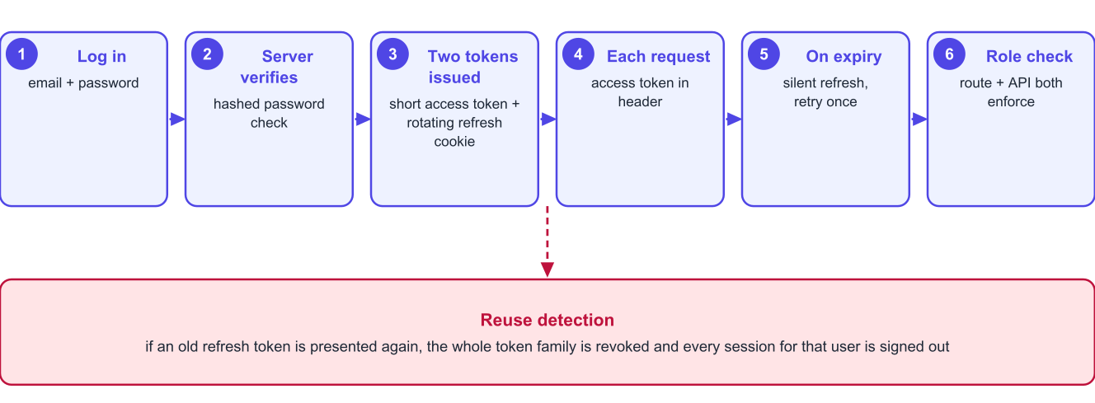
Figure 7.1: Authentication and session refresh, including reuse detection
Rotation makes theft detectable. If an old refresh token is presented again - which happens when a copied token is used after the legitimate client has already refreshed - the server treats it as compromise, revokes the entire token family and forces every session for that user to sign in again. Password verification uses bcrypt with a work factor of 12, and passwords are never logged or returned.

7.2.4 Roles, status and the audit log
Every protected route declares which roles may reach it. Two middleware functions do the work: one authenticates the bearer token and loads the user, the other compares the user's role against the list the route declares. Account status is checked at the same point, so a suspended user is refused even though their token has not yet expired, and an organiser awaiting approval can reach only the pages meant for that state. Every privileged action writes an audit row recording the actor, the action, the entity, a small metadata document and the request address.

7.3 Phase 2 - Events, Venues and the Public Catalogue

7.3.1 Venues and seat layouts
A venue belongs to the organiser who created it. A seat layout is stored as a document describing sections, each with rows and a number of seats per row, together with a computed total. Keeping the layout as a reusable definition rather than as seats means one auditorium plan can serve many events; the expansion into individual seat rows happens once per event, when the event is created with that layout.

7.3.2 Event life cycle
An event moves through a small set of states, and the permitted transitions are enforced in the service layer rather than left to the interface.
Table 7.2: Event states and transitions
State | Meaning | Permitted transitions
draft | Private to the organiser; fully editable | to published
published | Visible in the catalogue; tickets on sale | to sales_closed, to cancelled
sales_closed | Visible but no longer selling | to published (reopen), to cancelled
cancelled | Called off; all confirmed bookings refunded automatically and tickets voided | terminal
completed | The end time has passed; eligible for payout | terminal

Publishing is guarded by a readiness check - the event needs its details, at least one ticket type with a quantity, a start time in the future and, for reserved seating, a layout whose sections are all mapped to ticket types. After publishing, the venue, the seating mode and the layout become immutable, because attendees hold tickets for specific seats; prices, quantities, description and banner remain editable.

7.3.3 Public catalogue and search
The public endpoints expose only published, unblocked events whose start time has not passed. Search matches across the title, description, venue name, city, category and tags, so a search for a city or a category name behaves the way a visitor expects. Filters for category, city, date range, price band and featured status combine with sorting by date, price or relevance, and every list is paginated.

7.3.4 Administrative moderation
Two administrative flags sit beside the organiser's own status. Featuring places an event on the home page; blocking removes it from the catalogue immediately while leaving already-sold tickets valid, which is the correct behaviour when an event is under review rather than cancelled.

7.4 Phase 3 - The Booking Engine

7.4.1 The reservation problem
The booking engine is the part of the system where a plausible implementation is easy and a correct one is not. The naive sequence - read availability, decide in application code, then write - is a lost-update bug: two requests can both read the same availability and both write. The implementation therefore never trusts an earlier read.
1. Open a transaction and lock the affected inventory rows with SELECT ... FOR UPDATE, so concurrent transactions queue rather than interleave.
2. For general admission, update the tier's sold count with the condition that the requested quantity still fits within the declared quantity; for reserved seating, update the chosen seats with the condition that their status is still available.
3. Compare the number of rows actually affected with the number requested. If they differ, roll back the entire transaction and return a conflict response that tells the buyer exactly how many are left.
4. Otherwise create the order in pending state with a hold expiry timestamp, write the order items with prices copied from the tiers, and commit.
The decisive detail is that the pre-condition is re-stated in the WHERE clause of the write. The database evaluates it at write time under its own locking, so there is no window between the check and the write. Section 10.4 reports the concurrency tests that verify this behaviour.

7.4.2 Holds and expiry
A pending order holds its inventory for a configurable window - ten minutes in this deployment. A scheduled job releases expired holds, returning seats to available and decrementing sold counts, and marks the order expired. Release is written as its own transaction and is safe to run repeatedly, because it too is expressed as a conditional update on the current state.

7.4.3 Cancellation policy
Each event carries a cancellation policy describing how much is refunded within which period before the event. When an attendee cancels, the service evaluates the policy against the current time, computes the refundable amount in paise, cancels the order, voids its tickets, returns the inventory to sale and creates a refund record. Because the policy is data on the event rather than code, different organisers can offer different terms without any change to the engine.

7.5 Phase 4 - Payments, Tickets and Invoices

7.5.1 Provider abstraction
Payment providers are reached through a small interface with three operations: create an intent, verify a signature, and refund. Two implementations exist - a mock provider used for development and demonstration, which behaves exactly like the real one including signed callbacks and a deliberate failure switch, and a Razorpay-compatible provider that calls the live API. Switching is a single environment variable; no business code is aware of which provider is active.

7.5.2 Idempotent confirmation
Confirmation is the most-retried operation in the system, so it was written to be repeatable from the start. Both the browser callback and the webhook enter the same service function, which verifies the signature, records the webhook event identifier for de-duplication, locks the order row, and performs the confirmation work only if the order is still pending.
Table 7.3: Cases the confirmation path handles
Case | Behaviour
Callback arrives first, webhook later | First confirms the order; the second finds it already confirmed and records the payment without repeating any effect.
Webhook delivered twice | The second delivery matches an existing webhook event identifier and is ignored.
Browser closed before returning | The webhook alone confirms the booking; the attendee finds it confirmed in My bookings.
Payment fails | The attempt is recorded, the order stays pending, and the attendee may retry until the hold expires.
Payment captured after the hold expired | The capture is recorded against the expired order and a refund is created automatically, so money is never silently kept.
Signature invalid | The request is rejected and logged; no order state changes.

7.5.3 Ticket issue and QR tokens
Confirmation issues one ticket per seat or per admission. Each ticket carries a unique human-readable code and a signed token of the form EBT1.<ticket id>.<event id>.<signature>, where the signature is an HMAC-SHA256 digest computed with a server-held secret. The token is what the QR image encodes. Because the signature can be verified without a database lookup, the gate can reject forged codes even while offline; the database is still consulted, when reachable, to enforce single use.

7.5.4 Documents and invoice numbering
Ticket and invoice PDFs are generated on demand with PDFKit, the ticket embedding the QR image and the event details, the invoice carrying the platform's seller details, the buyer's contact details and the tax breakdown. Invoice numbers are sequential and gapless within an Indian financial year: a dedicated sequence row per financial year is locked while the next number is allocated inside the same transaction that confirms the order, so two simultaneous confirmations cannot receive the same number and no number is consumed by a booking that fails.

7.5.5 Refunds
A refund record is created by three paths - attendee cancellation within policy, event cancellation by the organiser, and an administrator's decision on a refund request - and is then processed against the provider by the scheduler. Failures are retried with a bounded number of attempts and the last error is stored, so a temporary gateway outage resolves itself while a permanent failure remains visible to the administrator.

7.6 Phase 5 - QR Check-in

7.6.1 Verification and single use
A scan is resolved in three steps: the token's signature and event binding are checked; the ticket's current state is read; and the check-in is written with a conditional update that sets the timestamp only where it is currently null. The number of rows affected decides the answer - one row means this is the first scan and entry is allowed, zero rows means the ticket was already used and the earlier scan's time and gate are returned. Two gates scanning the same ticket at the same instant are arbitrated by the database, not by the application.

7.6.2 Check-in window
Scanning is permitted only inside a window around the event - by default from 24 hours before the start until six hours after the end - which prevents accidental scanning of next week's tickets at today's gate.

7.6.3 Offline operation
The gate screen can download a manifest of the event's valid tickets and keep scanning with no network, recording each scan locally with its own timestamp and gate name. When connectivity returns the queued scans are uploaded in one request. The server replays every scan through the same rules and resolves conflicts by keeping the earliest timestamp, reporting any duplicates so the organiser can investigate. An undo operation exists for the common human error of scanning the wrong person, and it too is recorded in the scan log rather than erasing history.

7.6.4 Live statistics
The check-in screen shows tickets sold, tickets scanned and the resulting attendance percentage, refreshed as scans arrive, along with the most recent scans. The same aggregates feed the organiser's post-event analytics and the administrator's platform-wide attendance view.

7.7 Phase 6 - Finance, Analytics and Notifications

7.7.1 One financial calculation
Sales summaries, organiser earnings, payouts and platform analytics all derive from a single SQL common table expression that computes, per order, the gross amount, the refunded amount, the net amount, the commission at the rate frozen on that order, and the organiser's earnings. Defining this once removed an entire class of defect: a figure shown on the organiser's earnings page cannot disagree with the figure used to generate their payout, because both are the same expression.
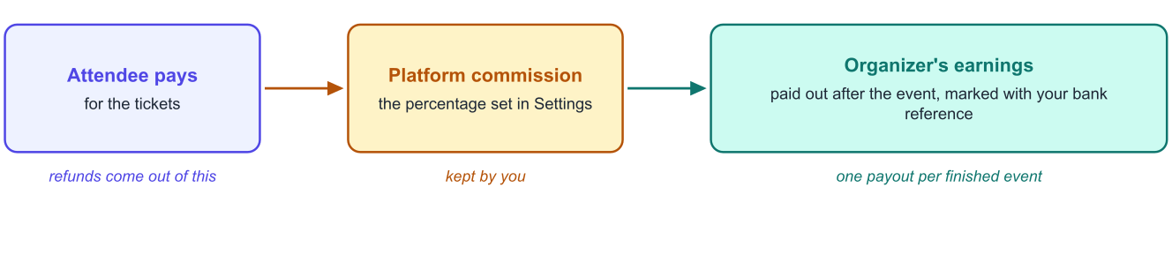
Figure 7.2: How the money from a booking is divided

7.7.2 Commission model
The platform commission is a percentage held in settings, with an optional per-organiser override. The effective rate is resolved when an order is confirmed and stored on the order, so changing the platform rate affects only future bookings. This preserves the commercial terms that applied at the time of each sale and makes historical reports stable.

7.7.3 Payouts
Payouts are generated for events that have finished. For each such event the system computes gross sales, refunds, commission and the net payable, and creates a payout row with a unique constraint on the event so a second payout cannot be created. The administrator transfers the money through their own bank and records the transfer reference, which moves the payout to paid and notifies the organiser. Generation also runs on a schedule, so the manual button is a convenience rather than the only path.

7.7.4 Refund request workflow
When cancellation is no longer permitted the attendee may raise a request with a reason. An administrator sees the booking, the amount already refunded and the maximum still refundable, and may approve any amount up to that maximum, choosing separately whether to cancel the tickets - a partial refund with tickets left valid is a real case, for example compensation for a downgraded seat. Declining requires a note. Both outcomes email the attendee and are recorded in the audit log.

7.7.5 Transactional email
Email is never sent inline. Messages are written to an outbox table inside the same transaction as the business change and dispatched later by the scheduler, so a mail server outage can never roll back a confirmed booking. Ten templates cover the account, booking, refund, payout and reminder messages. Templates may also decline to send: if a booking was cancelled before its confirmation email went out, the template returns a skip result and the message is marked skipped rather than retried, which removed a defect where cancelled bookings produced repeated failed sends.

7.7.6 Background scheduler
Table 7.4: Scheduled jobs
Job | Purpose | Frequency
Expire holds | Release inventory from unpaid orders and mark them expired | Every minute
Dispatch outbox | Send queued emails and retry failures with backoff | Every minute
Retry refunds | Re-attempt refunds that the provider rejected temporarily | Every five minutes
Complete events | Move finished events to completed | Hourly
Generate payouts | Create payout rows for finished events | Hourly
Event reminders | Queue reminder emails to attendees before an event | Daily

Chapter 8 Frontend Implementation

8.1 Implementation Approach
The client was also built in six phases, in the order in which a real user meets the product: the shell and authentication first, then the public catalogue, then the attendee's purchase journey, then the organiser workspace, then the gate scanner, and finally the administrative console. Every phase was verified in a real browser at both desktop and phone widths before the next began.
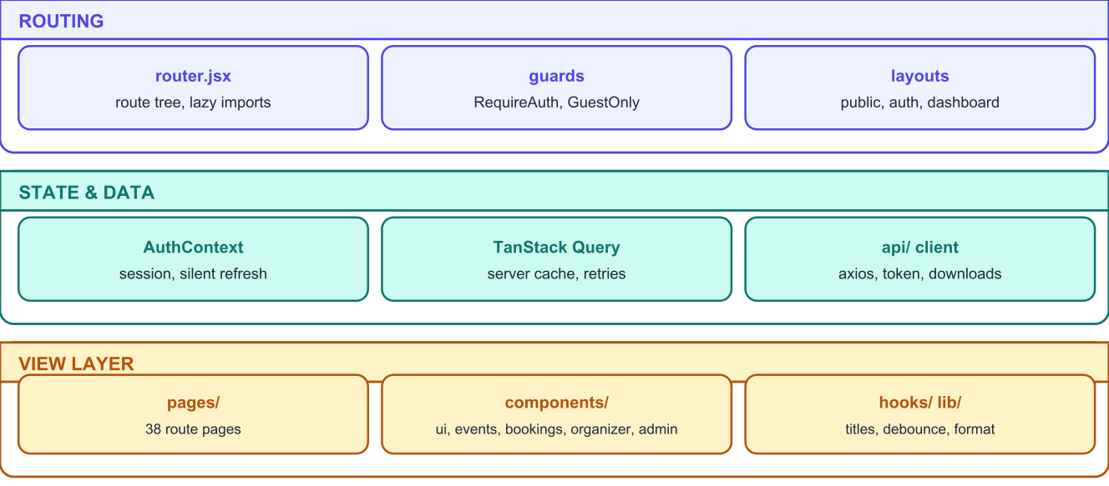
Figure 8.1: Frontend structure
Table 8.1: Frontend phases
Phase | Scope | Screens
1 | Application shell, API client with silent refresh, authentication context, layouts, login and registration, account settings, organiser pending page | 6
2 | Home page, catalogue with search and filters, event details, ticket selection, seat map | 4
3 | Checkout and payment, booking confirmation, QR tickets, document downloads, booking history, cancellation and refund requests | 3
4 | Organiser dashboard, venues, seat layout builder, event form, event management tabs | 8
5 | Check-in event list, scanner with camera and offline mode, earnings, analytics | 4
6 | Administrative console: overview, organisers, users, events, categories, bookings, payments, refund requests, payouts, settings, analytics, email log | 12 (13 routes)
Total |  | 36 route pages, 30 shared components

8.2 Application Shell and Session Handling
The access token is held in memory only. It is never written to local storage, because anything in local storage is readable by any script that manages to run on the page. Persistence across reloads comes from the http-only refresh cookie: on start-up the application asks the API to refresh, and either receives a new access token and the current user, or learns that there is no session.
The API client centralises three behaviours that would otherwise be repeated in every screen. It attaches the access token to each request; on a 401 response it performs a single refresh and replays the original request, with concurrent failures sharing one refresh rather than starting several; and it exposes a download helper that turns an authenticated binary response into a saved file, which is how ticket and invoice PDFs and CSV exports reach the user.
Route protection is declarative. A guard component requires a session, optionally a role, and by default an active status; unapproved organisers are redirected to their pending page, and a visitor sent to the login screen returns to the page they wanted after signing in, provided that page is open to their role.

8.3 Public Catalogue
The catalogue keeps every filter in the URL. Searching, filtering by category, city, date or price, changing the sort order and paging all update query parameters, which means a filtered list can be bookmarked, shared or reached with the browser's back button - behaviour that is easy to lose when filters live in component state. Active filters are shown as removable chips so the user can always see why a list is short.
The seat map renders sections, rows and individual seats from the event's layout, with sold and held seats visually distinct and unselectable. It scrolls horizontally inside its own container, with an explicit hint on small screens, because a seating plan cannot be reflowed into one column without losing its meaning.

8.4 Attendee Journey
Checkout shows the countdown for the current hold, the contact details that the tickets will be sent to, and a payment summary. The payment step opens the gateway screen; in the demonstration configuration this is the mock gateway, which mirrors the real sequence including a switch to simulate failure, so the failure path can be shown without a real declined card.
After confirmation the booking page shows one QR ticket per attendee, enlargeable for scanning, with downloads for the ticket and the invoice. The bookings list separates upcoming from past, and each booking offers exactly the action that is currently valid - cancel while the policy allows it, request a refund afterwards - so the user is never presented with a button that will be refused.

8.5 Organiser Workspace
The workspace is a dashboard shell with a grouped sidebar. Two screens deserve particular mention. The seat layout builder lets the organiser add sections, rows and seats per row, showing a live preview and a running total, and warns that the layout is fixed once an event using it is published. The event management screen collects everything about one event into tabs - overview with the readiness checklist and the publish, close, reopen and cancel actions; tickets; bookings; attendees with a CSV export for the gate; and sales.
Dates required specific care. All times are entered and displayed in India Standard Time regardless of the device's time zone, using explicit conversion helpers, so an organiser travelling abroad cannot accidentally publish an event shifted by several hours. Two defects found during testing came from this area and are recorded in Section 10.5.

8.6 Gate Scanner
The scanner was the most demanding screen to build, because it runs on a phone, uses the camera, must survive a flaky network and is operated by volunteers. The camera library is loaded only when this screen opens, so its cost is not paid by any other page. The video surface stays mounted while the result overlay is displayed and while the operator switches to another tab, so the camera never restarts mid-queue; it is stopped only when the operator leaves the scanning view.
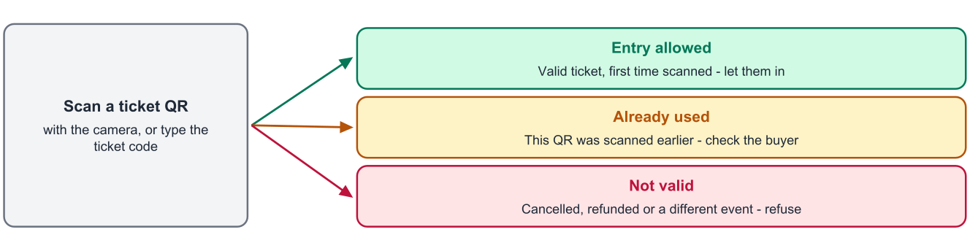
Figure 8.2: The three possible outcomes of a scan, as shown at the gate
Results are deliberately loud and simple - a full-width green, amber or red panel with one line of explanation - because they are read at arm's length in poor light. A guard suppresses further scans while a result is displayed, so a code held in front of the camera is not read repeatedly. Offline mode stores the manifest and queued scans on the device and shows a badge with the number of scans waiting to be uploaded.

8.7 Administrative Console
The console is thirteen routes behind one sidebar grouped into Marketplace, Finance and System. Because these screens are structurally similar - a filtered, paginated list with actions - they share a small set of list primitives: a search box, filter selects, and a list card that renders a table on wide screens and a stack of labelled cards on a phone, with paging and empty states handled centrally. Building these once kept the console consistent and made the whole phase considerably smaller than the organiser workspace despite covering more screens.
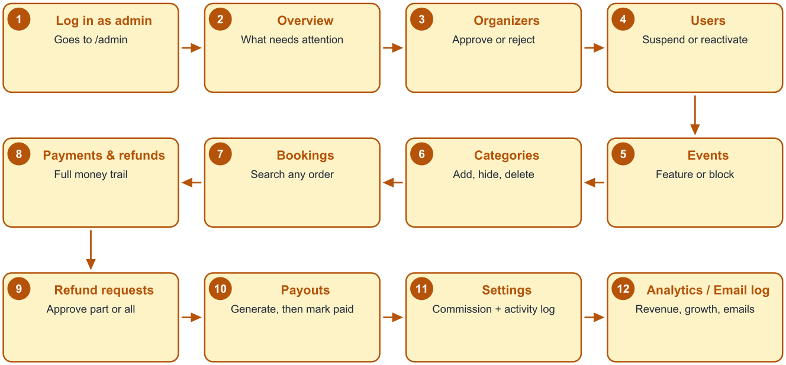
Figure 8.3: Order in which an administrator uses the console
Destructive or consequential actions - reject, suspend, block, decline, delete - go through a confirmation dialog that states the consequence in plain language, and those that affect a person require a reason, which is stored and, where appropriate, emailed.

8.8 Responsive Implementation
Table 8.2: Responsive techniques applied
Screen type | Wide screen | Phone
Dashboard shell | Fixed sidebar beside the content | Sidebar collapses into a drawer opened from the header
Data tables | Dense table with sticky header | Each row becomes a labelled card; no horizontal scrolling
Statistic tiles | Four across | Two across, then one on the narrowest screens
Checkout | Sticky order summary in a sidebar | Summary block above the pay button
Seat map | Full plan visible | Horizontal scroll inside the map container with a hint
Charts | Full width with hover tooltips | Reduced bar count with a table view toggle
Scanner | Camera panel beside the session log | Camera fills the width, log below

Every page was verified at 375 pixels width by measuring the document's scroll width against its client width; a difference of zero means no horizontal overflow. All 36 routes, including modals and the navigation drawer, passed this check.

8.9 Performance Measures
- Route-level code splitting. Every page is imported lazily, so a visitor browsing events never downloads the administrative console or the camera library. The production build emits one main chunk of 382 kB (120 kB compressed) plus 36 page chunks, most under 12 kB.
- Cached server state. Repeated navigation reuses cached data and revalidates in the background instead of re-fetching from scratch; lists keep the previous page visible while the next one loads.
- Debounced search. Typing in a search box issues one request after the user pauses rather than one per keystroke.
- Paginated queries everywhere. No screen fetches an unbounded list, so a platform with thousands of bookings behaves like one with ten.
- On-demand libraries. The QR scanner and its worker are fetched only when the gate screen opens.

Chapter 9 Security Implementation

9.1 Security Objectives
The platform holds three things worth protecting: personal data of attendees and organisers, money in the form of payments, refunds and payouts, and the integrity of tickets, which are bearer instruments. The security work therefore concentrated on authentication, authorisation, input handling, ticket forgery and financial correctness rather than on perimeter concerns alone.

9.2 Authentication Security
Table 9.1: Authentication measures
Measure | Implementation | Threat addressed
Password hashing | bcrypt with a work factor of 12; hashes never leave the server | Disclosure of passwords if the database is exposed
Short-lived access token | Signed token valid for fifteen minutes, held in memory only | Long-lived credential theft; token persistence in readable storage
Refresh token in an http-only cookie | Not readable by scripts; sent only to the API origin | Token theft through cross-site scripting
Refresh token rotation | Each use invalidates the presented token and issues a successor in the same family | Replay of a captured refresh token
Reuse detection | Presenting a superseded token revokes the whole family | Continued use of a stolen session
Status enforcement on every request | Suspended users are refused even with a valid token | Access continuing after suspension
Sign out of all devices | Revokes every refresh token for the account | Sessions left open on shared machines
Rate limiting | Request throttling, applied most strictly to authentication endpoints | Credential stuffing and brute force

9.3 Authorisation
Authorisation is applied in three places, and the server is always the authority. Navigation hides what a role cannot use; route guards prevent a page from rendering; and the API re-checks the role and, crucially, ownership on every request. Ownership matters as much as role: an approved organiser is authorised to edit events, but only their own, so each service verifies that the record belongs to the requesting user before acting. This was tested explicitly by requesting another organiser's resources with a valid session, which is refused.

9.4 Input Validation and Injection Defence
- Schema validation at the boundary. Every endpoint declares the shape of its body, query and parameters; anything not declared is rejected before business code runs, which prevents both malformed input and mass-assignment of fields the client should not set.
- Parameterised SQL everywhere. Values are passed as query parameters and never concatenated into SQL, so injection through search terms or identifiers is not possible.
- Output encoding by default. React escapes interpolated content, and the project uses no raw HTML injection, so stored text such as an event description cannot execute as script.
- Upload restrictions. Banner uploads are limited by type and size and stored outside the application code path with generated names.
- Security headers and origin policy. Helmet sets standard protective headers and cross-origin requests are limited to the configured client origin.
- Uniform error responses. Failures return a message meant for the user; internal details and stack traces are logged on the server only.

9.5 Ticket and Payment Integrity
Tickets are protected by a signature rather than by obscurity. The QR payload carries a keyed hash computed with a secret held only by the server, so a ticket cannot be manufactured by guessing identifiers, and the same secret is what allows a gate device to reject an obvious forgery without network access. Single use is enforced by the database, so even a perfectly valid ticket admits exactly one person.
Payment integrity rests on three rules: the amount charged is always recomputed on the server from the order rather than taken from the client; every gateway notification's signature is verified before it is acted upon; and every notification identifier is recorded so that replaying a captured webhook has no effect. Refund amounts are validated against the amount actually paid less the amount already refunded, so an administrator cannot refund more than was collected.

9.6 Data Protection and Auditability
Table 9.2: Data protection measures
Concern | Measure
Secrets | All secrets - database credentials, token signing keys, the QR secret, gateway keys - are read from environment variables and kept out of the code base; the sample environment file contains placeholders only.
Personal data exposure | Endpoints return only the fields a role needs; an attendee cannot enumerate other attendees, and an organiser sees contact details only for their own event's bookings.
Financial history | Payments, refunds, invoices and payouts are written once and superseded rather than edited, so history cannot be quietly rewritten.
Administrative accountability | Every administrative action records actor, action, entity, metadata, address and time in the audit log, which is visible in the console.
Email traceability | Every message the platform queued is recorded with its status, so a claim that a ticket never arrived can be checked.
Development data | The demonstration seed uses clearly fictitious accounts; the report and guides note that demonstration passwords must be changed before real use.

9.7 Known Security Limitations
An honest security assessment must state what is not done. The present build does not implement two-factor authentication, email verification on registration, or a password-reset flow by email - all three were out of scope for the academic timeline and are listed as enhancements in Chapter 13. Rate limiting is applied per process rather than through a shared store, so several API instances would need a shared limiter. Uploaded images are not virus-scanned. Finally, the platform has not been subjected to an independent penetration test; the testing described in Chapter 10 is functional and adversarial in intent but was performed by the developer.

Chapter 10 Testing and Validation

10.1 Test Strategy
Testing was organised around the risks identified in Chapter 1 rather than around a coverage percentage. Three questions had to be answered convincingly: can the system sell the same seat twice, can a ticket admit two people, and can any rupee be lost or created. Everything else - validation messages, list filters, layout at phone width - was verified as well, but these three determined how the effort was distributed.
Table 10.1: Levels of testing applied
Level | What was tested | Method
Unit-level logic | Money conversion and percentage calculation, cancellation policy evaluation, QR token signing and verification, date handling in India Standard Time | Exercised through the API endpoints that use them, with values chosen to expose rounding and boundary errors
Integration | Each endpoint against a real PostgreSQL database, including authorisation and validation failures | 254 scripted checks across six suites, run against a running server
Concurrency | Simultaneous booking of the last seats; simultaneous scanning of one ticket | Parallel requests issued from a script, with the database inspected afterwards
End-to-end interface | Every screen and every action for the three roles | Scripted browser interaction plus manual inspection at desktop and phone widths
Responsive | All 36 routes, modals and the navigation drawer | Document scroll width compared with client width at 375 pixels
Build verification | Production bundle | Clean build with chunk sizes recorded

10.2 Test Environment
Table 10.2: Test environment
Item | Detail
Server | Node.js 26.4 running the API on the development machine
Database | PostgreSQL 18, a dedicated database seeded with demonstration data
Payment provider | Mock provider producing correctly signed callbacks and webhooks, with a deliberate failure mode
Email | SMTP disabled, so each message was written to disk as an .eml file and inspected
Client | Vite development server with the production build also verified
Browsers | Chromium-based browser at 1280 and 375 pixels width
Data hygiene | Test accounts used a reserved email domain so that a cleanup script could remove them without touching demonstration or real data

10.3 Backend Test Results
Each backend phase has its own suite, executed against a running server. A suite creates its own accounts and data, exercises both the success and the failure paths of every endpoint, and asserts on the response and, where relevant, on the resulting database state. All 254 checks pass.
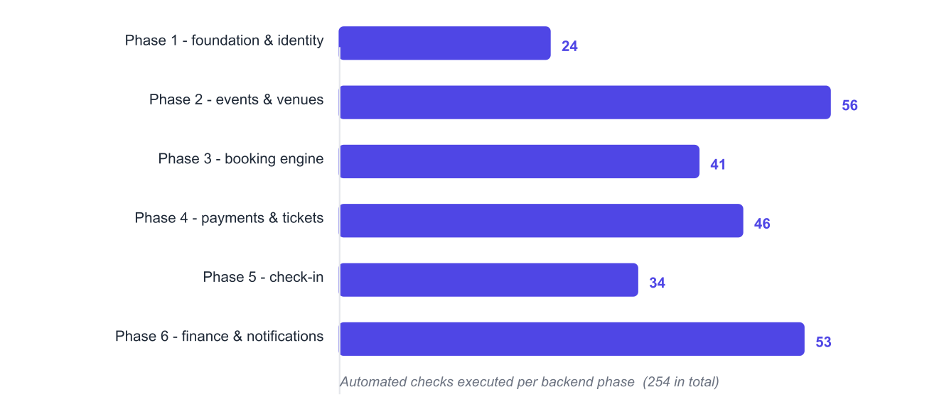
Figure 10.1: Automated checks per backend phase
Table 10.3: Backend test results by phase
Suite | Area | Checks | Passed | Representative assertions
1 | Identity and access | 24 | 24 | Registration validation; login and refresh; rotation; reuse of an old refresh token revokes the family; suspended user blocked; password change invalidates sessions; audit rows written
2 | Events and venues | 56 | 56 | Venue and layout creation; tier validation; publish readiness; immutability of venue after publishing; catalogue filters and sorting; search across venue, city and category; blocked events hidden; ownership enforced
3 | Booking engine | 41 | 41 | Hold creation and expiry; insufficient inventory rejected with remaining count; seat already held rejected; cancellation within and outside policy; released inventory returns to sale
4 | Payments and tickets | 46 | 46 | Checkout intent; signature verification; duplicate webhook ignored; callback and webhook in either order confirm once; tickets issued per seat; invoice numbers sequential and gapless; refund created and retried
5 | Check-in | 34 | 34 | Valid scan admits; second scan reports already used; wrong event refused; forged signature refused; outside the window refused; offline synchronisation keeps the earliest scan; undo recorded
6 | Finance and notifications | 53 | 53 | Order financial breakdown; commission frozen per order; earnings and payout arithmetic; payout uniqueness per event; refund request approval and decline; analytics aggregates; outbox dispatch and skip behaviour
Total |  | 254 | 254 | Pass rate 100%

10.4 Correctness Tests of Critical Behaviour

10.4.1 Overselling under concurrency
Two experiments were run, each repeated several times.
Table 10.4: Concurrency test results
Experiment | Setup | Expected | Observed
Contested seat | Ten simultaneous requests for the same single seat | Exactly one succeeds, nine are refused with a conflict | Exactly one order created; seat status booked once; nine conflict responses
Last tickets | Ten simultaneous buyers requesting one ticket each when three remain | Exactly three succeed | Three confirmed orders; sold count equals the declared quantity; seven conflict responses
Repeated confirmation | The same payment confirmation replayed five times | One confirmation, no duplicate tickets | One confirmed order, one ticket per seat, four no-effect responses
Simultaneous scan | Ten simultaneous scans of one ticket | One entry allowed, nine already used | One allowed; nine reported the first scan's time and gate

10.4.2 Monetary correctness
Money was tested with values chosen to produce fractional paise in intermediate steps, because that is where floating-point arithmetic fails.
Table 10.5: Monetary calculation tests
Case | Input | Expected | Observed
Commission on a round amount | Sale of Rs 999 at 10% | Commission Rs 99.90, organiser earns Rs 899.10 | As expected
Partial refund of an odd amount | 50% refund of Rs 999 | Rs 499.50 | As expected
Percentage producing a fraction | 80% of Rs 501 | Rs 400.80 | As expected
Payout after refunds | Gross Rs 4,800, refunds Rs 1,200, commission 10% of the net | Commission Rs 360, payout Rs 3,240 | As expected, and identical on the earnings screen and in the generated payout
Refund ceiling | Attempt to refund more than was paid less already refunded | Rejected | Rejected with a message stating the refundable maximum

10.4.3 Invoice numbering
Invoice numbers were checked for the two properties that matter to an auditor: they are sequential within a financial year with no gaps, and no number is consumed by a booking that never confirmed. Simultaneous confirmations were issued and the resulting numbers inspected; each was unique and consecutive.

10.5 Defects Found and Resolved
The defects below were found during testing and fixed. They are reported in full because the reasoning behind each fix is part of the engineering record.
Table 10.6: Defect log
# | Defect | Cause | Resolution
1 | Releasing an expired hold failed with a type error from the database | A parameter used in two comparisons left its type ambiguous to the query planner | Explicit type casts on the parameter; re-tested by the phase 3 suite
2 | A payment captured after a hold expired could not be recorded | A unique index allowed only one captured payment per order, which made the legitimate late-capture case unrepresentable | Index removed and the invariant moved into the confirmation logic, which then refunds the late capture automatically
3 | Confirmation emails for cancelled bookings were retried five times and failed | The template assumed the booking was still confirmed when the message was dispatched | Templates may now return a skip result; the outbox marks the message skipped without retrying
4 | The event edit form was rejected with "start time must be in the future" when only the price had changed | The form sent the unchanged start time, which the API correctly refused for a past date | Only changed date fields are now sent
5 | A price of 19.99 was rejected by the client as invalid | A strict equality check against a rounded value failed for numbers not representable in binary floating point | Comparison with a small tolerance
6 | Horizontal scrolling appeared on checkout and booking details at phone width | Grid children defaulted to their minimum content width | Single-column grid with explicit minimum width zero on the children
7 | The camera stopped when the operator switched tabs on the scanner | The video element was unmounted with the inactive tab | The scanning view stays mounted and hidden; the camera is stopped only on leaving, and repeated reads during a result overlay are suppressed
8 | Search did not find events by venue, city or category | The search clause covered only title and description | Clause extended across venue, city, category and tags
9 | The organiser list's All tab showed only applications awaiting approval | Clearing the filter parameter re-applied the default value | An explicit value now represents "all"
10 | The commission column always displayed "Default", and its dialog opened empty | The organiser projection did not select the commission column, and the dialog kept its first mounted state | Column added to the projection; the dialog is remounted per organiser
11 | A session that expired on an administrative page returned the user to the dashboard home instead of the page they were on | The post-login redirect was honoured only for attendees | A shared helper returns any role to the requested page when that page is open to the role
12 | The development server restarted in a loop | The file watcher included the dependency folder | The watch path narrowed to the source folder

Two further observations were recorded as behaviour rather than defects. A rate limiter rejection appeared when two test suites ran back to back, which is the protection working as intended rather than a fault. And during administrative testing an organiser account belonging to the project owner was rejected by mistake; it was restored to its previous state, which is exactly the kind of incident the audit log exists to make visible.

10.6 Interface and Responsive Verification
Table 10.7: Interface verification summary
Area | Checks performed | Result
Attendee journey | Browse, filter, sort, open event, select tickets and seats, checkout, pay, view tickets, download documents, cancel, request refund | All passed
Organiser workspace | Venue and layout creation, event creation and publishing, tier management, banner upload, bookings and attendee export, sales view | All passed
Gate scanner | Camera scan, typed code, duplicate scan, wrong event, undo, offline queue and synchronisation, live counters | All passed
Administrative console | All 13 routes; approve and reject organisers; suspend and reactivate; feature, block and unblock events; category create, hide and delete; partial refund approval; commission change and revert; payout generation and settlement | All passed
Negative cases | Access to another role's pages, another organiser's event, an unauthenticated API call, an over-limit refund | All correctly refused
Responsive | 36 routes at 375 pixels, plus modals and the navigation drawer | Zero horizontal overflow on every route

Two verifications are worth quoting exactly, because they demonstrate that the administrative actions have real effect rather than only a visual one. Blocking an event reduced the public catalogue result count from two to one immediately, and unblocking restored it. Suspending an attendee caused their next login attempt to be refused with an explanatory message, and reactivating restored access.

10.7 Build Verification
Table 10.8: Production build result
Measure | Value
Build status | Successful, no errors or warnings
Main bundle | 382 kB, 120 kB compressed
Page chunks | 36 lazily loaded chunks, most below 12 kB
Largest page chunk | Event management screen, 28 kB
Scanner library | Loaded only on the check-in screen
Build time | Approximately 5 seconds

Chapter 11 User Interface and Operating Flow

11.1 Screen Inventory
Table 11.1: Screens by role
Role | Screens
Public and attendee | Home; Explore events; Event details; Seat selection; Checkout; Booking confirmation and tickets; My bookings; Booking details; Account settings; Log in; Register
Event organizer | Dashboard; Events list; Event form; Event management (overview, tickets, bookings, attendees, sales); Venues; Venue details; Seat layout builder; Check-in event list; Scanner; Earnings and payouts; Analytics; Approval pending
Administrator | Overview; Organizers; Users; Events; Categories; Bookings; Payments and refunds; Refund requests; Payouts; Settings; Analytics; Email log

11.2 Attendee Operating Flow
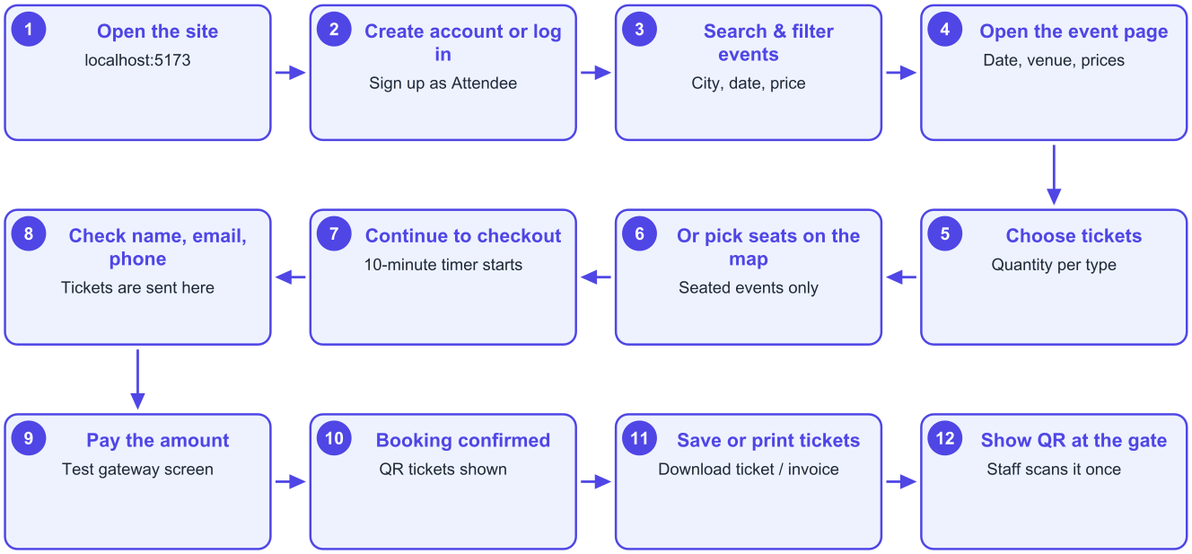
Figure 11.1: Attendee flow from first visit to entry at the gate
The journey is deliberately conventional, because an attendee should not have to learn anything: browse or search, open an event, choose tickets or seats, check contact details, pay, and receive QR tickets. The only element unique to ticketing is the hold countdown on checkout, which is labelled in plain language so that its purpose - protecting the seats being paid for - is obvious.
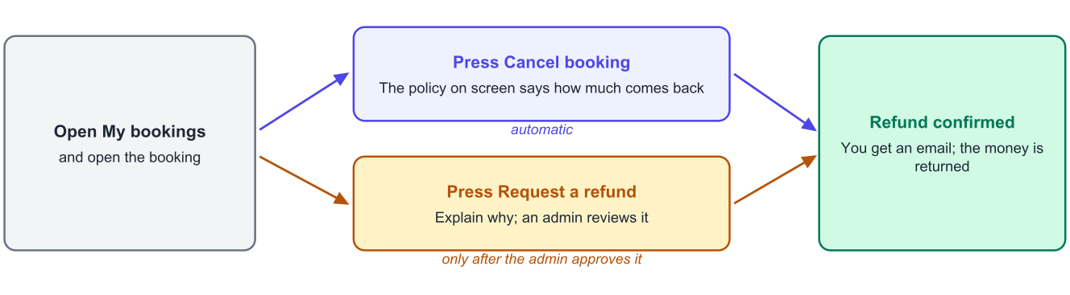
Figure 11.2: The two ways an attendee can recover money, and where each one ends

11.3 Organizer Operating Flow
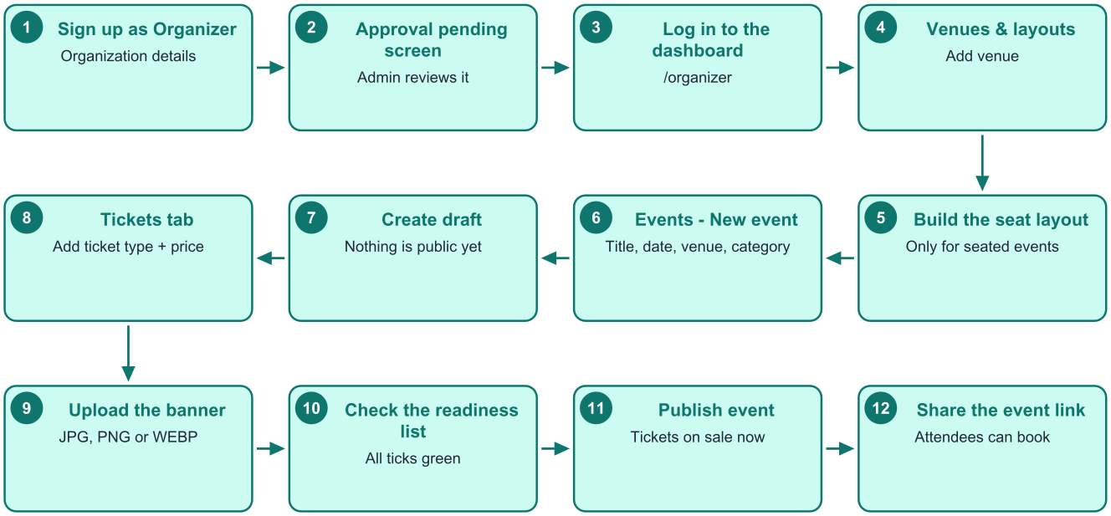
Figure 11.3: Organizer flow from registration to tickets on sale
The organiser flow has one deliberate interruption: the approval gate after registration. Everything after it is linear - venue, layout if seats are reserved, event draft, ticket types, banner, readiness check, publish - and the readiness checklist on the event overview states precisely what is still missing, so publishing never fails for an unexplained reason.
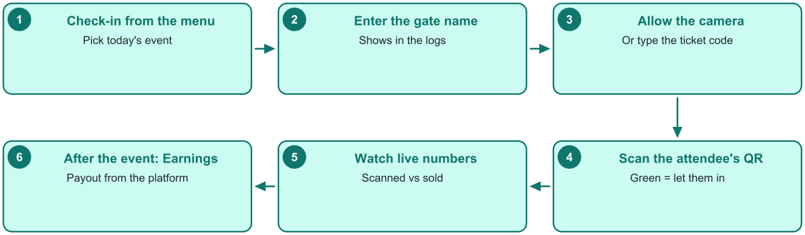
Figure 11.4: Organizer flow on the day of the event

11.4 Administrator Operating Flow
The administrator's console opens on an overview that counts exactly the two things that block other people's work: organisers awaiting approval and open refund requests. The remaining screens are reference and control surfaces used as needed rather than in sequence, which is why they are grouped by subject rather than numbered.

11.5 Accessibility and Usability Considerations
- Every form control has a visible label and an associated error message; errors appear beside the field rather than only as a notification.
- Icon-only buttons carry accessible names, so screen readers announce their purpose.
- Colour is never the only carrier of meaning: scan results, statuses and validation states all pair colour with text.
- Interactive elements meet a comfortable touch target size on phones, which matters most for the seat map and the scanner.
- Dialogs trap focus, close on the escape key, and return focus to the control that opened them.
- Lists show skeleton placeholders while loading, so the page does not jump as data arrives.

Chapter 12 Results and Discussion

12.1 Objectives Against Outcomes
Table 12.1: Achievement of the stated objectives
Objective (Section 1.3) | Outcome | Evidence
Role-based platform for three roles | Achieved | 36 screens behind role guards; 93 endpoints with server-side role and ownership checks
Inventory model that cannot oversell | Achieved | Transactional conditional updates; ten simultaneous buyers for three tickets produced exactly three orders
Payment flow correct under duplication and reordering | Achieved | Callback and webhook idempotent; replayed confirmation produced no duplicate tickets
Signed QR ticket verified once at the gate | Achieved | HMAC-signed tokens; ten simultaneous scans admitted exactly one
Offline gate operation | Achieved | Manifest and queued synchronisation; earliest scan wins on conflict
Exact money arithmetic | Achieved | All calculations in paise; commission, refund and payout cases exact to the paisa
Analytics for organisers and administrators | Achieved | Sales, revenue, refund rate and attendance views derived from one shared calculation
Fully responsive interface | Achieved | All 36 routes verified at 375 pixels with no horizontal overflow
Validation through testing | Achieved | 254 automated checks passing, plus scripted interface verification and twelve resolved defects

12.2 Discussion of Key Results

12.2.1 Correctness is cheaper when delegated to the database
The most valuable technical lesson of the project is that the guarantees hardest to achieve in application code - no overselling, no double entry, no duplicate invoice number - are inexpensive when expressed as transactions, locks and conditional updates. Each of these took a few lines of SQL and produced provable behaviour, whereas the equivalent application-level checks would have been longer, slower and still wrong under concurrency.

12.2.2 Idempotency is a design property, not a patch
Payment confirmation, check-in and refund initiation were written from the start as operations that can be attempted repeatedly. This decision removed an entire category of defect that typically appears late in such systems - duplicate tickets from a retried webhook, double refunds from an impatient click - and made the system tolerant of exactly the conditions that occur in production: flaky networks and impatient users.

12.2.3 One calculation for money
Deriving every financial figure from one shared expression removed the classic reporting complaint that two screens disagree. During testing the earnings screen, the generated payout and the administrator's analytics all reported the same Rs 3,240 for the same event, because they are literally the same computation.

12.2.4 Phased delivery exposed defects early
Because each phase ended in a testable increment, most defects were found within hours of the code being written. The database type error in the release path, the index that made a legitimate case unrepresentable and the email retry problem were all found by the suite of the phase that introduced them, when the context was still fresh.

12.2.5 Building the administrative console last was correct
The console is the largest set of screens but took the least time per screen, because by then the list, filter, dialog and badge patterns already existed. It also served as an end-to-end test of everything built earlier: approving an organiser, blocking an event, approving a partial refund and generating a payout all exercised backend paths from a real interface rather than a script.

12.3 Quantitative Summary
Table 12.2: Summary of delivered work
Measure | Value
Total application code | 15,947 lines across 160 files
Backend | 5,834 lines, 71 files, 10 modules, 93 endpoints
Frontend | 10,113 lines, 89 files, 36 route pages, 30 shared components
Database | 24 tables, 72 indexes, 6 migrations
Email templates | 10 transactional templates with a persistent outbox
Automated checks | 254, all passing
Defects found and fixed during testing | 12
Documentation | Architecture PDF, user flow guide, two application READMEs and this report

Chapter 13 Limitations and Future Enhancements

13.1 Limitations of the Present Build
Table 13.1: Known limitations
Limitation | Explanation and consequence
No email verification or password reset by email | Accounts are usable immediately after registration and a forgotten password must be reset by an administrator. Acceptable for a demonstration, not for public operation.
No two-factor authentication | Administrator and organiser accounts rely on a password alone.
Seat availability is not pushed live to open browsers | A seat taken by someone else is discovered on the next refresh or selection attempt rather than instantly. Correctness is unaffected, only immediacy.
Payouts are recorded, not executed | The platform computes what is owed and records the transfer reference; the transfer itself is made manually through the administrator's bank.
Single-process background scheduler | Running several API instances would require the scheduler to be elected or extracted, otherwise jobs would run more than once.
Rate limiting is per process | Effective for one instance; a shared store would be needed behind a load balancer.
Files are stored on the application server | Banner images and generated documents live on local disk; a horizontally scaled deployment would need object storage.
Single language and currency | The interface is English and all money is in Indian rupees.
No independent security assessment | Testing was thorough and adversarial in intent but performed by the developer.

13.2 Planned Enhancements
Table 13.2: Enhancement roadmap in priority order
Priority | Enhancement | Value
1 | Email verification, password reset and two-factor authentication for privileged accounts | Required before any public deployment
2 | Automated payouts through a payment provider's transfer API | Removes the last manual financial step and shortens settlement time
3 | Live seat availability over a persistent connection | Removes the small frustration of selecting a seat that has just been taken
4 | Progressive web application for the gate | Installable scanner with reliable offline storage and faster startup at the venue
5 | Discount codes and promotional pricing | A frequently requested commercial feature for organisers
6 | Waiting list and automatic release notification | Recovers demand for sold-out events
7 | Object storage and a content delivery network for images and documents | Needed for horizontal scaling
8 | Shared scheduler and distributed rate limiting | Prerequisites for running multiple API instances
9 | Multi-language interface and additional currencies | Broadens the addressable market
10 | Organiser-facing public reporting and exportable statements | Reduces support questions about settlement

Chapter 14 Conclusion
This project set out to replace an informal, error-prone ticketing process with a single platform that is correct where correctness matters. The result is a working system of 15,947 lines across a Node.js and Express API of 93 endpoints over a PostgreSQL schema of 24 tables, and a React and Tailwind CSS client of 36 responsive screens, serving three roles with their own workspaces.
The substantive achievements are not the number of screens but the guarantees behind them. Inventory cannot be oversold, and that claim is backed by a test in which ten simultaneous buyers competing for three tickets produced exactly three bookings. A ticket admits exactly one person, verified by ten simultaneous scans of one code yielding a single admission. A payment confirms a booking exactly once no matter how many times, or in which order, the gateway reports it. Every rupee is computed in integer paise from one shared expression, so the organiser's earnings screen, the payout and the platform's analytics cannot disagree. And the gate keeps working when the venue's network does not.
The work also produced a clear engineering lesson. The problems that look hardest in such a system - concurrency, duplicate notifications, financial precision - become tractable when they are pushed to the layer designed to solve them: transactions and conditional updates in the database, idempotency at the integration boundary, and integer arithmetic for money. Most of the remaining effort is then ordinary application development, which is where a phased approach with a testable increment at the end of each phase proved its worth: every defect recorded in Chapter 10 was found while the code that caused it was still fresh.
The platform is complete for its intended purpose: an organiser can be approved, publish an event, sell reserved or general-admission tickets, admit attendees with a phone and be paid what they are owed, while an administrator can see and control every step. The limitations are stated honestly in Chapter 13, and the enhancement roadmap there - beginning with email verification, password reset and automated payouts - describes what would be required before opening the platform to the public. As an academic exercise, the project demonstrates the full life cycle of a transactional web application: analysis, design, phased implementation, deliberate adversarial testing and documentation.

References
1. React Documentation. react.dev - component model, hooks and data loading patterns.
2. Tailwind CSS Documentation. tailwindcss.com - utility-first styling and responsive design.
3. React Router Documentation. reactrouter.com - data routing, lazy loading and route guards.
4. TanStack Query Documentation. //tanstack.com/query// - server-state caching, invalidation and retries.
5. Node.js Documentation. nodejs.org - runtime, modules and the file watcher.
6. Express Documentation. expressjs.com - routing and middleware composition.
7. PostgreSQL 18 Documentation. //postgresql.org/docs// - transactions, isolation levels, SELECT ... FOR UPDATE, enumerated types, JSONB and indexing.
8. node-postgres Documentation. node-postgres.com - connection pooling and parameterised queries.
9. Zod Documentation. zod.dev - schema declaration and validation.
10. React Hook Form Documentation. react-hook-form.com - form state and resolvers.
11. JSON Web Token specification, RFC 7519, Internet Engineering Task Force.
12. HMAC: Keyed-Hashing for Message Authentication, RFC 2104, Internet Engineering Task Force.
13. OWASP Top Ten and OWASP Cheat Sheet Series. owasp.org - authentication, session management and input validation guidance.
14. Razorpay Developer Documentation. //razorpay.com/docs// - payment orders, signature verification, webhooks and refunds.
15. PDFKit Documentation. pdfkit.org - document generation.
16. Nodemailer Documentation. nodemailer.com - SMTP transport and message composition.
17. Vite Documentation. vite.dev - development server, proxying and production builds.
18. Fowler, M. Patterns of Enterprise Application Architecture. Addison-Wesley - repository and service layer patterns, and money representation.
19. Kleppmann, M. Designing Data-Intensive Applications. O'Reilly Media - concurrency control, isolation and idempotency.
20. Nielsen, J. Usability Heuristics for User Interface Design. Nielsen Norman Group - feedback, error prevention and recognition over recall.

Appendix A API Reference
All routes are mounted under /api/v1. Auth indicates the required role: public means no session, any means any signed-in user.

A.1 Authentication and account
Table A.1: Authentication and account endpoints
Method and path | Auth | Purpose
POST /auth/register | public | Create an attendee or organiser account
POST /auth/login | public | Sign in and receive tokens
POST /auth/refresh | cookie | Rotate the refresh token and issue a new access token
POST /auth/logout | any | Revoke the current refresh token
POST /auth/logout-all | any | Revoke every refresh token for the account
POST /auth/change-password | any | Change password and invalidate other sessions
GET /users/me | any | Current profile with organiser details where applicable
PATCH /users/me | any | Update profile, organisation details or payout details

A.2 Catalogue, venues and events
Table A.2: Catalogue, venue and event endpoints
Method and path | Auth | Purpose
GET /categories | public | Active categories
POST /categories, PATCH /categories/:id, DELETE /categories/:id | admin | Create, update or delete a category
GET /events | public | Search the catalogue with filters, sorting and pagination
GET /events/:slug | public | Full public detail of one event
GET /events/:slug/seats | public | Seat map with live availability
POST /events | organizer | Create a draft event
PATCH /events/:id | organizer | Edit an event within the rules for its state
POST /events/:id/publish | organizer | Publish after the readiness check
POST /events/:id/close-sales, /reopen-sales | organizer | Close or reopen ticket sales
POST /events/:id/cancel | organizer | Cancel the event and refund every booking
POST /events/:id/banner | organizer | Upload or replace the banner image
GET, POST, PATCH, DELETE /events/:id/tiers | organizer | Manage ticket types
GET /organizer/events | organizer | The organiser's own events with status filters
GET /admin/events | admin | Every event on the platform
PATCH /admin/events/:id/feature, /block | admin | Feature or block an event
GET, POST, PATCH, DELETE /venues | organizer | Manage venues
GET, POST, DELETE /venues/:id/layouts | organizer | Manage seat layouts

A.3 Booking, payment and tickets
Table A.3: Booking, payment and ticket endpoints
Method and path | Auth | Purpose
POST /bookings | attendee | Reserve inventory and create a pending order
GET /bookings | attendee | Booking history with upcoming and past filters
GET /bookings/:id | attendee | One booking with its tickets and payment
POST /bookings/:id/cancel | attendee | Cancel within the policy and refund automatically
GET /bookings/:id/ticket.pdf, /invoice.pdf | attendee | Download documents
POST /bookings/:id/refund-request | attendee | Raise a refund dispute
GET /organizer/events/:id/bookings, /attendees | organizer | Bookings and the attendee list, with CSV export
GET /admin/bookings | admin | Every booking on the platform
POST /payments/checkout | attendee | Create a payment intent for a pending order
POST /payments/callback | attendee | Browser return from the gateway
POST /payments/webhook | signature | Server-to-server notification from the gateway
GET /admin/payments, /admin/refunds | admin | Payment and refund registers

A.4 Check-in
Table A.4: Check-in endpoints
Method and path | Auth | Purpose
GET /check-in/events | organizer | Events currently eligible for check-in
GET /check-in/:eventId/manifest | organizer | Ticket manifest for offline scanning
POST /check-in/scan | organizer | Verify a token and admit once
POST /check-in/sync | organizer | Upload queued offline scans
POST /check-in/undo | organizer | Reverse a mistaken scan
GET /check-in/:eventId/stats | organizer | Live scanned and sold counters
GET /check-in/:eventId/logs | organizer | Scan history for the event

A.5 Finance and administration
Table A.5: Finance and administration endpoints
Method and path | Auth | Purpose
GET /organizer/earnings | organizer | Sales, commission, refunds and net payable
GET /organizer/analytics | organizer | Sales over time, tier performance, attendance
GET /admin/organizers | admin | Applications and organiser accounts
PATCH /admin/organizers/:id/approve, /reject | admin | Decide an application
PATCH /admin/organizers/:id/commission | admin | Set a per-organiser commission rate
GET /admin/users, POST /admin/users | admin | List users; create an administrator
PATCH /admin/users/:id/status | admin | Suspend or reactivate an account
GET /admin/refund-requests, /:id | admin | Dispute queue and detail
POST /admin/refund-requests/:id/approve, /reject | admin | Decide a dispute
GET /admin/payouts, POST /admin/payouts/generate | admin | Payout register and generation
PATCH /admin/payouts/:id/paid | admin | Record settlement with a bank reference
GET /admin/settings, PATCH /admin/settings | admin | Read and set the platform commission
GET /admin/analytics | admin | Platform-wide revenue, growth and attendance
GET /admin/audit-logs, GET /admin/emails | admin | Activity log and email log

Appendix B Configuration and Accounts

B.1 Environment configuration
Table B.1: Backend environment variables
Variable | Purpose
PORT, NODE_ENV, CLIENT_URL | Server port, mode and the permitted client origin
DB_HOST, DB_PORT, DB_NAME, DB_USER, DB_PASSWORD | Database connection
JWT_SECRET, JWT_EXPIRES_IN, REFRESH_TOKEN_EXPIRES_IN | Token signing and lifetimes
BOOKING_HOLD_MINUTES | How long inventory is held during checkout
CONVENIENCE_FEE_PERCENT | Optional buyer-side fee
PAYMENT_PROVIDER, MOCK_PAYMENT_SECRET | Active provider and mock signing secret
RAZORPAY_KEY_ID, RAZORPAY_KEY_SECRET, RAZORPAY_WEBHOOK_SECRET | Live gateway credentials
TICKET_QR_SECRET | Secret used to sign QR ticket tokens
CHECKIN_OPENS_HOURS_BEFORE, CHECKIN_CLOSES_HOURS_AFTER | Check-in window
SMTP_HOST, SMTP_PORT, SMTP_USER, SMTP_PASS, MAIL_FROM | Email transport; when empty, messages are written to disk
PLATFORM_NAME, PLATFORM_ADDRESS, PLATFORM_GSTIN | Seller details printed on invoices
ADMIN_NAME, ADMIN_EMAIL, ADMIN_PASSWORD | The first administrator created by the seed

B.2 Setup commands
# backend
npm install
cp .env.example .env # then fill in the values
npm run setup # create database, migrate and seed
npm run dev
# frontend
npm install
cp .env.example .env
npm run dev
# the application opens at http://localhost:5173

B.3 Demonstration accounts
Table B.2: Accounts created by the seed scripts
Role | Email | Password | Notes
Administrator | admin@eventbooking.com | From ADMIN_PASSWORD | Created by the standard seed from environment configuration
Event organizer | organizer@demo.com | Demo@12345 | Approved organiser owning the demonstration events
Attendee | attendee@demo.com | Demo@12345 | Has bookings, tickets and an open refund request

Before any real use
The demonstration passwords above are published in the seed scripts and in the project documentation. They must be changed, or the demonstration data omitted entirely, before the platform is exposed to real users.

Appendix C Project Structure

C.1 Backend
backend/
src/
config/ environment loading, database pool
db/
migrations/ six ordered SQL files
seed.js categories and the first administrator
seedDemo.js venues, events, bookings for demonstration
middleware/ auth, validation, error handling, rate limits
modules/
auth/ users/ events/ venues/ bookings/ payments/
checkin/ finance/ categories/ notifications/
lib/ money, tokens, dates, documents
jobs/ background scheduler
app.js server.js
storage/ uploaded banners, generated documents, development emails
.env.example README.md

C.2 Frontend
frontend/
src/
api/ axios client and one module per API area
components/
layout/ navigation bar, footer, dashboard shell
routing/ route guards
ui/ buttons, forms, cards, badges, modals, feedback
events/ bookings/ organizer/ admin/ charts/
context/ authentication context
hooks/ small reusable hooks
lib/ formatting, error helpers, shared validation
pages/ 36 route pages grouped by area
router.jsx route tree with lazy loading
index.html vite.config.js README.md

C.3 Documentation
Table C.1: Documents delivered with the project
Document | Contents
High_Level_Architecture.pdf | The architecture study produced before implementation
User_Flow_Guide.pdf | Nine-page operating guide with flow diagrams for each role
backend/README.md | Setup, response format, authentication and the full API reference by phase
frontend/README.md | Setup, demonstration accounts, structure, phase table and scanner notes
This report | Analysis, design, implementation, testing and results

The source code, the database migrations, the seed scripts and the test scripts accompany this report on the submitted media, arranged exactly as shown in Sections C.1 and C.2.
- End of Report -

