

## Tribhuvan University

### Faculty of Humanities and Social Sciences

**GoParcel: Find a delivery guy**

A PROJECT REPORT

**Submitted to**

**Department of Computer Application**

**Kathmandu business Campus**

**Banasthali, kathmandu**

***In partial fulfillment of the requirements for the Bachelors in Computer Application***

**Submitted by**

**Name: Nitin Maharjan**

**Roll no : 14**

Under the Supervision of



## Tribhuvan University

### Faculty of Humanities and Social Sciences

**Kathmandu Business Campus**

Banasthali, kathmandu

Bachelor in Computer Applications (BCA)

## SUPERVISOR’S RECOMMENDATION

I hereby recommend that this project prepared under my supervision by **Nitin Maharjan** entitled “**GoParcel : Find parcel delivery guy”** in the Partial Fulfillment of requirement for the degree of Bachelor in Computer Application is recommended for that final evaluation.

Project Supervisor

BCA Department

Kathmandu business Campus



## Tribhuvan University

**Faculty of Humanities and Social Sciences**

**Kathmandu Business Campus**

Banasthali, kathmandu Bachelor in Computer Applications (BCA)

# LETTER OF APPROVAL

This is certify that this project prepared by **Nitin Maharjan** entitled “**GoParcel : Find a parcel delivery guy”** in the Partial Fulfillment of requirement for the degree of Bachelor in Computer Application has been evaluated. In our opinion it is satisfactory in the scope and quality as a project for the required degree.

|  |  |  |
| --- | --- | --- |
|  |  |  |
| Supervisor  BCA Department  Kathmandu business campus                  External Examiner |  | Ram prasad subedi  Program Coordinator  Kathmandu Business Campus  Banasthali, kathmandu                  Internal Examiner |

# ABSTRACT

People who are struggling to get the services on time in the country were waiting for the platform like “**GoParcel : Find a parcel delivery guy**”. That helps the people to getting services easy and fast. Time is valuable and sometimes, people needs service right away. Our platform connects you with rider having their vehicle for delivery of parcel and are ready to provide their services whenever and wherever people needs them.

Time is one of the valuable assest. Most people looks for the services which is immediately serviced. Sometimes, problem can’t be wait to be solved, it must fixed right away, in such a scenario, our platform come up as the most desired form of solution. This is because, unlike others, people don’t have to wait or keep finding the delivery guy, they can easily find the delivery person in just few clicks. If we are facing some listed problem in the platform then we can get services after requesting right away. “**GoParcel : Find delivery guy on your request**” is the web based application for the people who are looking for the perfect delivery person to help you with whatever you need to delivery your parcel. Whether a parcel is small or mediun or large ,our platform can help you find a delivery person that can delivery your parcel in safe condition.

# ACKNOWLEDGEMENT

We would like to express our special thanks of gratitude to our supervisor gave us the golden opportunity to do this wonderful project on the topic of We Care: Service on demand, which also helped us in doing a lot of research and we came to know about so many new tools and technologies.

We would like to express our special thanks of gratitude to our Campus Chief who gave us permission for doing this Project.

I would like to express my special gratitude and thanks to our BCA Program Coordinator **Mr. Ram Prasad Subedi** for his support and help for our personnel development and mainly for the completion of this Project.

I am highly indebted to Kathmandu Business Campus for their guidance and constant supervision as well as for providing necessary information regarding the Project and support in the completion.

We would also like to express my gratitude towards library and member of Kathmandu Business Campus for their kind co-operation and encouragement which help me in completion of this Project

In the end, we would also like to thank Tribhuvan University for giving us this opportunity via the course of Computer Application to help us understand the project ethics at this early stage and helped us to evaluate my knowledge and expand it a little more.

Yours sincerely,

Nitin Maharjan

## TABLE OF CONTENTS

**SUPERVISOR’S RECOMMENDATION LETTER OF APPROVAL ABSTRACT .........................................................................................................................** i **ACKNOWLEDGEMENT .................................................................................................** ii

**LIST OF ABBREVIATIONS…………………………………………………..…………..**v **LIST OF FIGURES ..........................................................................................................** vi

### LIST OF TABLES…………………………………………………………………………vii CHAPTER: 1 INTRODUCTION ................................................................................... 1

1.1 Introduction ................................................................................................................ 1

1.2 Problem Statement ..................................................................................................... 2

1.3 Objectives .................................................................................................................. 2

1.4 Scope and Limitation ................................................................................................. 3

1.4.1 Scope .................................................................................................................... 3

1.5 Report Organization ................................................................................................ 3-4

### CHAPTER: 2 BACKGROUND STUDY AND LITERATURE REVIEW .................. 5

2.1 Background Study ...................................................................................................... 5

2.2 Literature Review .................................................................................................... 5-6

### CHAPTER: 3 SYSTEM ANALYSIS AND DESIGN ..................................................... 7

3.1 System Analysis ......................................................................................................... 7

3.1.1 Requirement Analysis .......................................................................................... 7

3.1.2 Feasibility Analysis ............................................................................................ 10

3.1.3 Data Modeling (ER-Diagram) ........................................................................... 12

3.1.4 Process Modeling (DFD) .............................................................................. 13-14

3.2. System Design ......................................................................................................... 15

3.2.1. Architectural Design…………………………………………………………..15

3.2.2. System Flowchart………………………………………………………………..16

3.2.3. Database Schema Design .................................................................................. 19

3.2.3. Interface Design (UI Interface) ......................................................................... 20

**CHAPTER: 4 IMPLEMENTATION ........................................................................** 23

4.1. Implementation ........................................................................................................ 23

4.1.1. Tools Used (CASE tools, Programming language, Database platforms) .......... 23

4.1.2. Implementation Details of Modules ( Description of procedures)…………….24

# LIST OF ABBREVIATIONS

|  |  |
| --- | --- |
|  |  |
| CRUD | Create, Read, Update and Delete |
| CSS | Cascading Style Sheet |
| DFD | Data Flow Diagram |
| ERD | Entity Relationship Diagram |
| HTML | Hyper Text Markup Language |
| JS | Java Script |
| DOB | Date of birth |
| UI | User Interface |
|  |  |
|  |  |
|  |  |
|  |  |
|  |  |
|  |  |
|  |  |

# LIST OF FIGURES

Figure 3.1: Waterfall Methodology for GoParcel:Find a parcel delivery guy ..................... 7

Figure 3.2 : Use Case Diagram of GoParcel:Find a parcel delivery guy ............................ 9

Figure 3.3: Gantt chart for GoParcel:Find a parcel delivery guy ....................................... 11

Figure 3.4: Entity Relational Diagram for GoParcel:Find a parcel delivery guy .............. 12

Figure 3.5: level 0 DFD for GoParcel:Find a parcel delivery guy ..................................... 13

Figure 3. 6: Level 1 DFD for GoParcel:Find a parcel delivery guy 14

**LIST OF TABLES**

Table 3.1: Gantt chart Table for GoParcel: find a delivery guy ........................................ 11

**CHAPTER: 1**

## INTRODUCTION

### 1.1 Introduction

“GoParcel:Find a parcel delivery guy” is the web based system which provide full range of assistance under one website to the user where the people can get delivery person whenever they want fast and easily whether it’s delivery of small or large parcel or light weight or heavy weight parcel.

It is a web application that is designed to make people life easier. The main focus of the “GoParcel:Find a parcel delivery guy” is to find a delivery person to easily and fast. It is designed to solve the problem of the people who were struggling to get delivery person on time and have to search through directories or rely on word-of-mouth recommendations.

" GoParcel:Find a parcel delivery guy” platform aims to bridge this gap by offering a userfriendly website that connects users with a diverse range of service providers. From deliverying a small to big and of any types of parcel as the platform strives to cater to a wide variety of service needs. The interface is designed user friendly and the function is displayed in a simple manner. The platform provide a convenient and efficient way for users to connect with skilled professionals who can offer their services whenever and wherever they are needed.

“GoParcel:Find a parcel delivery guy” is the web based system that has one admin that helps to manage data and information of user and validate delivery guy and also helps to keep their data more safely and securely by storing all data into the database

### 1.2 Problem Statement

In the context of Nepal, many people struggle in sending parcel to their person who live far away from their location. Even the location is near people find difficulty in sending their parcel to their people. Well it helps in delivery of the parcel to their required person at very low cost.

On other hand, the process of finding delivery guy is time-consuming. People often have to rely on word-of-mouth recommendations or spend hours searching through directories.

### 1.3 Objectives

The system gives remedies for the problem that are currently being faced by the people.

Some of the objectives of system are as follow:

* To search delivery person for a customer.
* □ list delivery person for a customer.
* To provide expert delivery person on demand for a customer.
* To get easily connected to customer for delivery person.

### 1.4 Scope and Limitation

#### 1.4.1 Scope

The system will connect users with a network of verified and skilled delivery person across different categories. This will help to create trustworthy ecosystem where users can confidently find professionals who can deliver high quality services.

#### 1.4.2 Limitations

There are some criteria that may not be fulfilled by our application implemented. Some of such limitations of our project are mentioned below:

* There are no any prices listed of services.
* There are no any options of payment methods.

### 1.5 Report Organization

#### Introduction

This chapter deals with the introduction of the system with its objectives and limitations along with the reason why the system is made.

#### Background Study and Literature Review

This chapter summarizes the work that has been carried out in the field of data mining and also describes the features about some existing applications related to the service on providing delivery guy.

#### System Analysis and Design

This chapter focuses on the different requirement of the system, which describes about the functional, non-functional, feasibility analysis, Entity Relational diagram, Data Flow Diagram, design of the system with system architecture, database schema, and interface design.

#### Implementation and Testing

This chapter emphasizes tools used in system development, implementing details and result of test performed.

#### Conclusion and Future Recommendation

This chapter highlights brief summary of lesson learnt, outcome and conclusion of the whole project and explain what have been done and what further improvements could be done.

**CHAPTER: 2**

## BACKGROUND STUDY AND LITERATURE REVIEW

### 2.1 Background Study

The background study focuses on understanding the current suitation of providing a delivery guy in Nepal and the challenges faced by individuals in search of quality and the assistance that can be reliable on. It aims to provide a understanding of the need for a service on demand platform in Nepal.

Individuals often encounter difficulties in receiving proper quality in sending parcel through delivery guy. Traditional methods of finding delivrey guy, such as relying on wordof-mouth recommendation or searching through directories, can be unreliable and timeconsuming. This leads to frustration and delays in resolving issues that arise in daily life.

Before getting into the development of the project we did a comprehensive background study, to understand the basic available resources and current practice. It helped us very much for planning the road map for the development and also the insights into the existing few organizations that are currently providing the services to the people in their needs in the market and overview of the market conditions about the user expectation, preferences and identify key areas where service on demand can make impact on. We tried to understand how they are running the system and how different it is from “GoParcel: Find a delivery guy” is studied on the basis of the available resources online.

### 2.2 Literature Review

There are few system related to finding a guy for delivering a parcel to people . We recently had studied about different system which works as like this application.

A limited number of studies have reported on the application of parcel delivering guy**.** In the early, almost every finding are traditionally done so, the people were facing some problem of not getting the services that can be reliable, hard to find the services or locate the service provider. All the finding were being done word of mouthing

recommendation or searching through directories.

While the literature on service on demand platforms is extensive, there is limited research specifically focused on the Nepalese market. However, studies conducted in neighboring countries and similar contexts provide valuable insights that can be applied to the development of a service on demand platform in Nepal.

One common finding across studies is the importance of trust and reliability in service on demand platforms. Users place significant emphasis on the reputation and credibility of service providers. Implementing a thorough verification process, including background checks and user reviews, is crucial to building trust among users and ensuring the quality of services offered.

Furthermore, studies have emphasized the need for user-friendly interfaces and intuitive platforms. The ease of browsing, searching, and booking services greatly impacts user adoption and engagement. Incorporating features such as user reviews, service provider profiles can enhance the user experience and differentiate the platform from traditional methods of accessing home services.

Taking the pathao-parcel as reference, the site doesn’t offers the list of the service providers aswell, it doesn’t allow users to select the provider of the choices. The services might not be delivered in the mean time, it takes the booking and delivers the service later, unlike the GoParcel.

Overall, the literature review highlights the importance of trust, reliability, puser-friendly interfaces in the development of a service on demand platform in Nepal. By drawing upon these insights and adapting them to the local context, the platform can effectively address the existing challenges and provide a valuable solution for individuals seeking home services in Nepal.

**CHAPTER: 3**

## SYSTEM ANALYSIS AND DESIGN

### 3.1 System Analysis

This system is designed with the series of processes starting with requirement analysis, design, implementation, testing and maintenance. During requirement analysis, all the functional and nonfunctional requirement are analyzed and system is developed according to the requirement then designing of the system is carried out. After the design process, coding and development part is started then after integrating the system there is testing of the system. If the testing is positive then system is implemented otherwise some maintenance is done and system come in operation.

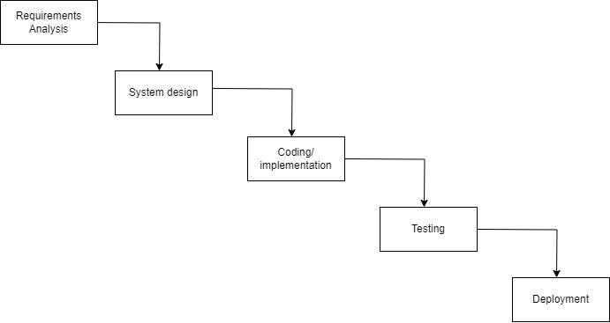

#### Figure 3.1: Waterfall Methodology for We Care: Service on demand

##### 3.1.1 Requirement Analysis

The requirements are to be collected before starting projects’ development life cycle. To design and develop system, functional as well as non-functional requirement of the system has been studied.

#### i. Functional Requirement

Different functional requirement of the system have been identified and are listed as below: **For Administration:**

* The system should allow the system administrator to login and logout from the system.
* The system should allow the system administrator to add, delete, and update details and information of users and sponsors.
* The system should allow the system administrator to monitor the service providers’ document.

**For User:**

* User will be able to register and login.
* User can request the service that they are looking forward.

.

**For Provider:**

* Provider will be able to register and login.
* Provider can see the request of service once they are verified from admin. • Provider can accept the request and go to serve.

#### USECASE DIAGRAM

In GoParcel: find a delivery guy, there are three actors such as admin, customer and service provider where admin can login, verify provider and view document. Likewise, user can register, login, search service, request service and give feedback. Lastly, Service provider can register, login, view service, upload documents.

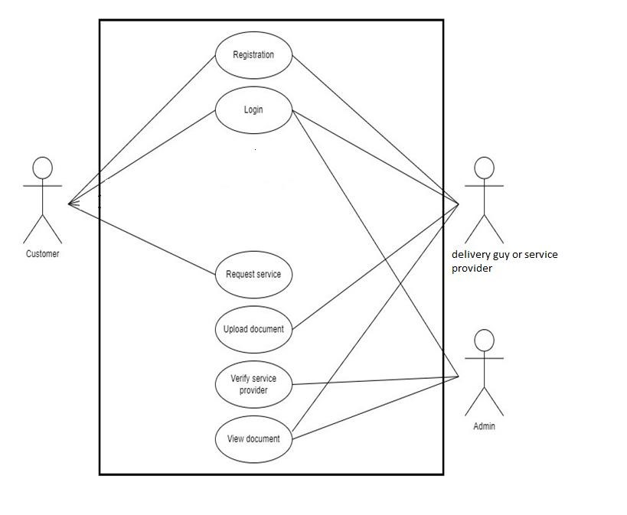

**Figure 3.2 : Use Case Diagram of We Care: Service On Demand**

#### ii. Non Functional Requirement

Different non-functional requirement have been studied and identified and are listed as below:

* **Security**: -The system is secure from outside attacks as authorized user, provider and admin are allowed to access the data. Admin representative on duty can log into the system and have access to the service on demand system but access to have various subsystems is protected by the user login screen that requires a username and password. This system uses at least 8-character passwords for security. Different validation process is used.
* **Performance**: - The performance of the system is fast and accurate as in this system database is normalized so it provide fast operations.

##### 3.1.2 Feasibility Analysis

The feasibility study concluded that the project is able to be implemented to success as it was carefully planned.

#### i. Technical Feasibility Study

The system is technically feasible as the requirement for the development of the system is easily accessible. The necessary hardware and software required for the development and implementation of the system is available. The basic programming language which is suitable for project is available for project is capable of achieving the result that we are aiming for. All the existing resources can be used for the development and maintenance system.

#### ii. Operational Feasibility Study

The system is easy to operate with the basic knowledge of computer and internet and well trained manpower is not necessary. User can also easily access the system as it is user friendly in many aspects with good User Interface (UI). This system include all the requirements used for service on demand and this system is completely operational and can be successfully implemented and administration feel easy to use this system as it is user-friendly.

#### iii. Economic Feasibility Study

The system is economically feasible and cost effective. As all the tools and resources required are either open sources or free. After the completion of the system organization didn’t need to deploy any new hardware and software as the required software and hardware. The existing resource of the system can be used. **iv. Schedule Feasibility Study**

The system is expected to be completed within scheduled time and do not exceed the scheduled time.

**Project schedule:**

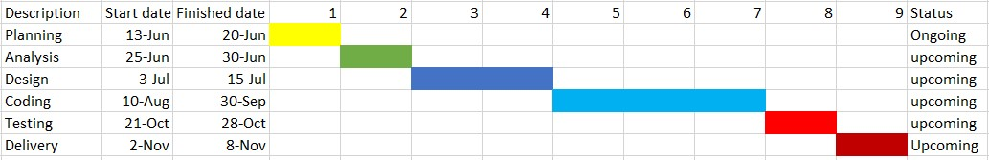

#### Figure 3.3: Gantt chart for We Care

##### 3.1.3 Data Modeling (ER-Diagram)

In Entity-Relationship diagram, Admin has attributes like Admin id, email, password. Likewise Service provider has id, address,phone,dob, occupation,code and customer has attributes like id, address, password, email, gender, code.. Service requests has id,location, name,phone,gender ,date. Accepted table and Customer_response has id, provider, reciver. Admin can add and delete user, service provider and user can request for service.

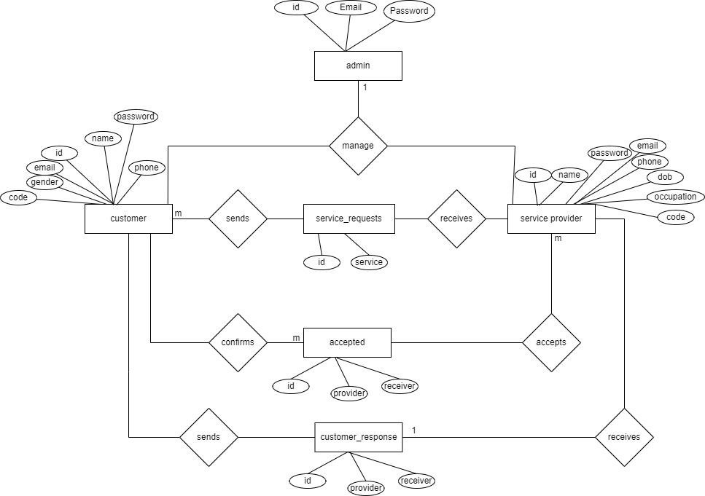

#### Figure 3.4: Entity Relational Diagram for We Care : Service on demand

##### 3.1.4 Process Modeling (DFD)

Data Flow Diagram of We Care: Service on demand consists of two levels of DFD context diagram and level one dfd. Both these levels are used for making data flow diagram of We Care.

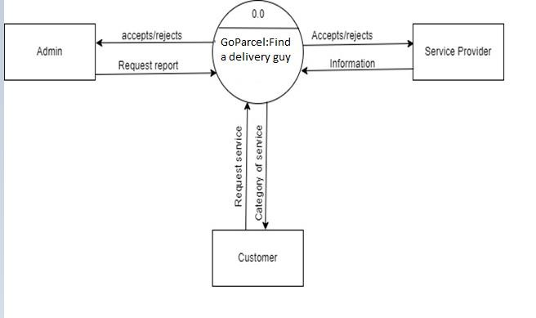

#### Figure 3.5: level 0 DFD for GoParcel:Find a delivery guy

**DFD Level 1:**

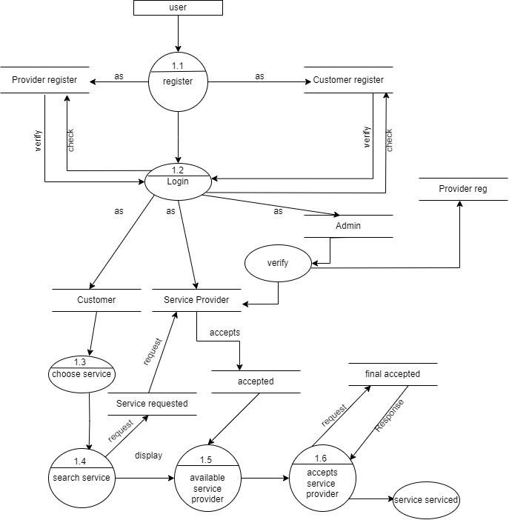

**Figure 3. 6: Level 1 DFD for GoParcel:find a delivery guy**

### 3.2. System Design

To realize the different functional requirement of the system in graphical form, different design diagram of the system has been prepared which are as follows:

#### 3.2.1.System Flowchart

The figure below is the flowchart of GoParcel: Find a delivery guy. Here, admin and users and service provider has to login the system and if user is not register then they need to register first. After login success, it redirects to dashboard and can see the services that we provide, then can request for the service. Likewise for service provider, service provider sees dashboard after login then can view the service that are requested by the user and accept the request which they want. The admin do not need to register they can directly login the system and after login success it redirects to dashboard of admin and admin can manage categories, and all the details of users and providers. Then admin and users log out the system.

#### Admin

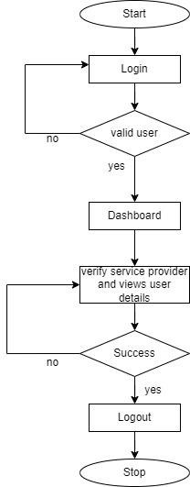

#### Figure 3.8: Flow chart of GoParcel for Admin

**Service provider:**

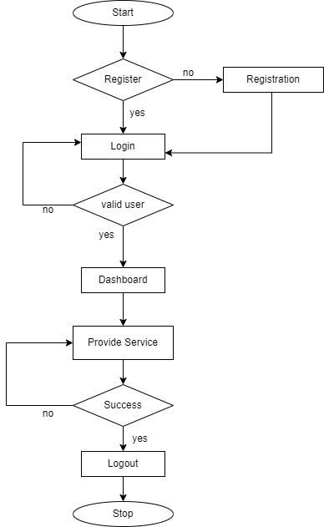

#### Figure 3.9: Flow chart of GoParcel for Service provider

**Customer:**

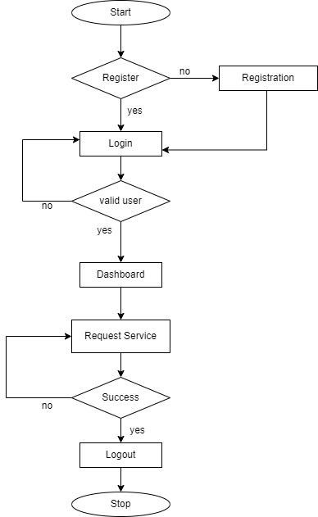

**Figure 3.10: Flow chart of GoParcel for Customer.**

#### 3.2.3 Algorithm detail

In this system, we are going to use K-NN algorithm for finding nearest plumbers. K-NN is a simple and effective method for locating the closest points in a dataset based on a given metric, typically Euclidean distance. Here’s how we can implement it for finding the nearest plumbers:

**Steps to Use K-NN for Finding Nearest Plumbers:**

1. **Collect Plumber Locations**:

• Gather the geographic coordinates (latitude and longitude) of all available plumbers.

2. **Customer location**:

• Obtain the geographic coordinates of the customer who needs the service.

3. **Calculate Distances**:

• Calculate the distance between the customer's location and each plumber's location. The Haversine formula is commonly used to calculate distances between two points on the Earth's surface.

**4. Sort and Select:**

• Sort the plumbers by distance and select the nearest K plumbers.

Using the K-NN algorithm for finding the nearest plumber is a practical and effective approach.

Especially when combined with geospatial distance calculations like the Haversine formula. This method is simple to implement and provides accurate results for locating nearby service providers

**CHAPTER: 4**

## IMPLEMENTATION

### 4.1. Implementation

**4.1.1. Tools Used (CASE tools, Programming language, Database platforms)**

Following are the tools and framework used for the accomplishment of this project:

**Front End Tools**

#### • React.js

React.js is a javascript library for building user interface. Its commonly used to create singlepage application and allows developers to create reusable UI components.

#### • HTML

Html is used for creating different webpage and sites. It is used to create and structure sections, headings, links, paragraphs using various tags and elements. We also define headers, paragraphs, links, and images by using html.

#### • CSS

Css is used for designing different tags of html. It is also used to design different component by the help of class and id. Different css are used such as inline css, internal css, and external css to design this system. It is used for defining the styles for web pages. By using css, we can control the text color, font style, the spacing between paragraphs, sizing of columns, layout designs, and many more.

#### • Tailwind Css

Instead of writing custom CSS rules,We have use Tailwind css in most part of design we have apply utility classes to a elements. These classes define specific styles like spacing, colors, and alignment. It's a powerful way to build modern designs

#### • JavaScript

JavaScript is used for client-side validation and to make dynamic, interactive and responsive web pages. It is used to add dynamic behavior to the webpage and add special effects to the webpage.

**Back End Tools**

#### • Node

node is used for the backend purpose and for making dynamic web pages. It is used for server side scripting purpose to add connectivity to the database and also used to encrypt the data, validate the user data, confirm user to go to certain pages, login pages. It also includes add, update and delete the data from the database.

#### • Express.js

Express.js is a minimal and flexible web application framework for Node.js. It provides a robust set of features for building web and mobile applications.

**Server**

• **APACHE SERVER**

Apache server is used to run php files and creating fast and dynamic web pages.

**Database**

#### • MongoDB

MongoDB is a popular open-source document-oriented NoSQL database. Unlike traditional relational databases, MongoDB doesn't rely on a table-like structure. Instead, it stores data in flexible, JSON-like documents. This approach allows developers to handle complex data structures intuitively. MongoDB is widely used for modern application development and cloud-based systems due to its scalability and flexibility.

**Documentation Tools**

#### • MS Office

This is used for writing and editing the documentation of sponsorship management system.

#### • Draw.io

This is used to generate diagrams for system analysis and design of “GoParcel:find a delivery guy” Diagrams were created using this tool in order to save time since all components are available with drag and drop functions.

**Documentation Tools**

#### • MS Office

This is used for writing and editing the documentation of sponsorship management system.

#### • Draw.io

This is used to generate diagrams for system analysis and design of “GoParcel:find a delivery guy” Diagrams were created using this tool in order to save time since all components are available with drag and drop functions.

**4.1.2 Implementation Details of Modules (Description of procedures/functions)**

#### Admin Module

In this comprehensive module, the admin is empowered with the authority to manage both customer and users in the existing system. The admin begins by logging in using the provided credentials, gaining access to the administrative functionalities.

Once logged in, the admin can seamlessly perform the following actions:

* **User Management:**

The admin has the privilege of managing users in the system. They can add new users, view user profiles, and make any required updates to user information.

* **Dashboard:**

The dashboard offers a comprehensive view of the overall system.

#### User Module

This module ensures that users can interact with the system effectively, providing a seamless experience for requesting service, managing their profile.

In this module, users are required to log in to access the home page where they can view the services, request services in their location. When their session is complete, users can log out using the "Sign Out" button, ensuring security and a user-friendly experience throughout the system.

#### Login Module

This module validates users by requesting their user and password, ensuring only authorized individuals gain access. If the user is a regular user, they can enter the homepage, while an admin gains entry to the dashboard. The module implements both client-side and server-side validation methods to enhance website security and safeguard the data, ensuring a protected user experience.

#### Register Module

This module, users have the option to register their accounts by providing various details, including full name, gender, phone number, email address, password, and and Providers has to do same but has to fill up the address and the occupation. However, it is important to note that users can only log in as normal users and not as administrators.