Exercise Question: Use Case Diagram for a Hotel Reservation System
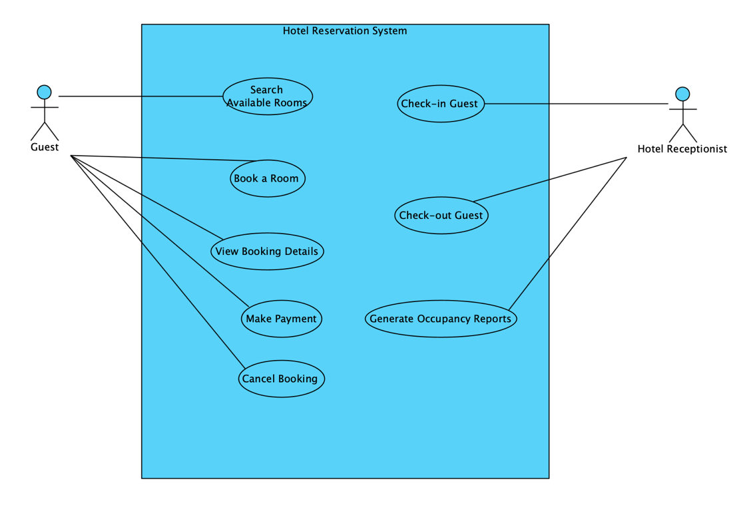
Exercise Question: Use Case Diagram for an Airline Ticket Booking System
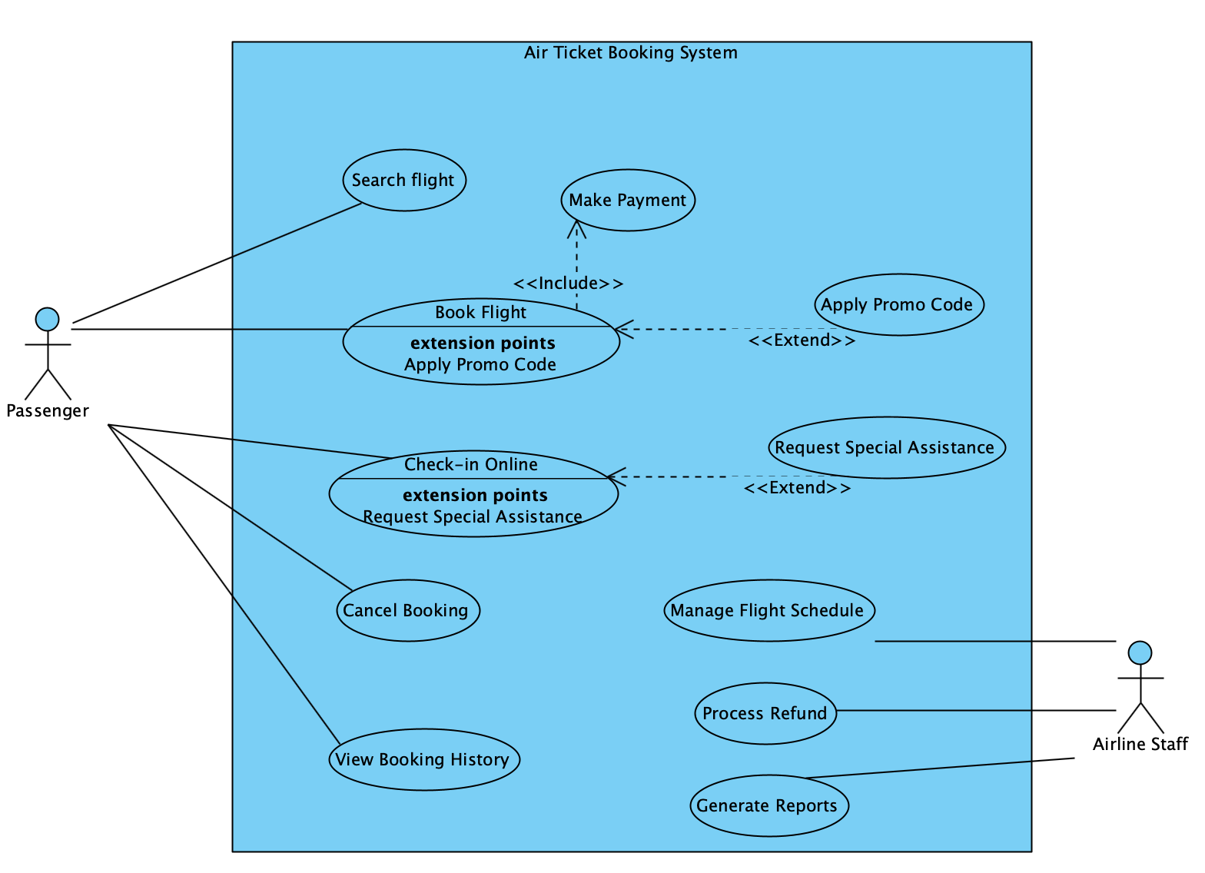
Exercise Question: Sequence Diagram for User Login Process

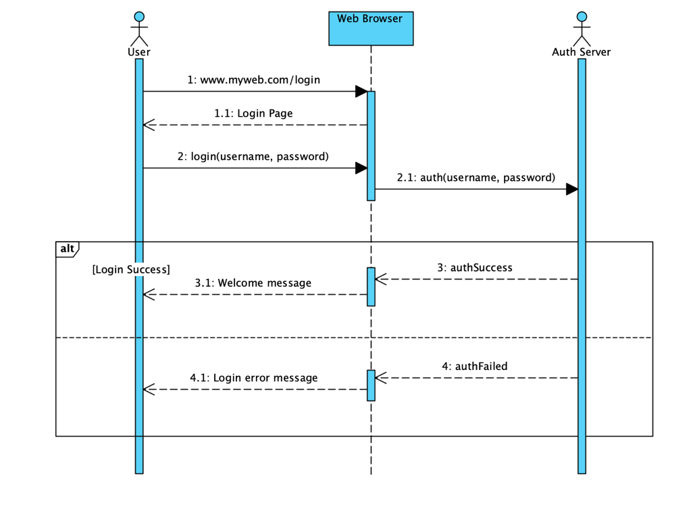
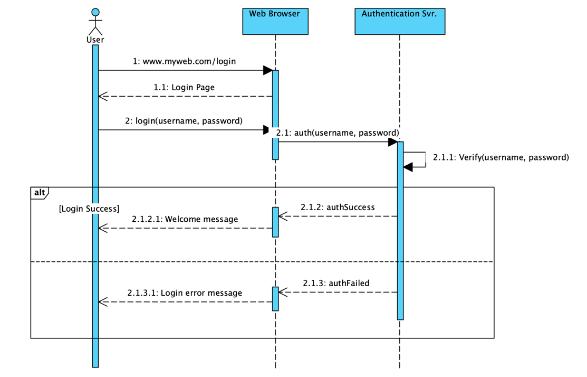

Exercise Question: Sequence Diagram for Online Shopping Checkout Process
