Hello fellow netizens, if you’ve arrived at this corner of the internet, it means you are considering participating in a Decentralized Autonomous Organization or as the cool kids sometimes call it a DAO.

各位网友大家好，如果你到达互联网的这个角落，就意味着你正在考虑参加一个去中心化的自治组织，或者酷孩子有时称之为DAO。

Since the famous [The Dao hack in 2016](https://medium.com/swlh/the-story-of-the-dao-its-history-and-consequences-71e6a8a551ee), few people have remained believers of the possibility we’ll ever see a functioning DAO, but my friend [Matan Field](https://medium.com/@matanfield" \t "_blank)and the awesome team at [DAOstack](https://medium.com/@daostack) are true pioneers of this space and so they’ve been busy working on building the unimaginable!

自2016年著名的[The Dao hack](https://medium.com/swlh/the-story-of-the-dao-its-history-and-consequences-71e6a8a551ee)以来，很少有人相信我们有可能看到一个功能正常的DAO，但我的朋友[Matan Field](https://medium.com/@matanfield)和 DAOstack团队是这个领域真正的先驱，因此他们一直忙于打造难以想象的工作！

In this post, I won’t go into the whole depth of what DAOs are and what they can enable, I trust that the team at [DAOstack](https://medium.com/@daostack) as well as other teams provide better content than I would. I will also not focus on security aspect of using decentralized tech, use this guide at your own risk ⚠️⚠️⚠️

在这篇文章中，我不会详细介绍DAO以及DAO可以实现的内容，我相信[DAOstack](https://medium.com/@daostack)团队以及其他团队提供的内容比我更好。 我也不会关注使用去中心化技术的安全方面，使用本指南需要您自担风险⚠️⚠️⚠️

What I’ll focus on is the steps required to onboard yourself to the experimental DAO that’s currently running through DAOstack’s [Alchemy](https://alchemy.daostack.io/)platform.

If you want to ask any questions about the steps and products mentioned in this tutorial feel free to jump in and ask a friendly cryptocat in the chat on [bitfwd community](http://bitfwd.com/) ([bitfwd.com](http://bitfwd.com/)) Telegram channel at: [t.me/bitfwd](http://t.me/bitfwd)

我将关注的是把自己加入到目前正在运行DAOstack的[Alchemy](https://alchemy.daostack.io/)平台的实验性DAO中。

如果你想问任何关于本教程中提到的步骤和产品，欢迎加入[bitfwd community](http://bitfwd.com/) ([bitfwd.com](http://bitfwd.com/)) Telegram channel at: [t.me/bitfwd](http://t.me/bitfwd)

译者注：中文可以访问HiBlock官方网站（<http://www.hiblock.net>）

👩🏼‍🎤👨🏾‍💻👧🏻👩🏼‍🏫🧕🏻🧔🏻🐨🌈⏩

Before we start, here are the list of digital products you’re gonna need to follow this tutorial:

开始之前，你需要准备的内容如下：

**Ingredients**

**准备清单**

1. Web Browser: 🔥🦊 [Firefox](https://www.mozilla.org/en-US/firefox/new/) of Mozilla is my recommendation but you can also use Brave or Chrome.
2. [Metamask](http://metamask.io/): 🦊 This is a web browser plugin that makes your browser compatible with Web3 supported sites and serves as your browser wallet.
3. ETH: ⛓💰 You’ll need a small amount of ETH to pay your gas fees as you submit your proposal to the Ethereum Blockchain.
4. Google Docs or GitHub account: 📑 You’ll need to draft an external proposal and conveniently allow people to publicly view your proposal and be able to post suggestions.
5. [Twitter](http://twitter.com/) account: 🐥 This is optional though, it’s recommended as this is a way to publicly demonstrate your social proof. LinkedIn and many other networks force people to be signed in when they want to see posts published by others.
6. [Telegram](https://telegram.org/) or [Discord](https://discordapp.com/): 💬 These are optional, but they will be very useful because a lot of the crypto community discussions are happening on those two platforms.
7. 科学上网技术：这里有一些工具都需要你会这个技能，如metamask, google docs, twitter, telegram等
8. 浏览器：Firefox是我推荐的浏览器，但你也可以使用Brave或Chrome
9. [Metamask](http://metamask.io/): 🦊浏览器插件，可以让浏览器兼容Web3以及轻钱包
10. ETH: 你需要一点点以太币，来支付提议的手续费
11. Google Doc或者Github账号: 你需要草拟一份对外的提议，并允许其他人方便的查看该提议且提建议
12. Twitter账号：可选项，强烈建议用一种工具来证明你的社交关系。LinkedIn以及其他工具都需要人们强制登录。
13. Telegram 或 Discord: 可选项，因为有需要的加密社区讨论在这2个平台上进行，所以很有用。

**Preparing the proposal**

**准备提议**

We’ll break it into steps, if you get stuck in any of the steps, feel free to reach out on bitfwd community Telegram. If you find the order doesn’t make sense to you, feel free to carve your own way.

我们一步一步来看，如果卡住了，欢迎到bitfwd社区提问。

1. Using Google Docs (or GitHub), write a reputation request proposal following the format of the proposal I wrote here: [Daniel’s reputation request proposal](https://docs.google.com/document/d/11Vxarj_aMtk2jcrv-ueNmwPWYDAva7ZEtBQqXChDEA8/edit). If you’re using google docs, when you’re generating the document sharing link, make sure you enable ‘suggestions’ but not ‘edit’ mode, otherwise trolls may wipe your proposal.

用google docs（或github），撰写声望（reputation）请求提议，可以采用如下参考样例：[Daniel’s reputation request proposal](https://docs.google.com/document/d/11Vxarj_aMtk2jcrv-ueNmwPWYDAva7ZEtBQqXChDEA8/edit).如果你在用google docs，生成文档共享链接时，确保打开“建议”而不是编辑模式，否则其他人可能会搞乱你的提议。

1. Paste the google doc (or GitHub) link into a public tweet similar to the one I wrote: <https://twitter.com/danieltbar/status/1118482875869831173>

把google doc（或github）链接发布到twiiter上，例如<https://twitter.com/danieltbar/status/1118482875869831173>

1. Paste the tweet link into the Google doc to cross reference.

twitter链接复制到google doc里面，交叉引用

1. Using your browser, head over to [Genesis DAO](https://alchemy.daostack.io/dao/0x294f999356ed03347c7a23bcbcf8d33fa41dc830) on [Alchemy](https://alchemy.daostack.io/) (DAOstack’s DAOs portal). There are more DAOs coming, but the Genesis DAO is the experiment that is most relevant to start with at this point.

在浏览器里打开[Genesis DAO](https://alchemy.daostack.io/dao/0x294f999356ed03347c7a23bcbcf8d33fa41dc830) （[Alchemy](https://alchemy.daostack.io/)是DAOstack的门户）。会有很多DAO组织加入，Genesis DAO是这个点上的最相关的实验。

1. Assuming you’ve set up your [Metamask](http://metamask.io/) and have some ETH loaded on your account (and if you’re struggling — bitfwd Telegram: [t.me/bitfwd](http://t.me/bitfwd)) you can start the proposal submission on Alchemy interface.

假设你已经安装好了[Metamask](http://metamask.io/)（译者注：需要科学上网），并且你的账号里有以太币，那么久可以开始在Alchemy上提交你的提议

1. Open up a new proposal by clicking the “+ New Proposal” button at the top right of the screen.

在右上角点击“+ New Proposal”打开一个新的提议

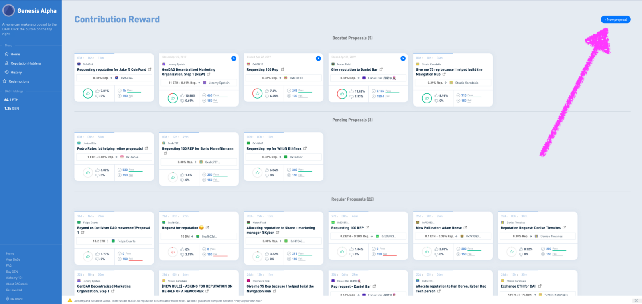

DAOstack’s Genesis DAO Alchemy interface

1. Fill in the fields of the proposal as shown in the screen:

按照如下提示填写提议：

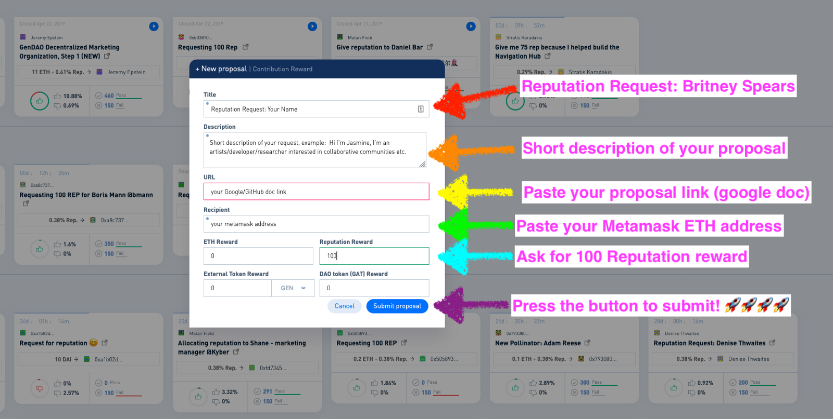

7.1 Reputation Request: Your Name.

声望请求：你的名字

7.2 Short description to your request.

请求的简短介绍

7.3 Paste your google/GitHub proposal link.

google doc的提议链接（或者是github的提议链接）

7.4 Paste your dedicated Metamask ETH address.

metamask中你的以太坊账号地址

7.5 Insert ‘100’ (that’s the current convention) at the Reputation reward field, leave all other reward fields at ‘0’.

在Reputation reward字段填写100，其他字段保留原来的默认值0

7.6 Press submit. You’ll then be required to approve the transaction using your Metamask, to do that you’re gonna have to pay the associated gas fees.

点击submit，metamask会弹出窗口，需要确认交易，这里需要少量的交易费。

Next, existing Genesis DAO members who have reputation can vote on your proposal and discuss it in the various channels. If you’d like to get in touch with the Genesis DAO community and the DAOstack community follow their [Telegram](https://t.me/daostackcommunity) (<https://t.me/daostackcommunity>) and [Discord](https://daostack.io/community) groups and feel free to ask questions.

接下来，现有有声望的Genesis DAO会员会投票你的提议，并在不同的渠道进行讨论。如果你想要联系Genesis DAO社区，可以关注他们的[Telegram](https://t.me/daostackcommunity) (<https://t.me/daostackcommunity>) and [Discord](https://daostack.io/community) .

**Socials for Daniel**

* Twitter: [@danieltbar](http://twitter.com/danieltbar)
* LinkedIn: <https://www.linkedin.com/in/dtbar/>
* Instagram: <https://www.instagram.com/danieltbar/>
* GitHub: <https://github.com/dtbx>

**Socials for Bob Jiang（译者）**

* Twitter: [@bobjiang123](https://twitter.com/bobjiang123)
* LinkedIn:  <https://www.linkedin.com/in/xinbaojiang/>
* GitHub: <https://github.com/bobjiang/>

**Learn More about bitfwd**

* Website: [bitfwd.com](http://bitfwd.com/).
* Twitter: [bitfwdxyz](http://twitter.com/bitfwdxyz)
* Telegram: [t.me/bitfwd](http://t.me/bitfwd)
* [Instagram: https://www.instagram.com/bitfwd/](https://www.instagram.com/bitfwd/)

**Learn More about HiBlock**

* Website: <http://www.hiblock.net/>

**From DAOstack:**

*Learn More about DAOstack*

*Experience*[*Alchemy*](https://alchemy.daostack.io/)*, currently live (in alpha) and in use on the Ethereum mainnet.*

*Follow DAOstack on*[*Medium*](https://medium.com/daostack)*,*[*Twitter*](https://twitter.com/daostack?lang=en)*, or any of the other channels you’ll find on our*[*website*](https://daostack.io/)*.*

*Interested in joining the Pollinators, our official early-adopter community, and participating in the Genesis DAO?*[*Message*](mailto:erik@daostack.io?subject=Pollinators%20Inquiry)*our Pollinators program coordinator.*

*Part of an organization interested in creating a pilot DAO or building on DAOstack? Connect with us*[*here*](https://airtable.com/shrMMAocbDEoZO6Wd)*.*

*Developer? Check out the*[*DAOstack Github*](https://github.com/daostack)*, or jump into the stack with our friendly*[*Hacker’s Kit*](https://github.com/daostack/DAOstack-Hackers-Kit)*.*