**ACCT 6309/MIS 6309 – DB Refresher**

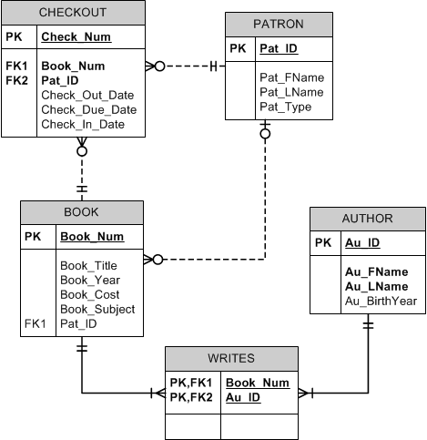

1. **Due to inflation, the cost of all books published in 2014 will increase by 6%. Write a single SQL command to increase all book costs by 6%.**

UPDATE BOOK

SET BOOK_COST = BOOK_COST * 1.06;

2. **Write a query that will display all the Books that were published in 2016. Display the book year, book title, book subject, author last name, and author first. Sort the records by book title.**

SELECT BOOK_YEAR, BOOK_TITLE, BOOK_SUBJECT, AU_LNAME, AU_FNAME

from BOOK

Left join Writes on book.book_num = writes.book_num

Left join author on writes.au_id = author.au_id

where book.book_year = 2016

order by book.book_title

1. **Write a query to display the book title, book year, book subject , and book cost for all books that are either Database or Programming books and that have a replacement cost that is greater than $50. Sort the results in ascending order by Subject then cost.**

SELECT BOOK_TITLE, BOOK_YEAR, BOOK_SUBJECT, BOOK_COST

from book

where book_subject = 'Database' or book_subject = 'Programming'

group by BOOK_TITLE, BOOK_YEAR, BOOK_SUBJECT, BOOK_COST

having book_cost > 50

order by book_subject, book_cost ASC

1. **Write a query to show the min, max, and average replacement cost for all books.**

SELECT MIN(BOOK_COST), MAX(BOOK_COST), AVG(BOOK_COST)

FROM BOOK

1. **Write a query to display the book subject and the number of books in each subject, order by the subject.**

SELECT BOOK_SUBJECT, COUNT(BOOK_NUM)

FROM BOOK

GROUP BY BOOK_SUBJECT

ORDER BY BOOK_SUBJECT

1. **Write a query to display the patron type and the number of patrons in each type, order by the number of patrons in descending order.**

SELECT PAT_TYPE, COUNT(PAT_ID)

FROM PATRON

GROUP BY PAT_TYPE

ORDER BY COUNT(PAT_ID) DESC

1. **Write a query to display books that have the word “database” in the title regardless of how it is capitalized.**

SELECT BOOK_TITLE

FROM BOOK

WHERE UPPER(BOOK_TITLE) LIKE '%DATABASE%'

1. **Write a query to display the total number of books.**

SELECT COUNT(BOOK_NUM)

FROM BOOK