**Lab Sheet 01**

3)

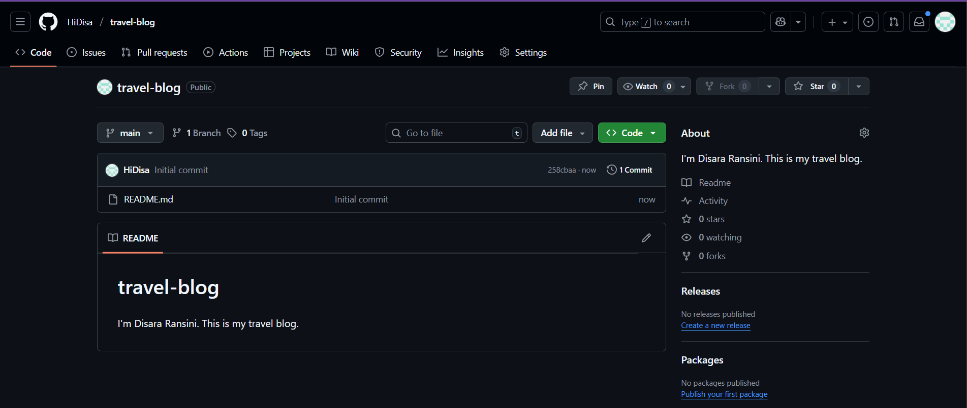

4)

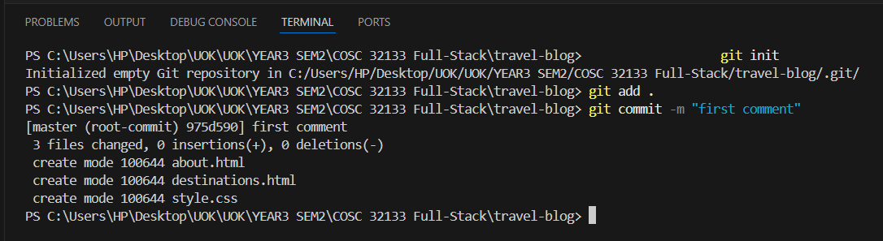

5)

(a) git remote add origin <https://github.com/HiDisa/travel-blog.git>

(c)

6)

(a) , (b)

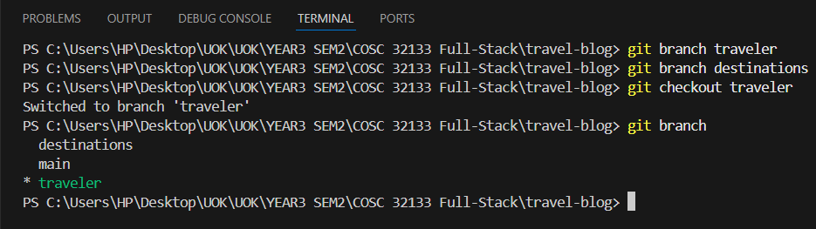

(c)

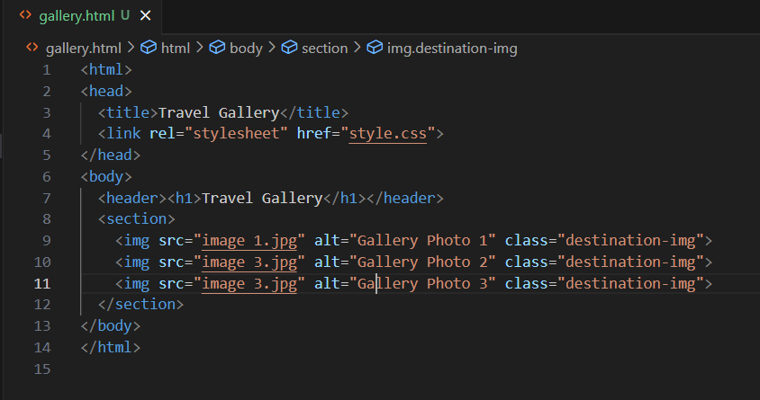

(d)

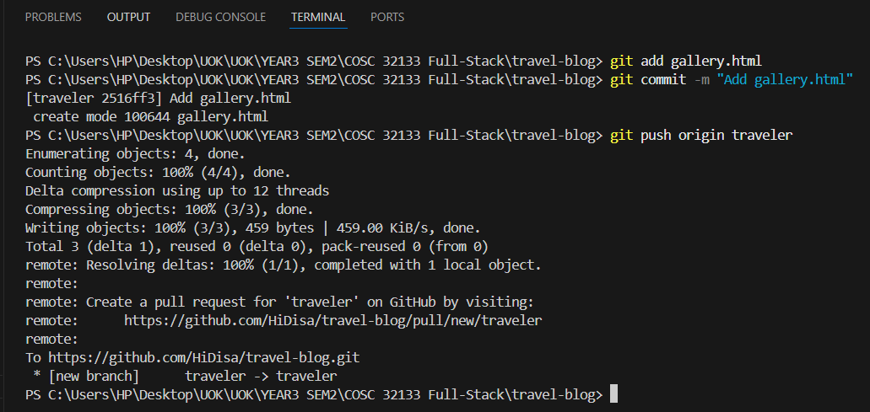

(7)

(a)

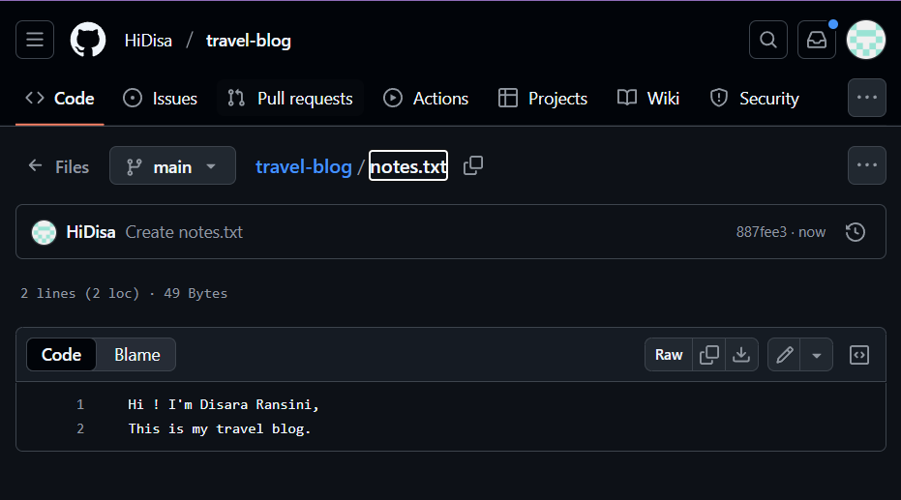

(b) git fetch

(c) , (d)

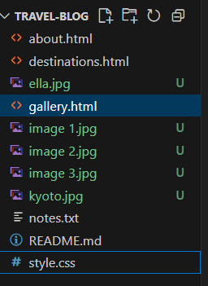

**Website output**

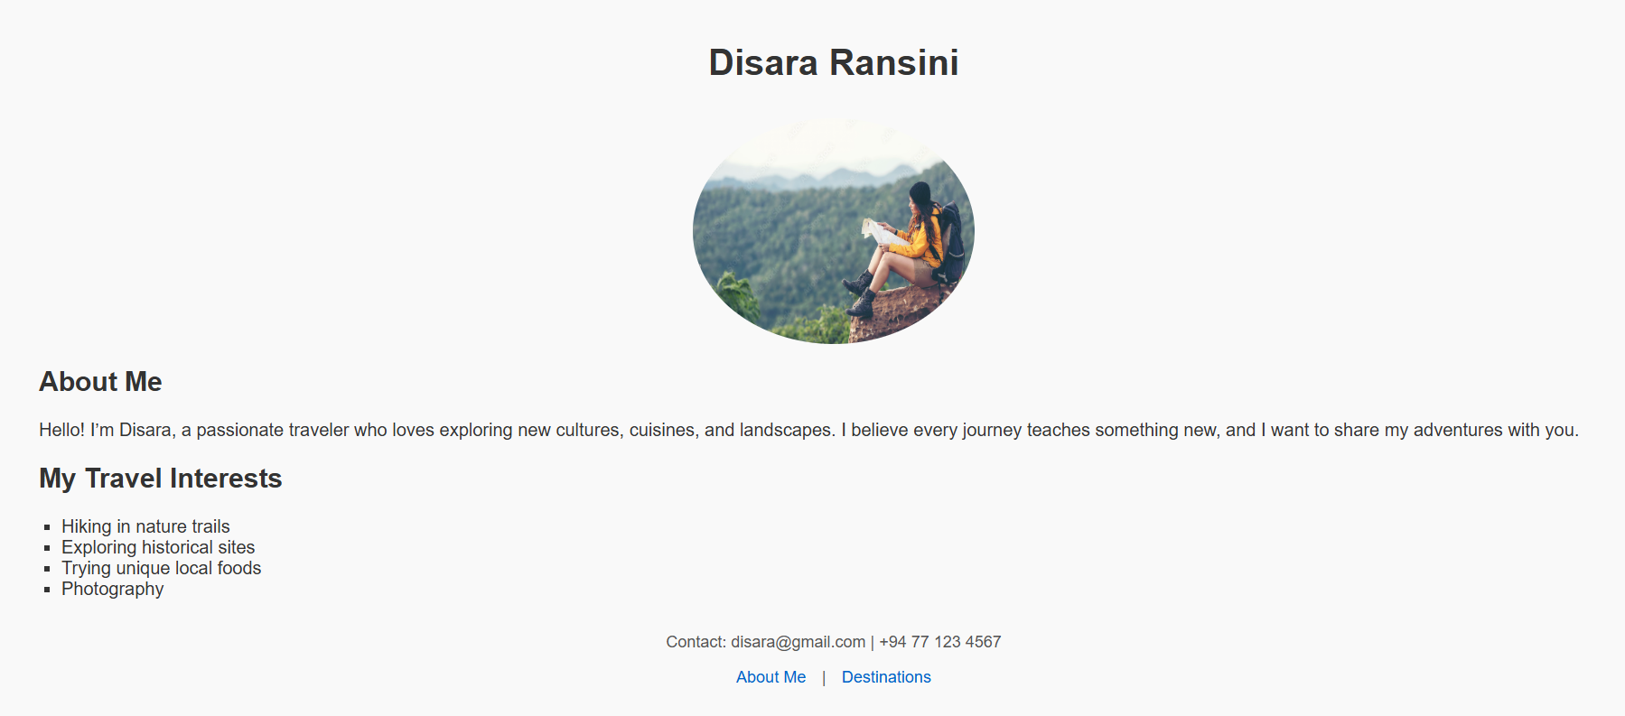

(8)

(a)

git clone https://github.com/STEM-Link-AI-Engineer-Org/class-2-notebooks.git

(b)

