1. datamart_monthly_supplier_gross_revenue

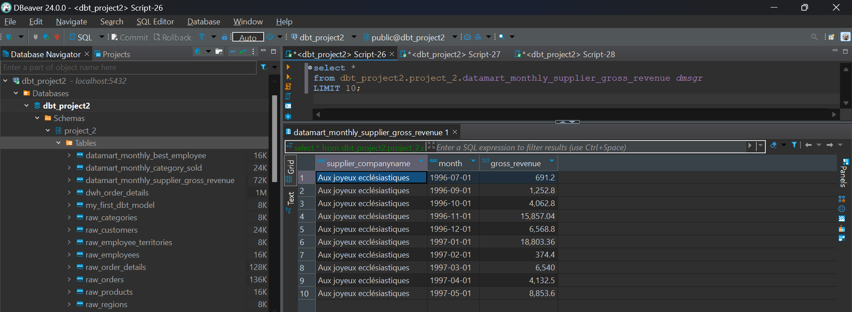

1. datamart_monthly_category_sold

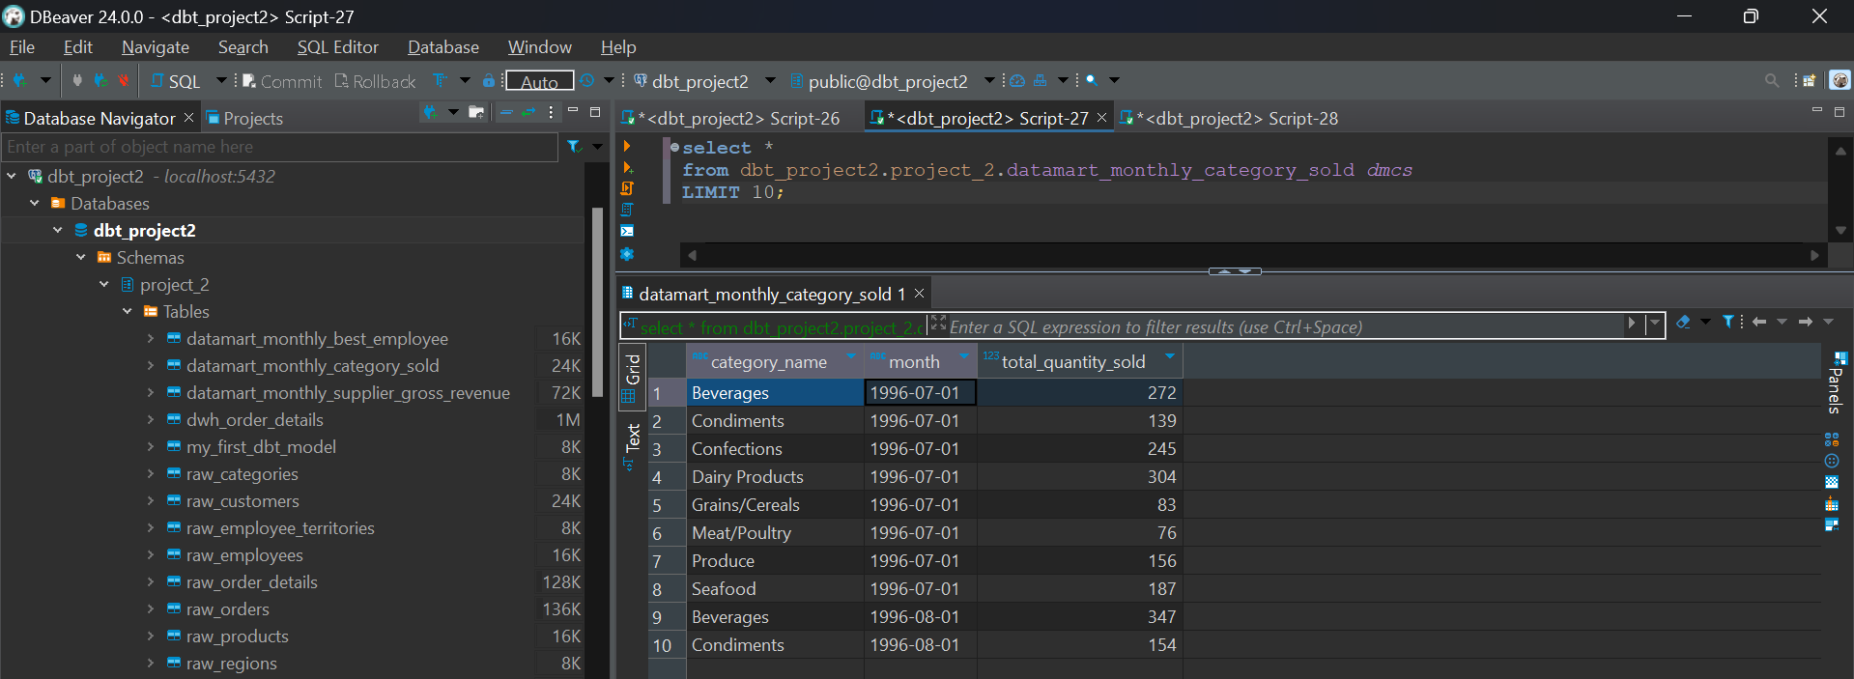

1. datamart_monthly_best_employee

