**IT2002 Project Report**

**Project members**

Ng Tze Kean

Chen Yao Quan

Lee Wen Yang

Lian Kah Seng

What is our project about?

Our project aims to build a web application that acts as an online marketplace for users to apply for a short homestay, as well as to place their house up on listings for other users to apply.

We used Flask framework to create the web application. We kept track of the sessions that users are in ___.

Entity-Relationship Diagram

SQL Data Definition Language Code

SCHEMA

Our Schema consists of users, houses, credit cards, rental and house ratings.

For our users table, we set the primary key as email as everyone’s email is unique. We set the first name, last name and age to be not null as these are information that is crucial and should not be blank.

For our houses table, we set the id of the user to be the primary key as everyone’s id is unique. We set the location, price, number of rooms as not null as these are essential information for people who want to rent an apartment. It references the table users, where table.email == users.email.

For our credit card table, we set the credit card number as the primary key as every credit card number is unique. The type and email are not null as these are important information of the user and card. It references users where credit_card.email == users.email.

For our rental table, we set the primary keys to be email and houseid as both are unique. They are the foreign keys that references users and houses where rental.email == users.email and house.id = rental.houseid. The start date and number of days intended for rental is also set to be not null as they are important information to be filled in for the owner to know the time period of the rental. This ensures that the system does not allow a user to rent an apartment that has been booked.

For our house ratings table, we set the primary keys to be date, house id and email. House id and email references houses where house.id == house_ratings.houseid and users where users.email == house_ratings.email. We have also set the date and rating integer to be not null as they have to be filled in for the rating to be valid.

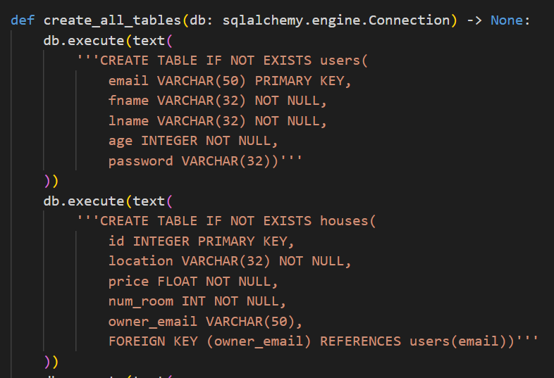

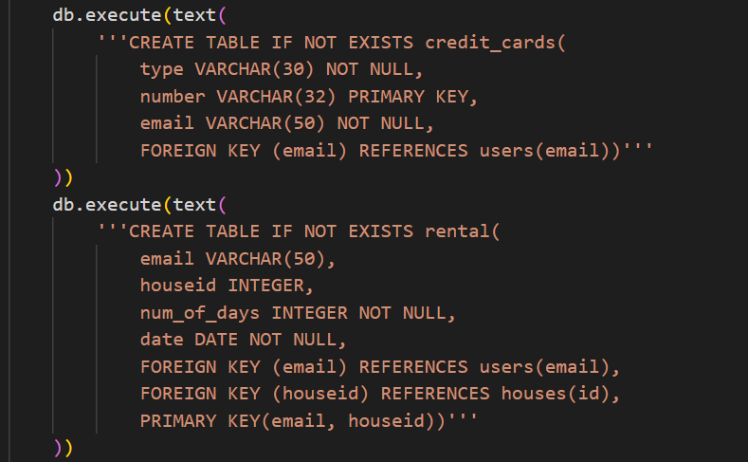

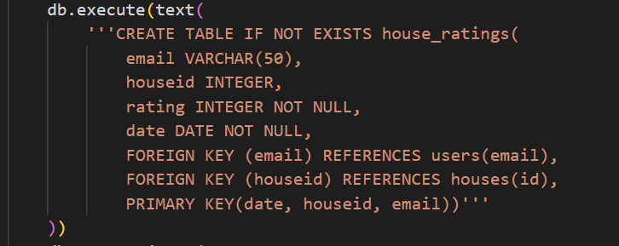

SQL Queries

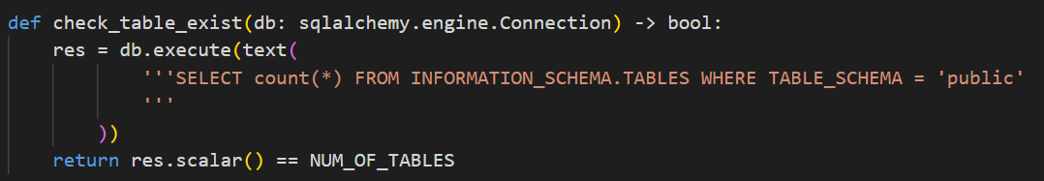

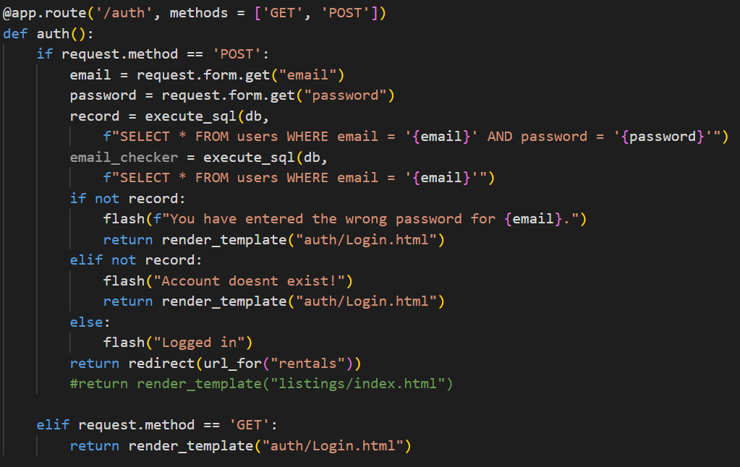

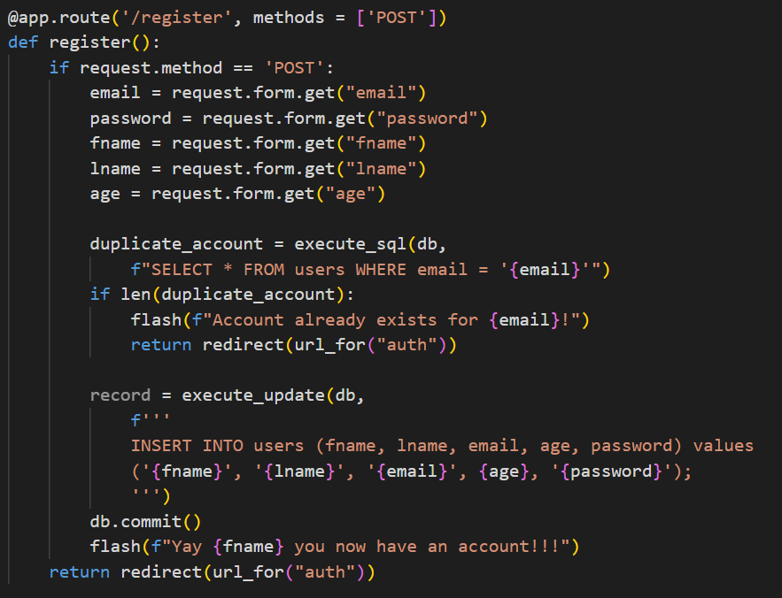

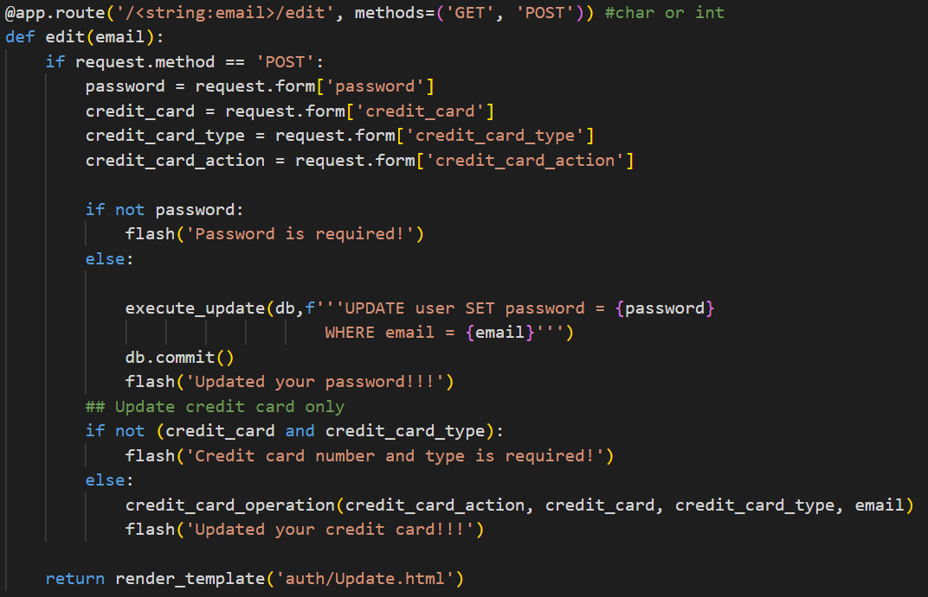

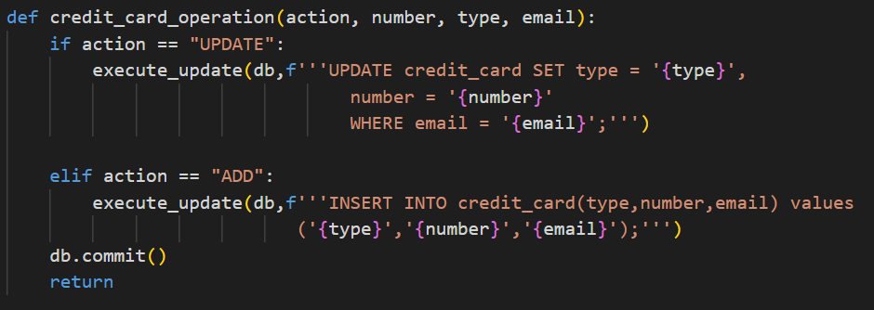

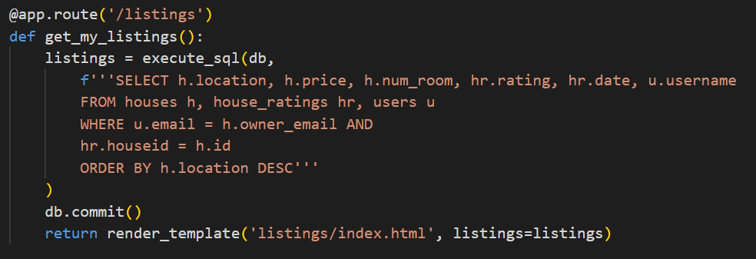

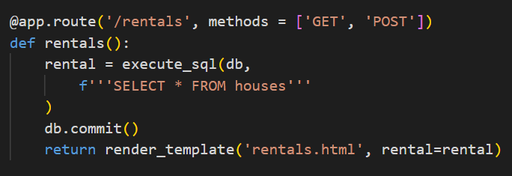

HTML, JavaScript & Flask Components

Example