Junior programmer OOP mission design document
The goal: create a project from scratch that implements the four pillars of Object Oriented Programming, managed through version control, including a branch and a successful pull.

The idea: Create three dancing shapes on a plane. Shapes can be started or stopped with keystrokes.

Object Oriented Programming Pillars:
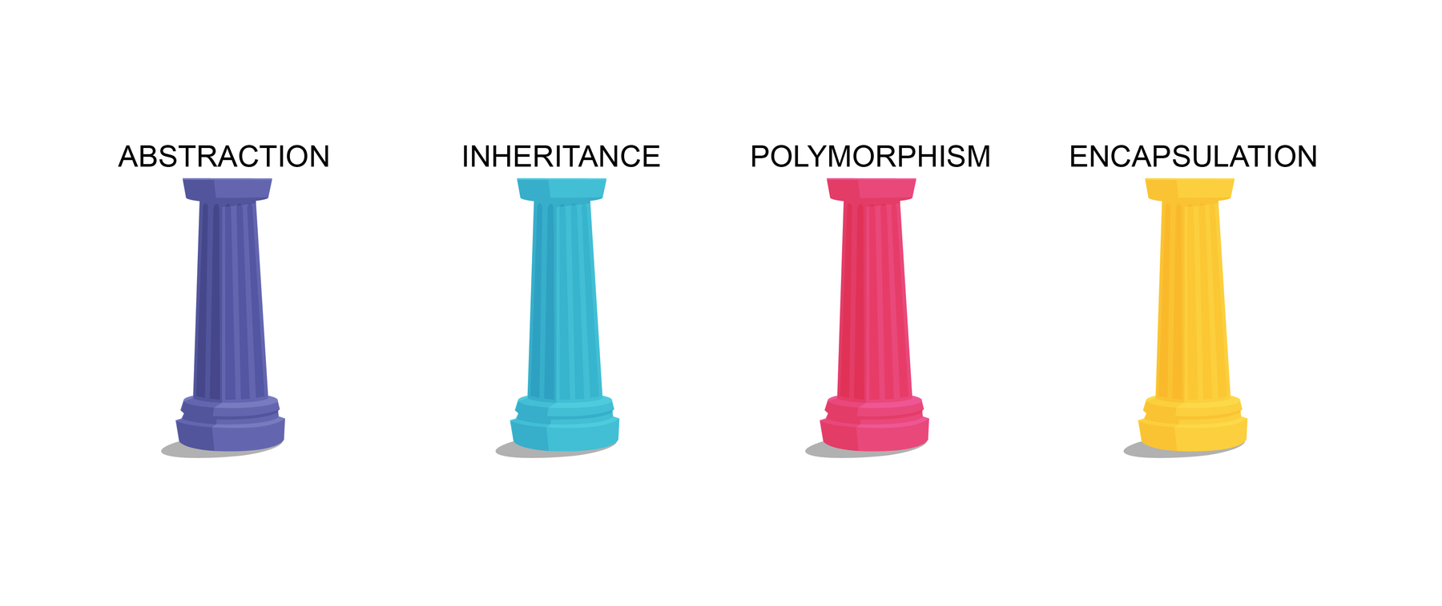
Abstraction:
Dance() allows cubes to dance
Inheritance:
Create a base shape class which contains Dance()
Polymorphism:
Dance() is an abstract method which needs to be filled-in for each shape
Encapsulation:
The dance speed can be set, but only to a positive amount

