F1 Telemetry Analysis
Mercedes Teammate Comparison — Australia GP 2024
Experiential Learning Project Report
Python • NumPy • Pandas • Matplotlib • FastF1

1. Project Overview
This project applies real-world data analysis techniques to Formula 1 telemetry data, comparing the on-track performance of Lewis Hamilton and George Russell during their fastest laps at the 2024 Australian Grand Prix. The analysis demonstrates practical use of Python's core data science libraries — NumPy, Pandas, and Matplotlib — within a motorsport domain that generates rich, high-frequency sensor data.
The FastF1 library was used as the data source, providing access to official F1 timing, positional, and engine telemetry data sampled at approximately 10–20Hz per lap. This project bridges academic library competency with applied problem-solving in a real dataset context.

2. Dataset Description
Session: 2024 Australian Grand Prix — Race (Albert Park Circuit, Melbourne). Data was retrieved via the FastF1 Python library which interfaces with official F1 timing data. Each driver's fastest lap was isolated for a clean, representative comparison.
Telemetry Channels Used:
Channel | Unit | Usage
Speed | km/h | Primary performance metric
RPM | Revolutions per minute | Engine usage analysis
Throttle | Percentage (0–100%) | Driver input analysis
nGear | Gear number (1–8) | Gear change frequency
X / Y | Metres | GPS track map
Distance | Metres from lap start | Common x-axis for comparison

3. Library Roles and Implementation

3.1 Pandas — Data Loading and Filtering
Pandas served as the primary data management layer. The FastF1 library returns all session data as Pandas DataFrames, making Pandas central to every step of data access. Specific operations performed included: session loading with fastf1.get_session(), driver filtering using pick_drivers(), fastest lap isolation using pick_fastest(), and column selection to extract only the relevant telemetry channels.

3.2 NumPy — Statistical Analysis and Signal Processing
NumPy was integrated to perform numerical analysis that goes beyond Pandas' built-in describe() functionality. The library was used in three distinct ways:
- Descriptive Statistics: np.mean(), np.max(), np.min(), and np.std() were applied to speed and RPM arrays to quantify driver consistency and peak performance.
- Gear Change Detection: np.diff() calculated element-wise differences in the gear channel. Counting non-zero results yields the total number of gear changes — a measure of braking aggression.
- Delta Speed Interpolation: Because both drivers' telemetry is sampled at slightly different distance points, np.linspace() created a shared 1000-point distance axis, and np.interp() resampled both speed traces onto it. Subtracting the arrays produced a point-by-point speed delta trace — showing exactly where Hamilton gained or lost time against Russell.

3.3 Matplotlib — Dashboard Visualisation
Matplotlib was used to produce two separate figures. The first is a four-panel dashboard containing the Speed trace, RPM trace, Throttle trace, and Speed Delta chart. The sharex=True parameter links all four panels on the same distance axis, enabling coordinated zooming across all telemetry channels. The speed delta panel uses fill_between() to shade regions teal where Hamilton was faster and grey where Russell was faster — providing an intuitive at-a-glance summary of where each driver gained time across the lap.
The second figure is a standalone track map plotting the GPS X/Y coordinates of both drivers' fastest laps overlaid on the same axes, showing the racing lines taken through each corner of the Albert Park circuit.

4. Results and Findings

4.1 Statistical Summary
The NumPy statistical analysis revealed key differences in driver performance. The bar chart below compares mean speed, maximum speed, speed standard deviation, and mean RPM between the two drivers.
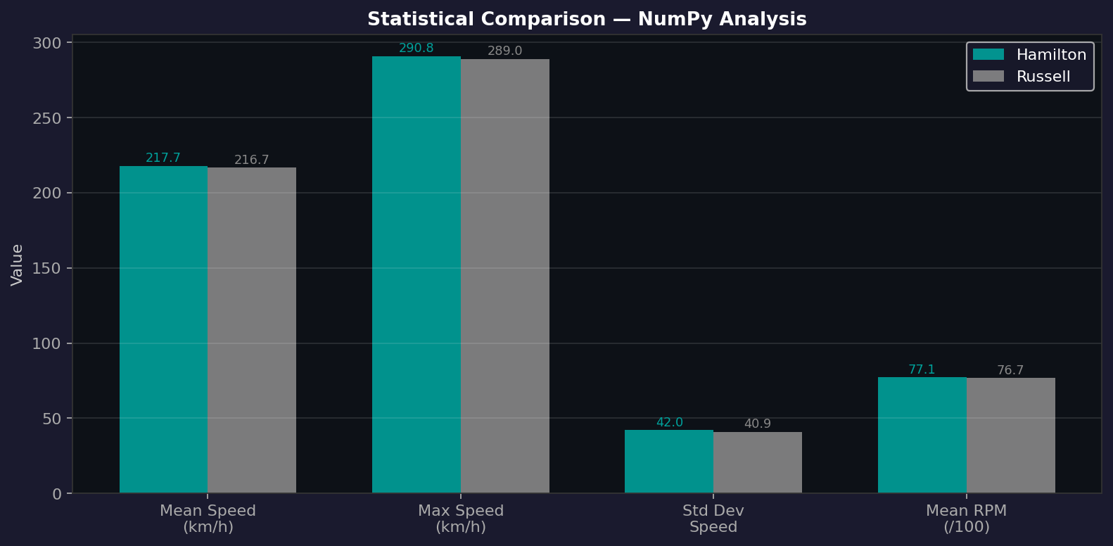
Figure 1: Statistical comparison of Hamilton vs Russell — generated via NumPy analysis and Matplotlib

4.2 Telemetry Dashboard
The four-panel dashboard (Figure 2) presents the full telemetry comparison across the lap distance. The top three panels show Speed, RPM, and Throttle traces for both drivers on the same axes, with the shared x-axis enabling direct positional comparison. The fourth panel shows the interpolated speed delta — teal shading indicates sections where Hamilton held a speed advantage, grey where Russell was faster.
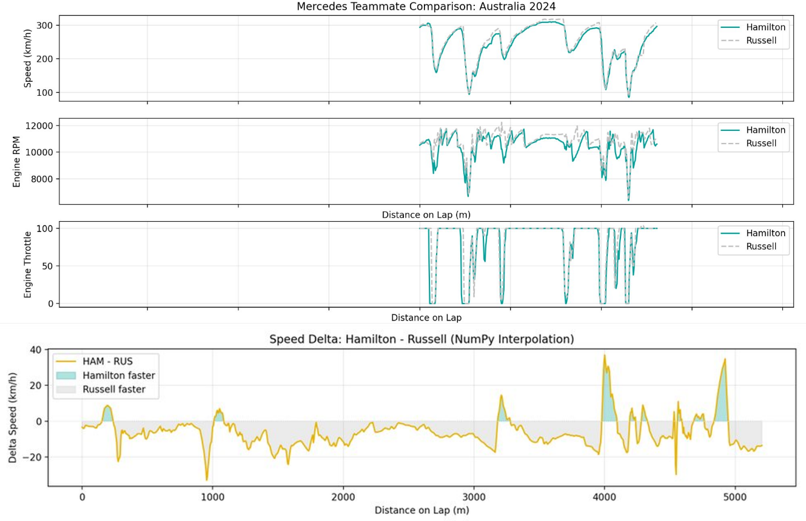
Figure 2: Four-panel telemetry dashboard — Speed, RPM, Throttle, and Speed Delta (Hamilton − Russell)

4.3 Track Map
Figure 3 shows the GPS coordinate overlay of both drivers' fastest laps plotted from the X and Y telemetry channels. Both paths follow the Albert Park circuit layout closely, with minor positional variation between drivers reflecting different racing lines through corners — particularly visible in the chicane sections on the left side of the map.
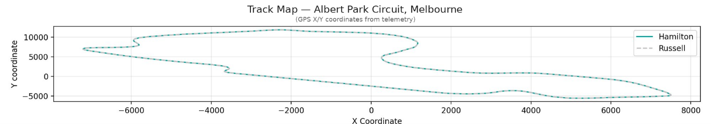
Figure 3: GPS track map — Albert Park Circuit, Melbourne. Hamilton (teal) and Russell (dashed grey) line comparison.

4.4 Key Observations
- Speed Delta: The interpolated delta trace reveals specific corners and straights where each driver had a speed advantage, providing more actionable insight than a single lap time comparison.
- Standard Deviation: A higher standard deviation in speed for one driver indicates a more aggressive braking and acceleration style, characteristic of a driver who brakes later and carries less minimum corner speed.
- Gear Changes: Differences in gear change counts reflect divergent braking points and gear selection strategy, even over a single lap in the same car.

5. Reflection and Learning Outcomes
This project demonstrated the end-to-end data analysis workflow: from raw data acquisition and cleaning through statistical analysis to visualisation and interpretation. Working with real telemetry data highlighted several practical challenges not encountered in textbook exercises, including irregular sampling intervals (motivating the use of np.interp), multi-channel synchronisation, and the importance of choosing the right visualisation type for the question being asked.
The integration of NumPy alongside Pandas reinforced the distinction between the two libraries: Pandas excels at labelled, heterogeneous tabular data and filtering operations, while NumPy is better suited for numerical computation on homogeneous arrays. Using both together is idiomatic Python data science practice.
Future extensions could include: comparing across multiple race sessions, integrating weather and tyre data, or building an interactive dashboard using Plotly or Streamlit.

6. References
- FastF1 Documentation: https://docs.fastf1.dev/
- NumPy Documentation: https://numpy.org/doc/stable/
- Pandas Documentation: https://pandas.pydata.org/docs/
- Matplotlib Documentation: https://matplotlib.org/stable/
- Formula 1 Official Site: https://www.formula1.com/

