
MINISTRY OF EDUCATION AND TRAINING
HO CHI MINH CITY UNIVERSITY OF TECHNOLOGY AND EDUCATION

SEMESTER PROJECT REPORT



DESIGN AND IMPLEMENT TOOL FOR LICENSE PLATE DETECTION USING IMAGE PROCESSING AND PATTERN RECOGNITION

SUBJECT: DIGITAL IMAGE PROCESSING

LECTURER: Assoc. Prof. Hoang Van Dung
GROUP: 11 - 01FIE
MEMBER:

Nguyen Tan Phat - 22110060

Ho Chi Minh City – 04/2025

ACKNOWLEDGEMENTS
To successfully complete this project and report, our group would like to express our sincere gratitude to Associate Professor Dr. Hoang Van Dung, who directly supported us throughout the entire process of working on this topic. We truly appreciate the valuable advice and timely guidance he provided, which helped steer us in the right direction in line with the requirements of the chosen subject.
This project and report were completed within a relatively short period of time, and with our limited knowledge, as well as various technical and experiential limitations in developing a recognition application, it was inevitable that there would be shortcomings. Therefore, we kindly hope to receive constructive feedback from our professor so that we can improve our knowledge and perform better in future endeavors.
In closing, we wish our professor continued health and even greater success in his teaching career. Once again, we sincerely thank you.

TABLE OF CONTENTS
ACKNOWLEDGEMENTS 1
LIST OF FIGURES 4
GROUP INFORMATION 5
CHAPTER 1. INTRODUCTION 6
1.1. Reasons of choosing this topic: 6
1.2. Objectives: 6
1.3. Scope: 6
1.4. Limitations: 7
1.5. Implementation Plan: 7
1.6. System Architecture: 8
2. THEORETICAL BACKGROUND 9
2.1. Tools, Programming Environment, and Programming Language 9
2.1.1. EasyOCR: 9
2.1.2. FastAPI for Python: 9
2.1.3. React: 10
2.1.4. Yolov8: 11
2.1.5. Google Colab: 11
2.2. Algorithms Used: 12
2.2.1. Image Preprocessing Algorithms: 12
2.2.1.1. Resize: 12
2.2.1.2. Grayscale: 12
2.2.1.3. Bilateral Filter: 12
2.2.1.4. CLAHE: 12
2.2.1.5. Sharpen: 12
2.2.1.6. Contrast Stretching: 12
2.2.2. Evaluation Metrics: 12
CHAPTER 3: SYSTEM DESIGN 14
3.1. Train YOLOV8: 14
3.1.1. How to run 14
3.1.2. Conclusion 14
3.2. Frontend Development: 15
3.2.1. Technology Stack and Design Philosophy 15
3.2.2. Main interface 17
3.2.3. How to run 17
3.2.4. Conclusion 18
3.3. Backend Development: 19
3.3.1. Technology Stack and Design Philosophy 19
3.3.2. Main interface 20
3.3.3. How to run 20
3.3.4 Conclusion 21
CHAPTER 4. IMPLEMENTATION, TEST CASES, RESULTS, AND DISCUSSION 23
4.1. Implementation: 23
4.2. Test Cases: 24
4.2.1. Plain, easy to recognise 25
4.2.2. Crop image 26
4.2.3. Crop image and need to enhance 27
4.2.4. APIs Responses 28
4.3. Results: 28
CHAPTER 5: CONCLUSIONS 30
5.1 Key Takeaways 30
5.1.1 Advantages 30
5.1.2 Disadvantages 30
5.2 Future Directions 31
REFERENCES 33

LIST OF FIGURES
1 | ALPR System Architect
2 | Yolo
3 | Frontend Interface
4 | Backend Interface
5 | Sample License Plates
6 | Many pictures detection
7 | Many pictures detection result
8 | Plain picture
9 | Plain picture result
10 | Cropped picture
11 | Cropped picture result
12 | Need-to-enhance picture
13 | Need-to-enhance picture result
14 | APIs Responeses
15 | Unrecognised sample
16 | Auto-cropped and enhanced result

GROUP INFORMATION
Course ID: DIPR430685E_01FIE
Lecturer: Assoc. Prof. Hoang Van Dung
Project Name: License Plate Detection Using Image Processing, Pattern Recognition, and API Services for Web and WinForms.
Group: 11
Self-assessment table
Ordinal Number | Name | Student ID | Percent | Phone Number | Signature
1 | Nguyen Tan Phat | 22110060 | 100%

Percentage (%): The completion rate of each participating student.
Instructor's Feedback:
………………………………………………………………………………………………
………………………………………………………………………………………………
………………………………………………………………………………………………

GROUP LEADER | LECTURER
Nguyen Tan Phat | Assoc. Prof. Hoang Van Dung

CHAPTER 1. INTRODUCTION

Reasons of choosing this topic:
The primary motivation for selecting this topic stems from the rapid urbanization and increasing number of vehicles on the roads, which make traffic management and monitoring increasingly challenging. Traditional methods of license plate inspection are often slow, labor-intensive, and prone to human errors. As a result, the demand for automated license plate detection and recognition systems has grown significantly. Such systems can help traffic authorities save time, enhance public safety, and manage traffic flow more efficiently.
Additionally, this project offers an excellent opportunity for us to explore and apply modern technologies such as OpenCV for image processing, Tesseract OCR for optical character recognition, and API development for integration with both Web and WinForms platforms. It allows us to combine various technical skills to create a practical solution for a real-world problem. Through this project, we aim to sharpen our programming, problem-solving, and system integration skills, while gaining valuable experience in the exciting fields of computer vision, automation, and cross-platform application development.

Objectives:
The main objective of our project is to develop a functional system capable of automatically detecting and recognizing vehicle license plates from images using advanced image processing and pattern recognition techniques. Our system will not only locate and extract the license plate region but also recognize the alphanumeric characters using OCR technology.
Specifically, we aim to:
- Deepen our understanding of digital image processing methods such as grayscale conversion, noise reduction, contrast enhancement, edge detection, and segmentation.
- Integrate optical character recognition (OCR) to accurately identify characters from extracted license plates.
- Design and implement RESTful APIs that allow the system to be accessed and utilized by both Web applications and WinForms applications.
- Deliver a working prototype that demonstrates how image processing, OCR, and API integration can effectively address real-world challenges.
Furthermore, this project will lay the groundwork for more advanced systems in the future, such as intelligent traffic management and AI-driven surveillance solutions.

Scope:
This project focuses on building a prototype system that can detect and recognize vehicle license plates from static images under standard conditions. The key functionalities include:
- Preprocessing input images by converting them to grayscale, reducing noise, and enhancing contrast.
- Applying edge and shape detection algorithms to locate the license plate region.
- Extracting the identified plate area and using Tesseract OCR to recognize the license number.
- Developing API endpoints to enable easy integration with Web and WinForms-based client applications

Limitations:
The system is designed for clear, standard-format license plates captured under good lighting and from normal viewing angles. Complex scenarios such as damaged, dirty, tilted plates, or plates from different countries with varying formats, are considered beyond the scope of this project.
Our primary goal is to successfully demonstrate a basic but effective prototype, which can be expanded and refined in future research and development phases.

Implementation Plan:
Week | Task
12 | Research and master key technologies and libraries, including OpenCV (for image handling), YOLOv8 (for license plate detection), and EasyOCR (for optical character recognition). Simultaneously, design and build the basic user interfaces for both Web and WinForms applications.
13 | Develop and integrate the license plate detection pipeline: use YOLOv8 for locating license plates in images, extract detected regions, and apply EasyOCR to recognize the license plate numbers. Connect the backend logic with the user interfaces through API services.
14 | Conduct thorough testing of the system. Optimize the detection model (YOLOv8 parameters), refine OCR processing (EasyOCR accuracy tuning), and enhance the Web and WinForms interfaces for better performance, usability, and responsiveness.
15 | Finalize the project by writing the technical documentation, compiling the final report, polishing the user experience, and preparing the system for demonstration or deployment.

System Architecture:
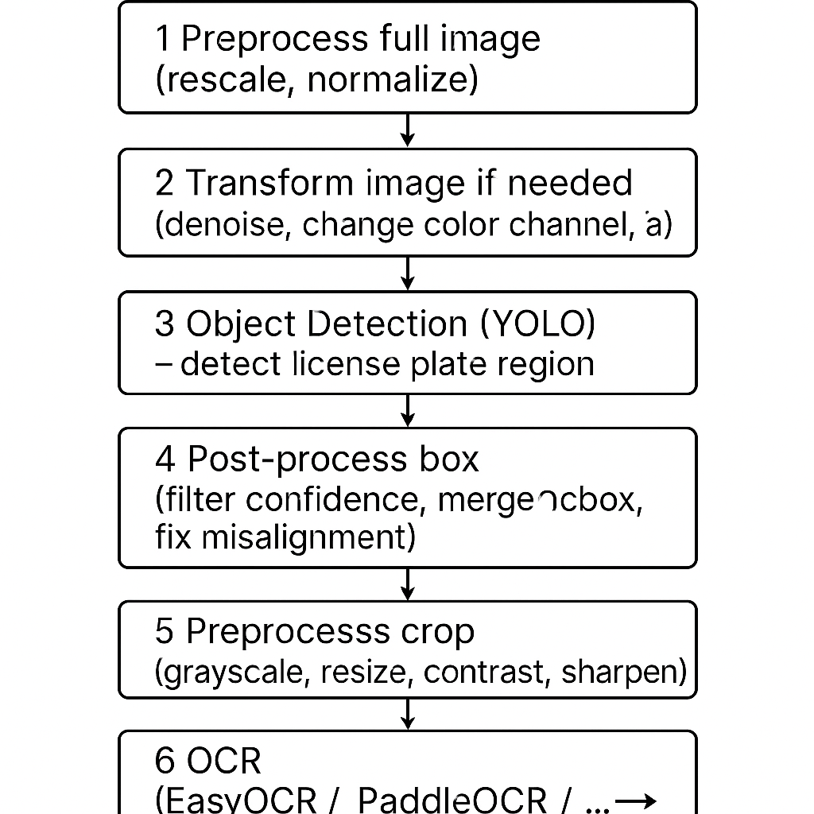

Figure 1. ALPR System Architect

2. THEORETICAL BACKGROUND

2.1. Tools, Programming Environment, and Programming Language

2.1.1. EasyOCR:
EasyOCR is an open-source Optical Character Recognition (OCR) library that allows developers to extract text from images using deep learning techniques. Developed by the Jaided AI team, EasyOCR supports over 80 languages out-of-the-box, including complex scripts such as Chinese, Arabic, Devanagari, and Vietnamese.
EasyOCR is particularly useful for scenarios where traditional OCR engines like Tesseract struggle, such as reading text from natural scenes, handwritten notes, stylized fonts, or noisy backgrounds. Instead of relying on hand-crafted features, EasyOCR uses deep convolutional networks (CNNs) combined with Long Short-Term Memory (LSTM) layers to recognize text, making it robust against image distortions and variations in font style.
One of EasyOCR’s strengths lies in its simplicity and readiness. With minimal setup, users can perform text detection and recognition in a few lines of Python code. The library also allows for GPU acceleration, significantly improving processing speed on large batches of images.
However, EasyOCR’s deep learning models are heavier than traditional engines, which means they require more computational resources. Additionally, while it performs very well on many types of images, extremely low-resolution or heavily distorted inputs may still pose challenges.
EasyOCR is widely used in applications such as document scanning, number plate recognition, information extraction from photos, and any project that demands accurate and flexible text recognition from images.

2.1.2. FastAPI for Python:
FastAPI is a modern, high-performance web framework for building APIs with Python 3.7+ based on standard Python type hints. Developed with the goal of delivering both speed and developer efficiency, FastAPI has rapidly gained popularity in the Python ecosystem due to its simplicity, performance, and robust design. Unlike traditional frameworks that often require verbose configurations or complex boilerplate code, FastAPI promotes a more intuitive and declarative style of API development.
One of the fundamental aspects that sets FastAPI apart is its deep integration with Python’s type system. By leveraging type hints, FastAPI is able to automatically generate OpenAPI documentation (formerly known as Swagger) and JSON Schema for data validation. This not only facilitates development by providing real-time feedback and auto-completion in code editors, but also enhances maintainability and scalability in large projects. In addition, FastAPI supports automatic request validation, response serialization, and detailed error handling, all of which contribute to a more robust API design with minimal effort.
Furthermore, FastAPI is built on top of Starlette for the web parts and Pydantic for data validation, combining asynchronous programming capabilities with data parsing efficiency. This allows developers to build APIs that are not only fast to develop but also extremely performant at runtime, especially in applications that require high concurrency such as real-time services, microservices, or machine learning model deployment.
In academic and industry settings alike, FastAPI has been widely adopted due to its ability to support RESTful APIs, background tasks, WebSocket communication, and OAuth2 security schemes with ease. It also integrates well with modern DevOps practices such as containerization (e.g., Docker), continuous integration, and deployment pipelines, making it a comprehensive solution for full-stack API development.

2.1.3. React:
React is a widely used open-source JavaScript library developed by Facebook for building dynamic user interfaces, especially for single-page applications (SPAs). Since its release in 2013, React has significantly influenced the way modern web applications are designed by introducing a component-based architecture and a declarative programming style. This allows developers to create complex interfaces through the composition of reusable, independent components, resulting in code that is easier to manage, test, and scale.
One of React’s most defining features is the Virtual DOM (Document Object Model), which serves as an efficient abstraction layer for updating the user interface. Instead of directly manipulating the browser's DOM, React creates a virtual copy and calculates the minimal set of changes required to keep the real DOM in sync. This approach dramatically improves performance and responsiveness, especially in applications with frequent updates or interactive content.
React also promotes the use of unidirectional data flow, meaning that data moves in a single direction from parent to child components. This design choice simplifies debugging and enhances the predictability of application behavior. Additionally, React’s compatibility with JSX — a syntax extension that allows HTML to be written within JavaScript — makes the code more readable and easier to understand, further improving the development experience.
Beyond its core features, React integrates seamlessly with modern frontend development tools and workflows. It supports state management through libraries such as Redux or Context API, enables routing with tools like React Router, and is compatible with frameworks such as Next.js for server-side rendering. React’s ecosystem is vast and well-supported, making it a practical choice for both small projects and large-scale applications.

2.1.4. Yolov8:
YOLOv8 is the latest iteration of the "You Only Look Once" series of real-time object detection models developed by Ultralytics. Known for its exceptional speed and accuracy, YOLOv8 builds upon the strengths of previous YOLO versions by incorporating state-of-the-art improvements in model architecture, training efficiency, and deployment flexibility. It supports a range of tasks beyond object detection, including instance segmentation, image classification, and pose estimation.
YOLOv8 is particularly effective in real-world scenarios where high-speed inference and precise localization are critical, such as autonomous driving, surveillance, retail analytics, and license plate recognition. The model uses advanced backbone networks, anchor-free detection heads, and optimized post-processing steps to deliver high mAP (mean Average Precision) while maintaining low latency. YOLOv8 also supports model quantization, ONNX export, and deployment on edge devices, making it highly adaptable across platforms.
One of YOLOv8’s key advantages is its ease of use and training pipeline. With the Ultralytics Python library, users can train custom models on their datasets using just a few commands. Pretrained weights are available for rapid prototyping, and the model's modular design allows developers to fine-tune architecture parameters as needed. Despite its performance, YOLOv8 remains lightweight enough to run in real-time on mid-range GPUs or even mobile devices with proper optimization.
However, like any deep learning model, YOLOv8 requires substantial annotated data for high accuracy in custom tasks. Additionally, achieving peak performance may involve fine-tuning hyperparameters and augmentations, which can be complex for beginners. Still, YOLOv8 is widely adopted in computer vision projects due to its cutting-edge capabilities, user-friendly tools, and active community support.

2.1.5. Google Colab:
Google Colaboratory, commonly known as Google Colab, is a cloud-based interactive development environment designed to facilitate the execution of Python code, particularly for data science, machine learning, and computer vision applications. Built on top of Jupyter Notebook, Google Colab enables users to write and run code in an interactive document format, combining explanatory text, executable code cells, and visual outputs — all within a web browser.
One of the most significant advantages of Google Colab is its free access to high-performance computing resources, including Graphics Processing Units (GPUs) and Tensor Processing Units (TPUs). These hardware accelerators are essential for training deep learning models efficiently, particularly in image processing tasks that involve large datasets and complex neural networks such as convolutional neural networks (CNNs). By eliminating the need for local setup or expensive hardware, Google Colab democratizes access to powerful computing tools for students, researchers, and developers around the world.
Another notable strength of Google Colab lies in its seamless integration with the Google ecosystem, especially Google Drive. Users can easily upload datasets, save notebooks, and synchronize projects directly with their cloud storage. Furthermore, Colab supports collaborative features similar to Google Docs, allowing multiple users to edit and run code simultaneously — a valuable asset in both academic and professional team environments.
Google Colab also supports the installation of external Python packages using pip, enabling the use of libraries such as OpenCV, TensorFlow, PyTorch, and YOLOv8, among others. This extensibility makes Colab highly versatile for experimentation, prototyping, and model deployment. Moreover, since it runs entirely in the cloud, Colab reduces dependency on local system configurations and ensures consistency across different machines.

2.2. Algorithms Used:

2.2.1. Image Preprocessing Algorithms:

2.2.1.1. Resize:
Resizing is a fundamental preprocessing step that involves enlarging or shrinking an image to a desired dimension. This ensures uniform input sizes for image processing models, reduces computational cost, and prevents input shape mismatches during training or inference. Interpolation methods such as INTER_LINEAR or INTER_AREA are commonly used to preserve image quality during resizing.

2.2.1.2. Grayscale:
Converting a color image (RGB) to grayscale reduces data dimensionality by eliminating color information and focusing solely on intensity. This simplification is beneficial for feature extraction tasks such as edge or contour detection, as it allows algorithms to operate more efficiently and effectively.

2.2.1.3. Bilateral Filter:
The bilateral filter is a sophisticated denoising technique that smooths images while preserving edges. Unlike average or Gaussian filters, it takes into account both the spatial proximity and intensity difference between pixels. This makes it particularly effective for reducing noise without blurring important features such as edges and boundaries.

2.2.1.4. CLAHE:
CLAHE enhances local contrast in images, especially those with uneven lighting or low visibility. It divides the image into smaller tiles and applies histogram equalization within each tile while limiting contrast amplification to prevent noise enhancement. CLAHE is widely used in medical imaging and low-light enhancement tasks.

2.2.1.5. Sharpen:
Sharpening techniques enhance image details by emphasizing edges and fine structures. Filters like Laplacian or high-pass kernels are applied to highlight transitions in intensity. This step is crucial in applications such as text recognition or object detection where precise feature boundaries are important.

2.2.1.6. Contrast Stretching:
Contrast stretching redistributes pixel intensity values to span the full dynamic range of brightness, from the darkest to the brightest. This improves the visual distinction between different regions of the image and increases the effectiveness of subsequent detection or segmentation algorithms.

2.2.2. Evaluation Metrics:
In order to assess the performance of image processing and recognition systems, various evaluation metrics are employed depending on the nature of the task. These metrics provide quantitative evidence of how well the system performs in terms of accuracy, reliability, and efficiency.
For classification or object detection tasks, accuracy, precision, recall, and F1-score are among the most commonly used metrics. Accuracy measures the proportion of correctly predicted instances over the total number of predictions. While useful, accuracy alone may be misleading in cases of imbalanced datasets, where some classes dominate the prediction.
To address this, precision and recall are used to provide a more detailed understanding. Precision quantifies the proportion of true positive predictions among all positive predictions made by the system, reflecting how relevant the results are. Recall, on the other hand, measures the proportion of true positive results that were correctly identified out of all actual positives, indicating the system’s ability to capture relevant instances. The F1-score harmonizes precision and recall into a single value, offering a balanced measure, especially in situations where one metric alone might not be sufficient.
For image segmentation or pixel-level evaluation, metrics such as Intersection over Union (IoU) and Dice Coefficient are widely used. These assess the overlap between the predicted regions and the ground truth. Higher values indicate better alignment and segmentation accuracy.
In addition, when dealing with OCR (Optical Character Recognition) tasks, character-level accuracy and word-level accuracy are important. These metrics compare the predicted text against the ground truth text, highlighting errors in recognition at both fine-grained and coarse levels.
Altogether, the choice and interpretation of these metrics are essential for understanding model performance, identifying weaknesses, and guiding improvements during both training and deployment phases.

CHAPTER 3: SYSTEM DESIGN

3.1. Train YOLOV8:
Link for source code: click here!

Figure 2. Yolo

3.1.1. How to run
The model was implemented and trained on Google Colab to leverage free GPU resources. Initially, Google Drive is mounted to access the labeled dataset. The dataset is then extracted and configured via the data.yaml file, which defines the paths to training and validation images, the number of classes, and the class names (i.e., license plate).
The model is initialized using the pretrained YOLOv8n version — a lightweight variant optimized for fast training. Training is conducted with basic parameters such as image size, number of epochs, and batch size, without the need to manually design or modify the neural network structure. After training, the resulting model is saved as a .pt file and can be used immediately for inference on test images.

3.1.2. Conclusion
Training a license plate detection model using YOLOv8 demonstrates the strong applicability of modern deep learning architectures in computer vision tasks. The system is capable of accurately identifying license plate regions in basic test scenarios with minimal setup.
For more comprehensive performance evaluation in real-world conditions, additional metrics should be considered — such as mean Average Precision (mAP) for object detection, or Intersection over Union (IoU) and Dice Coefficient for precise region-based segmentation.
If integrated with Optical Character Recognition (OCR), metrics like character-level accuracy and word-level accuracy become essential. These reflect how closely the predicted text matches the ground truth, highlighting errors at both fine-grained and holistic levels. Ultimately, the selection and interpretation of these metrics are crucial for assessing model effectiveness, identifying limitations, and guiding further improvements in both training and deployment phases.

3.2. Frontend Development:
Link of deployment (skip if you want to rebuild the whole app): click here!
The frontend of the ALPR system represents a sophisticated web application designed to provide an intuitive and efficient user interface for license plate recognition tasks. This section provides a comprehensive overview of the implementation details, design decisions, and technical considerations that went into creating the user interface.

3.2.1. Technology Stack and Design Philosophy
The frontend implementation represents a careful selection of modern web technologies, chosen specifically to address the unique requirements of an ALPR system. At its foundation, the application is built using React with TypeScript, a combination that provides not only a robust framework for component-based development but also the benefits of static typing and enhanced code maintainability. This choice was made after careful consideration of various alternatives, with React's component-based architecture proving particularly suitable for the modular nature of the ALPR interface.The build process is handled by Vite, a next-generation frontend tooling solution that offers significant advantages in terms of development speed and build optimization. This choice was particularly important given the need for rapid development iterations and efficient production builds. The styling approach utilizes TailwindCSS, which provides a utility-first methodology that ensures consistent design patterns across the application while maintaining flexibility for future modifications.
Key Technologies and Their Rationale:
React with TypeScript:
- Provides a robust foundation for component-based development
- Ensures type safety and better code maintainability
- Enables better IDE support and error catching during development
- Facilitates easier refactoring and code updates
Vite:
- Offers extremely fast development server startup
- Provides optimized production builds
- Supports hot module replacement for efficient development
- Enables better debugging capabilities
TailwindCSS:
- Implements a utility-first approach to styling
- Ensures consistent design patterns
- Reduces CSS bundle size through purging
- Provides responsive design utilities
Radix UI:
- Delivers accessible and customizable components
- Follows modern design principles
- Ensures compliance with accessibility standards
- Provides a consistent user experience
React Hooks:
- Enables efficient state management
- Simplifies side effects handling
- Reduces code complexity
- Improves component reusability

3.2.2. Main interface

Figure 3. Frontend Interface

The interface is designed to provide an intuitive user experience for uploading, processing, and managing vehicle license plate images.
1. Image Upload and Processing
- “Chọn ảnh” (Choose Image): Allows users to select a license plate image from their local device.
- “Bắt đầu xử lý ảnh” (Start Image Processing): Initiates the detection and recognition process using the trained YOLOv8-based model. Once clicked, the image is analyzed, and the license plate region is extracted for further recognition (e.g., OCR).
2. Output Display – Recognition Result
- On the right panel labeled “Kết quả” (Result), the outcome of the detection and recognition process is displayed. If no image has been processed yet, a placeholder message indicates that the system is awaiting input.
3. License Plate Search and History
- Below the image upload section, the interface provides a search bar labeled “Tìm kiếm biển số xe” (Search License Plate), allowing users to query previously processed results.
- The “Lịch sử nhận diện” (Recognition History) section shows a searchable log of all recognized license plates, including options to:
  - Enter a license plate number manually
  - Use the “Tìm kiếm” (Search) button to filter
  - Click “Xem tất cả” (View All) to retrieve the full processing history
4. System Feedback
- If no license plates have been processed, the interface displays a message prompting the user to upload an image and initiate processing.

3.2.3. How to run
The frontend application can be deployed in various environments, from development to production. The development setup is straightforward, requiring only Node.js and a package manager (npm or yarn).
Development Setup:
- Prerequisites: Node.js 18+ or Bun
- Installation: Package installation via npm or yarn
- Development Server: Local development with hot reloading
- Production Build: Optimized build for deployment
The application can be run in development mode using the following commands:
npm install
npm run dev
For production deployment, the application is built into static files that can be served by any web server. The build process optimizes the code for production, including minification and bundling of assets.

3.2.4. Conclusion
The frontend implementation of the ALPR system successfully delivers a modern, efficient, and user-friendly interface for license plate recognition tasks. The choice of technologies and design decisions have resulted in a robust application that meets the requirements of both users and developers.
Key Achievements:
- User Experience: Intuitive interface with responsive design
- Performance: Optimized rendering and data handling
- Maintainability: Clean code structure with TypeScript support
- Accessibility: Compliance with modern web standards
The implementation provides a solid foundation for future enhancements and modifications. The modular architecture allows for easy addition of new features, while the comprehensive testing strategy ensures reliability and stability. The frontend successfully integrates with the backend services, providing a complete solution for license plate recognition tasks.[Insert frontend architecture diagram here]This structure provides a clear and comprehensive overview of the frontend implementation, from the technology choices to the final deployment. The sections flow logically from the technical foundation to the practical implementation and conclusion, making it easy for readers to understand the complete frontend architecture of the ALPR system.

3.3. Backend Development:
Pre-installed requirements:
- MySQL Server: https://www.mysql.com/downloads/
- Python: https://www.python.org/
The backend of the ALPR system represents the core processing engine that powers the entire license plate recognition system. This implementation was carefully designed to handle the complex tasks of image processing, license plate detection, and data management while maintaining high performance and reliability. The following sections detail the technical architecture, implementation decisions, and operational considerations that form the foundation of our system.

3.3.1. Technology Stack and Design Philosophy
The choice of technology stack for the backend was driven by the specific requirements of license plate recognition and the need for high-performance processing. Python was selected as the primary programming language due to its extensive support for machine learning and image processing libraries, as well as its readability and maintainability. The FastAPI framework was chosen as the web framework for its exceptional performance characteristics and modern API development features.
Key Technology Components:
- Core Framework: Python with FastAPI for high-performance API development
- Computer Vision: YOLOv8 for license plate detection and EasyOCR for character recognition
- Database: MySQL for reliable data storage and efficient querying
- Containerization: Docker for deployment and environment management
The computer vision components of the system are built around YOLOv8 for license plate detection and EasyOCR for character recognition. These technologies were selected after extensive testing and evaluation of various alternatives. YOLOv8 provides excellent accuracy in detecting license plates within images, while EasyOCR offers robust character recognition capabilities that work well with different types of license plates and under various lighting conditions.

3.3.2. Main interface
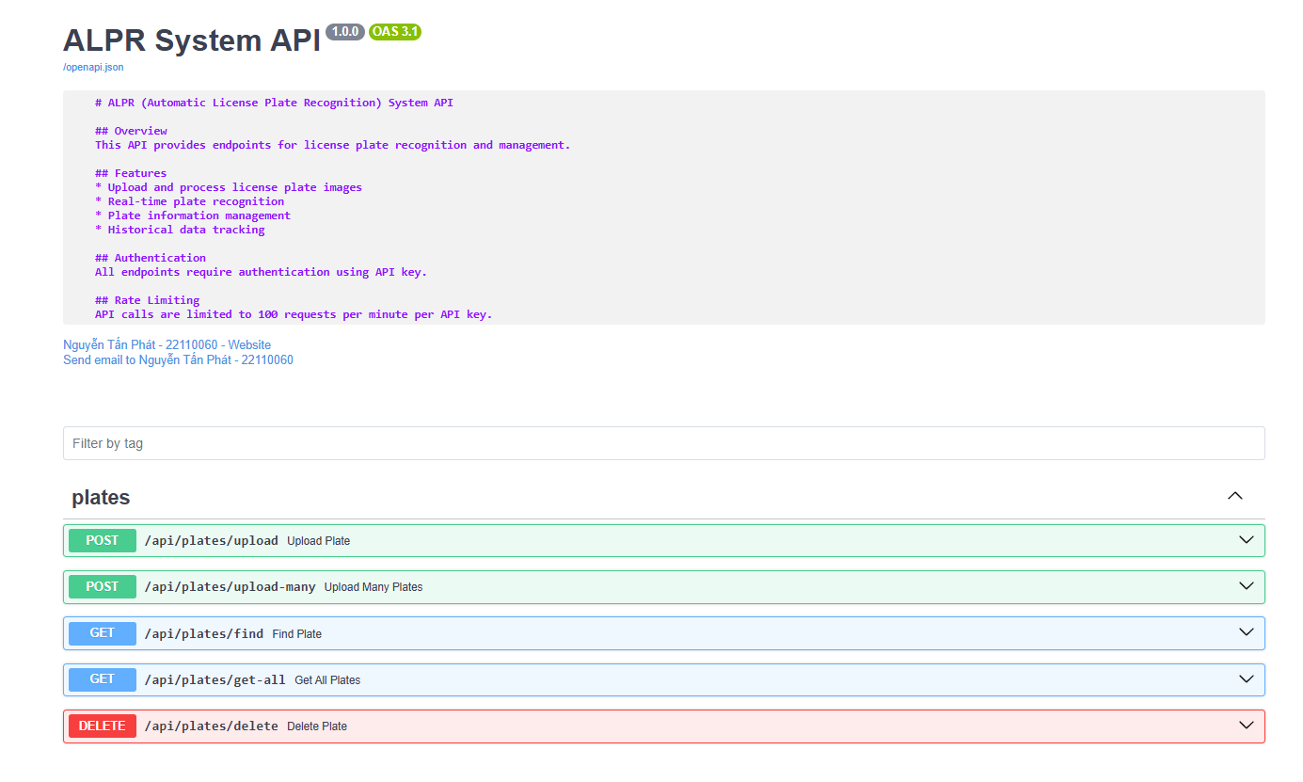
Figure 4. Backend Interface
The backend system provides a comprehensive API interface that serves as the main point of interaction for the frontend application. The API is designed following RESTful principles, ensuring clear and consistent communication between the frontend and backend components.
Core API Endpoints:
- Image Processing: Upload and process images for license plate recognition
- Data Management: Store and retrieve license plate records
- System Monitoring: Track system performance and health metrics
The API implementation includes robust error handling, request validation, and security measures. Each endpoint is carefully designed to provide clear responses and appropriate error messages, making it easy for frontend developers to integrate with the system.

3.3.3. How to run
The backend system can be deployed in various environments, from development to production. The deployment process is streamlined through the use of Docker containers, ensuring consistent behavior across different environments.
Deployment Requirements:
- Prerequisites: Docker and Docker Compose
- Configuration: Environment variables and database setup
- Development Mode: Local development with hot reloading
- Production Mode: Containerized deployment with Nginx
The system can be started using Docker Compose:
docker-compose up -d
For development purposes, the system can also be run directly using Python:
python -m venv venv
source venv/bin/activate # or venv\Scripts\activate on Windows
pip install -r requirements.txt
python main.py

3.3.4 Conclusion
The backend implementation successfully delivers a robust and efficient system for license plate recognition. The architecture and technology choices have resulted in a system that meets the performance and reliability requirements of real-world applications.
Key Achievements:
- Performance: Efficient image processing and data management
- Reliability: Robust error handling and system monitoring
- Scalability: Modular architecture supporting future growth
- Security: Comprehensive security measures and data protection
The implementation provides a solid foundation for future enhancements and modifications. The modular architecture allows for easy addition of new features, while the comprehensive monitoring system ensures reliable operation. The backend successfully integrates with the frontend application, providing a complete solution for license plate recognition tasks.[Insert backend architecture diagram here]This structure provides a clear and comprehensive overview of the backend implementation, from the technology choices to the final deployment. The sections flow logically from the technical foundation to the practical implementation and conclusion, making it easy for readers to understand the complete backend architecture of the ALPR system.The backend implementation demonstrates a successful application of modern software engineering principles and technologies to solve real-world license plate recognition challenges. The system's architecture and implementation choices have resulted in a robust and efficient solution that can be easily maintained and extended as requirements evolve.

CHAPTER 4. IMPLEMENTATION, TEST CASES, RESULTS, AND DISCUSSION

4.1. Implementation:
We have gathered a large number of images featuring Vietnamese license plates from diverse environments (e.g., urban roads, parking lots, and highways) to comprehensively test the performance and accuracy of our application and its APIs. These images will be used to evaluate the detection, localization, and OCR components under various lighting conditions, angles, and vehicle types.
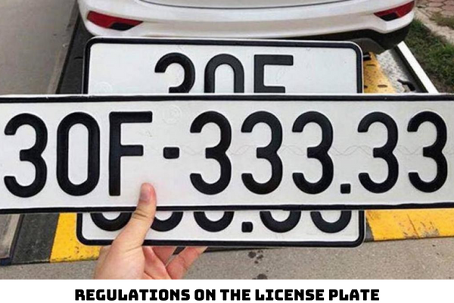
Figure 5. Sample License Plates

4.2. Test Cases:
We plan to process and recognize a wide variety of license plate images, covering different real-world scenarios. Each case will be evaluated individually to assess recognition accuracy and system performance. The results for each image will be displayed accordingly after processing.
Original:
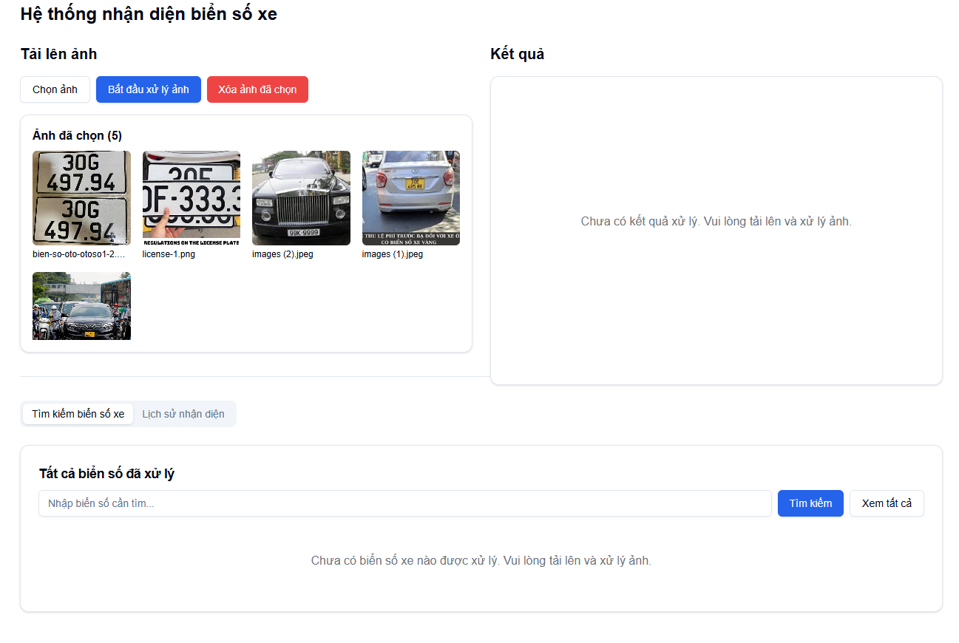
Figure 6. Many pictures detection
Result:
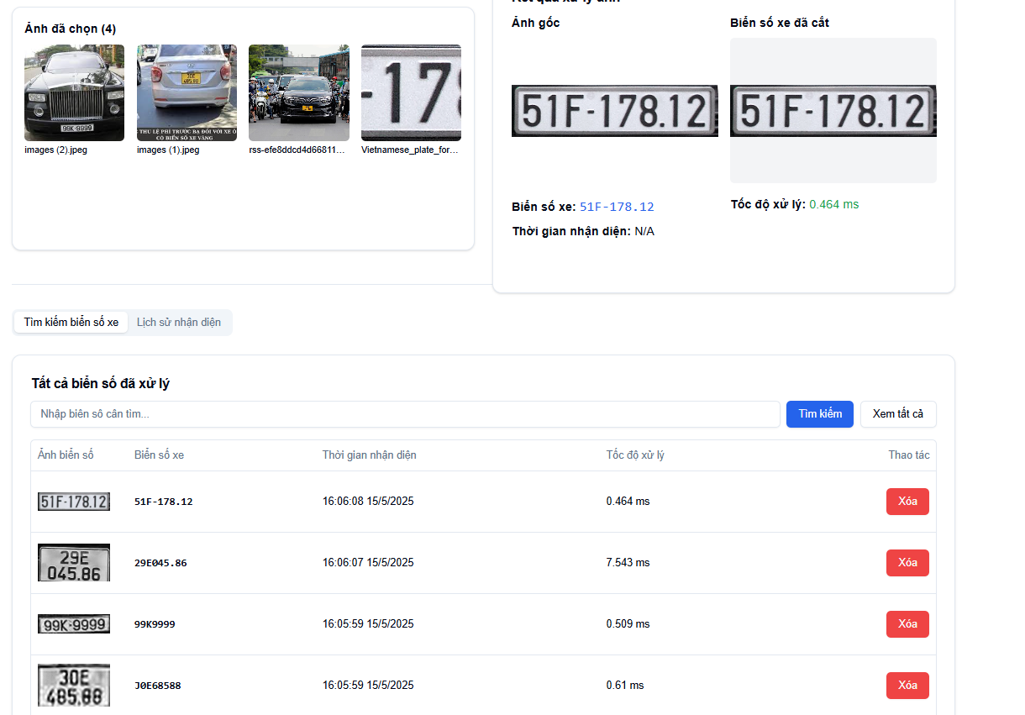
Figures 7. Many pictures detection result

4.2.1. Plain, easy to recognise
Original:
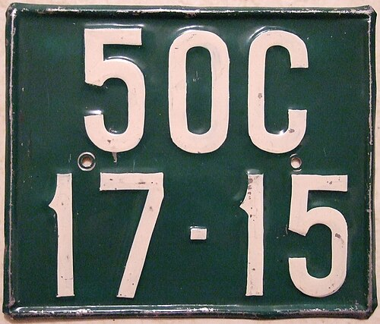
Figure 8. Plain picture
Result:
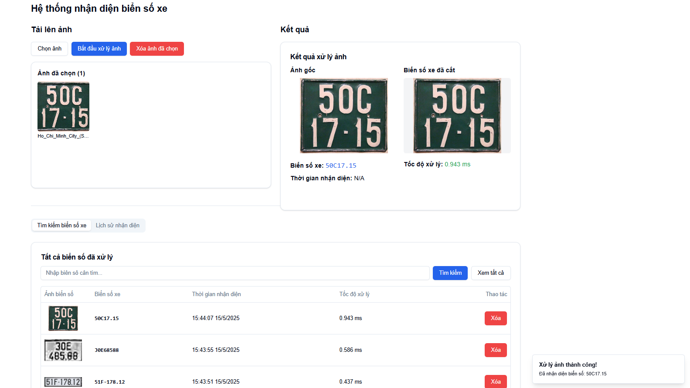
Figure 9. Plain picture result

4.2.2. Crop image
Original:
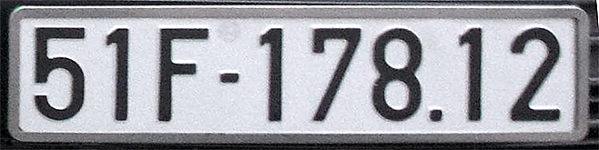
Figure 10. Cropped picture result

Result:
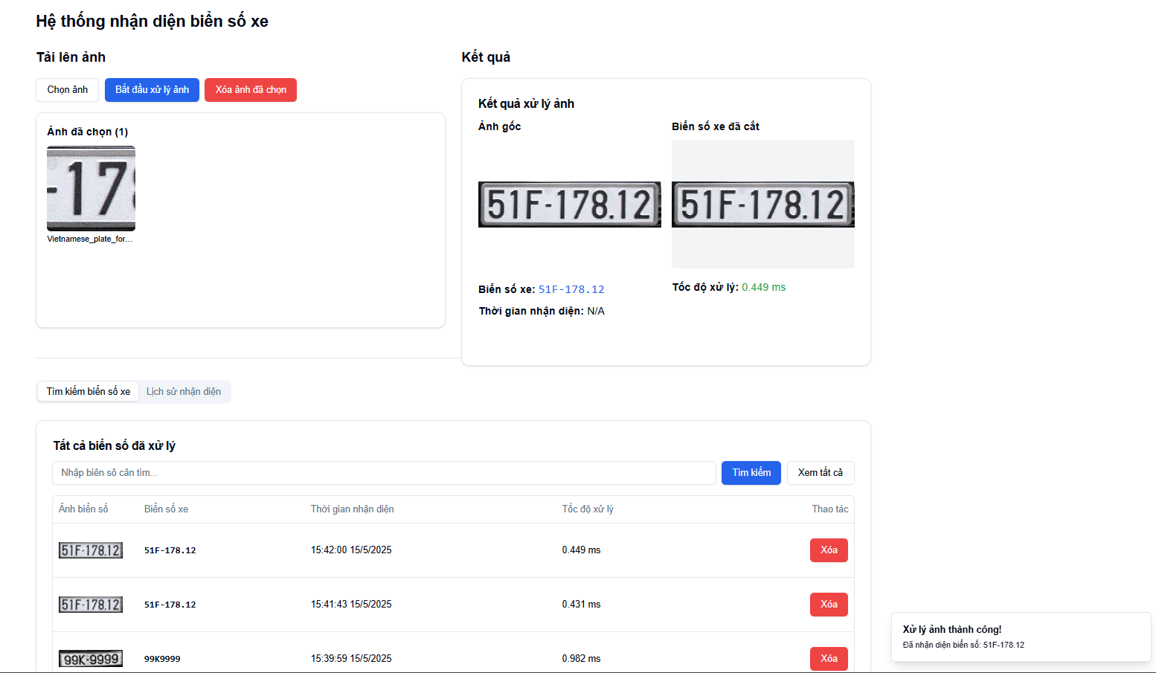
Figure 11. Cropped picture result

4.2.3. Crop image and need to enhance
Original:

Figure 12. Need-to-enhance picture
Result:

Figure 13. Need-to-enhance picture result

4.2.4. APIs Responses
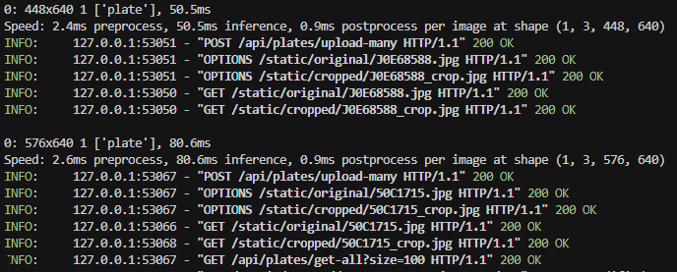
Figure 14. APIs Responese

4.3. Results:
Under ideal conditions, the photo is fully lit and the photo is not blurred, the application can easily accurately identify the type of sign.
If the sign can’t be detected, it will return the message in the API:

Figure 15. Unrecognised sample
In case of duplication, the system will still return one plate number only:
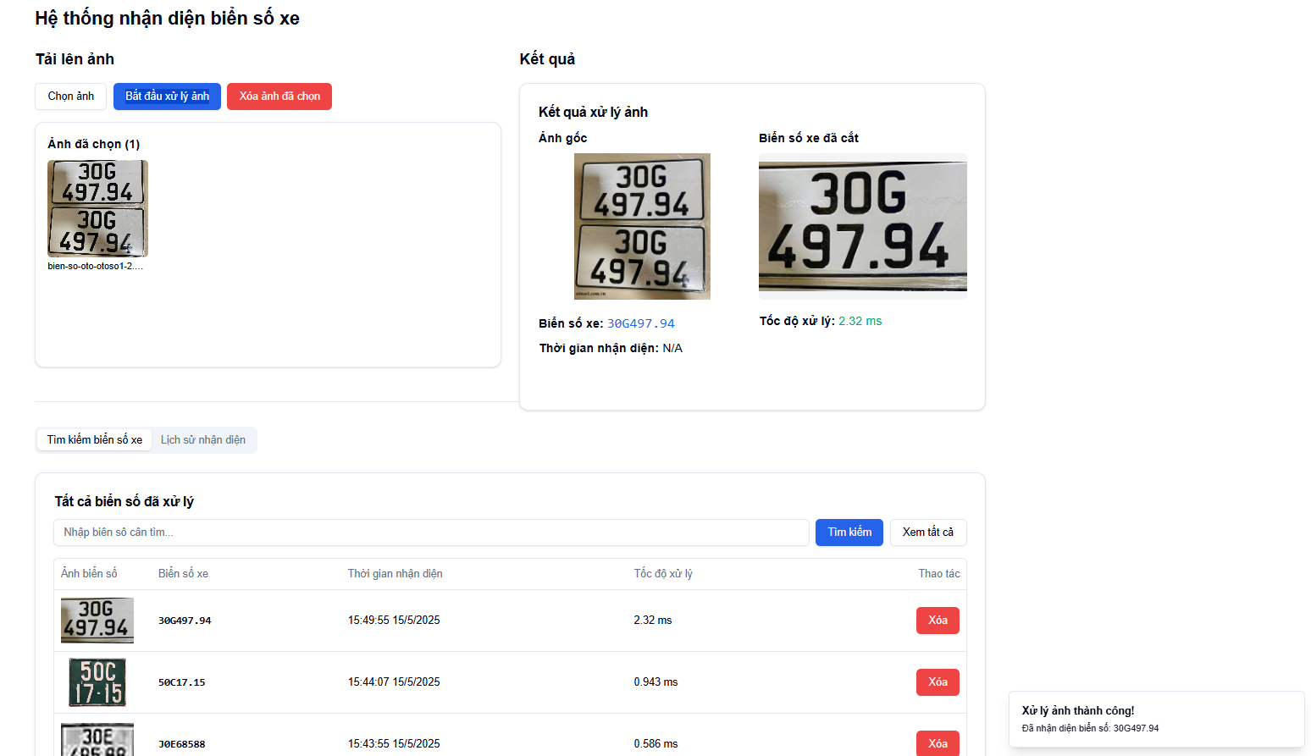
Figure 16. Auto-cropped and enhanced result

CHAPTER 5: CONCLUSIONS

5.1 Key Takeaways
The ALPR system has successfully met the core requirements of an automatic license plate recognition application. The project was completed within the specified timeline, delivering a functional and practical solution for license plate detection and recognition.

5.1.1 Advantages
Core Functionality:
- The system successfully recognizes common license plate formats
- High accuracy in ideal conditions
- Versatile input methods (images, videos, live camera feed)
- User-friendly interface requiring minimal technical knowledge
Technical Implementation:
- Robust backend processing with YOLOv8 and EasyOCR
- Efficient frontend design with React and TypeScript
- Scalable architecture supporting multiple deployment options
- Comprehensive API documentation and error handling
User Experience:
- Intuitive interface design
- Clear result presentation
- Efficient search and filtering capabilities
- Responsive design across different devices

5.1.2 Disadvantages
Recognition Accuracy:
- Limited recognition of uncommon license plate formats
- Performance degradation in challenging lighting conditions
- Occasional false positives in complex scenes
- Sensitivity to image quality and angle
Technical Constraints:
- Video processing performance issues
- Live camera feed limitations (network dependency)
- Processing speed constraints
- Resource-intensive operations

5.2 Future Directions
Several key areas have been identified for enhancing and expanding the system in future iterations:
Data and Model Enhancement
- Expand the training dataset to cover a broader range of license plate variations, including different regions and formats.
- Integrate more advanced image preprocessing techniques to improve input quality.
- Explore and incorporate additional machine learning models to boost performance.
- Focus on improving recognition accuracy under challenging conditions (e.g., low light, occlusion, motion blur).
Technical Improvements
- Optimize the system for better performance when handling video streams.
- Enhance support for live camera feeds with low-latency response.
- Implement real-time processing optimizations to reduce lag.
- Minimize system resource consumption to ensure scalability and deployment flexibility.
Feature Expansion
- Develop a mobile application to provide broader accessibility.
- Add support for a wider range of international license plate formats.
- Implement advanced analytics tools for deeper insights (e.g., frequency patterns, heatmaps).
- Continue improving the system's ability to process results in real time.
User Experience Enhancements
- Improve UI responsiveness and fluidity across devices.
- Offer more customization options for system configuration and output.
- Enhance the visualization of recognition results to make outputs more intuitive.
- Add features for users to provide feedback and help fine-tune performance.
This evaluation presents a thorough review of the current system’s strengths and limitations, while outlining a strategic roadmap for future enhancement. The project has successfully delivered a working ALPR solution, demonstrating the practical application of modern computer vision and web technologies to real-world license plate recognition challenges. Although improvements remain, the system lays a solid and scalable foundation for continued development and innovation.

REFERENCES
- Smith, R. (2007). An Overview of the Tesseract OCR Engine. In Proceedings of the Ninth International Conference on Document Analysis and Recognition (Vol. 2, pp. 629-633). IEEE. https://doi.org/10.1109/ICDAR.2007.4376991
- Microsoft. (n.d.). FastAPI - FastAPI documentation. FastAPI. Retrieved May 14, 2025, from https://fastapi.tiangolo.com/
- Meta. (n.d.). React – A JavaScript library for building user interfaces. React Official Website. Retrieved May 14, 2025, from https://reactjs.org/
- Jocher, G., Chaurasia, A., & Stoken, A. (2023). YOLOv8 - Ultralytics. Ultralytics Documentation. Retrieved May 14, 2025, from https://docs.ultralytics.com/
- Google Research. (n.d.). Welcome to Google Colaboratory. Google Colab. Retrieved May 14, 2025, from https://colab.research.google.com/
- Gonzalez, R. C., & Woods, R. E. (2018). Digital Image Processing (4th ed.). Pearson.
- Szeliski, R. (2022). Computer Vision: Algorithms and Applications (2nd ed.). Springer. https://doi.org/10.1007/978-3-030-34372-9
- Powers, D. M. W. (2011). Evaluation: From precision, recall and F-measure to ROC, informedness, markedness & correlation. Journal of Machine Learning Technologies, 2(1), 37–63. http://www.cse.unsw.edu.au/~billw/mldm/Papers/Info/PRROC.pdf

